SUBJECT* | 36C25026R006 FY26 RLP Kalamazoo Clinic

GENERAL INFORMATION
CONTRACTING OFFICE’S ZIP CODE* | 46240
SOLICITATION NUMBER* | 36C25026R0006
RESPONSE DATE/TIME/ZONE | 04-14-2026 12PM EASTERN TIME, NEW YORK, USA
ARCHIVE | 99 DAYS AFTER THE RESPONSE DATE
SET-ASIDE | SDVOSBC
PRODUCT SERVICE CODE* | X1DB
NAICS CODE* | 531120
PLACE OF PERFORMANCE
 | Kalamazoo MI
POSTAL CODE
COUNTRY | USA
CONTACT INFORMATION
CONTRACTING OFFICE ADDRESS | Department of Veterans Affairs  Network Contracting Office 10  8888 Keystone Crossing  Suite 325  Indianapolis IN 46240
POINT OF CONTACT* | Lease Contracting Officer  Brian Walton  Brian.Walton@va.gov  (216) 447-8300 x49519  Kevin Adkins  kevin.adkins@va.gov
ADDITIONAL INFORMATION
AGENCY’S URL | https://department.va.gov/construction-and-facilities-manage
URL DESCRIPTION | CFM Website Real Property
AGENCY CONTACT’S EMAIL ADDRESS | kevin.adkins@va.gov
EMAIL DESCRIPTION | Lease Contract Specialist

DESCRIPTION
Set-aside:
RLP 36C25026R0006 will be set-aside for Service-Disabled Veteran Owned Small Business (SDVOSB).
Description: The Department of Veterans Affairs seeks to lease a minimum of 10,000 ABOA Square Feet (SF) of medical office space and 77 surface/outside parking spaces , inclusive of seven (7) ADA compliant parking spaces, reserved for the exclusive use by the VA as a Consolidated Medical Clinic in the delineated area explained below within Kalamazoo, Michigan. The space shall be located within the delineated area stated below. VA will consider space located in an existing building as well as a building being constructed for multi-tenant use and not specifically a build-to-suit for VA use only.
ABOA is generally defined as the space remaining once common areas, lessor areas, and non-programmatic areas required by code are deducted from the rentable square feet of the facility. ABOA does not include areas such as stairs, elevators, mechanical and utility rooms, ducts, shafts, vestibules, public corridors, and public toilets required by local code. VA will provide all detailed definitions, should a solicitation for offers or request for proposals be issued for this project.
Lease Term: Up to 20 Years
The Government requests Space in an area bounded as follows:

North Boundary: E G Ave; N. Riverview Drive. Commerce Lane; W. Mosel Ave; Barney Rd.; Nichols Road; Ravine Road, N. Drake Road; W H Ave;
West Boundary: North 6th Street. M 43/West Main St, South 9th Street, Rt. 94; S. 4th St, S. 3rd St.;
South Boundary: W Q Ave, West & East Centre Ave
East Boundary: S Sprinkle Road; N. Sprinkle Road;

The map below is just for visual purposes and does not change the written boundaries delineated above.
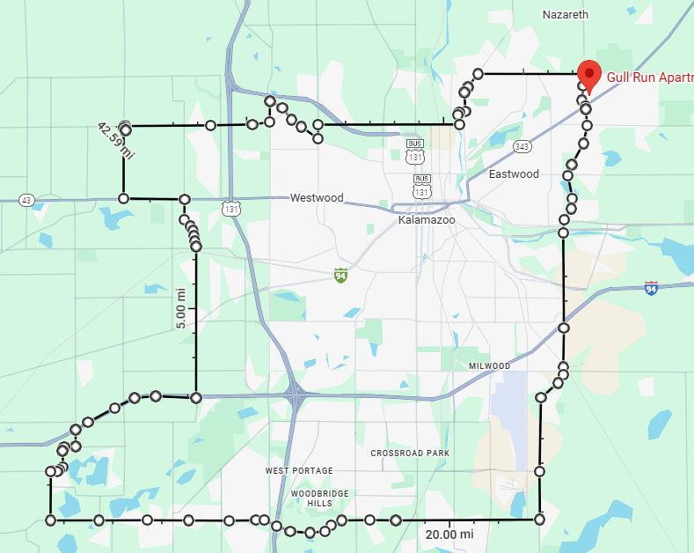
Buildings with Property boundary(ies) on the boundary streets are deemed to be within the delineated Area of Consideration.
The offered Building and/or Property must have the following features as a minimum requirement:

1. Site must be able to support municipal water and sewer utility services.
2. Offered Space shall be located on a single floor within one building; located on the Ground level or first (1st) floor. VA will consider space located in an existing building as well as a building being constructed for multi-tenant use and not specifically a build-to-suit for VA use only. However, existing space within a single tenant building is preferred.
3. Bifurcated sites, inclusive of parking, are not permissible;
4. The following space configurations will not be considered: Space with atriums or other areas interrupting contiguous space, extremely long or narrow runs of space (more than twice as long as wide), irregularly shaped space configurations or other unusual building features adversely affecting usage,
5. Offered space cannot be in the FEMA 1-percent-annual-chance flood;
6. Offered space must be zoned for VA’s intended use
7. Offered space will not be considered if located in close proximity to property with incompatible uses, including but not limited to the following uses: Cannabis dispensaries, liquor establishments, treatment centers, correctional facilities, where firearms are sold/discharged, railroad tracks, or within flight paths;
8. Space will not be considered where apartment space or other living quarters are located within the same building; neighborhoods; or industrial areas;
9. Offered space must be located in close proximity to amenities including but not limited to restaurants, hotels, pharmacy, and shopping;
10. Offered space must be located in proximity to a hospital or stand-alone emergency room center and a fire department;
11. Offered space must be located in close proximity to public transportation. A bus rapid transit stop shall be located within the immediate vicinity of the principle functional entrance to the building (walkable 2,640 feet);
12. Offered space must be easily accessible to multiple highways which provide multiple routes of travel,
13. Loading doors with a two exterior doors each 3’-0” opening width; and a single interior door at 4’-0” opening width.
14. The parking lot must be able to accommodate deliveries by box trucks; and provide enough area for a semi-trailer to enter, park, and exit the lot; however; semi-trailers would not utilize the loading dock.
15. Structured parking under the space is not permissible;
16. Offered space must meet Federal and Local Government requirements for fire safety, physical security, accessibility, seismic, and sustainability standards per the terms of the formal request for proposals (pending issuance);
17. A fully serviced lease is required;
18. Offered space must be compatible for VA’s intended use;
19. Space must not have any environmental issues or hazards.
20. Must meet Government requirements for fire safety, accessibility, seismic, and sustainability standards per the terms of the Lease.
21. Column size shall not exceed two (2) feet square and space between columns and/or walls shall not be less than twenty (20’) feet
The expected issuance date for the RLP shall be on or around April 15,2026.

Government Points of Contact:
Lease Contracting Officer- Brian Walton- Brian.Walton@va.gov , 216-447-8300 x49519;
Lease Contract Specialist Kevin Adkins- kevin.adkins@va.gov, 317-988-1544

