
US Department of Agriculture (USDA)

Quality Assurance Surveillance Plan

Contents
Project Name 3
Section 1: Introduction 3
1.1 Purpose 3
1.2 QASP Relation to the Contract 3
1.2.1 QASP Revisions 3
1.2.2 Surveillance of Performance Progression 3
1.3 QASP Relation to the Quality Control Plan (QCP) 3
Section 2: Performance Description 3
2.1 Performance Standards and Acceptable Quality Levels (AQLs) 3
2.1.1 Allowable Deviation 4
2.1.2 Substantially Complete 4
2.2 Non-Performance 4
2.2.1 Documentation 4
2.2.2 Remedial Actions 4
Section 3: Contractor and Government Responsibilities 4
3.1 Contractor Responsibility 4
3.2 Government Responsibility 5
3.2.1 Contracting Officer (CO) 5
3.2.2 Contracting Officer Representative (COR) 5
3.2.3 Customers 5
Section 4: Surveillance Methods to Perform Quality Assurance 5
4.1 Surveillance Methods 5
4.2 Analysis and Results 6
Appendix A: Planting Inspection Forms 7
Appendix B- Planting Inspection Method 9
Appendix C: Performance Requirements Summary, Acceptable Quality Levels, and Payment Calculation 13
Appendix D: Acceptable Seedling Placement 17
Appendix E: Utilization of Material to Provide Shade 19
Appendix F: Plot Radius and Slope Correction Table for Inspection 20

Project Name
2025 Rio Grande Tree Planting

Section 1: Introduction
This Quality Assurance Surveillance Plan (QASP) is pursuant to the requirements listed in the statement of work (SOW) entitled 2025 Rio Grande Tree Planting. This plan sets forth the procedures and guidelines that the USDA, Rio Grande National Forest will use in ensuring the required performance standards or services levels are achieved by the contractor.

Purpose
The purpose of the QASP is to describe the systematic methods used to measure performance and to identify the reports required and the resources to be employed. The QASP provides a means for evaluating whether the contractor is meeting the performance standards identified in the SOW. This QASP is designed to define roles and responsibilities, identify the performance objectives, define the methodologies used to monitor and evaluate the contractor’s performance, describe quality assurance reporting, and describe the analysis of quality assurance monitoring results.

QASP Relation to the Contract

QASP Revisions
The Contracting Officer Representative (COR) may make revisions or changes to the QASP procedures and surveillance methods or increase or decrease the degree of surveillance methods at any time during the contract performance period. Changes to the Metric must be incorporated into the SOW, Performance Requirement Summary (PRS) and QASP by a bilateral modification to contract that is issued by the Contracting Officer (CO). A copy of the QASP is provided to the contractor to enable the contractor to enhance its Quality Control (QC) program to perform in accordance with its Quality Control Plan (QCP).

Surveillance of Performance Progression
As the performance period progresses, the levels of surveillance may be altered for service areas where performance is either consistently excellent or unsatisfactory. If consistently good performance, then the amount of surveillance may be reduced. If observations reveal consistent deficiencies, increased surveillance may be implemented.

QASP Relation to the Quality Control Plan (QCP)
The QCP is a required element of contract and the Contractor shall adhere to its established quality control processes and procedures in managing and performing work as described in the contract. While the QCP represents the way in which the Contractor will ensure its quality and timeliness of services, as defined in the SOW (see Attachment 3- Supplemental Contract Information), the QASP represents the way in which the Government personnel specified in Section 3: Contractor and Government Responsibilities, Paragraph 3.2, Government Responsibilities (below) will evaluate the contractor’s performance. The contractor’s QC program and the residual organization’s QASP should be complementary programs that ensure successful contractor performance.

Section 2: Performance Description
Performance of the contractor will be monitored through the surveillance methods described below in Section 4: Surveillance Methods to Perform Quality Assurance to assess the Contractor’s performance against SOW requirements.

Performance Standards and Acceptable Quality Levels (AQLs)
For selected activities in the SOW, the PRS provides a performance standard and an AQL. A performance standard is the expected level of contractor performance. An AQL defines the level of performance that is satisfactory. Depending on the service evaluated and the evaluation method selected, performance standards and AQLs may be stated as a number of occurrences or as a percentage. Performance standards and AQLs for random sampling and 100 percent inspection are generally stated as percentages. For periodic inspections, performance standards may be stated as either percentages or as absolute numbers.

The contract requires the Contractor to perform all work as specified. Any inaccuracies or omissions in services or products are referred to as “defects” on the part of the Contractor. The Contractor shall be responsible for all identified defects and may be required to perform the work at no cost to the government. The AQLs take into account that in some instances an allowable level of deficiencies (deviations) is possible while overall performance continues to meet the government’s desired level of service. See Appendix C for performance standards and acceptable quality levels.

Allowable Deviation
The AQLs define the level or number of performance deficiencies the Contractor is permitted to reach under this contract. AQLs take into account the difference between an occasional defect and a gross number of defects. AQLs can be expressed as a percentage of or as an absolute number (e.g., three per month). There may be instances where 100 percent compliance is required, and no deviation is acceptable (e.g., where safety is involved).

Substantially Complete
In some cases, service outputs are evaluated using subjective values (e.g., excellent, satisfactory, unsatisfactory). The criteria for acceptable performance and for defects must be defined for these service outputs. The concept of “substantially complete” should be the basis for inspections based on subjective scales. Work is considered “substantially complete” where there has been no significant departure from the terms of the contract and no omission of essential work. In addition, the Contractor has performed the work required to the best of its ability and the only variance consists of minor omissions or deficiencies.

Non-Performance
Non-performance occurs when the contractor’s performance does not meet the AQL for a given requirement. Requirements may contain multiple performance elements, and therefore, deficiencies may occur in one or more aspects of performance (e.g., timeliness, accuracy, completeness, etc.) or subject areas of effort.

When surveillance indicates that the contractor's service output is not in compliance with the contract requirements, the Contracting Officer’s Representative (COR) must determine whether the Contractor or the Government caused the deficiency. If the cause of the defect rests with the Government, corrective action must be taken through Government channels. If the cause of the defect is due to action or inaction by the contractor, the contractor is responsible for correction of the problem at no additional expense to the Government. See Appendix C for performance standards, acceptable quality levels, and determination of unacceptable work.

Documentation
Documentation of work non-performed or unacceptable work is essential for tracking Contractor performance. The COR will document deficient work by compiling facts describing the inspection methods and results and to substantiate nonconformance with the contract. A sample documentation reporting form is provided in Appendix A. The documentation, with any recommendations, will be forwarded to the CO. In the case of the Contractor, the COR will decide whether to elevate the problem to the CO for corrective action.

Remedial Actions
The Federal Acquisition Regulation allows for penalties in the event that the Contractor fails to perform the required services. Penalties are defined as those actions taken under the direction of the CO against the contractor within the general provisions of the contract for nonconformance to the SOW and PRS.

Section 3: Contractor and Government Responsibilities

Contractor Responsibility
The Contractor is responsible for: 1) delivering products or services in accordance with the contract; 2) implementing its QCP, which describes the Contractor’s methods for ensuring all products and services under the contract meet established performance standards and AQLs; 3) maintaining, and providing for audit, quality control records and reports and all records associated with the investigation and complaint resolutions; 4) appointing a single quality control point-of-contact to act as a central recipient of communication from the COR or CO.

Government Responsibility

Contracting Officer (CO)
The CO is responsible for administering and monitoring contract compliance, contract administration, and cost control and for resolving any differences between the observations documented by COR and the contractor’s performance. The CO may delegate various day-to-day contract administration duties to an Administering CO (ACO) and/or the COR for performance management and administrative actions such as invoice approval and issuance of Contract Discrepancy Reports may be, and normally are, delegated by the CO to the COR. The CO shall approve any revisions to the QASP processes or standards.

Contracting Officer Representative (COR)
The COR, is designated in writing, by the CO. The COR will ensure that the QA function is properly executed, plays a key role in contract administration and performs the contract surveillance and monitoring. Some key contract administration duties include, but are not limited to, performs surveillance as required by this QASP; make recommendations to the CO for issuance of Contract Discrepancy Reports or letters of commendation and acceptance or rejection of completed work and for administrative actions based on unsatisfactory or non-performed work, and revisions or changes to the QASP; and assists the CO in identifying necessary contract modifications and preparing reports of Contractor performance and cost.

The COR may use the form(s) included in the Appendices to perform the inspection or other forms as approved by the CO. The Contractor overall guidance is also provided by FAR clause 52.246-4 in Section 4 of the BPA.

Customers
This section is not applicable to this contract.

Section 4: Surveillance Methods to Perform Quality Assurance

Surveillance Methods
The surveillance methods used in the QA process are the Government’s tools to monitor the Contractor’s products and services. The best means of determining whether the Contractor has met all contract requirements is to inspect the Contractor’s service products and analyze the results. Further, documented inspection results are an effective tool in contract administration that can confirm the successful achievement of all performance requirements or highlight areas where defects exist and improvements are necessary.

Inspection While Work is in Progress. The COR and Inspector(s) shall inspect the Contractor's work during all aspects of tree planting from the time trees are issued to the Contractor until they are returned or planted. This form of inspection is a surveillance of the planting operation. The surveillance may include informal plots to check spacing and below ground planting quality. The surveillance will follow guidance outlined in the Region 2 Supplement to Forest Service Handbook (FSH) 2409.17, Section 2.82.

Inspectors shall be with the Contractor at all times that the contractor has trees in possession for per-acre and per-tree contracts. When the COR or Inspector detect violations in tree handing or planting technique, they will advise the Planting Foreman or Contractor’s Representative such that the Contractor can correct lapses before the scale of the issue escalates into a problem which cannot be resolved. This may mean the Contractor will have to rework areas to bring the planting quality up prior to formal plot inspections.

See Appendix A for the Planting inspection sheet that will be used by the government for surveillance. See Appendix B for the planting inspection method that will be used to calculate planting quality and payment for work.

Analysis and Results
When the inspections and validations have been completed, the COR will perform an analysis of the Contractor’s performance. The purpose of the analysis is to ensure Government is receiving high-quality products and services from the Contractor. The COR will review the results, rate the Contractor’s compliance with the performance standards and AQLs, and characterize the Contractor’s overall performance. Analysis of all types of contract monitoring will result in one of the following outcomes:
- Acceptance
- Rework
- Unacceptance
See Appendix C for guidance related to acceptable work, unacceptable work, and method of calculating payment.

Appendix A: Planting Inspection Forms
Planting Inspection Sheet – Contract and Force Account
(Ref. FSH 2409.17)
FOREST |  |  |  |  |  |  |  | DISTRICT |  |  |  |  |  |  | INSPECTOR |  |  |  |  |  |  |  |  |  |  |  | CONTRACT NUMBER
COR |  |  |  |  |  | PLOT SIZE |  |  |  |  |  | STAND NUMBER |  |  |  |  |  |  |  | CONTRACTOR |  |  |  |  |  |  |  |  |  |  |  | SUB ITEM NUMBER
 |  |  |  |  |  |  |  |  |  |  |  |  |  |  |  |  |  |  |  |  |  |  |  |  |  |  |  |  |  |  |  | 3.1
ACRES |  |  |  |  |  | AVERAGE SPACING |  |  |  |  |  | MAX TREES/PLOT |  |  |  |  |  |  |  |  |  |  |  |  |  |  |  |  |  |  |  | SHEET NUMBER
 |  |  |  |  |  |  |  |  |  |  |  |  |  |  |  |  |  |  |  | Shade req’d., use stationary first |  |  |  |  |  |  |  |  |  |  |  | 1 of
DATE | Plot No. | (2) |  |  |  |  |  |  |  |  |  |  |  |  |  |  | (3) |  | (4) |  |  | (5) |  | (6) |  | (7) |  |  | (8) |  | (9) |  |  | (10) |  | (11) |  | Remarks
 |  | Examine & Tally Planted Trees |  |  |  |  |  |  |  |  |  |  |  |  |  |  | Desired No. of Plantable Spots |  | No. Unplantable |  |  | Actual No. Plantabe Spots |  | Actual No. Allowable |  | No. Planted Trees |  |  | No. Wasted Trees |  | No. Trees Statis. |  |  | No. Trees Dug |  | No. Trees Statis. Below Ground
 |  | (1) | (2) | (3) | (4) |  | (5) |  | (6) | (7) | (8) |  | (9) | (10) | (11)
*First line for above ground.  Second line for below ground. |  |  |  |  |  |  |  |  | TOTALS |  |  |  |  |  |  |  | 60 |  | 7 |  |  | 53 |  | 63 |  | 65 |  |  | 6 |  | 55 |  |  | 20 |  | 17 |  | FINAL % _____

INSTRUCTIONS
1. Locate and mark the plot center on the ground.
2. Locate and examine planted trees for above ground criteria. Record results in column 2 of inspection form.

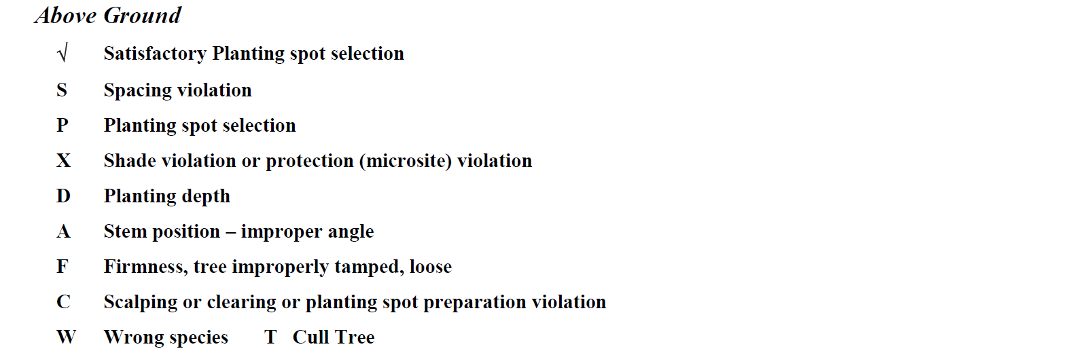
3. Determine from table 1 the average number of desired plantable spots for the plot based on the specified average spacing. Record results in column 3.
4. Determine and record in column 4 the number of spots void of planted trees that are unplantable due to acceptable existing natural regeneration or on-the-ground conditions. (Refer to definitions in supplement to the General Provisions.)
5. Subtract column 4 from the average number of planting spots and record the difference as the actual number of plantable spots on which trees should be planted on the plot in column 5.
6. Determine the maximum number of allowable trees from table 2 and record in column 6.
7. Record the number of trees planted on the plot from column 2 in column 7.
8. Determine wasted trees by subtracting the maximum number of allowable trees in column 6 from those planted (column 7) and if more than zero, record in column 8.
9. Record the number of planted trees meeting the above-ground contract specifications from column 2 in column 9. The maximum number of satisfactory trees to be credited shall not exceed the maximum number recorded in column 6.
10. Determine and dig at least the minimum number of trees from those determined satisfactory above ground in accordance with table 3 and record in column 10. The trees will be dug starting with those closest to the plot center and progressing outwards.
11. Tabulate below ground results in column 2 and record the number of trees meeting below-ground contact specifications in column 11.
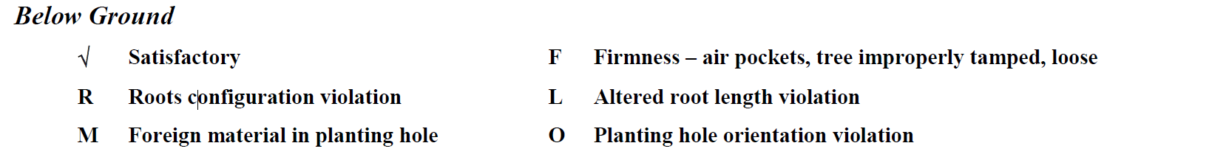

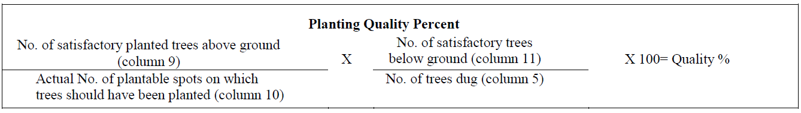

Appendix B- Planting Inspection Method
Planting contracts require intensive inspection. The government shall conduct quality assurance inspections as described below. The contractor’s quality control plan shall be consistent with the following procedures.

There are two phases of contract inspection: (1) Inspection while work is in progress observing tree care, wasting of trees, and planting technique while planting is in progress, and (2) plot inspection where the inspector checks quality of planting using systematically placed plots.

1. Inspecting for Planting Quality. The primary factor in determining the contractor's payment is the plot inspection. Use the following process and standard inspection form (R-1, 2, 3, 4 FS-2470-9). Variations to this may be done with approval of the CO and regional silviculturist or reforestation specialist to meet specific planting requirements. Specify the inspection process in the contract. Refer to exhibit 01 for a sample of the standard inspection form. The inspector shall sign the inspection form and initial any changes, as this is the main basis for contract payment. All inspectors should fully understand the inspection forms and procedures for completing the inspection.

a. Equipment Needed.
(1) Clipboard and pencils.
(2) Inspection sheets
(3) Full contract (with exhibits).
(4) Fifty-foot logger's tape.
(5) Plot pole or shovel with swivel on handle to attach the tape.
(6) Flagging.
(7) Screwdriver, ice-pick, or garden trowels that aid in below ground inspection.
(8) Tile spade, hognose spade, planting hoe for hoe planting.
(9) Slope correction table.
(10) Clinometer or Abney.
b. Plot Design.
(1) Plot Size. Use either 1/50th- or 1/100th-acre plots for planting up to 10- by 10-foot spacing. At wider spacings, use the 1/50th-acre plot to ensure there are adequate trees per plot for statistical reliability.
Plot radius will vary depending on slope. After determining slope percent, use the plot table in section 2.73; exhibit 01, for determining radii for plot on 1/100th- and 1/50th-acre plots. Use these radii for the full plot. Do not compensate by changing radius or raising and lowering the tape when going around the plot. Such adjustments are included in the table.
(2) Plot Placement. Establish plot in a systematic manner, distributed uniformly over entire acreage. A grid system is recommended.
(3) Quantity of Plots. The minimum sampling intensity is specified in the contract. When payment reductions are anticipated, a 2 percent sample is required.
c. Inspection Within The Plot. Mark the plot so that it can be relocated by the COR or Contractor. Inspect each plot in accordance with contract. Utilize the following inspection for most contracts. Follow this procedure in the described order for accurate inspection results.
(1) Locate and mark plot center on the ground. A pin flag with plot number or similar locator is recommended for the center point.
(2) Inspect and record the aboveground condition of each tree planted. Working in a clockwise direction from true north, locate, examine, and record the condition of planted trees in spaces under column 2 of the inspection form. Use codes listed below. A poorly planted tree may have more than one violation, however, only one code may be listed. Identify the most severe.
Check - Satisfactory tree above ground.
S - Spacing Violation. A tree that has been planted closer than one-half of the spacing allowance to another acceptable tree is a violation unless otherwise stated in the contract. For example, if the spacing is 10 feet by 10 feet and a tree is closer than 5 feet to another planted tree, one tree is in violation for spacing. If one of the trees is improperly planted due to another reason, charge the spacing violation to the improperly planted tree and check the remaining good tree as properly planted.
P - Planting Spot Violation. Tree planted in debris, loose soil, duff, ashes, or similar material.
X - Shade Protection Violation. Shade and seedling protection is not consistent with the contract clause specified for the unit.
D - Planting Depth Violation. Trees are planted too deep or shallow. The contract requires that after filling, packing, and leveling, the soil shall come up to a point even with, or up to 1 inch above, original ground line of tree. Note that the original ground line is always above the root collar and should be considered in the area between the cotyledon scar and the root collar. No portion of the roots shall be exposed nor any branches covered with packed soil.

If soil is loose around branches and needles above the ground line, soil will settle and no harm is done. However, if soil is packed tightly or branches and needles are in the hole (below the normal ground line), a violation should be cited. Inspectors must ensure that they recognize where the root collar is. It can be seen by scraping bark back to the cambium in the root collar area. Stem tissue immediately under bark of the stem will have some green color. Below the root, scraping reveals only white tissue. Trees with roots exposed are in violation. The root system on ponderosa pine and occasionally Douglas fir and grand fir generally does not branch for 2-4 inches below the root collar. This unbranched portion of the root system is often erroneously interpreted as stem and left above ground. The root does not have thickened bark and can be easily damaged by insolation and high soil surface temperatures. Make sure the entire root system is below ground. Container plugs should be covered with soil (1/2 inch or more) in order to prevent frost heave problems.

A - Stem Position Violation (erect tree). The stem should be oriented between vertical and 90 degrees with the slope plane. Improper angle may result from improper hole opening with hoes. If the tree looks erect above ground but slanted below ground, then a belowground violation instead should be cited.
F - Firmness Violation. Trees should be tamped as firmly as soil conditions allow. In most Rocky Mountain soils, trees should not pull easily from soil. The inspector may grab the stem and gently tug. If tree comes up to expose roots (below the root collar) then the tree was not firmed up and is in violation. This test must be used with caution in very light or sandy soils.
C - Scalp or Clearing Violation. Scalp or cleared area is too small or too shallow.
W - Wrong (incorrect) Species. Species planted in area of unit where it is not supposed to be
T - Cull Trees. Cull tree is planted. Use when the contract specifies that the contractor shall not plant cull trees and identifies what constitutes a cull tree.
(3) Determine average number of planting spots from Table 1 and record results in column 3 of the inspection form.
TABLE 1
Average number of planting spots based on plot size
Average Spacing | TPA | 1/10th Acre | 1/20th Acre | 1/50th Acre | 1/100th Acre
5x5 | 1600 | N/A | N/A | N/A | 16
6x6 | 1100 | N/A | N/A | N/A | 11
7x7 | 900 | N/A | N/A | 18 | 9
8x8 | 700 | N/A | N/A | 14 | 7
9x9 | 550 | N/A | N/A | 11 | 5
10x10 | 440 | N/A | 22 | 9 | 4
11x11 | 360 | N/A | 18 | 7 | N/A
12x12 | 300 | N/A | 15 | 6 | N/A
13x13 | 260 | N/A | 13 | 5 | N/A
14x14 | 220 | 22 | 11 | 4 | N/A
15x15 | 190 | 19 | 10 | 4 | N/A
16x16 | 170 | 17 | 9 | N/A | N/A
17x17 | 150 | 15 | 8 | N/A | N/A
18x18 | 130 | 13 | 7 | N/A | N/A

(4) Determine number unplantable spots by identifying spots void of planted trees that are unplantable due to ground conditions or acceptable existing natural regeneration. Recognizing average number of planting spots on the plot, scan plot for areas void of natural and planted trees. Look for voids the planters missed. Then check to see if it is a non-plantable spot. Record in column 4.
(a) When a tree has been planted, the contractor, by default, has determined it to be a plantable spot. In terms of the inspection, the spot with a planted tree is a plantable spot no matter what the inspector finds after the fact.
(b) An unplantable spot as defined by the contract is an area within the specified spacing limits in which it is not possible to plant a tree according to specifications, and no tree has been planted. For hoe planting, a plot is considered unplantable if the inspector cannot find a suitable spot in three attempts within spacing requirements and if the hole cannot be opened at the spot with five swings or less. Auger planting requires three attempts to find the spot that will be scalped or cleared, and then three attempts to open the hole in the spot with the auger, first attempt being made in the middle of the scalp.
One unplantable spot is allowed for each single unplantable area equal in size to the average specified spacing. For example, if a single unsatisfactory area of 64 square feet exists on an 8- by 8-feet spacing, one unplantable spot will be recognized. If half of a 1/50th- plot is unplantable, then 435.6 square feet (half of 871.2) is unplantable. For 9- by 9-feet spacing, five spots would be credited as unplantable.
(5) Determine number of planting spots by subtracting column 4 from average number of planting spots (column 3). Record in column 5 of inspection form.
(6) Determine maximum number of allowable trees from Table 2, and record in column 6 of inspection form.
TABLE 2
Maximum Allowable Trees based on Number of Plantable Spot (determined in Table 1)
Plantable Spots | Maximum Trees | Plantable Spots | Maximum Trees | Plantable Spots | Maximum Trees
1 | 2 | 9 | 11 | 17 | 20
2 | 3 | 10 | 12 | 18 | 22
3 | 4 | 11 | 13 | 19 | 23
4 | 5 | 12 | 14 | 20 | 24
5 | 6 | 13 | 16 | 21 | 25
6 | 7 | 14 | 17 | 22 | 26
7 | 8 | 15 | 18
8 | 10 | 16 | 19
(7) Record the number of trees planted on the plot (also listed in column 2) in column 7 of inspection form.
(8) Determine wasted trees by subtracting maximum number of allowable trees in column 6 from those planted (column 7). If more than 0, record in column 8.
(9) Record number of planted trees meeting aboveground specifications from column 2 only up to maximum listed in column 6 of the inspection form.
Below Ground Inspection.
(10) Determine minimum number of trees to be inspected below ground utilizing Table 3 based on number of trees that are satisfactory above ground. Record in column 10 of the inspection form. To avoid bias, dig trees nearest plot center first and progress outward. Do not dig any trees that were unsatisfactory in the aboveground inspection. Correctly replant sampled trees immediately. Use moist mineral soil to pack roots.

TABLE 3
Minimum number of trees to be dug based on number of trees satisfactory above ground.
Number of above ground satisfactorily planted trees on plot | Minimum number of trees to dig
1 | 1
2-6 | 2
7-9 | 3
10-12 | 4
13-16 | 5
17 plus | 6
* Note this is the minimum; there is no maximum. The inspector may dig all satisfactory trees on plot.

(11) Inspect and record the below-ground condition of each planted tree in spaces under column 2 of inspection form using appropriate codes listed below. Record the number of trees meeting belowground specification in column 11.
Check - Satisfactory Tree Below Ground.
R - Root Configuration Violation. Root systems must not be twisted, jammed in one plane, or curved in the shape of the letters U, J, or L. Individual lateral roots may be slightly bent like the letters J or U but the primary vertical root system cannot be distorted. Container plug must not be jammed from the top (accordion effect) or the side (flattened).
To inspect for this violation, dig a rectangular shaped hole on one side of the tree. Start the hole far enough away from the tree stem (at least 10 inches) so that roots are not disturbed in the process of inserting the spade. This is best done with a tool like a tile spade. Once the primary hole is dug, probe toward the root system with a pointed instrument such as a screwdriver, ice pick, or similar tool to explore the seedling roots for orientation.
M - Foreign Material Violation. Holes must not contain large rocks, sticks, litter, cones, or other foreign debris. Inspect the same as that for root configuration. In hoe planting, if rocks, roots, and pieces of wood are present in soil prior to opening the hole, they are not considered foreign material to the hole.
F - Firmness Violation. Firmness, as determined from below ground, is done while probing the root system as described under root configuration. Soil should be nearly as firm as the undisturbed surrounding soil. There should be no air pockets where the soil is not firm. Firmness may be a problem in the bottom of auger holes if planters have not firmed soil progressively upward.
L - Altered Root Length Violation. If the dug tree has an obviously shortened root system, consider it as an improperly planted tree below ground. The contract shall state a minimum root length; trees with substandard roots should not be planted and considered a violation if they are planted.
Fresh root cuts can often be distinguished from roots cut at the nursery or during tree preparation. Living inner tissue of roots cut in advance of planting should be brown at the cut. The brown color may extend up the root under the bark for a short distance. Freshly cut roots will be white under the bark unless roots are dead when cut. Root shortening violations can also be detected during inspection while work is in progress.
O - Planting Hole Orientation Violation. This violation is seldom observed in absence of aboveground stem angle or root configuration violations. Occasionally, trees with small root systems can be propped up following slit planting. Roots may not be distorted and angle looks okay from above ground, but hole is not properly opened. Examples would be a V-shaped hole or a hole not vertical with slope plane.

(12) After all plots have been taken and recorded for the pay item, calculate the planting quality by the following formula:


Appendix C: Performance Requirements Summary, Acceptable Quality Levels, and Payment Calculation
The following information describes how activities listed in the Statement of Work will be measured for acceptance of work and payment. AQLs, as well as what constitutes damages to the government, are also defined.

Acceptance The Contractor’s Quality Control inspections for planting shall be inspected separately from artificial shade/protection and both shall and be within five percent (5%) of the Government quality assurance to be considered acceptable. If the results differ by 5 percent or less, the Contractor’s inspection will be used as the basis for payment.

The Contractors quality control will be deemed unacceptable when the Contractor fails to provide planting quality within 5 percent of the Government’s quality assurance results at the completion of a sub-item/unit. When the Contractor’s quality control is unacceptable, payment for the unit will be based on results of the Government’s quality assurance.

If the Government’s inspection results for planting on any sub-item/unit are objectionable to the Contractor, the Contractor may request a re-examination in writing within 5 calendar days after receipt of the Government’s inspection results for that sub- item/unit. The request shall include documentation that supports that the probability of an error exists. The Government’s re-examination will consist of a 2-percent sample utilizing the same inspection method as the original examination, but new plots will be selected with different plot centers than the plots previously inspected by the Government.

If the results of the re-examination are within five percent (5%) of the original inspection, the inspection results of the original inspection will be used in determining acceptability and payment, and the Contractor will be assessed the costs incurred by the Government that are directly related to the performance of such service. If the results of the re-examination exceed five percent (5%) of the original inspection results, the Government’s re-examination results will be used for the basis of pay, and the Contractor will not be assessed the costs incurred by the Government for the re-inspection.

Rework of Unacceptable Work The Government reserves the right to require unacceptable trees (wasted trees) or unacceptable planting to be replaced or replanted.

Unacceptable Work Any unit, which is planted or other material installed, at less than the performance standard of 80 percent, is considered unacceptable and may be rejected. For these areas the Government may (i) accept the work at a reduced price (ii) require the area to be reworked at no additional expense to the Government, or (iii) reject the work in its entirety. If the work quality is unacceptable, the Contractor’s right to proceed is subject to immediate termination for default.

The Government will permit the Contractor to rework an area only if planting stock or other material is available and/or the existing deficiencies can be corrected. When planting quality falls below 80 percent in areas of 1 acre or larger and the quality of work can be corrected, the Government may require the area to be reworked. If the Government does not require the area to be reworked or the quality remains below 80 percent, the area may be separated from the subitem and payment made in accordance with the Payment Calculations section.

Any Government quality assurance assessment needed due to the Contractor reworking an area, either at the Contractor's request or because of unacceptable work, will be at the Contractor's expense. The Contractor may be assessed actual damages which may include, but is not limited to, wages of the COR and Government inspector(s) incurred due to the rework, costs of vehicles, meals and lodging that are incurred while administering the contract during the rework. The Government shall document unacceptable work quality in the performance assessment.

Payment Calculations The area or number of seedlings to be planted is provided in the Schedule of Items in the Call Order. All linear and area measurements under this contract are measured on a horizontal plane. The Detailed Information Chart located under Section 2, “Specifications,” in the Call document will state what color flagging and tags are used for marking the boundaries. Payment less damages will be based on the following methods:

Per Acre Unit of Measure When the quantity of measure is by the acre, the actual number of seedlings planted will be computed based on GPS’ed acres and Tree per Acre (TPA) desired within that unit. If the number of issued trees exceeds the calculated number of trees then the contractor shall be penalized by the wasted trees clauses.

Per Tree Unit of Measure Tree planting and/or artificial shade/protection installation. Measurement for Schedule Items where a per tree is stated (Section B - Schedule of Items) will be based on the number of seedlings successfully planted on estimated acreage. The calculation will be measured by “Box Count” of the seedlings and materials delivered to the job site, minus cull trees/materials, minus wasted trees/materials, and reduced by planting quality score if necessary.

Total No. Trees _ Total Wasted
Planted (Col. 7) Trees (Col 8) X Reciprocal of Plot Size X Acres = Number of Trees
Number of Plots

Remeasurement The Contractor may at any time after award request re-measurement of any unit/subitem. The request must be in writing within 10 calendar days after completion of a unit or pay item.
The Government’s re-measurement of the unit/subitem will be made within the established boundaries.

Payment will be based on the re-measurement of the acreage or quantity count except when:
(a) Per Acre unit of measure: No payment adjustment shall be made for areas less than 1 acre.
(b) Per Tree unit of measure: No payment adjustment shall be made for quantities of less than 500.

The Contractor shall pay for the cost of re-measurement if the re-measurement results in:
(a) Per Acre unit of measure: An increase of less than 1 percent in planting quality on units smaller or equal to 20 acres or an increase of less than 5 percent on units larger than 20 acres.
(b) Per Tree unit of measure: An increase of less than five percent (5%).

Planting quality meets or exceeds 90 percent. Whenever the quality of planting exceeds 90 percent, based on the Contractor’s quality control inspection (plots) and verified by the Government assessment, the quality of planting will be acceptable and payment will be made at the full unit price for tree planting.

Payment Example per Acre: With a unit price of $100 per acre and a unit size of 60 acres, the sub-item price would be $6,000. If the Contractor’s planting quality were 95 percent, payment would be $6,000.
Payment Example per Tree: With a seedling price of $0.32 per tree. Plot data indicates 400 trees were planted per acre and the acreage of the planting unit is 250 acres, making the total trees planted 100,000. If the Contractor’s planting quality were 95 percent, payment would be $32,000.

Planting Quality less than 90 percent and at least 80 percent or over. Whenever the quality of planting is below 90 percent but is 80 percent or over, based on the Contractor’s quality control inspection (plots) and verified by the Government monitoring/assessment, the quality of planting will be considered unacceptable and payment will be made for the value of the services provided. This means that payment will be made after a 1-percent deduction in the unit price for each 1-percent the planting quality is below 100 percent. This payment will only be made after the Government determines that no further work shall be required, nor allowed.

Payment Example per Acre: With a unit price of $100 per acre and a unit size of 60 acres, the bid price would be $6,000. If the planting quality were 85 percent, payment would be $100 x 85% x 60 acres = $5,100.00.
Payment Example per Tree: With a seedling price of $0.32 per tree. Plot data indicates 400 trees were planted per acre and the acreage of the planting unit is 250 acres, making the total trees planted 100,000. If the Contractor’s planting quality were 85 percent, payment would be $0.32 x 100,000 trees x 85% = $27,200.

Planting Quality below 80 percent. Whenever the quality of planting is below 80 percent, based on the Contractor’s quality control inspection (plots) as verified by the Government, the quality of planting will be considered unacceptable. Payment for work performed will be made only after the assessment of damages as provided in the Damages section of this contract, and will be at the rate of contract price times the planting quality percentage, minus damages. When the value of damages are greater than the value of the work performed, no payment will be made for the work, and no billing will occur for the damages.

Payment Example per Acre: Assume a contract unit price of $100 per acre, damages amount of $250 per acre, and a pay item planting quality of 60 percent. The amount earned by the Contractor would be $100 x 60 percent = $60 per acre. The damages to be assessed in accordance with provision would be $250 per acre. Because the damages amount exceeds the amount earned by the Contractor, the Contractor would be assessed damages in an amount equal to the amount earned, $60 per acre. Payment: $0. ($60 - $60 = $0.)

Payment Example per Acre: Assume a contract unit price of $200 per acre, damages amount as stated in this contract of $100 per acre, and a pay item planting quality of 60 percent. The amount earned by the Contractor would be $200 x 60 percent = $120. The damages would be assessed at $100. Because the damages amount does not exceed the amount earned by the Contractor, the full- damages are assessed. Payment: $20 per acre. ($120 - $100 = $20.)

Payment Example per Tree: Assume a seedling price of $0.32 per tree, damages amount of $0.75 per tree, and a pay item planting quality of 60 percent. The amount earned by the Contractor would be $0.32 x 60 percent = $0.19 per tree. The damages to be assessed in accordance with provision would be $0.75 per tree. Because the damages amount exceeds the amount earned by the Contractor, the Contractor would be assessed damages in an amount equal to the amount earned, $0.19 per tree. Payment: $0. ($0.19 - $0.19 = $0.)

Payment Example per Tree: Assume a contract unit price of $1.00 per tree, damages amount as stated in this contract of $0.40 per tree, and a pay item planting quality of 60 percent. The amount earned by the Contractor would be $1.00 x 60 percent =
$0.60. The damages would be assessed at $0.40. Because the damages amount does not exceed the amount earned by the Contractor, the full- damages are assessed. Payment: $0.20 per tree. ($0.60 - $0.40 = $0.20.)

Damages
Planting Quality. It is agreed that when the quality of planting is below 80 percent, the Government is damaged and replanting will likely be necessary. Therefore, if the Contractor fails to plant any unit within a subitem at a level of 80 percent or higher planting quality, the Contractor shall, in the place of actual damages, pay the Government the following fixed and agreed damages for each unit as determined by the Governments measure plots with planting quality of less than 80 percent:
Contract per acre $ x number of acres for that unit = total $ owed to the Government
Contract per tree or thousand trees $ x number of trees for that unit = total $ owned to the Government.

If the amount of damages as stated above exceeds the amount earned by the Contractor pursuant of this contract, damages will be assessed in an amount equal to the amount earned. If the quality of planting falls below 80 percent and is not corrected, the Government may terminate this contract in whole or in part under the Default clause (FAR 52.246-4) in the contract. In that event, the Contractor will be liable for fixed, agreed, and damages on all units planted where the planting quality is less than acceptable. The damages shall be in addition to other incurred costs under the Default clause (FAR 52.246-4)

The Contractor shall not be charged with damages when the quality of planting arises out of causes beyond the control and without the fault or negligence of the Contractor as defined in the Default Clause (FAR 52.246212-4).

Wasted Trees. When the Contractor wastes trees, the Government is considered damaged. Damages will be charged based on the following clauses:
Wasted trees in inspection plot. The sum total of the wasted trees on each of the inspection plots will be used to determine wasted trees in the unit. The inspection plots, either Contractor or Government’s plots, that are being used for the calculation of payment shall be used to calculate wasted trees. The damage charge for trees wasted will be based on this plot calculation:
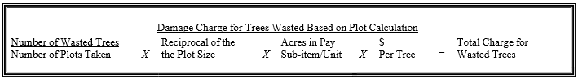

Wasted trees not on plot. When wasted trees are found that are not part of the inspection plot being used for payment, and they are not considered minor in nature, the location of the found trees becomes a plot center for the calculation of the wasted tree charge. The plot calculation will be used to determine the damage charge.

When wasted trees are found, and the damage is considered minor in nature, the Contracting Officer may waive the wasted tree charge. In no case will a waiver be given if the total Planted Trees on the Inspection plot exceeds the Maximum Number Allowable Trees for any unit.

Artificial Shade (Tree Shade Cards)/Protection (Vexar Tubing). Excess Tree Shade Card / Vexar Tubing material that is used to protect trees unnecessarily on the unit will be considered wasted material and noted on the plot inspection. The total of wasted material is the sum of all plots for each sub-item based on the inspection accepted for payment. The charge for wasted material will be calculated under Actual Damages.

Actual Damages
Wasted Trees. Actual damages for wasted trees will be assessed when trees are dropped or damaged by Contractor and are not considered intentional in nature. If the Contractor mishandles trees in such a way that it results in actual or potential damage to the tree(s), the trees(s) will be considered wasted. The Contractor shall pay the actual charge for wasted trees based on this calculation:

When wasted trees are found, and the damage is considered minor in nature, the Contracting Officer may waive the wasted tree charge.

Mishandled Artificial Shade (Tree Shade Cards)/Protection (Vexar Tubing). Wasted material charge will be assessed when material is dropped or damaged by Contractor and is not considered intentional in nature. If the Contractor mishandles material in such a way that it becomes unusable, the material will be considered wasted. Charge for wasted material:

When wasted materials are found, and the damage is considered minor in nature, the Contracting Officer may waive the wasted material charge.

The actual charge rate for wasted trees or materials and other Government-furnished property that is not returned, or returned in a non-usable condition, is as follows:
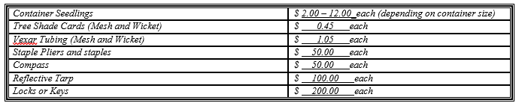

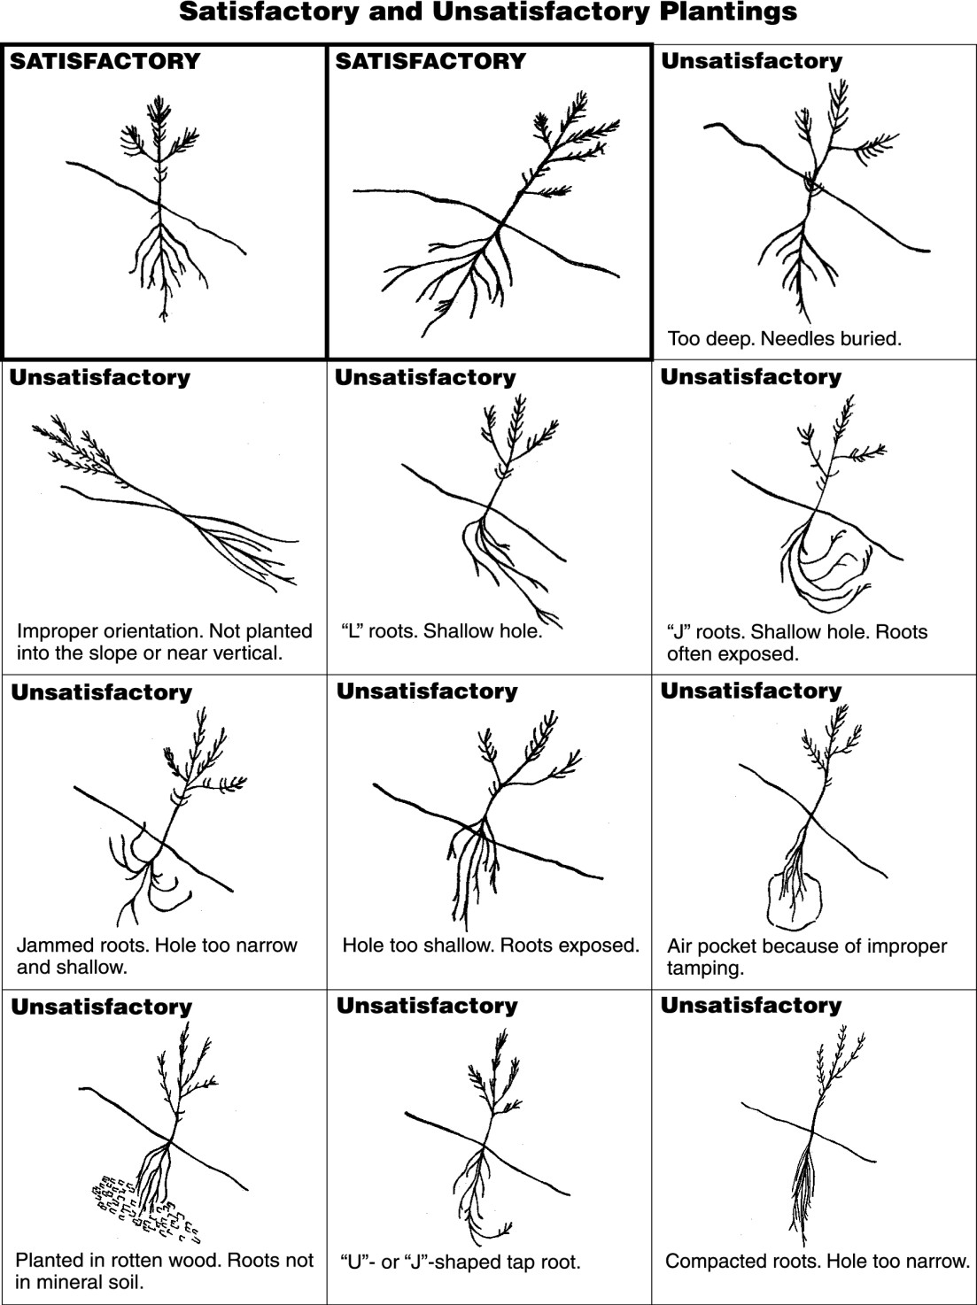
Appendix D: Acceptable Seedling Placement

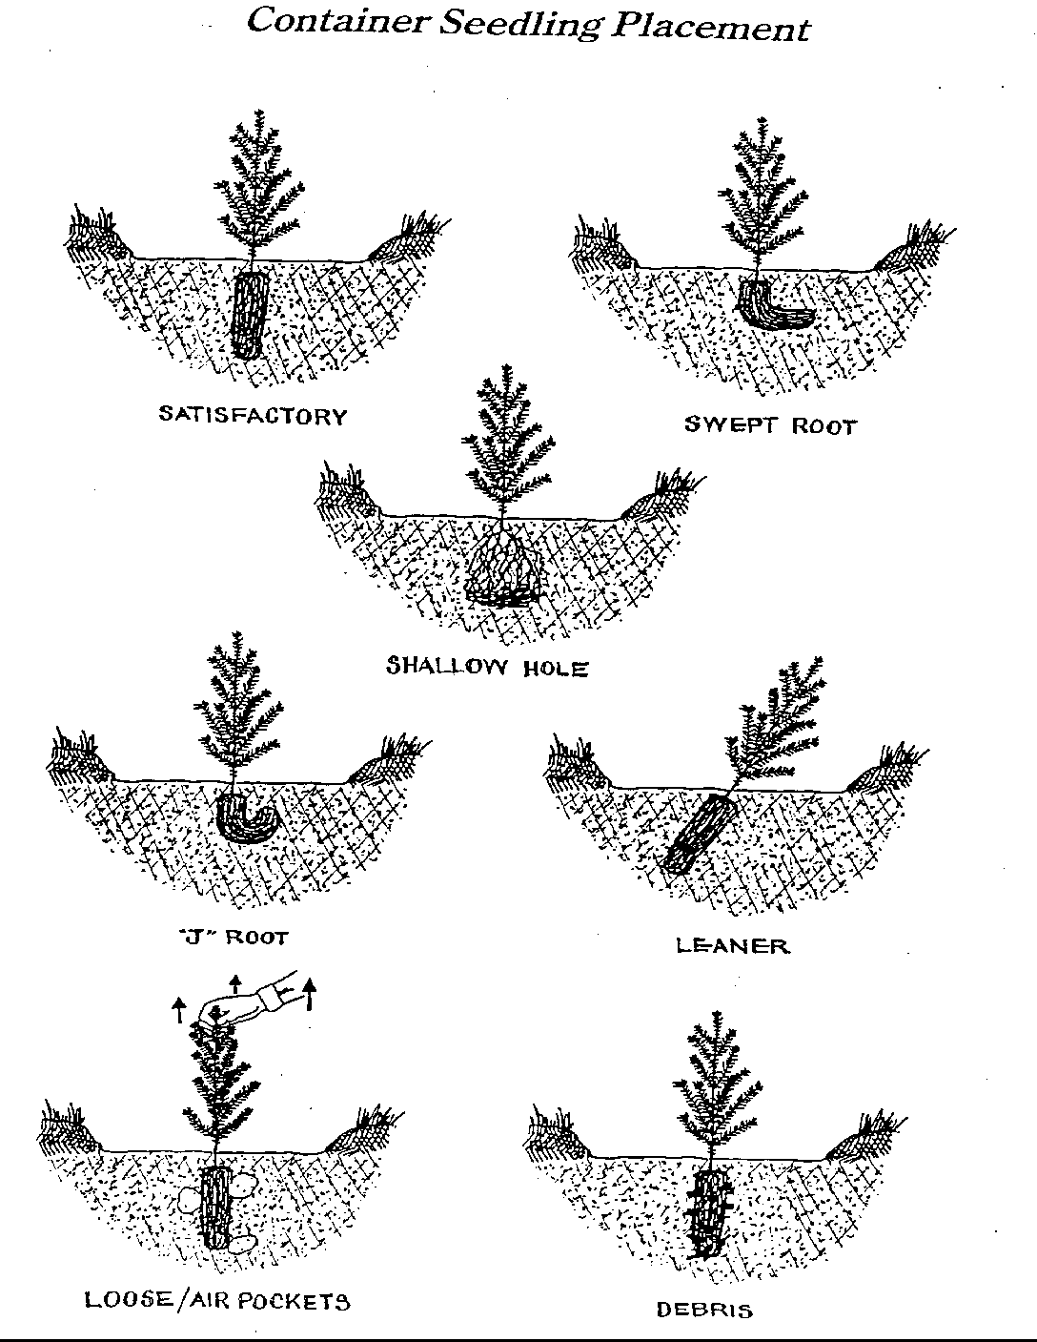

Appendix E: Utilization of Material to Provide Shade
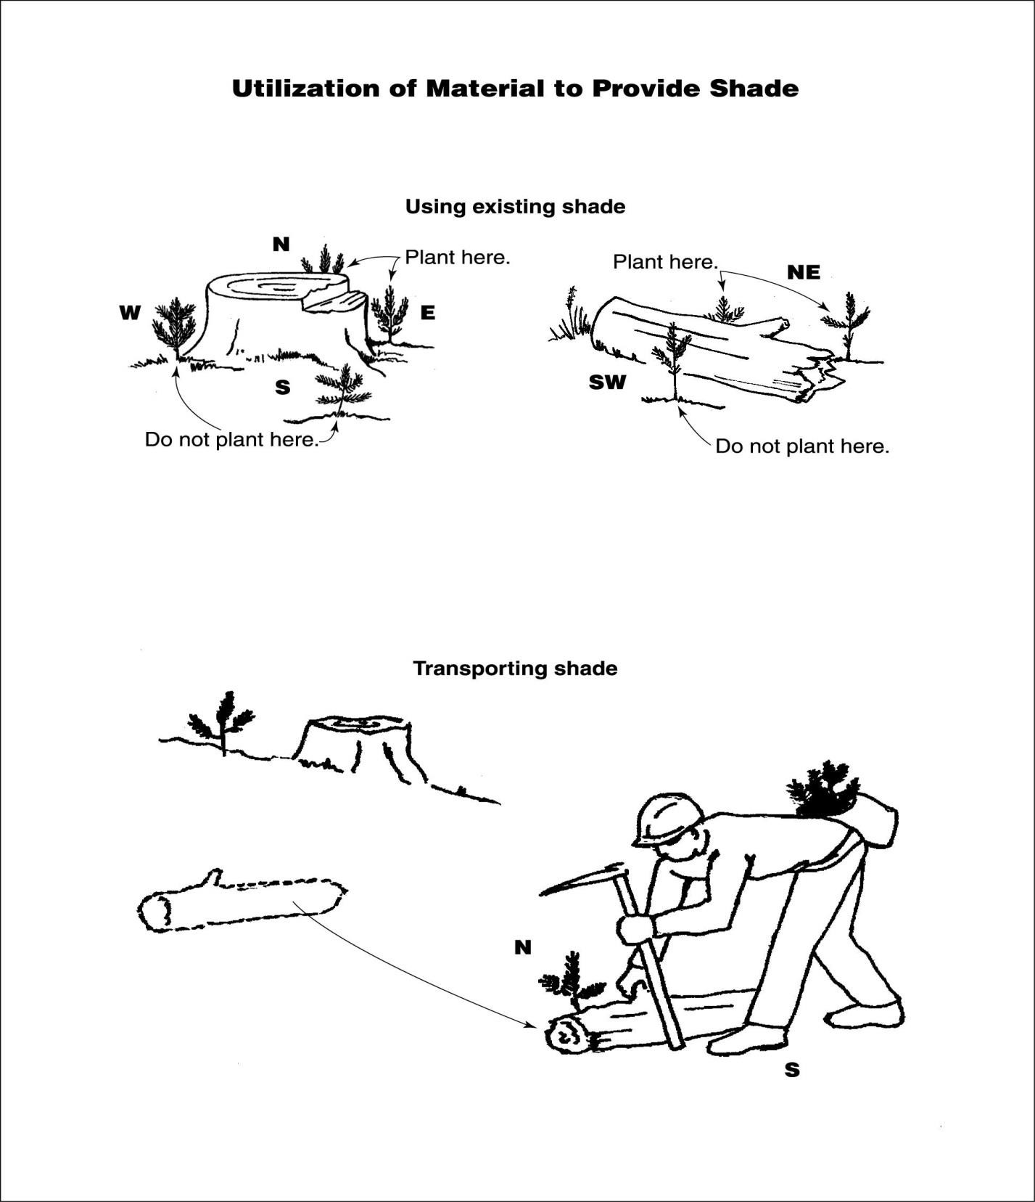

Appendix F: Plot Radius and Slope Correction Table for Inspection
Acre | Feet Radius | Percent of Slope | Slope Correction Factor
1 | 117.8 | 0 to 9 | 1.00
1/2 | 83.3 | 10 to 17 | 1.01
1/3 | 68.0 | 18 to 22 | 1.02
1/4 | 58.9 | 23 to 26 | 1.03
1/5 | 52.7 | 27 to 30 | 1.04
1/10 | 37.2 | 31 to 33 | 1.05
1/20 | 26.3 | 34 to 36 | 1.06
1/25 | 23.5 | 37 to 39 | 1.07
1/40 | 18.6 | 40 to 42 | 1.08
1/50 | 16.7 | 43 to 44 | 1.09
1/100 | 11.8 | 45 to 47 | 1.10
1/300 | 6.8 | 48 to 49 | 1.11
1/500 | 5.3 | 50 to 51 | 1.12
1/1000 | 3.7 | 52 to 53 | 1.13
 |  | 54 to 55 | 1.14
 |  | 56 to 57 | 1.15
 |  | 58 to 59 | 1.16
 |  | 60 to 61 | 1.17
 |  | 62 to 63 | 1.18
 |  | 64 to 65 | 1.19

