Statement of Work (SOW) / Performance Work Statement (PWS)
Project Title: South LAMS Electrical Power Supply Installation – Air Base 71, Câmpia Turzii, Romania
1.0 Purpose and Background
The purpose of this project is to design, install, test, and commission a permanent electrical power supply system for the South LAMS (Large Aircraft Maintenance Shelter) at Air Base 71, Câmpia Turzii, Romania. The new system will replace temporary generator-based power and provide a stable, utility-fed 120 kW supply to support aircraft maintenance operations.
The project includes trenching, conduit installation, underground cable routing, panel modifications, grounding and lightning protection upgrades, and full civil restoration. The installation is classified as Importance Category “C” under Romanian construction regulations, indicating a standard-importance infrastructure system requiring compliance with national norms, safety standards, and quality assurance procedures.
2.0 Scope of Work
The contractor shall furnish all labor, materials, equipment, and supervision necessary to deliver a fully functional electrical power supply system. Work includes:
- Installation of a 315 A switch (disconnector) in the existing electrical panel.
- Excavation of a 156-meter trench, 80–90 cm deep, along the designated route.
- Placement of sand bedding and installation of Ø110 mm protective conduit.
- Installation of underground copper power cables sized for a 120 kW load.
- Installation of a new external electrical panel with a 250 A switch and revenue metering.
- Construction of a grounding electrode system using OL-Zn electrodes and galvanized flat bar.
- Lightning protection and low-voltage electrical installations.
- Civil engineering works and full site restoration.
3.0 Requirements
3.1 Electrical Power Supply
- Installed electrical power: 120 kW
- Maximum absorbed power: 110–120 kW/kVA
- Power factor: 0.92
- Utilization voltage: 230/400 V, 50 Hz
3.2 Trenching & Conduit Installation
- Excavate a trench 156 meters in length, with a finished depth of 80–90 cm, ensuring compliance with IEC 60364-5-52 and Romanian underground cable installation norms.
- Provide a 10 cm sand bedding layer at the trench bottom prior to conduit placement.
- Provide HDPE or PVC conduits, minimum Ø110 mm, suitable for underground electrical installation.
- All phase conductors (L1, L2, L3) and neutral (N) shall be installed together within the same conduit or in grouped conduits arranged to maintain close physical proximity, in accordance with IEC 60364-5-52, to prevent inductive heating and impedance imbalance.
- Provide two (2) additional Ø110 mm HDPE or PVC conduits along the full trench length for future expansion. Spare conduits shall be installed parallel to the primary conduit with proper spacing and shall be fully usable (no crushed, blocked, or discontinuous sections).
- Maintain required horizontal and vertical separation from existing utilities; contractor is responsible for utility locating and avoidance.
- After conduit installation, place 10 cm sand cover above the conduits, achieving a total sand thickness of 20 cm (approx. 12.48 m³).
- Install approved warning tape at standard depth above the sand layer along the entire trench.
- Backfill with native soil, compacted in layers, and restore all disturbed surfaces (soil, gravel, asphalt, pavers) to original condition.
3.3 Cable Installation
- Install underground copper NYY single-core power cables rated for direct burial or conduit installation, sized for a 120 kW load at 400v, 3-phase, 50Hz:
  - 3 × 1×240 mm² (L1, L2, L3)
  - 1 × 1×120 mm² (Neutral)
- Cables shall be installed together within the conduit system in a trefoil or closely grouped configuration to minimize electromagnetic effects and comply with IEC installation practices.
- Provide minimum of 20 meters of additional cable length (10 m at each end) to allow for service loops, pulling requirements, and termination inside the existing panel and new subpanel.
- Pull cables using rollers, lubricants, and approved methods to prevent insulation damage.
- Minimum bending radius shall comply with cable manufacturer specifications.
- Identify all conductors at both ends using permanent phase labeling
- Perform insulation resistance testing and continuity checks prior to energization.
- Install a dedicated grounding conductor along the trench, including redundant grounding paths per reviewer comments.
- Ensure cable installation accounts for voltage drop over 156 m distance.
3.4 Electrical Panels
- Modify the existing electrical panel to install a 315 A disconnector, including all internal wiring adjustments required for safe and compliant integration.
- Install a new external electrical panel at the designated location, mounted on a reinforced concrete foundation sized to manufacturer requirements.
- The new electrical panel shall be designed, manufactured, and certified in full compliance with IEC 61439 (Low-Voltage Switchgear and Controlgear Assemblies) and shall include:
  - 250 A disconnector
  - IP54 minimum enclosure rating
  - Certified 3-phase revenue metering unit
  - Surge protection devices (SPDs), labeling, and breaker configuration in accordance with IEC 60364 and IEC 61643
- Provide all required terminations, lugs, labeling, and panel identification plates, ensuring workmanship and materials meet IEC and Romanian standards.
3.5 Grounding & Lightning Protection
- Construct a grounding electrode system consisting of:
  - 25×4 mm galvanized steel flat bar
  - 1.5 m OL-Zn electrodes (3.8 kg)
- Install redundant grounding conductors to ensure equipotential bonding between the existing panel, new subpanel, and LAMS structure.
- Achieve a grounding resistance of Rp < 4 ohms, verified through certified earth resistance testing.
- Install lightning protection and bonding in accordance with Romanian regulation and the IEC 62305.
3.6 Safety & Occupational Health
- All work must comply with Romanian and EU safety regulations, including:
  - Law 319/2006 (Occupational Safety)
  - GD 1425/2006
  - GD 300/2006
  - Law 307/2006 (Fire Defense)
- Electrical work must be performed de-energized, following LOTO procedures.
- Trenches must comply with safe excavation standards.
3.7 Environmental Protection
- Comply with GEO 195/2005, Law 211/2011, and GD 856/2002.
- Manage waste (soil, concrete, asphalt, metals) per regulations.
- Restore all disturbed areas to original condition.
- Minimize dust, noise, and vibration during construction.
4.0 Deliverables
The contractor shall provide:
- Fully installed and operational electrical supply system.
- New electrical panel with breaker, metering, and labeling.
- Completed trench, conduit, cable, and grounding system.
- Testing & commissioning documentation, including:
  - Insulation resistance tests
  - Continuity and phase sequence checks
  - Earth resistance measurements
  - Functional load tests
- As-built drawings (PDF + editable format).
  - Exact horizontal location of all conduits, trenches, manholes, and access points.
  - Depth profile along the full 156 m route.
  - Final conduit configuration, including spare conduits.
  - Locations of bends, junctions, and any deviations from the design.
  - Grounding electrode locations and bonding paths.
  - Panel locations, cable entry points, and termination details.
- Material certificates and warranties.
- O&M briefing notes.
- Daily work reports are required and must be submitted in PDF format.
- Includes a one-year warranty on all electrical line work.
5.0 Period of Performance
- The construction phase shall be completed within 45 working days after all materials are available on site.

- Weather delays caused by heavy snow, frozen ground, or severe storms may extend the schedule and will be coordinated through the contracting officer.
6.0 Place of Performance
Air Base 71, RoAF Câmpia Turzii, Romania
Work occurs along the designated 156 m trench route and at the South LAMS location.

7.0 USAF & RoAF Assistance
The USAF and RoAF will provide coordination, site access, and utility marking support as required.
8.0 Contractor-Furnished Equipment & Materials
The contractor shall provide all labor, materials, and equipment, including:
- Excavators, compactors, cable pulling equipment
- Copper power cables (1×240 mm², 1×120 mm²)
- Protective conduit Ø110 mm
- Sand bedding
- 315 A and 250 A disconnectors
- LV subpanel and metering unit
- Grounding materials
- Traffic management equipment
- All consumables, labels, connectors, and accessories
9.0 Acceptance Criteria
- Electrical system installed per approved design and Romanian/EU standards.
- Grounding resistance Rp < 4 ohms.
- Successful completion of all testing and commissioning.
- Site restored to original condition.
- Final inspection and acceptance by the USAF project officer.
10.0 Security Requirements
- All personnel must comply with USAF and RoAF access procedures.
- RoAF requires seven working days’ advance notice to process base access requests for Romanian nationals.
- Work areas must remain secured and controlled at all times.
11.0 Safety
- PPE is mandatory.
- LOTO procedures must be strictly followed.
- Trenches must comply with safe excavation standards.
- Winter safety measures must be implemented.
12.0 Appendix
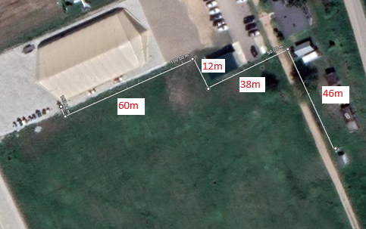
Figure 1: South LAMS Electrical Route Overview
Figure 1 shows the planned underground electrical route from the existing power source to the South LAMS area. The aerial image includes key measured segments of 60 m, 12 m, 38 m, and 46 m which together define the approximate 156-meter trench alignment.

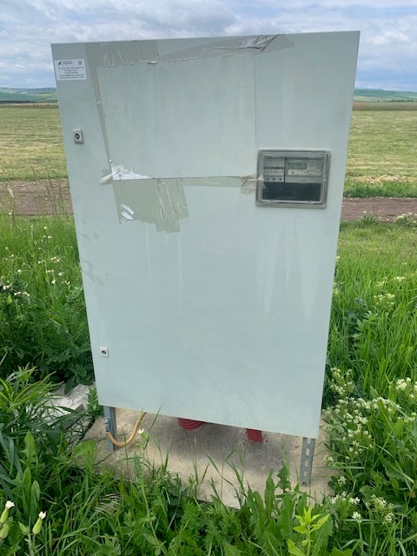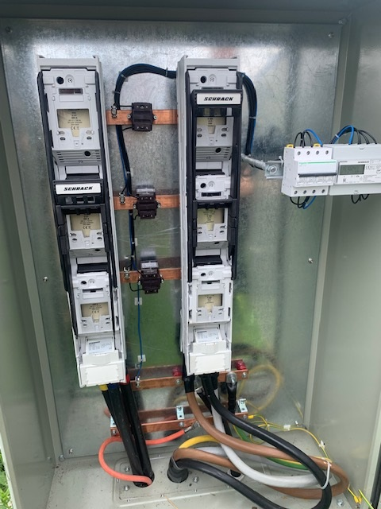
Figure 2: Existing Substation/Subpanel (Utility Power)

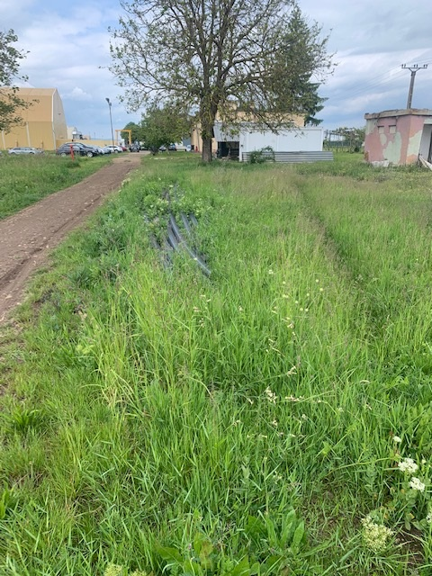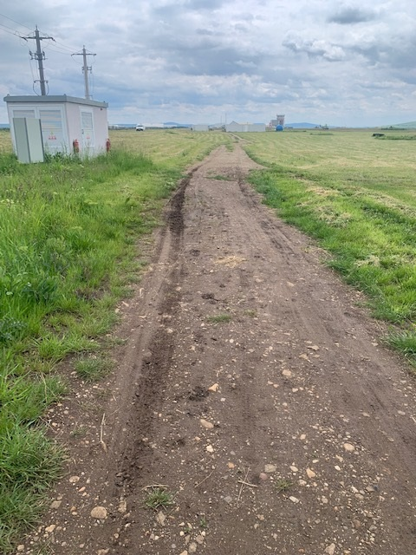
Figure 3: Approximate Trench Path

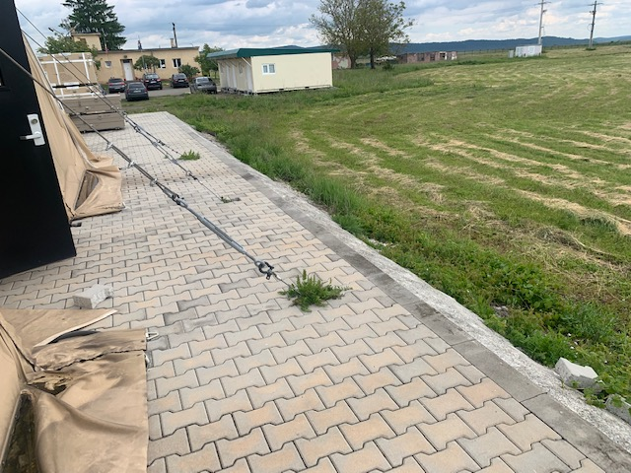
Figure 4: New Subpanel Location Pad (near South LAMS)

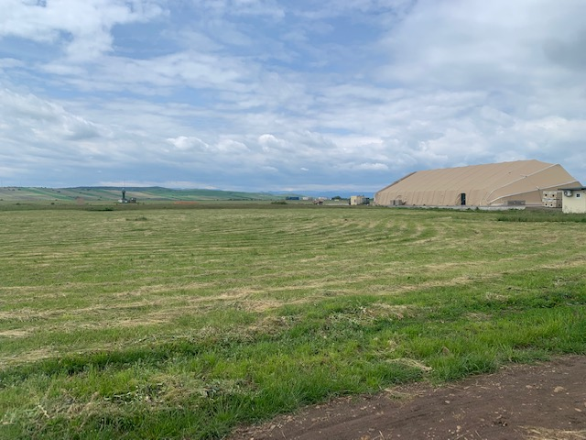
Figure 5: View from utility power to South LAMS

