Sources Sought Title:
N00019-26-RFPREQ-TPM265-0560: Main Line Contactors Sources Sought
NOTICE ID:
Department: Department of Defense
Sub-Tier: Department of the Navy
Sub Command: Naval Air Systems Command

Attachment 1: MLC Specifications
Background
The F/A-18E/F and EA-18G are increasingly reliant on sophisticated avionics systems for navigation, communication, and other critical functions. These systems, particularly those employing switch mode power supplies (SMPS), have significantly higher power demands than older technologies. This increased power draw necessitates an upgrade to the aircraft's electrical system.
The generator control unit (GCU) and the main line contactors (MLCs) work together to manage and distribute electrical power throughout the aircraft. The GCU receives power from the generators and regulates it to ensure a stable voltage and frequency output. The GCU constantly monitors the electrical system for any faults or abnormal conditions. The GCU sends signals to control the MLCs. Each MLC is responsible for connecting and disconnecting a specific portion of the electrical system to the main power bus. When a particular system or component requires power, the GCU commands the corresponding MLC to close. This action connects the load to the main power bus, allowing current to flow and power the system. The MLCs also play a crucial role in protecting the electrical system from overloads. If a fault occurs or a load tries to draw too much current, the GCU will detect the issue and immediately open the relevant MLC, isolating the faulty section and preventing damage to the rest of the system. The GCU directs the flow of electricity by switching the MLCs on and off, ensuring that the right amount of power reaches each destination safely and efficiently.
The existing GCU is not designed to handle high-frequency noise and rapid load changes, characteristic of SMPS. It is also limited in power delivery capacity. The current MLCs, responsible for switching and protecting the power distribution circuits, are rated for a maximum of 65 kVA.
The Navy is interested in upgrading the existing 65 kVA MLCs to 90 kVA MLCs to accommodate the increased power delivery of an upgraded GCU. This upgrade ensures that the system can safely and reliably handle the higher currents required by the avionics systems.
Required Capabilities
The Government requires MLCs rated as 90 kVA. The intent of this Sources Sought is to assess the available technology in MLCs that could be applied to meet this requirement.
The Government envisions a solution for the F/A-18E/F and EA-18G that meets the following operational and programmatic requirements:
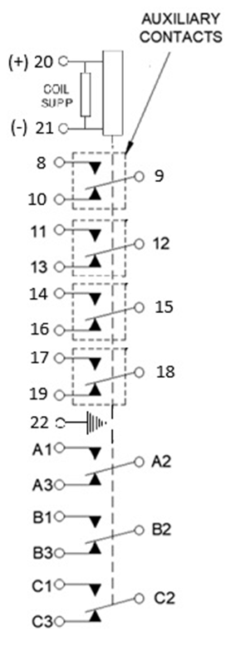
FIGURE 1. Relay, schematic diagram
- CONSTRUCTION:
  - MIL-PRF-6016R Type I, Hermetically Sealed, Continuous Operation
- DESIGNED TO THE PERFORMANCE STANDARDS OF:
  - MIL-PRF-6106R
  - MIL-STD-704E with PSCN-285
  - MIL-STD-810G
- MAIN CONTACTS
  - 3PDT SIDE STABLE
  - NOMINAL VOLTAGE: 115/200 VAC, 3 PHASE, 400HZ
  - CURRENT:
    - RESISTIVE: 260 AMPS
    - INDUCTIVE: 260 AMPS
    - RUPTURE: 2600 AMPS
- AUXILIARY CONTACTS
  - 4PDT SIDE STABLE
  - NOMINAL VOLTAGE: 28 V dc
  - CURRENT:
    - RESISTIVE: 5 AMPS
    - INDUCTIVE: 5 AMPS
  - NOMINAL VOLTAGE 115 V ac, 1 PHASE, 400HZ
    - RESISTIVE: 5 AMPS
    - INDUCTIVE: 5 AMPS
- Max Weight:
  - Maximum Weight: 5 lbs.
- Max Size:
  - Height: 4.4 In.
  - Width: 4.7 In.
  - Length: 5.6 In.
- COIL DATA
  - DUTY CYCLE
    - CONTINUOUS (ECONOMIZED)
  - OPERATING VOLTAGE
    - MAX: 32 VDC
  - PICKUP VOLTAGE
    - MAX: 16 VDC @ 160 °F
  - DROPOUT VOLTAGE
    - RANGE: 2 – 7 VOLTS
  - COIL CURRENT
    - MAX: 4.0 AMPS @ 32 VDC AT 73 +/-18 °F
  - COIL TRANSIENT VOLTAGE LIMITED TO +/- 42 VOLTS REFERENCED TO ZERO VOLTS
  - CASE IS ELECTRICALLY INSULATED FROM MOUNTING SURFACE

8. The contactor shall meet the requirements in Table I.

TABLE I – GENERAL SPECIFICATIONS

 |  |  |  | Main Contact Rating (Amperes) |  |  |  |  |  |  | Auxiliary Contact Rating (Amperes) |  |  |  |  |  |  | Max Coil Current (Amperes) 73 ± 018oF |  |  |  | Weight LBS. (Max) | Release Time (Sec) | Closing Time (Sec) | Pickup Voltage (Volts) | Dropout Voltage (Volts) | Transfer Time (Sec) | Terminal Temp Rise (oF) | Endurance (Cycles)
 |  |  |  | Lamp | 28  VDC |  |  | 115/200 VAC  400 Hz 3  Phase |  |  | Lamp | 28  VDC |  |  | 115 VAC  400 Hz |  |  | 32 VDC |  | 115/200  VAC 400 Hz 3  Phase
Dash No. | Type | Mains | Auxiliaries |  | Resistive | Inductive | Motor | Resistive | Inductive | Motor |  | Resistive | Inductive | Motor | Resistive | Inductive | Motor | Pull – In | Holding | Pull-In | Holding
 |  | 3PDT | - | - | - | - | - | 260 | 260 | - | 4 | 5 | 5 | - | 5 | 5 | - | 4.0 | 0.5 | - | - | 5 | 0.35 | .090 | 16 | 7  +0  ―5.5 | .002-  .010 | 167 | 50K

Note: Absence of value (-) indicates relay is not rated for that application

9. ENVIRONMENTAL
9.1 TEMPERATURE:
9.1.1 AMBIENT: - 80 °F to +160 °F
9.1.2 TEMPERATURE EXCURSION TO +/- 203 °F
9.2 VIBRATION
9.2.1 Vibration testing shall be per MIL-STD-810H CHG 1, Method 514.8, Procedure I (general), tailored per the reference profile shown in Figure 2 and Table 2. Test duration shall be a minimum of 2-hours in each of three mutually perpendicular axes or the minimum duration needed to evaluate contactor function per of MIL-PRF6106R (whichever is greater).

Table 2: Vibration reference profile breakpoints
Hz | g²/Hz
10 | 0.473
11.2 | 0.178
16 | 0.178
18.4 | 0.594
21.5 | 0.594
23.5 | 0.320
32 | 0.320
36.5 | 1.475
42 | 1.475
50 | 0.206
80 | 0.206
96.7 | 0.058
617.4 | 0.058
630 | 0.074
1000 | 0.074
1120 | 0.197
1250 | 0.197
1413 | 0.098
1718 | 0.098
2000 | 0.133
g RMS | 14.7
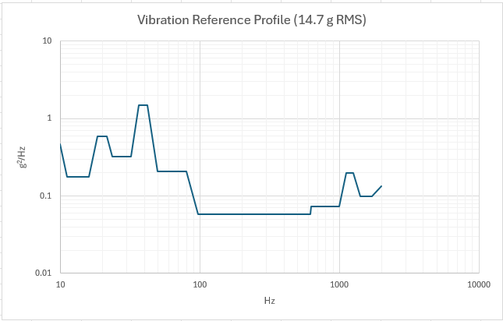
Figure 2: Vibration reference profile

9.3 SHOCK
9.3.1 Shock testing shall be per MIL-STD-810H CHG 1, Method 516.8, Procedure I (functional), tailored per the reference profile shown Figure 3 and Table 3. The shock excitation shall be applied for a minimum of 3 positive and 3 negative excitations or the minimum number of pulses needed to evaluate contactor function per MIL-PRF6106R (whichever is greater). The test shall be performed in each of three mutually perpendicular axes with minimum peak input acceleration of 30 g and a maximum allowable effective shock duration of 0.091 seconds

Table 3: SRS reference profile breakpoints
Hz | nominal (g) | upper tolerance (g) | lower tolerance (g)
10 | 14.8 | 17 | 12.6
12.5 | 14 | 16.1 | 11.9
24.2 | 35 | 38 | 32
33 | 41 | 47.2 | 34.9
39.7 | 61.7 | 71 | 52.4
43.8 | 61.7 | 71 | 52.4
53.1 | 39.7 | 45.6 | 33.7
67 | 39.6 | 45.5 | 33.6
76.6 | 49.8 | 57.2 | 42.3
84.9 | 49.9 | 57.3 | 42.4
93.2 | 45 | 51.8 | 38.3
110 | 45 | 51.8 | 38.3
169 | 55 | 63.3 | 46.8
195 | 58.5 | 67.3 | 49.7
240 | 58.5 | 67.3 | 49.7
259.1 | 66.6 | 76.6 | 56.6
289.8 | 66.6 | 76.6 | 56.6
365.8 | 46.5 | 53.5 | 39.5
418.4 | 46.5 | 53.5 | 39.5
478.6 | 38.1 | 43.9 | 32.4
525.8 | 38.1 | 43.9 | 32.4
560 | 33 | 38 | 28.1
1000 | 30.5 | 35.1 | 25.9

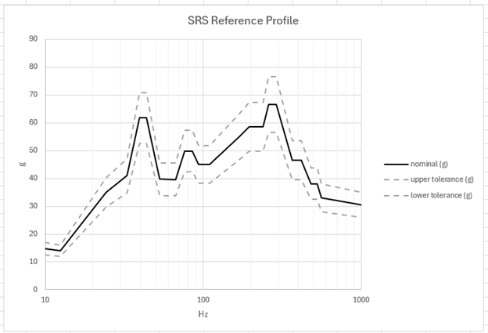
Figure 3: SRS reference profile

9.4 ALTITUDE
9.4.1 MAX: 70,000 FEET
10. LIFE CYCLE
10.1 ELECTRICAL (MIN): 50,000 CYCLES MIN.
10.1.1 MECHANICAL: 100,000 CYCLES MIN.
11. STUDS
11.1 SIZE: 1/4 – 28
12. INTERFACE
12.1 Connector Per D38999/25NC35PN
12.2 9 Studs per Figure 4
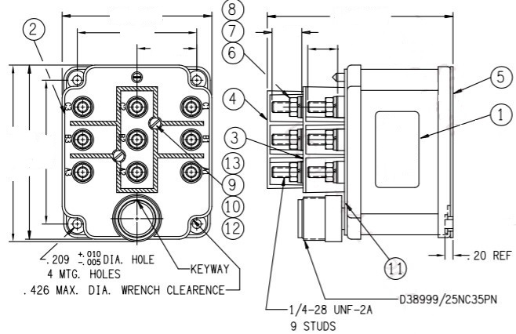
Figure 4. Interface Configuration
13. ELECTRICAL INSULATION
13.1 Case shall be electrically insulated from mounting surface

