

VA Transition Assistance Program (TAP) Curriculum Development and Revision Standard Operating Procedure

Responsible Office
The development and maintenance of this document is the responsibility of the Department of Veterans Affairs (VA) Office of Military to Civilian Transition (M2CR) Transition Assistance Program (TAP). Proposed changes to this document should be submitted in writing to the Chief of TAP Curriculum.

Table of Contents
Contents

- Purpose 1
- Applicability 1
- References 2
- Acronyms 3
- Definitions 4
- Background 5
 Suppliers, Inputs, Process, Outputs and Customers 5
 Adult Learning Approach 6
    - Introduction 6
    - Adult Learning Principles 6
    - Interactivity and Objectives 7
    - Multimedia Principles 7
 The ADDIE Process 8
- Success Criteria 9
- Function, Roles and Responsibilities 10
- Tools and Technology 14
- Curriculum Development and Revision Procedure 14

Curriculum Development and Revision Process Flow Charts 16

New Curriculum Development 18
    - ANALYSIS 18
    - DESIGN 20
    - DEVELOPMENT 23
    - IMPLEMENTATION 30
    - Curriculum Development Integration Points 31

Existing Curriculum Revision 32
    - ANALYSIS 32
    - DESIGN 34
    - DEVELOPMENT 35
    - IMPLEMENTATION 39
    - Program Alert Sub-Process 39
    - Curriculum Revision Integration Points 40

Review and Concurrence 41

EVALUATION 42
    - Curriculum Development Technical Evaluation 43
    - Curriculum Quality Management 44
- Distribution and Storage 46
- Training 46
Appendix A: Sample Design Document Contents 48
Appendix B: Sample Slide Deck 49
Appendix C: Sample Instructor Guide 50
Appendix D: Sample Participant Guide 51
Appendix E: Revision Matrix 52
Appendix F: Sample Pen and Ink Communication – Field 53
Appendix G: Curriculum Quality Assurance Checklist 56
Appendix H: 508 Review Checklist 58
Figure 1: ADDIE Process 9
Figure 2: New Curriculum Development Process 16
Figure 3: Existing Curriculum Revision Process 17
Table 1: Acronyms 3
Table 2: Definitions 5
Table 3: SIPOC Table 6
Table 4: Interactivity and Objective Alignment 7
Table 5: Functions, Roles and Responsibilities 10
Table 6: Curriculum Development RACI 13
Table 7: Tools and Technology 14
Table 8: Learning Objectives Definitions 20
Table 9: Learning Materials List 29
Table 10: Curriculum Development Integration Points Table 31
Table 11: Change Review Definitions 33
Table 12: Curriculum Revision Integration Points 41
Table 13: Curriculum Quality Management Integration Points 46

Purpose
The purpose of this Curriculum Development and Revision Standard Operating Procedure (SOP) is to provide guidance for the development and revision of the VA TAP Curriculum.
This SOP aligns VA TAP Curriculum processes and procedures with the required (prescribed) evidence-based instructional systems design methodology, ADDIE (Analysis, Design, Development, Implementation and Evaluation). The ADDIE method is the industry standard in education for curriculum design and revisions. The ADDIE method is a front-end analysis and systematic approach that yields rapid responses when identifying learner performance gaps and determining factors that affect changes in the learning environment. It provides a structured process for continuous performance improvements.
The objectives of the SOP’s alignment with ADDIE are to provide:
    - Objective one – Standardization in the VA TAP Curriculum review and development
    - Objective two – Structure to the VA TAP Curriculum processes and procedures
    - Objective three – Results and evidence-driven data to ensure relevancy and accuracy of course content

Applicability
The scope of this procedure includes curriculum work products generated by the Curriculum office that will be delivered to external stakeholders. This SOP applies to the processes and activities required to develop and revise the curriculum. The procedures described herein apply to:
    - Benefits & Services (VABAS) Curriculum and Materials Development
    - VABAS Curriculum and Materials Revision
    - Military Life Cycle (MLC) Module Curriculum and Materials Development
    - MLC Module Curriculum and Materials Revision
    - Women’s Health Transition (WHTT) Training Curriculum and Materials Development
    - WHTT Curriculum and Materials Revision
The process for developing the Curriculum follows the same steps for Curriculum Development and Revision.

References
Anderson, L. W. et al. (2000) A taxonomy for learning, teaching, and assessing: A revision of Bloom’s taxonomy of educational objectives, complete edition. Upper Saddle River, NJ: Pearson.
Dirksen, J. (2016). Design for how people learn (2nd edition). United States: New Riders
Gagne, R.M. (1985). The conditions of learning and theory of instruction (4th edition). New York: Holt, Rinehart & Winston.
Gagne, R.M. & Briggs, L.J. (1974). The principles of instructional design. New York: Holt, Rinehart & Winston.
Golombisky, K. & Hagen, R., (2017). White space is not your enemy: A beginner’s guide to communicating visually through graphic, web, & multimedia design. Taylor & Francis: Boca Raton, FL.
Kirkpatrick, J. D. & Kirkpatrick, W. K. (2016) Kirkpatrick’s four levels of training evaluation. Alexandria, VA: ATD Press.
Knowles, M. (1988). The adult learner. Houston, TX: Gulf Publishing.
Mayer, R. E. (2020) Multimedia Learning. 3rd ed. Cambridge, England: Cambridge University Press.
Merrill, M. D. (2002) “First principles of instruction,” Educational technology research and development: ETR & D, 50(3), pp. 43–59.
Plain Language Action and Information Network (2011), Federal Plain Language Guidelines, March 2011, Rev. 1, May 2011, viewed 25 August 2021, https://www.plainlanguage.gov/media/FederalPLGuidelines.pdf
Veterans Benefits Administration – CATHEXIS Contract 36C10X21D0007 (2021), PWS Section 3.6.2 (Page 14).
Veterans Benefits Administration (2017) Creating/Maintaining Standard Operating Procedure.
Veterans Benefits Administration (2021), Standard Operating Procedures (SOP) Transition Assistance Program (TAP) Curriculum Review Process per Curriculum Working Group.
Veterans Benefits Administration (2020), TAP Quick Ref Style Guide_06092020.
Veterans Benefits Administration (2018), VA TAP QM_QA_QC_SOP_Quality Management SOP_20180823_v1.7.
World Wide Web Consortium, Web Content Accessibility Guidelines (WCAG), viewed 25 August 2021, https://www.w3.org/WAI/standards-guidelines/wcag/

Acronyms
Term | Definition
ADDIE | Analyze, Design, Development, Implement and Evaluate
AO | Authorizing Official
VABAS | VA Benefits and Services course
CWG | Curriculum Working Group
CWV | Center for Women’s Veterans
DHS | Department of Homeland Security
DK | Declarative Knowledge
DoD | Department of Defense
DOL | Department of Labor
ED | Department of Education
FG | Facilitator’s Guide
FY | Fiscal Year
GUI | Graphical User Interface
IG | Instructor’s Guide
ILT | Instructor-Led Training
ISD | Instructional System Developer
LOB | Line of Business
LMS | Learning Management System
M2CR | Office of Military to Civilian Readiness
MCTO | Military-Civilian Transition Office
MLC | Military Life Cycle
MOA | Memorandum of Agreement
OPM | Office of Personnel Management
ORG | Online Reference Guide
OSE | Office of Strategic Engagement
PDF | Portable Document Format
PG | Participant Guide
PMWG | Performance Management Working Group
SBA | Small Business Administration
SCORM | Shareable Content Object Reference Model
SME | Subject Matter Expert
SOP | Standard Operating Procedure
T3 | Train-the-Trainer
TACPA | Transition Assistance Curriculum Participant Assessment
TAIWG | Transition Assistance Interagency Working Group
TAP | Transition Assistance Program
TAPCA | Transition Assistance Program (TAP) Course Assessment
TOL | Transition Online Learning
TSM | Transitioning Service Member
UAT | User Acceptance Test

Term | Definition
VA | Department of Veterans Affairs
VBA | Veterans Benefits Administration
VHA | Veterans Health Administration
vILT | Virtual Instructor-Led Training
VOW | Veterans Opportunity to Work Act of 2011
WBT | Web-based Training
WHTT | Women’s Health Transition Training
WSR | Weekly Status Review

Definitions
Table 1: Acronyms

Term | Definition
Alpha Testing | A type of acceptance testing performed to identify all possible bugs/issues before releasing the product to the end-user.  Alpha test is a preliminary carried out by a team of users to find out the bugs that were not found previously by other tests during the product build. Alpha testing simulates a real user environment by carrying out tasks and operations that actual users might perform.
Beta Testing | Conducted after alpha testing, this is the final test before release into the production environment. Beta testing of a product is implemented by “real users “of the software application in a “real environment.” The Vendor Curriculum Team conducts the beta testing and acts the role of the “real users” in the testing sandbox provided by the Learning Management System (LMS) vendor.
Build Materials | The draft set of materials designed and developed based upon Subject Matter Expert (SME) content and guidance.
Enabling Learning Objective | An Enabling Learning Objective (ELO) states the expectations of knowledge, skills, or abilities and the steps to accomplish the TLO.
In-Depth Revision Cycle | In-depth revision includes:  - a full review of all content for accuracy and conciseness,  - analysis of content for potential program additions,  - updates to learning objectives,  - inclusion of trends and best practices in adult learning to increase engagement and retention and  - review and approval of the CWG and TAIWG.

Term | Definition
Supplementary or Complementary Products | Educational tools, materials, or resources that are designed to complement and enhance the main curriculum content. These products are aligned to the core curriculum and are used to reinforce, expand, or enrich the learning experience, e.g. posters, marketing material, announcements,
Technical Revision Cycle | Technical revisions allow subject-matter experts to:  - update for accuracy of content, such as external links and resource availability,  - changes necessary due to the implementation of recent legislation and or changes in agency policy or procedures.  It is an extension of the existing annual July release rather than a new version.
Terminal Learning Objective | A Terminal Learning Objective (TLO) states the expectations of knowledge, skills, or abilities upon completing a specific module or course.

Background

Table 2: Definitions

M2CR is one of the first VA touchpoints with Transitioning TSMs (TSM) as they begin their transition journey. Central to M2CR’s mission is the delivery of VA TAP, MLC modules, WHTT and other collaborative efforts with our interagency partners and other stakeholders.
Established in 1991 and refined by the Veterans Opportunity to Work (VOW) Act of 2011, TAP is an interagency initiative designed to ensure TSMs have a smooth and successful transition to civilian life.
As a critical, mandatory part of the transition ecosystem, the Veteran transition is supported by “interagency partners”— the Departments of Defense (DoD), VA, Labor (DOL), Education (ED), and Homeland Security (DHS); Small Business Administration (SBA); and Office of Personnel Management (OPM). Together, these interagency partners help provide the skill-building, resources, and tools that TSMs need to achieve emotional health, physical health, and economic stability in civilian life.

 Suppliers, Inputs, Process, Outputs and Customers
The below Suppliers, Inputs, Process, Outputs, Customers (SIPOC) table provides a high-level, holistic view of the curriculum development and revision process’ suppliers; the inputs received from them; the ADDIE process that adds value to those inputs; and the outputs that meet or exceed customer requirements.
Supplier(s) – The provider of inputs into a process.
Input(s) – Materials, information and other resources needed to complete a process.
Process – Structured steps used to convert inputs into outputs.
Output(s) – Products or services resulting from the process.
Customer(s) – Recipient of the outputs.

SIPOC | Details
Supplier (S) | VA TAP Governance, Bi-annual curriculum In-Depth Review; Curriculum Working Group. VBA Line of Business Subject Matter Experts and Program Managers
Input (I) | Skill building, resources, and tools that TSMs need to achieve emotional health, physical health, and economic stability in civilian life
Process (P) | ADDIE:  Step 1: Analysis  Step 2: Design  Step 3: Development  Step 4: Implementation  Step 5: Evaluation
Output (O) | New/Developed TAP Virtual Curriculum and Materials Revised TAP Curriculum and Materials New/Developed MLC Module Curriculum and Materials Revised MLC Module Curriculum and Materials New/Developed WHTT Curriculum and Materials Revised WHTT Curriculum and Materials
Customer (C) | TSMs, Veterans, their spouses, domestic partners, dependents, caregivers and survivors
Table 3: SIPOC Table

 Adult Learning Approach
    - Introduction
The TAP curriculum is designed for professional, working adults, primarily for the ages 18 to 24, who are TSMs or Veterans. In addition to the primary audience, the program is also available to spouses, domestic partners, dependents, caregivers and survivors of TSMs and Veterans.
    - Adult Learning Principles
TSMs, Veterans, and other learners in TAP courses bring a wealth of knowledge that should be valued and considered in both developing and delivering any training.
Further, the benefits and services explored in all TAP curriculum are critical to the livelihoods and wellbeing of TSMs and Veterans. Combining these two factors leads to a heightened need to expertly incorporate adult learning practices that maximize the prior experience and foster understanding (Merrill, 2002). TAP curriculum recognize that:
      - prior experience of learners must be valued and incorporated (Merrill, 2002; Knowles, 1988)
      - adult learners thrive when instruction is relevant and problem-based rather than content-centered (Merrill, 2002; Knowles, 1988)
      - adult learners need feedback on performance and understanding (Gagne, 1985)

    - Interactivity and Objectives
TAP curriculum utilizes a four-level approach to interactivity as follows. Each level serves to align the objectives, training intent, content, and training strategies. Though discrete levels are created for ease of discussion and decision-making, most courses will utilize various interactivities. For example, a course may begin with a level 3 case study, transition to a level 2 explanation, and close with a level 1 summary. This course would be considered overall level 3, but variation is also essential in maintaining the interest and engagement of learners (Gagne, 1985).
- Level 1: passive learning with little working memory demand
- Level 2: limited interactivity focused on comprehension
- Level 3: moderate interactivity that allows for analysis and judgment
- Level 4: real-world simulated interactivity that promotes creation, integration and generation

TAP  Interactivity Level | Dimensions | Sample Verbs
Level 1 | Knowledge; Remember | Recognize, recall, name, list, identify, locate, state, match
Level 2 | Conceptual; Understand | Describe, compare, explain, predict, summarize, classify, compare, demonstrate
Level 3 | Procedural; Apply | Provide, carry out, apply, respond to find errors
Level 4 | Metacognitive; Create; Evaluate | Reflect, design, create, integrate, differentiate, assemble, generate, role-play, substitute, rewrite

Table 4: Interactivity and Objective Alignment
    - Multimedia Principles
All TAP curriculum includes a variety of engaging, relevant multimedia. Much like the overarching design of each course or module, the embedded and stand-alone multimedia must also adhere to evidence-based practices from the field. Such best practices extend beyond the visual appeal to:
      - focus on a learner-centered approach, rather than technology-centered;
      - reduce unnecessary information for the learner;
      - help learners focus on essential information and processes; and
      - foster understanding and generation rather than memorization (Mayer, 2021).
Multimedia materials, including presentations, videos, audio files, and web-based training, will adhere, whenever possible, to the following multimedia principles:
      - information is chunked into bit-sized segments;
      - narrator or presenter uses a friendly, natural speaking voice;
      - a conversational tone is used for all instruction, narration and text;

      - on-screen content focuses on graphics and narration;
      - the use of narration with graphics and text is limited;
      - unnecessary text, graphics, and sound are removed; and
      - essential content is highlighted and easy to identify (Dirksen, 2016; Mayer, 2021).
Note that multimedia principles align well with both Section 508 requirements and plain language guidelines. For example, a key element of multimedia principles is utilizing clear, conversational language, critical for plain language implementation.

 The ADDIE Process
The VA TAP Curriculum Team follows the industry standard ADDIE (Analyze, Design, Develop, Implement, and Evaluation) Model for course content review and development. ADDIE is a systematic approach that brings structure to the design process when determining optimal instructional strategies, sequencing, delivery methods, learning objectives, and course outcomes. Applying a systems approach ensures training programs and support materials are continually evaluated to meet the TSM’s needs in a rapidly changing environment.
The results of the Evaluation phase are returned to the origination point (fed back), closing the loop, facilitating further refinement of the learning product. If the evaluation shows that the module has shortcomings, for example, that the objectives of the module do not align with organizational objectives, those shortcomings are returned to be analyzed again. Further design and development efforts follow until the module meets organizational needs.

Analysis clarifies learning needs, defines the requirements and provides a solid foundation for the learning solutions.
Front-end analysis ensures that curriculum
m ng
aterials meet learning objectives by assessi
performance needs, audience, environment, and content.
Analysis
Design
The design for learning solutions is carefully crafted based on the outcomes of the analysis phase.
Design includes a high-level description of content, delivery methods, materials, and interactions that will support the learning goals.
Development
The design team creates curriculum materials to support the design. This includes the look and feel that will engage learners and deliver information in a format that ensures retention.
The Curriculum team will collaborate with the Quality Team to ensure that the products are developed according to approved quality standards.
Implementation

The curriculum development team collaborates with the Planning, Analysis, and Evaluation Task and the Quality team regarding how to collect and evalutate the curriculum and facilitation.
Evaluation

The curriculum development team collaborates with the Training Task and the Operations Command and Conrol Task teams regarding training field staff and implementing new curriculum in the field.
Figure 1: ADDIE Process

Success Criteria
  - Curriculum development delivers required information to TSMs, Veterans, their families, caregivers and survivors.
  - Revision requests and comments are adjudicated and accurately implemented on time to meet all publication deadlines.

  - Accuracy of content in all curriculum material development and revisions is ensured and maintained.
  - Quality of print and online deliverables meet established criteria regarding writing, formatting, graphics language and 508 accessibility compliance.

Function, Roles and Responsibilities
Function(s) | Sub-Function (Role) | Responsibilities
Analysis Evaluation | Transition Assistance Interagency Working Group  (TAIWG) | Reviews major revisions and final approval for curriculum  development.
Analysis Evaluation | Curriculum Working Group (CWG)  (DoD, VA, DOL, and SBA) | The TAP Curriculum Reviews occur annually and are conducted by the CWG. The CWG role is to:  - annually review all curriculum modules for accuracy and consistency,  - ensure independent curriculum modules are interconnected and demonstrate inter-agency collaboration and  - ensure independent curriculum modules are delivered in partnership with each military Service’s delivery goals,  - approves requests for pilots.
Analysis | Subject Matter Experts (SMEs) | VA Line of Business (LOB) staff member with a thorough understanding of specific processes, functions and in-depth knowledge of topics delivered via the TAP curriculum.  The staff member will engage with the VA TAP Curriculum Team in the technical development and review of content as the SME. The SME staff member will also support the development and review of Program Alert s, as needed, to ensure correct and timely changes are made to the impacted curriculum deliverables.

Function(s) | Sub-Function (Role) | Responsibilities
Analysis Design Development Evaluation | VA TAP Curriculum Team VA Chief of TAP Curriculum VA TAP Curriculum Specialist (CS)  VA Curriculum Program Analyst | VA personnel that oversee day-to- day operations for VA TAP Curriculum. Final Authorizing Official (AO) activities and actions. Communicates issues and risks to the VA TAP Program Manager.  VA personnel responsible for the processes, products, and deliverables to support the development of VA TAP curriculum materials, revisions, and quality  assurance.
Design Development | Vendor Curriculum Team (Task lead, Instructional Systems Designers, e-Learning, Analysts and Curriculum Developers) | Are contractually assigned resources that manage the design and development, including revision and testing, of all assigned curricular materials on behalf of the VA M2CR Curriculum Team.
Implementation | Master Trainer | VA TAP contractor personnel provide Benefits Advisor certification training before deployment of all field operations staff. Provides ongoing training to all staff to ensure quality performance across all locations.
Implementation | Benefits Advisor (BA) | VA TAP contractor personnel at installations. Performs benefits briefings and on-site activities to fulfill VA TAP mission, including one-on-one assistance sessions and events, as directed by the Site Lead and/or the Region Lead.
Evaluation | Quality Team  VA TAP Quality Functional Lead  VA TAP Quality Manager | VA personnel that direct the Quality Management program for VA TAP. Communicates quality assurance activities with TAP Program Analysts; works with and guides contractor Quality Team personnel; maintains the Quality Action Items list based on After Action Reports.  VA TAP contractor personnel that oversee implementation activities

Function(s) | Sub-Function (Role) | Responsibilities
 | TAP Program Analysts  Quality Assurance Specialist (QA Specialist) | associated with this SOP and VA TAP Quality Assurance Framework. Oversees day-to-day operations of the Quality Program for the VA TAP.  Government personnel assigned to services and regions and provide oversight to contractor implementation of VA TAP Quality Assurance Activities. Provides command and control of quality- related activities associated with their assigned services and regions.  VA TAP contractor personnel conducts third-party observations and performance evaluations of Benefits Advisors and provides on- the-job training. Performs quality activities together with the TAP Program Analysts to assure quality across the Program.
Evaluation | The Military-Civilian Transition Office (MCTO) Evaluation and Assessment Team  Performance Management Working Group (PMWG) | DoD personnel who collect and analyze participant survey assessment data to recommend Declarative Knowledge (DK) and Learning Objectives (LO) items that need revision.
Table 5: Functions, Roles and Responsibilities

Role | ANALYZE | DESIGN | DEVELOP | IMPLEMENT | EVALUATE
Transition Assistance  Interagency Working Group (TAIWG) | I | I | I | I | I
Curriculum Working Group (CWG)  (DoD, VA, DOL, and SBA) | I | I | I | I | I
Subject Matter Experts (SMEs) | C | C | C | C | C
VA TAP Curriculum Team  VA Chief of TAP Curriculum  VA TAP Curriculum Specialist (CS)  VA TAP Subject Matter Expert (SME)  VA Curriculum Program Analyst | A | A | A | A | A
Vendor Curriculum Team  (Task lead, Instructional Systems Designers, e- Learning and Curriculum Developers) | R | R | R | R | C
Master Trainer |  | C | C | R
Benefits Advisor (BA) |  | C | C | R
Quality Team VA TAP Quality Functional Lead VA TAP Quality Manager  TAP Program Analysts Quality Assurance Specialist (QA Specialist) | I | I | I | I | R
R = Responsible, A = Accountable, C = Consulted, I = Informed
Table 6: Curriculum Development RACI

Tools and Technology
Tool/Technology | Details
Adobe Acrobat | Application to view, create, manipulate, print and  manage files in Portable Document Format (PDF)
Adobe Illustrator | Vector graphics editor and design program
Adobe InDesign | Desktop publishing and page layout designing software application
Adobe Premiere | Timeline-based video editing software application developed
Articulate 360 | Application to develop custom, interactive courses.
Events+ (powered by Inquisiq) | DoD hosted LMS  Transition Online is the User Interface System of the LMS
Microsoft Excel | Spreadsheets, graphs, and visualization
Microsoft PowerPoint | Presentations and briefings
Microsoft SharePoint | Project document repository and collaboration for select file types
Microsoft Visio | Process maps, workflows and brainstorming
Microsoft Word | Primary document development platform
Table 7: Tools and Technology

Curriculum Development and Revision Procedure
The Curriculum Team follows the industry standard ADDIE (Analyze, Design, Develop, Implement and Evaluation) Model for course content review and development. ADDIE is a systematic approach that brings structure to the design process when determining optimal
  - instructional strategies,
  - sequencing,
  - delivery methods,
  - learning objectives and
  - course outcomes.
Applying a systems approach ensures training programs and support materials are continually evaluated to meet TSMs’ needs in a rapidly changing environment. The results of the Evaluation phase are integrated with other inputs, such as changes in policy or updated best practices from the field. Analyzing inputs ensures the curricular materials perform as expected and facilitate ongoing but practical refinement of the learning products. For example, if it is noted that a significant portion of learners repeats the same module or lesson within a course, a deeper analysis of the difficulty should be pursued. It may be as simple as a SCORM discrepancy or as complex as an overhaul of the presented content.

The timeframe for each curriculum review is the following:
    - VABAS timeline of update: every six (6) months (January, July)
    - MLCs timeline of update: every two (2) years
    - WHTT timeline of update: every year

 Curriculum Development and Revision Process Flow Charts
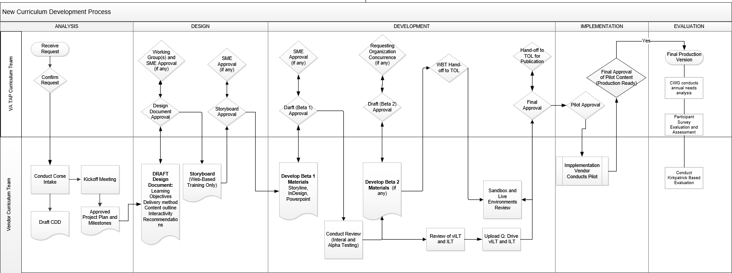
Figure 2: New Curriculum Development Process

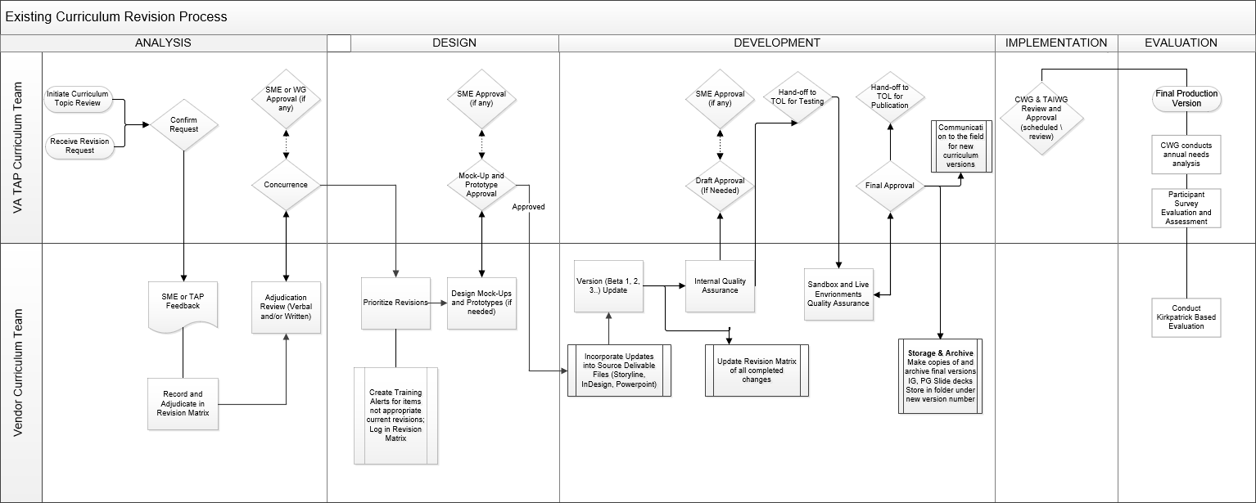
Figure 3: Existing Curriculum Revision Process

 New Curriculum Development
New curriculum is that which has never been released to learners. The addition of a new lesson or section of an existing course or module would not constitute this process. The request is to develop new curriculum materials that may result from a variety of events. Examples include:
    - Governance: The VA TAP Governance team aligns all transition services and support activities to enable and support the transition from military to civilian input from governance research, findings, environmental scans, or working group participation that might require curriculum to address issues or initiatives.
    - Curriculum Working Group (CWG): CWG reviews all Transition Goals, Plans, Success (GPS) curriculum modules and makes recommendations to the Senior Steering Group (SSG) and Executive Council (EC) leaders on the status of all curricula and TAP Training programs.

 | Activity | Roles
10.2.1 ANALYSIS
Course Intake
1 | Identify team members and resources (e.g., SMEs, reviewers, AO, testers). | Vendor Curriculum Team, VA TAP Curriculum Team and/or LOB AO
2 | Review identified learning problem. | Vendor Curriculum Team
3 | Draft learning goal(s). | Vendor Curriculum Team
4 | Discuss audience. | Vendor Curriculum Team
5 | Identify constraints (e.g., SME availability, LMS requirements, external timelines). | Vendor Curriculum Team
6 | Identify delivery options and recommendations, including taxonomy level (e.g., Level 2 comprehension). | Vendor Curriculum Team
7 | Draft high-level project timeline. | Vendor Curriculum Team
8 | Identify concurrence and approval expectations. | Vendor Curriculum Team
9 | Identify other relevant characteristics, such as alignment to other products, modalities, modules and/or courses. | Vendor Curriculum Team, VA TAP Curriculum Team and/or SME

 | Activity | Roles
10 | Initiate the Course Design Document (CDD). | Vendor Curriculum Team
Kickoff Meeting
1 | Hold Kickoff Meeting. | Curriculum Program Analyst, the Curriculum Development Team, SME AO, and TAP Leadership as required
2 | Review and confirm the problem and goal(s).
3 | Define sources of information (e.g., source documents, changelogs), points of contact, roles and responsibilities
4 | Validate audience and characteristics that would impact the design of learning programs.
5 | Discuss timelines as well as known constraints and events that would impact the development schedule.
6 | Submit planning documentation, to date, to TAP Curriculum Team for Feedback. | Vendor Curriculum Team
VA Lines of Business Curriculum Review Process
1 | Twenty-one (21) days before curriculum review: Identify VA SMEs and Authorizing Officials (AOs) documented in the previous review cycle in Curriculum Team SME Repository. | VA TAP Curriculum Team
2 | Ten (10) to fourteen (14) days before curriculum review: Notify VBA and VHA lines of business (LOB) via organizational email boxes. Notify external SMEs and stakeholders, as appropriate. Request confirmation of SMEs. | VA TAP Curriculum Team
3 | Curriculum Review: Submit course materials (instructor guides, participant guides, and PPT slides) to SMEs via LOB organizational email boxes and previous year’s AOs. Include the requested response date. Request GS-15 concurrence on changes. | VA TAP Curriculum Team
4 | Adjudicate feedback within 10-14 days of receipt to eliminate duplication of feedback and ensure accuracy. | VA TAP Curriculum Team  Vendor Curriculum Team
5 | Return change log to SMEs with questions regarding feedback or requested updates. | VA TAP Curriculum Team
6 | Integrate SME feedback into course materials as development progresses. | Vendor Curriculum Team
7 | Share updated course materials with SMEs for concurrence, including integrated feedback. This may include virtual or face-to-face meetings to ensure accuracy or to demonstrate the course delivery intended for participants. | VA TAP Curriculum Team  Vendor Curriculum Team
8 | Integrate any final SME feedback and share with SMEs in tandem with the course launch. | VA TAP Curriculum Team  Vendor Curriculum Team
VA Lines of Business (LOB)-Initiated Curriculum Update Process
 | Designated Action | Responsible Party
1 | Send an email to the VA TAP Curriculum organizational email box with:  - Recent legislative or VA policy or regulation change. | VA Line of Business or Content Subject Matter Expert
2 | Confirm authorizing official (GS-15 or higher) and  - Create a program alert  - Within 10 calendar days  - To notify Benefits Advisors of the change to VA Benefit, Service or resource.  See page 48 for the Program Alert process. | VA TAP Curriculum Team  Vendor Curriculum Team
3. | - Create a mock-up of the proposed changes.  - Add to the course change log,  - Share updated course materials and change log with SMEs for concurrence (see page 27). | Vendor Curriculum Team  VA TAP Curriculum Team  VA Line of Business or Content Subject Matter Expert

4. | Integrate approved mock-ups into the curriculum  Transfer updated files to the delivery team (Benefits Advisors) to implement updates. | Vendor Curriculum Team  VA TAP Curriculum Team

Information Gathering and Analysis
1 | Compile source files, documents and information key to developing the curriculum. | Vendor Curriculum Team
2  3 | Perform audience analysis (e.g., demographics, existing knowledge, environment). | Vendor Curriculum Team and/or VA TAP Curriculum Team
4 | Analyze and consolidate SME-provided materials. | Vendor Curriculum Team
5 | Draft high-level and detailed content outline (i.e., content, not course flow). | Vendor Curriculum Team and/or SME
6 | Confirm technology requirements for virtual and web-based curriculum. | Vendor Curriculum Team

Activity | Roles

Project Plan and Milestone Approval
- The project plan and milestone delivery dates will be approved.

VA Chief of TAP Curriculum

    - DESIGN

Design Documents
      - Complete the CDD, including enabling learning objectives (see table 2 below), course flow (e.g., order of learning, segmenting), content chunking and engagement and interactivity recommendations (e.g., use of case study or branching scenario).
      - Describe the activities and exercises to reinforce the learning objectives.

Vendor Curriculum Team

Vendor Curriculum Team

Terminal Learning Objective | A Terminal Learning Objective (TLO) states the expectations of knowledge, skills, or abilities upon completing a specific course or module.  An example of a TLO is the following:  - To provide awareness of VA Home Loan Guaranty Program benefits for Transitioning Service members and Veterans, including the Native Americans living on trust land
Enabling Learning Objective | An Enabling Learning Objective (ELO) states the expectations of knowledge, skills, or abilities and the steps to accomplish the TLO.  An example of an ELO is the following:  - Identify the Home Loan Guaranty program’s eligibility requirements

Table 8: Learning Objectives Definitions

 | Activity | Roles
3 | Create a graphical user interface (GUI) and curriculum style prototype (for web- based curriculum). | Vendor Curriculum Team
4 | Submit the CDD and applicable template prototype to the Curriculum Program Analyst and/or SMEs for review and feedback. Additional approvals from M2CR Leadership will be obtained from the Curriculum Program Analyst, as appropriate. | Vendor Curriculum Team
Mock-Ups and Prototype
1 | Verify specifics on changes or updates with the Curriculum Program Analyst or designated SME, if needed. | VA TAP Curriculum Team
2 | Draft revised materials as per the change request, to include a technical edit and QA review. | VA TAP Curriculum Team
3 | Submit to the Curriculum Program Analyst for feedback. | VA TAP Curriculum Team
4 | Approval by the Curriculum Program Analyst. | VA TAP Curriculum Team
5 | Send to SME for approval, if needed. | VA TAP Curriculum Team
6 | Make edits as recommended by SME, if needed. | VA TAP Curriculum Team
7 | Submit the final version to the Curriculum Program Analyst. | VA TAP Curriculum Team
8 | Submit to VA on all major changes. | VA TAP Curriculum Team

 | Activity | Roles
Design Document Approval
1 | Approval: The approval requirements vary by curriculum and whether it is a major design change. Based on the VA Chief of TAP Curriculum approval, the design document and content outline. Revisions will be implemented, and the final approved design document filed. | VA Chief of TAP Curriculum
2 | Course flow outline and other applicable elements of the CDD submitted to CWG, for approval by the TAIWG, during the spring curriculum review cycle for feedback and approval. | TAP Interagency Working Group Co-Chairs
3 | Return Curriculum Review feedback. | VA TAP Curriculum Team
4 | Review CWG Feedback. | VA TAP Curriculum Team
5 | Provide feedback to Vendor Curriculum Team. | VA TAP Curriculum Team
Note: The design document is a working document; multiple iterations and SME reviews might be required to confirm and approve the approach, which is particularly critical for WBT. The design document reflects the initial design of the course and is not updated during the development process. See Appendix A for a sample Design Document Table of Contents.
6 | Design a detailed storyboard for WBT only. | Vendor Curriculum Team
7 | Submit the WBT storyboard to the Curriculum Program Analyst and/or SMEs for review and feedback.  Additional approvals from M2CR Leadership will be obtained from the Curriculum Program Analyst, as appropriate. | Vendor Curriculum Team

 | Activity | Roles
10.2.3 DEVELOPMENT
Training Materials
1 | Develop/program source materials based on the outlines and storyboards above to create the build/draft version. | Vendor Curriculum Team
2 | Conduct a review to include writing, formatting, consistency, and accuracy. | Vendor Curriculum Team
3 | Web-based training is uploaded to a test environment in the designated LMS (Events+) and tested to ensure that the programming, activities, navigation, and other items are critical to the curriculum function as designed. Any required changes will be logged in the Revisions Matrix and the program updated accordingly.
4 | Review all products for compliance with the Americans with Disability Act (ADA) Section 508 standards, as applicable. | Vendor Curriculum Team
5 | Submit the build/draft version deliverables to the Curriculum Program Analyst and/or SMEs for review and feedback. Additional approvals from M2CR Leadership will be obtained from the Curriculum Program Analyst, as appropriate. | Vendor Curriculum Team
6 | The Curriculum Program Analyst reviews the draft materials and provides feedback as needed. | VA TAP Curriculum Team
7 | The Curriculum Team revises the materials based on feedback and internal review. | Vendor Curriculum Team
8 | WBT materials are handed off to the TOL LMS Team for testing, and all other materials are placed in the Q-Drive. | Vendor Curriculum Team

 | Activity | Roles
Build and Testing
1 | The documented revisions are incorporated into the identified source delivery files to include the Storyline, InDesign and PowerPoint documents. | Vendor Curriculum Team
2 | Build/draft versions of each delivery file are created for feedback and review by the VA TAP Curriculum Team and the SMEs. | Vendor Curriculum Team
3 | Internal reviews within the Vendor Curriculum team are conducted for each delivery file for each documented revision. | Vendor Curriculum Team
4 | The Revision Matrix is updated through each stage of the build/draft version delivery file development and review. | Vendor Curriculum Team
5 | Once the internal review is completed and passed, draft delivery files are developed and reviewed with the identified SMEs. | VA TAP Curriculum Team
6 | If required, multiple rounds of SME reviews and delivery file build/draft version development will be executed until ready for Transition Online Learning (TOL) testing. | VA TAP Curriculum Team
7 | Working with the TOL testing resource, the Vendor Curriculum Team conducts sandbox testing of all impacted delivery files to ensure the revisions are incorporated while maintaining the integrity and quality of the existing curriculum materials. | Vendor Curriculum Team
8 | Testing involves creating and uploading the Shareable Content Object Reference Model (SCORM) packages into the LMS. The SCORM files are loaded into the sandbox by the LMS team. The goal is | Vendor Curriculum Team

 | Activity | Roles
to test and validate the whole LMS file experience for the revision. Both alpha and beta testing are performed.

SCORM Package Best Practices:
- Keep file size less than 75 megabytes (MB).
- For large courses, break it into nodules or sections to maintain the file size limit.
- Upload no more than 200 files at one time for testing.
- Compressing audiovisual files before adding to Storyline and thus the SCORM package.
- SCORM package file names must contain the date and version of the course for release (e.g., 4.1, 5.0, v2)
Sandbox Testing
1 | Hand-off the published SCORM files to the LMS Team. | Vendor Curriculum Team
2 | Test and upload the provided SCORM files into the sandbox/ testing environment. This process may take 2-3 business days. | LMS Team
3 | Access the sandbox testing environment and perform reviews, including 508 testing, against all provided content. | Vendor Curriculum Team
4 | Correct all issues in source files and repackage for hand-off to LMS Team. | Vendor Curriculum Team
5 | The package will be uploaded to replace the faulty SCORM package for an additional round of can be replaced with 2-3 business days. | LMS Team

 | Activity | Roles
6 | All testing and corrections must be completed no fewer than five (5) business days before the planned production release of the content. | Vendor Curriculum Team
7 | Once the LMS and web-based delivery files are validated and approved through the testing cycle(s), they are released to the SME for review and approval. | VA TAP Curriculum Team
8 | With final approval, the aligned print versions of the impacted delivery files are released for inclusion in the print production schedule for the curriculum. | VA TAP Curriculum Team
Approval and Release
1 | Conduct final testing in the live environment to ensure that WBT materials work as programmed. If any issues arise, they are addressed collaboratively with the LMS Team.  Production testing will be executed three (3) days after the WBT materials are released, with ongoing testing quarterly of all production WBT materials. | Vendor Curriculum Team
2 | Approval: The first draft of the curriculum material will be approved by the TAP Curriculum Chief. | VA Chief of TAP Curriculum
3 | The Curriculum Team revises the materials based on feedback. | Vendor Curriculum Team
4 | Based on feedback from the approving authority as defined for the type of curriculum, the Curriculum Team revises the curriculum materials into the next build/draft version. The Curriculum Team will log all resulting line-item changes in a Revisions Matrix available for | Vendor Curriculum Team

 | Activity | Roles
 | approvers to review as needed. SMEs and points of contact for topic areas might also need to review and concur with content of the materials. Reviewers will log comments in the Revision Matrix.
5 | After testing and approval are complete, non-WBT materials are placed in the Q- Drive. vILT materials are placed appropriately in Connect. | Vendor Curriculum Team
6 | When the Curriculum Program Analyst approves the curriculum material, it will be submitted to TAP Assistant for review and approval. | VA TAP Curriculum Team
7 | Approval: The approval requirements vary by curriculum. Based on the VA Chief of TAP Curriculum approval, the build/draft of the curriculum material will be approved by the VA Chief of TAP Curriculum. | VA Chief of TAP Curriculum &
8 | Return Curriculum Review feedback. | Curriculum Working Group (CWG)
9 | Review CWG Feedback. | VA TAP Curriculum Team
10 | Provide feedback to Vendor Curriculum Team. | VA TAP Curriculum Team
11 | The curriculum materials developed for VA TAP programs could include 1 or more of the following items:
Material Description Curriculum
Instructor A document for ILT instructors to use MLC, BAS,
Guide while facilitating the course face-to-face. WHTT The document includes scripts, notes,
and other useful information for set-up, delivery, reinforcement, and activities. (See Appendix C for an example.)

Activity Roles
 | Facilitator Guide | A document for virtual instructors to use while facilitating the course via a virtual delivery platform, Adobe Connect. The document includes scripts, notes, and other useful information for set-up, delivery, reinforcement, and activities.  Detailed notes are also provided for the Producer’s role, not found in the Instructor Guide. | MLC, BAS, WHTT
 | Participant Guide | A document that the participants will take with them when they leave the course. It typically includes reference materials and follow-up information. (See Appendix D for an example.) | MLC, BAS, WHTT
 | Interactive Participant Guide | A document that the participants will download and keep when participating in the virtual instructor-led or web-based training. The interactive guide is a PDF that includes embedded links to key pages and websites and fillable fields. | BAS, WHTT¹
 | Presentation Materials | A PowerPoint presentation is typically used to guide the briefing or class. The presentation could include imbedded videos, links to websites, or other activities. (See Appendix B for an example.) Note that the vILT presentation consists of three (3) PowerPoint presentation files for upload to the delivery platform (e.g., Adobe Connect). | MLC, BAS, WHTT
 | Activity Worksheets | If activities require instructions or the participants need to record information, an Activity Worksheet will be developed. | MLC, BAS, WHTT
 | Web-Based Training | Curriculum designed for web-based, asynchronous delivery, housed on Tapevents.mil. In that case, the final materials will include a Sharable Content | MLC, BAS, WHTT

¹ The future need for a vILT option for MLC is known and tracked for future development as of August 2021.

 | Activity | Roles
Object Reference Model (SCORM) 2004 published package uploaded to the LMS.
Table 9: Learning Materials List
Curriculum Pilot
1 | To validate the accuracy and effectiveness of a new program or curriculum, a pilot may be conducted. The requesting organization determines the decision to pilot the curriculum, which includes: |  | Implementation Vendor
 | - Multiple iterations involving a crosscut of the various audiences. |  | Implementation Vendor / Vendor Curriculum Team
 | - Observation and review from SMEs, stakeholders, and/or approving authority (Observer Evaluations). |  | VA TAP Curriculum Team
 | - A systematic review of the materials by SMEs, stakeholders, and the Curriculum Team. |  | Vendor Curriculum Team
 | - An evaluation of the program from the audience (Participant Evaluations). |  | Vendor Curriculum Team
2 | Pilot evaluation and feedback forms to support the pilot are updated and provided by the Curriculum Program Analyst. The forms capture both quantitative and qualitative data. For a successful pilot program, the Curriculum Team collaborates with the Training and Command and Control Teams. |  | Vendor Curriculum Team
Pilot Analysis
1 | Following the pilot session or sessions, the results are compiled by the Curriculum Team, and the following tasks are performed: |  | Vendor Curriculum Team
 | - Scan of all feedback forms from  observers and participants for each pilot session. |  | Vendor Curriculum Team

 | Activity | Roles
 | - Analyze quantitative feedback from both observers and participants for each pilot session and cumulative for all pilots. |  | Vendor Curriculum Team
 | - Create a pilot analysis deck to include quantitative data and a summary of major themes from qualitative data. |  | Vendor Curriculum Team
 | - Create a Revisions Matrix documenting recommended revisions to the curriculum by both observers and participants. |  | Vendor Curriculum Team
2 | This information will be presented to VA Curriculum TAP Leadership. Based on feedback and direction from leadership, the logged changes are adjudicated. Updated curriculum materials will be reviewed for quality and 508 compliance and submitted to VA Curriculum TAP Leadership for final approval. |  | Vendor Curriculum Team
3 | Approval: The approval requirements vary by curriculum. Based on the VA Chief of TAP Curriculum approval, the final draft of the curriculum material will be approved. |  | VA Chief of TAP Curriculum
10.2.4 IMPLEMENTATION
Brick-and-Mortar or Virtual Synchronous Delivery
1 | Once the curriculum is finalized for brick-and- mortar delivery, the Curriculum Team coordinates training and delivery with the TAP Training Team and the TAP Operations Command and Control team. Based on the complexity and content of the program, the Training Team and M2CR Leadership will determine the training approach that will be used. These could be 1 of the following options: |  | TAP Operations
 | - In-person training.

Activity | Roles
- Virtual facilitated training.

    - Curriculum Development Integration Points
Below are the Integration Points related to Curriculum Development:

Functional Area | Function | Sub - Function | Type of Integration (Transfer or  Collaboration) | Description
Governance | Interagency Governance | CWG | Collaboration | The Curriculum Team meets regularly to discuss legislation, strategies, and executive orders impacting  curriculum development or revision.
Quality management | Quality Assurance |  | Collaboration | Refer to the “Curriculum & Training” section in the Quality Management SOP Quality Assurance is performed to ensure a factually accurate and appropriate curriculum. It is paired with training that meets industry best practices. They are critical elements for providing high- quality briefings, services, and support to TSMs, Veterans, their families and  survivors.
Operations | BA Training |  | Collaboration | The Curriculum Team works with the Benefit Advisor Training Team (VA TAP contractor) to ensure they have the materials required to train 1 or more Master Trainers to  facilitate the curriculum pilot.
Table 10: Curriculum Development Integration Points Table

 Existing Curriculum Revision
The request is for a change to an existing curriculum, which may include the addition of a section or full module to an existing course. Events that may initiate the revision of an existing curriculum include:
      - A LOB updates benefits, eligibility or processes for receiving benefits impacting the curriculum and/or delivery.
      - Relevant working group(s) identify potential revisions.
      - New executive orders or legislation need to be addressed in the curriculum.
      - Findings provided to VA TAP Curriculum Team during annual CWG working group reviews.
      - A critical change is discovered and must be addressed and communicated to the field.

 | Activity | Roles
10.3.1 ANALYSIS
Change Event
1 | The process starts with either as part of the revision cycle or a line of business revision request. | LoBs or VA TAP Curriculum Team
2 | The change event is captured in the Revision Matrix. The change is adjudicated with the submitting stakeholder. | Vendor Curriculum Team
3 | Concurrence is executed with the appropriate SME for approval through the Curriculum Program Analyst. Additional review cycles and clarification are conducted with the SME and the submitting stakeholder until concurrence is achieved. | VA TAP Curriculum Team
 | The CWG definitions of the major curriculum deliverables are the following:

Type of Change | Description | Implementation | Version
Pen and Ink | A critical change that needs to be communicated to the field immediately  Examples: Inaccurate or outdated information about VA benefits; changes to web links used in the classroom | The change will be communicated to the field as a Pen and Ink change to be implemented immediately. A Program Alert will be sent out to the field to communicate the change. | No Version Change

Type of Change | Description | Implementation | Version
Next Version | A change that does not impact the description, eligibility, or application process for VA benefits but will improve the delivery and clarity of the information for the TSMs  Examples: Clarifying statements; formatting changes | The change will be logged to be included in the next version of curriculum materials that will be printed and distributed to the field. | Changes to printed materials only are documented using an interim version number (such as 1.0 to 1.1)
Technical Revision Cycle | A change or design idea to consider with clients/SMEs at the next formal Technical Review update (bi-annual)  Examples: Reorganizing flow of content within existing modules; removing or adding benefits under existing module structure | The change will be logged for review and discussion at the next Technical Review. | Version number increased to the next whole number (for example, when a tech review is done for v1.1, the resulting materials will be v2.0)
In-Depth Revision Cycle | A change or design idea to consider with clients/SMEs at the next formal In-Depth Review update (twice a year)  Examples: Changes to the learning objectives; requests for new modules or redesign of the existing module structure | The change will be logged for review and discussion at the next In- Depth Review analysis phase. | In-Depth Revision requires starting at 1.0
New Development | Changes to the program design or delivery methods; requests to develop supplemental or complementary material | The changes are considered Curriculum Development and will follow the SOP and approval process documented therein. | No Version Change

Table 11: Change Review Definitions

 | Activity | Roles
VA Lines of Business Curriculum Review Process
1 | Identify VA SMEs and Authorizing Officials (AOs) documented in previous review cycle | VA TAP Curriculum Team
2 | Ten (10) to fourteen (14) days before review: Send notification of request for curriculum review via e-mail to VBA and VHA lines of business (LOB), and external SMEs and stakeholders, as appropriate. | VA TAP Curriculum Team
3 | Curriculum Review: Submit any existing (previous) course materials (instructor guides, participant guides, and PPT slides) with previously tracked changes integrated, as appropriate, to SMEs via LOB email boxes and previous year’s AOs. Include requested turnaround time period and request GS-15 concurrence on changes. | VA TAP Curriculum Team
4 | Adjudicate feedback within 7-10 days of receipt to eliminate duplication of feedback and ensure understanding. | VA TAP Curriculum Team  Vendor Curriculum Team
5 | Return change log to SMEs with any questions regarding feedback or updates. | VA TAP Curriculum Team
6 | Integrate SME feedback into course materials as development occurs. | Vendor Curriculum Team
7 | Share updated course materials with SMEs for concurrence, inclusive of integrated feedback. This may include virtual or face-to-face meetings to ensure accuracy or model course just as intended for participants. | VA TAP Curriculum Team  Vendor Curriculum Team
8 | Integrate any final SME feedback and share with SMEs simultaneously with the course launch. | VA TAP Curriculum Team  Vendor Curriculum Team
Revisions Matrix
1 | Reviewers provide comments for the deliverable on a TAP Curriculum-provided SME changelog. | VA TAP Curriculum Team
2 | The Curriculum Team logs and adjudicates all line-item changes from reviewer comments in the Revisions Matrix (Appendix E). | Vendor Curriculum Team
3 | Ensure that the Revisions Matrix indicates the status of when the updates were distributed to the field. | Vendor Curriculum Team
4 | A copy of the Pen and Ink communication and the materials sent to the field previously must be kept in a shared folder for cross-checking for the next Version Update. | Vendor Curriculum Team
5 | All Pen and Ink communications and the materials and log of Version Change requests must be updated and kept in the Pen and Ink binder. | Vendor Curriculum Team
Concurrence and Authorization to Proceed
1 | The VA Chief of TAP Curriculum will determine if the changes are to be made based upon recommendations from the Curriculum Program Analyst. | VA TAP Curriculum Team
2 | If YES: The Curriculum Program Analyst will respond to the requestor that the changes will be made and work with the Curriculum Team on the schedule and priority for making the change. The Curriculum Team will change the item in the Revisions Matrix to Approved by Client and proceed with materials revision and approval. | VA TAP Curriculum Team
3 | If NO: The Curriculum Program Analyst will respond to the requestor with an explanation of why the change will not be made. The Curriculum Team will change the status of the item in the Revisions Matrix to Disapproved by Client and proceed with materials revision and approval. | VA TAP Curriculum Team
10.3.2 DESIGN
Prioritization
1 | The list of revisions will be prioritized for Design | Vendor Curriculum Team
2 | Create Program Alert if a Pen and Ink Change | Vendor Curriculum Team
Materials Revision
1 | The process for updating both the Pen and Ink changes and Version Updates is the same; however, the timing of the updates varies. | VA TAP Curriculum Team

 | Activity | Roles
2 | Pen and Ink changes will be completed immediately upon authorization and logged for inclusion in the final materials. | VA TAP Curriculum Team
3 | Version Updates will be logged for inclusion in the next print version of the curriculum. All changes will be made immediately prior to the print submission to ensure that any updates are made to the most current Pen and Ink pages. | VA TAP Curriculum Team
Mock-Ups and Prototype
1 | Verify specifics on changes or updates with the Curriculum Program Analyst or designated SME, if needed. | VA TAP Curriculum Team
2 | Draft revised materials as per the change request, to include a technical edit and QA review. | VA TAP Curriculum Team
3 | Submit to the Curriculum Program Analyst for feedback. | VA TAP Curriculum Team
4 | Approval by the Curriculum Program Analyst. | VA TAP Curriculum Team
5 | Send to SME for approval, if needed. | VA TAP Curriculum Team
6 | Make edits as recommended by SME, if needed. | VA TAP Curriculum Team
7 | Submit the final version to the Curriculum Program Analyst. | VA TAP Curriculum Team
8 | Submit to VA on all major changes. | VA TAP Curriculum Team
Approval - Pen and Ink
9 | The Curriculum Program Analyst will submit the final Pen and Ink changes for approval as completed. | VA TAP Curriculum Team
10 | Approval: The approval requirements vary by curriculum. Based on the VA Chief of TAP Curriculum approval, the Pen and Ink revisions will be approved by the VA Chief of TAP Curriculum. | VA TAP Curriculum Team
10.3.3 DEVELOPMENT
Incorporate Updates
1 | The documented revisions are incorporated into the identified source delivery files to include the Storyline, InDesign and PowerPoint documents. | Vendor Curriculum Team
2 | Build/draft versions of each delivery file are created for feedback and review by the VA TAP Curriculum Team and the SMEs. | Vendor Curriculum Team
3 | Internal reviews within the Vendor Curriculum team are conducted for each delivery file for each documented revision. | Vendor Curriculum Team

 | Activity | Roles
4 | The Revision Matrix is updated through each stage of build/draft delivery file development and review. | Vendor Curriculum Team
5 | Once the internal review is completed and passed, draft delivery files are developed and reviewed with the identified SMEs. | VA TAP Curriculum Team
6 | If required, multiple rounds of SME reviews and delivery file build/draft development are executed  until ready for Transition Online Learning (TOL) testing. | VA TAP Curriculum Team
7 | Working with the TOL testing resource, the Vendor Curriculum Team conducts sandbox testing of all impacted delivery files to ensure the revisions are incorporated while maintaining the integrity and quality of the existing curriculum  materials. | Vendor Curriculum Team
8 | Testing involves creating and uploading the Shareable Content Object Reference Model (SCORM) packages into the LMS. The SCORM files are loaded into the sandbox by the LMS team. The goal is to test and validate the whole LMS file experience for the revision. Both alpha and beta testing are performed.  SCORM Package Best Practices:  - Keep file size less than 75 megabytes (MB).  - For large courses, break it into nodules or sections to maintain the file size limit.  - Upload no more than 200 files at one time for testing.  - Compressing audiovisual files before adding to Storyline and thus the SCORM package.  - SCORM package file names must contain the date and version of the course for release (e.g., 4.1, 5.0, v2) | Vendor Curriculum Team
Sandbox Testing
1 | Hand-off the published SCORM files to the LMS Team. | Vendor Curriculum Team
2 | Test and upload the provided SCORM files into the sandbox/ testing environment. This process may take 2-3 business days. | LMS Team

 | Activity | Roles
3 | Access the sandbox testing environment and perform reviews, including 508 testing, against all provided content. | Vendor Curriculum Team
4 | Correct all issues in source files and repackage for hand-off to LMS Team. | Vendor Curriculum Team
5 | The package will be uploaded to replace the faulty SCORM package for an additional round of can be replaced with 2-3 business days. | LMS Team
6 | All testing and corrections must be completed no fewer than five (5) business days before the planned  production release of the content. | Vendor Curriculum Team
7 | Once the LMS and web-based delivery files are validated and approved through the testing cycle(s), they are released to the SME for review and approval. | VA TAP Curriculum Team
8 | With final approval, the aligned print versions of the impacted delivery files are released for inclusion in the print production schedule for the curriculum. | VA TAP Curriculum Team
Communicate Changes
1 | Once all changes are approved, the revisions need to be implemented in the field.  Communications procedures vary depending on the type of change being implemented. | VA TAP Curriculum Team
 | - The Revisions Matrix is prepared for distribution. | VA TAP Curriculum Team
 | - The combined PDF of updated Instructor Guide pages, if applicable. | VA TAP Curriculum Team
 | - The updated Participant Guide Edits handout, if applicable. | VA TAP Curriculum Team
 | - The link to the updated Active Version of the slide deck, if applicable. | VA TAP Curriculum Team
2 | The Curriculum Team provides the Training Team the draft email content with all attachments and links. | VA TAP Curriculum Team
Next Version Updates
1 | Upon final approval by VA, the Curriculum Team prepares the materials affected by the Next Version updates for communication to the field: | VA TAP Curriculum Team
 | - For Instructor Guide changes: Convert all affected pages to PDF and save them as individual PDF files. Combine all individual | VA TAP Curriculum Team

Activity Roles

PDF files into a single PDF, using a
standard file naming convention: VA_ [curriculum name] _version [XX]_updates.
- For Participant Guide changes: Update the content of the Participant Guide. Coordinate with TAP Operations on schedule and process for printing and distributing the guide to the field.
- For Slide Deck changes: Update the slide deck file in the Active Versions folder with the new pptx file (be sure to retain the master file of the slide deck in the appropriate version folder, for example, v1.1.)
- The Curriculum Team prepares the Revisions Matrix for distribution to the field.
  - Save a copy of the Revisions Matrix to your desktop.
  - Delete all tabs except the Pen and Ink tab and the Next Version tabs.
  - Conduct spell check/quality review; ensure all descriptions are enough.
- The Curriculum Team drafts a field communication email for the Training Task Lead to distribute. This email summarizes changes made and refers the audience to review the Revisions Matrix for a detailed list of changes.
  - The Revisions Matrix is prepared for distribution
  - The combined PDF of updated Instructor Guide pages (if applicable).
  - The link to the updated Active Version of the slide deck (if applicable).
- The Curriculum Team provides the Training Task Lead the draft email content with all attachments and links:
  - The updated Participant Guide Edits handout (if applicable).
  - See Appendix F for examples of communication to the field for curriculum revisions.

VA TAP Curriculum Team

VA TAP Curriculum Team

VA TAP Curriculum Team VA TAP Curriculum Team VA TAP Curriculum Team VA TAP Curriculum Team VA TAP Curriculum Team

VA TAP Curriculum Team VA TAP Curriculum Team VA TAP Curriculum Team VA TAP Curriculum Team
VA TAP Curriculum Team VA TAP Curriculum Team

Pen and Ink
1 Once changes are approved and communicated to the field, no further action is necessary. The

VA TAP Curriculum Team

 | Activity | Roles
 | working version of the materials should be up to date.
2 | Archive the final version of the Instructor Guide, Participant Guide, and slide deck in a folder labeled with the version number here. | VA TAP Curriculum Team
3 | Make copies of all three(3) files and move them to a new folder labeled as the next version number.  This will be the working file to incorporate all Pen and Ink or Next Version changes until the next print submission. | VA TAP Curriculum Team
10.3.4 IMPLEMENTATION
1 | The approved and developed revisions are executed per the defined production release schedule for each revision and for each impacted delivery file within that revision. | VA TAP Curriculum Team
2 | Production testing will be executed t three (3) days after the WBT materials are released, with ongoing testing quarterly of all production WBT materials. | Vendor Curriculum Team

Program Alert Sub-Process (Program Alert Process)
 | Activities | Roles
1 | Notification/Issue presented at "anytime". | Any Input Source
2 | Delegate Issue for validation. | VA Chief of TAP Curriculum
3 | Validate the issue and report results to VA TAP Curriculum Chief within 3 business days. | Vendor Curriculum Team
4 | Decide to create a Program Alert. If decision =  NO, then End process. | VA TAP Chief  Curriculum
5 | Send a request to SMEs for input. | VA TAP Curriculum Team
6 | SME provides input within 2-3 days of request. | Subject Matter Expert
7 | Within 1 day after receiving SME input:  - Create Program Alert  - Update PowerPoint, Instructor Guide, Facilitator Guides, to include but not limited to supplementary or complementary products that directly align to the Program Alert in question | Vendor Curriculum Team
8 | - Update Interactive PG within 2-3 days after receiving SME input.  - Make updates to supplementary or complementary products within 7-10 calendar days. | Vendor Curriculum Team
9 | Send Program Alert to Training Delivery Team. | VA TAP Curriculum Team
10 | Implement Program Alert within 1 day of receiving the Program Alert. | Training Delivery Team (CALIBRE)

12 | Add to relevant Change Log (ILT & PG, MLC) within 1 day of delivery of the Program Alert (if  applicable). | Vendor Curriculum Team
- 13 | If the Program Alert requires additional Program Alert s, go to step 1; If not, end the Program Alert process. | Vendor Curriculum Team

    - Curriculum Revision Integration Points

Functional Area | Function | Sub - Function | Type of Integration (Transfer or Collaboration) | Description
Operations | Training |  | Transfer | The Training team will provide feedback received on the curriculum through  the training delivery.
Operations | Field Operations |  | Transfer | The Contract Vendor Field Operations team will provide feedback via TAP Operations
Quality Management | Quality Assurance |  | Transfer | The Quality Management team (TAP Operations; Contract Vendor) will provide feedback received from Quality Managers based on their review of Benefits Advisors in their delivery of TAP Curriculum to TSMs.
Governance |  |  | Transfer | The Governance Task and the Curriculum team meet regularly to discuss legislation, strategies, and executive orders impacting curriculum development or revision.
Governance | Planning, Analysis, and Evaluation |  | Transfer | The Planning, Analysis and Evaluation team provides feedback based on the quarterly TAP Course  Assessment (TAPCA) provided 30-days by the

Functional Area | Function | Sub - Function | Type of Integration (Transfer or Collaboration) | Description
DoD after the end of the
quarter.
Quality Management | Quality Assurance |  | Transfer | The Quality Assurance team processes TAPCA negative comments and performs an adjudication of those comments. The results are provided to the VA TAP Curriculum office via the TAP Critical Comments report.
Table 12: Curriculum Revision Integration Points

 Review and Concurrence
For both New Curriculum Development and Existing Curriculum Revision there will be multiple levels of concurrence depending upon the organization requesting the development of the material. The concurrence levels required will be determined in the Analysis phase and documented in the project plan. Review cycles of developed curriculum artifacts will be executed with the appropriate stakeholders throughout the Design and Development phases.

 | Activities | Roles
1 | Send the materials to the stakeholder from whom concurrence is requested when all reviews, revisions, and quality checks are complete, | VA TAP Curriculum Team
2 | A time frame will be established to respond with concurrence via email or  provide a concurrence decision on a working group call. | VBA and VHA Lines of Business (LOB)
3 | If any of the reviewers do not concur with the curriculum, the reason for non-concur will be communicated to the rest of the approval team for discussion and recommendations. | VBA and VHA LOB
4 | If updates are identified as part of  the concurrence process, the review and revision step will be executed until concurrence is reached or the update is terminated. The concurrence status is updated in the Revision | VBA and VHA LOB

Activities | Roles
Matrix, which is stored in the M2CR Shared Drive.

 EVALUATION
 | Activities | Roles
1 | The Kirkpatrick training evaluation model is utilized to help assess training success and effectiveness as follows:  Level 1 Reaction: assess the degree to which participants find the training favorable, engaging and relevant to their job; to include engagement, relevance, and satisfaction (Kirkpatrick & Kirkpatrick, 2016, 10)  Level 2 Learning: assess the degree to which participants acquire the intended knowledge, skills, attitude, confidence and commitment based on their participation in the training (Kirkpatrick & Kirkpatrick, 2016, 10)  If appropriate data are available:  Level 3 Behavior: assess the degree to which participants apply what they learned during training to their transition into civilian life (Kirkpatrick & Kirkpatrick, 2016, 10).  Level 4 Results:  assess the degree to which targeted outcomes occur as a result of the training and the support and accountability package (Kirkpatrick & Kirkpatrick, 2016, 10). | VA TAP Curriculum Team Vendor Curriculum Team
2 | Participant survey comments are compiled in a quarterly TGPS (TACPA) Survey report.  The MCTO Evaluation and Assessment Team through the Performance Management Working Group (PMWG) recommends Declarative Knowledge (DK) and Learning Objectives (LO) items that need revision based on the analysis of participant assessment data; the CS or SME reviews suggestions by PMWG and provides the final decision for the changes. The LO and DK questions are sent to the CWG. | DoD MCTO Evaluation and Assessment Team

 | Activities | Roles
3 | Each year, the CWG conducts a needs analysis of all curriculum content and information to determine if the curriculum is correct and meets the needs of the Service members. If a curriculum is determined to need profound changes, an in-depth review will be conducted. If the curriculum is still relevant and valid and needs only minor changes, a technical review will be conducted. (See the Standard Operation Procedures (SOP), Transition Assistance Program (TAP), Curriculum Review Process per Curriculum Working Group) | Curriculum Working Group (CWG)
4 | Recommendations for changes to the curricula will be presented to and approved by the Transition Assistance Interagency Working Group (TAIWG). An overview of the updates will be presented to the Senior Steering Group (SSG) and the Executive Council (EC) leaders for informational purposes to maintain knowledge and awareness on the status of all curriculum components. After the curriculum is finalized and reviewed by the CWG, the CWG sends a recommendation to the TAIWG to give final approval for curriculum implantation. | Transition Assistance Interagency Working Group (TAIWG)

Quality management is an essential process for developing and delivering a high-quality curriculum that will successfully meet the learning objectives it is designed to meet.
    - Curriculum Development Technical Evaluation
To ensure the quality within the curriculum development process, the following activities are conducted:
      - The Curriculum Program Analyst reviews all materials for accuracy, clarity, and formatting.
      - SMEs review materials to ensure technical accuracy and clarify.
      - Materials are reviewed to ensure that content is aligned with the learning objectives.
      - A technical edit is conducted to ensure the materials are accurate and formatted according to requirements.
      - All WBT materials will undergo initial production testing three (3) days after production release with an ongoing review (quarterly) of WBT materials by the Vendor Curriculum Team.

      - The Curriculum courses, training and modules will be tested for web-based training to ensure programming and functionality operate as designed and meet 508 compliance testing. Please see Appendix H for the 508 checklists.
    - Curriculum Quality Management
There is a Quality Management SOP for Curriculum Implementation (Delivery). See Appendix G for an example of the Curriculum Quality Control Checklist.
Below are the Integration Points related to Curriculum Quality Management:

Functional Area | Function | Sub - Function | Type of Integration (Transfer or  Collaboration) | Description
Quality Management | Quality Assurance | On-site Visits | Collaboration | Quality Management also ensures VA Benefits Information is accurate, complete, relevant, current, 508 compliant and delivered in the way  the training intended.
Operations | Training |  | Transfer | The Curriculum Team works closely with TAP Operations and the Contract Vendor Training Team to understand the curriculum goals, audience, and materials to develop BA Training materials to support the rollout of the curriculum.
TAP  Operations | Command and Control | Logistics | Transfer | The Curriculum Team works closely with the TAP Operations Team to understand the logistics required to ensure that materials get to the sites according to the deadlines and  requirements.

Functional Area | Function | Sub - Function | Type of Integration (Transfer or Collaboration) | Description
Program Integration | Integration | Strategic Communications | Collaboration | The Curriculum Team works closely with the Strategic Communications Team to ensure they understand the target audience, content, and implementation timeline for the curriculum, for effective communication to the  field regarding the curriculum.
Governance | Planning, Analysis, and Evaluation | Analysis | Collaboration | The Curriculum Team works with the Planning, Analysis, and Evaluation Task Team to ensure their understanding of the curriculum, learning objectives, audience, and implementation strategies. They can conduct analysis and evaluation of the  curriculum according to their processes.
Quality Management | Quality Control |  | Collaboration | The Curriculum Team works with the Quality Management Team (TAP Operations / Contracted Vendor) to ensure their understanding of the curriculum, learning objectives, audience, and implementation strategies for the curriculum to include  curriculum delivery

Functional Area | Function | Sub - Function | Type of Integration (Transfer or Collaboration) | Description
and understanding in the quality management processes for evaluating the success of the
curriculum and facilitation.
Quality Management | Quality Assurance |  | Collaboration | The Curriculum Team collaborates with the Quality Management Team (Contract Vendor) to provide oversight on ensuring and maintaining the  quality of the curriculum materials.
Table 13: Curriculum Quality Management Integration Points

Distribution and Storage
This SOP should be internal to M2CR and only distributed to internal team members associated with VA TAP. This SOP is stored in the VA M2CR Governance SOP repository in the VA M2CR SharePoint.
The following artifacts are uploaded monthly and maintained in the Q: drive:
    - Changelogs (Revisions Matrix)
    - Draft uploaded for each series of feedback loop
    - Final versions uploaded post-approval.
Working drafts of all Curriculum artifacts are stored within the Vendor Curriculum Team system of record.

Training
The SOP will be reviewed and updated annually to reflect the current state of operations. Training on the revised SOP will be held for all existing VA M2CR Curriculum & Governance staff and the assigned Vendor Curriculum Team.

New or temporary support staff, either within the VA M2CR Curriculum office or the Vendor Curriculum Team, will be trained as part of their on-boarding process.

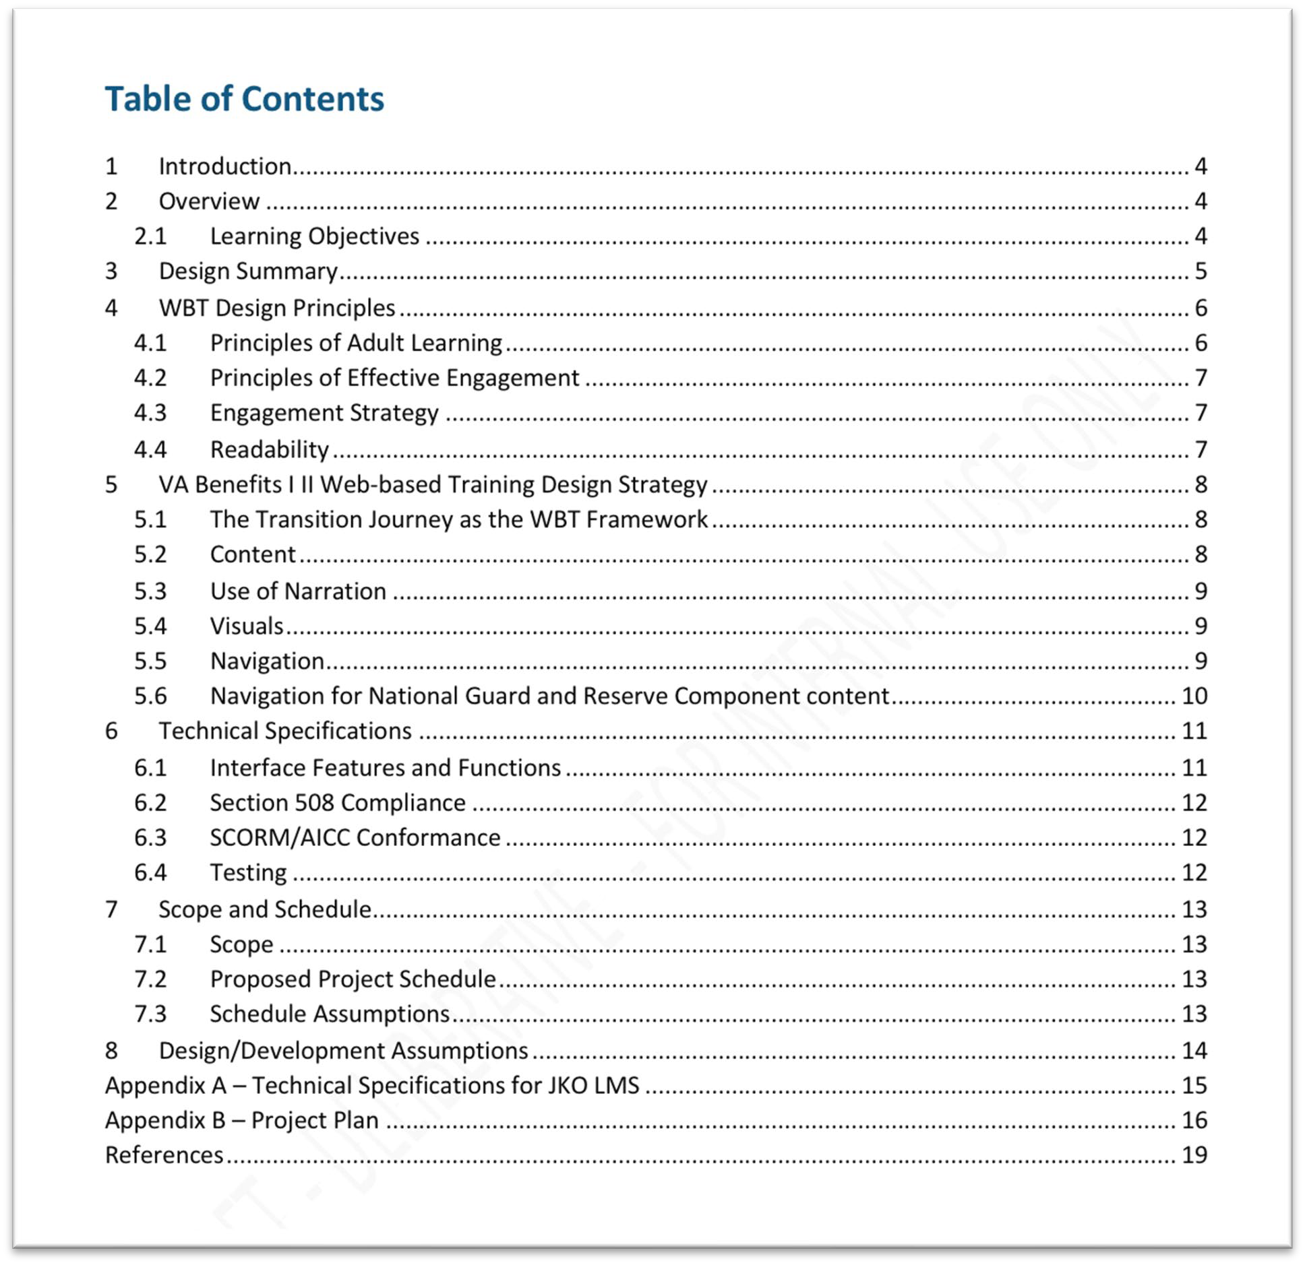
Appendix A: Sample Design Document Contents

Appendix B: Sample Slide Deck

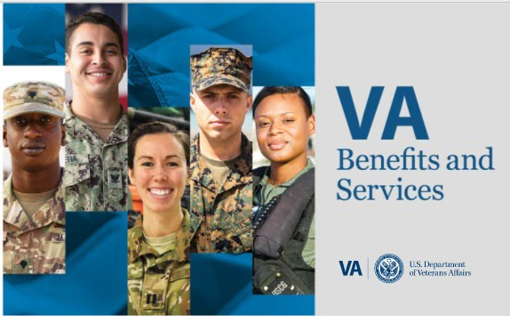
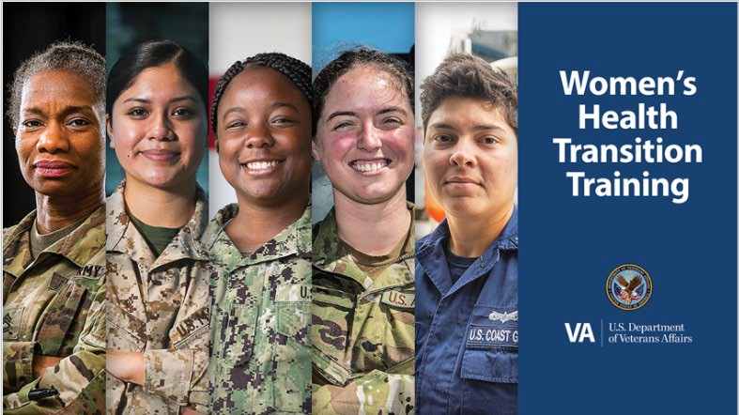
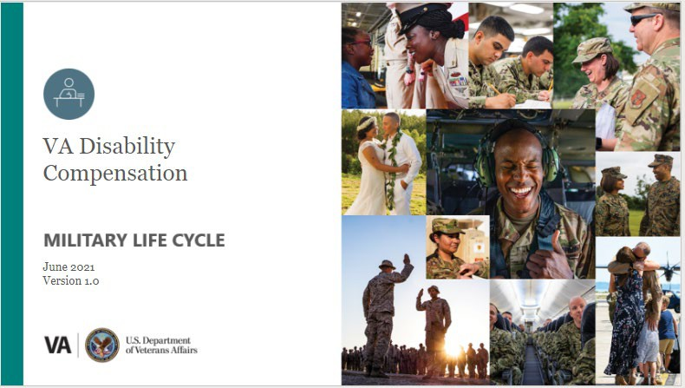

Appendix C: Sample Instructor Guide
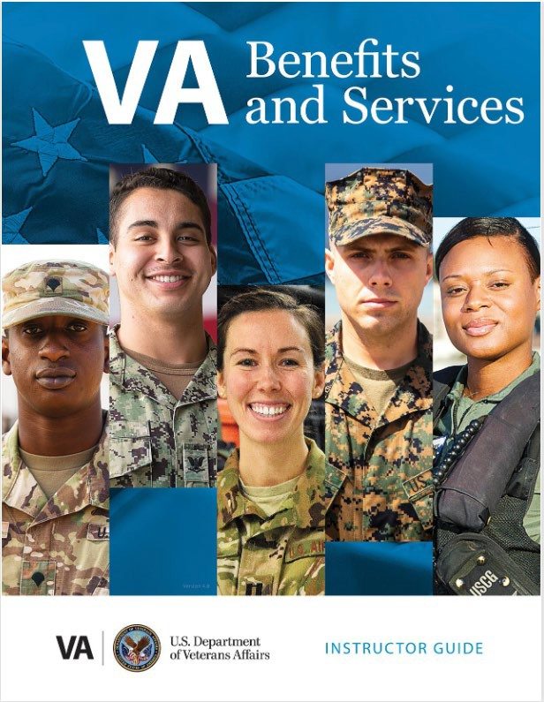
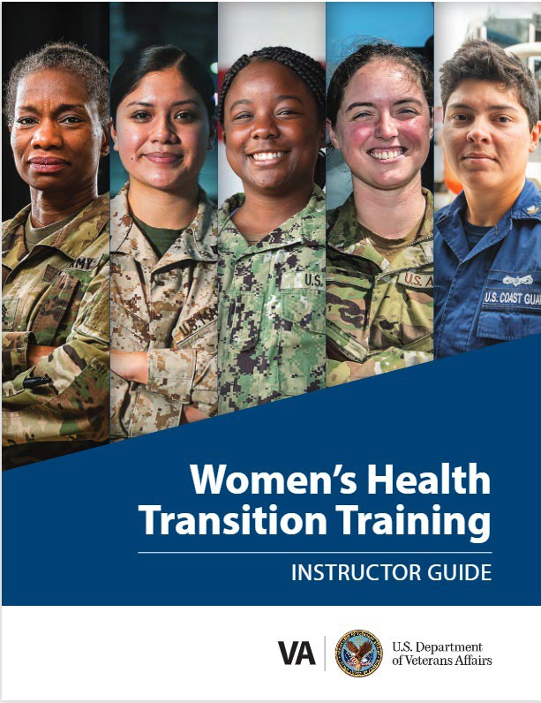
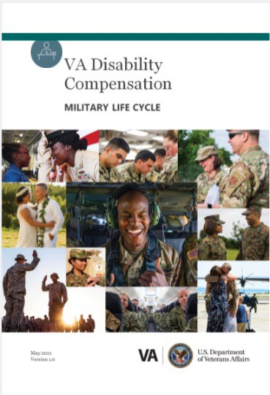

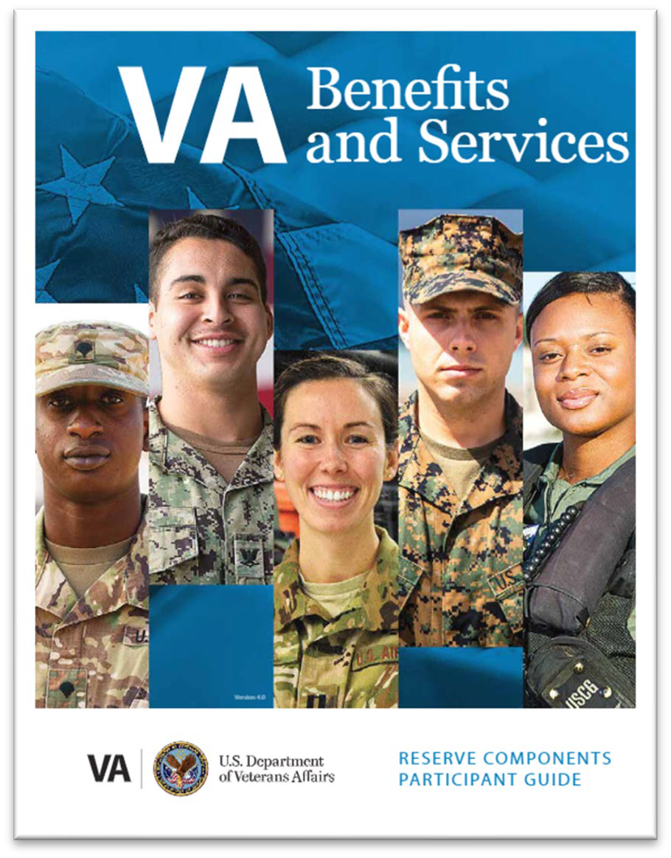
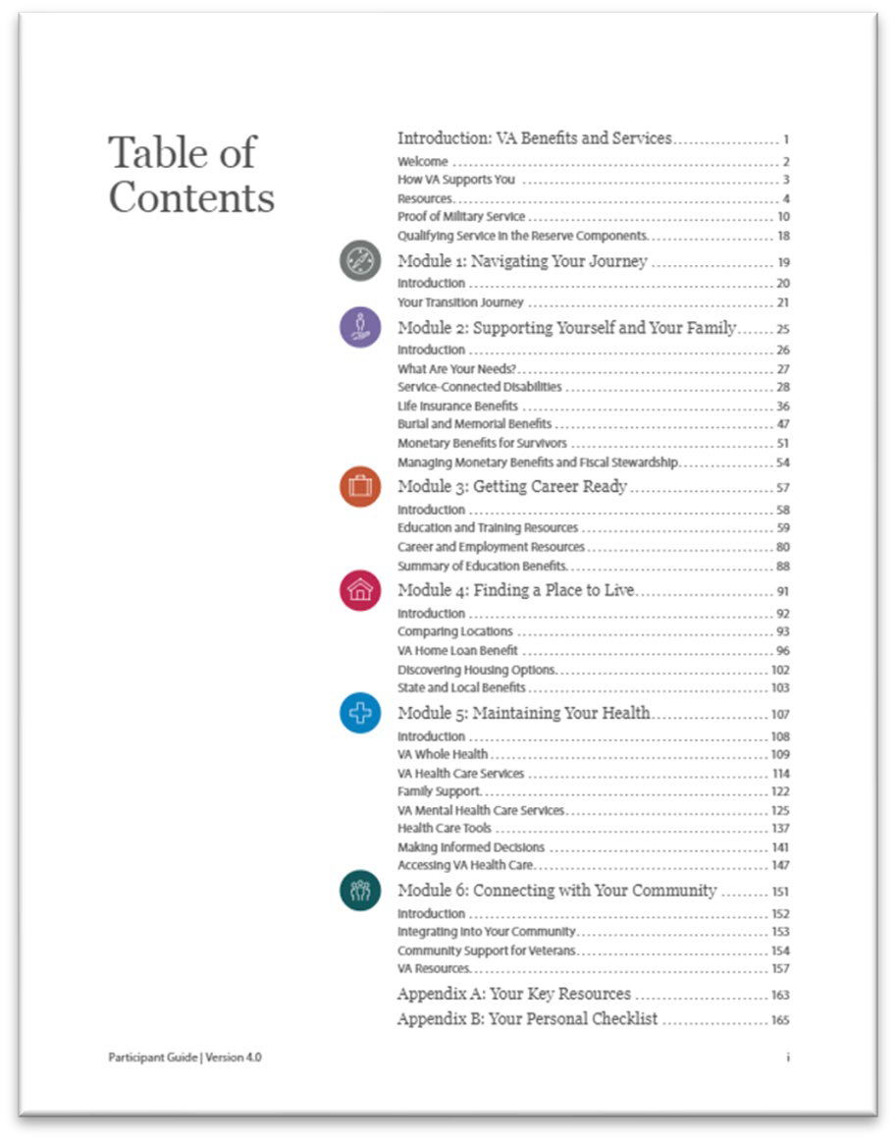
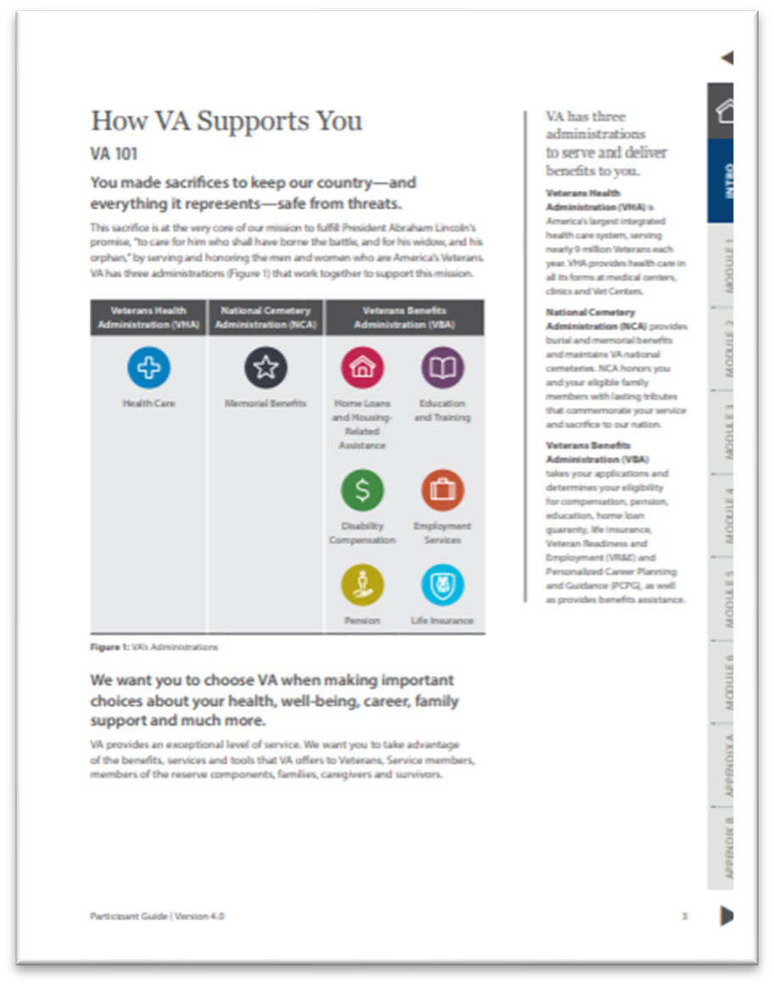
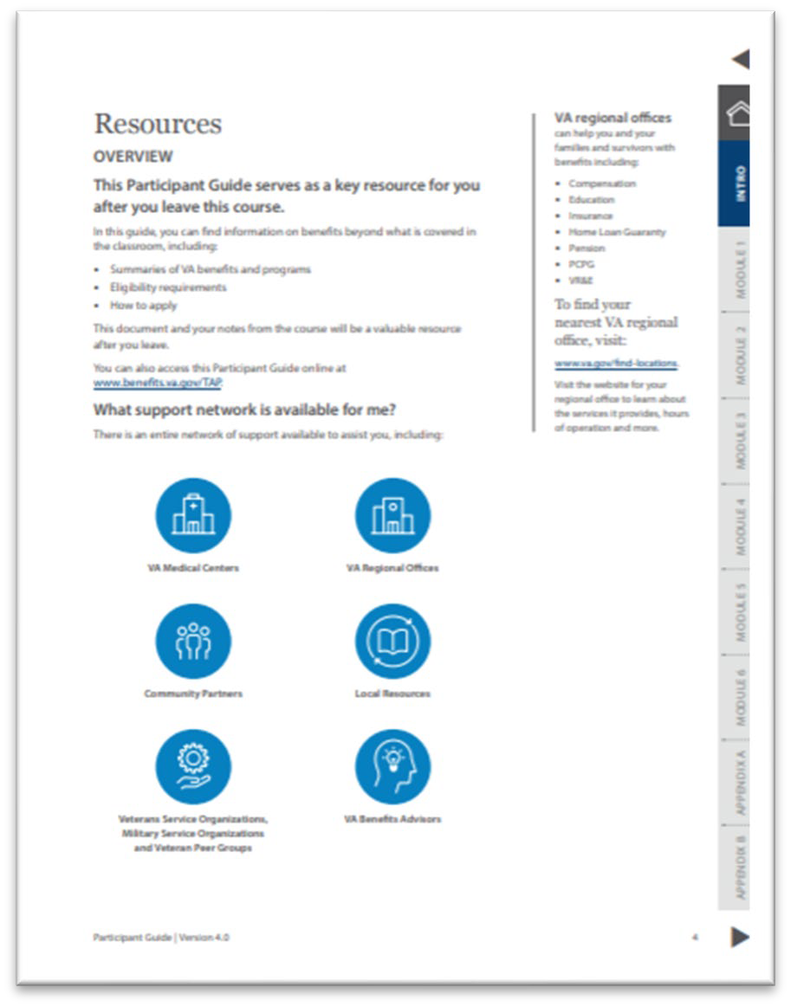
Appendix D: Sample Participant Guide

Responsible Office: TAP Curriculum 02 JAN 2024
Subject: TAP Curriculum Development and Revision Final

Appendix E: Revision Matrix
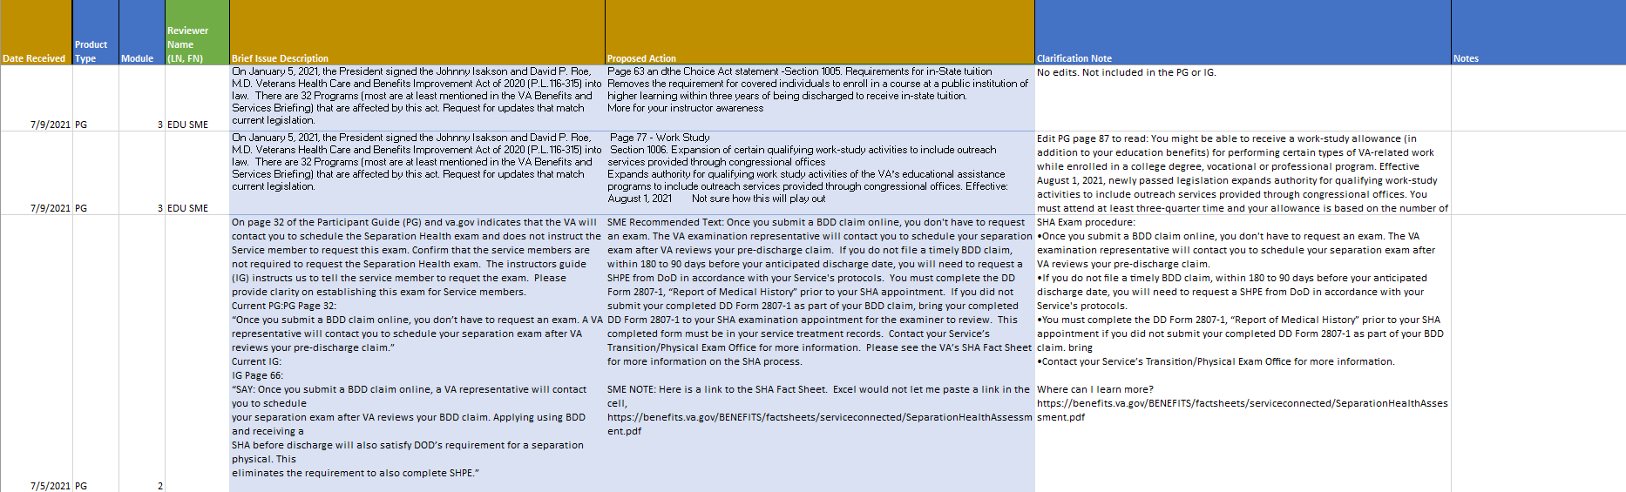


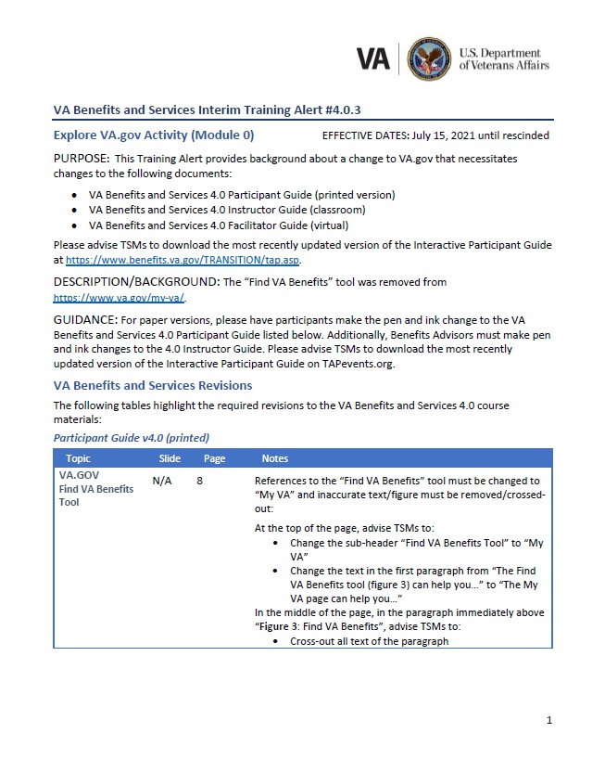
Appendix F: Sample Pen and Ink Communication – Field

VA Benefits and Services Program Alert #<Number> <Title>
EFFECTIVE DATE: <Month Day, Year> until rescinded
PURPOSE:
This Program Alert provides background about a change to <name of issue> that necessitates changes to the following documents:
- <Document list>
Please advise TSMs to download the most recently updated version of the Interactive Participant Guide at https://www.benefits.va.gov/TRANSITION/tap.asp.

DESCRIPTION/BACKGROUND:
<Description Text>
For paper versions, please have participants make the pen and ink changes to the VA Benefits and Services 4.0 Participant Guide as listed below. Additionally, Benefits Advisors must make pen and ink changes to the 4.0 Instructor Guide and/or Facilitator Guide. Please advise TMSs to download the most recently updated version of the Interactive Participant Guide onTapevents.mil.

VA Benefits and Services Revisions
The following tables highlight the required revisions to the VA Benefits and Services 4.0 course materials:

Participant Guide v4.0 (printed)
Topic | Slide | Page | Notes
<Text> | <Slide> | <Page> | <Text>  - <Bullets>
<Text> | <Slide> | <Page> | <Text>  - <Bullets>

Instructor Guide v4.0 (classroom)
Topic | Slide | Page | Notes
<Text> <Slide> <Page> <Text>
- <Bullets>
<Text> | <Slide> | <Page> | <Text>  - <Bullets>
Facilitator Guide v4.0 (virtual)
Topic Slide Page Notes
<Text> | <Slide> | <Page> | <Text>  - <Bullets>

ADDITIONAL GUIDANCE:
If you have any questions about this Program Alert, please
email VATAPTraining@vatap.calibresys.com. This guidance is posted on VA TAP MOST
> Documents for future reference. This Program Alert may not be further distributed without express permission from VA TAP leadership.

Appendix G: Curriculum Quality Assurance Checklist
QA Site Visit Step-by-Step: A checklist used by QA Specialists to prepare for a site visit.
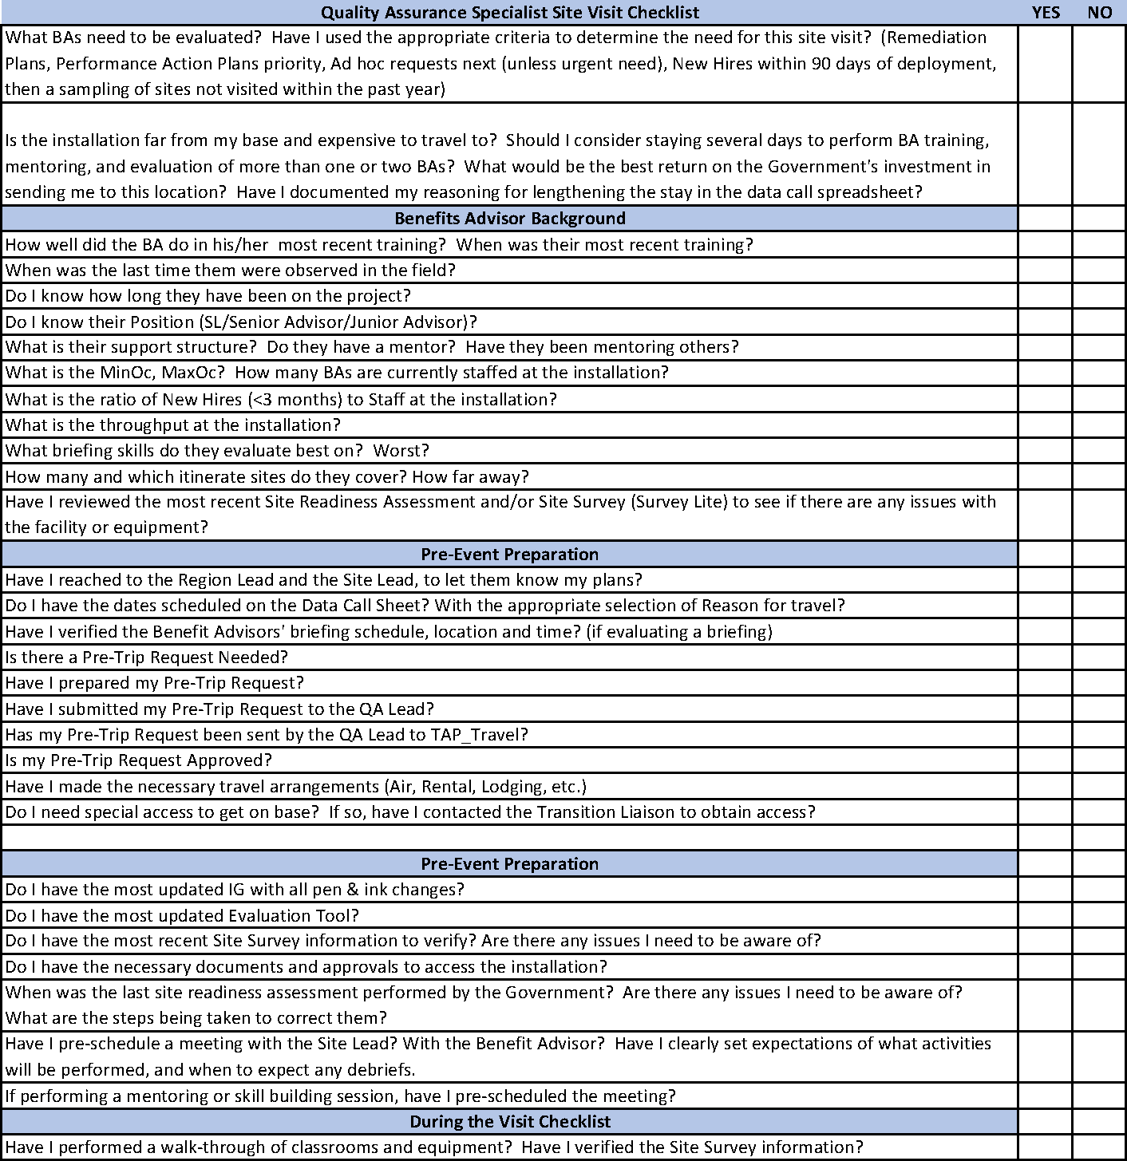

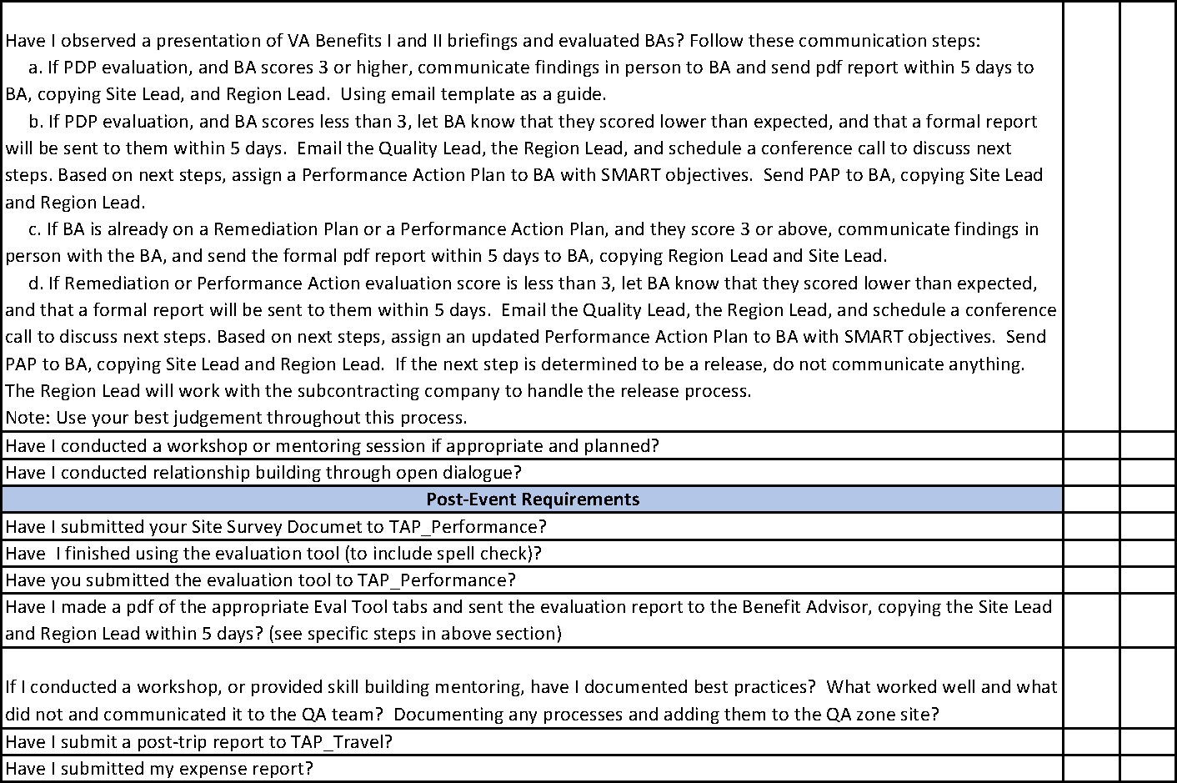

Appendix H: 508 Review Checklist

Indicator or Task | Confirmed | Date | Reviewer | Notes | Helpful Resources
FILE NAME & TYPE
File name is descriptive and ends in .docx format
No macros or forms are used
STYLES, TAGS, TEXT
Document language is set to English
All text is formatted accurately with Styles |  |  |  | For example, an existing PG Word document will already have all the Styles for bullets, colorful text, figure names, etc. This is CRITICAL for publishing an accessible PDF with appropriate tags. If not using a template or existing document, set up the appropriate styles in the Home ribbon, particularly for heading levels, numbered lists, bulleted lists, bold (strong) text, color/highlighting. You may also need to setup the Style Separator to use two (2) styles on the same row (each a heading with a date in normal text next to it. | Setting Up and Using Style Separator in Word: https://www.youtu be.com/watch?v=g OVTET-_dDM
Logical reading order is achieved with tags/Styles |  |  |  | The hierarchy makes sense amongst heading levels

Indicator or Task | Confirmed | Date | Reviewer | Notes | Helpful Resources
All headings created with Styles (Heading 1, 2, 3) and no changes to text formatting is completed outside of modifying styles |  |  |  | For example, you cannot use "B" to make text Bold, you must highlight and use the "Strong" style - this ensures that a different tone is used with screen readers, such as JAWS, when applicable. Bold (I, U, etc.) is not recognized by assistive technology.
All lists (bullet, numbered) created with Styles (Numbered List, etc.) and no changes to text formatting is completed outside of modifying styles |  |  |  | For numbered lists, each numbered list will need to be its own Style to prevent continuation of numbering across sections.
Approved Fonts from the VA Style Guide are used exclusively
Correct Unicode characters are used |  |  |  | dashes, hyphens, minus sign, and other math/science symbols
Unnecessary hard returns and double spaces are removed |  |  |  | Under home, select "show/hide paragraph" button to reveal markups for review
Hyphens |  |  |  | Ensure no double hyphens are used, convert them to en and em dashes, as required.
Table of Contents for longer documents
Columns must be created using the column feature NOT tabs

Indicator or Task | Confirmed | Date | Reviewer | Notes | Helpful Resources
Lists created using the Bullet feature
COLOR
High contrast of 4.5:1 is achieved for all text |  |  |  | Colors can be tested with WebAIM or CCA (all Curriculum Team Members should have CCA downloaded per the onboarding checklist)
Large size text (14p Bold/18 pt. regular) contrast ratio greater or  equal to 3:1 |  |  |  | Incidental text, overlayed in images of logotype is excluded from the requirement
VA Style Guide color codes are used for all graphics and texts
TABLES
Table caption is provided |  |  |  | A brief, but descriptive caption should be provided.
Simple Table |  |  |  | Simple table is used to support layout or format images. Simple tables may or may not be visible to learners and do NOT need row or column headers.
Reading order matches visual
Table is placed in line |  |  |  | Right click on the table. Select "Table Properties." "None" should be selected  under "Text Wrapping."
Color Coding |  |  |  | Each cell must have text to distinguish it. Cannot only use color coding
Simple Data Table |  |  |  | Simple data table have only one header row, should not have merged cells.

Indicator or Task | Confirmed | Date | Reviewer | Notes | Helpful Resources
Original table NOT picture of a table is used |  |  |  | Mark as NA if not a simple table
Header row is identified |  |  |  | Highlight the header row. Click "Layout" in the ribbon. Ensure that "Repeat Header Row" (far right) is selected for only the header row.
Table is placed in line |  |  |  | Right click to confirm in-line status
No blank rows or columns
No Merged Cells
Complex Data Table |  |  |  | To understand you need information from the column and row header.  Multilevel headings or merged/split cells cannot be made accessible in MS Word.
Merged cells are appropriate for all columns below them |  |  |  | With merged cells, they are read at the start of each column they are over.  Word indicates merged cells are not compliant, this is not necessarily the case. AT should read the merged cell then each column below it fine.
LINKS
Links need unique and descriptive names |  |  |  | It should be clear to the individual what will happen when the link is clicked (i.e., where will the context change take them). | Making accessible links: https://www.sitepoi nt.com/15-rules- making-  accessible-links/
Remove all unintended context changes |  |  |  | Rare in word, there should be no formatting where a context change (go to a new page, website, etc.) happens

Indicator or Task | Confirmed | Date | Reviewer | Notes | Helpful Resources
 |  |  |  | without the individual initiation (intentionally click with mouse or use keyboard controls).
OBJECTS
Alternative Text (alt- text) is provided for each graphic, photo, illustration |  |  |  | Alt text should be descriptive for images that are necessary for learning. Logos, decorative images or graphics do not need descriptive alt-text, instead write "  " in the alt-text description.
Decorative objects are marked |  |  |  | Select edit Alt Text (right click object). Once in dialogue box/panel, select the "Mark as decorative" box.
Avoid Color-Only Meaning |  |  |  | Ensure that text, icons, and other objects do not exclusively use color to convey meaning. For example, if color key is used in a bar graph, there must be a secondary way to interpret the graph, such as text labels or pattern with color.
Anchor Graphics
Text Box |  |  |  | Must be "in Line" with text
PLAIN LANGUAGE REQUIREMENTS
Text is edited for plain language |  |  |  |  | https://www.plainla nguage.gov/guideli  nes/audience/
Grammarly Check |  |  |  | Run at least 25% of the document through Grammarly to confirm reading level. Aim is 6th-8th grade; however, given the technical terms 10th grade may be permissible. At times the  terminology will increase the reading | https://www.nih.go v/institutes-nih/nih- office- director/office- communications-  public-

Indicator or Task | Confirmed | Date | Reviewer | Notes | Helpful Resources
 |  |  |  | level because it appears technical to Grammarly (e.g., Home Long Guaranty (HLG), etc.). If the reading level is college level, it may need to go to an editor for global review. | liaison/clear- communication/pla in-language/plain- language-getting- started-or- brushing
OTHER
Add document properties and  metadata |  |  |  | Author, Title,
Set file language |  |  |  | File > Options > Language
Accessibility Checker |  |  |  | Review > Check Accessibility Click "Keep accessibility checker  running while I work" to be continuously notified of issues. | https://support.mic rosoft.com/en- us/office/improve- accessibility-with- the-accessibility- checker-a16f6de0- 2f39-4a2b-8bd8- 5ad801426c7f#pic ktab=windows
embedded files need to also be checked for accessibility |  |  |  | transcripts, captioning, etc.
Basic MS Word Testing Guides |  |  |  |  | https://www.sectio n508.gov/create/d  ocuments
End

