Supporting Documentation for TCA Low to Medium Volume Project.
The layout below will be the area that will already be cleared out for new equipment. The new TCA will be in the area marked in Blue, which is approximately 2,500 square feet.

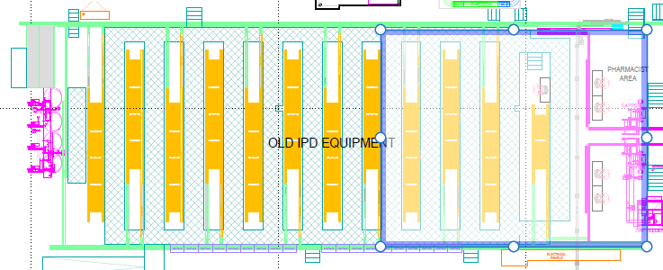

- TCA Low to Medium Mover Information
  - Example Layout of new TCA Area for reference. This area is depicted above
  - The drawing and or layout should include Storage areas and replenishment Carts
  - There should also be vertical secure storage included in the design.
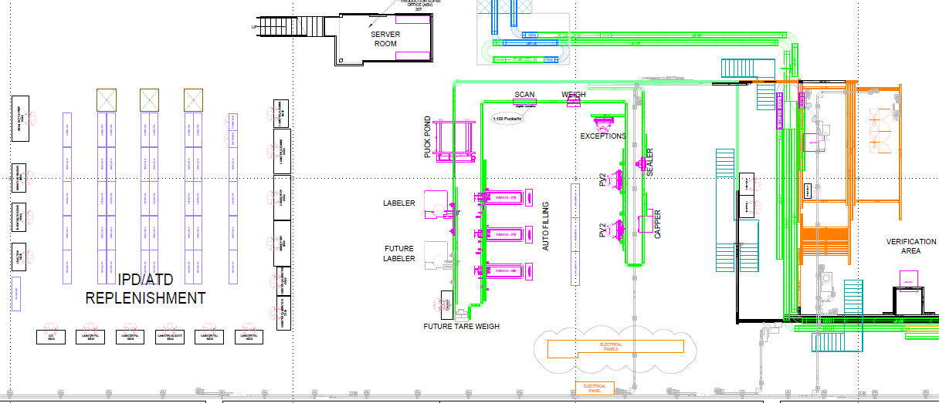
Current Loop, De pucker, and sortation area.
The current operational events are below
Pucks will enter the loops from current TCA from spirals at each loop. These pucks will then loop around and be pushed into the exit conveyor to travel to the current sorting table. From the sorting table they will travel to the current de pucking robot and be placed in totes. Current manipulator holds two vials at a time. Multiple vials can be transferred to a tote as needed.
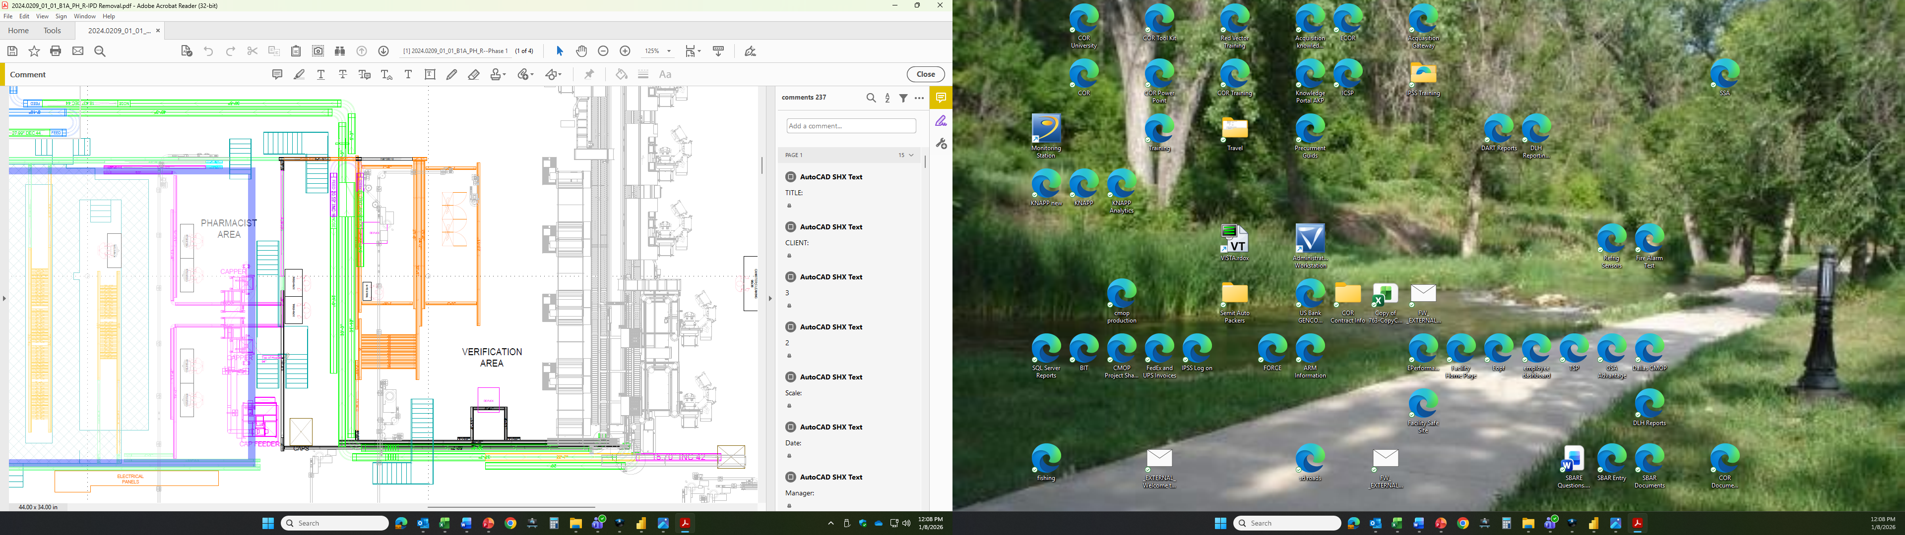
New Loop Sortation area will be in the same location as the existing equipment. Means of sorting and combining mates of multiple vial orders, and de pucking into totes would be designed by the awarded contractor. Proof of concept and tentative design drawings will need to be included in bidding documentation.

Operational tasks shall include the following
- Means to de puck multiple and single vials into totes
- Sortation of multi-vial orders to de pucker and puck packing stations
- Must be able to divert vials to puck packing stations or de pucker
- Software must track all vials through the loops, sorter, and de pucker for audit trail reports. Example reports are included in this document, under Subsection d. Audit Trail Example, for reference.
- In the case of out of sequence errors, there must be a way to reject pucks in order to eliminate mis matched or mixed orders. Ability to allow Pucks to bypass the removal if there is a scanning, verification, and or quality problem
- Error rates for this event shall be under 1% of total throughput.

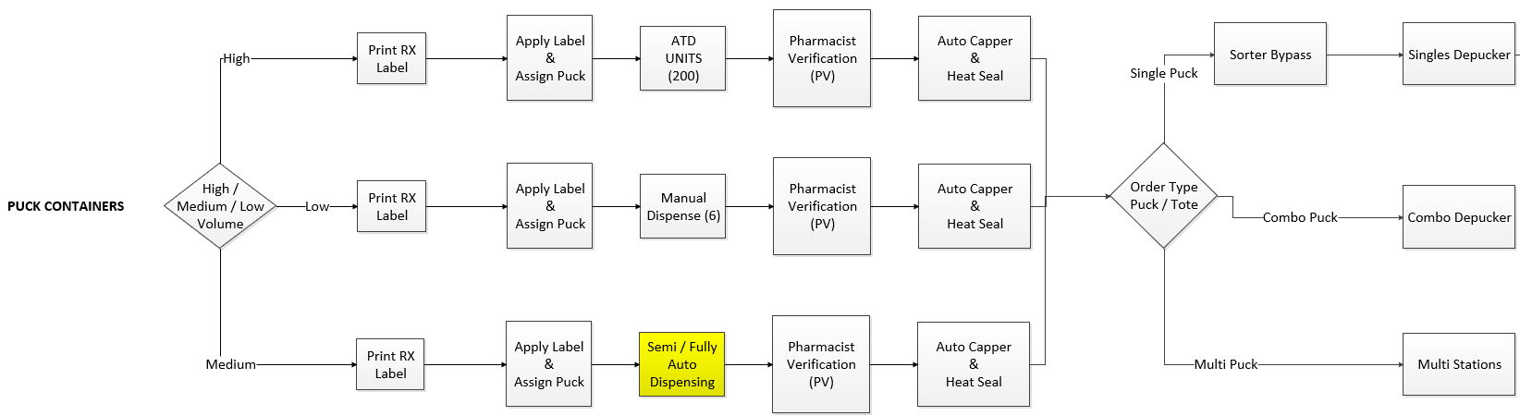
Operational Flow Chart

Current Process Flow and Operations for Single Vial Orders

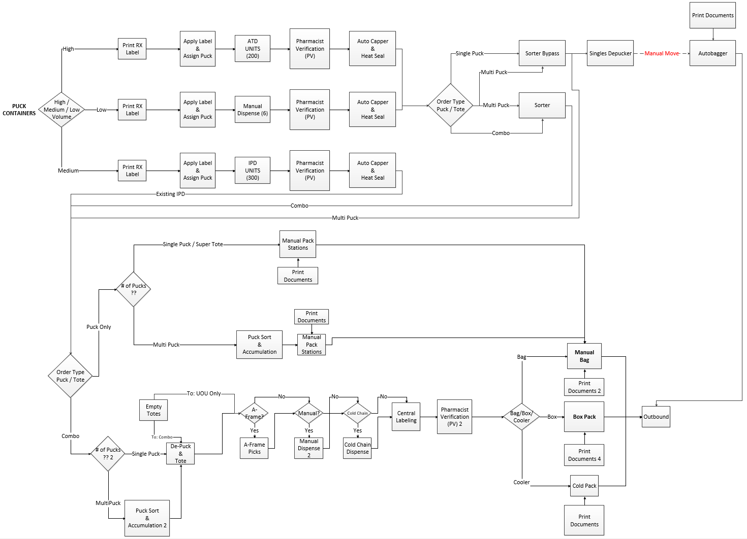

  - Audit Trail Example

OperationEvents(LongTerm) by OrderNumber: 580-134708-57
Event Date Time | Operator ID | Event Text | Station Name
1/13/2025 1:19:12 AM | Allocator | Backordered <580-134708-57:406773> | VHACMDMULAPP1 | Allocation of order events
1/13/2025 1:19:12 AM | Allocator | Backordered <580-134708-57:406774A> | VHACMDMULAPP1
1/13/2025 1:19:13 AM | Allocator | Splitting out Rx <406773> from <580-134708-57;01> | VHACMDMULAPP1
1/13/2025 1:19:13 AM | Allocator | Splitting out Rx <406774A> from <580-134708-57;01> | VHACMDMULAPP1
1/13/2025 1:19:13 AM | Allocator | Allocated order split <580-134708-57;01> | VHACMDMULAPP1
1/13/2025 5:30:29 PM | Allocator | Backordered <580-134708-57:406774A> | VHACMDMULAPP1
1/13/2025 5:30:29 PM | Allocator | Splitting out Rx <406774A> from <580-134708-57;02> | VHACMDMULAPP1
1/13/2025 5:30:29 PM | Allocator | Allocated order split <580-134708-57;02> | VHACMDMULAPP1
1/14/2025 10:34:56 PM | Allocator | Backordered <580-134708-57:406774A> | VHACMDMULAPP1
1/14/2025 10:34:56 PM | Allocator | Backordered <580-134708-57> for the first time | VHACMDMULAPP1
1/15/2025 2:41:55 PM | Allocator | Allocated order split <580-134708-57;03> | VHACMDMULAPP1
1/16/2025 7:54:03 AM | IPD | Script complete for <580-134708-57;0103> Rx <416555> | VHACMDMULAPP1 | IPD/ATD filling events
1/16/2025 7:54:03 AM | IPD | Order split <580-134708-57;01> complete | VHACMDMULAPP1
1/16/2025 7:54:03 AM | IPD | Received Pick Complete event for order 580-134708-57;0103011; Rx#416555 | VHACMDMULAPP1
1/16/2025 7:58:57 AM | vhacmdlechun | Puck [1785] scanned at PV2. Order [#580-134708-57;01030111]. | VHACMDKNAPPATD | ATD Pharmacist verification events
1/16/2025 7:58:59 AM | vhacmdlechun | Pharmacist verified vial [#580-134708-57;01030111] at PV2 | VHACMDKNAPPATD
1/16/2025 9:37:22 AM | vhacmdweslev | Label <#580-134708-57;01030111> has been scanned at Packing. | CMD-WSPACKIN13 | ATD Order packing events
1/16/2025 9:37:22 AM | vhacmdweslev | Assigning Package to Order <580-134708-57;1> | CMD-WSPACKIN13
1/16/2025 9:37:23 AM | vhacmdweslev | Packing Documents Printed for Order <580-134708-57;1> | CMD-WSPACKIN13
1/16/2025 9:37:34 AM | vhacmdweslev | Label <E580-134708-57> has been scanned at Packing. | CMD-WSPACKIN13
1/16/2025 9:37:35 AM | vhacmdweslev | Label <B580-134708-57> has been scanned at Packing. | CMD-WSPACKIN13
1/16/2025 9:37:35 AM | vhacmdweslev | Printing Packing Label for Order <580-134708-57;1>. | CMD-WSPACKIN13
1/16/2025 9:37:46 AM | vhacmdweslev | Accepting PackageID <007630000580GJ005800013470800000570000101007756800> for Order <580-134708-57;1> | CMD-WSPACKIN13
1/16/2025 9:37:46 AM | vhacmdweslev | Order Detail 580-134708-57;0103 Packed. | CMD-WSPACKIN13
1/16/2025 9:37:46 AM | vhacmdweslev | Packing Order 580-134708-57;01 Complete. | CMD-WSPACKIN13
1/22/2025 11:45:53 AM | vhacmddobbic | Reallocated order <580-134708-57;03> | CMD-WSDOBBIC | Reallocation events
1/22/2025 12:27:33 PM | Allocator | Allocated order split <580-134708-57;03> | VHACMDMULAPP1
1/22/2025 12:27:33 PM | 2010 | Lot Number Removed <GPC241077A> replaced with <> | Server
1/23/2025 8:10:50 AM | IPD | Received Pick Complete event for order 580-134708-57;0302061; Rx#406774A | VHACMDMULAPP1 | IPD/ATD filling events
1/23/2025 8:10:51 AM | IPD | Received Pick Complete event for order 580-134708-57;0302031; Rx#406774A | VHACMDMULAPP1
1/23/2025 8:10:52 AM | IPD | Received Pick Complete event for order 580-134708-57;0302041; Rx#406774A | VHACMDMULAPP1
1/23/2025 8:11:03 AM | IPD | Received Pick Complete event for order 580-134708-57;0302011; Rx#406774A | VHACMDMULAPP1
1/23/2025 8:11:04 AM | IPD | Received Pick Complete event for order 580-134708-57;0302051; Rx#406774A | VHACMDMULAPP1
1/23/2025 8:11:05 AM | IPD | Script complete for <580-134708-57;0302> Rx <406774A> | VHACMDMULAPP1
1/23/2025 8:11:05 AM | IPD | Order split <580-134708-57;03> complete | VHACMDMULAPP1
1/23/2025 8:11:05 AM | IPD | Received Pick Complete event for order 580-134708-57;0302021; Rx#406774A | VHACMDMULAPP1
1/23/2025 8:20:39 AM | vhacmdparke | Puck [1046] scanned at PV2. Order [#580-134708-57;03020321]. | VHACMDKNAPPATD | ATD Pharmacist verification events for each vial in order
1/23/2025 8:20:40 AM | vhacmdparke | Pharmacist verified vial [#580-134708-57;03020321] at PV2 | VHACMDKNAPPATD
1/23/2025 8:21:22 AM | vhacmdnguyer | Puck [2084] scanned at PV2. Order [#580-134708-57;03020621]. | VHACMDKNAPPATD | ATD Pharmacist verification events for each vial in order
1/23/2025 8:21:24 AM | vhacmdnguyer | Pharmacist verified vial [#580-134708-57;03020621] at PV2 | VHACMDKNAPPATD
1/23/2025 8:25:23 AM | vhacmdlechun | Puck [2174] scanned at PV2. Order [#580-134708-57;03020121]. | VHACMDKNAPPATD | ATD Pharmacist verification events for each vial in order
1/23/2025 8:25:25 AM | vhacmdlechun | Pharmacist verified vial [#580-134708-57;03020121] at PV2 | VHACMDKNAPPATD
1/23/2025 8:28:29 AM | vhacmdlechun | Puck [1999] scanned at PV2. Order [#580-134708-57;03020421]. | VHACMDKNAPPATD | ATD Pharmacist verification events for each vial in order
1/23/2025 8:28:34 AM | vhacmdlechun | Pharmacist verified vial [#580-134708-57;03020421] at PV2 | VHACMDKNAPPATD
1/23/2025 8:48:54 AM | vhacmdsamuer | Puck [1718] scanned at PV2. Order [#580-134708-57;03020521]. | VHACMDKNAPPATD | ATD Pharmacist verification events for each vial in order
1/23/2025 8:49:01 AM | vhacmdsamuer | Pharmacist verified vial [#580-134708-57;03020521] at PV2 | VHACMDKNAPPATD
1/23/2025 8:57:03 AM | vhacmdmoorej1 | Puck [1211] scanned at PV2. Order [#580-134708-57;03020221]. | VHACMDKNAPPATD | ATD Pharmacist verification events for each vial in order
1/23/2025 8:57:17 AM | vhacmdmoorej1 | Pharmacist verified vial [#580-134708-57;03020221] at PV2 | VHACMDKNAPPATD
1/23/2025 9:06:49 AM | HandleToteUpdat | Order <580-134708-57;03>, married to ToteID <5118> | VHACMDMULAPP1
1/23/2025 9:09:28 AM | VHACMDNguyeR | Starting order split <580-134708-57;03> | CMD-WSVERIN03
1/23/2025 9:09:42 AM | VHACMDNguyeR | Script rejected for <580-134708-57;0302> Rx <406774A> for <PHARMACIST-FAILURE (QA REVIEW REQUIRED)> | CMD-WSVERIN03 | Pharmacist verification events with order rejection reason
1/23/2025 10:45:09 AM | vhacmdsamuer | Starting order split <580-134708-57;03> | CMD-WSVERIN02 | Pharmacist verification events with no rejection
1/23/2025 10:45:19 AM | vhacmdsamuer | Rx Label Scanned <#580-134708-57;03020421> | CMD-WSVERIN02
1/23/2025 10:45:27 AM | vhacmdsamuer | Rx Label Scanned <#580-134708-57;03020621> | CMD-WSVERIN02
1/23/2025 10:45:32 AM | vhacmdsamuer | Rx Label Scanned <#580-134708-57;03020121> | CMD-WSVERIN02
1/23/2025 10:45:40 AM | vhacmdsamuer | Rx Label Scanned <#580-134708-57;03020321> | CMD-WSVERIN02
1/23/2025 10:45:47 AM | vhacmdsamuer | Rx Label Scanned <#580-134708-57;03020521> | CMD-WSVERIN02
1/23/2025 10:45:54 AM | vhacmdsamuer | Script complete for <580-134708-57;0302> Rx <406774A> | CMD-WSVERIN02
1/23/2025 10:45:54 AM | vhacmdsamuer | Rx verification complete for <580-134708-57;0302> | CMD-WSVERIN02
1/23/2025 10:45:54 AM | vhacmdsamuer | Order split <580-134708-57;03> verified | CMD-WSVERIN02
1/23/2025 10:49:02 AM | vhacmdmoodyd | Label <#580-134708-57;03020321> has been scanned at Packing. | CMD-WSPACKIN08 | Order packing events
1/23/2025 10:49:02 AM | vhacmdmoodyd | Assigning Package to Order <580-134708-57;3> | CMD-WSPACKIN08
1/23/2025 10:49:02 AM | vhacmdmoodyd | Packing Documents Printed for Order <580-134708-57;3> | CMD-WSPACKIN08
1/23/2025 10:49:10 AM | vhacmdmoodyd | Label <#580-134708-57;03020421> has been scanned at Packing. | CMD-WSPACKIN08
1/23/2025 10:49:10 AM | vhacmdmoodyd | Label <#580-134708-57;03020421> has been scanned at Packing. | CMD-WSPACKIN08
1/23/2025 10:49:12 AM | vhacmdmoodyd | Label <#580-134708-57;03020521> has been scanned at Packing. | CMD-WSPACKIN08
1/23/2025 10:49:12 AM | vhacmdmoodyd | Label <#580-134708-57;03020521> has been scanned at Packing. | CMD-WSPACKIN08
1/23/2025 10:49:16 AM | vhacmdmoodyd | Label <#580-134708-57;03020621> has been scanned at Packing. | CMD-WSPACKIN08
1/23/2025 10:49:16 AM | vhacmdmoodyd | Label <#580-134708-57;03020621> has been scanned at Packing. | CMD-WSPACKIN08
1/23/2025 10:49:18 AM | vhacmdmoodyd | Label <#580-134708-57;03020121> has been scanned at Packing. | CMD-WSPACKIN08
1/23/2025 10:49:18 AM | vhacmdmoodyd | Label <#580-134708-57;03020121> has been scanned at Packing. | CMD-WSPACKIN08
1/23/2025 10:49:21 AM | vhacmdmoodyd | Label <#580-134708-57;03020221> has been scanned at Packing. | CMD-WSPACKIN08
1/23/2025 10:49:21 AM | vhacmdmoodyd | Label <#580-134708-57;03020221> has been scanned at Packing. | CMD-WSPACKIN08
1/23/2025 10:49:27 AM | vhacmdmoodyd | Label <E580-134708-57> has been scanned at Packing. | CMD-WSPACKIN08
1/23/2025 10:49:30 AM | vhacmdmoodyd | Label <B580-134708-57> has been scanned at Packing. | CMD-WSPACKIN08
1/23/2025 10:49:31 AM | vhacmdmoodyd | Printing Packing Label for Order <580-134708-57;3>. | CMD-WSPACKIN08
1/23/2025 10:49:49 AM | vhacmdmoodyd | Accepting PackageID <007630000580GJ005800013470800000570000301007756800> for Order <580-134708-57;3> | CMD-WSPACKIN08
1/23/2025 10:49:49 AM | vhacmdmoodyd | Order Detail 580-134708-57;0302 Packed. | CMD-WSPACKIN08
1/23/2025 10:49:49 AM | vhacmdmoodyd | Packing Order 580-134708-57;03 Complete. | CMD-WSPACKIN08
1/23/2025 6:15:20 PM | AM Release | Released automarry order split <580-134708-57;02>. | VHACMDTOTECTRL | Non-IPD/ATD order filling/labeling events
1/23/2025 6:18:21 PM | HandleToteUpdat | Order <580-134708-57;02>, married to ToteID <5010> | VHACMDMULAPP1
1/23/2025 6:26:51 PM | VHACMDLewisT1 | Starting order split <580-134708-57;02> | CMD-WSLABIN04
1/23/2025 6:26:51 PM | VHACMDLewisT1 | Starting script <580-134708-57;0201> | CMD-WSLABIN04
1/23/2025 6:26:52 PM | VHACMDLewisT1 | NDC Scanned <5140781830> | CMD-WSLABIN04
1/23/2025 6:26:53 PM | VHACMDLewisT1 | NDC <51407081830> Scan accepted for order <580-134708-57> | CMD-WSLABIN04
1/23/2025 6:26:57 PM | VHACMDLewisT1 | Rx Label Scanned <#580-134708-57;02010111> | CMD-WSLABIN04
1/23/2025 6:26:57 PM | VHACMDLewisT1 | Script complete for <580-134708-57;0201> Rx <406773> | CMD-WSLABIN04
1/23/2025 6:26:57 PM | VHACMDLewisT1 | RX <580-134708-57> accepted by Check Scan | CMD-WSLABIN04
1/23/2025 6:26:58 PM | VHACMDLewisT1 | NDC Scanned <5140781830> | CMD-WSLABIN04
1/23/2025 6:26:59 PM | VHACMDLewisT1 | NDC <51407081830> Scan accepted for order <580-134708-57> | CMD-WSLABIN04
1/23/2025 6:27:02 PM | VHACMDLewisT1 | Rx Label Scanned <#580-134708-57;02010211> | CMD-WSLABIN04
1/23/2025 6:27:02 PM | VHACMDLewisT1 | Script complete for <580-134708-57;0201> Rx <406773> | CMD-WSLABIN04
1/23/2025 6:27:02 PM | VHACMDLewisT1 | RX <580-134708-57> accepted by Check Scan | CMD-WSLABIN04
1/23/2025 6:27:04 PM | VHACMDLewisT1 | NDC Scanned <5140781830> | CMD-WSLABIN04
1/23/2025 6:27:04 PM | VHACMDLewisT1 | NDC <51407081830> Scan accepted for order <580-134708-57> | CMD-WSLABIN04
1/23/2025 6:27:08 PM | VHACMDLewisT1 | Rx Label Scanned <#580-134708-57;02010311> | CMD-WSLABIN04
1/23/2025 6:27:08 PM | VHACMDLewisT1 | Script complete for <580-134708-57;0201> Rx <406773> | CMD-WSLABIN04
1/23/2025 6:27:08 PM | VHACMDLewisT1 | RX <580-134708-57> accepted by Check Scan | CMD-WSLABIN04
1/23/2025 6:27:09 PM | VHACMDLewisT1 | NDC Scanned <5140781830> | CMD-WSLABIN04
1/23/2025 6:27:10 PM | VHACMDLewisT1 | NDC <51407081830> Scan accepted for order <580-134708-57> | CMD-WSLABIN04
1/23/2025 6:27:13 PM | VHACMDLewisT1 | Rx Label Scanned <#580-134708-57;02010411> | CMD-WSLABIN04
1/23/2025 6:27:13 PM | VHACMDLewisT1 | Script complete for <580-134708-57;0201> Rx <406773> | CMD-WSLABIN04
1/23/2025 6:27:13 PM | VHACMDLewisT1 | Order split <580-134708-57;02> complete | CMD-WSLABIN04
1/23/2025 6:27:13 PM | VHACMDLewisT1 | RX <580-134708-57> accepted by Check Scan | CMD-WSLABIN04
1/23/2025 6:27:51 PM | vhacmdchenje | Starting order split <580-134708-57;02> | CMD-WSVEROUT01 | Non- IPD/ATD Pharmacist verification events
1/23/2025 6:27:53 PM | vhacmdchenje | Rx Label Scanned <#580-134708-57;02010411> | CMD-WSVEROUT01
1/23/2025 6:27:54 PM | vhacmdchenje | Rx Label Scanned <#580-134708-57;02010211> | CMD-WSVEROUT01
1/23/2025 6:27:55 PM | vhacmdchenje | Rx Label Scanned <#580-134708-57;02010111> | CMD-WSVEROUT01
1/23/2025 6:27:55 PM | vhacmdchenje | Rx verification complete for <580-134708-57;0201> | CMD-WSVEROUT01
1/23/2025 6:27:56 PM | vhacmdchenje | Order split <580-134708-57;02> verified | CMD-WSVEROUT01
1/23/2025 6:28:47 PM | VHACMDBlowC | PIL <C:/Temp/QPakStation\580-134708-57_02_5__HD_05.pdf> printed | CMD-WSSAPIN01 | Order packing events
1/23/2025 6:29:42 PM | VHACMDBlowC | PHI Displayed on QPak Main window | CMD-WSSAPIN01
1/23/2025 6:29:44 PM | VHACMDBlowC | [Bag Scanner] scanned [007630000580GJ005800013470800000570000201007756800] | CMD-WSSAPIN01
1/23/2025 6:29:44 PM | VHACMDBlowC | [Bag Scanner] Valid bag scanned <007630000580GJ005800013470800000570000201007756800> <580-134708-57> | CMD-WSSAPIN01
1/23/2025 6:29:46 PM | VHACMDBlowC | [Operator] has scanned [E580-134708-57] | CMD-WSSAPIN01
1/23/2025 6:29:46 PM | VHACMDBlowC | A valid document scanned at operator scanner <E580-134708-57> <580-134708-57> Bin [1-5] | CMD-WSSAPIN01
1/23/2025 6:29:46 PM | VHACMDBlowC | Scanned Packing document E580-134708-57 | CMD-WSSAPIN01
1/23/2025 6:29:46 PM | VHACMDBlowC | [Operator] has scanned [B580-134708-57] | CMD-WSSAPIN01
1/23/2025 6:29:47 PM | VHACMDBlowC | A valid document scanned at operator scanner <B580-134708-57> <580-134708-57> Bin [1-5] | CMD-WSSAPIN01
1/23/2025 6:29:47 PM | VHACMDBlowC | Scanned Packing document B580-134708-57 | CMD-WSSAPIN01
1/23/2025 6:29:51 PM | VHACMDBlowC | [Queue Entrance] scanned [5162] | CMD-WSSAPIN01
1/23/2025 6:29:51 PM | VHACMDBlowC | [Operator] has scanned [#580-134708-57;02010111] | CMD-WSSAPIN01
1/23/2025 6:29:51 PM | VHACMDBlowC | Operator scanned <#580-134708-57;02010111> Bin [1-5] | CMD-WSSAPIN01
1/23/2025 6:29:53 PM | VHACMDBlowC | [Operator] has scanned [#580-134708-57;02010411] | CMD-WSSAPIN01
1/23/2025 6:29:53 PM | VHACMDBlowC | Operator scanned <#580-134708-57;02010411> Bin [1-5] | CMD-WSSAPIN01
1/23/2025 6:29:56 PM | VHACMDBlowC | [Operator] has scanned [#580-134708-57;02010211] | CMD-WSSAPIN01
1/23/2025 6:29:57 PM | VHACMDBlowC | Operator scanned <#580-134708-57;02010211> Bin [1-5] | CMD-WSSAPIN01
1/23/2025 6:29:57 PM | VHACMDBlowC | [Queue Entrance] scanned [5272] | CMD-WSSAPIN01
1/23/2025 6:29:58 PM | VHACMDBlowC | [Operator] has scanned [#580-134708-57;02010311] | CMD-WSSAPIN01
1/23/2025 6:29:58 PM | VHACMDBlowC | Operator scanned <#580-134708-57;02010311> Bin [1-5] | CMD-WSSAPIN01
1/23/2025 6:30:01 PM | VHACMDBlowC | Order Detail <580-134708-57;0201> Packed. | CMD-WSSAPIN01
1/23/2025 6:30:01 PM | VHACMDBlowC | Order Detail <580-134708-57;0201> Packed. | CMD-WSSAPIN01
1/23/2025 6:30:01 PM | VHACMDBlowC | Packing Order 580-134708-57;02 Complete. | CMD-WSSAPIN01
1/23/2025 6:30:01 PM | VHACMDBlowC | Packing Order 580-134708-57;02 Complete. | CMD-WSSAPIN01

  - Expected equipment to CMOP POS and Back to TCA Messages.

NOTE: CMOP has no prior information as to what equipment will be installed and the capabilities there in. This may have some impact on audit trail messages that are specifically for the new equipment.
- Orders.
  - From legacy system.
    - New order. OrderNumber and OrderSplitNumber constitute a unique identifier. If a duplicate OrderNumber/OrderSplitNumber is sent, it should overwrite the existing record.
      - OrderNumber.
      - OrderSplitNumber.
      - OrderPriority.
      - OrderReceivedDate. Orders must be processed in priority order. Orders with the same priority must be processed in received-date order, ascending.
      - Order type/routing information.
      - OrderDetails. An order may contain multiple order details – i.e., prescriptions.
        - Vial barcode. The vial barcode identifies the OrderNumber, OrderSplitNumber, OrderDetailNumber, and Vial Number.
        - Dispense location. The legacy system identifies locations by unit number and cell number. Messages passed to the TCA system can use these identifiers, or a different numbering system specified by the vendor.
        - Min weight.
        - Max weight.
        - NDC.
        - Quantity.
        - Long SIG needed.
        - RX Number.
        - RX Date.
        - SIG Notes.
    - Change order priority.
      - OrderNumber.
      - OrderSplitNumber.
      - OrderPriority.
    - Cancel/delete order.
      - OrderNumber.
      - OrderSplitNumber.
- Order progress messages.
  - To legacy system.
    - Print request. Printing is controlled by the legacy system. No PHI/PII is ever transmitted to the TCA system.
      - OrderNumber.
      - Vial barcode.
      - Printer ID. Or printer exclusion list.
    - Vial started.
      - OrderNumber.
      - Vial barcode.
      - Puck ID.
      - Dispense location.
      - Station name.
    - Vial married to puck.
      - OrderNumber.
      - Vial barcode.
      - Puck ID.
    - Vial pre-fill weight.
      - OrderNumber.
      - Vial barcode.
      - Puck ID.
      - Pre-fill weight.
    - Vial dispensed.
      - OrderNumber.
      - Vial barcode.
      - Puck ID.
      - Dispense location.
      - NDC.
      - Quantity requested.
      - Quantity dispensed.
    - Vial post-fill weight.
      - OrderNumber.
      - Vial barcode.
      - Puck ID.
      - Post-fill weight.
    - Vial restarted.
      - OrderNumber.
      - Vial barcode.
      - Puck ID.
    - Vial cancelled.
      - OrderNumber.
      - Vial barcode.
      - Puck ID.
      - Dispense location.
    - Vial unfilled. Includes timeouts.
      - OrderNumber.
      - Vial barcode.
      - Puck ID.
    - Vial routed to exceptions station.
      - OrderNumber.
      - Vial barcode.
      - Puck ID.
      - Dispense location.
      - Station name.
      - Reason.
    - Vial complete.
      - OrderNumber.
      - Vial barcode.
      - Puck ID.
      - Dispense location.
- Canister refills.
  - From legacy system.
    - Refill request.
      - Request ID.
      - Canister location.
      - NDC.
      - Number of canisters.
      - Quantity.
      - Available lots.
    - Refill request cancel.
      - Request ID.
  - To legacy system.
    - Return message with status/results.
      - Request ID.
      - Completion status.
      - Fill Operator ID.
      - Tech check Operator ID.
      - NDC.
      - Quantity requested.
      - Canisters.
        - Canister ID.
        - Tamper seal barcode.
        - Lots.
          - Lot number.
          - Quantity.
- Dispenser replenishment.
  - From legacy system.
    - Replenishment request.
      - Request ID.
      - Dispense location.
      - Canister ID.
      - Tamper seal barcode.
      - NDC.
    - Replenishment request cancel.
      - Request ID.
  - To legacy system.
    - Return message with status/results.
      - Request ID.
      - Completion status.
      - Operator ID.
      - Dispense location.
      - Canister ID.
      - Tamper seal barcode.
- Inventory.
  - From legacy system.
    - Product assignment.
      - Dispense location.
      - NDC.
      - Description.
    - Product removal.
      - Dispense location.
- Audit trail.
  - To legacy system.
    - General.
      - User logged on to verification station.
        - Operator ID.
        - Station name.
      - User logged off of verification station.
        - Operator ID.
        - Station name.
      - User logged on to canister replenishment station.
        - Operator ID.
        - Station name.
      - User logged off of canister replenishment station.
        - Operator ID.
        - Station name.
      - User logged on to exceptions station.
        - Operator ID.
        - Station name.
      - User logged off of exceptions station.
        - Operator ID.
        - Station name.
      - User logged on to manual fill station.
        - Operator ID.
        - Station name.
      - User logged off of manual fill station.
        - Operator ID.
        - Station name.
      - User logged on to dispenser replenishment station.
        - Operator ID.
        - Station name.
      - User logged off of dispenser replenishment station.
        - Operator ID.
        - Station name.
    - Pharmacist verification.
      - Puck scanned at verification station.
        - Operator ID.
        - Station name.
        - OrderNumber.
        - Vial barcode.
        - Puck ID.
      - Pharmacist verified prescription.
        - Operator ID.
        - Station name.
        - OrderNumber.
        - Vial barcode.
        - Puck ID.
      - Pharmacist rejected prescription.
        - Operator ID.
        - Station name.
        - OrderNumber.
        - Vial barcode.
        - Puck ID.
        - Rejection reason. List of rejection reasons must be configurable – i.e., can be changed by the customer at any time, without software modifications.
    - Canister refill.
      - Operator started canister refill.
        - Operator ID.
        - Station name.
        - Request ID.
        - Canister location.
      - Operator scanned canister barcode.
        - Operator ID.
        - Station name.
        - Request ID.
        - Canister location.
        - Canister ID.
      - Operator scanned manufacturer barcode at canister refill.
        - Operator ID.
        - Station name.
        - Request ID.
        - Canister location.
        - Canister ID.
        - NDC/GTIN.
        - Lot.
        - Expiration date.
        - Serial number.
      - Operator scanned tamper seal.
        - Operator ID.
        - Station name.
        - Request ID.
        - Canister location.
        - Canister ID.
        - Tamper seal barcode.
      - Operator scanned an invalid barcode.
        - Operator ID.
        - Station name.
        - Request ID.
        - Barcode scanned.
      - Scanned manufacturer barcode has invalid expiration date.
        - Operator ID.
        - Station name.
        - Request ID.
        - Canister location.
        - NDC/GTIN.
        - Lot.
        - Expiration date.
        - Serial number.
      - Operator completed canister refill.
        - Operator ID.
        - Station name.
        - Request ID.
        - Canister location.
      - Tech check.
        - Operator ID.
        - Station name.
        - Request ID.
        - Canister location.
    - Dispenser replenishment.
      - Operator started dispenser replenishment.
        - Operator ID.
        - Dispense location.
        - Request ID.
      - Operator scanned dispenser barcode.
        - Operator ID.
        - Dispense location.
        - Request ID.
        - Dispenser ID.
      - Operator scanned canister barcode.
        - Operator ID.
        - Dispense location.
        - Request ID.
        - Canister ID.
      - Operator scanned tamper seal.
        - Operator ID.
        - Dispense location.
        - Request ID.
        - Tamper seal barcode.
      - Operator scanned an invalid barcode.
        - Operator ID.
        - Dispense location.
        - Request ID.
        - Barcode scanned.
      - Operator completed dispenser replenishment.
        - Operator ID.
        - Dispense location.
        - Request ID.
    - Exceptions.
      - Puck released from exceptions station with no changes.
        - Operator ID.
        - Station name.
        - OrderNumber.
        - Vial barcode.
        - Puck ID.
      - Repick additional pills.
        - Operator ID.
        - Station name.
        - OrderNumber.
        - Vial barcode.
        - Puck ID.
        - Quantity requested.
        - Quantity picked.
        - Additional quantity to pick.
      - Cross-check failure.
        - Operator ID.
        - Station name.
        - OrderNumber.
        - Puck ID.
        - Expected vial barcode.
        - Scanned vial barcode.
      - Weight error.
        - Operator ID.
        - Station name.
        - OrderNumber.
        - Vial barcode.
        - Puck ID.
        - Min weight.
        - Max weight.
        - Measured weight.
        - NDC.
        - Dispense location.
      - Printed long SIG.
        - Operator ID.
        - Station name.
        - OrderNumber.
        - Original Vial barcode.
        - Updated Vial barcode. The barcode printed should be slightly different, because the label instance increments.
        - Puck ID.
      - Foreign object in vial.
        - Operator ID.
        - Station name.
        - OrderNumber.
        - Vial barcode.
        - Puck ID.
        - Dispense location.
      - Incorrect pills.
        - Operator ID.
        - Station name.
        - OrderNumber.
        - Vial barcode.
        - Puck ID.
        - Dispense location.
      - Broken pills.
        - Operator ID.
        - Station name.
        - OrderNumber.
        - Vial barcode.
        - Puck ID.
        - Dispense location.
      - Excess pills.
        - Operator ID.
        - Station name.
        - OrderNumber.
        - Vial barcode.
        - Puck ID.
        - Quantity requested.
        - Quantity picked.
        - Quantity removed.
      - Reprinted label.
        - Operator ID.
        - Station name.
        - OrderNumber.
        - Original Vial barcode.
        - Updated Vial barcode. The barcode printed should be slightly different, because the label instance increments.
        - Puck ID.
      - Insufficient inventory.
        - Operator ID.
        - Station name.
        - OrderNumber.
        - Vial barcode.
        - Puck ID.
        - Dispense location.
        - Quantity requested.

  - An example of the Pharmacist Verification station screen

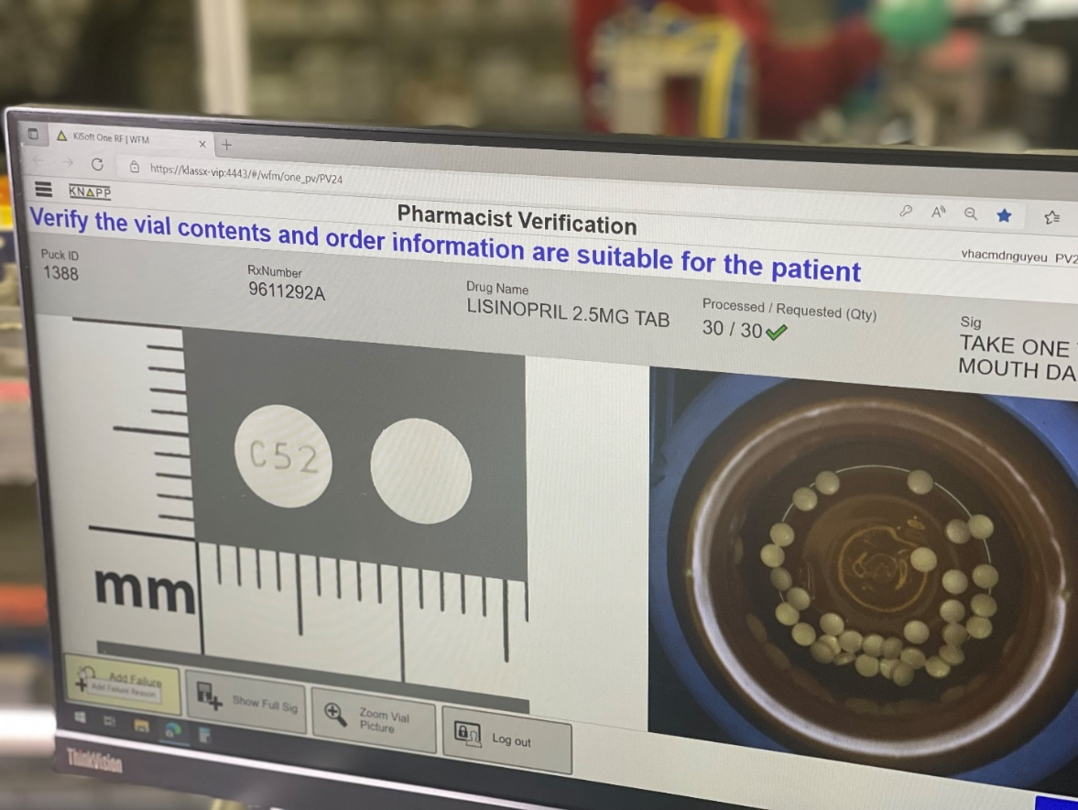

  - An example of the Exception Station screen

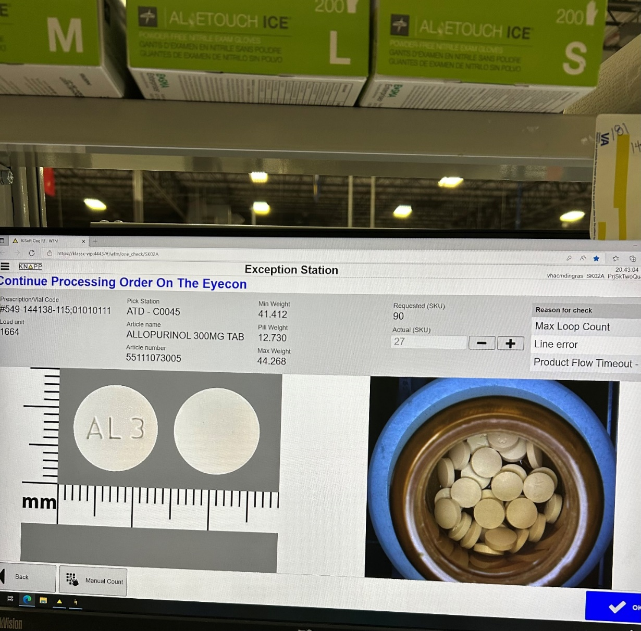

  - Example of the Eyecon screen at Exceptions

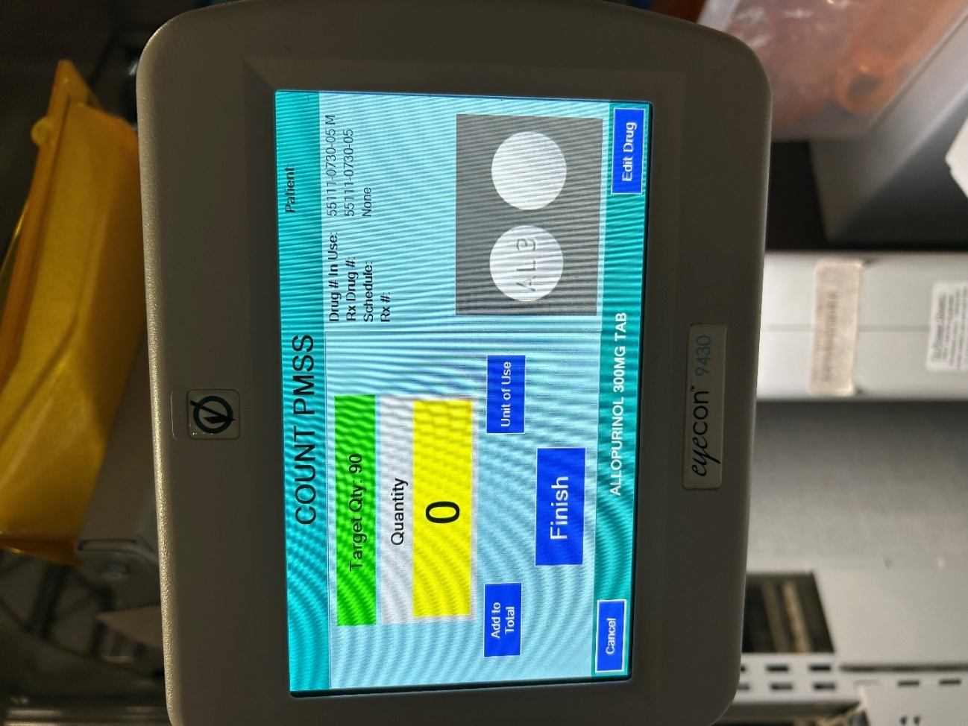

  - Example of Current Dispenser Replenishment Procedures
Technicians – 2 or 3 Technicians are assigned to the Mezzanine daily, depending upon staff availability. The 12 banks will be split equally among the working Technicians.
Each Technician is responsible daily for:

- Replenishing dispensers
- Rotating canisters
- Cleaning the photo eyes and dispensers as needed
- Vacuuming tablet spills on the mezzanine and under the banks
- Retrieving and unloading the full cart
- Observes and reports abnormalities with the pucks along the conveyors

Replenishment – Required replenishment for the banks appear on the handhelds. To replenish, first highlight the cell to be replenished. Place the canister on top of the cell so that it makes the connection. Then scan the Technician’s barcode, the barcode on the cell, and lastly the barcode on the seal of the canister. The handheld then prompts the canister to be dumped. The handheld will then prompt the Technician that the replenishment is complete.

Occasionally an error appears on the handheld when scanning the barcode on the seal. If this occurs, the Technician will remove the canister from the cell and bring it to the Verifying Technician in the IPD room. The Verifying Technician will scan the canister and determine if any manual adjustments are required to resolve the error.

Any technical problems with the handhelds should be brought to the attention of the Supervisor/Lead Technician /Maintenance Technician immediately.

Rotation - Rotation must be performed at least twice before the canister cart is brought out every hour. There are two ways of rotating the canisters. Technicians will implement one of the following choices that will work best for them:

- Rotate canisters as they are taken out of the assigned slot for replenishment
- Stop replenishing every 30 minutes to rotate the stock of the banks, which you are assigned.

Observance – All Technicians will be observant in the following areas:
An abundance of spilled tablets underneath a cell should be reported to the Lead Technician or Maintenance Technician, as this is probably a mechanical problem.

Loose bottles and/or pucks should be brought to the problem station to be reviewed.
Bottles coming out of a cell empty could be either a funnel jam or other mechanical problems and should be reported to the Lead Technician or Maintenance Technician.

Hardware – Handheld devices will be placed on chargers during all breaks, lunches, and at the end of shift. The handheld devices will be operated only for business use and are not to be played with or misused in any way.
Any discrepancies found with canisters are to be given to the VA Lead/VA Supervisor ONLY.

  - REPLENISHMENT STATION
    - Replenishment stations must be included for the canister’s refills for the TCA equipment. Number is contingent on throughput and number of NDCs. 350 dispensers for approximately 350 unique NDCs
    - The replenishment system must provide a unique physical identifier for each canister and supply a mechanism to assign and track status for each canister. A description of our procedure has been addressed in this document.
    - The replenishment system shall require electronic certification of filled cannister to include the generation of the unique identifier which includes NDC, Lot, Expiration date, quantity, date time of the fill, and operator name.
    - The replenishment system shall provide an accurate mechanism to verify the count quantity of items placed in canisters.
    - After canister is filled, a supervisor will inspect and accept the cannister. All these procedures are screen driven on a computer.
    - The software must provide a failsafe mechanism to identify, track, and utilize any product NDC designated for return to stock product transferred to stock or dispenser location, or wasted, as indicated. Include NDC, lot code, expiration date and associated cost data, and provide reporting tools. A system of barcode scans and other checks shall guide the operators throughout the process.
    - The system shall require an independent NDC scan of each commercial bottle prior to transferring it into the cannister. the system will retain all 2D bare code data from the commercial bottle to comply with DSCSA requirements. The system shall be able to read serialized commercial information to ensure that each bottle scanned replenishment is unique to prevent operators scanning one bottle multiple times.
    - the cannister shall be sealed in a tamper evident manner, electronically tracked, and can only be introduced to the correct dispensing device.
    - Example Canister Fill SOP procedure is below.

  - Example of our current Canister Fill Procedures
Certified Pharmacy Technicians process and fill canisters for replenishment of dispensers on the mezzanine. The technicians are responsible for selecting the correct location, scanning the correct number of bottles, and selecting the correct lot numbers required for replenishment.

Log on to the system:

Insert PIV card in designated slot
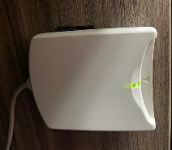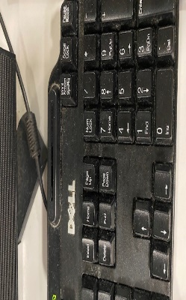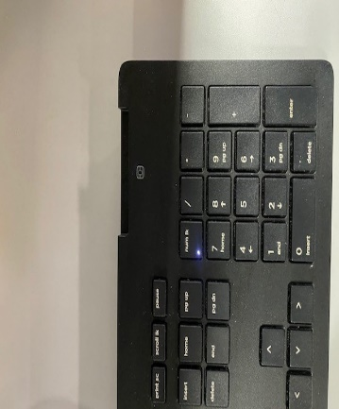
External Card Reader Card Reader Card Reader

- Ctrl+Alt+Delete (to unlock workstation)
- Enter pin code and hit enter
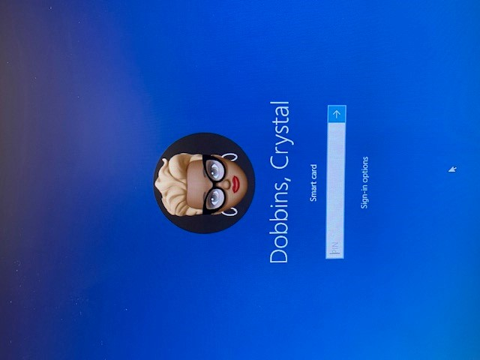
JANE DOE
If user does not have a PIV card:
Enter Username
Press tab key and enter password then click on “Verify AD”

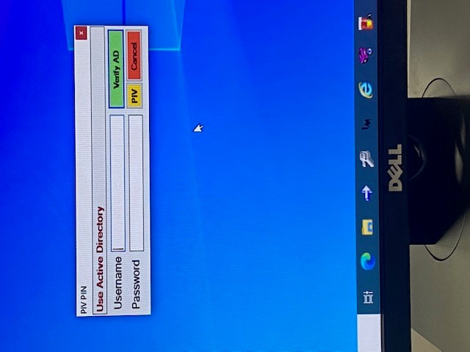

Applications Needed for Canister Replenishment:

Canister Replenishment (allows replenishment technician to view location list)
Canister Maintenance (allows replenishment technician remove previously assigned canister information)

Double Click Each Application Icon
Enter User ID and Password or PIV Card to access application
Log In Screen

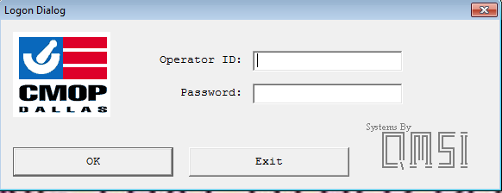

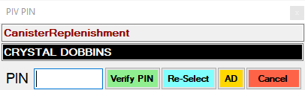
JANE DOE

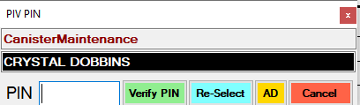
JANE DOE

Click on the Canister Maintenance Icon  to view the application screen

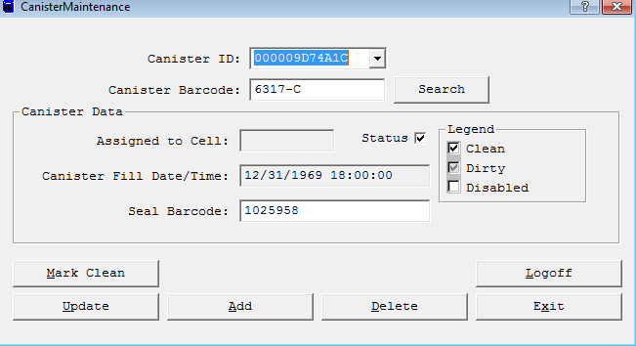

- Scan the canister barcode 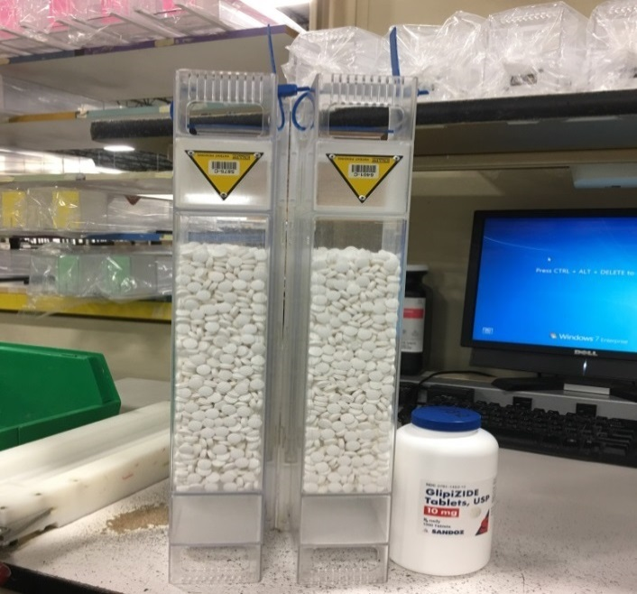 ***DO NOT manually enter canister barcode***

- Click “Mark Clean”


Mark Clean

- Click “OK”

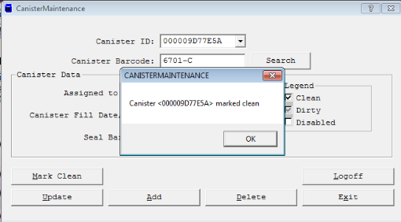
OK

Loose Pill(s) Canisters That Contain Drug Residue

Lodged Tablet Lodged Tablet (2) Lodged Capsule

- After determining the canister is free from loose pills, drug residue or lodged pills; place canister on port (see canister image(s) below)

***If it is determined that a canister has not been properly cleaned, return canister to the canister cleaning area***

Keep workstation clean, neat, always organized and clutter free. Keeping workstations organized will help to minimize accidental scans (-i.e., wrong NDC scanned, miscellaneous barcode scans, etc.)

Single Canister:

- Remove product from replenishment basket and place on workstation. Product will be received in a box with location written on both ends of the box or individual bottle(s) with the location written on the cap (see examples below)

Location Written on Front Of Box Location Written On Cap
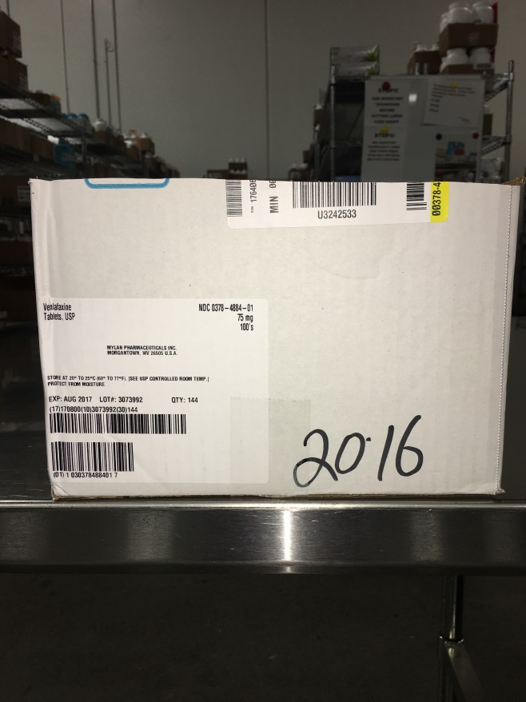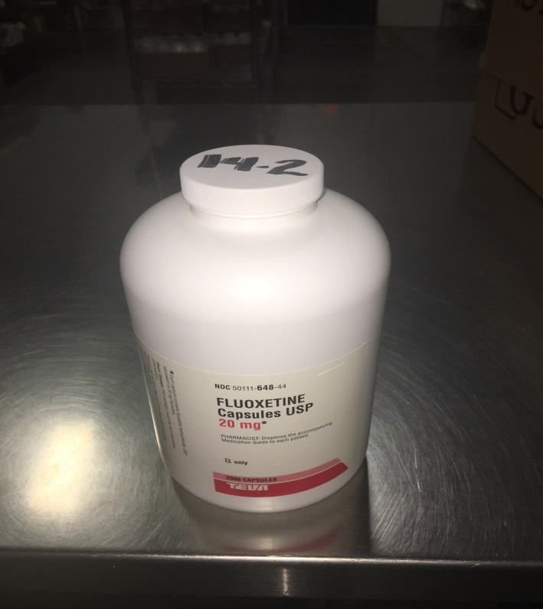

- BEFORE selecting location on replenishment list, check the Caution Canister List to determine if drug selected requires a Caution Canister. (see image of caution canisters above)

If a caution or warfarin canister is required for replenishment, retrieve canister from designated location (see area diagram for canister location)

After determining if a caution or warfarin canister is needed, proceed to step 2:

- Click the Canister Replenishment Icon  To View The Canister Replenishment Information Screen
- Highlight the location needed for replenishment from the Canister Replenishment List (see example below)

Canister Replenishment List
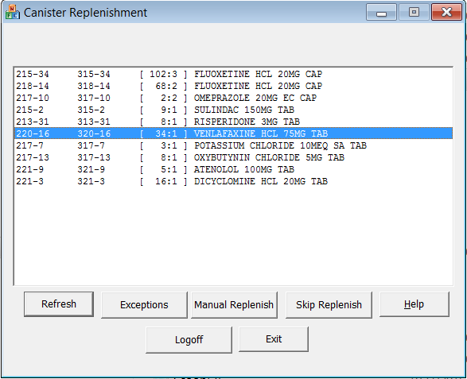

***Note the first number (220-16/320-16) of the highlighted location will not be written on the box/bottle***

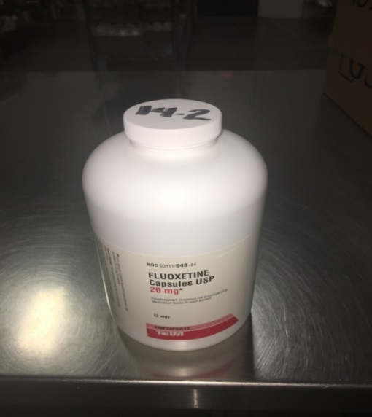

- If location is not on list, place product underneath basket
- Return to step 1 and continue process

- Scan CMOP Badge Barcode (Once badge is scanned it assigns the highlighted location to the canister on the port)

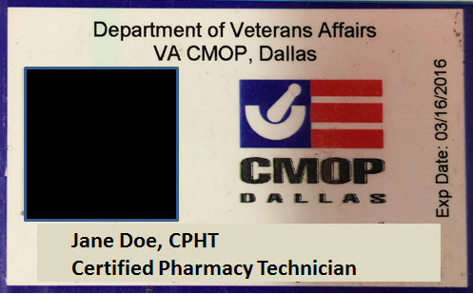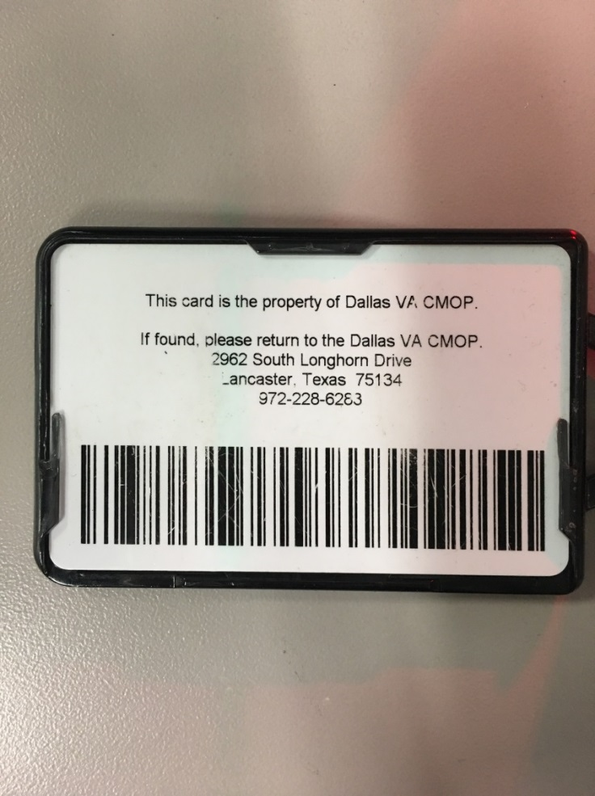

- If you select a location that does not match the location written on the box or the stock bottle retrieved from the replenishment basket, scan CMOP Badge to get out of the selected location.
- Check written location on the box/bottle then highlight the location that matches the location written on the box/bottle to the replenishment list and scan CMOP badge
- If selected location reads (0:0) bottle/canister (this indicates that the location is at canister capacity), notify the Verification Technician/Lead/Supervisor and they will determine the appropriate action to resolve the issue (see example below)

Canister Replenishment Screen (0:0)
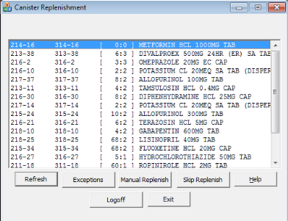
Skip Replenish
0:0

Do Not Use the “Skip Replenish” function. This function disables the replenishment function of a dispenser without the knowledge of the Lead/Supervisor. The “Skip” function is to ONLY be done by the Lead/Supervisor) (see image above)

Count the number of bottles given by Shopper to verify you have the correct amount required for replenishment. If the Shopper delivers an amount less than required for replenishment, the quantity will be annotated as follows: (see image below)

- Written quantity given on front of the box and circle

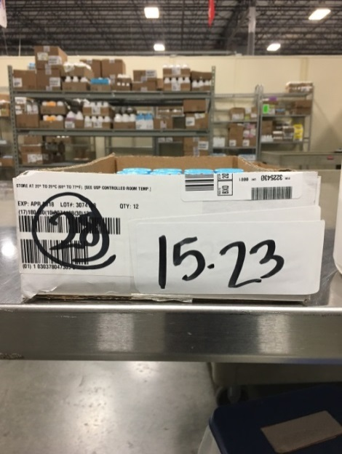
Quantity Given

- Written quantity given on a white label and attach it to the stock bottle

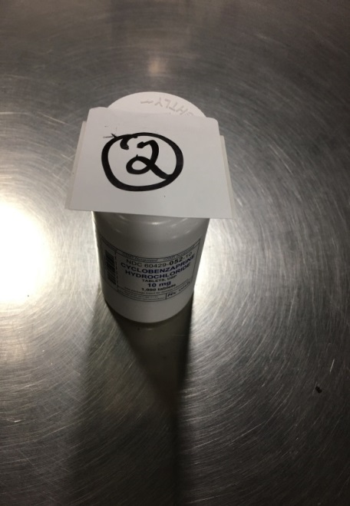
Quantity Given

- Written quantity given on cap of large bottles and circle (small bottles should be placed in a box)

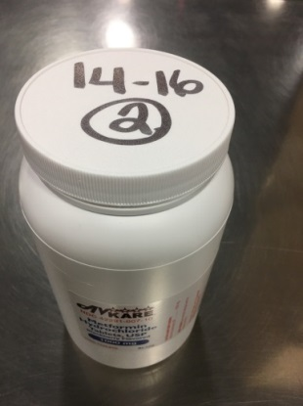
Quantity Given

- Write location on white label. (Location tags are created from blank white labels that cannot be used at the IPD Labelers)
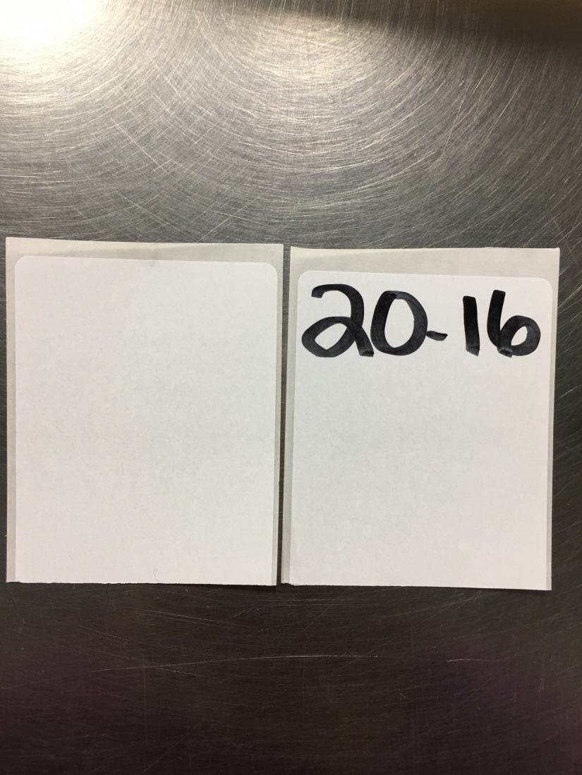
Blank White Label

- Once the Canister ID number appears, this indicates that the canister is registered and ready for replenishment
- Choose lot number that matches the stock bottle from the drop down menu
- If lot number does not appear in the drop-down box, scan CMOP Badge to exit location
- Notify the Verification Technician/Lead/Supervisor that lot number(s) are not in system and how many bottles were given of that lot number. The Verification Technician will notify the Lead/Supervisor via verbal or written communication. The Supervisor or Lead will add the missing lot number and quantity in the system. The lot number will appear in the drop-down box once added and updated in Inventory Maintenance

Canister Information Screen
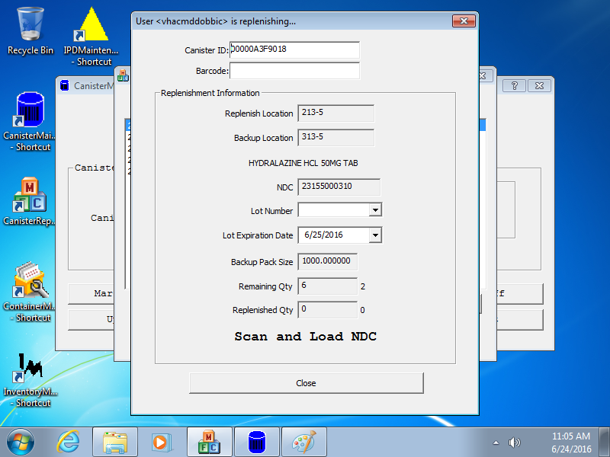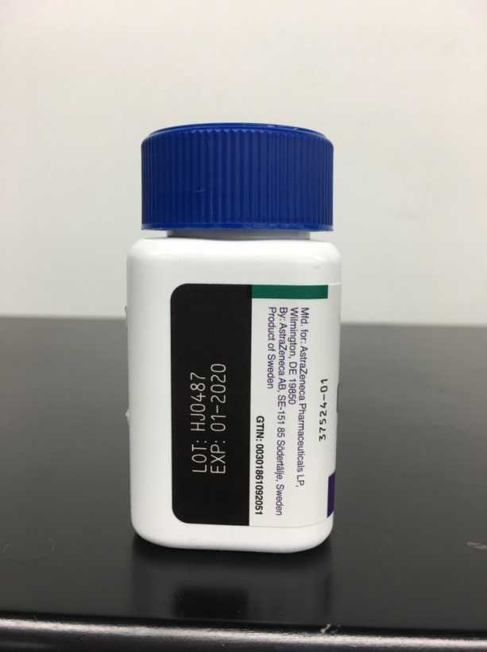
Required Number Of Bottles
Lot Number Drop Down Box
Number of Canisters Needed
Canister ID

- Open stock bottles and remove foil, cotton, desiccants, etc. (this can be done before scanning begins or during the scanning process)

Multiple lot numbers
- Only process one lot number at a time
- Once scanning is complete for one lot number, use the lot number drop down box to select additional lot number(s) required for replenishment
- This has to be done for each lot number associated with the location being processed

Before scanning begins, make sure volume on the speaker attached to the monitor is on and the volume is turned up. This is a safeguard to ensure that when the incorrect NDC is scanned an alert will sound indicating an error has occurred. ***DO NOT turn the speaker off or adjust the volume down*** Please note that random checks of the workstation will be done periodically to ensure all technicians are always utilizing this safeguard.

Begin Scanning:

- Scan EACH stock bottle during replenishment process ***DO NOT scan one bottle for multiple bottles needed*** Example: If replenishment requires 48 bottles, each individual bottle must be scanned. This process is a safeguard against the wrong drug being selected or cross contamination of products.

- When scanning small bottles, DO NOT scan more than THREE bottles before pouring medication in scoop.

- Pour contents of each stock bottle into medication scoop

***DO NOT TOUCH MEDICATION WITH BARE OR GLOVED HANDS***

- Use tweezers to remove any desiccants, cotton, foil cardboard or other foreign debris from the medication scoop BEFORE dumping medication into the canister.

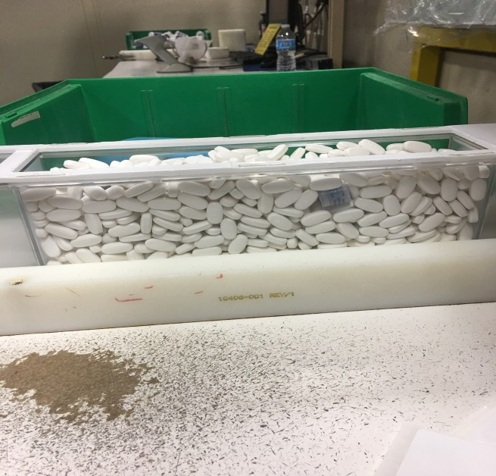 (Desiccant)

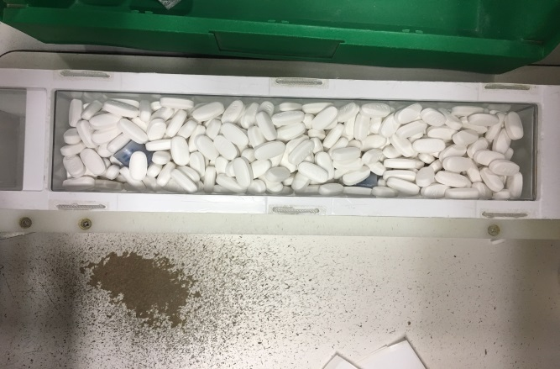 (Desiccant)

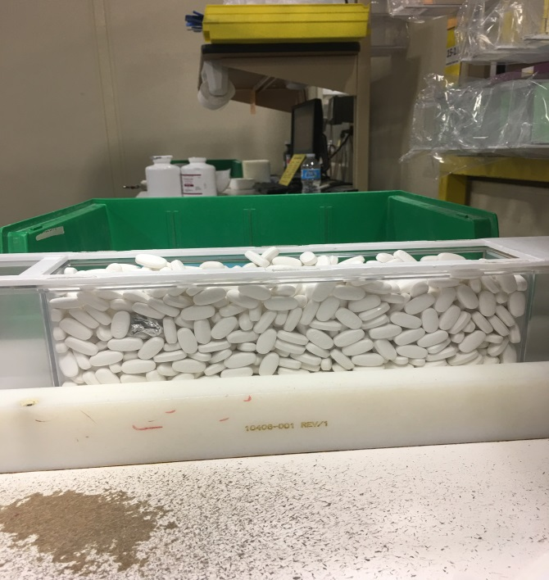 (Foil)

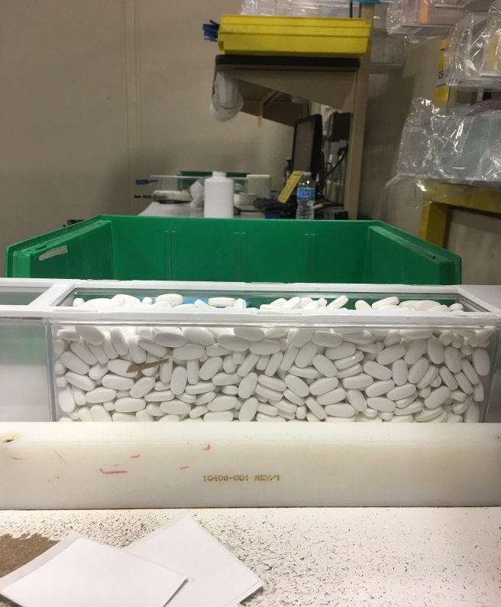 (Cardboard)

- Place empty stock bottle(s) in green bin located to the left of each workstation (This allows for easy retrieval of stock bottles during replenishment process if needed)

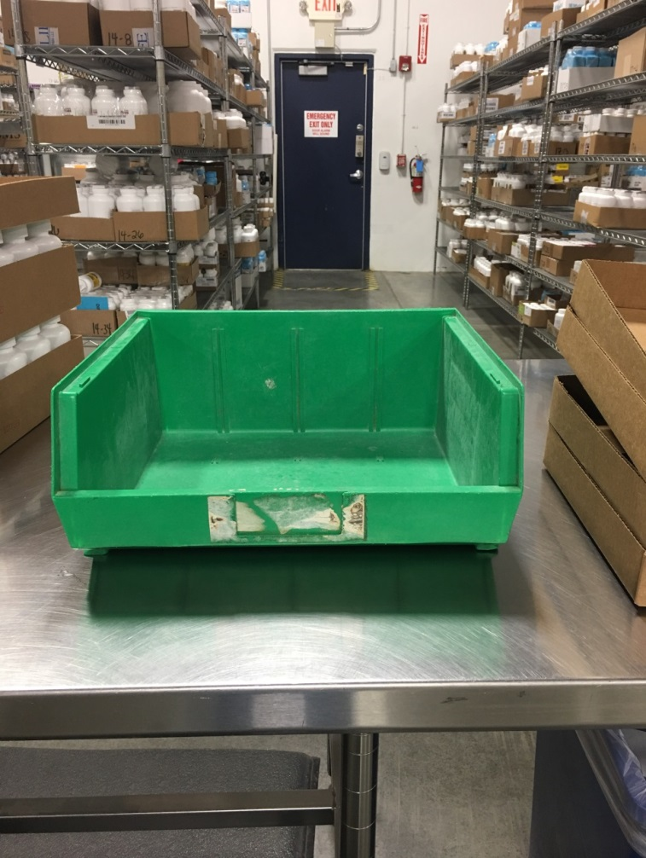

- Continue steps 5-11 until the message “canister replenishment complete” appears on screen

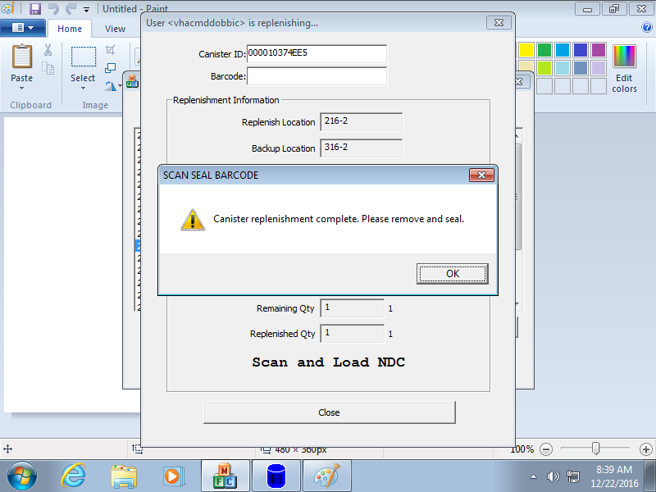
If station becomes locked, notify the Verification Technician/Lead/Supervisor to unlock workstation. Once workstation is unlocked, if bottle scanning is complete proceed to step 13. If bottle scanning was not complete, continue scanning until the message “canister replenishment complete” appears on screen (see image above)

System Locked
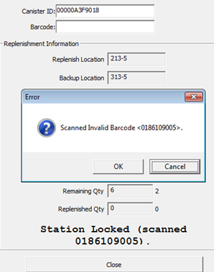

Once scanning is complete and the message “Canister replenishment complete. Please remove and seal” appears on screen

Click “OK”

Verify that you have scanned all stock bottles given for replenishment by the Shopper

Number of Bottles Scanned

The message “Scan Seal Barcode” will appear on screen

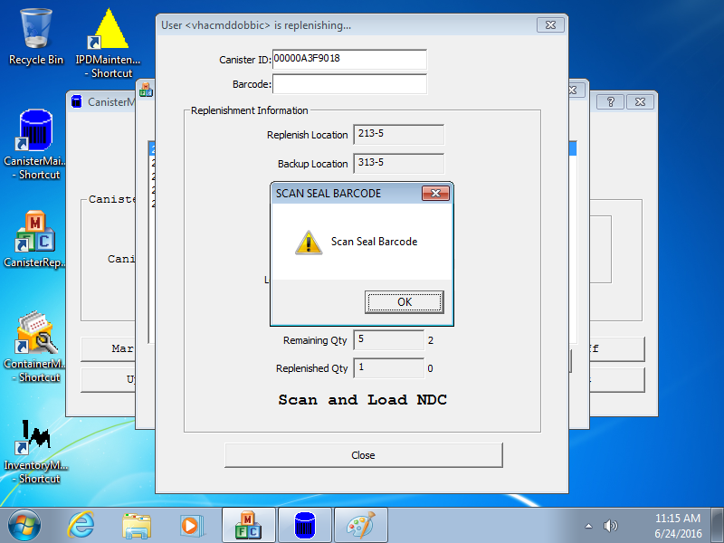

Click “OK”
- Scan the seal barcode 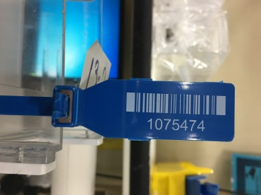
- Place seal between openings of the front of the canister with barcode facing away from replenishment technician

Canister Opening Seal Thru Opening Seal In Front Of Lid
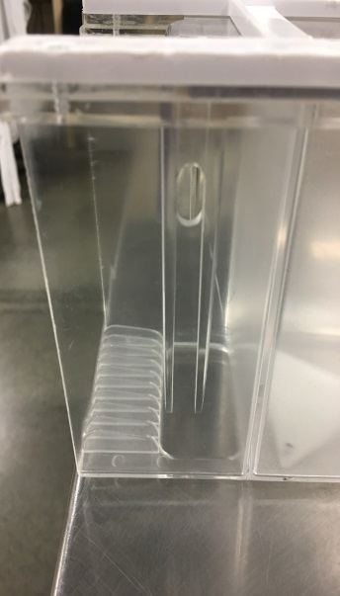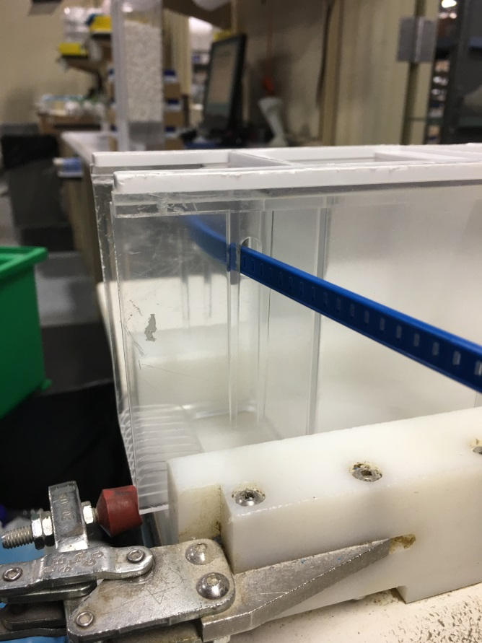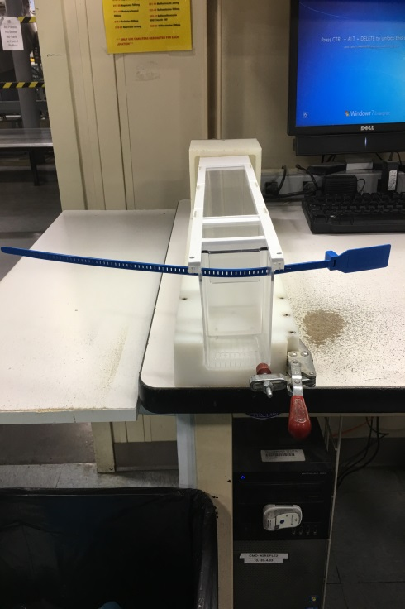

- Then feed stem of barcode through the back of seal until it appears in the front of seal

Back of Seal Front of Seal
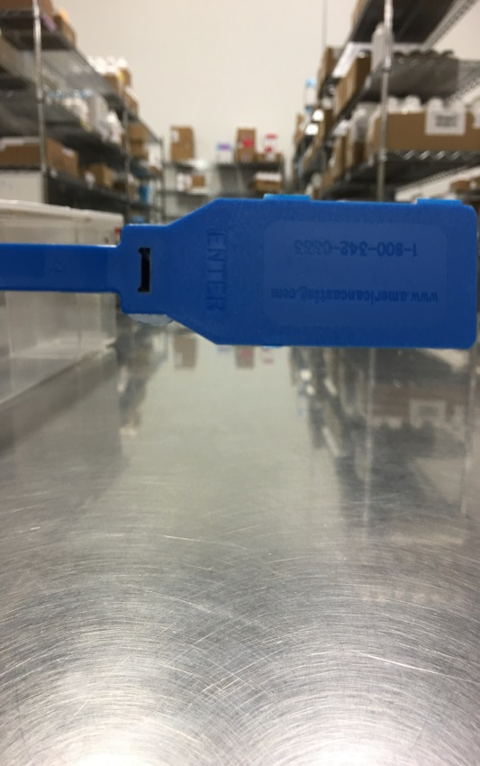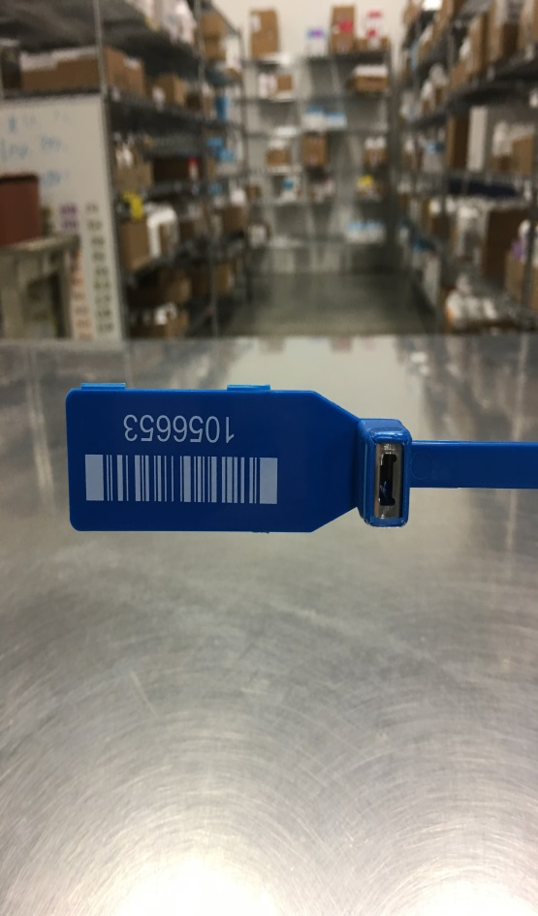

Stem Fed Thru Back of Seal and Appears in Front
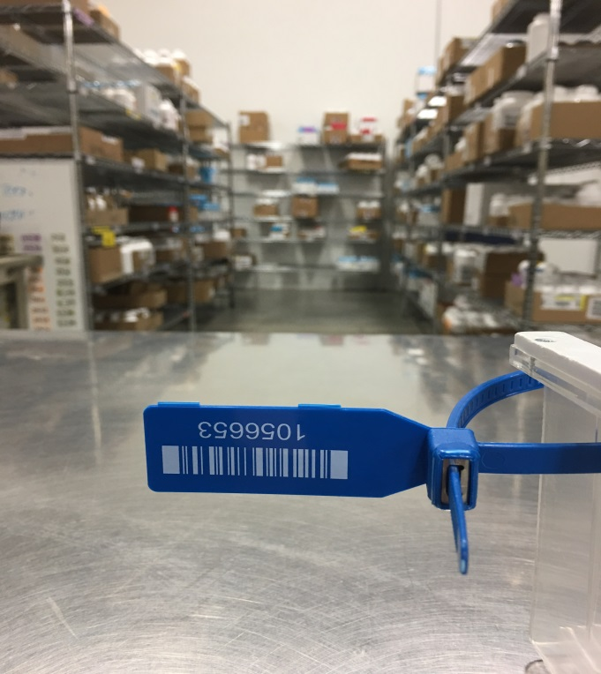

Pull stem through front opening so barcode will be even with side of canister opening
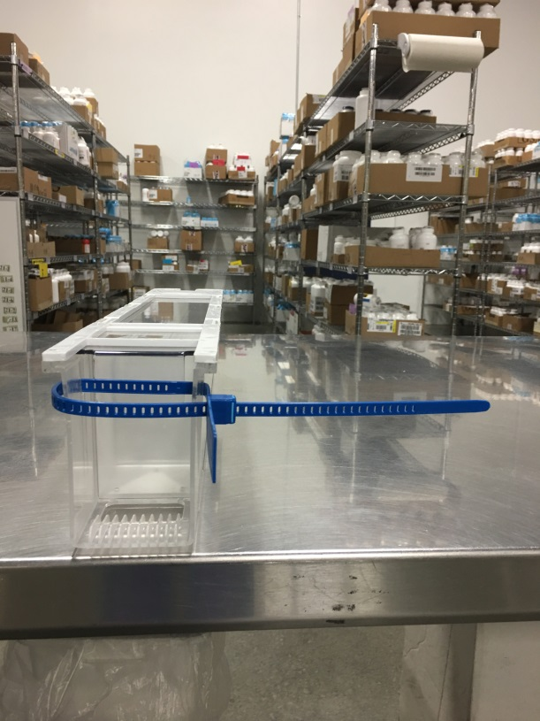

- Place location tag on front of seal upside and affix label to seal
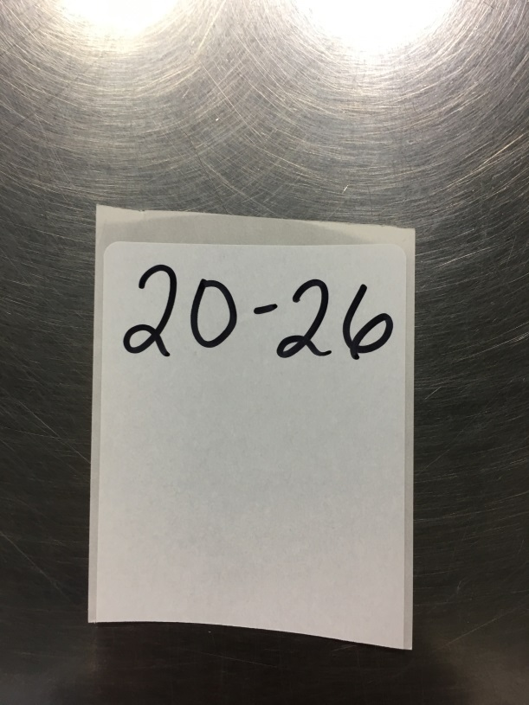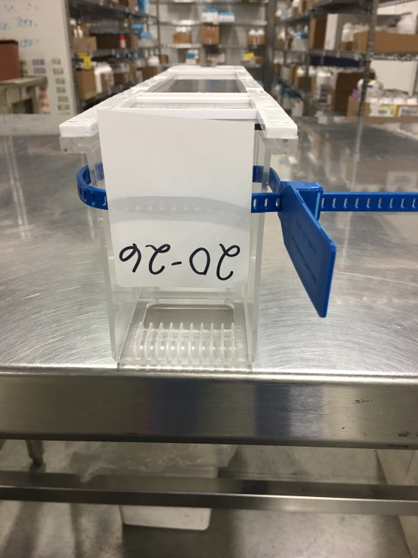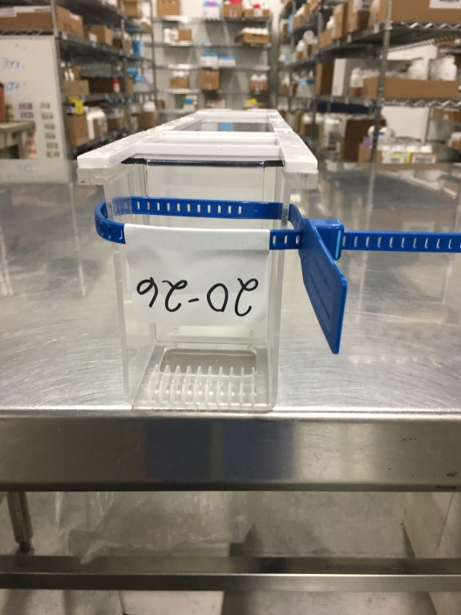
Location Tag

- Use clippers to remove excess stem from seal barcode

Seal with excess stem Seal after excess stem removed
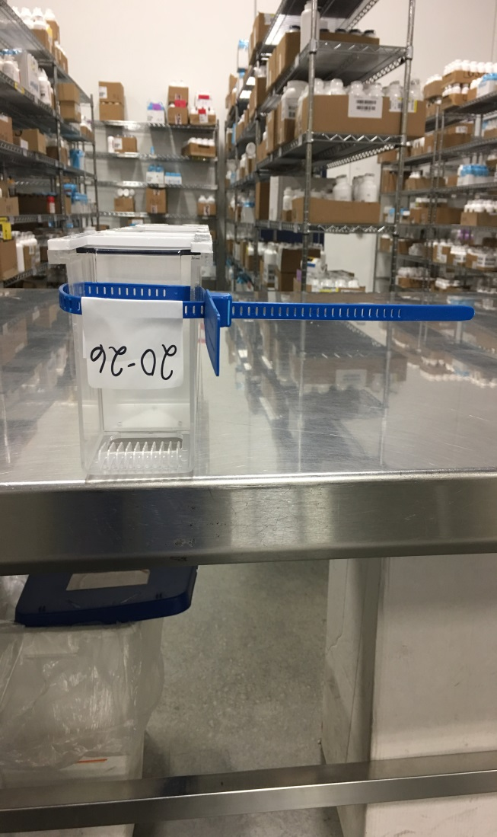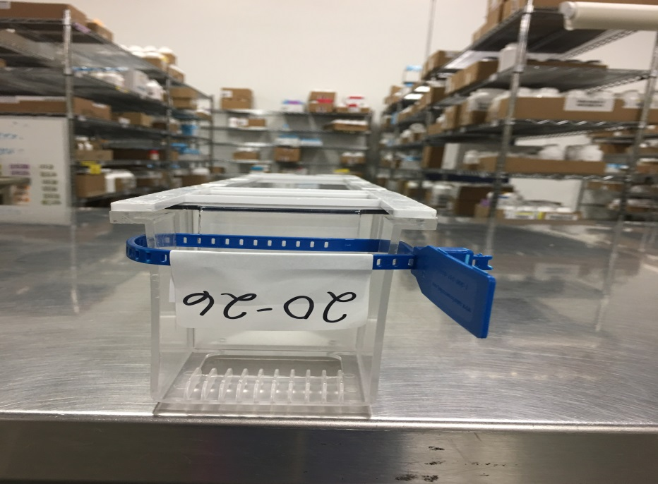

- Click “Yes” to verify that seal barcode in correct

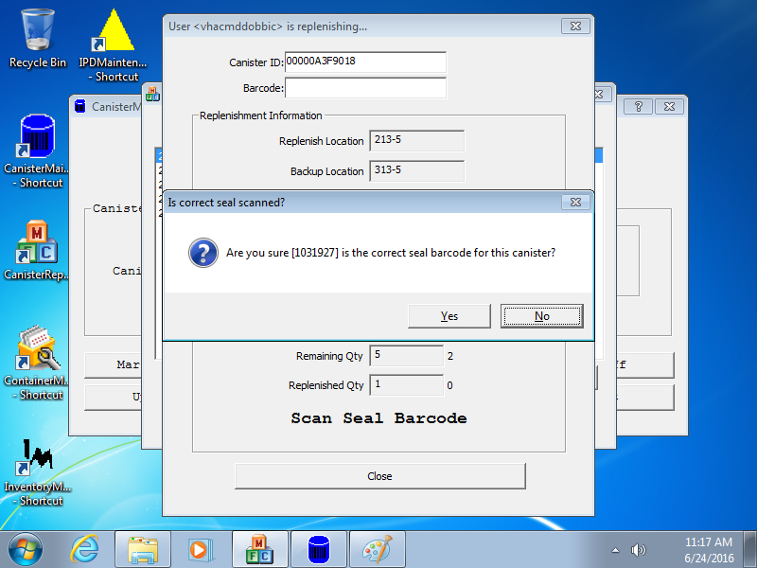

If “Yes” is selected accidentally (indicating that the barcode is correct), notify the Verification Technician/Lead/Supervisor to correct the barcode (Replenishment Technicians are not allowed to update seal barcodes)

- Stand canister(s) upright to the left of workstation with the canister barcode facing outward with last scanned stock bottle. Once complete step back from workstation so the Verification Technician has a visual of workstation. (This visual will alert the verification technician that the replenishment process is complete and canisters are ready for verification)

Example One Example Two
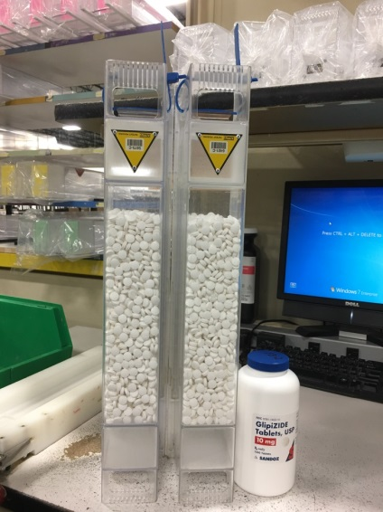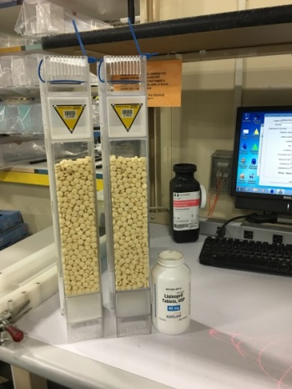

- Once canister(s) have been verified discard stock bottles that have been placed in green bin into trash receptacle.
- Make sure to clean scoop, spatula, and tweezers with alcohol after replenishing medications that leave heavy residue, sulfa, or warfarin product to avoid cross contamination of medication and/or color transfer
- You may utilize the dust collector 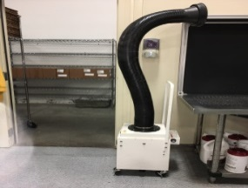 located in the IPD area to remove excessive pill residue during replenishment
Multiple Canisters:

After clicking “Yes” to verify seal barcode is correct the following message will appear if multiple canisters are required

Message: “Do you want to replenish another canister?”
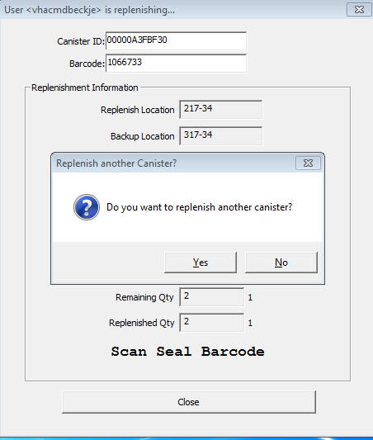

- Unwrap and place new canister on port
- Click “Yes” if multiple canisters are required for replenishment
- Repeat steps 1 through 20 until all canister(s) are complete

Ending Replenishment Early: When quantity given is less than the required amount needed for replenishment

- After scanning all stock bottles given for replenishment
- Scan CMOP Badge Barcode
- Message will Appear “Ok to complete replenishment early?”

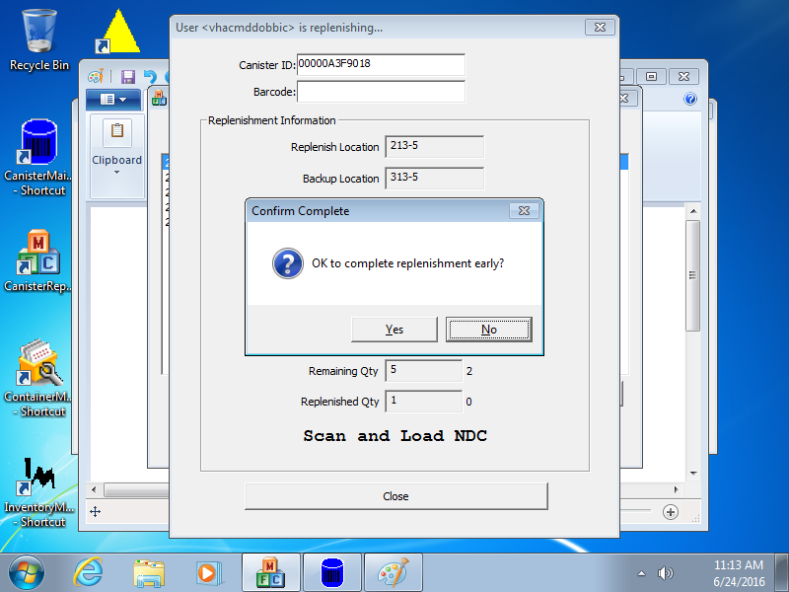

- Click “Yes”
- Proceed to Steps 13 through 20

Manual Drugs: These products are replenished as needed based on allocation amount

Example One Example Two
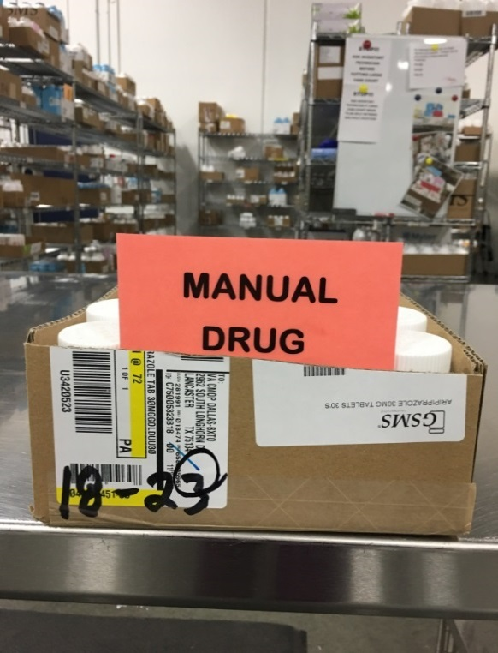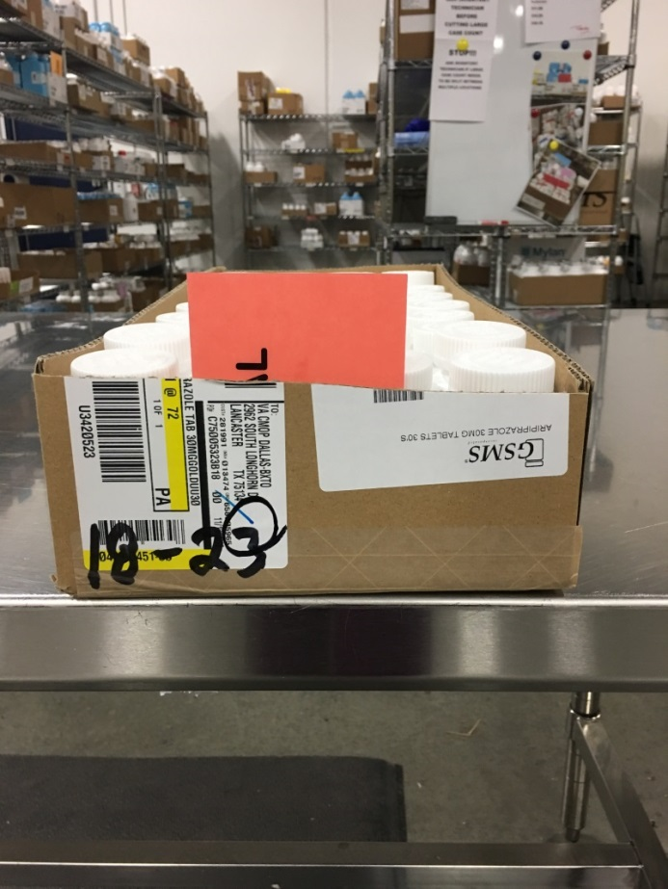
318-23
318-23
Location
Location

- If you have a manual drug for replenishment
- Select “Manual Replenish”
- Enter location unit and cell (enter a “2” in front of the location in the “Unit” section)
  - Example: Location 18-23
Enter: Unit: 218 - Cell: 23
- Select “Schedule”

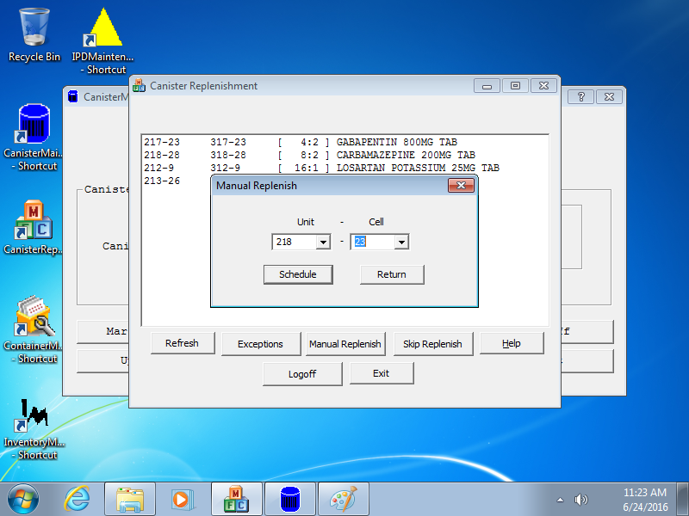
Manual Replenish
Enter Location
Schedule

- Message “Successfully added Replenishment Queue Record for location ex. <218-23> will appear on screen
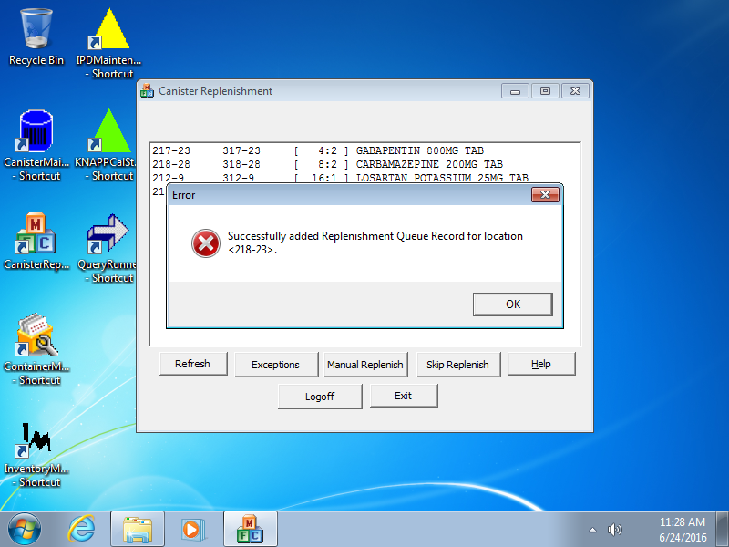

- Click “Ok”
- Click “Return”
- Selected location will appear at the top of the list
- Proceed to steps 2-20

Return To Stock (RTS): These are items that have been returned to stock for various reasons but can be utilized for replenishment

- If you receive an RTS for replenishment

Example One Example Two
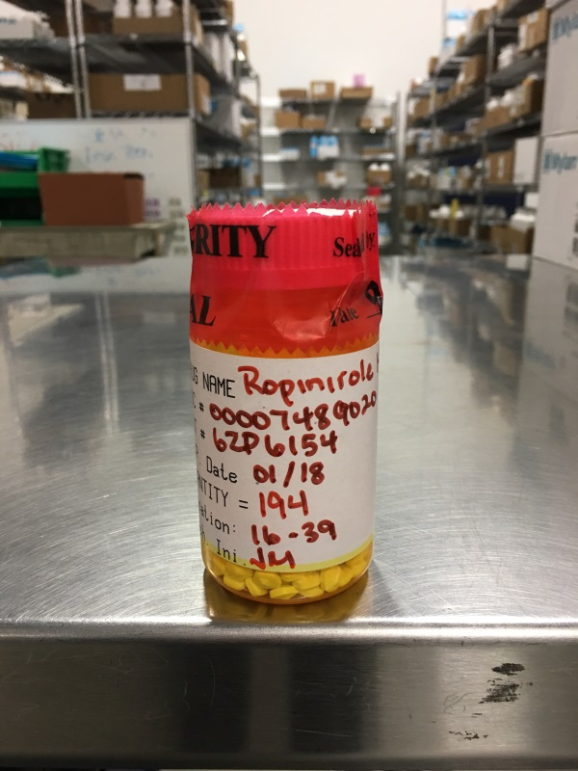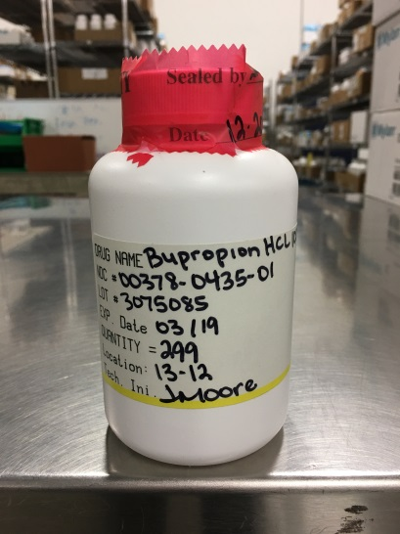

- Follow Steps 1 through 11

***Note change to Step 5 when processing a RTS drug***

- Write location on blank white label. (Location tags are created from blank white labels)
- Write an asterisk * in the upper right-hand corner of the location tag that will be placed on the canister containing the RTS product.

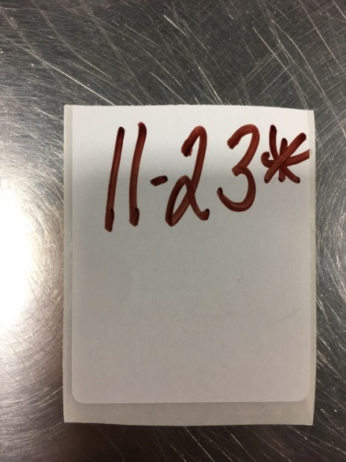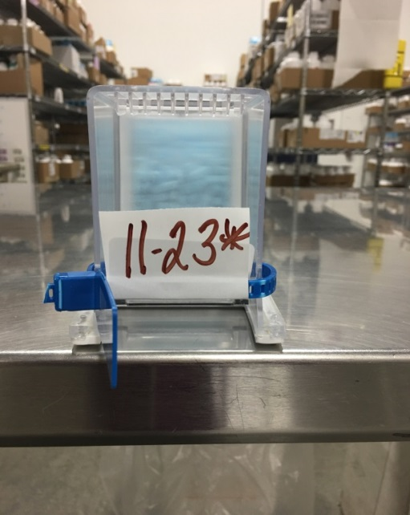

- Once all stock bottles have been scanned
- Notify the Verification Technician that the RTS is ready to be verified and added to the canister
- DO NOT break the seal on a RTS bottle (Only the Verification Technician/Lead/Supervisor is authorized to verify an RTS)
- Once the RTS bottle has been verified and medication added to the canister
- Proceed to step 12 and continue through step 20

***Note change below to step 20 when processing a RTS drug***
Stand canister(s) upright to the left of workstation with the canister barcode facing outward with last scanned stock bottle. In addition to the stock bottle, place the RTS bottle in front of canister containing RTS product. Once complete step back from workstation so the Verification Technician has a visual of workstation. (This visual will alert the verification technician that the replenishment process is complete, and canisters are ready for verification)
Completed RTS Canister
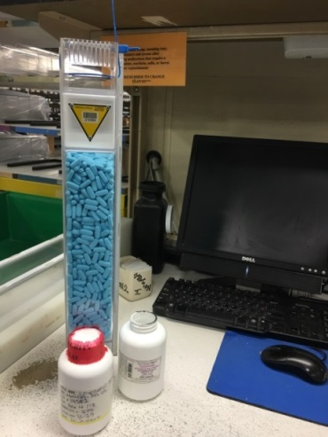

Reminder:

- DO NOT prep warfarin products prior to replenishment

- Obtain barcode from Lead/Supervisor for MINOCYCLINE HCL 100MG CAP (312-38) if needed

- ALWAYS wear required PPE when replenishing

- Remove PPE when leaving the area (-i.e., going to bathroom, breakroom, leaving the building)

- REMEMBER TO CHANGE GLOVES EVERY 90 MINUTES

- DO NOT adjust speaker volume at workstation (This is a safeguard to prevent procedural errors during the replenishment process (-i.e., wrong drug being replenished, wrong NDC number scanned, etc.)

- If you have a drug allergy, notify the Lead/Supervisor immediately

- Maintain a clean, neat, and orderly workstation

- Only one drug on workstation at a time

- Pay attention to products with multiple lot numbers

- Always count stock bottles to verify quantity given by shopper

- DO NOT pick up tablets/capsules that will be used for dispensing with gloved or bare hands

- Any questions regarding policies and procedures should be directed to the VA Supervisor, VA Lead or Trainer

