SUBJECT* | Albany Dental Clinic Lease

GENERAL INFORMATION
CONTRACTING OFFICE’S ZIP CODE* | 23667
SOLICITATION NUMBER* | 36C24626Q0459
RESPONSE DATE/TIME/ZONE | 04-10-2026 5PM EASTERN TIME, NEW YORK, USA
ARCHIVE | 90 DAYS AFTER THE RESPONSE DATE
RECOVERY ACT FUNDS | N
SET-ASIDE | SDVOSBC
PRODUCT SERVICE CODE* | X1AA
NAICS CODE* | 531120
CONTRACTING OFFICE ADDRESS | Department of Veterans Affairs  Network Contracting Office 6  100 Emancipation Drive  Hampton VA 23667
POINT OF CONTACT* | Lease Contracting Officer  L. Weldon Hammond II  Louis.Hammond@va.gov  757-726-6089

PLACE OF PERFORMANCE
ADDRESS | TBD
 | Albany GA
POSTAL CODE
COUNTRY | USA

ADDITIONAL INFORMATION
AGENCY’S URL | https://www.va.gov
URL DESCRIPTION | Department of Veterans Affairs
AGENCY CONTACT’S EMAIL ADDRESS | Louis.Hammond@va.gov
EMAIL DESCRIPTION | va.gov

DESCRIPTION

SUBJECT | Albany Dental Clinic Lease

GENERAL INFORMATION
CONTRACTING OFFICE’S ZIP CODE | 23667
SOLICITATION NUMBER | 36C24626Q0459
RESPONSE DATE/TIME/ZONE | 04-10-2026 5PM EASTERN TIME, NEW YORK, USA
ARCHIVE | 90 DAYS AFTER THE RESPONSE DATE
RECOVERY ACT FUNDS | N
SET-ASIDE | SDVOSBC
PRODUCT SERVICE CODE | X1AA
NAICS CODE | 531120
CONTRACTING OFFICE ADDRESS | Department of Veterans Affairs  Network Contracting Office 6  100 Emancipation Drive  Hampton VA 23667
POINT OF CONTACT | Lease Contracting Officer  L. Weldon Hammond II  Louis.Hammond@va.gov  757-726-6089

PLACE OF PERFORMANCE
ADDRESS | TBD
 | Albany GA
POSTAL CODE
COUNTRY | USA

ADDITIONAL INFORMATION
AGENCY’S URL | https://www.va.gov
URL DESCRIPTION | Department of Veterans Affairs
AGENCY CONTACT’S EMAIL ADDRESS | Louis.Hammond@va.gov
EMAIL DESCRIPTION | va.gov

DESCRIPTION
SOURCES SOUGHT NOTICE: Albany Dental Clinic NEW LEASE: 36C24626Q0459
U.S. DEPARTMENT OF VETERANS AFFAIRS DESIRES TO LEASE SPACE
The Department of Veterans Affairs is conducting market research/seeking capable sources from bondable and experienced firms that are interested in a forecasted lease project. Functional, performance, or physical requirements including number and type of parking spaces surface or parking garage and buildout for telecommunication closets if applicable; Carl Vinson VA Medical Center - CVVAMC is requesting a new lease requirement for 20,528 net usable square feet - NUSF of clinical dental space along with 75 surface parking spaces. Which includes areas exclusively used by the tenant. This new lease will be in Albany, GA and provide dental care to Veterans in the southwest region of Georgia.
SDVOSB / VOSB Set-Aside Under 38 USC 8127
- 38 USC § 8127 sets VHA contracting goals for participation by small businesses owned by veterans, including SDVOSBs and VOSBs
- VAAR Part 819 implements these preferences in procurement and leasing, authorizing set-asides or sole-source awards to VIP-listed SDVOSBs or VOSBs, provided they meet the NAICS-based
- For this procurement, the size standard to determine small business eligibility is $34 million per NAICS 531120.
The magnitude of the anticipated construction/buildout for this project is:
- Less than $25,000.
- Between $25,000 and $100,000.
- Between $100,000 and $250,000.
- Between $250,000 and $500,000.
- Between $500,000 and $1,000,000.
- Between $1,000,000 and $2,000,000.
- Between $2,000,000 and $5,000,000.
_x_ Between $5,000,000 and $10,000,000.
- Between $10,000,000 and $20,000,000.
- Between $20,000,000 and $50,000,000.
- Between $50,000,000 and $100,000,000.
- More than $100,000,000.
VA makes monthly lease rental payments in arrears upon facility acceptance and may elect to make a single lump-sum payment or amortize over the course of the firm term for specified tenant improvements. VA makes no progress payments during the design or construction/build-out phases of the project.
This is not a request for proposals, only a request for information for planning purposes, and does not constitute a solicitation. A solicitation may or may not be issued. This notice is being published in accordance with Federal Acquisition Regulation 19.14 and VA Acquisition Regulation 819.70.
To receive consideration, submitted properties must be able to provide 20,528 NUSF of commercial clinical space, provide 75 surface parking spaces, meet all VA and ADA accessibility requirements. Additionally, the submitted properties must be located within the following area described below, which is bound by the following roads, or must front on any of the following boundary lines:
Delineated Area:

- Bounded on the North: Hwy 82
- Bounded on the South: Hwy 234
- Bounded on the East: Hwy 300
- Bounded on the West: N. Doublegate Dr./ Lockett Station Rd.

The attached map of the delineated area is provided for further clarification of the boundaries.
County: Dougherty County
City, State, ZIP: Albany, GA 31701
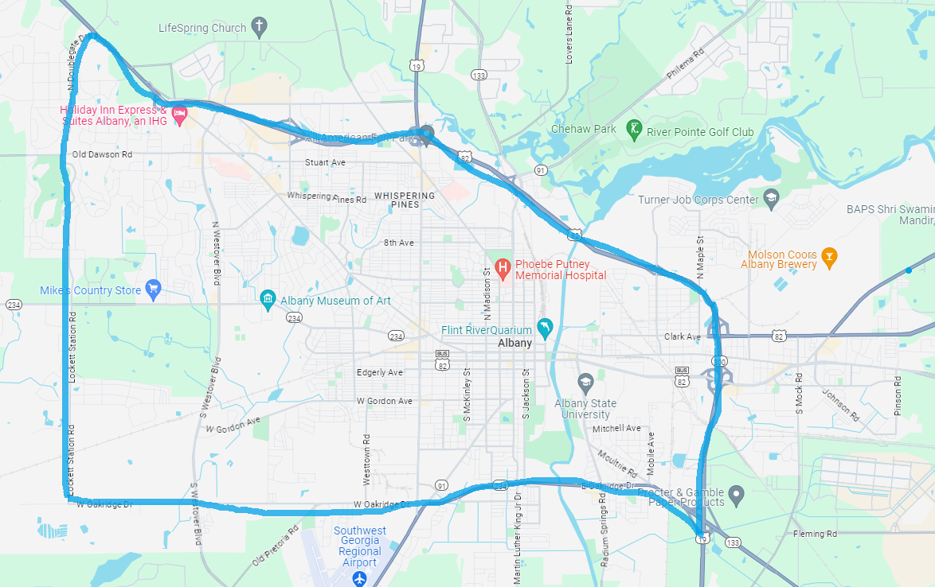
Special Requirements
The Carl Vinson VA Medical Center is requesting a new requirement that shall meet all directives pertaining to dental services, security, patient safety, and accessibility. The clinic is to provide routine dental services and dental surgeries. The location shall have sterile processing abilities, workstations for employees, and staff administrative areas. The desired space should be contiguous, on no more than one floor and must meet or be able to meet the Department of Veterans Affairs Life Safety codes and other applicable regulations. A 20-year lease (10-year firm); 10 years soft will be considered.
A market survey of the properties offered for lease will be conducted by the Department of Veterans Affairs. All interested offerors-owners, brokers, or their legal representatives must provide written acknowledgement NO LATER THAN MONDAY, April 10, 2026, 5:00 PM EST

Other applicable requirements:
- Compliant with Americans with Disabilities Act
- Parking – Minimum 75 or more parking spaces
- Proximity to public transportation
- Proximity to public amenities stores, restaurants, banks, etc.
- Building cannot be within a 100-year flood plain
- Shall be built to VA specifications
- Shall be zoned for intended use
- Shall not be next to a bar, liquor, gun store or like establishment
- Shall meet specific information technology and security requirements
SUBMISSION REQUIREMENTS:
Net usable square feet do not include such areas as stairs, elevators, mechanical and utility rooms, ducts, shafts, vestibules and public corridors, and public toilets required by local code. The Government is limited by law 41 C.F.R. 102-73.55 to pay no more than the appraised fair market rental value for space. The Government’s decision regarding whether to relocate will be based in part on information in response to this advertisement.
Expressions of interest shall include the following:
- Building name, address, and age
- Location of the available space within the building
- Rentable Square Feet - RSF available and expected rental rate per RSF
- Net Usable Square Feet - NUSF to be offered and expected rental rate per NUSF
- Building ownership information
- Amount of parking available on-site; include its cost and indicate whether the expected rental rate includes such required for Government parking, if applicable.
- Date of space availability
- Energy efficiency and renewable features exist within the building
- Contact information of authorized representative

Expressed interested may be sent electronically to the following e-mail address: Louis.Hammond@va.gov
PLEASE BE ADVISED: This is an inquiry only and must not be construed as a guarantee on the part of the Department of Veterans Affairs to enter into a lease agreement with any interested party. Only properties that can provide the requested space requirement and those that meet applicable government standards will be considered.
L. Weldon Hammond II
Lease Contract Officer
VHA Minor Leasing
Regional Procurement Office RPO-West-VHA

