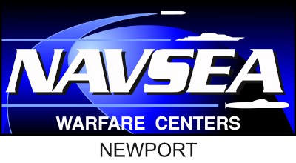


SEAPORT COUNCIL:
The Naval Undersea Warfare Center, Division Newport (NUWCDIVNPT) will be hosting a SeaPort-NxG and Contracts Council Meeting, Tuesday, 07 APRIL 2026. These meetings are held as a means of facilitating and encouraging communications between the NUWDIVNPT Contracts Department and Industry. Industry is invited to submit questions in advance of this event; Industry’s questions foster the discussion and form the basis of the meeting. This event will be UNCLASSIFIED and will be held in-person at Naval Undersea Warfare Center (NUWC) Division Newport, Building 80 Gymnasium, 1176 Howell Street, Newport, RI 02841.
REGISTRATION:
To participate in the Seaport Council, Registration is required no later than 03 APRIL 2026. Interested attendees must register by providing Name of attendee(s), Company, CAGE Code, Size and Socio-economic Status, Phone Number and E-mail address to Ms. Maria Gregory at maria.f.gregory.civ@us.navy.mil. See attached form. No on-site or day-of registration will be permitted. Attendee information will be published following the event unless otherwise requested.
QUESTIONS:
Registered attendees should submit questions to Ms. Maria Gregory at maria.f.gregory.civ@us.navy.mil by Wednesday, 01 APRIL 202.

TENTATIVE AGENDA:

1030 EST- Registration and Networking
1100 EST- Council Meeting
- Welcome and Introductions
- Contracts Department (Code 02) Leadership presentations
- Industry Q&A
1200 EST- Event Concludes

GENERAL STIPULATIONS AND DISCLAIMERS:
Any information provided in response to this notice is not binding upon the Government. This is not a pre-solicitation, pre-bid, or pre-proposal conference; this event is for informational purposes only and will not be designed to provide formal briefings on any specific acquisition requirement. There will be no fee to attend, however, industry participants will be required to preregister.
Industry will not be permitted to set up marketing material or have booth space at this event. Respondents are advised that the Government will not pay for any information or administrative costs incurred in response to this notice; all costs associated with responding to this notice will be solely at the interested parties' expense. Not responding to this notice does not preclude participation in any future event. It is the responsibility of the potential interested respondees to monitor Seaport NxG for additional information pertaining to the upcoming Seaport Council.

