STATEMENT OF WORK
Reverse Osmosis Water Purification Base + 4 Option Years

DESCRIPTION OF SERVICES The Contractor shall provide all management, labor, transportation, tools, supplies, and equipment necessary to provide maintenance and testing of the reverse osmosis water purification system at the Iowa City VA Healthcare System, 601 Hwy 6 West, Iowa City, Iowa 52246. Reverse osmosis testing is required to comply with AAMIST-108 for critical and utility water.

SERVICE REQUIRED
Contractor will provide the necessary parts, manpower, and supervision to properly execute the maintenance of the water purification systems at the Iowa City VA Healthcare System. Contractor to include labor, testing supplies, and shipping/delivery.

- Contractor will provide a custom-configured data collection tool with all the parameters of the system clearly defined.
- The ICVAHCS will be notified immediately if the current data is outside the engineered limits of the system.
- Corrective action and potential problems will be clearly outlined in a written notification from the Contraction. Email to the Contracting Officer and Contracting Officer Representative is preferred.
- Contractor technicians will analyze the data and take the proper corrective measure to repair the system.
- A “Field Service Report” (FSR) must be generated and a copy given to the ICVAHCS representative after each episode of scheduled maintenance.
- Preventive Maintenance:
- Preventive maintenance will be performed by the contractor at intervals that are in accordance with the following schedules (see below).

Critical Water – 12 sites/tests monthly testing including the following.
- Bacterial
- Endotoxin
- Water quality (PH, conductivity, total alkalinity, total hardness.

Utility Cold Water – 11 sites/tests monthly
- Bacterial
- Water quality (PH, conductivity, total alkalinity, total hardness.

Utility Hot Water – 7 sites/tests monthly
- Bacterial
- Water quality (PH, conductivity, total alkalinity, total hardness.

Base Year – 09/01/2026 – 08/31/2027
Option Year 1 – 09/01/2027 – 08/31/2028
Option Year 2 – 09/01/2028 – 08/31/2029
Option Year 3 – 09/01/2029 – 08/31/2030
Option Year 4 – 09/01/2030 – 08/31/2031

CLEAN-UP:
The Contractor shall keep the service area free from accumulations of waste material or rubbish.

Upon completion of the service, the Contractor shall ensure the work area and premises are clean and restored to their original condition. Contractor shall be responsible for ensuring the area is in the same condition in which they were prior to the calibration and maintenance. At the completion of each area, the Contractor shall complete a walk through with the facility POC prior to acceptance.

HOURS OF SERVICES:
Contractor shall perform services Monday through Friday.

Unavailable service days are Federal holidays, unless otherwise coordinated with VA POC.

If the holiday falls on a Saturday, the previous Friday will be observed and if the holiday falls on a Sunday, the following Monday will be observed.

A list of federal holidays is available at: https://www.opm.gov/policy-data-oversight/pay-leave/federal-holidays/#url=2024

REPORTS AND DOCUMENTATION

At the conclusion of each scheduled or unscheduled maintenance visit, the contractor will provide:
- Building number/name of facility where maintenance/service were performed.
  - Date and time of maintenance/service.
  - Provide a written service report indicating the date of service, the model, serial number, and location of equipment services.
  - Name of technician performing the work.
  - List of services performed and parts replaced.
  - Defects (if applicable)

GENERAL INFORMATION

CLOSURES:
Work scheduled, but not accomplished due to unforeseen weather conditions, facility exercises, or actual alert, will be rescheduled as soon as possible after reopening.

SECURITY REQUIREMENTS / BADGES:
Contractor and/or all sub-contracted personal are required to always wear and have visible a Contractor Badge.

Badges are issued by Facilities Management (FM), B-2, second floor. FM Office hours are Monday – Friday, 7:30 am – 4:00 pm.

The Contractor shall be required to obtain and display identification badges for all employees requiring access to the Iowa City VA Healthcare System.

These badges will be Government furnished and issued to Contractor employees upon initial entry, under contract.

Identification shall be always worn on the outer clothing between the neck and waist on the front of the body and visible with the Contractor’s name plainly displayed.

Loss of a contractor badge shall be reported to the VA POC no later than the following workday.
All contract personal shall be checked in by Facilities Management (FM) located in building 2, second floor.

Contractor personnel will be escorted by VA staff.

SAFETY REQUIREMENTS AND REPORTS:

The Contractor is solely responsible for compliance with all federal, state, and local laws, the Occupational, Safety and Health Act (OSHA) (Public Law 91-596) and the resulting standards, OSHA Standards 29 CFR 1910 and 1926, as applicable and shall perform all work in a safe manner as required by these standards.

The Contractor shall implement an Occupational Safety and Health Plan to ensure the safety of their personnel, as well as the protection of Government personnel and property. Additionally, the Contractor is responsible for the safety and health of all sub-Contractor employees.

The Contractor shall provide a verbal report to the CO within 24 hours of an accident resulting in injury, death, occupational disease, or adverse environmental impact.

The Contractor shall provide a completed copy of required accident investigation reports to the CO within five calendar days of each occurrence.

DAMAGE TO GOVERNMENT EQUIPMENT AND PROPERTY:
The Contractor shall take all necessary precautions to prevent damage to Government equipment and property.

The Contractor shall report damage of Government property or equipment to the Contracting Officer and/or VA POC within 24 hours of the incident.

SPECIAL CERTIFICATIONS AND QUALIFICATIONS:
To be considered eligible for consideration, bidders must be able to provide documentation that the technicians performing calibration services are NASED-certified, and the equipment used to calibrate must be able to calibrate to ANSI standards.

Schedule:

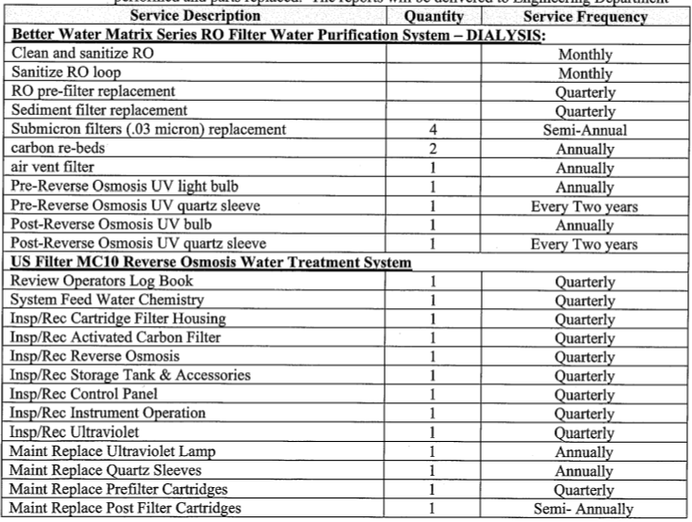
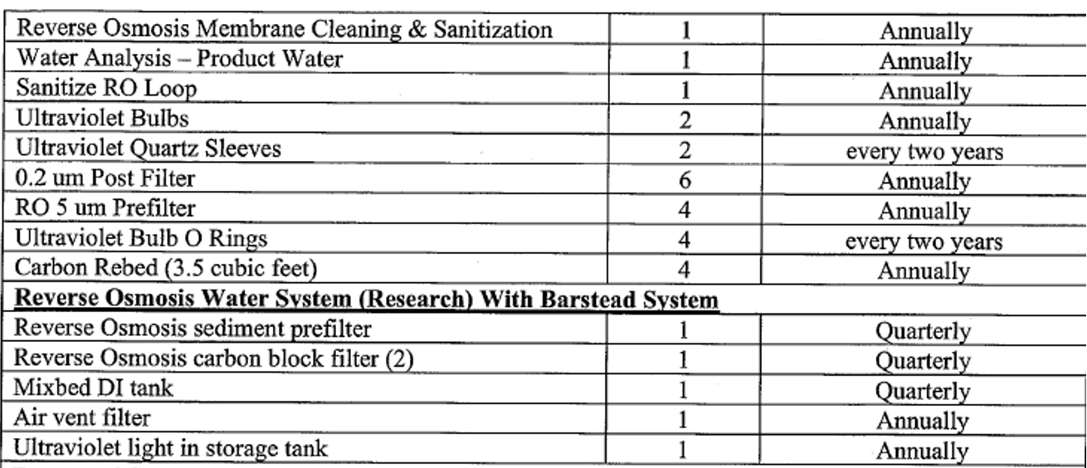
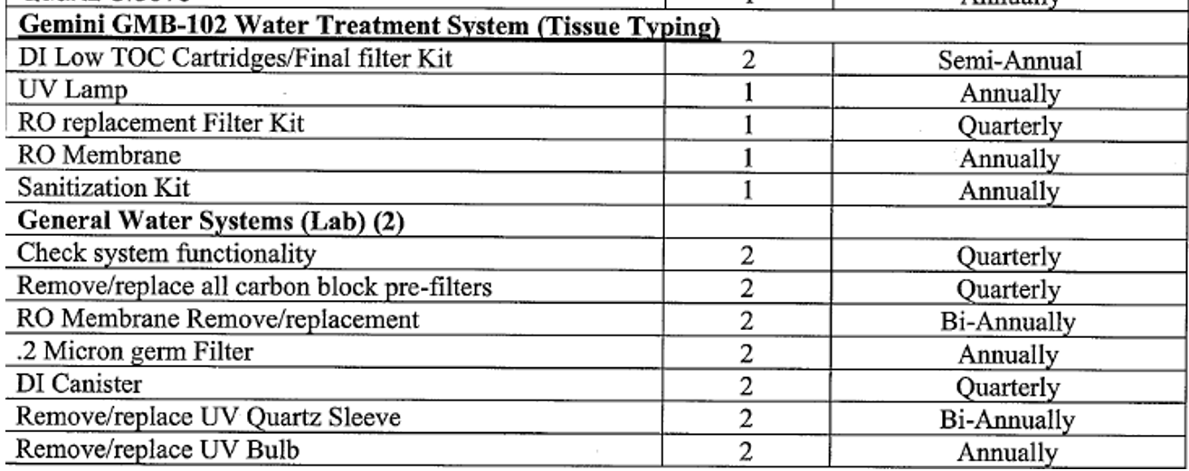

EQUIPMENT:

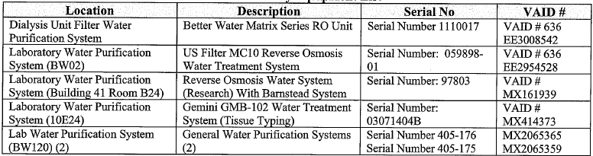

RECORDS MANAGEMENT OBLIGATIONS
A. Applicability
This clause applies to all Contractors whose employees create, work with, or otherwise handle Federal records, as defined in Section B, regardless of the medium in which the record exists.
B. Definitions
“Federal record” as defined in 44 U.S.C. § 3301, includes all recorded information, regardless of form or characteristics, made or received by a Federal agency under Federal law or in connection with the transaction of public business and preserved or appropriate for preservation by that agency or its legitimate successor as evidence of the organization, functions, policies, decisions, procedures, operations, or other activities of the United States Government or because of the informational value of data in them.
The term Federal record:
- includes Iowa City VAHCS records.
- does not include personal materials.
- applies to records created, received, or maintained by Contractors pursuant to their Iowa City VAHCS contract.
- may include deliverables and documentation associated with deliverables.
C. Requirements
- Contractor shall comply with all applicable records management laws and regulations, as well as National Archives and Records Administration (NARA) records policies, including but not limited to the Federal Records Act (44 U.S.C. chs. 21, 29, 31, 33), NARA regulations at 36 CFR Chapter XII Subchapter B, and those policies associated with the safeguarding of records covered by the Privacy Act of 1974 (5 U.S.C. 552a). These policies include the preservation of all records, regardless of form or characteristics, mode of transmission, or state of completion.
- In accordance with 36 CFR 1222.32, all data created for Government use and delivered to, or falling under the legal control of, the Government are Federal records subject to the provisions of 44 U.S.C. chapters 21, 29, 31, and 33, the Freedom of Information Act (FOIA) (5 U.S.C. 552), as amended, and the Privacy Act of 1974 (5 U.S.C. 552a), as amended and must be managed and scheduled for disposition only as permitted by statute or regulation.
- In accordance with 36 CFR 1222.32, Contractor shall maintain all records created for Government use or created in the course of performing the contract and/or delivered to, or under the legal control of the Government and must be managed in accordance with Federal law. Electronic records and associated metadata must be accompanied by sufficient technical documentation to permit understanding and use of the records and data.
- Iowa City VA HCS and its contractors are responsible for preventing the alienation or unauthorized destruction of records, including all forms of mutilation. Records may not be removed from the legal custody of Iowa City VAHCS or destroyed except for in accordance with the provisions of the agency records schedules and with the written concurrence of the Head of the Contracting Activity. Willful and unlawful destruction, damage or alienation of Federal records is subject to the fines and penalties imposed by 18 U.S.C. 2701. In the event of any unlawful or accidental removal, defacing, alteration, or destruction of records, Contractor must report to Iowa City VAHCS. The agency must report promptly to NARA in accordance with 36 CFR 1230.
- The Contractor shall immediately notify the appropriate Contracting Officer upon discovery of any inadvertent or unauthorized disclosures of information, data, documentary materials, records or equipment. Disclosure of non-public information is limited to authorized personnel with a need-to-know as described in the [contract vehicle]. The Contractor shall ensure that the appropriate personnel, administrative, technical, and physical safeguards are established to ensure the security and confidentiality of this information, data, documentary material, records and/or equipment is properly protected. The Contractor shall not remove material from Government facilities or systems, or facilities or systems operated or maintained on the Government’s behalf, without the express written permission of the Head of the Contracting Activity. When information, data, documentary material, records and/or equipment is no longer required, it shall be returned to Iowa City VA HCS control or the Contractor must hold it until otherwise directed. Items returned to the Government shall be hand carried, mailed, emailed, or securely electronically transmitted to the Contracting Officer or address prescribed in the [contract vehicle]. Destruction of records is EXPRESSLY PROHIBITED unless in accordance with Paragraph (4).
- The Contractor is required to obtain the Contracting Officer's approval prior to engaging in any contractual relationship (sub-contractor) in support of this contract requiring the disclosure of information, documentary material and/or records generated under, or relating to, contracts. The Contractor (and any sub-contractor) is required to abide by Government and Iowa City VA HCS guidance for protecting sensitive, proprietary information, classified, and controlled unclassified information.
- The Contractor shall only use Government IT equipment for purposes specifically tied to or authorized by the contract and in accordance with Iowa City VAHCS policy.
- The Contractor shall not create or maintain any records containing any non-public Iowa City VAHCS information that are not specifically tied to or authorized by the contract.
- The Contractor shall not retain, use, sell, or disseminate copies of any deliverable that contains information covered by the Privacy Act of 1974 or that which is generally protected from public disclosure by an exemption to the Freedom of Information Act.
- The Iowa City VA HCS owns the rights to all data and records produced as part of this contract. All deliverables under the contract are the property of the U.S. Government for which Iowa City VA HCS shall have unlimited rights to use, dispose of, or disclose such data contained therein as it determines to be in the public interest. Any Contractor rights in the data or deliverables must be identified as required by FAR 52.227-11 through FAR 52.227-20.
- Training. All Contractor employees assigned to this contract who create, work with, or otherwise handle records are required to take Iowa City VAHCS-provided records management training. The Contractor is responsible for confirming training has been completed according to agency policies, including initial training and any annual or refresher training.
D. Flowdown of requirements to subcontractors
- The Contractor shall incorporate the substance of this clause, its terms and requirements including this paragraph, in all subcontracts under this [contract vehicle], and require written subcontractor acknowledgment of same.
- Violation by a subcontractor of any provision set forth in this clause will be attributed to the Contractor.

