STATEMENT OF WORK
Soil Remediation Services Building 53

- SCOPE: Provide all labor, supervision, materials, equipment, to remediate and replace soil near Building 53 at the Amarillo Veterans Affairs (VA) Health Care Facility located in Amarillo, Texas 79106.

- CONTRACTOR RESPONSIBILITIES: The Contractor shall exercise extreme care to avoid damaging Government property such as buildings, equipment, trees, shrubs, turf, sprinkler lines, or utility lines. Any damage to Government property by the Contractor shall be repaired by the Contractor to its original condition at no additional cost to the Government. The contractor shall restore ALL disturbed grounds to existing conditions. The Contractor shall ensure that all materials are new, free from defects, imperfections and asbestos free (NO ASBESTOS CONTAINING MATERIALS SHALL BE USED ON THIS PROJECT).

- SCHEDULE OF WORK: The Contractor shall notify the Contracting Officer’s Representative (COR) prior to start of work. The Contractor shall schedule work through the COR. The Contractor shall coordinate work with COR NLT 7 days before starting work. Work shall be completed within forty-five (30) days of start date. Other contractors may be working in the same area performing other work. The contractor shall execute work in a manner so as not to impede other contract work.
- HOURS OF WORK: The normal hours of work are 07:30 to 16:30 (4:30) Monday through Friday. Work shall be performed during normal work hours. Work to be performed in other than normal hours and shall be approved by the COR at least seven (7) Calendar Days prior.
Contractors shall make a secure way to access to get on the roof. Access through the building shall be scheduled with the COR.
  - The Federal Holidays are as follows:
Holiday Name | Day of Week | 2025 Observed Date
New Year's Day | Thursday | January 1, 2026
Birthday of Martin Luther King, Jr. | Monday | January 29, 2026
President’s Day | Monday | February 16, 2025
Memorial Day | Monday | May 25, 2026
Juneteenth | Friday | June 19, 2026
Independence Day | Friday | July 4, 2026
Labor Day | Monday | September 7, 2026
Columbus Day | Monday | October 12, 2026
Veterans Day | Wednesday | November 11, 2026
Thanksgiving Day | Thursday | November 26, 2026
Christmas Day | Friday | December 25, 2026

- DAILY PROGRESS REPORTS: The Contractor shall provide daily progress report no later than 9:00 AM the following day of work accomplished the previous day to the COR by e-mail. Daily Progress Reports shall be typed and sent to the COR in PDF format.

- WORKING CONDITIONS: The buildings and the surrounding site areas will be occupied, and Government operations will continue on a normal, temporary or restricted basis for the duration of the contract. The Contractor shall take all precautions to ensure that his operations are conducted in a manner so as not to interfere with the normal operation of surrounding facilities. The Contractor shall execute work in a safe manner and shall not subject personnel to unsafe conditions. The Contractor shall provide safety barricades, devices, and equipment to protect personnel and property and repair damage caused by construction operations. Take all precautions to protect the building and its occupants during the construction period.

- SITE VISIT: The Contractor shall visit the site to determine the full extent of the work. Failure to inspect the site will not constitute grounds for a claim after contract award. A site visit will be scheduled through the Contracting Officer.

- DISPOSAL: Disposal of materials removed under this contract at an approved disposal site in accordance with all local, state, and federal laws, regulations, and guidelines are the Contractor’s sole responsibility. The contractor shall adhere to all Environmental Protection Agency, Texas Commission on Environmental, and Quality Occupational Safety and Health Administration (OSHA) requirements concerning removal, transporting, and disposal of the material. All waste and recycling receipts shall be turned in to the COR by e-mail.

- CLEAN-UP: The Contractor shall keep the area and surrounding areas clean and organized; as in neat, tidy, free of trash and debris daily. Contractor to exercise methods such as clean as you go as part of keeping the area clean. The Contractor is responsible for verifying NO screws, nails or any hardware is to be left on roads, parking or sidewalks to where they will cause a flat tire or harm.

- TEMPORARY FACILITIES: Temporary electrical power and water may be provided by the Government at no cost to the Contractor from existing lines and sources located at the building site. The characteristics and source locations may be verified by a visit to the site. If applicable, the Contractor shall provide ample temporary storage shed space for materials requiring shelter from the weather, and security and safety protection. Storage facilities shall be in the areas of the facility designated by the Contracting Officer’s Representative.

- SAFETY AND FIRE: The Contractor shall comply with the most recent fire and safety rules and regulations; NFPA and OSHA Standards, for minimum safety requirements.

- PERMITS: The Contractor shall be responsible for obtaining any licenses and permits and complying with any laws, codes, and regulations applicable to the execution of this work as required Federally and by the State of Texas.

- PARKING: Parking is limited. The COR will notify the Contractor at the start of the project where the contractor may or may not park. This is an active Hospital and there is parking that is reserved for Patients Only as well as various medical staff. Contractor is to put together an internal plan for Carpooling to reduce the amount of Parking Spaces to be taken over by the Contractor during construction.

- STATEMENT OF WORK: The Contractor shall provide remediation services. Work shall include, but not limited to the following:
- Project Initiation and Planning
  - Develop a detailed remediation plan in compliance with TCEQ standards.
  - Obtain all necessary permits and approvals from relevant regulatory bodies.
  - Notify TCEQ and provide an initial incident report including the nature and extent of the spill.
- Site Assessment
  - Conduct a site assessment to determine the extent of contamination.
  - Collect soil samples from various locations and depths to identify the spread of alkali salts.
  - Perform laboratory analysis of soil samples to establish baseline contamination levels.
- Health and Safety Planning
  - Develop a Health and Safety Plan (HASP) to protect workers and nearby residents.
  - Include procedures for proper handling, transportation, and disposal of contaminated soil.
  - Ensure the use of personal protective equipment (PPE) for all site personnel.
- Excavation and Removal of Contaminated Soil
  - Excavate contaminated soil to the determined depth and perimeter.
  - Continuously monitor air quality around the excavation site to ensure safety.
  - Use appropriate containment methods to prevent the spread of contamination during excavation.
- Soil Treatment and Disposal
  - Treat contaminated soil on-site, if feasible, using appropriate remediation techniques such as soil washing or stabilization.
  - Transport and dispose of untreated contaminated soil at an approved off-site facility.
  - Ensure all soil treatment and disposal activities comply with TCEQ regulations.
- Backfilling and Site Restoration
  - Import and place clean fill material to restore the excavation site.
  - Compact and grade the backfilled area to match the surrounding topography.
  - Restore any disturbed vegetation or landscaping.
- Post-Remediation Monitoring
  - Conduct post-remediation soil sampling to ensure the removal of contaminants to acceptable levels.
  - Compare post-remediation sample results with baseline levels and TCEQ cleanup standards.
- Reporting to TCEQ
  - Prepare a comprehensive remediation report to be submitted to TCEQ.
  - Include the following sections in the report:
    - Introduction: Project background and objectives.
    - Site Assessment: Detailed findings from the initial site assessment, including lab results.
    - Remediation Activities: Description of remediation methods used, volume of soil removed, and disposal methods.
    - Health and Safety: Summary of safety measures taken during the project.
    - Post-Remediation Results: Post-remediation soil sample results and comparison with TCEQ standards.
    - Conclusion: Confirmation of compliance with TCEQ standards and any recommendations for further actions.
  - Submit the remediation report to COR and TCEQ within the stipulated time frame and respond to any follow-up queries or requests for additional information.
The figure below shows the approximate effected area of the leak.
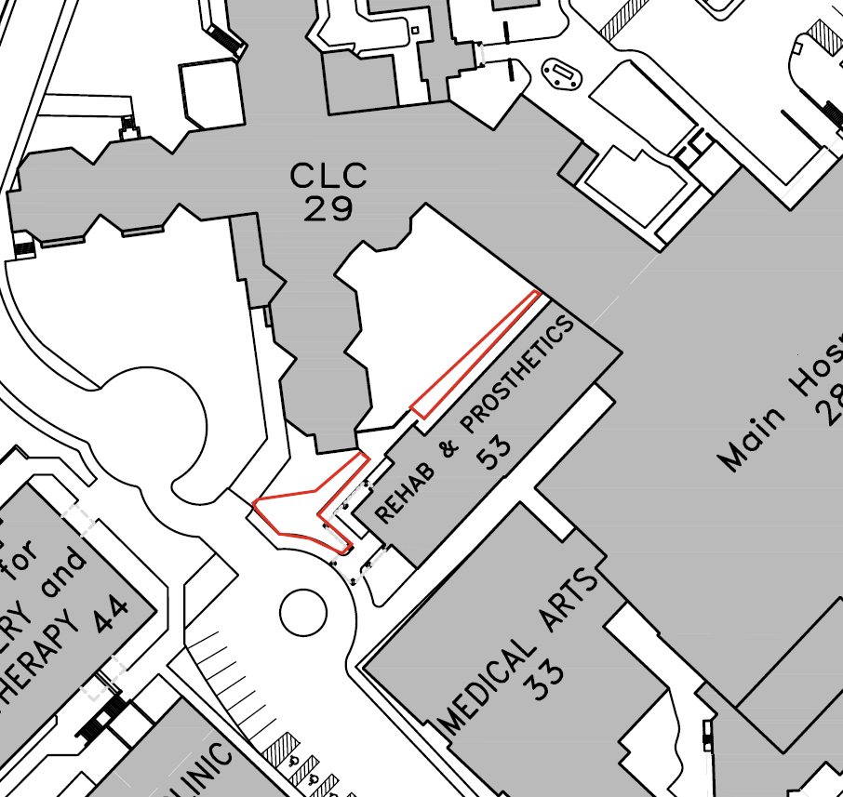
- QUALITY ASSURANCE: The Contracting Officer reserves the right to conduct any inspections or perform any tests deemed necessary at any time during the execution of the contract to determine conformance with the requirements of these specifications.

- ATTACHMENTS:

  - Attachment 1 - Safety Data Shet CHEM-AQUA 51709

END OF SECTION

