Performance Work Statement

Swinomish Channel Eelgrass Survey

La Conner, WA

Skagit County, Washington

  - March 2026
Table of Contents
PART 1 – GENERAL INFORMATION 5
1.1 DESCRIPTION OF SERVICES / INTRODUCTION 5
1.2 BACKGROUND 5
1.3 SITE DESCRIPTION 5
1.4 OBJECTIVES 6
1.5 SCOPE 6
1.6 PERIOD OF PERFORMANCE (PoP) 6
1.7 GENERAL INFORMATION 6
1.7.1 Quality Control Plan 6
1.7.2 Quality Assurance 6
1.7.3 Schedule 6
1.7.3.1 USACE Review 6
1.7.3.2 Recognized Holidays 6
1.7.3.3 Hours of Operation 7
1.7.4 Place of Performance 7
1.7.5 Type of Contract 7
1.7.6 Security Requirements 7
1.7.7 Post Award Conference/Periodic Progress Meetings 7
1.7.8 USACE Personnel 7
1.7.9 Billing Procedures 8
1.7.10 Contractor Key Personnel 8
1.7.11 Pre-screening Requirements for Personnel Candidates 9
1.7.12 Identification of Contractor Employees 9
1.7.13 Contractor Travel 9
1.7.14 Other Direct Costs 9
1.7.15 Data Rights 9
1.7.16 Organizational Conflict of Interest 10
1.7.17 Subcontracts 10
PART 2 - DEFINITIONS AND ACRONYMS 11
2.1 DEFINITIONS 11
2.1.1 Contractor 11
2.1.2 Contracting Officer (KO) 11
2.1.3 Contracting Officer's Representative (COR) 11
2.1.4 Defective Service 11
2.1.5 Deliverable 11
2.1.6 Contractor Key Personnel 11
2.1.7 Physical Security 11
2.1.8 Quality Assurance 11
2.1.9 Quality Control 11
2.1.10 Subcontractor 11
2.1.11 Work Day 12
2.1.12 Work Week 12
2.2 ACRONYMS 12
PART 3 - GOVERNMENT FURNISHED PROPERTY, EQUIPMENT, AND SERVICES 13
3.1 SERVICES 13
3.2 FACILITIES 13
3.3 UTILITIES 13
3.4 EQUIPMENT 13
3.5 MATERIALS 13
PART 4 - CONTRACTOR FURNISHED ITEMS AND SERVICES 14
4.1 GENERAL 14
4.2 SECRET FACILITY CLEARANCE 14
4.3 MATERIALS 14
4.4 EQUIPMENT 14
PART 5 - SPECIFIC TASKS 15
5.1 BASIC SERVICES 15
5.2 BASE YEAR CLINS 15
5.2.1 CLIN 1 – Sampling and Analysis Plan (SAP) Preparation 15
5.2.2 CLIN 2 – Data Collection and Processing 16
5.2.3 CLIN 3 –Eelgrass Survey Report 17
PART 6 - APPLICABLE PUBLICATIONS pertaining to this PWS 18
PART 7 - ATTACHMENT/TECHNICAL EXHIBIT LISTING 18
7.1 Attachment 1 – Figures 19
7.2 Technical Exhibit 1 – Performance Requirements Summary (PRS) 25
7.2.1 Performance Objectives 25
7.3 Technical Exhibit 2 – Deliverables Schedule 26
7.3.1 Transmission of Submittals 26

PART 1 – GENERAL INFORMATION
This is a non-personnel services contract to provide technical services for an eelgrass survey at and next to the Swinomish Federal Navigation Channel (“Swinomish Channel”) near La Conner, WA (Figure 1). The U.S. Army Corps of Engineers (USACE) will not exercise any supervision or control over the contract service providers performing the services herein. Such contract service providers will be accountable solely to the Contractor who, in turn, is responsible to the USACE.

DESCRIPTION OF SERVICES / INTRODUCTION
Provide all personnel, equipment, facilities, transportation, tools, materials, supervision, and other items and non-personal services necessary to perform the tasks for an eelgrass survey as defined in this Performance Work Statement (PWS). Perform to the standards in this contract.

BACKGROUND
Congress authorized the Swinomish Channel in the Rivers and Harbors Acts of 1892 and 1935. The channel has an authorized depth of -12 ft Mean Lower Low Water (MLLW) and has three jetties at its southern entrance. Periodic dredging is required to maintain authorized depth. Maintenance dredging historically occurs every four to six years. The most recent maintenance dredging event was completed in January 2025.
The USACE is planning to perform two (2) feet of advance maintenance dredging (AMD) (to -14 ft MLLW + 2 ft overdepth) in the channel during future dredging events. The deeper dredging cut associated with AMD is expected to disturb a larger project footprint, disturbing approximately four (4) additional feet of width on either side of the existing area impacted by dredging. Side-slopes are 2H:1V (horizontal: vertical)
The USACE is also planning a major maintenance project to repair and modify the south entrance jetties. The Major Maintenance Project requires dredging a temporary access lane between the navigation channel and the McGlinn Island Jetty so that equipment and materials can be barged to the jetty. The project area is shown in Figure 6.
This PWS outlines tasks for the Contractor to assess the extent and abundance of submerged aquatic vegetation, particularly eelgrass (Zostera marina), that may be impacted by advance maintenance dredging and the major maintenance project.

SITE DESCRIPTION
The Swinomish Channel is an approximately 13-mile waterway connecting Skagit Bay and Padilla Bay in Skagit County, near La Conner, Washington (Figure 1). The channel features three jetties at its southern entrance: North Jetty, Goat Island Jetty, and the McGlinn Island Jetty. The authorized channel width is 100 feet with larger widths at turning basins and bends to facilitate safe vessel navigation, in accordance with Section 110 of the Rivers and Harbors Act of 1958.
Figures 2, 3, 4, and 5 show inset areas of the Swinomish Channel.
The McGlinn Island Jetty access lane project area (Figure 6) is a shallow mudflat bisected by a natural channel approximately 600 ft in length between the east McGlinn Island Jetty and the federal channel. Much of the project area is exposed at lower water levels; water depths are insufficient to allow all but shallow draft vessel access at high tide. Partially buried remnant logs are visible along the natural channel at low tides due to the area’s historical use as a temporary log storage area.

OBJECTIVES
The objectives for this contract are as follows:
- Conduct a Zostera marina eelgrass survey in the study areas to document and delineate the extent of eelgrass (areal coverage);
- Quantify Zostera marina eelgrass abundance (characterize the density of eelgrass meadows) within the study areas;
- Provide high-quality spatial and tabular data suitable for impact assessment, regulatory agency review, and mitigation planning; and
- Prepare a comprehensive data report that documents all survey methods, data, and findings in accordance with USACE guidance.

SCOPE
Perform an eelgrass survey in and around the Swinomish Channel. The services required under this contract are detailed in Part 5 – Specific Tasks.

PERIOD OF PERFORMANCE (PoP)
The Period of Performance shall be nine (9) months (270 days) from time of award to contract completion. Field survey activities shall be conducted between July 1 and August 30, when eelgrass is at peak biomass in Washington.

GENERAL INFORMATION

Quality Control Plan
Develop and maintain an effective Quality Control Plan (QCP) to ensure services are performed in accordance with this PWS. Prepare and submit the QCP in accordance with Part 5 Specific Tasks.

Quality Assurance
The USACE will evaluate the Contractor’s performance under this contract in accordance with the Performance Requirements Summary (See Section 7.2). The Performance Requirements Summary defines how the performance standards will be applied, the frequency of surveillance, and the minimum acceptable defect rate(s).
On the request of the Contracting Officer’s Representative (COR) or any inspector, provide the use of boats, boatmen, laborers, and material forming a part of the ordinary and usual equipment of the sampling team as may be reasonably necessary to inspect the sampling work.

Schedule
Submit a project schedule within ten (10) business days after the date of award. The schedule should target sampling with sufficient time for completion of all CLINs. Update the project schedule, at minimum, monthly. Include an updated schedule in all Pay Requests.

USACE Review
Include two (2) weeks for USACE review of any and all contract deliverables.

Recognized Holidays
The Contractor is not required to work on Federal Holidays:
New Year’s Day
Martin Luther King Jr.’s Birthday
President’s Day
Memorial Day
Independence Day
Juneteenth
Labor Day
Indigenous Peoples Day (Columbus Day)
Veterans Day
Thanksgiving Day
Christmas Day

Hours of Operation
The Contractor is responsible for being responsive to communication from USACE between the hours of 8:00 a.m. and 4:00 p.m. Pacific Time, Monday through Friday, except Federal holidays or when the USACE facility is closed due to local or national emergencies, administrative closings, or similar USACE-directed facility closings.

Place of Performance
The services described in this PWS will be performed in and around the Swinomish Channel and at the Contractor’s offices.

Type of Contract
The USACE will award a performance-based Firm Fixed Price Contract.

Security Requirements
There are no special security requirements. Work will not be conducted at a federal facility of any kind; will not involve the use of USACE equipment or vessels; and will not require access to USACE automated information systems. Refer to Section 1.7.11 for required pre-screening procedures for Contractor key personnel.

Post Award Conference/Periodic Progress Meetings
The Contractor agrees to attend any post award conference convened by the contracting activity or contract administration office in accordance with Federal Acquisition Regulation Subpart 42.5. The Contracting Officer (KO), COR, and other USACE personnel, as appropriate, may meet periodically with the Contractor to review the Contractor's performance. At these meetings the KO will apprise the Contractor of how the USACE views the Contractor's performance and the Contractor will apprise the USACE of problems, if any, being experienced. Appropriate action shall be taken to resolve outstanding issues. These meetings shall be at no additional cost to the USACE.
Attend a virtual initial coordination meeting with the COR and Quality Assurance Representative (QAR) within two (2) weeks of contract award. The purpose of this meeting will be to familiarize the Contractor with the project and discuss any issues with planning, project personnel, and necessary materials and equipment to assure the study goes forward as planned.

USACE Personnel

Contracting Officer (KO)
Refer to Part 2 of this PWS for the definition of a Contracting Officer (KO).

Contracting Officer’s Representative (COR)
Refer to Part 2 of this PWS for the definition of a COR. As determined by the Contracting Officer, a COR will be appointed. The COR is not authorized to change any of the terms and conditions of the resulting order. The COR monitors all technical aspects of the contract and assists in contract administration. The COR is not authorized to obligate the USACE. If the work is not written in the contract, the COR is not authorized to request new work.
The COR is authorized to perform the following functions: assure the Contractor performs the technical requirements of the contract, perform inspections necessary in connection with contract performance, maintain written and oral communications with the Contractor concerning technical aspects of the contract, issue written interpretations of technical requirements, including Government drawings, designs, specifications, monitor Contractor's performance and notifies both the KO and Contractor of any deficiencies, coordinate availability of USACE property, and coordinate site entry of Contractor personnel.

Quality Assurance Representative (QAR)
The QAR monitors technical aspects of the contract and assists in contract administration. The QAR assures the Contractor performs the technical requirements of the contract, performs inspections necessary in connection with contract performance, maintains written and oral communications with the Contractor concerning technical aspects of the contract, monitors Contractor performance and notifies both the KO and Contractor of any deficiencies. The QAR is not authorized to change any of the terms and conditions of the resulting order.

Billing Procedures
Submit invoices electronically to the QAR and COR for work performed under this contract. Submit invoices after the completion of significant tasks (e.g. submission of sampling and analysis plan, field sampling, submission of data report), but no more than monthly. The COR will review the invoice for acceptance and processing.

Contractor Key Personnel
Designate the following key personnel within ten (10) business days of contract award except as otherwise indicated:

Contract Manager
The Contract Manager is responsible for the overall management and administration of the contract. Designate in writing to the KO at the time of award, and in the SAP, the name of this person, and an alternate who will act for the Contractor when the Contract Manager is absent.

Project Manager
The Project Manager is responsible for the execution and coordination of all technical aspects of the project; assures timely completion of tasks, adherence to the statement of work, and maintenance of quality; communicates directly with the QAR as needed for resolution of technical issues; and notifies the COR, QAR and Contract Manager of any substantive changes needed in the PWS.
The Project Manager is responsible for developing work plans, coordinating and assisting the field collection team, and ensuring that laboratory data from the project meets the program requirements. The Project Manager oversees the interpretation and reporting of the project results.

Site Safety and Health Officer
The Site Safety and Health Officer (SSHO) is responsible for overseeing and ensuring implementation of the Contractor’s Safety and Occupational Health (SOH) program in accordance with the latest version of the USACE Safety and Occupational Health (SOH) Requirements Manual (EM 385-1-1). The SSHO must have the authority to shut down the site work if/when Health and Safety becomes an issue. The SSHO may enlist the support of safety and occupational health professionals with appropriate education and experience when working on sites with multiple (chemical, biological, and physical) hazards.
Designate the SSHO in the Sampling and Analysis Plan submittal.

Quality Control Manager
The Quality Control (QC) Manager is responsible for overall management of Contractor Quality Control (CQC) and has the authority to act in all CQC matters. The QC Manager is responsible for ensuring compliance with the requirements identified in the Performance Work Statement and the Contractor Quality Control procedures.
Designate the QC Manager in the Sampling and Analysis Plan submittal.

Pre-screening Requirements for Personnel Candidates
The following are prescreening requirements for key Contractor personnel required by USACE:
Pre-screen Candidates using the E-Verify Program (http://www.uscis.gov/e-verify) website to meet the established employment eligibility requirements. The Contractor must ensure the Candidate has two valid forms of Government issued identification prior to enrollment to ensure the correct information is entered into the E-Verify system. Provide an initial list of verified/eligible Candidates to the COR no later than three (3) business days after the initial contract award. When contracts are with individuals, the individuals will be required to complete a Form I-9 Employment Eligibility Verification, with the designated Government representative. This Form will be provided to the KO and become part of the official contract file.

Identification of Contractor Employees
All contract personnel attending meetings and working in other situations where their Contractor status is not obvious to third parties are required to identify themselves as such to avoid creating an impression in the minds of members of the public that they are USACE officials. They must also ensure all documents or reports produced by Contractors are suitably marked as Contractor products or that Contractor participation is appropriately disclosed.

Contractor Travel
Contractor will be required to travel to Skagit County, Washington for the survey. Contractor will be authorized travel expenses consistent with the substantive provisions of the Joint Travel Regulation (JTR) and the limitation of funds specified in this contract. All travel requires Government approval/authorization and notification to the COR. Travel expenses must be included in the proposal submitted in response to the request for proposals.

Other Direct Costs
This category includes travel, sampling vessels, sampling equipment and supplies, report reproduction, and shipping expenses.

Data Rights
The Government has unlimited rights to all documents/material produced under this contract. All documents and materials produced under this contract will be Government owned and are the property of the Government with all rights and privileges of ownership/copyright belonging exclusively to the Government. These documents and materials may not be used or sold by the Contractor without written permission from the KO. All materials supplied to the Government will be the sole property of the Government and may not be used for any other purpose. This right does not abrogate any other Government rights.

Organizational Conflict of Interest
Contractor and subcontractor personnel performing work under this contract may receive, have access to or participate in the development of proprietary or source selection information (e.g., cost or pricing information, budget information or analyses, specifications or work statements, etc.) or perform evaluation services which may create a current or subsequent Organizational Conflict of Interests (OCI) as defined in FAR Subpart 9.5. Notify the KO immediately whenever it becomes aware such access or participation may result in any actual or potential OCI and promptly submit a plan to the KO to avoid or mitigate any such OCI. The Contractor’s mitigation plan will be determined to be acceptable solely at the discretion of the KO and in the event the KO unilaterally determines any such OCI cannot be satisfactorily avoided or mitigated, the KO may affect other remedies as he or she deems necessary, including prohibiting the Contractor from participation in subsequent contracted requirements which may be affected by the OCI.

Subcontracts
The Contractor shall not subcontract any portion of this contract to any party other than those identified in the proposal submitted in response to this RFQ without written notification to and written authorization from the KO.

PART 2 - DEFINITIONS AND ACRONYMS

DEFINITIONS

Contractor
A supplier or vendor awarded a contract to provide specific supplies or service to the USACE. The term used in this contract refers to the prime.

Contracting Officer (KO)
A person with authority to enter into, administer, and or terminate contracts, and make related determinations and findings on behalf of the USACE. The KO is the only individual who can legally bind the USACE.

Contracting Officer's Representative (COR)
The COR is an individual designated and authorized in writing by the KO to perform specific technical or administrative functions. This individual has authority to provide technical direction to the Contractor as long as that direction is within the scope of the contract, does not constitute a change, and has no funding implications. This individual does NOT have authority to change the terms and conditions of the contract.

Defective Service
A service output that does not meet the standard of performance associated with the PWS.

Deliverable
Anything that can be physically delivered but may include non-manufactured things such as meeting minutes or reports.

Physical Security
Actions that prevent the loss or damage of USACE property.

Quality Assurance
The USACE procedures to verify that services being performed by the Contractor are performed according to acceptable standards.

Quality Control
All necessary measures taken by the Contractor to assure that the quality of an end product or service will meet contract requirements.

Subcontractor
One that enters into a contract with the prime Contractor. USACE does not have privity of contract with the subcontractor.

Work Day
The number of hours per day the Contractor provides services in accordance with the contract.

Work Week
Monday through Friday, unless specified otherwise.

ACRONYMS
AMD Advance Maintenance Dredging
CLIN Contract Line-Item Number
COC Chemical of Concern
COR Contracting Officer Representative
CY Cubic Yards
DO Dissolved Oxygen
DOD Department of Defense
EFH Essential Fish Habitat
EPA Environmental Protection Agency
ESA Endangered Species Act
ESRI Environmental Services Research Institute
FAR Federal Acquisition Regulation
GIS Geographic Information System
GPS Global Positioning System
KO Contracting Officer
MLLW Mean Lower Low Water
NAD83 North American Datum of 1983
NMFS National Marine Fisheries Service
NTU Nephelometric Turbidity Units
OCI Organizational Conflict of Interest
PRS Performance Requirements Summary
PWS Performance Work Statement
QA Quality Assurance
QAR Quality Assurance Representative
QC Quality Control
SAP Sampling and Analysis Plan
SPCS State Plane Coordinate System
USACE United States Army Corps of Engineers
USFWS U.S. Fish and Wildlife Service

PART 3 - GOVERNMENT FURNISHED PROPERTY, EQUIPMENT, AND SERVICES

SERVICES
The QAR will review the SAP and eelgrass survey report and provide comments to the Contractor on these documents. The QAR will provide guidance on any technical issues that arise.

FACILITIES
Not applicable.

UTILITIES
Not applicable.

EQUIPMENT
Not applicable.

MATERIALS
USACE will provide the following electronic information:
- GIS shapefile and/or HyPack design files for the federal navigation channel.
- The most recent hydrographic survey data for the McGlinn Island Jetty Access Lane area in .xyz format and PDF plots.
- GIS shape files or similar files delineating the project area footprint for the McGlinn Island Jetty Access Lane project area to be surveyed for this PWS.
- USACE 2018. Components of a Complete Eelgrass Delineation Report by Dr. Deborah Shafer Nelson. U.S. Army Engineer Research and Development Center.

PART 4 - CONTRACTOR FURNISHED ITEMS AND SERVICES

GENERAL
Furnish all supplies, equipment, facilities and services required to perform work under this contract that are not listed under Part 3 of this PWS.

SECRET FACILITY CLEARANCE
Not Applicable.

MATERIALS
Provide all applicable materials necessary for the successful completion of this contract including but not limited to sampling supplies, shipping supplies, lab supplies, and report publishing materials and expenses.

EQUIPMENT
Provide all needed equipment to meet the requirements under this PWS, including but not limited to, sampling vessels, navigation equipment, sampling equipment, data analysis software, and computers.

PART 5 - SPECIFIC TASKS

BASIC SERVICES
Provide all management, personnel, equipment, supplies, facilities, transportation, tools, materials, supervision, and applicable licenses and permits necessary to perform the services described in this PWS.

BASE YEAR CLINS

CLIN 1 – Sampling and Analysis Plan (SAP) Preparation
Develop and submit an approved SAP within eight (8) weeks of contract award. The purpose of the SAP is to provide a clear detailed description of how the project will be executed.
Detailed requirements for this CLIN are described in the following subsections.

Submittal Procedures
Submit the draft SAP to the COR and QAR for review. Revise and re-submit in response to comments received until all comments have been addressed.
No field activities may occur until the COR and QAR have approved the SAP. The SAP must be approved at least seven (7) days before field work is scheduled to occur.
USACE may hold a pre-sampling conference call between the time USACE approves the SAP and the commencement of field work.

Project Description and Organization
Provide a general project description; description of the project organization, including a chart showing roles, responsibilities, lines of authority, and key project personnel, including proposed subcontractors; and contact information.
Describe the means and methods to complete the required work, including horizontal and vertical positioning equipment, sample data collection, image analysis, and preparation of data deliverables. Prepare supporting figures and tables.
Provide complete survey coverage of the following study areas:
- 50 ft Adjacent to (outside of) the federal channel. Provide complete coverage of the 50 ft immediately outside of the channel toe lines of the federal navigation channel between Stations 0+00 to 690+00. (Figures 1, 2, 3, 4, and 5).
- McGlinn Island Jetty Access Lane Area. Provide complete coverage of the project area defined in Figure 6.

Quality Control Plan
Develop and maintain a Quality Control Plan (QCP) to ensure services are performed in accordance with this PWS and to identify, prevent, and ensure non-recurrence of defective services. Include, at a minimum:
- Name(s), title/role(s), duties, and responsibilities for all required key personnel and any primary subcontractors (including laboratories).
- A description of the quality control organization, including a chart showing key personnel, roles, and lines of authority.
- Description of the quality control procedures and methods to complete the required work including assurances that all data and analysis are scientifically accurate and verifiable.
- Procedures for identifying, tracking, and correcting deficiencies.
- Reporting procedures, including proposed reporting formats.
Submit the QCP as an attachment/appendix to the SAP.

Site-Specific Health and Safety Plan
Prepare a brief, site-specific Health and Safety Plan, in accordance with the USACE Safety and Health Requirements Manual (EM 385-1-1, current version) that addresses health and safety issues relevant to field activities associated with this project.
Submit the Site-specific Health and Safety Plan as an attachment/appendix to the SAP.

Other Requirements
Schedule and participate in an initial coordination/kick-off meeting (Section 1.7.7) with the COR and QAR within two (2) weeks of contract award. Prepare an agenda to include team introductions, key personnel and roles, lines of communication, preliminary project sample design, potential field target dates, and draft project schedule.

CLIN 2 – Data Collection and Processing
Provide all necessary vessels, equipment, and personnel to collect aquatic vegetation survey data within the study areas identified in Section 5.2.1.3.
This bid item includes the vessel, captain, crew, transportation, lodging, per-diem, and mobilization/demobilization costs for sample collection.

Positioning requirements
Positioning requirements are as follows:
- Horizontal Positioning. The vessel and vessel navigation system must be capable of positioning the underwater video or biosonic sampling device within one (1) foot of target sampling area, maintaining position during sampling, and recording sample positions with a minimum of 1-foot accuracy. Locations of eelgrass abundance sampling locations must be accurate to within 1 foot.
- Vertical Positioning. On-board instrumentation/equipment must be capable of determining water depths and/or mudline elevation to within 1 foot (corrected and converted to mean lower low water (MLLW)). A variety of tools are available to establish vertical control and determine accurate depth measurements. These include – but are not limited to – tide boards, NOAA tide stations with real-time water levels, electronic tide gauges (“Hazen” gauges), differential global positioning system (DGPS), and real time kinematic GPS (RTK GPS) instrumentation.
GIS data must be spatially accurate and consistent with field coordinates collected in State Plane Coordinate System NAD83 (2011).

Data Collection and Processing
Specific data collection and processing requirements are as follows:
- Utilize video, biosonic, and/or direct visual observation methods to detect and identify the presence/absence of submerged aquatic vegetation throughout the study areas, with a particular focus on Zostera marina eelgrass.
- Acquire depth, time and position data simultaneously during all sampling activities.
- Map Zostera marina eelgrass meadow extent across the study areas, following protocols defined in USACE eelgrass reporting guidance (USACE, 2018). Calculate eelgrass extent in acres.
- Perform abundance counts of Zostera marina eelgrass in randomized quadrat samples at a minimum frequency of two (2) quadrat samples per acre of detected eelgrass (Neckles et al. 2012). Abundance counts of nonnative seagrass, Zostera japonica, are not required.
- Use square quadrats with side length of 0.5 or 1 meter.
- Estimate Zostera marina eelgrass abundance across the study area using shoot density (number of shoots per square meter) measurements from the randomized quadrat samples.
- All data and analyses must be scientifically accurate and verifiable.
- Precision standards for video or biosonics surveys within 75 to 80%, except where percent cover of Zostera marina eelgrass is between 1–10%, where some variability is acceptable (Xu et al. 2019; Carr and Callaghan 2024). As such, precision standards require that estimates fall ±20–25% of the true value at a 95% confidence level.
- Relevant environmental variables (e.g., water temperature, turbidity, dissolved oxygen, photosynthetically active radiation (PAR), etc.).

Field Notes and Progress Reports
Collect detailed field notes. Data should include, but is not limited to:
- GPS location data (coordinates (State Plane Coordinate System, NAD83 2011 with vertical datum MLLW),
- Zostera marina eelgrass presence/absence, extent (USACE, 2018)
- Zostera marina eelgrass abundance estimates (number of shoots per square meter)
- Additional environmental data as required (e.g., water temperature, turbidity, dissolved oxygen, photosynthetically active radiation (PAR), etc.).
- Photographs and videos documenting Zostera marina eelgrass presence/absence, abundance, equipment, substrate, and survey areas, including location, time, and depth metadata.
Submit a daily progress report via email to the QAR at the end of each field workday, summarizing the events of the day, any problems encountered, and plans for the next field workday.

Other Considerations
Coordinate with the local waterway users of the Swinomish Channel to avoid any delays associated with vessel traffic or berth use.
Hazards and delays may arise from adverse weather conditions during field work. Anticipate and account for costs associated with potential weather delays before submitting bid. Complete weather records and reports may be obtained from any National Weather Service Office, i.e., NOAA.

CLIN 3 –Eelgrass Survey Report
Prepare and submit a report that summarizes the findings of the eelgrass survey that includes the following information:
- Summary of survey methodology and procedures, QA/QC procedures and any deviations from the approved SAP.
- Table(s) with distribution and abundance of Zostera marina eelgrass including coordinates (both latitude/longitude in decimal degrees (DD) with six decimal places, and State Plane North coordinates), date collected.
- Figure(s) showing survey locations, Zostera marina eelgrass extent and abundance along with photographic documentation.
- GIS shapefiles delineating Zostera marina eelgrass meadows per USACE, 2018. Format for compatibility with ESRI software.
- A discussion of findings relative to project objectives and regulatory requirements
- Appendices to include daily progress reports; field notes; and photographs.
- Shapefiles or a geodatabase with Zostera marina eelgrass locations; latitude and longitude; state plane coordinates.
Use text, figures, and tables to communicate data and findings clearly. For figures and visual graphics, use clear and consistent labeling of axes, titles, scales, legends, inset maps, orientation indicators (e.g., north arrow), and error representation where applicable. Prepare figures to enable clear interpretation by technical and non-technical stakeholders alike.
Submit a draft report to the QAR for review. Revise and re-submit the report in response to comments received from the QAR until all comments have been addressed. Submit the final approved report no later than 4 months after conclusion of field sampling.
Submit the report in Word or Excel format in addition to PDF versions of the report text, tables, figures, and appendices. Include the field notes, photographs and videos, ArcGIS files and any other information or data associated with the project.

PART 6 - APPLICABLE PUBLICATIONS pertaining to this PWS
USACE 2018. Components of a Complete Eelgrass Delineation Report. Dr. Deborah Shafer Nelson. U.S. Army Engineer Research and Development Center.

Carr Jillian and Callaghan Todd, 2024. An Inter-Method Comparison of Drones, Side-Scan Sonar, Airplanes, and Satellites Used for Eelgrass (Zostera marina) Mapping and Management. Geosciences 2024 DEC, volume 14, 345, doi: 10.3390/geosciences14120345.

Neckles, Hilary A., Blaine S. Kopp, Bradley J. Peterson, and Penelope S. Pooler. 2012. "Integrating Scales
of Seagrass Monitoring to Meet Conservation Needs." Estuaries and Coasts 35 (1): 23–46. doi.org.

Xu Shuai, Shaochun Xu, Yi Zhou, Peng Zhao, Shidong Yue, Xiaoyue Song, Xiaomei Zhang,
Ruiting Gu, Peiliang Wang, Yu Zhang, Single beam sonar reveals the distribution of the eelgrass Zostera marina L. and threats from the green tide algae Chaetomorpha linum K. in Swan-Lake lagoon (China), Marine Pollution Bulletin, Volume 145, 2019, Pages 611-623, ISSN 0025-326X, https://doi.org/10.1016/j.marpolbul.2019.06.022. (https://www.sciencedirect.com/science/article/pii/S0025326X19304680).

PART 7 - ATTACHMENT/TECHNICAL EXHIBIT LISTING
Attachment 1 – Figures
Technical Exhibit 1 – Performance Requirements Summary
Technical Exhibit 2 – Deliverables Schedule

Attachment 1 – Figures
Figure 1. Overview map of the Swinomish Federal Navigation Channel Project and the 50-foot survey area extending from the channel. The map includes eelgrass documented by Washington State Department of Natural Resources shown by the green polygons (WDNR, 2020).
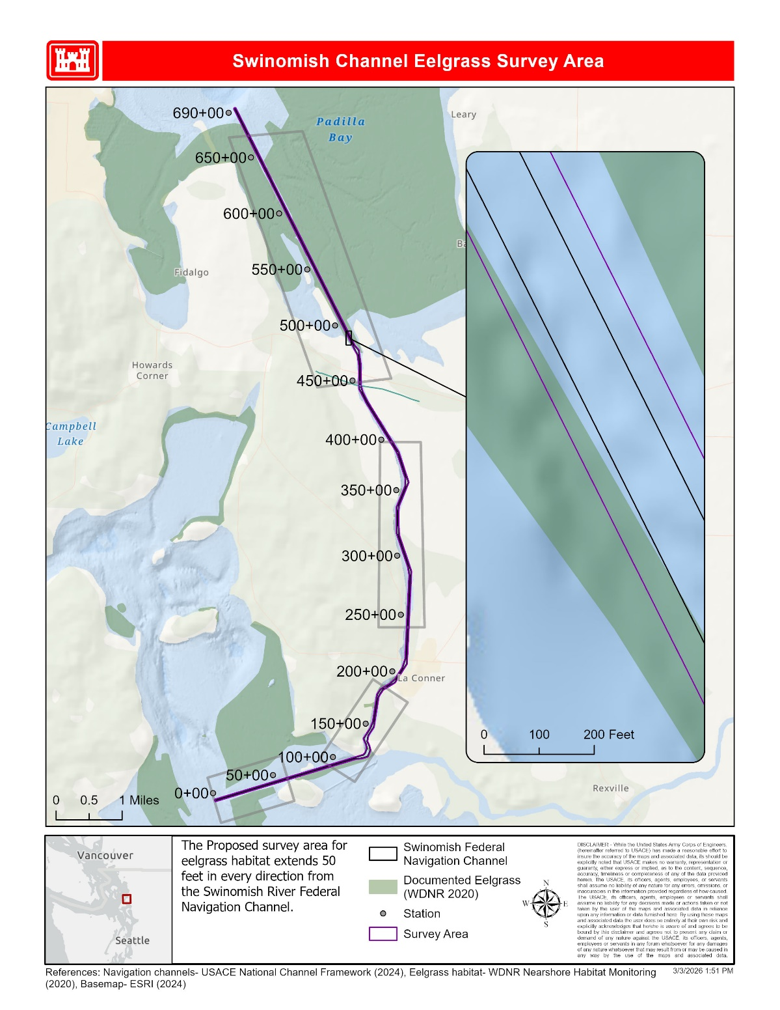
Figure 2. Section map of the Swinomish Channel showing the 50-foot survey area and eelgrass documented by Washington State Department of Natural Resources (WDNR, 2020) in the south end of the channel.
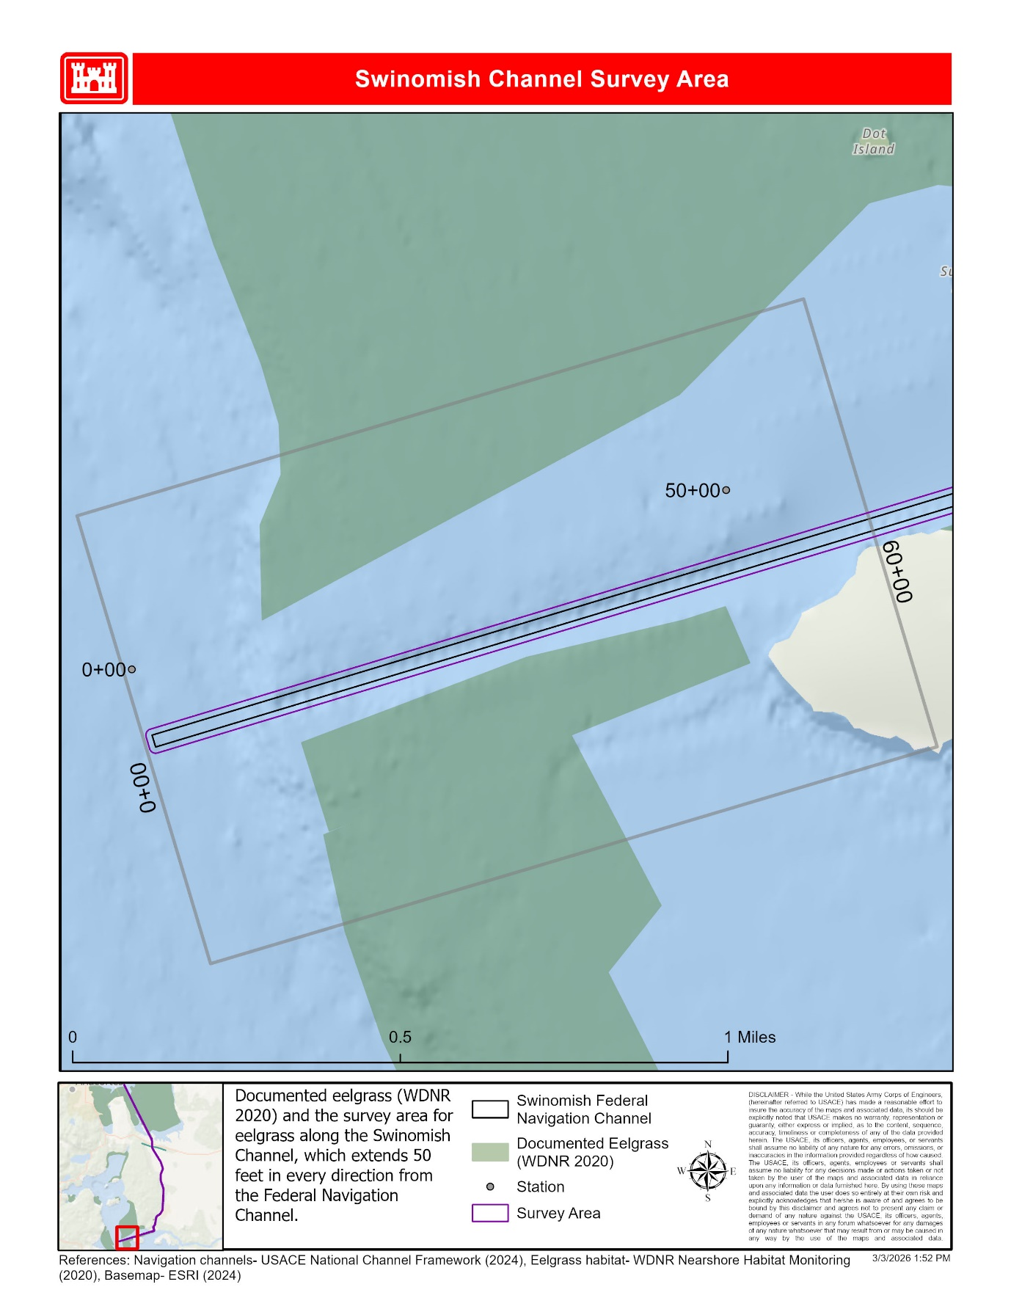
Figure 3. Section map of the Swinomish Channel showing the 50-foot survey area and eelgrass documented by Washington State Department of Natural Resources (WDNR, 2020) near the Hole-in-the-Wall area 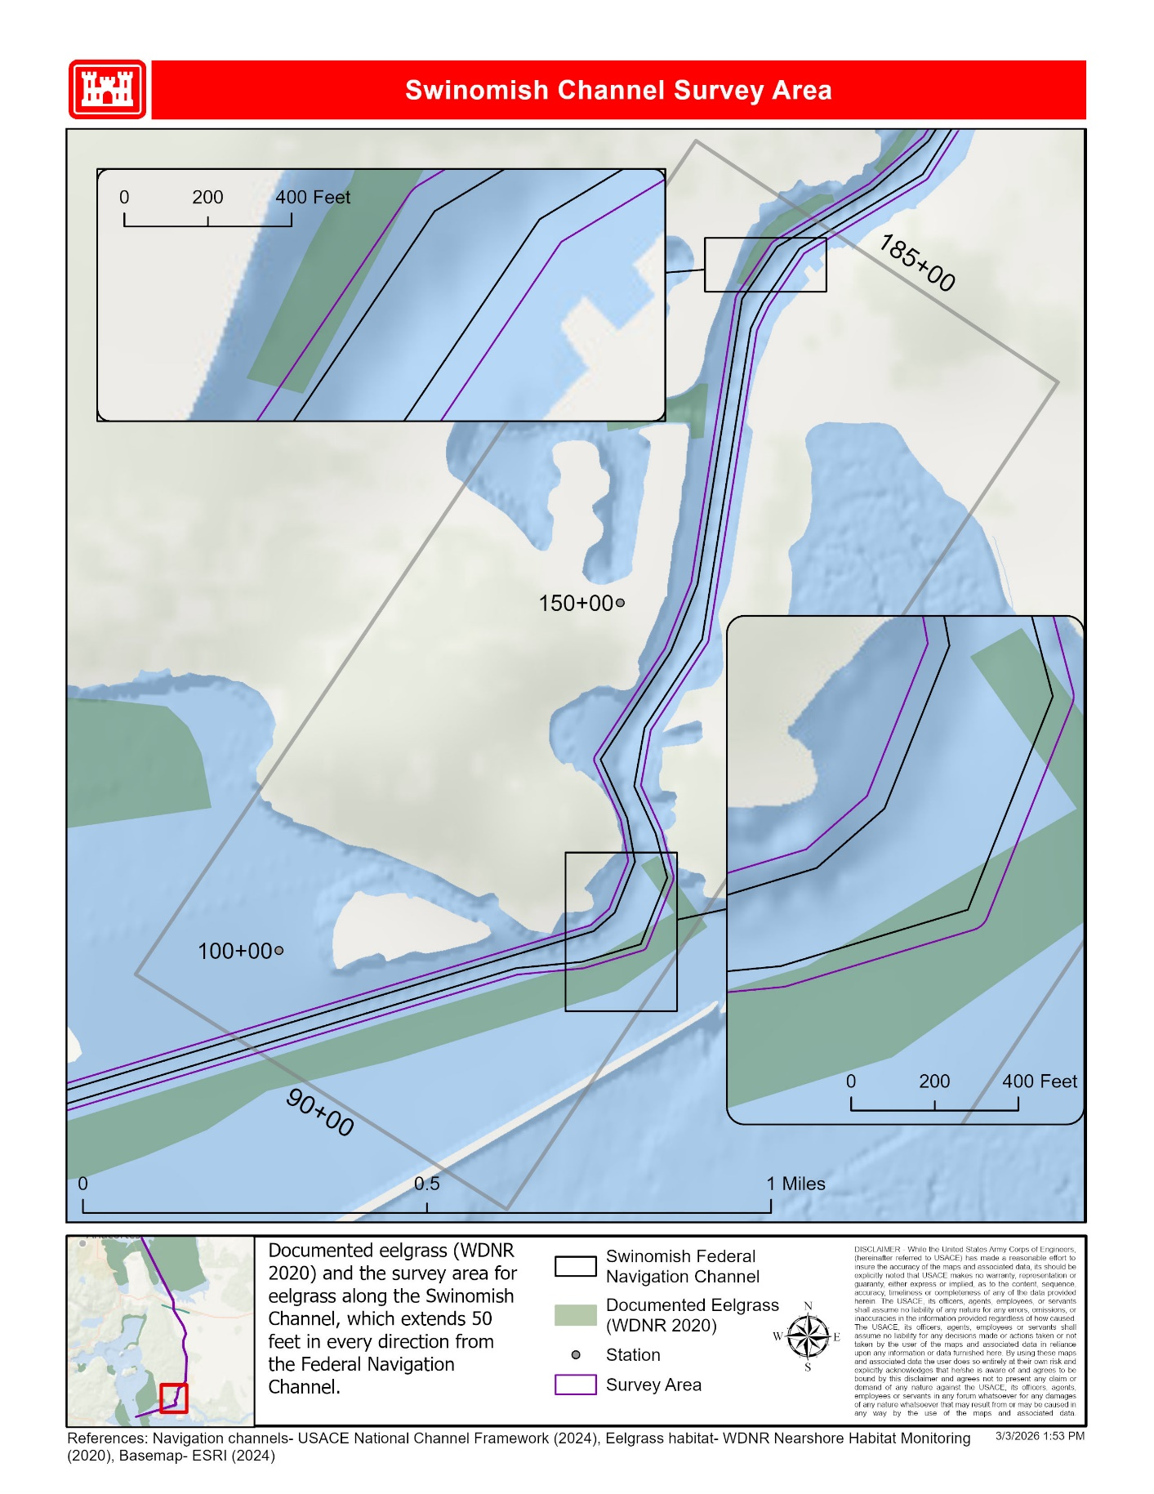Figure 4. Section map of the Swinomish Channel showing the 50-foot survey area and eelgrass documented by Washington State Department of Natural Resources (WDNR, 2020) in the middle of the channel.
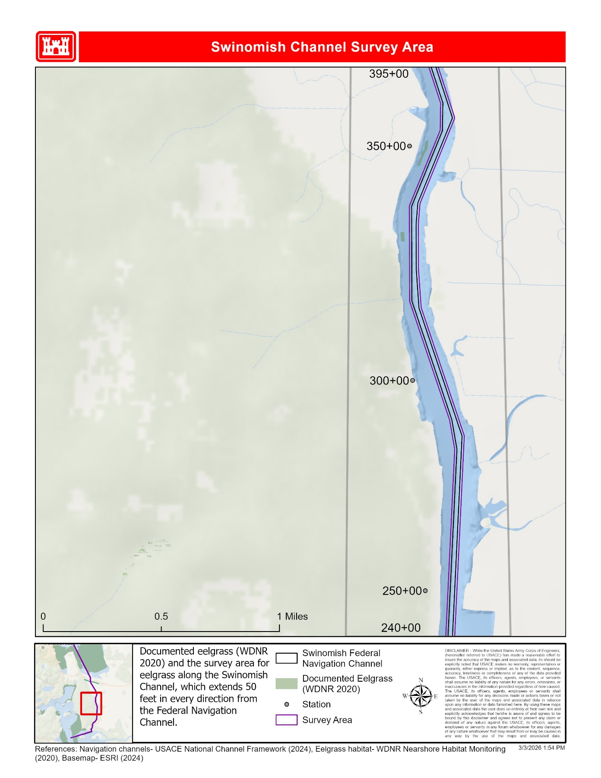
Figure 5. Section map of the Swinomish Channel showing the 50-foot survey area and eelgrass documented by Washington State Department of Natural Resources (WDNR, 2020) in the north end of the channel. 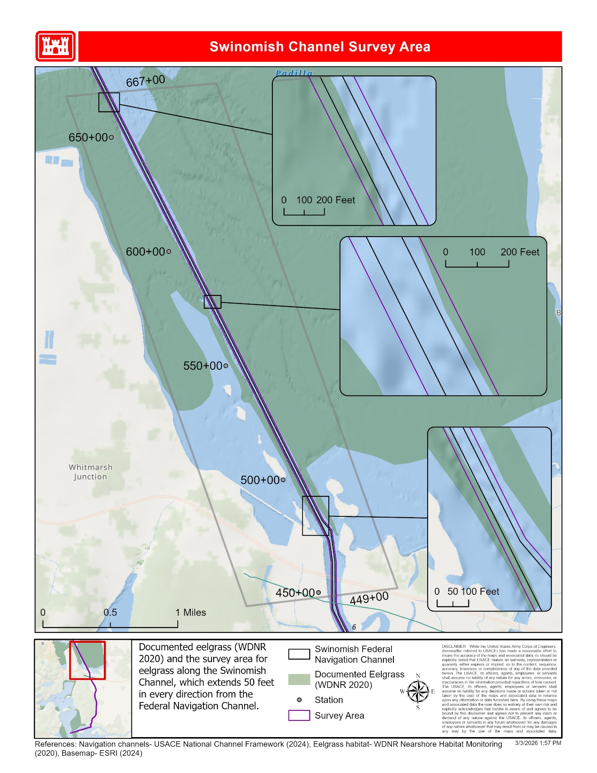

Figure 6. McGlinn Island Jetty Access Lane survey area is denoted by the yellow polygon. The green polygon represents potential areas where Zostera marina eelgrass were denoted by Washington State Department of Natural Resources (WDNR).

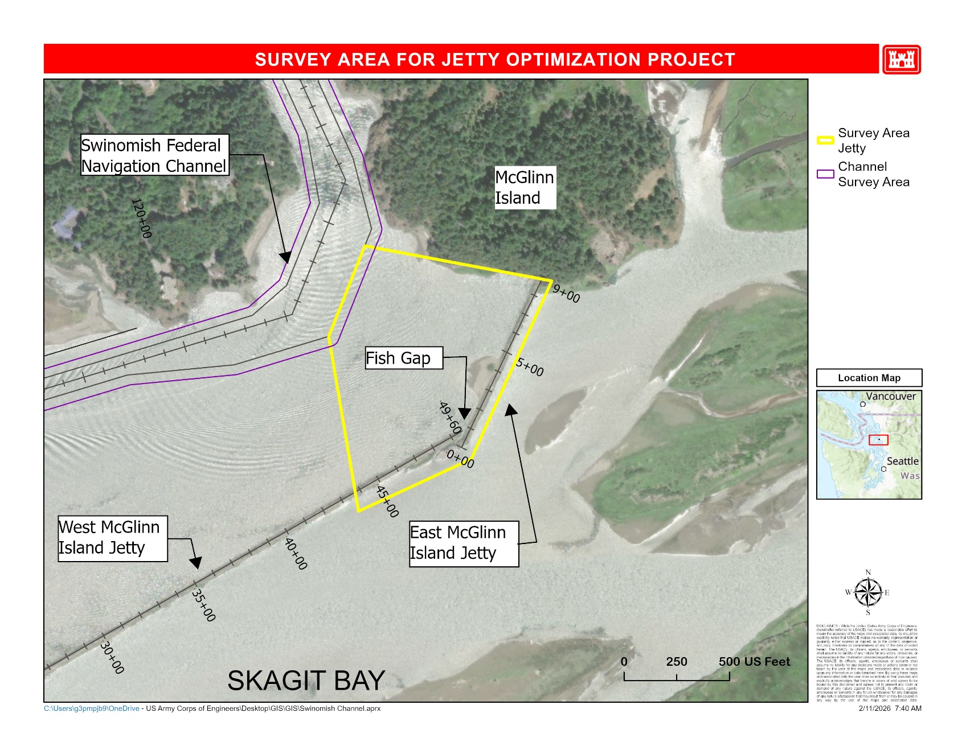

Technical Exhibit 1 – Performance Requirements Summary (PRS)

Performance Objectives
Contractor service requirements are summarized into performance objectives that relate directly to mission essential items. The performance threshold briefly describes the minimum acceptable levels of service required for each requirement. Performance objectives are listed in the table below.
Performance Objective | Standard | Performance Threshold | Method of Surveillance
Sampling and Analysis Plan (SAP) | Provide SAP that meets PWS requirements. | Meets or exceeds | USACE will evaluate performance by reviewing the SAP deliverable.
Data Collection and Processing | Collect field data in accordance with the PWS and approved SAP. | Meets or exceeds | USACE will evaluate performance by direct observation and/or reviewing the field records, daily reports, and final report.
Eelgrass Survey Report | Prepare and submit a written report in accordance with this PWS. | Meets or exceeds | USACE will evaluate performance by reviewing the report.

Technical Exhibit 2 – Deliverables Schedule
Submittal requirements for key contract deliverables are detailed in this section.
Deliverable | Frequency | Medium/Format | Submit To
Draft Sampling and Analysis Plan (SAP) | Once | Word and PDF document | COR and QAR
Revised Draft SAP | As needed until all comments are addressed. | Word and PDF document | COR and QAR
Final SAP | Once | PDF document | COR and QAR
Draft Eelgrass Survey Report | Once | Word and PDF document | QAR
Revised Draft Eelgrass Survey Report | As needed until all comments are addressed. | Word and PDF document | QAR
Eelgrass Survey Report | Once | PDF document | QAR

Transmission of Submittals
Transmit submittals electronically to the maximum extent possible. Unless otherwise noted, transmit all submittals via email or other Government-approved internet accessible service such as DoD SAFE Web application, located at the following website: https://safe.apps.mil/

