Issue Date: April 2, 2026

Due Date/Time: April 16, 2026/1200PM PST

BPA No. |  |  | 12363N23A __ __ __ __ | Project Name |  | HCRD and SMRD Invasive Treatment and Control
BPA call No. |  |  | 12363N23Q____ | Location |  | Rogue River-Siskiyou National Forest- High Cascades and Siskiyou Mountains Ranger Districts
Set-Aside |  |  | Small Business_ X_ Unrestricted_____  This will be sent out to the current BPA Award Holders.
Contractor:  UEI: |  |  |  | Issuing and Billing Office:  ROGUE RIVER-SISKIYOU NATL FOREST  3040 BIDDLE ROAD  MEDFORD OR 97504-0209
19.  ITEM NO. | 20.  SCHEDULE OF SUPPLIES/SERVICES |  |  | NAICS Code (per Scope of Work) | 21.  QUANTITY |  | 22.  UNIT | 23.  UNIT PRICE | 24.  Amount
1 | Manual Invasive Plant Treatment on Siskiyou Mountains and High Cascades Ranger Districts – See Section 1- Description/Statement of Work |  |  | 115310 | 63.5 |  | Acre
Remarks: See Attachments for additional terms and conditions. The Period of Performance for this Task Order is from the Date of Award through ______________. |  |  |  |  |  |  |  | Total Price:
No rounding off unit pricing or totals. Unit price and totals shall be in exact dollars and cents (two decimals).

Quoter shall submit copies of licensing with quote: MSPA licensing, Oregon BOLI license, and H2B Temp Employment certificate, if applicable. The same documents shall be included for all Subcontractors.
Quoter Signature:

1. DESCRIPTION/STATEMENT OF WORK

Work consists of removing, pulling, or digging up invasive plants either by hand or with tools. The plants must be pulled with as much of the root system still attached as possible (not broken off at ground level). Within the designated area, workers must pull at least 95% of the target plants. At each designated infestation (site) the species to be removed will be detailed. Workers will avoid impacts to non-target vegetation as much as possible. If the target species is at or past its blooming stage, workers must handle plants carefully to avoid spreading seeds, and pulled plants must be bagged and disposed of. There is a dumpster at the Siskiyou Mountains Ranger Station that can be used to dispose of bagged weeds. The Forest Service will provide bags.

2. SPECIFICATIONS:
Recommended tools: Tools with pointed metal heads such as small picks and jimmy bars are recommended for use in loosening soil around the roots of plants. Pulaskis or small planting shovels/trowels may be needed for removing more stubborn root systems in compact soil. Always wear gloves when pulling weeds. Some species of weeds are toxic, and continued exposure to bare hands can cause illness or allergic reactions.

Species: The three species to be removed, pulled, or dug up are spotted knapweed (Centaurea stoebe), yellow starthistle (Centaurea solstitialis), and sulfur cinquefoil (Potentilla recta).
Spotted knapweed has a fibrous taproot that can be forked. It is difficult to pull as the aerial portion of the plant easily breaks off of the root crown. This plant typically requires some loosening of the soil with a tool prior to pulling. Yellow starthistle has a fibrous root system that pulls up fairly easily in loose soil. In more compact soil, the smaller roots are more likely to break off when the plant is pulled. If the soil is compact or rocky, it is recommended to prep the plant by loosening the soil around its roots prior to pulling. Sulfur cinquefoil has a stout branched root system that spreads outward and downward making this plant impossible to pull without first loosening the soil around the root system. The base of the stem, where it attaches to the root system breaks easily. If portions of the stout root structures are left in the soil, the plants will re-sprout from those roots.

2.1 Key Personnel and Required Qualifications or Certifications

N/A

3. PROJECT LOCATION AND DESCRIPTION

The work will take place on the Siskiyou Mountains and High Cascades Ranger Districts. The infestations to be treated are all within 500 ft of a road. On the Siskiyou Mountains Ranger District the majority of the infestations are around Applegate Lake and up the Beaver Creek (FS 20) road system. Acreages are rough estimates at this time. Additional sites may be identified for work, if needed. See map and unit list for more details.

4. INSPECTION AND ACCEPTANCE:

4.1 FAR 52.246-4 INSPECTION OF SERVICES--FIXED-PRICE (AUG 1996)

(a) Definition. “Services,” as used in this clause, includes services performed, workmanship, and material furnished or utilized in the performance of services.

(b) The Contractor shall provide and maintain an inspection system acceptable to the Government covering the services under this contract. Complete records of all inspection work performed by the Contractor shall be maintained and made available to the Government during contract performance and for as long afterwards as the contract requires.

(c) The Government has the right to inspect and test all services called for by the contract, to the extent practicable at all times and places during the term of the contract. The Government shall perform inspections and tests in a manner that will not unduly delay the work.

(d) If the Government performs inspections or tests on the premises of the Contractor or a subcontractor, the Contractor shall furnish, and shall require subcontractors to furnish, at no increase in contract price, all reasonable facilities and assistance for the safe and convenient performance of these duties.

(e) If any of the services do not conform with contract requirements, the Government may require the Contractor to perform the services again in conformity with contract requirements, at no increase in contract amount. When the defects in services cannot be corrected by reperformance, the Government may—

(1) Require the Contractor to take necessary action to ensure that future performance conforms to contract requirements; and

(2) Reduce the contract price to reflect the reduced value of the services performed.

(f) If the Contractor fails to promptly perform the services again or to take the necessary action to ensure future performance in conformity with contract requirements, the Government may—

(1) By contract or otherwise, perform the services and charge to the Contractor any cost incurred by the Government that is directly related to the performance of such service; or

(2) Terminate the contract for default.

4.2 CONTRACTOR INSPECTION PROCEDURES

- General Instructions

- The Contractor shall conduct inspections of treatment units and record the results using procedures described herein. Inspections shall be maintained concurrent with contract work. Completed inspection forms shall be made available to the Government within 24 hours of completion of each treatment unit and will remain part of the permanent contract file.

- By submission of inspection forms to the Government, the Contractor is considered to be certifying that the unit is satisfactorily completed and that the inspection forms reflect the work accomplished.

- The Contractor shall submit legible inspection forms. Illegible and incomplete forms shall be returned to the Contractor for correction and re-submission.

- In the event the Contractor falsifies inspection results, as determined by the Contracting Officer, the Government may declare the Contractor to be in default of the contract. Additionally, the Government may refer such falsifications to the US Attorney’s Office for possible prosecution pursuant to 18 U.S.C. 1001 (Falsification of Government Documents) or 18 U.S.C. 287 (Fraud).

4.3 GOVERNMENT INSPECTION PROCEDURES – COMPLIANCE INSPECTION:

(A) The COR, or a designated inspector, will conduct compliance inspections while work is in progress, usually daily at first, to assure that work is proceeding satisfactorily. Compliance inspections will be accomplished by 100 percent visual inspection of each treatment unit and will be based on adherence to the required specifications / cutting prescriptions.

(B) The Contractor shall notify the COR when units are completed prior to his moving out of the general area. Compliance inspections will be conducted within three (3) business days of completion of treatment units and the Contractor notified of any part of the unit(s) requiring additional work or rework.

(Work will be accepted on the basis of visual inspection for compliance with specifications on areas reported as completed by the Contractor.)

5. COMMENCEMENT PROSECUTION, AND COMPLETION OF WORK (FAR 52.211-10) (APR 1984)

The Contractor shall be required to (a) commence work under this contract within 7 calendar days after the date the Contractor receives the notice to proceed, (b) prosecute the work diligently, and (c) complete the entire work ready for use not later than _TBD.

6. AGAR 452.215-73 POST AWARD CONFERENCE (NOV 1996)
A post award conference with the successful offeror is required. It will be scheduled within 10 days after the date of contract award. The conference will be held at:
Siskiyou Mountains RD, Rogue River Siskiyou NF
Star Ranger Station
6941 Upper Applegate Road
Jacksonville, OR 97530
POC: Botanist David Bowden
david.j.bowden@usda.gov

7. EVALUATION CRITERIA:

Contractor must send a technical capability statement briefly explaining:
How they intend to complete this contract as far as time frame, personnel, and
deliverables as well as explaining experience in survey work.

Quotes will be evaluated in two steps:

• Step 1, Quotes will be reviewed initially under a Pass/Fail evaluation to determine if the
Technical Capability meets requirements of the task order. Quotes must be signed. Those that do
not meet the requirements will be marked unresponsive. Acceptable quotes will then be
evaluated under Step 2.

• Step 2, Lowest Price with an acceptable quote will receive the award

8. CONTRACTING OFFICER’S REPRESENTATIVE:

Name: | Stuart Osbrack
Address: | 3040 Biddle Road
 | Medford, Oregon 97526
Telephone: | 541-254-4336

9. LIST OF ATTACHMENTS

The following attachments are made a part of this solicitation and any resultant contract.
Title | Pages
A. Siskiyou Mountain Ranger District Infestations and Project Area | 1
B. High Cascades Ranger District Infestations and Project Area | 1

ATTACHMENT A
Siskiyou Mountains Ranger District Infestions and Project Area
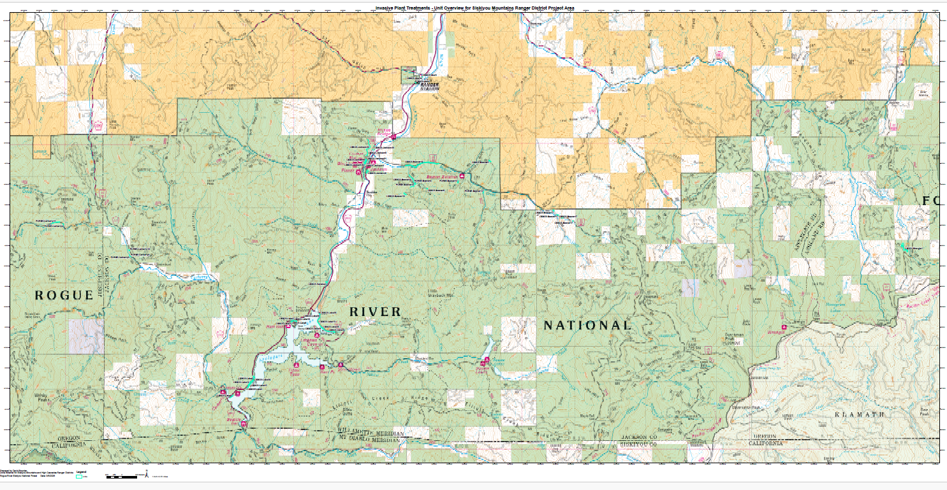

High Cascades Ranger District Infestions and Project Area
