Project Area 1: Washington Gulch Maps
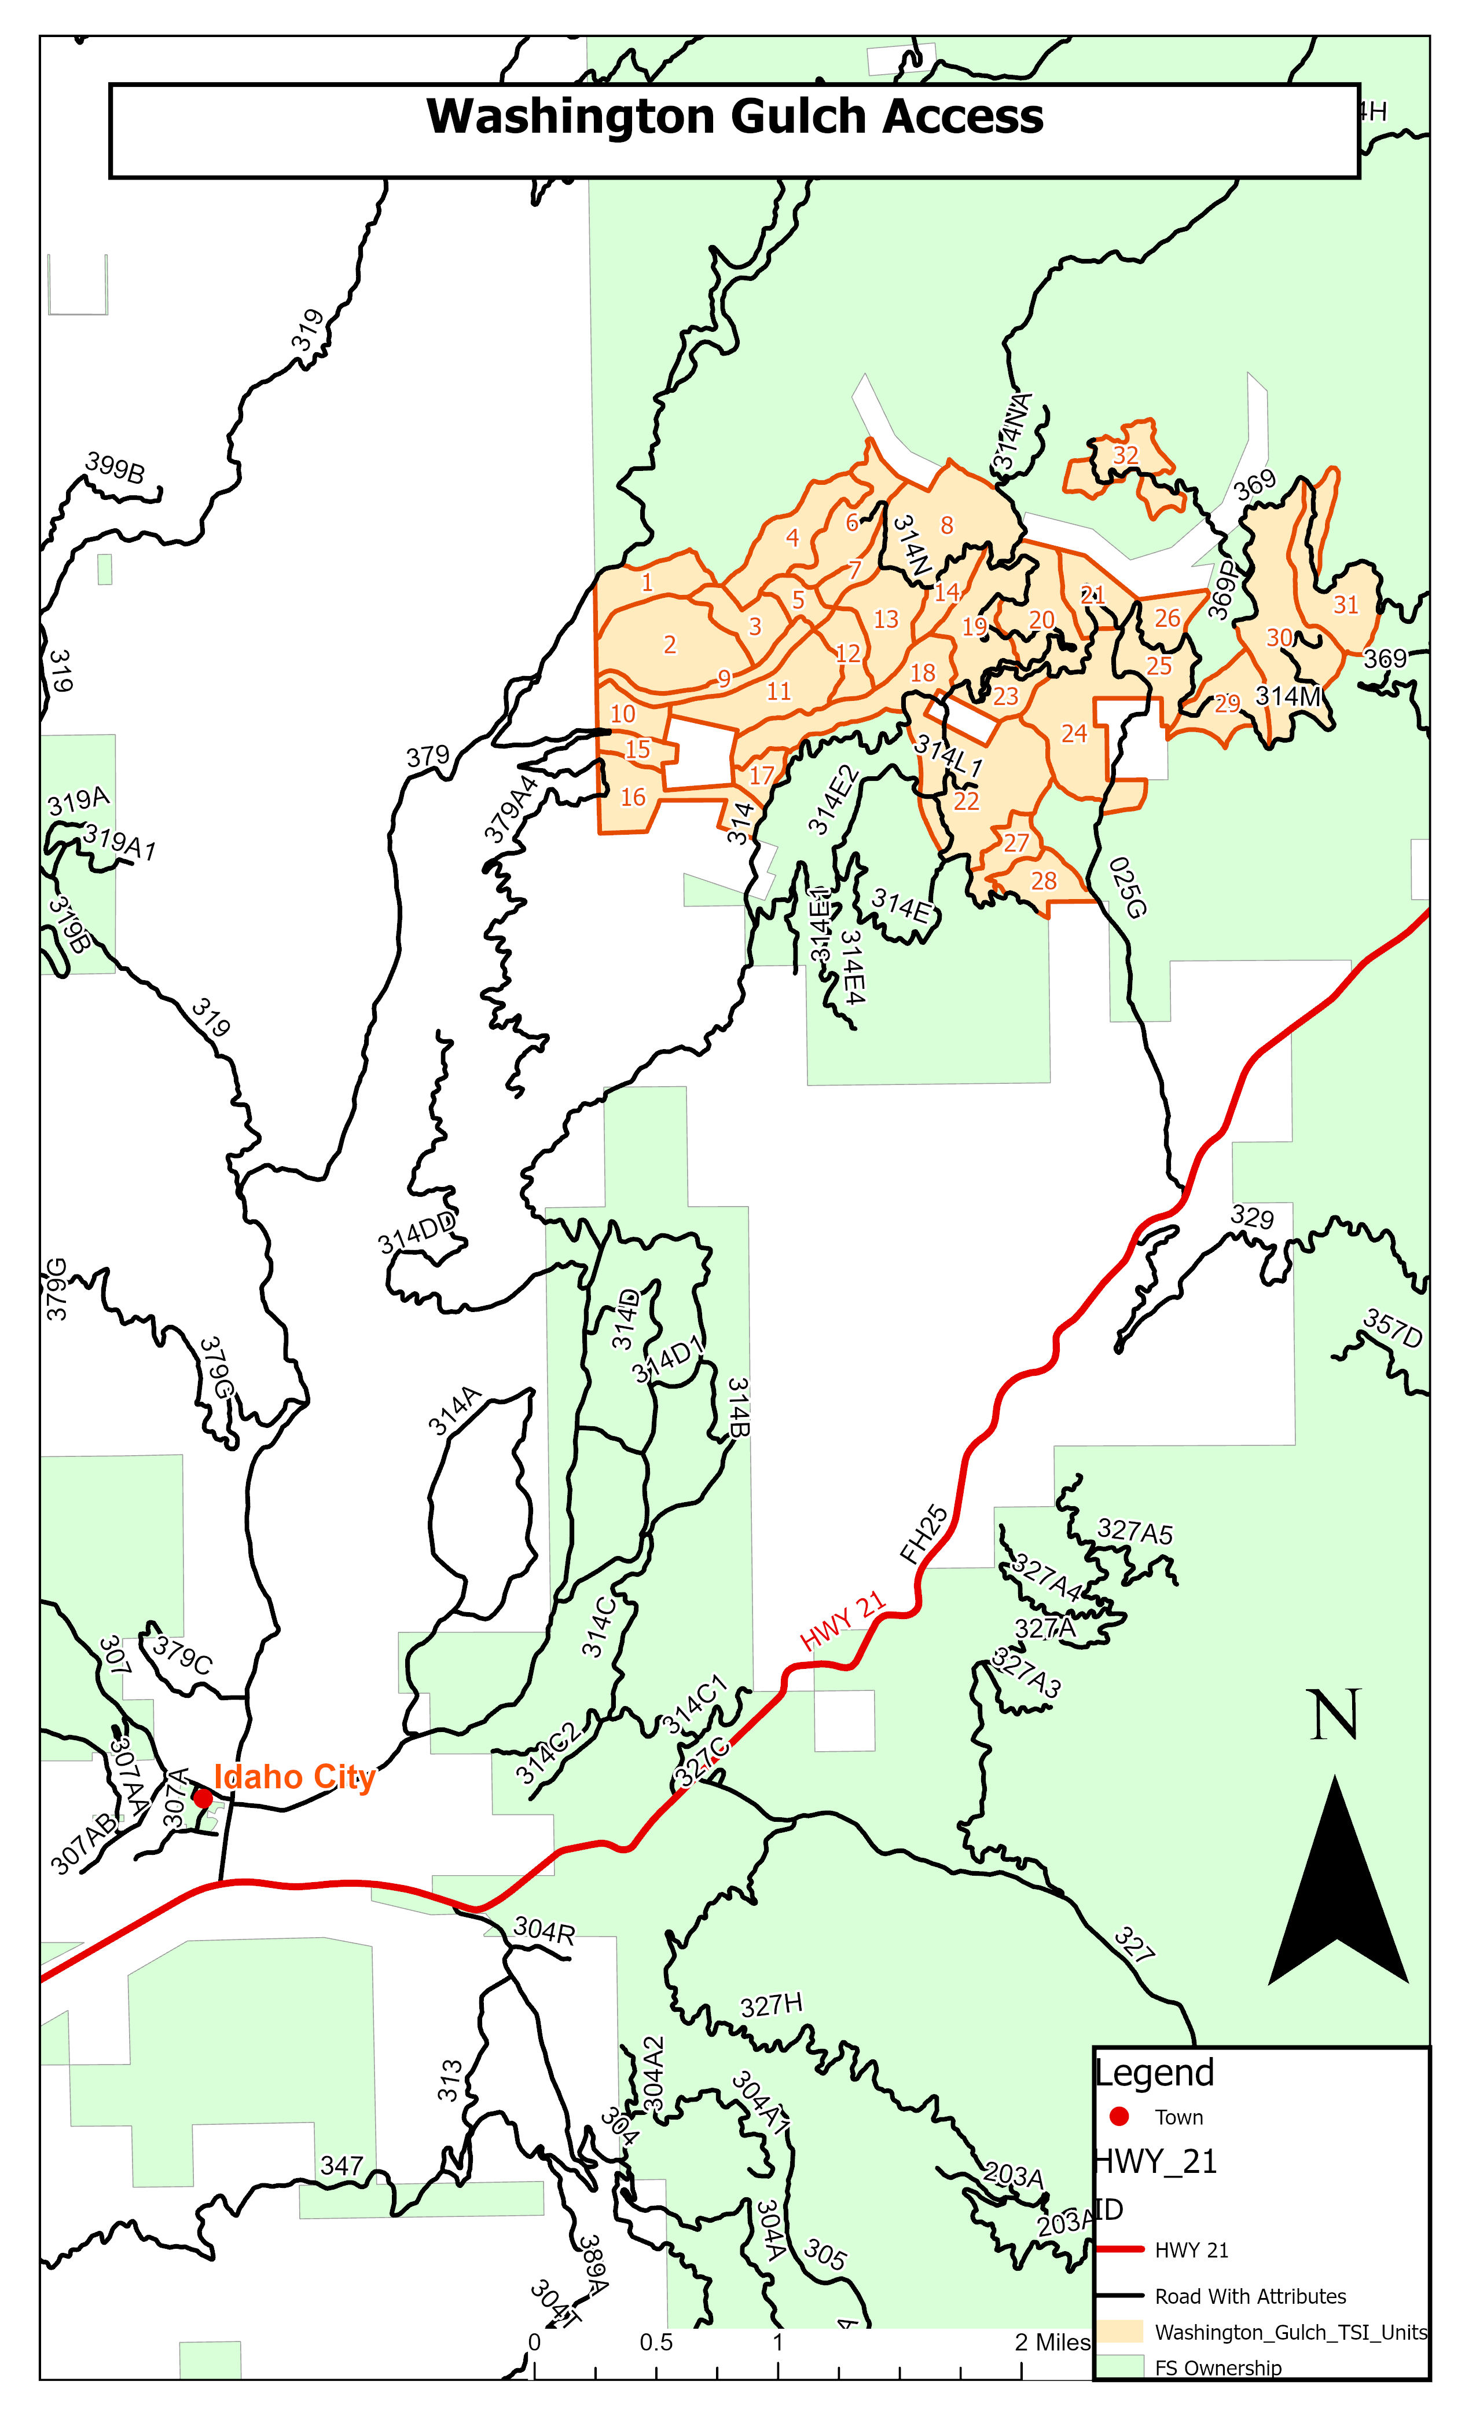

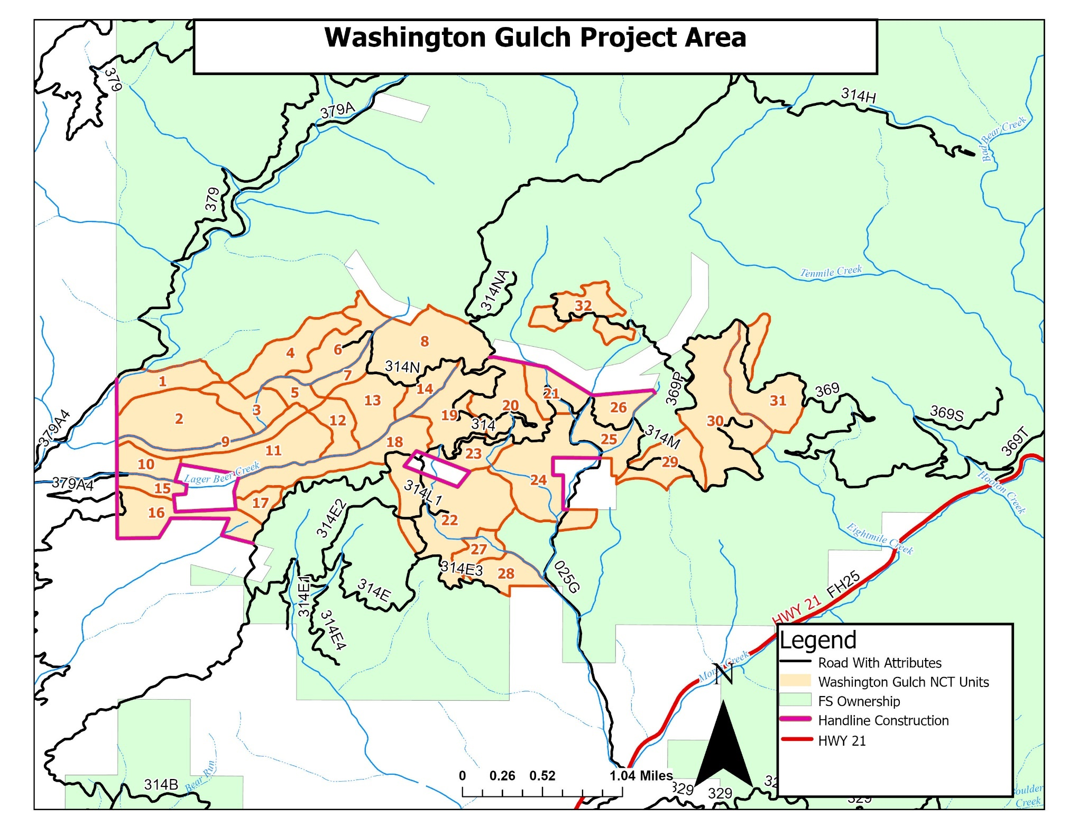
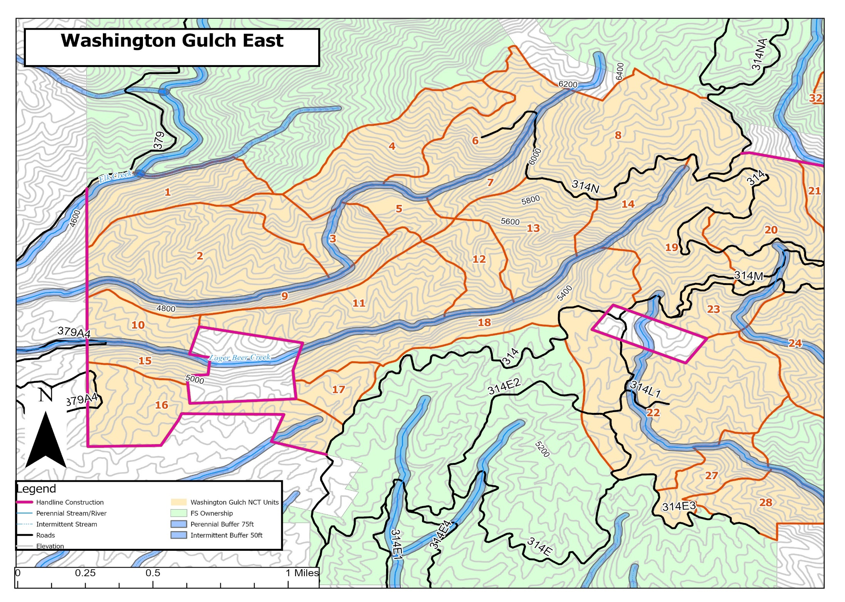
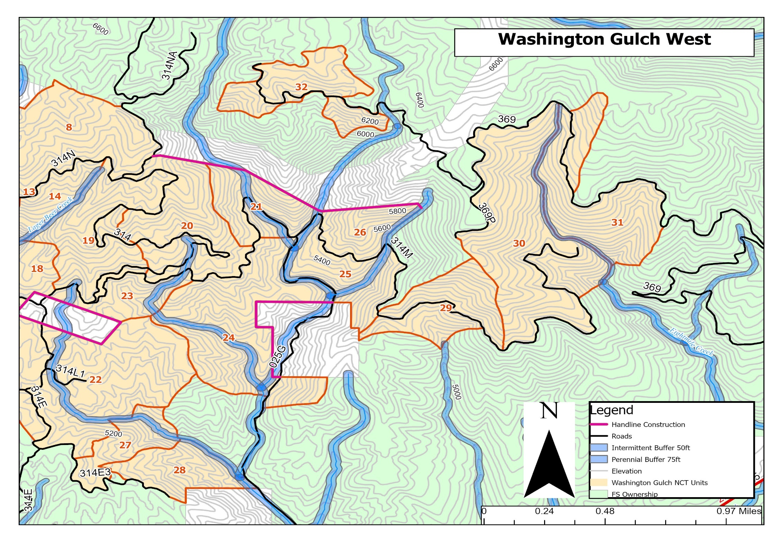
Project Area 1: Washington Gulch Summary Information Chart

Item | Site Description |  | Thinning Specs |  |  |  | Sanitation/Disease Tree Specs |  |  | Remarks
 | Area Unit No. | Acres | Average Spacing (feet) | Minimum Height (feet) | Maximum DBH (Inches) | Overstory Size to Ignore (DBH in Inches) | Minimum Damaged/ Diseased (height in feet) | Maximum Damaged (DBH in inches) | Dwarf Mistletoe Allowance | Major Work Categories/ Additional Specs
Project Area 1: Washington Gulch
1 | Unit 1 | 49 | 12-22 | 1 | 8 | N/A | 1 | 8 | none | T,SAN,HP,PAW,Access: Drive-in
1 | Unit 2 | 117 | 12-22 | 1 | 8 | N/A | 1 | 8 | none | T,SAN,HP,PAW,Access: Walk-in .25 Mile
1 | Unit 3 | 41 | 12-22 | 1 | 8 | N/A | 1 | 8 | none | T,SAN, L&S, PAW,Access: Walk-in .3 Mile
1 | Unit 4 | 70 | 12-22 | 1 | 8 | N/A | 1 | 8 | none | T,SAN,HP,PAW,Access: Walk-in .1 Mile
1 | Unit 5 | 21 | 12-22 | 1 | 8 | N/A | 1 | 8 | none | T,SAN,HP,PAW,Access: Walk-in .35 Mile
1 | Unit 6 | 61 | 12-22 | 1 | 8 | N/A | 1 | 8 | none | T,SAN,HP,PAW,Access: Drive-in
1 | Unit 7 | 21 | 12-22 | 1 | 8 | N/A | 1 | 8 | none | T,SAN, L&S, PAW,Access: Drive-in
1 | Unit 8 | 119 | 12-22 | 1 | 8 | N/A | 1 | 8 | none | T,SAN,HP,PAW,Access: Drive-in
1 | Unit 9 | 36 | 12-22 | 1 | 8 | N/A | 1 | 8 | none | T,SAN, L&S, PAW,Access: Walk-in .3 Mile
1 | Unit 10 | 30 | 12-22 | 1 | 8 | N/A | 1 | 8 | none | T,SAN, L&S, PAW,Access: Drive-in
1 | Unit 11 | 81 | 12-22 | 1 | 8 | N/A | 1 | 8 | none | T,SAN, L&S, PAW,Access: Walk-in .2 Mile
1 | Unit 12 | 33 | 12-22 | 1 | 8 | N/A | 1 | 8 | none | T,SAN,HP,PAW,Access: Walk-in .3 Mile
1 | Unit 13 | 62 | 12-22 | 1 | 8 | N/A | 1 | 8 | none | T,SAN, L&S, PAW,Access: Drive-in
1 | Unit 14 | 28 | 12-22 | 1 | 8 | N/A | 1 | 8 | none | T,SAN,HP,PAW,Access: Drive-in
1 | Unit 15 | 21 | 12-22 | 1 | 8 | N/A | 1 | 8 | none | T,SAN, L&S, PAW,Access: Drive-in
1 | Unit 16 | 72 | 12-22 | 1 | 8 | N/A | 1 | 8 | none | T,SAN,HP,PAW,Access: Drive-in
1 | Unit 17 | 20 | 12-22 | 1 | 8 | N/A | 1 | 8 | none | T,SAN, L&S, PAW,Access: Drive-in
1 | Unit 18 | 82 | 12-22 | 1 | 8 | N/A | 1 | 8 | none | T,SAN, L&S, PAW,Access: Drive-in
1 | Unit 19 | 79 | 12-22 | 1 | 8 | N/A | 1 | 8 | none | T,SAN,HP,PAW,Access: Drive-in
1 | Unit 20 | 79 | 12-22 | 1 | 8 | N/A | 1 | 8 | none | T,SAN,HP,PAW,Access: Drive-in
1 | Unit 21 | 44 | 12-22 | 1 | 8 | N/A | 1 | 8 | none | T,SAN,HP,PAW,Access: Drive-in
2 | Unit 22 | 159 | 12-22 | 1 | 8 | N/A | 1 | 8 | none | T,SAN,HP,PAW,Access: Drive-in
2 | Unit 23 | 29 | 12-22 | 1 | 8 | N/A | 1 | 8 | none | T,SAN,HP,PAW,Access: Drive-in
2 | Unit 24 | 120 | 12-22 | 1 | 8 | N/A | 1 | 8 | none | T,SAN,HP,PAW,Access: Drive-in
2 | Unit 25 | 48 | 12-22 | 1 | 8 | N/A | 1 | 8 | none | T,SAN,HP,PAW,Access: Drive-in
2 | Unit 26 | 30 | 12-22 | 1 | 8 | N/A | 1 | 8 | none | T,SAN,HP,PAW,Access: Drive-in
2 | Unit 27 | 32 | 12-22 | 1 | 8 | N/A | 1 | 8 | none | T,SAN,HP,PAW,Access: Drive-in
2 | Unit 28 | 38 | 12-22 | 1 | 8 | N/A | 1 | 8 | none | T,SAN,HP,PAW,Access: Drive-in
2 | Unit 29 | 56 | 12-22 | 1 | 8 | N/A | 1 | 8 | none | T,SAN,HP,PAW,Access: Drive-in
2 | Unit 30 | 149 | 12-22 | 1 | 8 | N/A | 1 | 8 | none | T,SAN,HP,PAW,Access: Drive-in
2 | Unit 31 | 88 | 12-22 | 1 | 8 | N/A | 1 | 8 | none | T,SAN,HP,PAW,Access: Drive-in
2 | Unit 32 | 56 | 12-22 | 1 | 8 | N/A | 1 | 8 | none | T,SAN,HP,PAW,Access: Drive-in
 | Total Acres | 1971

Abbreviations:

N/A- Not Applicable T- Thinning
DBH- Diameter Breast Height (4.5 feet above ground level) CTF- Cull tree Falling
DMT- Dwarf-Mistletoe San- Sanitation (Dwarf Mistletoe)
HP- Hand Pile (entire Unit) L&S- Lop & Scatter Slash
PAW- Pull Away Slash from residual trees DF- Directional Felling
Drivable- Access by drivable road Walk-In- Access other than drivable road
ATV- Access by All-Terrain Vehicle HPC- Hand Pile Concentrations
CTF- Damaged Tree Falling ACR- Aspen Clone Release
FO-Time- time constraints for wildlife cannot thin between May 1st and august 15th
WP-time-time constraints for wildlife cannot thin between April 1st to July 15th
P- Pruning

Project Area 2: Robie Creek Maps
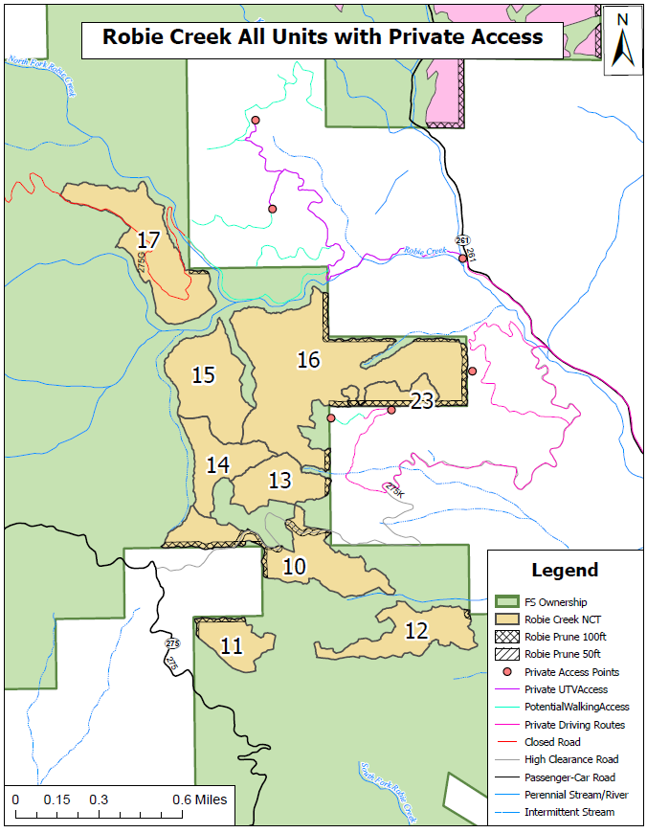

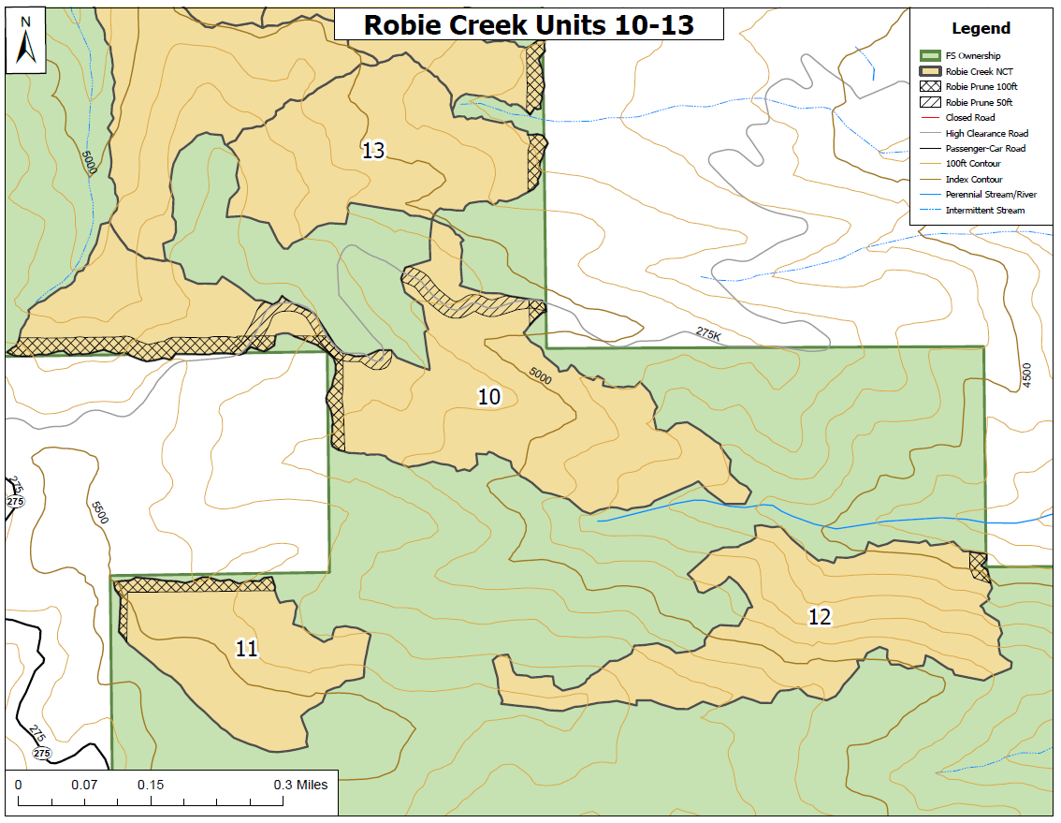

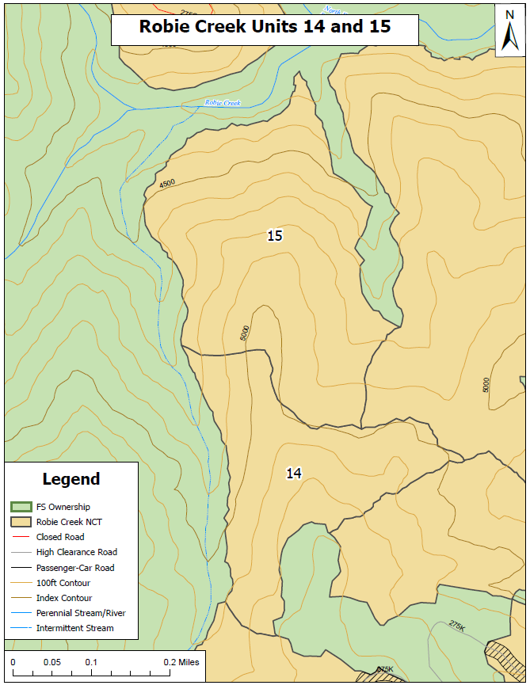
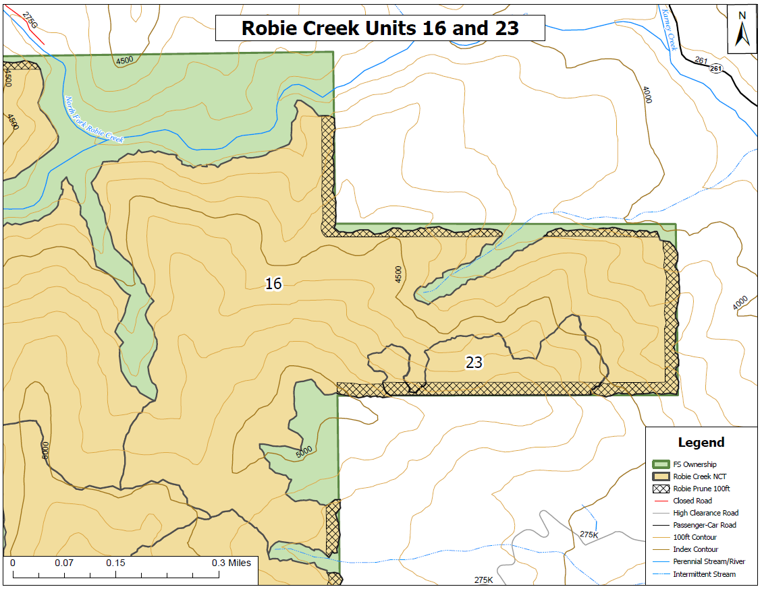
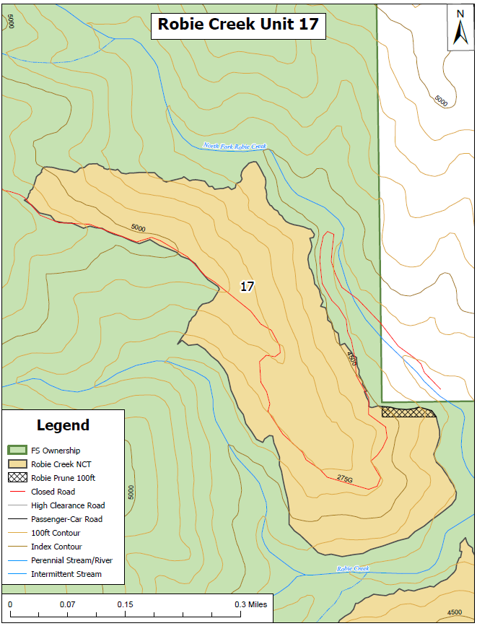
Project Area 2: Robie Creek Summary Information Chart

Item | Site Description | Thinning Specs |  |  |  |  | Sanitation/Disease Tree Specs |  |  | Remarks
 | Area Unit No. | Acres | Average Spacing (feet) | Minimum Height (feet) | Maximum DBH (Inches) | Overstory Size to Ignore (DBH in Inches) | Minimum Damaged/ Diseased (height in feet) | Maximum Damaged (DBH in inches) | Dwarf Mistletoe Allowance | Major Work Categories/ Additional Specs
Project Area 2: Robie Creek
3 | Unit 10 | 60 | See Cutting Guide | 1 | 14 | N/A | 1 | 14 | none | T, SAN, PAW, HP, P, Access: Drive in
4 | Unit 11 | 22 | See Cutting Guide | 1 | 14 | N/A | 1 | 14 | none | T, SAN, PAW, HP, P Access: Walk in .2 mile
5 | Unit 12 | 38 | See Cutting Guide | 1 | 14 | N/A | 1 | 14 | none | T, SAN, PAW, HP, P Access: Walk in .45 mile
6 | Unit 13 | 30 | See Cutting Guide | 1 | 14 | N/A | 1 | 14 | none | T, SAN, PAW, HP, P Access: Walk in .25 mile
7 | Unit 14 | 31 | See Cutting Guide | 1 | 14 | N/A | 1 | 14 | none | T, SAN, PAW, HP Access: Walk in .25 mile
8 | Unit 15 | 53 | See Cutting Guide | 1 | 14 | N/A | 1 | 14 | none | T, SAN, PAW, HP Access: Walk in .5 mile
9 | Unit 16 | 154 | See Cutting Guide | 1 | 14 | N/A | 1 | 14 | none | T, SAN, PAW, HP, P, Access: Parking S Side of Unit on Private Property
10 | Unit 17 | 64 | See Cutting Guide | 1 | 14 | N/A | 1 | 14 | none | T, SAN, PAW, HP, P, Access: Walk in .7 mile from UTV turnaround at Karney Lakes
11 | Unit 23 | 15 | See Cutting Guide | 1 | 14 | N/A | 1 | 14 | none | T, SAN, PAW, HP, P, Access: Parking S Side of Unit on Private Property
 | total acres | 467

Abbreviations:

N/A- Not Applicable T- Thinning
DBH- Diameter Breast Height (4.5 feet above ground level) CTF- Cull tree Falling
DMT- Dwarf-Mistletoe San- Sanitation (Dwarf Mistletoe)
HP- Hand Pile (entire Unit) L&S- Lop & Scatter Slash
PAW- Pull Away Slash from residual trees DF- Directional Felling
Drivable- Access by drivable road Walk-In- Access other than drivable road
ATV- Access by All-Terrain Vehicle HPC- Hand Pile Concentrations
CTF- Damaged Tree Falling ACR- Aspen Clone Release
Time- time constraints for wildlife cannot thin between May 15th and august 15th
P- Pruning

Project Area 3: Boise Peak Maps
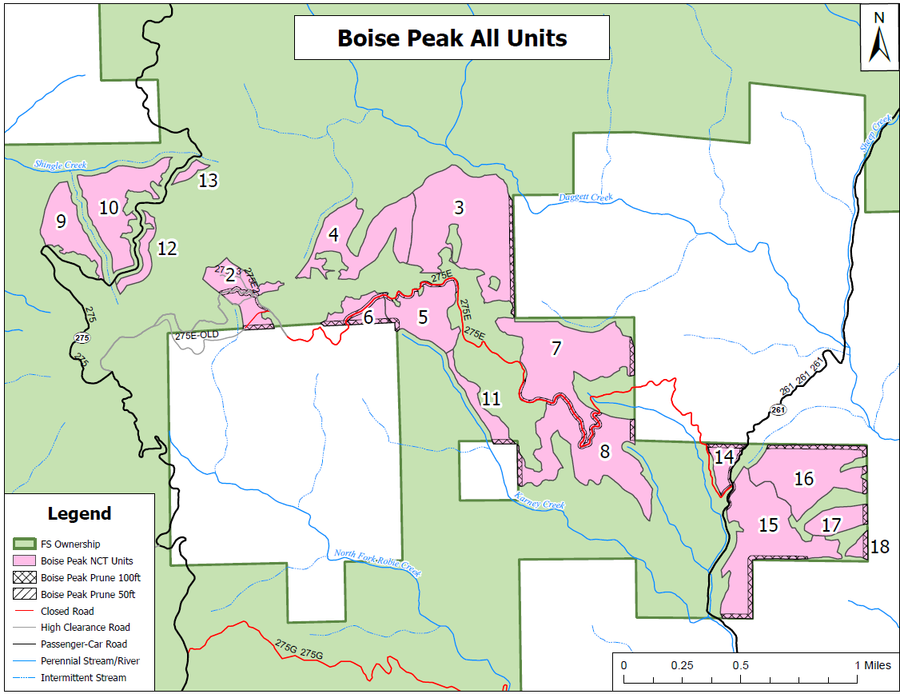
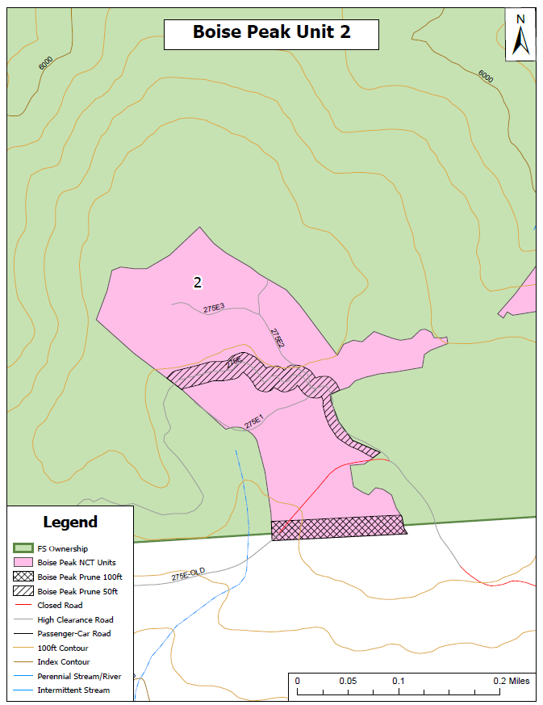

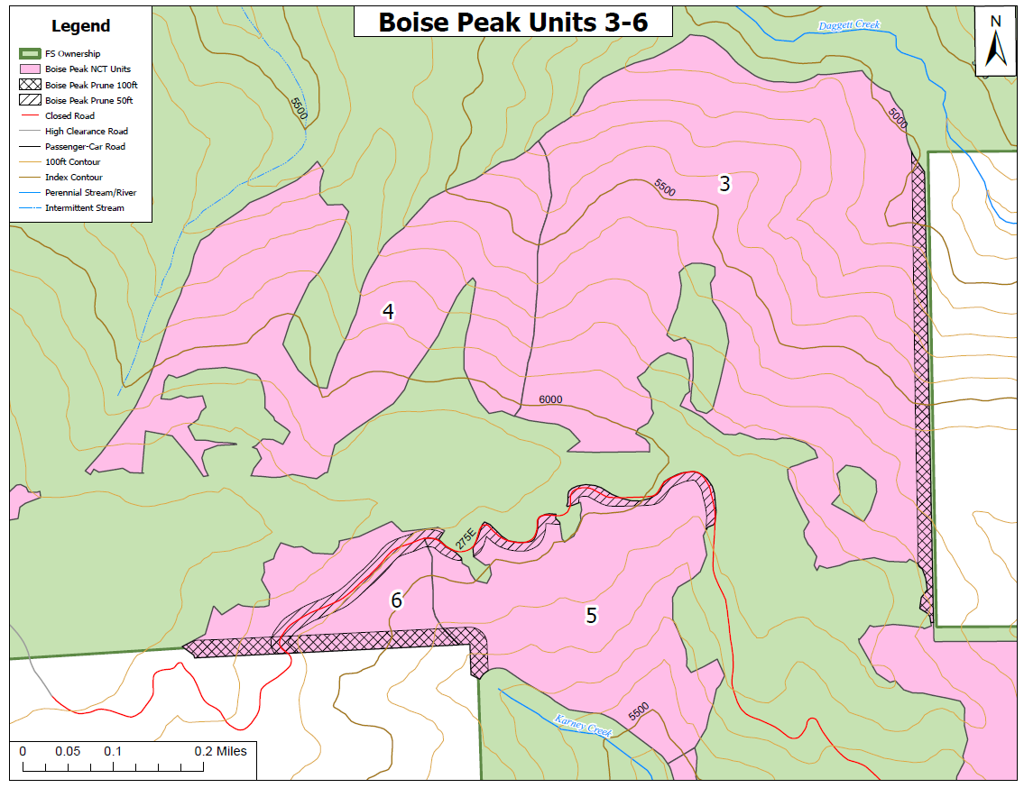
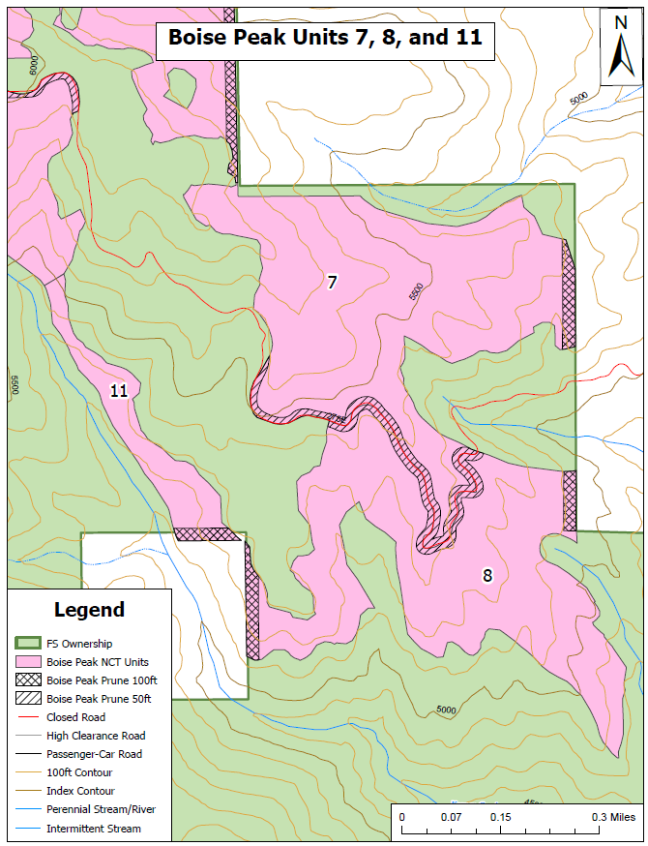
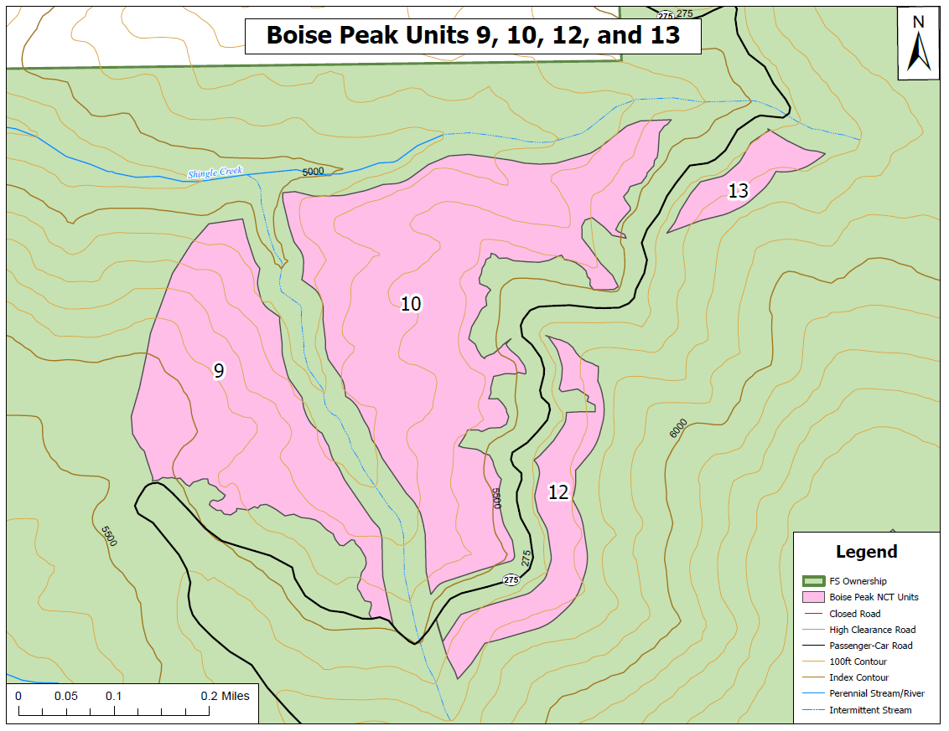
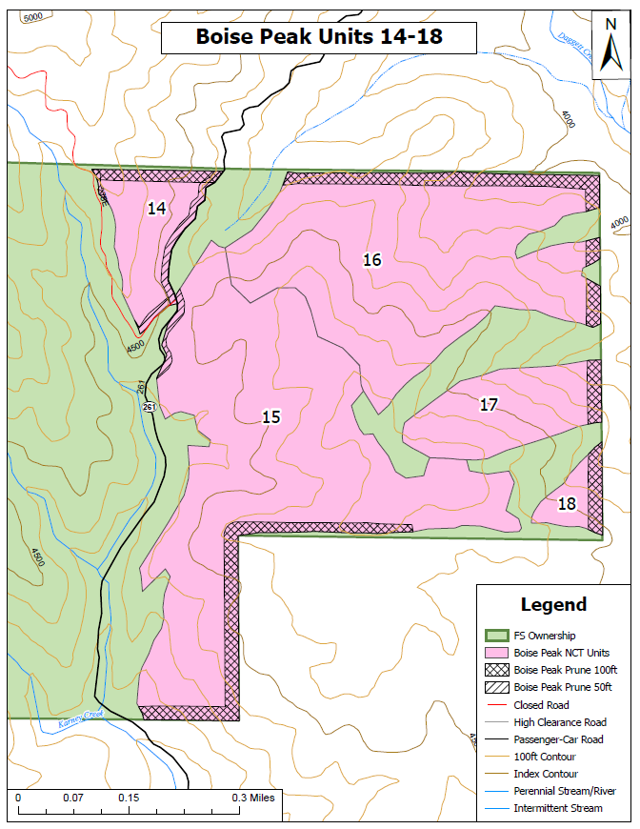

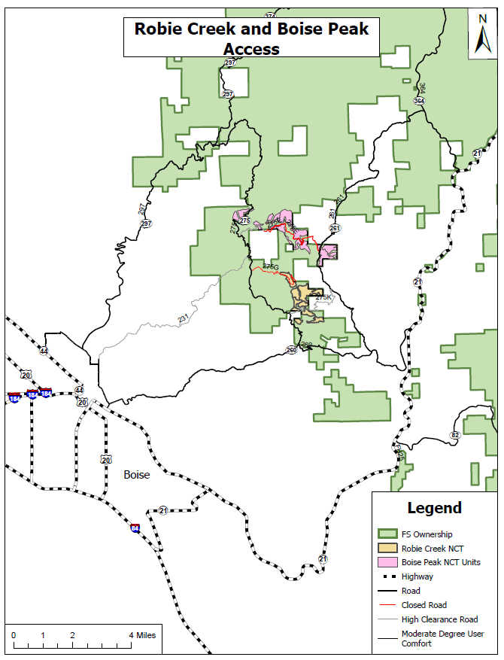
Project Area 3: Boise Peak Summary Information Chart

Item | Site Description | Thinning Specs |  |  |  |  | Sanitation/Disease Tree Specs |  |  | Remarks
 | Area Unit No. | Acres | Average Spacing (feet) | Minimum Height (feet) | Maximum DBH (Inches) | Overstory Size to Ignore (DBH in Inches) | Minimum Damaged/ Diseased (height in feet) | Maximum Damaged (DBH in inches) | Dwarf Mistletoe Allowance | Major Work Categories/ Additional Specs
Project Area 2: Boise Peak
12 | Unit 2 | 28 | See Cutting Guide | 1 | 16 | N/A | 1 | 16 | None | T, SAN, HP, PAW, P, Access: Drive-in
13 | Unit 3 | 114 | See Cutting Guide | 1 | 16 | N/A | 1 | 16 | None | T, SAN, HP, PAW, P Access: walk in 400ft
14 | Unit 4 | 55 | See Cutting Guide | 1 | 16 | N/A | 1 | 16 | None | T, SAN, PAW, HP Access: Walk in .4 mile
15 | Unit 5 | 39 | See Cutting Guide | 1 | 16 | N/A | 1 | 16 | None | T, SAN, PAW, HP, P, Access: Drive-in
16 | Unit 6 | 17 | See Cutting Guide | 1 | 16 | N/A | 1 | 16 | None | T, SAN, PAW, HP, P, Access: Drive-in
17 | Unit 7 | 90 | See Cutting Guide | 1 | 16 | N/A | 1 | 16 | none | T, SAN, PAW, HP, P, Access: Drive-in
18 | Unit 8 | 78 | See Cutting Guide | 1 | 16 | N/A | 1 | 16 | none | T, SAN, PAW, HP, P, Access: Drive-in
19 | Unit 9 | 29 | See Cutting Guide | 1 | 16 | N/A | 1 | 16 | none | T, SAN, PAW, HP, TIME Access: Walk in 250ft
20 | Unit 10 | 51 | See Cutting Guide | 1 | 16 | N/A | 1 | 16 | none | T, SAN, PAW, HP, TIME Access: Walk in 250ft
21 | Unit 11 | 14 | See Cutting Guide | 1 | 16 | N/A | 1 | 16 | none | T, SAN, PAW, HP, P Access: Walk in .2 mile
22 | Unit 12 | 10 | See Cutting Guide | 1 | 16 | N/A | 1 | 16 | none | T, SAN, PAW, HP, TIME Access: Walk in 100ft
23 | Unit 13 | 4 | See Cutting Guide | 1 | 16 | N/A | 1 | 16 | none | T, SAN, PAW, HP, TIME Access: Walk in 100ft
24 | Unit 14 | 12 | See Cutting Guide | 1 | 16 | N/A | 1 | 16 | none | T, SAN, PAW, HP, P, Access: Drive-in
25 | Unit 15 | 82 | See Cutting Guide | 1 | 16 | N/A | 1 | 16 | none | T, SAN, PAW, HP, P Access: Walk in 150ft
26 | Unit 16 | 64 | See Cutting Guide | 1 | 16 | N/A | 1 | 16 | none | T, SAN, PAW, HP, P Access: Walk in 400ft
27 | Unit 17 | 16 | See Cutting Guide | 1 | 16 | N/A | 1 | 16 | none | T, SAN, PAW, HP, P Access: Walk in .35 mile
28 | Unit 18 | 4 | See Cutting Guide | 1 | 16 | N/A | 1 | 16 | none | T, SAN, PAW, HP, P Access: Walk in .55 mile
 | Total Acres: | 707

Abbreviations:

N/A- Not Applicable T- Thinning
DBH- Diameter Breast Height (4.5 feet above ground level) CTF- Cull tree Falling
DMT- Dwarf-Mistletoe San- Sanitation (Dwarf Mistletoe)
HP- Hand Pile (entire Unit) L&S- Lop & Scatter Slash
PAW- Pull Away Slash from residual trees DF- Directional Felling
Drivable- Access by drivable road Walk-In- Access other than drivable road
ATV- Access by All-Terrain Vehicle HPC- Hand Pile Concentrations
CTF- Damaged Tree Falling ACR- Aspen Clone Release
Time- time constraints for wildlife cannot thin between May 15th and August 15th
P- Pruning

