THE SUBMISSION OF PRICING, CAPABILITIES FOR PLANNING PURPOSES, AND OTHER MARKET INFORMATION IS HIGHLY ENCOURAGED AND ALLOWED UNDER THIS RFI IN ACCORDANCE WITH (IAW) FAR 10.002(b)(2).

This is a SOURCES SOUGHT ANNOUNCEMENT ONLY.
It is neither a solicitation announcement nor a request for proposals or quotes and does not obligate the Government to award a contract. Requests for a solicitation will not receive a response. Responses to this sources sought must be in writing. The purpose of this sources sought announcement is for market research to make appropriate acquisition decisions and to gain knowledge of potential qualified Service- Disabled Veteran Owned Small Businesses and Veteran Owned Small Businesses interested and capable of providing the services described below. Documentation of technical expertise must be presented in sufficient detail for the Government to determine that your company possesses the necessary functional area expertise and experience to compete for this acquisition.

The North American Classification System (NAICS) code for this acquisition is NAICS Code

532289 (All Other Consumer Goods Rental) (12.5 million)

**Responses to this notice shall include Sources Sought number “36C78626Q50142 Crown Hill National Cemetery” in the subject line of the email no later than 3/20/2026 @ 4:00pm EST sent to April.Graves@va.gov

**The following shall be provided in the capabilities statement or in body of email:
- Company name
- Address
- Point of contact
- Phone, fax, and email
- DUNS number/ UIE number
- Type of Large or small business, e.g. Services Disabled Veteran Owned Small Business, Veteran-owned small business?
- Must provide a capability statement that addresses the organizations qualifications, years of experience and ability to perform as a contractor for the work described below.
- Provide any relevant FSS, NAC, GSA Contract vehicles the company holds if applicable.
  - If you are an FSS GSA/NAC or NASA SEWP contract holder or other federal contract holder, are the items/solutions you are providing information for available on your schedule/contract?
- Please review salient characteristics/ and provide feedback or suggestions. If none, please reply as N/A.
  - List any available options to meet needs as outlined in the statement of work.
  - Please include any questions about the statement of work below.
  - Please provide sample pricing of each deliverable if available.

________________________________________________________________________________

STATEMENT OF WORK

FRAME TENT AND CHAIRS

1. GENERAL INFORMATION
This is a supply-based contract for cemetery grounds needs at Crown Hill National Cemetery, 725 W. 42nd Street, Indianapolis, IN 46208, hereafter referred to as “CHNC” or “Cemetery.” The overall responsibility of the Contractor is to provide a tent and chairs for the public use during our 2026 Memorial Day ceremony.

2. THE NATIONAL CEMETARY ADMINISTRATION MISSION
The National Cemetery Administration honors veterans with a final resting place and lasting memorial that commemorates their service to our Nation. The standards for management, maintenance, appearance, and operational procedures performed by the Contractor have been established by the National Cemetery Administration to reflect this Nation’s elevated regard and respect for those interred there. Further, each National Cemetery is to be maintained as a National Shrine. A National Shrine is defined as a place of honor and memory that impresses upon the visitor/family who views it, that it is a majestic setting, offering a sense of serenity, historic sacrifice, and nobility of purpose. The National Cemetery is a beautiful and awe-inspiring tribute to those who gave much to preserve our Nation’s freedom and way of life.

3. CONTRACT OBJECTIVES
The life of the contract is a single purchase order for rental and services with no option years included.

4. DESCRIPTION OF EVENT PREPARATION
The Contractor shall furnish the event equipment, which will include:
- Frame Tent – the desired square feet of coverage is 30’ x 90’ area or equivalent (for 2700 sq. ft.) depending on schematics available.
- 250 folding chairs
- 8’ x 16’ stage
- Stage access steps
- Stage skirt
- Fire package for safety
- 811/utility verification prior to plating tent spikes
- Labor for set-up of all equipment

5. CONTRACTOR WORK HOURS AND WORKDAYS
All delivery and pick-up work will be done during the normal Federal workdays between the hours of 7:30 am and 4:00 pm.

A Standard Delivery offers a 3-Day Window which allows Contractor the ability to best route the delivery vehicles; Wednesday, 5/20 - Friday, 5/22.

A Standard Pickup offers a 2-Day Window which allows Contractor the
ability to best route the delivery vehicles; Tuesday, 5/26 - Wednesday, 5/27.

6. ADMINISTRATIVE RESPONSIBILITIES
Prior to the event, verification must be made regarding placing of tent spikes. This will be determined by the Cemetery, to coordinate with utility providers to ensure safe placement of the equipment. The Contractor is expected to wait for the Cemetery to make this determination before beginning the tent set-up.
The City of Indianapolis may also require licenses. In prior years, they have waived the requirement because our site is Federal property, and we maintain adequate procedures for fire safety. In case that status changes with the City, the Contractor should be aware of what is needed. If so, it is the responsibility of the Contractor to assure that these licenses have been obtained prior to beginning work. The Contractor is expected to maintain frequent and timely communications with Cemetery staff while these matters are resolved.
Cemetery personnel contact information:
Event Coordination: Erin Hamilton
Alternate: Rita Hunter-Haug

7. CONTRACTOR FURNISHED EQUIPMENT
The Contractor will furnish all personnel, equipment, tools, materials, supervision, transportation, and other items required to successfully perform the services specified in the contract.

8. SAFETY AND SECURITY
- The contractor shall always exercise care and caution in performing the duties described in the statement of work so as not to cause injury to themselves or other persons. The contractor shall perform the assigned tasks and duties in a safe manner in accordance with the VA, NCS, and OSHA regulations and policies. The contractor shall indemnify to protect itself and render the United States Government, its employees, agents, and representative harmless from any liability resulting from personal injury arising out of performance of the work contained herein. The contractor shall maintain insurance in accordance with FAR 52-228-5, Insurance – Work on a Government Installation, in an amount not less than $100,000 per occurrence per person. The contractor shall provide evidence of insurance coverage, as well as evidence that employees performing work under the contract are bonded or otherwise insured against theft, damage, and loss.
- The contractor and contractor’s employees shall follow the cemetery smoking policy. The policy is available at the cemetery.
- The contractor shall be responsible for any damage to Government and/or personal property. All damage by the contractor shall be repaired or replaced by the contractor at no additional cost to the Government.
- Contractor shall provide all safety warning devices at the worksite to eliminate all hazards to visitors and cemetery employees.

ATTACHMENTS
- Site map
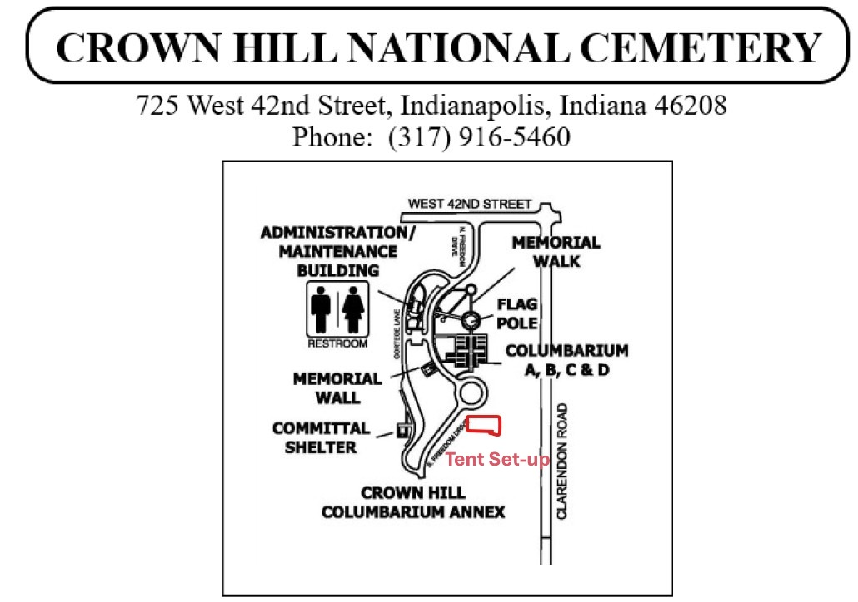

END OF STATEMENT OF NEED

