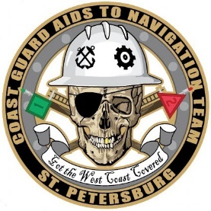
DEPARTMENT OF HOMELAND SECURITY
UNITED STATES COAST GUARD
Aids to Navigation Team St. Petersburg, FL

Statement of Work
Commercial Dive Operations & Salvage for ATON - Seahorse Reef Light

1. Description of Work: The contractor shall provide all labor, material, and insurance to cut and remove four steel piles from the remaining structure at Seahorse Reef Light. Wreckage remains at the following aid location:

- Seahorse Reef Light 28-58-31.211N, 083-09-13.280W

The period of performance is to be determined and the date of operations for this work is dependent on the weather. A total of four days will be given to complete the removal, recovery, and disposal for the wreckage remaining at Seahorse Reef Light. The work consists of providing full time supervision, certified commercial divers (3), 28’ dive boat, surface supplied diving equipment, hard wire communications, underwater burning torch, diving related expendables, materials, and insurance to remove and dispose of a total of 4 single pile steel markers as follows:
- Provide mobilization of men (3) and equipment
- Provide truck, dive boat, and trailer
- Provide underwater burning equipment
- Provide dump truck for disposal of 4 pile remnants
- Provide lodging and sustenance for 3 men for 3 nights
- Attend site – cut 4 single pile steel marker structures at the existing groundline – recover steel pile stumps
- Provide proper disposal of damaged piling remnants and signs
- Demobilize crew and equipment

The contractor is responsible for removing all remaining wreckage off bottom of river floor and disposal. If Coast Guard property is still attached the contractor is responsible to contact Aids to Navigation Team St. Petersburg, FL for pick up of property.
2. The Coast Guard will not provide any equipment or assistance for this project. ANT St. Petersburg will retrieve equipment from the contractor at the conclusion of the project (if any). Upon completion of work and removal of piles/wreckage, the contractor will do their best to provide pictures or video footage of wreckage removed from the bottom.
3. The contractor is responsible to visit the area and submit their bid proposal.
4. The contractor shall comply with the Immigration and Nationality Act (INA).
5. The contractor shall comply with all industrial safety requirements, personnel protective equipment (PPE), and OSHA Safety and Health Standards Digest (latest version) throughout all the activities and operations surrounding this evolution.

6. The contractor shall coordinate all required work with the St. Petersburg Aids to Navigation Officer in Charge, BMC Brittany Barlow at (727) 272-6847 or via e-mail at Brittany.E.Barlow@uscg.mil.

7. Examples of what destroyed aid/wreckage needing to be cut and removed is attached with pictures below.
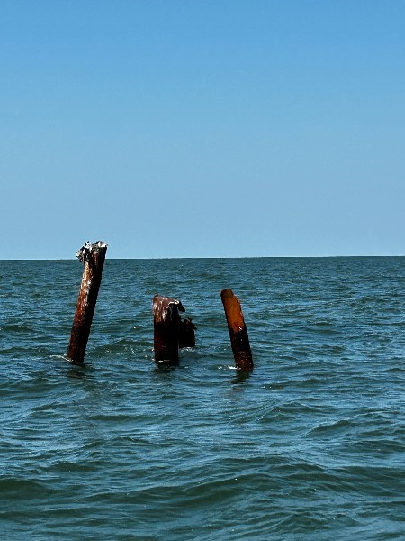
Seahorse Reef Light:

- Environmental concerns and mitigations:

- Steel wreckage that is cut at the mudline by the divers will be disposed of in a commercial dumpster being rented by the salvage company. Salvage company will be solely responsible for proper disposal of cut ATON markers and will ensure steel wreckage cut is not left on the seafloor.
- Steel wreckage cut is approximately 8’ in length from the mudline to the waterline, + or – 2’. The stumps or steel wreckage that will be cut are small enough to fit in the dive boat or be properly towed by the boat being used by the salvage/dive company.
- Dive company will not be using a barge or vessel that needs to spud down and disturb the seafloor.

