

BROAD AGENCY ANNOUNCEMENT (BAA) GUIDE FOR
INDUSTRY

Version 2.2
Jan 2025

SUMMARY OF CHANGES

Version 1.1 | Updated Chapter 3 to clarify communications with Industry | Mar 2015
Version 2.0 | Major re-write to update review process and regulation references | Mar 2020
Version 2.1 | Administrative Updates | April 2024
Version 2.2 | Administrative Update | Jan 2025

TABLE OF CONTENTS
Contents
SUMMARY OF CHANGES 2
B. PROPOSAL RETENTION 34 4
CHAPTER 11: ASSISTANCE INSTRUMENTS 35 4
C. WHEN A GRANT WOULD BE AWARDED 35 4
D. WHEN A COOPERATIVE AGREEMENT WOULD BE AWARDED……..36 4
E. WHEN AN OTHER TRANSACTION FOR RESEARCHWOULD BE AWARDED… 36 4
ATTACHMENT 1 GRAPHIC DEPICTION OF COMMON BAAs 38 4
ATTACHMENT 2 SAMPLE STATEMENT OF WORK 43 4
CHAPTER 1: INTRODUCTION 5
A. OVERVIEW 5
B. CRITERIA FOR USE 5
CHAPTER 2: DEFINITIONS 6
CHAPTER 3: PROCESSES 9
B. BAA VARIATIONS 11
CHAPTER 4: BAA ANNOUNCEMENT 14
A BAA announcement may include the following general categories: BROAD AGENCY ANNOUNCEMENT 14
CHAPTER 5: FREQUENTLY ASKED QUESTIONS 16
CHAPTER 6: WHITE PAPER PREPARATION 18
C. CONTENTS 18
CHAPTER 7: PROPOSAL PREPARATION 20
B. PROPOSAL TABLE OF CONTENTS/CHECKLIST 21
Note: Always compare this guide’s instructions with the announcement instructions as they may vary for some projects and may differ somewhat from the instructions herein. Should that occur, you must comply with the announcement instructions. 21
PART III --- Contractor Statement of Work (SOW) 25
NOTE: Review the SOW instructions in the announcement. If instructions are different from this guide, comply with the announcement instructions. 25
PART IV --- Guidelines for Cost Proposals 27
NOTE: Review the cost proposal instructions in the announcement. If instructions are different from this guide, comply with the announcement instructions. 27
CHAPTER 8: WHITE PAPER/PROPOSAL REVIEW 31
A. WHITE PAPER REVIEW 31
B. PROPOSAL REVIEW 31
C. AWARDS 32
2. Sequence of Awards: 32
CHAPTER 9: NEGOTIATION TO AWARD 33
A. NOTIFICATION OF AWARD DECISION 33
B. MODEL DOCUMENT 33
C. TECHNICAL AND COST NEGOTIATIONS 33
CHAPTER 10: FEEDBACK SESSIONS 36
A. FEEDBACK SESSIONS 36
B. PROPOSAL RETENTION 36
CHAPTER 11: ASSISTANCE INSTRUMENTS 37
A. BACKGROUND 37
B. GENERAL 37
C. WHEN A GRANT WOULD BE AWARDED 37
D. WHEN A CA WOULD BE AWARDED 38
E. WHEN AN OTHER TRANSACTION (OT) FOR RESEARCH WOULD BE AWARDED 38
F. WHEN A TECHNOLOGY INVESTMENT AGREEMENT WOULD BE AWARDED 39
ATTACHMENT 1: GRAPHIC DEPICTIONS OF COMMON BAAs 40
Two-Step Open BAA 41
One-Step Closed BAA 42
Open One-Step BAA 44
1.0 OBJECTIVE: 45
2.0 SCOPE: 45
3.0 BACKGROUND: 45
4.0 TASKS/TECHNICAL REQUIREMENTS: 45

- FEEDBACK SESSIONS 34

PROPOSAL RETENTION 34

CHAPTER 11: ASSISTANCE INSTRUMENTS 35
- BACKGROUND 35
- GENERAL 35

WHEN A GRANT WOULD BE AWARDED 35

WHEN A COOPERATIVE AGREEMENT WOULD BE AWARDED……..36

WHEN AN OTHER TRANSACTION FOR RESEARCHWOULD BE AWARDED… 36
- WHEN A TECHNOLOGY INVESTMENT AGREEMENT WOULD BE AWARDED 37

ATTACHMENT 1 GRAPHIC DEPICTION OF COMMON BAAs 38

ATTACHMENT 2 SAMPLE STATEMENT OF WORK 43

CHAPTER 1: INTRODUCTION

OVERVIEW

Broad Agency Announcements (BAAs) are solicitation methods for Research and Development (R&D) efforts based on synopses published in the Governmentwide Point of Entry (GPE) and/or Grants.gov that provide for full and open competition in accordance with (IAW) Federal Acquisition Regulations (FAR) 6.102(d)(2) and merit-based, competitive procedures IAW Office of Management and Budget (OMB) guidance, “Uniform Administrative Requirements, Cost Principles, and Audit Requirements for Federal Awards,” published in the Code of Federal Regulations (CFR) at 2 CFR part 200 and implemented by the DoD at 2 CFR part 1104, “Implementation of Governmentwide Guidance for Grants and Cooperative Agreements”. Provisions of the DoD Grants and Agreements Regulations (DoDGARs) other than 32 CFR parts 32 and 33 continue to be in effect, with applicability as stated in those provisions. BAAs are established in FAR 35.016 and are authorized for the acquisition of basic and applied research and that part of development not related to the development of a specific system or hardware procurement. The objective of a BAA is to encourage participation by science and technology firms and educational institutions in meeting Air Force R&D goals for innovative ideas and approaches for research that is general in nature.

CRITERIA FOR USE

Use of a BAA to solicit for research and development is encouraged when:

  - The Government desires new and creative solutions to problem statements.
  - Using a conventional statement of work could result in unintentionally stifling ideas and concepts given many possible approaches.
  - Fulfilling requirements for scientific study and experimentation directed toward advancing the state-of-the-art or increasing knowledge or understanding rather than focusing on a specific system or hardware solution.
  - The Government must be able to state its objectives in terms of areas of need or interest rather than specific solutions or outcomes.
  - Meaningful proposals with varying technical/scientific approaches are reasonably anticipated.

CHAPTER 2: DEFINITIONS

Agreements Officer: Title given to a person with the authority to enter into, administer, and/or terminate non-FAR based acquisitions.

Assistance Instrument: Business arrangement that is appropriate when the goal of the program is to transfer a thing of value to accomplish a public purpose of support or stimulation as authorized by law. Assistance instruments include Grants, Cooperative Agreements (CAs), Technology Investment Agreements (TIAs), and Other Transactions (OTs). Assistance instruments are covered by Office of Management and Budget (OMB) guidance, “Uniform Administrative Requirements, Cost Principles, and Audit Requirements for Federal Awards,” published in the Code of Federal Regulations (CFR) at 2 CFR part 200 and implemented by the DoD at 2 CFR part 1103, “Interim Grants and Cooperative Agreements Implementation of Guidance in 2 CFR part 200” (79 FR 76047, December 19, 2014).

Broad Agency Announcement (BAA): A general announcement of an agency’s research interest including criteria for selecting proposals and soliciting the participation of all offerors capable of satisfying the Government’s needs. (See FAR 6.102(d)(2) and FAR 35.016.).

BAA Amendment: Any change to the originally released Announcement. A BAA amendment may include a change to the time and date for receipt of proposals or white papers. A change to an individual Call issued under a BAA, will be classified as a Call Amendment.

Contract Specialist: Term used interchangeably to include the Contract Negotiator or Buyer. Be advised only a Contracting Officer is warranted to obligate the Government. Regulations specify several other functions that must be performed by a Contracting Officer.

Contracting Officer: Title given to a person with the authority to enter into, administer, and/or terminate contracts and make related determinations and findings. Only a Contracting Officer or Grants Officer has the authority to obligate the Government.

Contractor Acquired Property: Property acquired, fabricated, or otherwise provided by the contractor for performing a contract and to which the Government has title.

Cooperative Agreement: An assistance instrument in which there will be substantial involvement between the Government and the recipient to perform basic research, applied research, and advanced technology development. A cost-sharing arrangement may be required. (See 2 CFR §200.24)

Funding Opportunity Announcement (FOA): To avoid confusion between acquisition and assistance program solicitations, AFRL uses the term “FOA” for assistance only program solicitations. In general, the terms BAA or FOA will be used interchangeably within this document.

Government Furnished Property (GFP): Property in the possession of, or directly acquired by, the Government and subsequently furnished to the contractor for performance of a contract. Government-furnished property includes, but is not limited to, spares and property furnished for repair, maintenance, overhaul, or modification. Government-furnished property also includes contractor-acquired property if the contractor-acquired property is a deliverable under a cost contract when accepted by the Government for continued use under the contract. (See FAR Part 45.)

Governmentwide Point of Entry (GPE): The single point where Government business opportunities greater than $25,000, including synopses of proposed contract actions, solicitations, and and associated information, can be accessed electronically by the public. BAA solicitations are published at the GPE. The GPE is located at https:// sam.gov/.

Grant: An instrument under which the Government provides assistance to a recipient (college/university/non-profit organization) for basic, applied or advanced research. There is no substantial Government involvement. (See 2 CFR §200.51)

Grants.gov: The public notification media used when a BAA will allow for the award of an assistance instrument (grant, cooperative agreement, technology investment agreement) as well as a contract.

Grants Officer: Title given to a person with the authority to enter into, administer, and/or terminate grants and cooperative agreements.

Independent Research and Development (IR&D) Cost: The cost of effort which is neither sponsored by a grant, nor required in performing a contract, and which falls within any of the following four areas: (a) Basic research, (b) Applied research, (c) Development, and (d) Systems and other concept formulation studies. (See FAR 31.001.)

Other Transactions for Prototype 10 U.S.C 4022 provides the Secretary of the Air Force authority to enter into transactions (other than contracts) for prototype projects that are directly relevant to enhancing the mission effectiveness of military personnel and the supporting platforms, systems, components, or materials proposed to be acquired or developed by the Department of Defense, or to improvement of platforms, systems, components, or materials in use by the armed forces. Agreements issued under this authority are commonly referred to as Other Transaction (OT) for Prototype agreements.

Other Transactions for Research: An instrument under which the Government provides assistance to a recipient (can be a single recipient or a consortium) to transfer something of value to the public sector. Substantial Government involvement and 50/50 cost sharing are required. Used when it is not appropriate or feasible to use a contract, grant, or cooperative agreement. (See 10 U.S.C. 4021.)

Peer or Scientific Review: The process where each proposal is reviewed against the criteria called out in the BAA. It may also address the technical team’s assessment of applicable quantitative elements, to include number of labor hours proposed, skills mix, materials, subcontracting, etc.

Price Analyst: A contracting professional whose function is focused on analyzing and negotiating an offeror's cost proposal and documenting the results of the negotiation.

Program Manager (PM): The individual responsible for overseeing/managing a Science & Technology (S&T) acquisition or assistance project. This individual may have a different job title in their primary position.

Statement of Work (SOW): The document that captures the technical content of the contractual effort. The contract may incorporate portions of the offeror’s technical proposal instead of a formal SOW. For BAAs, offerors are often required to submit a non-proprietary contractor statement of work (sometimes referred to as a C-SOW).

Technology Investment Agreements (TIA): An assistance instrument used to attract non-traditional DoD contractors and facilitate the integration of the defense and commercial industries. It requires a 50/50 cost share unless waived. (See 32 CFR §37.100.)

White Paper: A brief (usually 2-5 pages) summary of the proposed technical approach with an accompanying rough-order-of-magnitude (ROM) price.

CHAPTER 3: PROCESSES

- BAA PROCESS: The first step usually involves an announcement on the Governmentwide Point of Entry (GPE) and, for assistance instruments, Grants.gov, that requests interested offerors to submit either a white paper or full proposal (depending on the BAA variation selected, see below). The BAA announcement on the GPE and, for assistance instruments, Grants.gov, will be the only solicitation. This may be a short announcement that links to further information or the full announcement. It is recommended interested offerors read the BAA very carefully. Typically, the following information will be included in the BAA announcements:

  - An identifying number and program name.

  - Points of contact for both contracting and technical matters. Offerors are encouraged to make contact with the listed individuals for any assistance required.

  - A description of the broadly stated areas of potential basic research or a description of the scientific or engineering problems needing new and creative solutions. A short summary of areas of program interest, expanded as appropriate, to include problems, objectives, and deliverable items (reports, software, prototypes, etc.).

  - Information on proposal or white paper format and number of copies of requested.

  - The address and/or method for submittal.

  - If a two-step BAA variation is used, a description of the full proposal invitation procedures.

  - Criteria for selecting white papers and proposals.

  - If an informational briefing is scheduled, details as to time, date, place, number of attendees permitted, clearances needed, etc.

  - Advice to foreign-owned firms that their participation is subject to foreign disclosure review procedures and that they should immediately contact the contracting focal point for information if they contemplate responding.

  - If export-controlled technical data is involved, a note advising that only firms holding certification under the US/Canada Joint Certification Program (JCP) https://www.public.dacs.dla.mil/jcp/ext/ are allowed access to such data.

  - The total dollar value or range of dollar values as well as anticipated period of performance may be stated in the announcement.

  - A statement that multiple white papers or proposals addressing different research areas, within the purview of the announcement, may be submitted by each offeror.

  - Notice to offerors that only Contracting/Grants/Agreements Officers are legally authorized to commit the Government.

  - Date and time when white papers or full proposals will be due. If an Open BAA variation has been selected white papers or proposals may be allowed over a specified extended period.

BAA VARIATIONS

Variations of the BAA process are available for use. The following types are commonly used but are not considered all inclusive.

One-Step: The one-step process is used to request full technical and cost proposals from each offeror. The proposals are reviewed in accordance with the solicitation criteria and typically all of a selected proposal, part of a selected proposal, or none of a proposal may be selected for award.

Two-Step: The two-step process is sometimes used when a large number of proposals are anticipated. Potential offerors are invited to submit brief descriptive white papers in lieu of full proposals. The BAA must state whether an unfavorable white paper review will bar the offeror from further consideration. Full proposals are requested from those offerors selected in the white paper review process. When proposals are received, they are reviewed consistent with the process for one-step BAAs.

Open BAA: This approach allows for white paper and/or proposal submittals at any time within a specified period. BAAs must be publicized no less frequently than annually. White papers/proposals are reviewed when received during the period that the BAA is open. One of the purposes of an Open BAA is consideration of Industry-Generated ideas. The open BAA concept gives the Government flexibility to accomplish some of the acquisition planning activities after white paper receipt when more details are known to the Gov’t. (Note: Under a Closed BAA, all acquisition planning activities are accomplished prior to solicitation release).

Closed BAA: This approach allows for white paper and/or proposal submittals at a specified date and time as set forth in the BAA. Late bid and proposal provisions (IAW FAR 52.215-1(c)(3)) are usually included in the BAA. The closed BAA is used when the Government has a better understanding of the existing R&D requirement and more defined research objectives.

BAA with Calls: This technique allows for publication of a basic BAA solicitation that contains overarching information. The basic BAA often functions as a framework identifying the technical areas and giving the basic terms and administrative information of the BAA, and it is usually open for at least 12 months. The requests for white papers and/or proposals are transmitted via Calls that are published separately from the basic BAA at various times during the open period of the basic BAA (Note: The first Call(s) may be published with the basic BAA). The Calls may further define the technology/government needs or just request white papers or full proposals. The Calls may also include specific terms that apply to that Call such as further technical details and any pertinent clauses such as available GFP or specific Organizational Conflict of Interest requirements. Typically, proposals or white papers are submitted only when Calls to the basic BAA request them. However, the BAA can be structured to accept proposals or white papers at any time against the basic BAA in addition to requesting proposals or white papers for specific requirements identified in Calls. Late bid and proposal provisions (IAW FAR 52.215-1(c)(3)) are usually included in the BAA as applicable to the individual Calls.

Staggered-Closed BAA: The staggered-closed BAA states a specified date and time for receipt of proposals or white papers, but also allows for proposals/white papers after the date and time set for proposal receipt. All offerors should be cautioned, however, that the likelihood of funding proposals received after the specified date and time is substantially reduced.

Combinations of the above may result in subsets such as but not limited to the following: closed one-step; closed two-step; open one-step; open two-step; two-step with calls; one-step with calls; or two-step staggered-closed.

(See Attachment 1 for graphic depiction of some common BAA variations.)

- PRE-PROPOSAL COMMUNICATION: Pre-proposal communication procedures established by the Contracting Officer will be included in the BAA. However, in any type of communication the AFRL program manager must follow communication guidelines as follows:

- Acquisition Team members cannot attempt to replace the potential proposer’s original ideas with their own ideas or the program office’s preferred approach.
- Acquisition Team members cannot share ideas or technical solutions provided in conversations, white papers, or proposals to a competing potential proposer or anyone else outside the Government BAA team.
- If the Acquisition Team member provides information concerning the objectives/goals/requirements of the BAA to one potential proposer, this information must be provided to all potential proposers with the CO’s coordination via a BAA amendment.
- If a potential proposer is provided with information that expands/contradicts/retracts information contained in the published announcement, this same information must be made publicly available to all potential proposers in a Questions and Answers document. In some cases, this will also require an amendment to the BAA.
- In addition to the above the following guidelines apply for one-on-one communications:
  - The PM may discuss whether the potential proposer is “on-track” and/or consistent with the needs of the AF. However, while the potential proposer may be “on-track” is no way intended to imply the potential proposer will be awarded a contract.
  - Any one-on-one communications are not a pre-screening process.
  - The PM cannot answer requests for advice regarding technical approach / desired solution or individual proposal elements, e.g., subcontractors, materials, labor hours, etc.
  - Notwithstanding anything discussed during a one-on-one communication all requirements of the announcement remain unchanged unless and until an amendment is issued.

CHAPTER 4: BAA ANNOUNCEMENT

A BAA announcement may include the following general categories: BROAD AGENCY ANNOUNCEMENT
FAXXXX-FY-S-XXXX
NAICS CODE:

FEDERAL AGENCY NAME:

BROAD AGENCY ANNOUNCEMENT TITLE: BROAD AGENCY ANNOUNCEMENT TYPE:
ASSISTANCE LISTING NUMBER: INTENT TO PROPOSE:
PROPOSAL DUE DATE AND TIME:
ANTICIPATED CONTRACT/INSTRUMENT TYPE:
ANTICIPATED NUMBER OF AWARDS:
BRIEF PROGRAM SUMMARY
COMMUNICATIONS BETWEEN PROSPECTIVE OFFERORS AND GOVERNMENT REPRESENTATIVES:

ADDRESS TECHNICAL QUESTIONS TO THE TECHNICAL POC:

ADDRESS CONTRACTING QUESTIONS TO THE CONTRACTING POC:

- PROGRAM DESCRIPTION:

  - Statement of Objective/Needs:
  - Deliverable Items:
  - Schedule:
  - Other Requirements
  - Other Information:

- AWARD INFORMATION:

  - Anticipated Award Date:
  - Anticipated Funding:

- ELIGIBILITY INFORMATION:

  - Eligible Offeror:
  - Cost Sharing or Matching:
  - Federally Funded Research and Development Centers:
  - Government Agencies:
  - Other:

- PROPOSAL SUBMISSION INFORMATION:

  - Overview:
  - Content and Form of Proposal Submission:
  - Funding Restrictions:

- PROPOSAL REVIEW INFORMATION:

  - Peer or Scientific Review Criteria
  - Review and Selection Process

- AWARD ADMINISTRATION INFORMATION:

  - Award Notices
  - Administrative and National Policy Requirements:
  - Reporting

- OTHER INFORMATION:

  - Acquisition of Commercial Items
  - Support Contractors
  - Feedback Session
  - Item Unique Identification and Valuation:
  - Pre-Award Clearance:
  - Updates of Publicly Available Information Regarding Responsibility Matters:
  - Proposal Reminders:

- ATTACHMENTS:

CHAPTER 5: FREQUENTLY ASKED QUESTIONS

The areas below are those that usually generate the most questions from offerors. The following paragraphs should clarify the information in the BAA and answer many potential questions.

  - BAA Amendments: Changes to the announcement can only be made by posting an amendment in the GPE and, for assistance, Grants.gov. Amendments to BAAs include, but are not limited to the following purposes:
    - change due dates, (b) change total estimated funding, and (c) clarify objectives. Any amendment will appear in the same section of the GPE as the original announcement.

  - Proposal Receipt Dates: All BAAs or BAA Calls will contain an “open and effective” date or a date when white papers or proposals are due. This is the last day for receipt of white papers or proposals. This date can only be changed through a formal amendment (i.e., publication of amendment) to the GPE announcement.

  - More Than One Award: BAAs may result in more than one award. When applicable, the GPE announcement may specify a range for length of performance expected or a dollar range anticipated for each award. However, to allow for program flexibility, the Government may not provide a range for each award. In this case, the Government may indicate the total value of all awards anticipated.

  - Source Lists: Due to the nature of the BAA process Contracting Officers do not prepare a “source list” or “bidders list.”

  - Availability of Referenced Documents: Copies of specifications or Data Item Descriptions (DIDs) cited in the BAA announcement may be obtained at the Quick Search website: http://quicksearch.dla.mil/qsSearch.aspx. Quick Search is a public website that lets users search for defense and federal specifications and standards, military handbooks, commercial item descriptions, data item descriptions, MS detail drawings, Qualified Product Lists (QPLs), and related technical documents prepared in accordance with the policies and procedures of the Defense Standardization Program (DSP).

  - Late Proposals: The due date for white papers or proposals will be specified in the BAA. The due date is firm unless otherwise specified in the BAA. Late proposals are only accepted if they comply with the provisions of FAR 52.215-1(c)(3).

  - Proposals Exceeding The Page Limitations Specified In The Solicitation: All BAA solicitations normally contain a page limitation for any white paper or proposal submitted. If a submittal exceeds the specified page limitation, the excess pages will normally be removed and not considered in the review. White paper and proposals must comply with the formatting requirements detailed in the BAA. Submissions not properly formatted will be re-formatted before the page count is evaluated. For example, if the BAA required proposals to be double spaced and an offeror submits a single-spaced proposal, each page will be counted as two pages toward the stated page limit.

  - Differences between the GPE and Grants.gov: BAAs are published in the GPE only when no assistance possibilities are anticipated. They are published in Grants.gov only when only possibilities for assistance are anticipated. Most BAAs are published in both. The GPE and Grants.gov function differently. For instance, there can be differences in process or specific forms required; sometimes electronic proposal submission is only accepted through Grants.gov. It is critical to read the BAA carefully to identify the differences in application methods between the two systems.

CHAPTER 6: WHITE PAPER PREPARATION

- GENERAL: If the Two-Step BAA variation is used, offerors will be required to submit a white paper. The purpose of this white paper is to preclude unwarranted effort on the part of an offeror whose work is not of interest to the Government.

- FORMAT: The white paper will generally be formatted as follows unless otherwise specified in the BAA:

  - Section A: BAA Number, Title of Program, Name of Company, Business Size, Company’s Unique Entity Identifier (UEI) , Dun & Bradstreet (D&B) Data Universal Numbering System (DUNS) number, Contracting POC and Technical POC with appropriate telephone numbers, and email addresses for the POCs. (Add the following information for classified submissions: Classified level at which company is cleared, contactor address for forwarding classified material (name, address, zip code), cognizant security office (name, address, zip code), and offeror’s security officer’s name and telephone number).

  - Section B: Period of Performance and Task Objectives;

  - Section C: Technical Summary and Proposed Deliverables; and

  - Section D: Cost of Task (Rough Order of Magnitude (ROM)).

CONTENTS

- Technical Portion: (Tailor as needed) The technical portion of the white paper shall include a discussion of the nature and scope of the research and the offeror’s proposed technical approach/solution. It may also include any proposed deliverables. Resumes, descriptions of facilities and equipment, a proposed Statement of Work are not required at this point.

- Cost Portion: The cost portion of the white paper shall include a ROM cost estimate. No detailed price or cost support information should be forwarded; only a time-phased bottom line figure should be provided.

- Other Information: Multiple white papers within the purview of this announcement may be submitted by each offeror. If the offeror wishes to restrict its white papers, they must be marked with the restrictive language stated in FAR 52.215-1(e).

- White Paper/Proposal Content Summary: You may be ineligible for award if all requirements of this solicitation are not met on the proposal due date.
- PROCESS: White papers should be submitted as specified in the BAA. The Peer or Scientific Review team will review the white paper against the criteria stated in the announcement. Those offerors whose white papers are of interest may be invited to submit a formal proposal. All offerors submitting white papers will be contacted by the Government; either informing them the effort proposed is not of interest to the Government or requesting a formal cost and technical proposal by a specified date.

CHAPTER 7: PROPOSAL PREPARATION

- GENERAL

  - The proposal is the only mechanism under which an offeror may receive consideration for award. The proposal must stand on its own merit; only information provided in the proposal will be considered in the review process leading to an award. The proposal should be prepared simply and economically, providing straightforward, concise delineation of the technical solution necessary to perform the proposed technical approach. The technical proposal must be accompanied by a fully supported cost proposal, as cost and technical considerations are reviewed simultaneously.

  - Do not put proprietary data or markings in the Statement of Work (SOW). Proposals containing data that is not to be disclosed to the public for any purpose or used by the Government except for review purposes shall include the following sentences in accordance with FAR 52.215- 1(e)(1) and (2) on the cover page:

“This proposal includes data that shall not be disclosed outside the Government and shall not be duplicated, used, or disclosed -- in whole or in part -- for any purpose other than to review this proposal. If, however, a contract is awarded to this offeror as a result of -- or in connection with -- the submission of this data, the Government shall have the right to duplicate, use, or disclose the data to the extent provided in the resulting contract. This restriction does not limit the Government's right to use information contained in this data if it is obtained from another source without restriction. The data subject to this restriction are contained in sheets [insert numbers or other identification of sheets]”; and

Each restricted data sheet should be marked as follows:

“Use or disclosure of data contained on this sheet is subject to the restriction on the title page of this proposal.”

  - The BAA may allow for electronic submittal of the white paper or full proposal. Please read the BAA closely for any specific submittal procedures or restrictions.

  - To ensure all technical proposals receive proper consideration, the Government requires all contractors to follow the same format. Below is a common proposal format. This format can be incorporated as the proposal Table of Contents and serves as a final checklist as well. Each individual BAA should specify which content will be included in the proposal page limit. If the BAA has a different format from the one below, the format listed in the BAA takes precedence over this format.

PROPOSAL TABLE OF CONTENTS/CHECKLIST

Note: Always compare this guide’s instructions with the announcement instructions as they may vary for some projects and may differ somewhat from the instructions herein. Should that occur, the announcement instructions take precedence over this guide.

Part I - Technical Proposal

- Cover Page
- Table of Content
- List of Illustrations/Tables
- Executive Summary
1.0 Technical Approach
  - Technical Discussion
  - Technical Program Summary
  - Risk Analysis and Alternatives
  - References
- Capabilities and Relevant Experience
  - Previous or Current Relevant Independent Research and Development (IR&D) Work
  - Related Government Contracts
  - Facilities/Resources
  - Resumes of Key Personnel (no names on the resumes)
  - Schedule
  - Timeline Chart by Task
  - Program Organization
  - Organization Chart(s)
  - Management and Technical Team
    - Prime Contractor Responsibilities
    - Subcontractor(s) Responsibilities
    - Consultant Responsibilities
5.0 Appendix(es)

PART II -- Technical Proposal

Format of the proposal shall be specified in the BAA. Note: Carefully review the peer or scientific review criteria specified in the BAA and ensure the proposal adequately addresses all elements of the criteria.

- Cover Page
The cover page shall include the BAA title and reference number, name, telephone number, and email for the offeror’s principal points of contact (both technical and contractual), the offeror’s IEU, and the business size for the NAICS code identified in the BAA. The page shall also contain the proprietary data disclosure statement, if applicable.

- Table of Contents
Follow the previously described table of contents for a final quality-control checklist.

- List of Illustrations/Tables
This list is a quick reference of charts, graphs, and other important information. A separate List of Tables is recommended.

- Executive Summary
The Executive Summary allows offerors to concisely present the important aspects of their proposals to key management personnel. The summary should present an organized progression of the work to be accomplished, without the technical details, so that the reader can grasp the core issues of the proposed program. The Executive Summary should rarely exceed two pages.

- Technical Approach
In this section, the offeror should provide as much technical detail and analysis as is necessary or useful to support the proposed technical approach. One must clearly identify the technologies, (basic, applied research or exploratory development) forming the “new and creative” solution(s) proposed. It is not effective to address a variety of possible solutions to the technology problems.

  - Technical Discussion: No technical approach is without its limitations or shortcomings. Every issue should be identified and compared with the successes/failures of previous approaches. A tradeoff analysis is a good way to make this comparison and should be supported by theory, simulation, modeling, experimental data, or other sound engineering and scientific practices. If the offeror has a “new and creative” solution to the problem(s), that solution should be developed and analyzed in this section. The preferred technical

approach should be described in as much detail as is necessary or useful to establish confidence in the approach.

  - Technical Program Summary: This section summarizes the above technical discussion in an orderly progression through the program, emphasizing the strong points of the proposed technical approach.

  - Risk Analysis and Alternatives: Every technology has limitations and shortcomings. The proposal evaluator(s) will formulate a risk assessment; therefore, it is in the best interest of the offerors to have their own understanding of the risk factors presented. Critical technologies should be identified along with their impact on the overall program, as well as fallback positions that could still improve on existing approaches.

  - References: Any good technology discussion must present the basis for, and reference, the findings cited in the literature.

- Capabilities and Relevant Experience

In this section, the offeror should describe any capabilities the offeror has that are uniquely supportive of the technology to be pursued. The following subparagraphs are offered as possible areas to be addressed.

  - Capabilities and Relevant Experience
  - Previous or Current Relevant IR&D Work and Points of Contact
  - Related Government Contracts and Points of Contact
  - Facilities/Resources
  - Resumes of Personnel (no names on the resumes)

- Schedule

The schedule represents the offeror’s commitment to perform the program tasks in an orderly, timely manner. Each major task identified in the SOW should appear as a separate line on a Timeline Chart by Task. Planned meetings, such as kick-off, presentations (including final presentation on the effort), Technical Interchange Meetings, etc., should be included in the timeline. The Timeline should also indicate the anticipated meeting site. All deliverables, such as hardware, software, and data items, should be included in the schedule.

- Program Organization

In this paragraph, the offerors should present their organization’s ability to conduct difficult technical programs. Any pertinent or useful information may be

included in this paragraph, but a minimum recommended response should address the following subparagraphs:

  - Organization Chart(s): Include prime offeror and subcontractor organization charts.

  - Management and Technical Team: This should specifically identify the tasks to be performed by each party and the criteria used to select each sub offeror, if any, to perform its task(s).

    - Proposer Responsibilities
    - Subcontractor(s) Responsibilities
    - Consultant(s) Responsibilities

- Appendix(es): Appendices may include technical reports, publish papers, and reference material. A listing of these reports/papers, with short description of the subject matter, is usually adequate. DO NOT PROVIDE COMMERCIAL PRODUCT ADVERTISING BROCHURES. Please be aware that these may be included in the proposal page limitation.

PART III --- Contractor Statement of Work (SOW)

NOTE: Review the SOW instructions in the announcement. If instructions are different from this guide, the announcement instructions take precedence over this guide.

Many BAAs request a contractor developed Statement of Work (SOW) submitted with the proposal. The SOW developed by the contractor and included in the proposal may be incorporated into a resulting, binding contract. Developing the SOW as a separate and distinct part of the proposal (Part II) will allow the Government to incorporate it as part of the contract with minimal time and effort. (See Attachment 2 for Sample SOW.)

- PLEASE USE THE FOLLOWING DECIMAL NUMBERING SYSTEM FOR SOW PREPARATION. Do not put proprietary data or restrictive markings in the Statement of Work (SOW).

Table of Contents
1.0 Objective
2.0 Scope
3.0 Background
4.0 Tasks/Technical Requirements
1st sub-level 4.1 Task
2nd sub-level 4.1.1 Sub-task
3rd sub-level 4.1.1.1 Second level sub-task

- A contractor developed SOW is required to accurately describe the work to be performed, is enforceable, and void of inconsistencies. If, in the Government’s opinion, the SOW does not reflect these requirements, changes or adjustments may be required which could delay or preclude the award. The SOW must be a separate and distinct part of the proposal. The proposed SOW must contain a summary description of the technical methodology as well as the task description, but not in so much detail as to make the SOW inflexible. DO NOT INCLUDE THE CONTRACTOR’S NAME, OR ANY PROPRIETARY INFORMATION IN THE SOW.

- The following is offered as the format for the SOW. Begin this section on a new page. Start your SOW at Paragraph 1.0. A sample SOW is included for reference as Attachment 2.

  - 1.0 - Objective: This section is intended to give a brief overview of the specialty area and should describe why it is being pursued, and what you are trying to accomplish.

  - 2.0 - Scope: This section includes a statement of what the SOW covers. This should include the technology area to be investigated, objectives/goals, and major milestones for the effort.

  - 3.0 - Background: The contractor shall identify appropriate documents that are applicable to the effort to be performed. This section includes any information, explanations, or constraints that are necessary in order to understand the requirements. It may include relationship to previous, current and future operations. It may also include techniques previously tried and found ineffective.

  - 4.0 - Technical Requirements:

    - This section contains the detailed description of tasks which represent the work to be performed which are contractually binding. Thus, this portion of the SOW should be developed in an orderly progression and in enough detail to establish the feasibility of accomplishing the overall program goals. The work effort should be segregated into major tasks and identified in separately numbered paragraphs according to the decimal system above. Each numbered major task should delineate, by subtask, the work to be performed. The SOW must contain every task to be accomplished.

    - The tasks must be definite, realistic, and clearly stated. Use “shall” whenever the work statement expresses a provision that is binding. Use “should” or “may” whenever it is necessary to express a declaration of purpose. Use “will” in cases where no contractor requirement is involved; e.g., power will be supplied by the Government. Use active voice in describing work to be performed.

    - Do not use acronyms or abbreviations without spelling-out acronyms and abbreviations at the first use; Place the abbreviation in parenthesis immediately following a spelled-out phrase. This provides the definition for each subsequent reuse. As an option, a glossary may contain definitions of acronyms and abbreviations.

    - If presentations/meetings are identified in your schedule, include the following paragraph in your SOW:

“Conduct presentations/meetings at times and places specified in the contract schedule.”

PART IV --- Guidelines for Cost Proposals

NOTE: Review the cost proposal instructions in the announcement. If instructions are different from this guide, the announcement instructions shall take precedence over this guide.

- For pricing purposes, offerors should assume a contract or agreement start date of approximately one hundred and fifty (150) days after submission of the proposal. Offerors are to provide any current Forward Pricing Rate Agreements (FPRA) in effect at time of proposal submission.

- The cost proposal should be limited to the minimum number of pages necessary to adequately support the proposed cost. The BAA should specify whether adequate price competition (APC), as defined in FAR 15.403-1(c), is anticipated. If it is later determined APC does not exist, and the threshold for a negotiated contract is equal to or expected to exceed
$2,000,000 (or $7.5M for SB and NDC), submission of certified cost or pricing data may be required. When certified cost or pricing data are required, the offeror shall submit to the contracting officer (and require subcontractors or prospective subcontractors submit to the prime contractor or appropriate subcontractor tier) the following:

  - The certified cost or pricing data.

  - A certificate of current cost or pricing data, in the format specified in FAR 15.406-2, certifying to the best of its knowledge and belief, the cost or pricing data were accurate, complete, and current as of the date of agreement on price or, if applicable, an earlier date agreed upon between the parties as close as practicable to the date of agreement on price.

- If certified cost or pricing data are requested and submitted by an offeror but an exception is later found to apply, the data will not be considered cost or pricing data as defined in FAR 2.101 and will not be certified in accordance with FAR 15.406-2.

- Cost Sharing: Air Force policy is that the Government will normally fully fund all R&D efforts with appropriated funds. However, there may be occasions where an offeror might anticipate some commercial or other form of additional benefit from participation in an Air Force project and may be willing to share in the costs of the project. In such cases, the offeror will be requested to verify or otherwise substantiate it, and a cost- sharing arrangement may be used. If so, a cost-sharing arrangement will be incorporated in the resulting award. No type of federal funding may be used as a source for the contractor's share of the cost. There are certain programs that may require cost sharing, such as Manufacturing

Technology, which statutorily require cost sharing. Certain types of assistance instruments, such as Technology Investment Agreements or some Cooperative Agreements, may also require cost sharing. On assistance instruments, however, some type of federal funding, such as IR&D, may be appropriate or acceptable as cost share.

- Additional Information: The following information should be contained in a cover sheet attached to the cost proposal:

  - Full company name and address
  - BAA number submitting proposal against
  - Point of contact, name, title, phone
  - UEI
  - DUNS number
  - Type of contract proposed (i.e. CPFF, T&M)
  - Name, address and phone number of administration (DCMA) office
  - Name, address and phone number of audit (DCAA) office
  - Will you require the use of any government property in the performance of this work? If yes, identify.
  - Is this proposal consistent with your established estimating and accounting practices and procedures and FAR Part 31 cost principles? If no, explain.

- Cost Element Breakdown: Clear, concise and accurate cost proposals reflect the offeror's financial plan for accomplishing the effort contained in the technical proposal. As a part of its cost proposal, the offeror shall submit, as appropriate, certified cost or pricing data in the format suggested by FAR 15.403-5(b)(1) or in contractor’s format containing the information outlined below, together with supporting breakdowns. All direct costs (labor, material, travel, computer, etc.) as well as labor and overhead rates should be provided by contractor fiscal year (CFY) and Government Fiscal Year (GFY) unless otherwise specified in the BAA. Following this narrative is an example of pricing information that may be required. The supporting schedules may include summary level estimating rationale used to generate the proposed costs. Information, such as historical cost information, judgment, analogy to other similar efforts, etc., is generally accepted methods of projecting labor expenditures. Purchase order history, catalog prices, vendor quotations, firm negotiated values, engineering estimates, etc. are generally accepted methods of projecting material requirements. The cost element breakdown(s) may include the following.

  - Direct Labor: Direct labor should be detailed by number of labor hours by category of labor.

  - Labor and Overhead Rates: Direct labor hours, with their applicable rates, must be broken out and the bases used clearly identified. The source of labor and overhead rates and all pricing factors

should be identified. For instance, if a Forward Pricing Rate Agreement (FPRA) is in existence, that should be noted, along with the Administrative Contracting Officer’s (ACO's) name and telephone number. If the rates are based on current experience in your organization, provide the historical base used and clearly identify all escalation, by year, applied to derive the proposed rates. If computer usage is determined by a rate, identify the basis used and rationale used to derive the rate.

  - Material/Equipment: List all material/equipment items by type and kind with associated costs and advise if the costs are based on vendor quotes, data and/or engineering estimates; provide copies of vendor quotes and/or catalog pricing data. If pricing data is available online, provide screen shots to support your proposal; do not submit weblinks.

  - Subcontractor Costs: Submit all subcontractor proposals and analyses with your cost proposal (See FAR 15.404-3(b)). If the subcontractor will not submit cost and pricing information to the offeror, this information must be submitted directly to the Government for analysis. On all subcontracts and interdivisional transfers, provide the method of selection used to determine the subcontractor and the proposed contract type of each subcontract. An explanation shall be provided if the offeror proposes a different amount than that quoted by the subcontractor. The offeror’s proposal must:

    - Identify principal items/services to be subcontracted.
    - Identify prospective subcontractors and the basis on which they were selected. If non-competitive, provide selected source justification
    - Identify the type of contractual business arrangement contemplated for the subcontract and provide rationale
    - Identify the basis for the subcontract costs (e.g., firm quote or engineering estimate, etc).
    - Identify the cost or pricing data submitted by the subcontractor.
    - Provide an analysis of the proposed subcontract in accordance with FAR 15.404-3(b). Provide an analysis concerning the reasonableness, realism and completeness of each subcontractor’s proposal. If the analysis is based on comparison with prior prices, identify the basis on which the prior prices were determined to be reasonable. The analysis should include, but not be limited to, an analysis of: materials, labor, travel, other direct costs and proposed profit or fee rates.

  - Special Tooling or Test Equipment: When special tooling, and/or test equipment is proposed, attach a brief description of items and indicate if they are solely for the performance of this particular

contract or project and if they are or are not already available in the offeror's existing facilities. Indicate quantities, unit prices, whether items are to be purchased or fabricated, whether items are of a severable nature and the basis of the price. These items may be included under Direct Material in the summary format.

  - Consultants: When consultants are proposed to be used in the performance of the contract, indicate the specific project or area in which such services are to be used. Identify each consultant, number of hours or days to be used and the consultant's rate per hour or day. State the basis of said rate and give your analysis of the acceptability of the consultant's rate.

  - Travel: Travel costs must be justified and related to the needs of the project. Identify the number of trips, the destination and purpose. Travel costs should be broken out by trip with number of travelers, airfare, per diem, lodging, etc.

  - Computer Use: Detail the amount and kind of computer usage, the cost, and how the costs were derived.

  - Facilities Capital Cost of Money: If Facilities Capital Cost of Money is proposed, a properly executed DD Form 1861 is required.

  - Project Funding Profile: Offerors should include a project funding profile by Government Fiscal Year (GFY) (1 Oct through 30 Sept) for budgetary purposes. This will enable the Government to easily identify program funding needs by GFY.

  - Forward Pricing Rate Agreements: Offerors who have forward pricing rate agreements (FPRA’s) and forward pricing rate recommendations (FPRR’s) should submit them with their proposal.

If an offeror takes exceptions to the requirements called out in the announcement (e.g., base support, Government-furnished property (GFP), CDRLs), the exceptions should be clearly stated in the cost proposal.

CHAPTER 8: WHITE PAPER/PROPOSAL REVIEW

WHITE PAPER REVIEW

If the Two-Step process (see Chapter 3) was used, offerors will be required to submit a white paper. The review team will review the white paper to determine its overall technical value and interest to the Government. Offerors that submitted white papers found to be of interest may be requested to submit formal technical and cost proposals by a specific date. Offerors that submit a proposal without first submitting a white paper may not be eligible for award; please read each BAA closely to determine if this restriction applies.

PROPOSAL REVIEW

Proposals received as a result of the BAA shall be reviewed in accordance with criteria specified therein through a peer or scientific review process. Proposals are reviewed solely on the criteria published in the BAA. The proposal must stand on its own merits as submitted. All BAA proposals are reviewed by Government personnel or as otherwise specified in the announcement. In some cases, when the necessary expertise cannot be found within the Government, outside consultants may be included on the review team. This will be indicated in the announcement.

Categories: Based on the Peer or Scientific Review, proposals will be categorized as Selectable or Not Selectable (see definitions below). The selection of one or more sources for award will be based on the Peer or Scientific Review, as well as importance to agency programs and funding availability.

(1) Selectable: Proposals are recommended for acceptance if sufficient funding is available. Letters will be sent to the unfunded offerors. These proposal may be funded at a later date without re-evaluation if funding becomes available.
(2) Not Selectable: Even if sufficient funding existed, the proposal should not be funded.

Note: The Government reserves the right to award some, all, or none of proposals. When the Government elects to award only a part of a proposal, the selected part may be categorized as Selectable, though the proposal as a whole may not merit such a categorization.

    - No other criteria will be used.

    - Prior to award of a potentially successful offer, the Contracting Officer will make a determination regarding price reasonableness. Additionally, prior to award, the Contracting Officer will also make an affirmative determination responsibility in accordance with FAR 9.103(b).

AWARDS

  - More Than One Award and Flexibility in Awards made:
Under the BAA method, more than one award is generally made based on the quality of the proposals and availability of funding. Occasionally, the Air Force may be interested in contracting for only a certain portion (or portions) of a proposal. The BAA method provides the flexibility to make an award for only those portions or tasks of the proposal that are of interest to the Government. You will be notified in writing if the Government intends to make an award based on your proposal. The notification will indicate if all or only portions of your proposal will be included in the award.

Sequence of Awards:
Awards will be made to Selectable proposals. However, because of the uniqueness of the BAA review process, it may be the case that while your overall proposal is ranked Not Selectable a certain part of the proposal may be ranked Selectable. In this case the flexibility of the BAA process (mentioned in paragraph 1) will allow the Government to make an award for that portion of your proposal that is of high interest to the Government. Not Selectable proposals, with the exception of certain parts of the proposal (as described above) are generally not awarded. Offerors whose proposal(s) are not recommended for acceptance will be notified by the Contracting Officer.

CHAPTER 9: NEGOTIATION TO AWARD

NOTIFICATION OF AWARD DECISION

The Contracting Officer or Contract Specialist will notify, in writing, offerors selected for negotiation for potential award and offerors that were not selected for contract award. Such notification can only occur after the peer or scientific review has been approved. During this notification process, the Contracting Officer or Contract Specialist may request any required updates or revisions begin immediately.

MODEL DOCUMENT

The Contracting Officer or Contract Specialist may transmit the Government's anticipated contractual format (Model Document) to the selected offeror(s) if a model document was not provided in the BAA. The model document provides the basis for negotiations on all contractual or agreement requirements, terms, and conditions.

TECHNICAL AND COST NEGOTIATIONS

  - Technical: Any unresolved technical issues, such as the SOW, will normally be addressed first. Typically, negotiations involve specific language issues or determining Government needs versus effort proposed. Most of these negotiations are conducted via telephone and supplemented by email. If many complex issues arise, the Government negotiator may request face-to-face meetings to resolve them.

  - Terms and Conditions: Any exceptions, changes, or additions to the model document should be clearly identified and justification should be provided. Some may affect pricing or technical considerations (e.g., limited and restricted rights, licensing agreements, or royalties) and should normally be resolved before negotiating cost and fee/price.

  - Cost and fee (if applicable)/Price should be addressed last. If rates, factors, or other cost elements change after proposal submission, the Government negotiator must be informed as quickly as possible to preclude any delays. The offeror may be asked to document these changes. To expedite negotiations, this information should be sent via email if it is not too voluminous. The contracting officer is responsible for evaluating the reasonableness of those offered prices. The analytical techniques and procedures employed are meant to ensure that the final price is fair and reasonable. The complexity and circumstances of each acquisition will determine the level of detail of the analysis required. FAR

15.404-1(d) requires that cost realism analysis be used on all cost reimbursement contracts to determine the probable cost of performance of the offeror. That cost may not necessarily coincide with the offeror’s.
Additionally, the government also performs a risk assessment. In that regard, the assessed risk should be commensurate with the fee. If the proposed and government assessed fee differ, then fee, like cost, will be negotiated.

  - Pre-Award Cost: Occasionally, circumstances arise within a specific program that may result in the offeror requesting Pre-award cost. Pre-award cost involves an offeror agreeing or requesting to start work on an award after the successful conclusion of negotiations, but without issuance of a signed award. The offeror assumes all risk in this situation. If no contract is awarded, all incurred costs shall be at the offeror's risk and not allowable on any Government contract. The offeror must weigh the benefit of starting an effort early against the possibility that a contract will not be awarded. If the Government agrees to pre-award cost, the CO will confirm the negotiated date in writing along with the provision of total cost risk assumption in the event that no award is issued. When the award is forwarded for signature, the early date the parties agreed to will be placed in the "Effective Date" block of the contract, which acknowledges allowability of the costs incurred prior to the offeror and CO signatures reflected on the document. Otherwise, the effective date is the mailing date. On assistance instruments, recognition of some pre-award costs may be acceptable and negotiated with the grants officer; however, costs which pre-date the announcement cannot be recognized.

  - Agreement: Once negotiations have been concluded, the Government negotiator will ask the offeror to confirm the negotiations in writing. The confirmation should include the cost and fee or price, and any terms and conditions agreed to (e.g., phase cost and fee, SOW changes, contract clause or instrument article exceptions, Small Business Subcontracting Plan, etc.). For an effort where the contracting officer determines there was not adequate price competition, if the total price of the contract reaches the regulatory threshold, the offeror must furnish to the Government a Certificate of Current Cost or Pricing Data as soon as possible following negotiations. While the offeror prepares this documentation, the Government negotiator initiates the contract preparation process.

  - Offeror Signature: Often the negotiator may submit the contract for internal review and contractor signature simultaneously. In this case the negotiator may ask the contractor to withhold signature until completion of that review. Any exceptions taken should be immediately brought to the attention of the Government negotiator for resolution prior to signing and forwarding the document.

  - Signature and Distribution: After the contractor has signed and returned the document, the CO signs the contract and the document is distributed. If it exceeds the threshold called out in DFARS 205.303, by regulation the CO must wait three days for public announcement of the award before distribution can be made.

CHAPTER 10: FEEDBACK SESSIONS

FEEDBACK SESSIONS

When a FAR-based contract was proposed, offerors may submit a written request to the Contracting Officer for a feedback session of the peer or scientific review results. The session may be accomplished by telephone, teleconference, or face-to-face as determined by the Contracting Officer.

PROPOSAL RETENTION

All proposals and white papers will be retained by the government in accordance with FAR 4.8.

CHAPTER 11: ASSISTANCE INSTRUMENTS

BACKGROUND

An award may be made from a BAA announcement in the form of a Grant, CA, TIA or OT for Research, rather than a contract. These are known as "Assistance Instruments." Assistance Instruments are appropriate when the goal of the project is to provide assistance by transferring a thing of value (such as money or government facilities) to accomplish a public purpose. On the other hand, a FAR contract is usually more appropriate when the goal of the program is the purchase of goods or services for the direct benefit of the government. Assistance Instruments, while legally termed a contract, are not subject to the Federal Acquisition Regulation (FAR). There are three basic kinds of assistance instruments: (1) Grants, (2) CAs, and (3) OTs for Research. Additionally, TIAs are a very flexible class of agreements that may be either a CA or OT, depending on the patent language contained in the document.

GENERAL
Assistance Instruments differ from contracts in that they are usually more streamlined and less complex. Assistance Instruments establish a “partnership” between the government and the recipient rather than the “buyer/seller” relationship common with a FAR contract. A grant does not require substantial Government involvement, whereas a CA or OT for Research does. “Substantial Government involvement” is defined as involvement, of a technical nature, over and above the normal program management functions. Assistance Instruments are similar to contracts in that they also require basic cost and technical proposals (including the requirement for a proposed SOW), as well as negotiation and agreement on articles, similar to terms and conditions.
They differ in that agreement is based on an estimated budget rather than a fair and reasonable price. They are covered by OMB guidance, “Uniform Administrative Requirements, Cost Principles, and Audit Requirements for Federal Awards,” published in the CFR at 2 CFR part 200 and implemented by the DoD at 2 CFR part 1103, “Interim Grants and Cooperative Agreements Implementation of Guidance in 2 CFR part 200” (79 FR 76047, December 19, 2014). Provisions of the DoDGARs other than 32 CFR parts 32 and 33 continue to be in effect, with applicability as stated in those provisions and are not subject to the Federal Acquisition Regulation.

WHEN A GRANT WOULD BE AWARDED
Grants are normally awarded for basic and applied research efforts. They are used when the objective is to advance the state of knowledge in an area of science or technology; to find a solution to a specific problem; or to achieve improved performance or reduce cost where no specific end result or product, other than documentation, is required. Any hardware involved would be for demonstration or proof-of-principle purposes only. The award of a Grant must meet several other requirements in addition to the above. A Grant must provide to the Government, at a minimum, a paid-up license and march-in rights in patents. The following characteristics apply to a Grant award:

  - Primarily awarded to educational or non-profit organizations.
  - Classified information is usually not involved.
  - There is no fee or profit.
  - 2 CFR 200 (2 CFR 1103) and DoDGARs (other than parts 32 and 33) applies.
  - Substantial involvement between the Government and recipient is not required.
  - Not subject to the terms of a procurement contract.

WHEN A CA WOULD BE AWARDED

CAs are normally awarded for basic research, applied research, or advanced research or development efforts. The following characteristics apply to a CA award:

  - Used when a contract or grant has been determined inappropriate.
  - Substantial involvement between the Government and recipient is required.
  - Paid-up license and march-in rights in patents must be obtained.
  - Government Purpose Rights in data usually obtained.
  - There is no profit/fee.
  - Cost share may be highly encouraged or required and may consist of other than cash; IR&D cost sharing allowable.
  - Not subject to the terms of the FAR.
  - 2 CFR 200 (2 CFR 1103) and DoDGARs (other than parts 32 and 33) applies.

WHEN AN OTHER TRANSACTION (OT) FOR RESEARCH WOULD BE AWARDED

An OT for Research is used when it has been determined a contract, grant, or CA is not appropriate. OTs are undefined legal instruments. An OT created under 10 U.S.C 4021 may only be used for purposes specifically authorized by law such as for basic, applied, and advanced research. The following characteristics apply to an OT for Research award:

  - Paid-up license and march-in rights in patents not required.
  - 50/50 cost sharing is required unless waived.
  - Not subject to the terms of a procurement contract.
  - 2 CFR 200 (2 CFR 1103) and DoDGARs (other than parts 32 and 33) does not apply to OTs.
  - Substantial involvement between the Government and recipient is required.
  - There is no fee/profit

WHEN A TECHNOLOGY INVESTMENT AGREEMENT WOULD BE AWARDED

A TIA is a class of assistance instrument that may be either a CA or OT depending on the patent language included in the agreement. It is used for stimulation or support of basic, applied, and advanced research when it is appropriate to use assistance instruments and the research is to be performed by a for-profit firm or a consortium including for-profit firms, particularly firms that traditionally do not conduct business with the government. TIAs allow for flexibility in a number of areas that are often barriers to participation by firms that normally do not do business with the government. These flexibilities include standards for financial management systems, cost principles, and rights to technical data and computer software. The following characteristics apply to a TIA:

  - Recipient must be a for-profit company or a consortium (multiple firms teaming together) including a for-profit company.
  - Used when a contract or Grant have been determined inappropriate.
  - 50/50 cost share required unless waived.
  - Paid-up license and march-in rights in patents may be required if TIA is determined to be a CA. Not required if TIA is determined to be an OT.
  - There is no profit/fee.
  - More flexibility in reporting requirements and payment procedures may be negotiated. Payment may be made based on completion of technical milestones.
  - 2 CFR 200 (2 CFR 1103) and DoDGARs (other than parts 32 and 33) applies.
  - Substantial involvement between the Government and recipient is expected.

ATTACHMENT 1: GRAPHIC DEPICTIONS OF COMMON BAAs

One-Step BAA with Calls

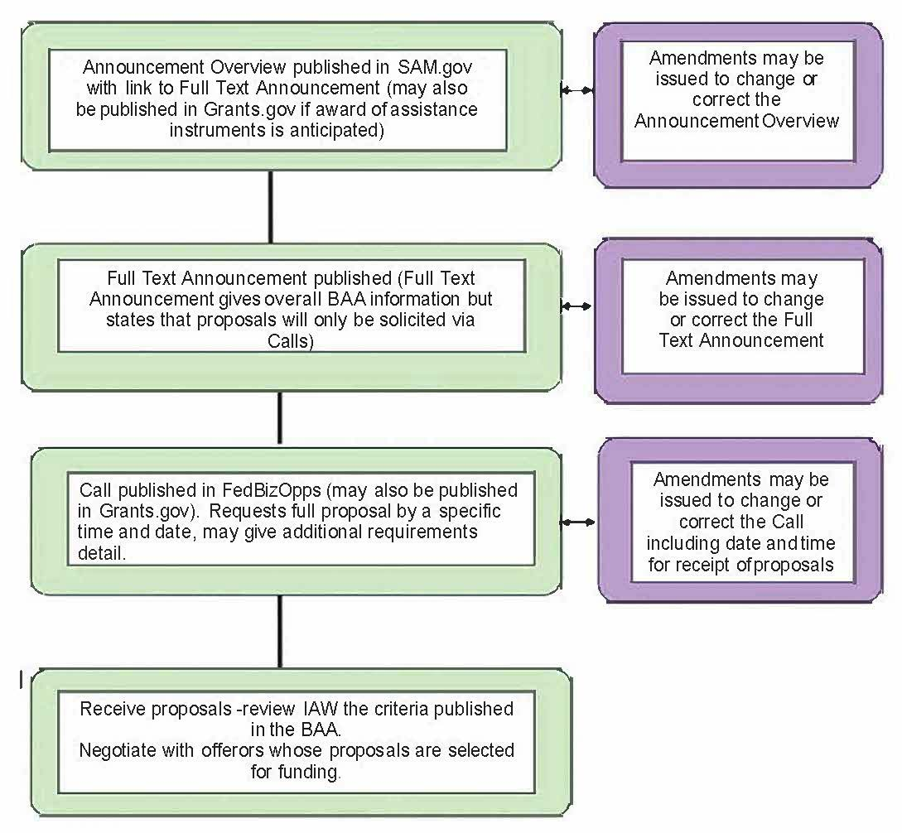

Two-Step Open BAA

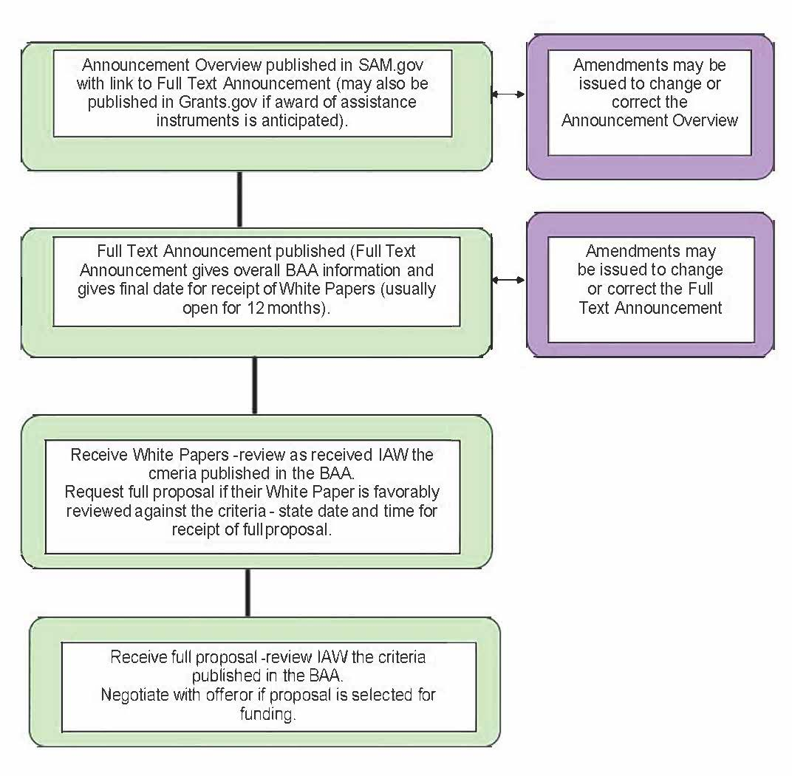

One-Step Closed BAA

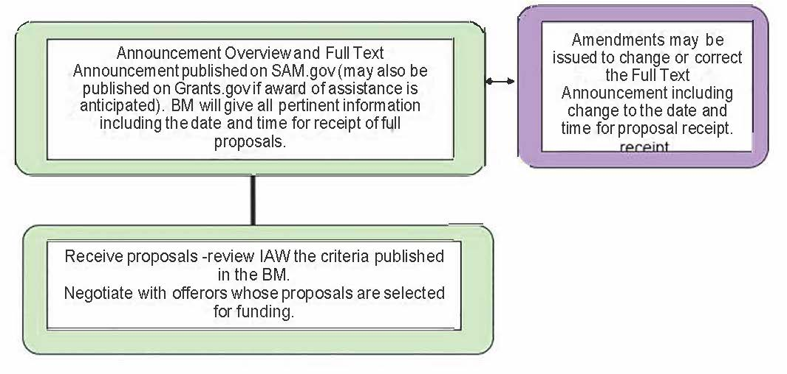

Two-Step Staggered-Closed BAA

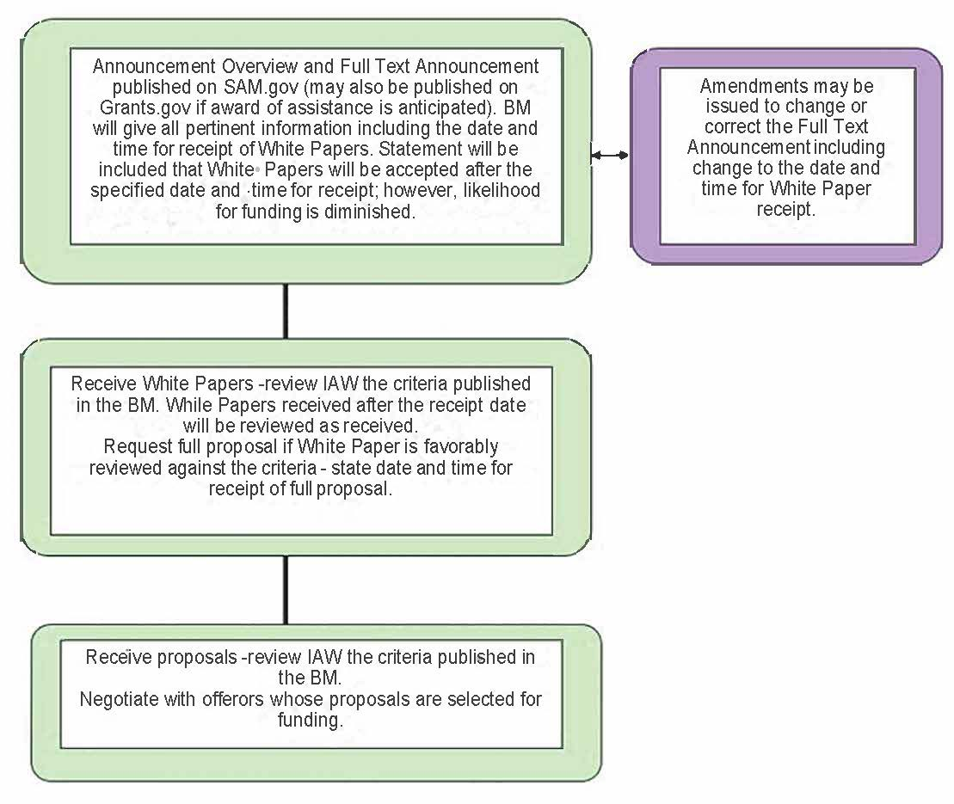

Open One-Step BAA

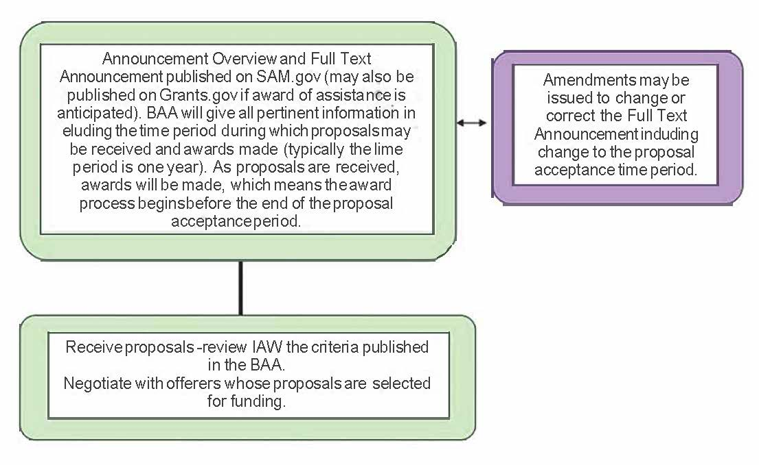

OBJECTIVE:
Attachment 2
SAMPLE STATEMENT OF WORK

  - The objective of this effort is to investigate: (a) techniques for generating code for (whatever); (b) technology that connect transformed variants of programs, crucial to debugging and performance analysis; and (c) exploitation of XXX by software environments.

SCOPE:

  - The scope of this effort is to develop technology for building integrated computational environments for XXXXX and distributing a set of advanced computational software tools based on this technology that demonstrates the ability to achieve improved performance on current XXXXXX computers.

BACKGROUND:

  - XXXXXX and computer communications networks are increasingly important to scientific advancement, economic computation, and national security. The technology is reaching the point of having a transforming effect on our society, industries, national defense, and educational institutions. The goal of the XXXXXXXXXXXXXX program is to accelerate significantly the commercial availability and utilization of the next generation of XXXXXXXXXXXX computers and software.

3.1 The key is by aggressively pursuing research in XXXXXXXX, and intelligent XXXXXXXXXXX to deliver revolutionary advances in XXXXXXXXXX software tools. An ideal XXXXXXXXXXXX environment will ultimately depend on a pervasive understanding of the relationship between XXXXXXXXXl programming methodology, XXXXXXXXX, XXXXXXXX implementation, and system performance characteristics.

TASKS/TECHNICAL REQUIREMENTS:
  - The contractor shall accomplish the following:

    - Design and implement a XXXXXXXXXX for a XXXXXXXXX computer. The XXXX shall include the design of initial data structures.

    - Develop an execution analysis infrastructure to debug and study the performance of XXXXXXXXXXXXX without having to understand the transformations caused upon the program by the XXXXXXXXXX, which includes:

      - Implementation of connections between XXXXXXXXXXX and XXXXXXXXXXXXX.

      - Implementation of connections from XXXXXXXXX to XXXXXXXXXX representation.

    - Develop technology to utilize the power of XXXXXX on the XXXXXXXXXXX tasks to develop a general XXXXXX environment which includes:
      - Tools for XXXXXXX to be XXXXXXXXX scheduled on XXXXXXXXX;

      - Interfaces for automatic scheduling of tools that are specifically designed to be executed on XXXXXXXX; and
      - Integrating the XXXXXX paragraph 4.1.1.

    - Identify XXXXX community members with relevant applications to experiment with the XXXXXXXXX of the XXXXXX from paragraph 4.1.1 and the general XXXXXXXX from paragraph 4.1.3.
    - Reporting.

      - Continually determine the status of the effort and report progress toward accomplishment of contract requirements. (See CDRL, A001)*

      - Continually determine the status of funding required for contract performance. (See CDRL, A002)**

      - Document all technical work accomplished and information gained during the performance of this acquisition. This shall include all pertinent observations, nature of problems, positive as well as negative results, and design criteria established, where applicable; also, procedures followed, processes developed, "Lesson Learned", etc. The details of all technical work shall be documented to permit full understanding of the techniques and procedures used in evolving technology or processes developed. Separate design, engineering, or process specifications delivered during this acquisition shall be cross-referenced to permit a full understanding of the total acquisition. (See CDRL, A003)***

*(See CDRL, A001) - indicates an R&D Project Summary Report, due either monthly or quarterly.
**(See CDRL, A002) - indicates a Contract Funds Status Report, due either monthly or quarterly.
***(See CDRL, A003) - indicates Final Technical Report due at the end of the contract term

