Request For Information (RFI) / SOURCES SOUGHT SYNOPSIS

The Regional Contracting Office MCI-West is issuing this sources sought synopsis as a means of conducting market research to identify parties having an interest in and the resources to support this requirement for Preventative Gym Maintenance. The result of this market research will contribute to determining the method of procurement.

THERE IS NO SOLICITATION AT THIS TIME. This request for capability information does not constitute a request for proposals; submission of any information in response to this market survey is purely voluntary; the government assumes no financial responsibility for any costs incurred. If your organization has the potential capacity to perform these contract services, please provide the following information: 1) Organization name, address, email address, Web site address, telephone number, and size and type of ownership for the organization; applicable North American Industry Classification System (NAICS) and 2) Tailored capability statements addressing the particulars of this effort, with appropriate documentation supporting claims of organizational and staff capability.

The government will evaluate market information to ascertain potential market capacity to 1) provide services consistent in scope and scale with those described in this notice and otherwise anticipated; 2) secure and apply the full range of corporate financial, human capital, and technical resources required to successfully perform similar requirements; 3) implement a successful project management plan that includes: compliance with tight program schedules; cost containment; meeting and tracking performance; hiring and retention of key personnel and risk mitigation; and 4) provide services under a performance based service acquisition contract.

BASED ON THE RESPONSES TO THIS SOURCES SOUGHT NOTICE/MARKET RESEARCH, THIS REQUIREMENT MAY BE SET-ASIDE FOR SMALL BUSINESSES OR PROCURED THROUGH FULL AND OPEN COMPETITION, and multiple awards MAY be made. Telephone inquiries will not be accepted or acknowledged, and no feedback or evaluations will be provided to companies regarding their submissions.

Submission Instructions: Interested parties who consider themselves qualified to perform the above-listed services are invited to submit a response to this Sources Sought Notice by Monday, 30 March 2026 at 1200 PST. All responses under this Sources Sought Notice must be emailed to Sgt Kersey, Quenton at Quenton.Kersey@usmc.mil and GySgt Duong, John at john.duong@usmc.mil

If you have any questions concerning this opportunity please contact: Sgt Kersey, Quenton. Quenton.Kersey@usmc.mil

Performance Work Statement
Marine Corps Recruit Depot (MCRD)
Walker Hall Gym Equipment Preventative Maintenance (PM)

1.0 Background

1.1 The Marine Corps Recruit Depot (MCRD), San Diego, CA Walker Hall Sports Medicine Facility is used for rehabilitation and reconditioning of injured recruits and Marines. Walker Hall contains various types of gym equipment that help with prevention, evaluation, treatment and rehabilitation of Musculoskeletal injury(ies) sustained by recruits, drill instructors and officers within the Recruit Training Regiment. In order to keep the equipment properly functioning, preventative maintenance and repair are required.
2.0 Scope
2.1 The purpose of this contract is to provide full PM/repair service of the gym equipment in support of Walker Hall Sports Medicine Facility located aboard Marine Corps Recruit Depot San Diego California. The equipment must be maintained at the proper safety levels required to ensure the equipment is fully functional and operational.
3.0 Requirement/Task
3.1 The contractor must provide qualified technicians, all labor, supervision, tools, materials, extra equipment and transportation necessary to maintain the gym equipment in working condition as follows:
3.2 Maintenance / Repairs Service Coverage:
3.2.1 Maintenance shall be performed on a monthly routine basis to prevent failure or breakdown of equipment (See “Walker Hall Gym Equipment List”). Maintenance includes general maintenance, lubricating, cleaning, adjustments, inspections, and performance testing of all equipment. This includes but is not limited to cleaning of chains and springs, lubrication of chains, springs, zirk fittings, weight guides, cleaning of alternator brush dust, adjustment of belt tension, vacuuming, cleaning, inspecting, testing, tightening of hardware, crank arms, tracking of treadmill belts, wiping the inner shrouds and vacuuming beneath the machines.

3.2.2 Repairs handled as needed and coordinated by Technical Point of Contact (TPOC). Repairs are defined as repairing a piece of equipment that is not functioning properly. This includes repairs done on equipment that has been damaged such as damage to internal or external parts. This would include, however, not limited to broken chains, springs, cables, ripped slipcovers or upholstery, failure of bearings, belts, electrical components, wires, power cords, alternators, bottom brackets, and noisy components.

3.2.3 Maintenance Exclusions: Repair of damaged parts due to negligence and abuse of the equipment. Also repairs and adjustments to correct unauthorized modifications or unauthorized service work. Does not include detergent and daily routine maintenance as specified in equipment maintenance manual.

4.0 Service Ticket
4.1 All Services performed under this contract shall be accomplished and followed by a service ticket submission which shall contain the following information:
Name of Contractor
Date of Service
Contract Number
Description of service/repair performed model and serial number
Physical Location
Description of recommended repairs
Anticipated end-of-life, if applicable

4.2 The technician will ensure that a service ticket is completed at the end of each visit and signed off by the technical point of contact or the Fiscal point of contact .
5.0 Unscheduled Maintenance Response Time
5.1 When the TPOC notifies the contractor that repair service is needed, the contractor will contact the TPOC within 24 business hours to schedule a service call for a day/time agreeable to the TPOC and contractor.
6.0 Working Hours for Service
6.1 On-site service/repair will be provided during normal working hours 0700-1530, Monday through Friday.
6.2 Contractor shall coordinate the routine schedule and work that must be done on evenings, weekends, or holidays in advance with the TPOC indicated below in paragraph 12.
6.3 Discontinuance of Service: The Government may discontinue maintenance service, in whole or in part, for any of the listed equipment upon thirty days’ notice to the contractor, if agreed to by the contractor at no additional cost to the Government.
7.0 Federal Holidays
New Year’s Day | ..Martin Luther King Jr Birthday
Presidents Day | ..Memorial Day
Independence Day | ..Labor Day
Columbus Day | Veterans Day
Thanksgiving Day | ..Christmas Day
Juneteenth Day

8.0 WARRANTY The Contractor shall perform all service, repair, and calibration work in accordance with manufacturers’ specifications and applicable certification standards including OSHA, NIOSH, MSHA, and NFPA requirements.

8.1 All work performed under this contract shall be warranted against defects in workmanship, materials, and parts under normal operating conditions for one (1) year from final acceptance by the Technical Point of Contact (TPOC), or until the next required service interval if shorter. The warranty does not apply to damage resulting from misuse, tampering, fire damage, or normal wear and tear. Determination of warranty exceptions shall be made at the discretion of the Contracting Officer.
8.2 Units requiring calibration shall be marked to indicate evidence of tampering. If recalibration is required during the warranty period and is not the result of a warranty exception, the Contractor shall recalibrate and return the unit to the Government at no cost. Recalibration required due to misuse, tampering, fire damage, or normal wear shall be performed under the applicable Over-and-Above repair CLINs.
8.3 The TPOC shall notify the Contractor and Contracting Officer in writing within ten (10) days of discovering any defect or failure. The Contractor shall correct the defect at no cost to the Government within a reasonable time after notification. If the Contractor fails to do so, the Government reserves the right to repair, replace, or otherwise remedy the defect at the Contractor’s expense.

9.0 Location of Work
9.1 All work shall be performed at the Walker Sports Medicine Facility at Walker Hall, building 573, Marine Corps Recruit depot, San Diego, CA.
10. OVER AND ABOVE WORK.
10.1 The Contractor shall provide all items necessary such as labor, transportation, equipment, tools, supervision, management, quality control, testing equipment, materials, and parts required to perform over and above work repair, modification or replacement of equipment, parts, etc. in a timely manner. The Contractor shall substantiate the need for over and above work by describing the conditions that warrant the repair and why minor repair measures accomplished as part of regular maintenance will not suffice. The Contractor shall report the need for over and above work repairs to the COR.
10.2 General Requirements and Procedures for Over and Above work. As described in DFARS Clause 252.217-7028, Over and Above Work authorizes the Contractor to perform repairs on identified equipment that is outside of the standard inspection requirements to ensure equipment is sustained in good working order in accordance with manufacturer’s instructions. Work performed under this requirement will be billed under the Over and Above Work line item identified for each year’s period of performance.
10.3 Response Time. The Contractor shall notify the COR within one (1) hour for emergency work or by 8:00 A.M. the following workday if other than emergency work and provide a description of the work with an estimate showing labor hours and material/parts. Each estimate shall be prepared by the Contractor and forwarded within five (5) calendar days of receipt of the request under routine conditions, and within two (2) hours under emergency conditions.
10.4 Authority to Performance Over and Above Work. The Contracting Officer is the only person(s) with authority to authorize the Contractor to proceed with the work in accordance with the over and above work portion of the contract and work will be negotiated and approved in advance for each work request. All work requests will be ordered and approved in writing. The Government may elect not to make repairs but instead replace items. Replacement items may be acquired either from the Contractor or from any other source determined to be advantageous to the Government.
10.5 Estimate, Preparation and Evaluation
a. The preparation of estimates is included in the price of the firm fixed-price portion of the contract.
b. Following equipment inspection, or if requested by the COR, the Contractor shall provide a written work estimate that will include the following minimum information:
(1) Contractor name and address.
(2) Contract number
(3) Date inspection was performed/call placed.
(4) Itemized list of parts required to perform repair, including quantity and price for each item.
(5) Estimated number of labor hours required to complete repairs.
(6) Number of hours charged for travel if the repair is not part of the scheduled maintenance inspection.
c. Materials and Parts.
(1) Material price and parts shall be the lowest price available considering the availability of materials and the time constraints of the job. It shall include any discounts and/or rebates received by the Contractor. Parts shall be provided to the Government at the Contractor’s cost without mark up.
(2) The Contractor shall provide quotations from three suppliers of the required materials exceeding $2,500.00 per parts/material.
d. Estimate Evaluation. The Contractor’s estimate will be evaluated to determine if:
(1) The scope has been clearly and accurately identified.
(2) The number of labor hours has been accurately estimated.
(3) The cost of materials and parts is reasonable and properly documented. The material and parts shall include a detailed estimate of materials including such items as the name of the part, manufacturer of the part, the part number, the size, quality, quantity (number of units) and the unit prices.
(4) The estimated lead-time for the delivery of the part to the Contractor is included.
(5) The Contractor shall state the actual time it will take to perform the work from commencement to completion.
(6) The detailed estimate will be used to negotiate over and above work repairs and award of a firm fixed price modification to the contract. The Contractor shall not assume that a modification will be issued and shall not order materials or proceed with any work until receipt of the modification.
12.0 Technical Point of Contact
12.1 The TPOC will provide assistance in identification and resolution of problems, conflicts in priority, subtask requirement definitions, and other operations type problems within the scope of this Performance Work Statement. The Technical Representative will provide technical clarification and assistance in support of the contract requirements. The Technical Representative DOES NOT have the authority to make changes and/or give directions under this contract. The only authority under this contract authorized to make changes, give direction, and/or provide monetary adjustments is the Contracting Officer from the Regional Contracting Office MCI-WEST, Camp Pendleton CA.
A. TPOC Contact information: Information will be provided at time of award
Name:
Title:
Email:
Phone Number:

13.0 Contracting Officer’s Authority
13.1 The Contracting Officer is the only person authorized to direct changes in any of the requirements under this contract, and, notwithstanding any provisions contained elsewhere in this contract, said authority remains solely in the Contracting Officer (Reference Block 31 on the SF1449). In the event the Contractor effects any such change at the direction of any person other than the Contracting Officer, the change will be considered to have been made without authority and solely at the risk of the contractor.
14.0 Equipment List
14.1 See attachment titled “Walker Hall Gym Equipment List”

15.0 Disposal
15.1 The Contractor shall provide for off base disposal of materials which result from the Contractor's operations in accordance with Federal, state, and local law and regulation. The Contractor shall not handle or dispose of any hazardous substances or wastes in a manner which would permit their release into the environment. Hazardous waste shall be captured and recycled or disposed of in conformance with all applicable local, state and Federal laws and regulations.

Walker Hall Gym Equipment List 1 of 2
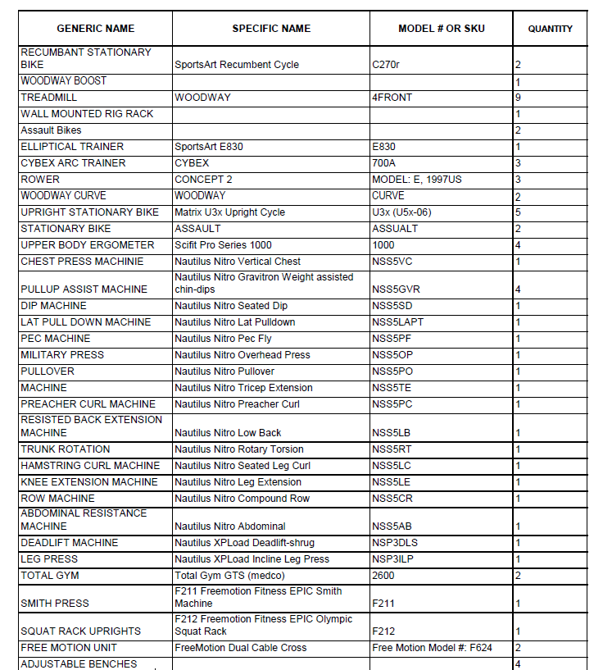
Walker Hall Gym Equipment List 2 of 2
