SUBJECT* | 36C24725Q0637 | Georgetown CBOC New Clinic | Sources Sought

GENERAL INFORMATION
CONTRACTING OFFICE’S ZIP CODE* | 30096
SOLICITATION NUMBER* | 36C24725Q0637
RESPONSE DATE/TIME/ZONE | 05-30-2025 12:00 EASTERN TIME, NEW YORK, USA
ARCHIVE | 99 DAYS AFTER THE RESPONSE DATE
RECOVERY ACT FUNDS | N
SET-ASIDE | SBA
PRODUCT SERVICE CODE* | X1DB
NAICS CODE* | 531120
CONTRACTING OFFICE ADDRESS | Department of Veterans Affairs  RPO-E, Network Contracting Office 7  2008 Weems Road  LaVista Business Park - Bldg A  Duluth GA 30096
POINT OF CONTACT* | Lease Contract Specialist  Brian C. Curtis  brian.curtis2@va.gov

PLACE OF PERFORMANCE
ADDRESS | See Delineated Area
 | In Description Below
 | Georgetown, SC
POSTAL CODE | 29440
COUNTRY | USA

ADDITIONAL INFORMATION
AGENCY’S URL
URL DESCRIPTION
AGENCY CONTACT’S EMAIL ADDRESS | brian.curtis2@va.gov
EMAIL DESCRIPTION | LCS Email Address
DESCRIPTION
Expression of Interest Sought
The Department of Veterans Affairs is conducting market research/seeking capable sources from bondable and experienced firms that are classified and registered in www.vip.vetbiz.gov as either Service-Disabled Veteran-Owned Small Businesses (SDVOSB) or Veteran-Owned Small Businesses (VOSB) that are interested in a forecasted lease project for a medical office space located in Georgetown, SC, to yield 10,000 net usable square feet (NUSF) for use as a Community Based Outpatient/Primary Care Clinic.
The NAICS Code is 531120 Lessors of Nonresidential Buildings (except mini warehouses), and the small business size standard is $47.0 million, using the exception of leasing space to the Federal Government. Responses to this notice will assist the VA in determining if the acquisition should be set-aside for competition restricted to SDVOSB or VOSB concerns in accordance with 38 USC Sec. 8127. Although this notice focuses on SDVOSB and VOSB, we encourage ALL small businesses and other interested parties to respond for market research purposes.
The magnitude of the anticipated construction/buildout for each project is:
__ (a) Less than $25,000;
__ (b) Between $25,000 and $100,000;
__ (c) Between $100,000 and $250,000;
__ (d) Between $250,000 and $500,000;
__ (e) Between $500,000 and $1,000,000;
X (f) Between $1,000,000 and $2,000,000;
__ (g) Between $2,000,000 and $5,000,000;
__ (h) Between $5,000,000 and $10,000,000;
__ (i) Between $10,000,000 and $20,000,000;
__ (j) Between $20,000,000 and $50,000,000;
__ (k) Between $50,000,000 and $100,000,000;
__ (l) More than $100,000,000.

The Department of Veterans Affairs desires to lease approximately 10,000 net usable square feet of medical / office space in Georgetown, South Carolina. The space will be occupied by the Charleston VHA Healthcare System and must include space for use by tenant for personnel, furnishings, and equipment. The Government requires a fully serviced lease. The Government anticipates this lease requiring tenant improvements between $1.0 and $2.0M estimated. There must be a minimum of 59 parking spaces, 6 spaces designated for handicapped individuals with at least 2 spots being van accessible (96” wide clearance ) and the other 4 having at least 60” clearance within one block of the building. Space offered should be contiguous and on the same floor (preferred). Access is required from 6:00 AM to 6:00 PM. Space shall not be in high crime areas or in any area that will require more stringent building security, preferably within a 10-mile radius of police facility. Building preferred to not be within a 100-year flood plain. A current certificate of seismic compliance must be submitted with all expressions of interest. Request a radius of 500 feet within a public transportation site.
Location: Space must be located within the following geographic boundaries of Savannah, GA:
Bounded on the North: County Road-S-22-362 and Trace Drive, Pawleys Island SC
Bounded on the South: Winyah Bay and Pennyroyal Road, Georgetown, SC
Bounded on the West: Brick Chimney Road, Georgetown, SC
Bounded on the East: Atlantic Ocean
*See Map Below. Building shall be located within the above geographical boundaries, and the lines on the map are for a close, but not exact, depiction.

Lease Term: The lease term shall be 5 years firm, and 5 years non-firm.

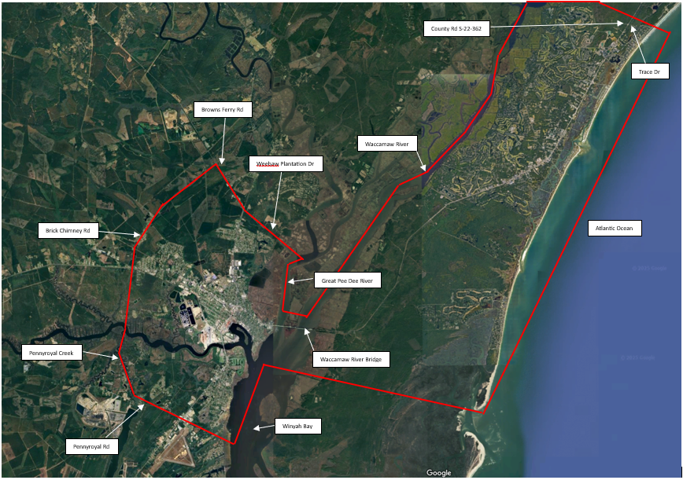
A market survey of properties for lease may be conducted by VA. Brokers or legal representatives submitting property must show written acknowledgement and permission to represent the property by the owner (have a letter of engagement you can produce upon at expression of interest). Property owners and developers must provide written proof of ownership or non-contingent control of property at the time of submission of initial proposals. The following information shall be provided along with the expression of interest: (1) Site plan depicting the building, (2) a map depicting location of building with the delineated area, (3) a block or floor plan of the proposed space for offer, (4) identification on site plan demonstrating location of parking to be dedicated for VA’s use, (5) the questionnaire below. Interested offerors should submit specific information concerning their properties to Brian C. Curtis (VA Lease Contract Specialist) at the following address no later than May 30th, 2025 at 12:00 p.m. EST to be considered:
Brian C. Curtis, Lease Contract Specialist
Department of Veterans Affairs
RPO-E, Network Contracting Office 7
2008 Weems Road
LaVista Business Park – Bldg A
Tucker, GA 30084-5207
brian.curtis2@va.gov

Net usable square feet does not include such areas as stairs, elevators, mechanical and utility rooms, ducts, shafts, vestibules and public corridors, and public toilets required by local code.
The Government will pay no more than the appraised fair market rental value for the building. This advertisement is not a request for proposals. A solicitation for offers may be issued by the Department of Veterans Affairs at a later date.

The NAICS code for this Notice is 531120
MARKET RESEARCH QUESTIONNAIRE
Response to Questionnaire is required from all interested parties.
Lessor’s Name & Contact Info (Phone & Email#_____________________________________
Building Name and Address ______________________________________________________
SAM UEI#____________________________________________________________________
Indicate your business size & socio-economic status under NAICS code 531120:
[ ] yes [ ] no Large Business (LB)
[ ] yes [ ] no Small Business (SB)
[ ] yes [ ] no Certified HUBZone
[ ] yes [ ] no Certified Small Business 8(a)
[ ] yes [ ] no Small Disadvantaged Business (SDB)
[ ] yes [ ] no Economically-Disadvantaged Women-Owned Small Business (EDWOSB)
[ ] yes [ ] no Women-Owned (WO) Small Business
[ ] yes [ ] no Certified Service Disabled Veteran Owned Small Business (SDVOSB)
[ ] yes [ ] no Veteran Owned Small Business (VOSB)
[ ] yes [ ] no Other (please specify)
[ ] yes [ ] no Registered with the System for Award Management (SAM) @
https://www.sam.gov
[ ] yes [ ] no Registered in SBA VetCert Registry @ Veteran Small Business Certification (sba.gov)
A SOLICITATION HAS NOT BEEN ISSUED. After review of responses, a solicitation may
be published at a later date. Responses to this Market Research Questionnaire will not be
considered as submission of an offer for future solicitation announcements. All interested parties
must respond to future solicitation announcements separately or in addition to this Market
Research Questionnaire. Contract award resulting from any future solicitation can only be made
to a contractor who is registered in SAM.
This notice is to assist the VA in determining sources only. A SOLICITATION IS NOT
CURRENTLY AVAILABLE. If a solicitation is issued it will be announced at a later date,
and all interested parties must respond to that solicitation announcement separately from
the responses to this announcement.
Please return this survey with your expression of interest. All responses shall be verified. Failure to provide the following shall result in elimination as an interested party:
- Market Research Questionaire.
- Site Plan Depicting the Building.
- Map with Location of Building with the Delineated Area.
- Block or Floor Plan of the Proposed VA Space.
- Identification on Site Plan Demonstrating Location of Parking dedicated for VA’s use.
- Proof of Ownership
- Authorized Letter of Engagement from the Owner if you are a Broker.

