Custom Surgical Packs – 36C24626Q0364
Q&A

- Section IV Past Performance (B): Providing past contract numbers may have proprietary implications. May we submit our response without disclosing this information?

The quoter should choose which contracts/information is disclosed. Proprietary information is not being requested. This information is used to evaluate past performance on similar contracts.

- Section IV Past Performance (G): Could you please provide clarification on this ask?

The quoter should state whether the supplies that were procured under the contract were provided by themselves or by a subcontractor.

- Section IV Past Performance (H): Could you please provide clarification on this ask?

The quoter should state whether the quoter was the awardee of the contract or if they were a subcontractor of the awardee.

- Upon review of the BOM, we are concerned that all items may not be TAA compliant. Is this required:

Clause 52.225-5 and Provision 52.225-6 apply to this acquisition. FAR Provision 52.225-6, must be completed for supplies that are U.S.- made or designated country end products.

- All Custom Packs are listed multiple times in the Section B.2 Price/Cost Schedule to distinguish specific QTYs of each pack being ordered at the Salisbury, Charlotte, and Kernersville locations; however, the packs being provided for all locations are identical and will be sourced/distributed from the same warehouse with our manufacturing partner. In order to streamline future ordering on contract, would it be possible to combine the QTYs being requested in Section B.2?

The Price/Cost Schedule will not be combined and will list quantities by facility.

- What is supposed to be in column BZ of the Attachment B spreadsheet? Is that an internal item number or does that need to be the local stock number from section B.2 of the SOW.

In attachment B, column BZ, enter the quoters part #. If it is the same as the manufacturer's part #, enter the manufacturer's part #.

- Are you able to provide the number of packs per case as referenced within attachment B? Please see the new Attachment B in amendment 0004

- Are you able to provide the QTY of components per pack? Please see Attachment A – Bill of Materials.

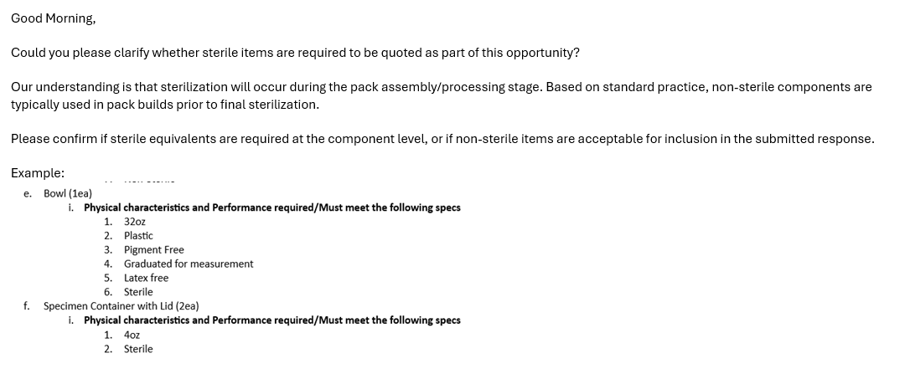
Response to question #9 is: During the packing assembly. The non-sterile items can be included in pack as it is sterilized once assembled.

- Could you please confirm whether the B.2 cost schedules are required to be completed for every SF30 amendment form, in addition to the SF1449 form? Please refer to the solicitation Instructions to Offerors in section E. You only have to complete the latest Price/Cost Schedule, and please sign the amendments to acknowledge the information in the amendments.

