NRL Institute for Nanoscience Process Gas Line Installation to Support Bosch-optimized ICP-DRIE Plasma Etch System

This document lists the requirements for installation of multiple ultra-high purity (UHP) stainless steel process gas delivery lines from source bottles located in the NRL-DC Building 250 north utility spine to a Bosch-optimized inductively coupled plasma deep reactive ion etching system (ICP-DRIE; Oxford Instruments PlasmaPro 100/Cobra 300)) located within a class 100 cleanroom. The new system replaces a de-commissioned ICP-DRIE tool with similar gas delivery configuration where all gases are delivered from source bottles to a wall-mounted gas mixing pod and a single process gas line delivers the mixed gases from the pod to the ICP-DRIE. Certain gas lines also require direct delivery to the ICP-RIE (see below). A plan view of the utility spine gas supply bottle location and machine location is shown in Figure 1. The installation will be performed at Building 250 of the Naval Research Laboratory, 4555 Overlook Ave SW, Washington DC 20375.

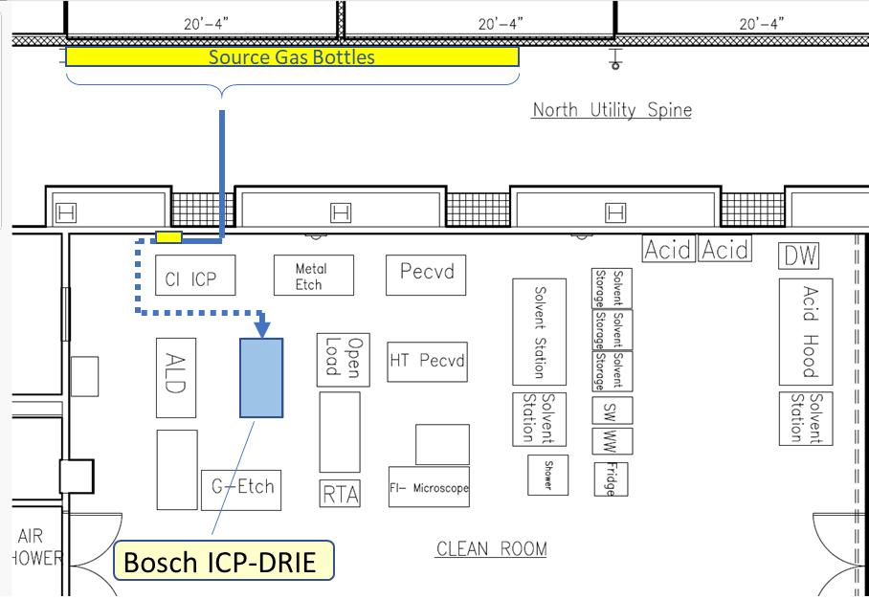
Figure 1. Plan view of B250 north utility spine and location of Bosch-optimized ICP-DRIE.

The following requirements are minimum performance specifications.
- All gas lines are to be rated ultra-high purity and made of 316L stainless steel.
- Swagelock, VCR or other mechanical fittings are not allowed over the length of the tubing except at endpoints requiring connection to equipment where matching mechanical connections are to be made. Mechanical fittings are typically ¼” VCR at the tool, gas pod, and gas bottles. Gas line pathways will be formed by bending and/or welding the stainless tubing from source to delivery point.
- Demo of existing and line re-use: The vendor will remove and dispose of existing process gas line tubing used to support the de-commissioned ICP-DRIE system. Lines may be reutilized if vendor and owner deem them of good integrity and match the chemistry of previous gas line use. Leak rate test qualifications will be in effect for re-used lines.
- The vendor will supply all mechanical fittings and valves. Each gas line will have a turn-off valve compatible with the gas chemistry and to maintain low leak rate at the location of the source bottle or, if teeing from an existing line, at the tee point.
- Individual gas delivery requirements are given below for 9 process gases. The gases SF₆, C₄F₈, O₂, and Ar require delivery both to the gas pod and to the one or more ports located on the ICP-DRIE to support Bosch-optimized processing.

  - Sulfur hexafluoride (SF₆): The vendor will install new or use existing SF₆ ¼” UHP stainless tubing to deliver process gas from the utility spine source bottle to both the gas pod inlet and the ICP-DRIE inlet. The vendor will provide a welded tee connection located on the inlet side of the gas pod with isolation valve on the line extending from the gas pod inlet to the ICP-DRIE. Connection fittings to both the gas pod and ICP-DRIE are to be provided by the vendor.
  - Octoflourocyclobutane (C₄F₈): The vendor will install new ¼” UHP stainless tubing to deliver process gas from the utility spine source bottle to both the gas pod and the ICP-DRIE. The vendor will provide a welded tee connection located on the inlet side of the gas pod with isolation valve on the line extending from the gas pod inlet to the ICP-DRIE. Connection fittings to both the gas pod and ICP-DRIE are to be provided by the vendor.
  - Tetraflouromethane (CF₄): The vendor will install new or use existing CF₄ ¼” UHP stainless tubing to deliver process gas from the utility spine source bottle to the gas pod inlet. Connection fittings to the gas pod are to be provided by the vendor.
  - Triflouromethane (CHF₃): The vendor will install new ¼” UHP stainless tubing to deliver process gas from the utility spine source bottle to the gas pod inlet. Connection fittings to the gas pod are to be provided by the vendor.
  - Methane (CH₄): The vendor will install new or use existing CH₄ ¼” coax UHP stainless tubing to deliver process gas from the utility spine source bottle to the gas pod inlet. Connection fittings to the gas pod are to be provided by the vendor.
  - Hydrogen (H₂): The vendor will install new or use existing H₂ ¼” coax UHP stainless tubing to deliver process gas from the utility spine source bottle to the gas pod inlet. Connection fittings to the gas pod are to be provided by the vendor.
  - Nitrogen (N₂): The vendor will install new or use existing N₂ ¼” UHP stainless tubing to deliver process gas from the utility spine source bottle to the gas pod inlet. Connection fittings to the gas pod are to be provided by the vendor.
  - Oxygen (O₂): The vendor will install new or use existing O₂ ¼” UHP stainless tubing to deliver process gas from the utility spine source bottle to both the gas pod inlet and two inlet ports on the ICP-DRIE (20 sccm, 200 sccm). The vendor will provide a welded tee connection located on the inlet side of the gas pod with isolation valve on the line extending from the gas pod inlet to the ICP-DRIE. The vendor will add a pigtail connection to provide the second O₂ flow channel at the ICP-DRIE. Connection fittings to both the gas pod and ICP-DRIE are to be provided by the vendor.
  - Argon (Ar): The vendor will install new or use existing Ar ¼” UHP stainless tubing to deliver process gas from the utility spine source bottle to both the gas pod inlet and inlet port on the ICP-DRIE. The vendor will provide a welded tee connection located on the inlet side of the gas pod with isolation valve on the line extending from the gas pod inlet to the ICP-DRIE. Connection fittings to both the gas pod and ICP-DRIE are to be provided by the vendor.
  - Process gas. The vendor will install a new ¼” coax UHP stainless steel tubing to deliver gas from the outlet of the pod module to the process gas inlet of the ICP-DRIE. Connection fittings to both the gas pod and ICP-DRIE are to be provided by the vendor.
  - The vendor will remove and dispose of existing hydrogen bromide (HBr) and chlorine (Cl) gas delivery lines between the gas pod inlet to the source bottle. Demo of these lines must not prevent delivery of these gases to other plasma processing tools within the cleanroom.
- All gas lines within the cleanroom space are to be routed below the raised floor (shown as dashed line in Figure 1.) All gas lines in the utility spine should provide a minimum of 8 feet clearance from the floor to allow for unfettered foot and equipment traffic.
- All lines carrying process gas are to be helium leak tested and demonstrate a leak rate of 1x10⁻⁸ atm-cc/sec or less. Vendor will provide qualified test system to verify leak rate. The vendor will follow industry standard “SEMI F1-0521: Specification for Leak Integrity of High-Purity Gas Piping Systems and Components” in performing leak rate tests.
- Several of these process gases are used by multiple tools within the cleanroom. The vendor will coordinate with the owner to complete the effort in a continuous time span and work to minimize the interruptions to other workers and tools within the cleanroom.
All proposals must include tabulated responses for each statement, 1-4, 5.1-5.11, 6-8 of ‘COMPLY’ or ‘DO NOT COMPLY’ with government requirements.

