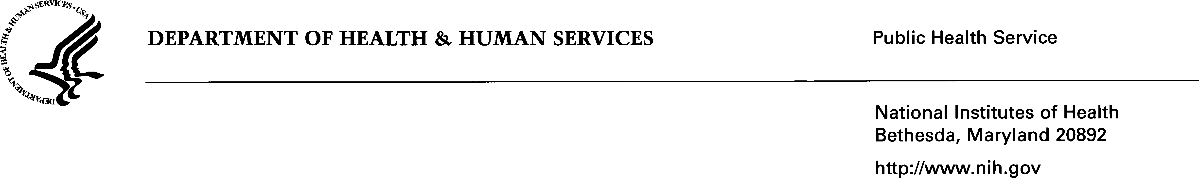


April 17, 2026

Dear Colleagues,

The NIH Small Business Program Office (SBPO) is hosting a Small Business Vendor Outreach Session (VOS) designed to strengthen engagement between small businesses and the NIH acquisition community.

Event Details
Date: Wednesday, April 29, 2026
Time: 10:00 AM – 12:30 PM
Location: 6700 Rockledge Drive,
Rm 6700B
Bethesda, MD 20817

This session will provide an opportunity for small businesses to:

- Overview provided by senior acquisition leadership
- Gain insight into the NIH centralization
- Better understand NIH procurement priorities and processes
We encourage participation from small business representatives to foster meaningful dialogue and collaboration. Due to limited spacing, one representative per company is allowed to register for this event. Registration will close on Friday, April 24, 2026.

Additional details, including the agenda and logistics, will be shared in advance of the session.
Please confirm your attendance by registering via NIH Small Business VOS Registration.

If you have any questions, please contact the NIH SBPO team at NIHSmallBusiness@mail.nih.gov.

We look forward to your participation.

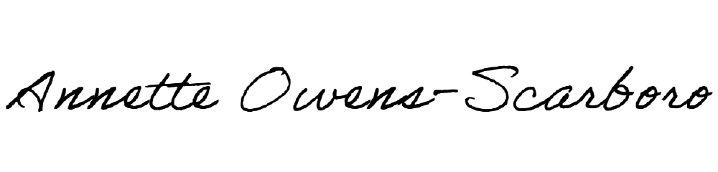
Sincerely,

Annette Owens Scarboro, NIH Small Business Program Office
Program Manager/HBCU Coordinator

