THIS IS A SOURCES SOUGHT ANNOUNCEMENT ONLY. This notice does not constitute a commitment by the Government. All information submitted in response to this announcement is voluntary, and the Government will not pay for information requested nor will it compensate any respondent for any cost incurred in developing information provided to the Government.
The 22nd Contracting Squadron (McConnell AFB, KS) is searching for FAA certified vendors who can provide:
Wheel Drive Key Manufacture/Plating Refurbishment
Part Number: 2615338 (320A)
Manufacturer: Honeywell
McConnell AFB, KS has over 300 drive keys in stock and over 2,000 on aircraft that will require plating repair services over time.
Repair must meet the following process requirements:
Process Description:
- Chemically strip the electroless nickel and tungsten carbide from the rotor drive keys.
- Perform a non-destructive test on rotor drive key(s) to identify cracks
- Reapply tungsten carbide to side rails & electroless nickel coat, or alternates (see method 2 and 3 in Alternate plating paragraph below).
  - .002-.004 tungsten carbide
  - .001-.0012 electroless nickel to all surfaces
- Heat treatment: 220,000-250,000 psi uts (ref AMS2759/2 and AMS 2750, ASTM E18 46-49.5 HRC)
Alternate PLATING:
Options of a solid H-11 part measuring 0.5”Hx1”Wx12”L with 0.25”Hx0.25”Wx1”L siderails on either side. Plating Thickness for all options = 0.0005
- Tungsten Carbide(Siderails only) / electroless nickel (all but the siderails)
NICKEL BAC5728 or MIL-C-26074 specs
TUNGSTEN CARBIDE: AMS2448C – Cobalt is acceptable, as its primary purpose is being the binder.
- Complete Cadmium
AMS-QQ-P-416 Type II (chromate treatment)
- Complete Chrome
AMS 2460 Class 2

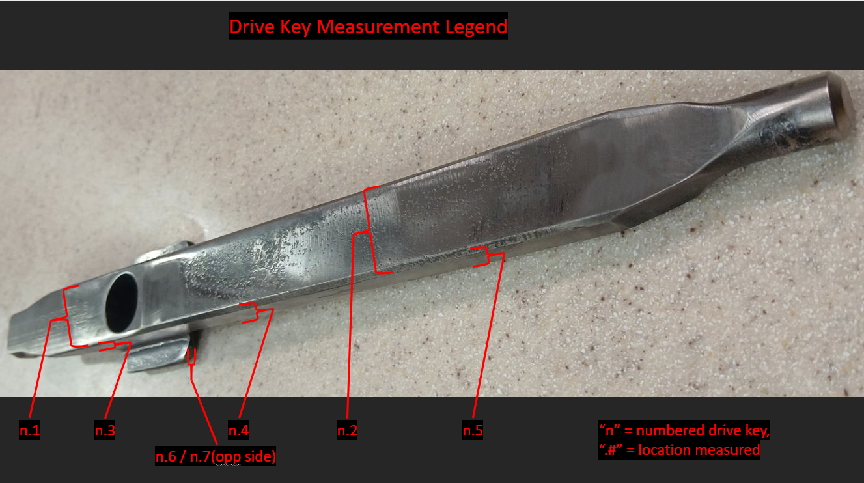

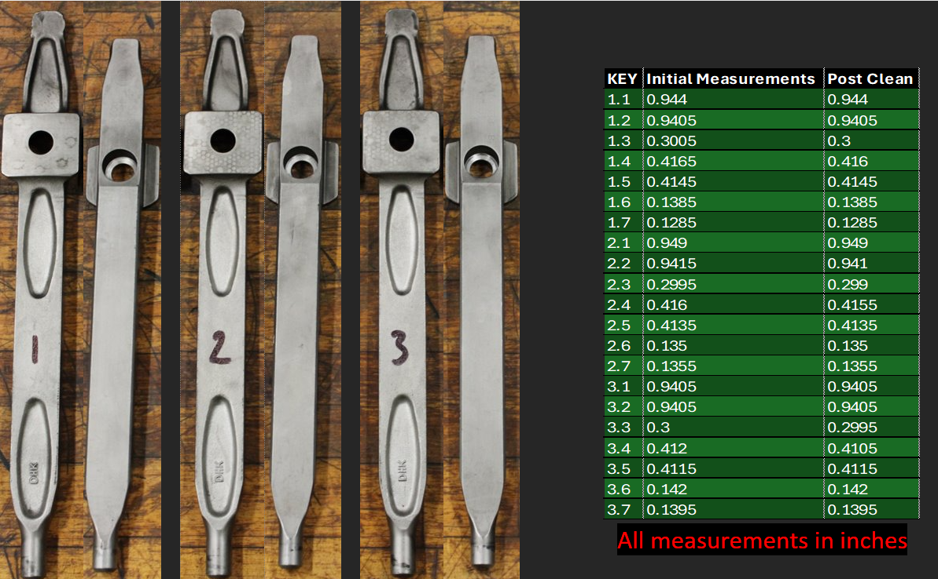

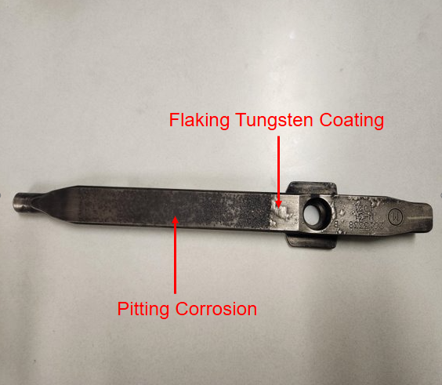

This Sources Sought is only for the purpose of identifying potential sources as part of 22 CONS/PKA market research. No Solicitation exists; therefore, do not request a copy.
Responses to this Sources Sought are not quotes on which the 22 CONS/PKA can issue any contract. This Sources Sought is issued for information and planning purposes only and does not itself constitute a Solicitation. The Government does not intend to award a contract based only on responses to this Sources Sought. Do not submit pricing information in response to this Sources Sought
All information received in response to this Sources Sought marked "Proprietary" will be protected and handled accordingly. Interested parties are responsible for adequately marking proprietary or competition sensitive information contained in their response.
Responses to the Sources Sought will not be returned. Responders are solely responsible for all expenses associated with responding to this Sources Sought. 22 CONS/PKA will not pay for information received in response to this Sources Sought.
Responses are due no later than 18 March 2026 at 1000 CST.
If your company is capable and interested, please send responses/capability statements with the subject heading McConnell AFB Wheel Drive Key Plating Refurbishments to SSgt Jacob Sandy 22 CONS/PKA; McConnell AFB email address: jacob.sandy@us.af.mil and TSgt John Szwec 22 CONS/PKP; McConnell AFB email address john.szwec@us.af.mil

Phone Number:316-759-2297

