SUBJECT* | Mt. Home Liquid Sealed Container

GENERAL INFORMATION
CONTRACTING OFFICE’S ZIP CODE* | 37129
SOLICITATION NUMBER* | 36C24926Q0143
RESPONSE DATE/TIME/ZONE | 03-19-2026 12:00 CENTRAL TIME, CHICAGO, USA
ARCHIVE | 15 DAYS AFTER THE RESPONSE DATE
RECOVERY ACT FUNDS | N
SET-ASIDE
PRODUCT SERVICE CODE* | 4540
NAICS CODE* | 333310
CONTRACTING OFFICE ADDRESS | Department of Veterans Affairs  Network Contracting Office 9  Aye A. A. King  1639 Medical Center Parkway, Suite 204  Murfreesboro TN 37129
POINT OF CONTACT* | Contract Specialist  Aye A. A. King  adrian.king@va.gov  (615) 225-2990
PLACE OF PERFORMANCE
ADDRESS | James H. Quillen VA Medical Center
 | Harry Richardson
 | P.O. Box 4000
 | Mountain Home TN
POSTAL CODE | 37684
COUNTRY

ADDITIONAL INFORMATION
AGENCY’S URL
URL DESCRIPTION
AGENCY CONTACT’S EMAIL ADDRESS
EMAIL DESCRIPTION

DESCRIPTION
This is a sources sought announcement only. It is neither a solicitation announcement nor a request for proposals or quotes and does not obligate the Government to award a contract. Responses in this sources sought notice must be in writing. The purpose of this sources sought announcement is for market research to make appropriate acquisition decisions and to gain knowledge of potential businesses interested and capable of providing the supplies described below.
The James H. Quillen VA Medical Center, 809 Lamont Street., Mt. Home, TN 37684 is looking to purchase a 40 cubic yard liquid sealed container that aligns with the Salient Characteristics below. To ensure compatibility with the equipment currently on campus this procurement shall be a brand name or equal that meet or exceed the physical, functional, and performance of the Statement of Work and characteristics below. Contractors shall show clear, compelling, and convincing evidence that all equal to items meet all requirements as outlined in the included salient characteristics and warranty sections, including brand name and model numbers IAW FAR 52.211-6 Brand Name or Equal.

STATEMENT OF WORK
40 Cubic Yard Liquid Sealed San-i- Pak Container building 205

SCOPE OF WORK: Provide and deliver 40 Cubic Yard Liquid Sealed container to replace failed San-i-Pak container at building 205 Mt. Home VA Medical Center (Johnson City) TN 37684. Must meet or exceed existing San-i-Pak Container, including fit. The container needs to fit and set correctly inside existing space available within the San-i-Pak equipment. Therefore, it must meet requirements without further expense to the government (modifications at our expense) because it will not fit space available where the existing unit sets.
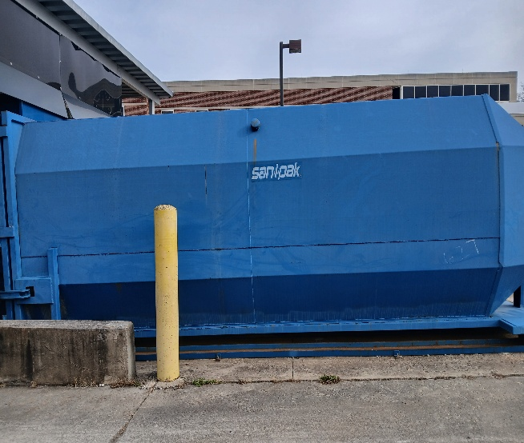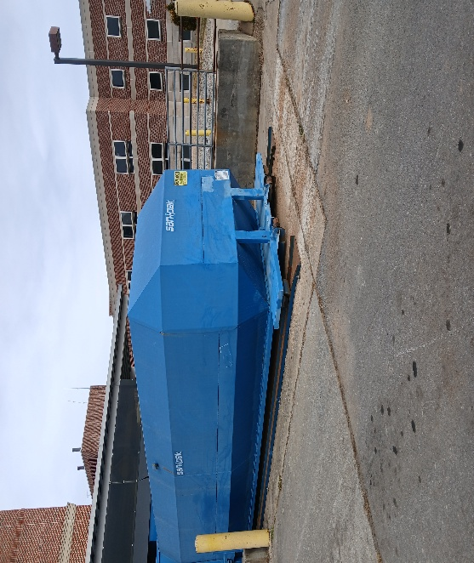
General description:
Roll off 40 cubic yard liquid tight San-i-Pak container shall be made of steel components. Container shall come standard to all measurements provided from drawings.

Specifications must meet or exceed:
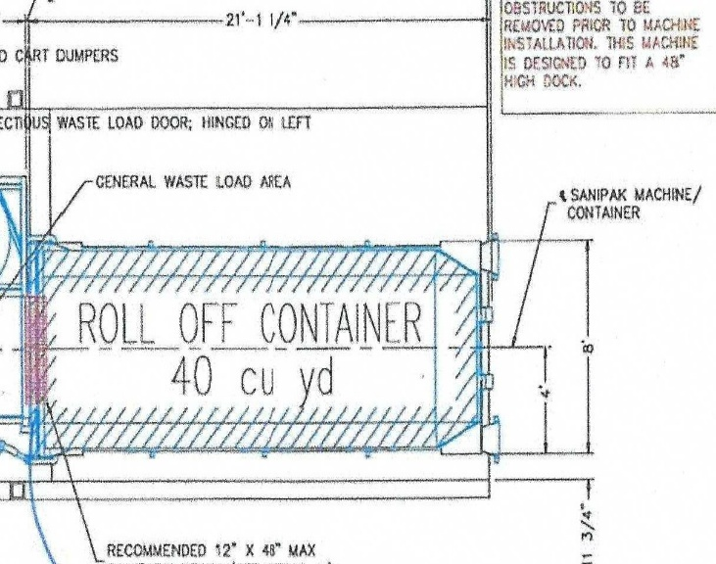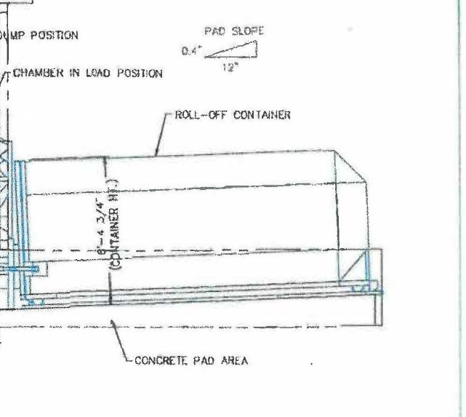
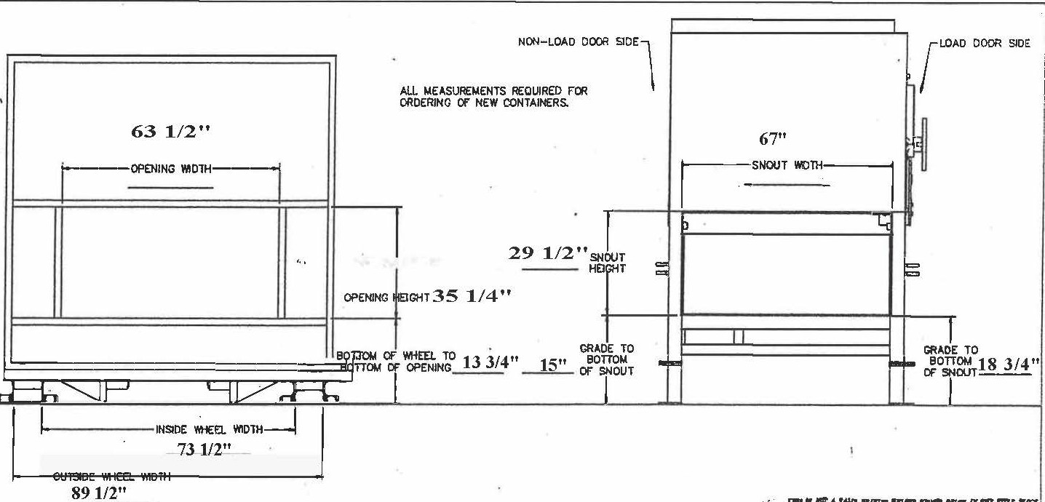
San-I-Pak roll-off containers, designed for heavy-duty waste and recycling, are primarily made from durable, high-grade steel, with reinforced corners, heavy-gauge steel walls and floors, and rust-inhibiting primers for longevity in demanding environments. They are built to withstand repeated loading, transporting, and heavy materials, with variations in steel thickness (like 1/4 inch for heavy-duty frames) for different applications.
Key Materials & Features:
Steel: The primary material for strength and durability, with varying thicknesses (gauge) for different parts.
Reinforced Construction: Includes heavy-gauge steel for walls and floors, ensuring they can handle significant weight and abuse.
Welded Seams: Thoroughly welded in-seams add to the container's structural integrity.
Protective Coatings: Rust-inhibiting primer is applied inside and out to prevent corrosion and extend the container's life.
Customization: Features like drainage holes, lockable lids, and specific wall heights can be added.
SUPPORTING INFORMATION:

Place of Performance – James H. Quillen VA Medical Center, Veterans Way & Lamont St.,
Mountain Home, TN 37684.

Scheduling – Delivery shall be performed during regular business hours, 7:00 a.m. to 4:30 p.m., Monday through Friday, except for Federal Holidays. Evening, night, and weekend delivery may be required as circumstances dictate and are approved by the Contracting Officer or Contracting Officer’s Representative (COR) only. Someone must be here to receive order.

- One-year warranty on provided components

The Government is not obligated to nor will it pay for or reimburse any costs associated with responding to this sources sought announcement. This notice shall not be construed as a commitment by the Government to issue a solicitation or ultimately award a contract, nor does it restrict the Government to a particular acquisition approach. The Government will in no way be bound to this information if any solicitation is issued.
The VA is mandated by Public Law 109-461 to consider a total set-aside for Service Disabled Veteran Owned Small Businesses. However, if there are insufficient Service Disabled Veteran Owned Small Business responses, an alternate set-aside or full and open competition may be determined. No sub-contracting opportunity is anticipated. The North American Classification System (NAICS) code for this acquisition is 333310 (1,000 employees).
Notice to potential offerors: All offerors who provide goods or services to the United States Federal Government must be registered in the System for Award Management (SAM) at www.sam.gov. Additionally, all Service Disabled Veteran Owned Small Businesses or Veteran Owned Small Businesses must be registered with U.S. Small Business Administration (SBA) located at https://search.certifications.sba.gov/
Responses to this notice shall be submitted via email to Adrian.king@va.gov. Telephone responses will not be accepted. Questions must be submitted no later than 03/13/2025 10:00 AM Central Standard Time (CST). Responses must be received no later than 03/19/2025 12:00 PM CST.

