SUBJECT* | Huntsville, Alabama Women's Health Clinic Lease

GENERAL INFORMATION
CONTRACTING OFFICE’S ZIP CODE* | 15215
SOLICITATION NUMBER* | 36C24426Q0369
RESPONSE DATE/TIME/ZONE | 03-26-2026 4:00pm EASTERN TIME, NEW YORK, USA
ARCHIVE | 60 DAYS AFTER THE RESPONSE DATE
RECOVERY ACT FUNDS | N
SET-ASIDE
PRODUCT SERVICE CODE* | X1DZ
NAICS CODE* | 531120
CONTRACTING OFFICE ADDRESS | Department of Veterans Affairs  Minor Leasing Division - Eastern Region  1010 Delafield Rd  Pittsburgh, PA 15215
POINT OF CONTACT* | Lease Contract Officer  Joel Garceau  joel.garceau@va.gov  412-654-0530

PLACE OF PERFORMANCE
ADDRESS | Huntsville, AL
POSTAL CODE
COUNTRY | USA

ADDITIONAL INFORMATION
AGENCY’S URL | https://www.va.gov
URL DESCRIPTION | Department of Veterans Affairs
AGENCY CONTACT’S EMAIL ADDRESS | joel.garceau@va.gov
EMAIL DESCRIPTION | Joel Garceau

DESCRIPTION
U.S. DEPARTMENT OF VETERANS AFFAIRS DESIRES TO LEASE SPACE
THERE IS NO SOLICITATION AT THIS TIME. This is a Sources Sought Notice (SSN) only and does not constitute a request for proposals. Submission of any information in response to this SSN is purely voluntary. The Government assumes no financial responsibility for any costs incurred associated with this SSN.
Notice: This notice is for market research purposes for a potential opportunity. This notice is not a solicitation for offers, nor is it a request for proposals. The purpose of this notice is to identify potential sources and suitable locations and is not intended to pre-qualify or disqualify any potential offers. The Government will not pay for any costs incurred because of this notice. The Government cannot provide any warranty, expressed or implied, as to the accuracy, reliability, or completeness of contents of the furnished information found within this notice. Respondents are advised that the Government assumes no responsibility to award a lease based upon responses to this notice.
The issuing of this SSN is to conduct market research and to seek capable sources for sufficient real property space to yield approximately 20,000 Net Usable Square Feet (NUSF), 27,000 Rentable Square Feet (RSF), or 24,000 American National Standards Institute/Building Owners and Managers Association (ANSI/BOMA) Square Feet in Huntsville, AL for use as a Women’s Health Clinic for a term up to 20 years (firm and soft).
The Department of Veterans Affairs will consider existing space that complies with all current building, seismic, and ADA code requirements. On-site, 100 total dedicated parking spaces including designated ADA compliant spaces are required. The desired space should be contiguous, on no more than one floor and must meet or be able to meet the Department of Veterans Affairs Life Safety codes and other applicable regulations. The VA seeks a fully serviced lease that includes, but is not limited to the following:

Heating system maintenance and repair Electrical system maintenance and repair
Plumbing maintenance and repair All Utilities: Electricity, Heat, Sewer, Water
Real Estate Taxes Landscaping
Window cleaning Common area supplies
Garbage removal Snow removal
Pest control Lawn Sprinkler
Common area maintenance Site lighting
Insurance Alarm System

Delineated Area for Huntsville Women’s Health Lease
To receive consideration, submitted properties must be located within the following area described below, which is bound by the following roads, or must front on any of the following boundary lines:

- Bounded on the North: From the Intersection of Old Railroad Bed Rd and Nick Davis Rd, east to Jeff Rd NW, south to Douglass Rd NW, East to Admore Hwy, southeast to Springfield Rd NW, east to Pulaski Pike NW, north to Winchester Rd NW, East to Homer Nance Rd
- Bounded on the South: From the intersection of I-565 and County Line Rd, east to Wall Triana Hwy SW, south to Martin Rd SW, east to Whitesburg Dr, north to Four Mile Post Rd SE (becoming Cecil Ashburn Dr SE, becoming Sutton Rd), east to US-431
- Bounded on the West: From the intersection of I-565 and County Line Rd (becoming Old Railroad Bed Rd), north to the intersection of Nick Davis Rd
- Bounded on the East: From the intersection of Winchester Rd NW and Homer Nance Rd, south to Jordan Rd, south to Ryland Pike, west to US-72, south to Dug Hill Rd, south to US-431, south to Sutton Rd

City Zip Code: 35805
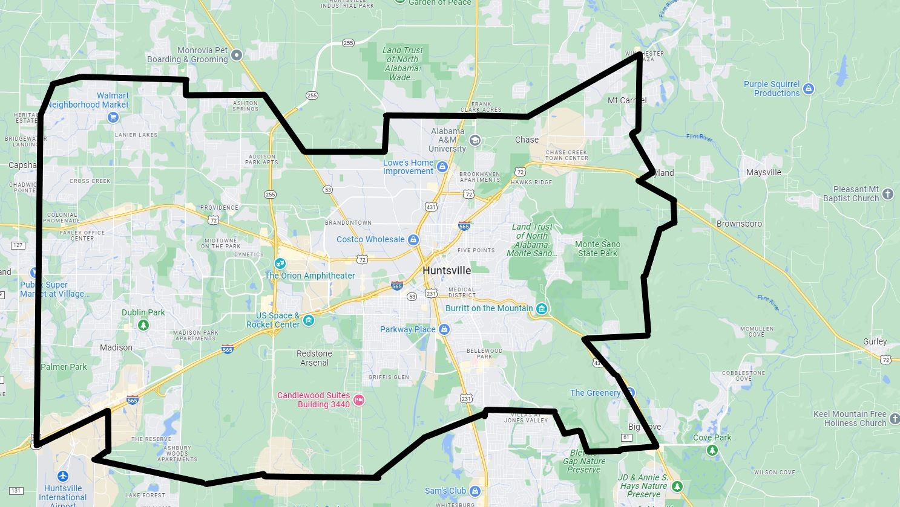
The NAICS Code is 531120 Lessors of Nonresidential Buildings (except Miniwarehouses), and the small business size standard is $34.0 million.
Access to public transportation shall be located within the immediate vicinity of the building, but generally not to exceed a walkable one mile as determined by the Lease Contracting Officer. Alternatively, two or more public or campus bus lines shall be located within the immediate vicinity of the building, but generally not to exceed a walkable ¼ mile.
Space shall be located on the first floor; space must be accessible by elevators if not on first floor. Proximity to gun stores, pawn shops, adult entertainment clubs, liquor stores, medical (or otherwise) marijuana distributors or methadone clinics are precluded within a walkable mile of the building.
All businesses are invited to respond to this SSN. Expressions of Interest must be submitted to the Lease Contracting Officer or point of contact (POC) electronically to Joel.Garceau@va.gov by the deadline publicized in the Sources Sought Notice and must include the following information:
- Building name, address, and location of available space; or address and location/acreage of location to be developed.
- Amount of available space and proposed rates in NUSF, RSF, and ANSI/BOMA.
- Building ownership information, brokers or legal representatives must show written acknowledgement and permission to represent the property.
- Amount of parking available on-site.
- Business socio-economic category if other than a large business.
- Contact information of authorized representative.

The Capabilities Statement Requirements below apply to SDVOSB and VOSB Firms:
SDVOSB and VOSB firms are invited to provide information in response to this SSN to contribute to the market research for this project. SDVOSB and VOSB firms must be registered with the Small Business Administration at https://certifications.sba.gov/ and have the technical skills and financial capabilities necessary to perform the stated requirements. Only SDVOSB and VOSB firms are requested to submit a Capabilities Statement to VA for review. SDVOSB and VOSB firms may provide a Capabilities Statement if they are interested in participating in this project.

Capabilities Statement will include:
- Company name, address, point of contact, phone number, Dunn & Bradstreet number, System for Award Management identification (if registered at www.SAM.gov), and e-mail address.
- Evidence of SDVOSB or VOSB status through registration with the Small Business Administration at https://certifications.sba.gov/
- Evidence of ability to offer under NAICS Code 531120 and listing in the System for Award Management (www.SAM.gov), including a copy of the representations and certifications made in that system.
- A summary describing up to three (3) projects of similar size and scope completed in the past five (5) years that demonstrate your experience designing, constructing, and managing Federal leased facilities or health care facilities relevant to the project described above. (3-page limit)
- Evidence of capability to obtain financing for a project of this size. If desired, the company may also submit a narrative describing its capability.

We encourage all businesses and other interested parties to respond for market research purposes.

The Government is limited by law (40 USC 278a, as Amended 10-1-81) to pay no more than the appraised fair rental value for space.

Joel Garceau
Lease Contract Officer
VHA Minor Leasing Division – Eastern Region
Joel.garceau@va.gov

End of Document

