General Instructions for Conducting Work at the NIST Boulder Campus

Contents
Part 1: GENERAL 3
1.1 INTRODUCTION: 3
1.2 BACKGROUND 3
1.3 HOURS OF OPERATION 3
1.4 UNFORESEEN FACILITY CLOSURES 5
1.5 SANITARY FACILITIES 6
1.6 EQUIPMENT AND MATERIAL STORAGE 6
1.7 ELECTRICITY AND WATER 7
1.8 TELEPHONE 8
1.9 ROADS 8
1.10 PARKING 8
1.11 CONTRACTOR’S USE OF PREMISES 8
PART 2: SAFETY 9
2.1 OCCUPATIONAL HEALTH AND SAFETY 9
2.2 CODES, ORDINANCES, REGULATIONS 10
2.3 RESPONSIBILITY AND LIABILITY 11
2.4 PRE-CONSTRUCTION/SAFETY MEETING 11
2.5 SAFETY INSPECTIONS 12
2.6 INCIDENTS ON THE JOB 12
2.8 PROPER WASTE DISPOSAL 12
2.9 STORM WATER PROTECTION/COMPLIANCE 13
2.10 FIRE PREVENTION/PROTECTION 16
2.11 EMERGENCY RESPONSE PROCEDURES FOR THE UNSCHEDULED MINOR DISTURBANCES OF ASBESTOS-CONTAINING MATERIAL (ACM) 17
PART 3: PERSONAL/PHYSICAL SECURITY & PROPRIETARY INFORMATION 18
3.1 GENERAL 18
3.2 CONTRACTOR’S SECURITY POINT OF INTEREST 18
3.3 PERSONAL SECURITY & EMPLOYEE IDENTIFICATION 18
PART 4: PROJECT PROCEDURES 19
4.1 GENERAL DESCRIPTION 19
4.2 PROJECT DOCUMENTATION PROCEDURES 20
4.3 PERMIT REQUIRED OPERATIONS DURING CONSTRUCTION OR MAINTENANCE ACTIVITIES 20
4.4 MAINTENANCE OF WORK SITE 21
4.5 WORK REQUIRING ADVANCE NOTICE AND COORDINATION 21
Appendix 22
Roof Access Permit 23
Penetration Permit 26
Hot Work Permit 27
Fire Protection System Impairment 28
Excavation Permit 29

Part 1: GENERAL

INTRODUCTION:
This document is intended to provide the necessary information/requirements for all contractors performing work at Department of Commerce (DOC) facilities. It is understood all information in this document may not apply for the specific project described in the Statement of Work; however, it is the responsibility of the contractor to ensure the requirements are met when applicable.
Specifics of the activities are described in the attached Statement of Work and supporting documentation.
Questions about the requirements can be addressed to the Contracting Officer (CO) and Contracting Officers Representative (COR)/Project Manager designated for the specific task order.

BACKGROUND
The Office of Facilities and Property Management (OFPM) Division manages and provides services to the DOC staff in support of their research, technical, and administrative programs. DOC agencies serviced by OFPM include but may not be limited to: The National Oceanic and Atmospheric Administration (NOAA), The National Telecommunications and Information Administration (NTIA), and The National Institute of Standards and Technology (NIST).

HOURS OF OPERATION
- DOC hours of operations are from 7:00 AM to 5:00 PM, Monday through Friday, on normal Federal workdays. Should the Contractor desire to work at times other than those specified above, the dates and hours must be scheduled at least 10 working days in advance and approved in writing by the Contracting Officer’s Representative (COR).
- Use the Main Entrance at the DOC site for materials supply and entry for:
  - Special arrangements may be made through the COR for delivery of material/supplies, and/or overtime beyond these hours or on holidays.
  - Check-in required at DOC Visitor’s Center located at the site main entrance.
- Employee identification shall include the name, country of citizenship, employer, and green card (if applicable) is needed for each Contractor and Subcontractor's employee working on the DOC site. These shall be submitted to the COR for review 10 days prior to the work date. After hours work will require a hard badge from the General Contractor and a COR/Federal escort 100 percent of time if accessing DOC buildings (see section 3.3). Follow the specific procedures pertaining to security and work hours prescribed by the COR/Security. Contractor vehicles must show current registration and proof of insurance.
- Department of Homeland Security (DHS) Advisory System:
Note: The following paragraphs describe the threat levels that may be changes at any time due to national security issues. If a change is issued by the DHS all changes in procedures/directions for entering and performing work at the site will be communicated to the contractor through the COR. Contractor’s access to the DOC campus grounds may occasionally be restricted as a result of a change in the Nation’s Threat Level when publicly announced by DHS.
- National Terrorism Advisory System (NTAS)
  - The National Terrorism Advisory System, or NTAS, replaces the color-coded Homeland Security Advisory System (HSAS). This new system will more effectively communicate information about terrorist threats by providing timely, detailed information to the public, government agencies, first responders, airports and other transportation hubs, and the private sector.
  - It recognizes that Americans all share responsibility for the nation’s security and should always be aware of the heightened risk of terrorist attack in the United States and what they should do.
- NTAS Alerts
  - After reviewing the available information, the Secretary of Homeland Security will decide, in coordination with other Federal entities, whether an NTAS Alert should be issued.
  - NTAS Alerts will only be issued when credible information is available.
  - These alerts will include a clear statement that there is an imminent threat or elevated threat. Using available information, the alerts will provide a concise summary of the potential threat, information about actions being taken to ensure public safety, and recommended steps that individuals, communities, businesses and governments can take to help prevent, mitigate or respond to the threat.
  - The NTAS Alerts will be based on the nature of the threat: in some cases, alerts will be sent directly to law enforcement or affected areas of the private sector, while in others, alerts will be issued more broadly to the American people through both official and media channels.
  - NTAS Alerts contain a sunset provision indicating a specific date when the alert expires - there will not be a constant NTAS Alert or blanket warning that there is an overarching threat. If threat information changes for an alert, the Secretary of Homeland Security may announce an updated NTAS Alert. All changes, including the announcement that cancels an NTAS Alert, will be distributed the same way as the original alert.
  - Contractor coordinates procedures with COR.
  - Threat Levels:
    - Low Condition (Green): A Low Condition is declared when there is a low risk of terrorist attacks.
      - Federal departments and agencies will implement general and agency-specific Protective Measures to assure that all facilities and regulated sectors take reasonable measures to mitigate vulnerabilities to terrorist attack.
      - Contractor coordinates procedures with COR.
    - Guarded Condition (Blue): A Guarded Condition is declared when there is a general risk of terrorist attacks.
      - In addition to Protective Measures taken in previous Threat Condition, Federal departments and agencies will implement general measures in addition to agency-specific Protective Measures to check communications with designated emergency response or command locations, update emergency response measures, and provide public with information.
      - Contractor coordinates procedures with COR.
    - Elevated Condition (Yellow). An Elevated Condition is declared when there is a significant risk of terrorist attacks.
      - In addition to Protective Measures taken in previous Threat Conditions, Federal departments and agencies may develop protective measures for the DOC campus grounds such as increased surveillance, coordinating emergency plans as appropriate with nearby jurisdictions, and implementing contingency and emergency response plans.
      - Contractor coordinates procedures with COR.
    - High Condition (Orange): A High Condition is declared when there is a high risk of terrorist attacks.
      - In addition to Protective Measures taken in previous Threat Conditions, Federal departments and agencies will implement general and agency-specific Protective Measures for the DOC campus grounds.
      - At this Threat Level the Government may restrict access to site and facility to essential personnel only.
      - Contractor coordinates procedures with COR.
    - Severe Condition (Red). A Severe Condition reflects a severe risk of terrorist attacks.
      - Under most circumstances, the Protective Measures for a Severe Condition are not intended to be sustained for substantial periods of time. In addition to Protective Measures for previous Threat Conditions, Federal departments and agencies may close Public and Government sites and facilities as a protective measure.
      - Contractor coordinates procedures with COR.

UNFORESEEN FACILITY CLOSURES
When an unforeseen facility closure occurs, the Contractor will either reschedule the work or perform the work on the next regularly scheduled workday. If the facility is closed, the contractor is not to be on-site unless notified by the contracting officer they are essential. Contractor personnel may be required by the COR to remain on site to handle problems as a result of a closure, e.g., severe weather, national emergency, changes in national security levels.
Information about the status of the site may be obtained by calling the switch board at 303-497-3000. Usually the day’s site status is available by 6 AM MST. Contractor can verify site status and sign up for email and text site notifications at the following website:
http://www.boulder.doc.gov/cgi-bin/docstatus.cgi

SANITARY FACILITIES
Toilet rooms in existing buildings may be used by the Contractor when performing work inside DOC owned buildings at the discretion of the COR. When toilet rooms in existing buildings are not available or work is being conducted outside the Contractor shall:
- Provide temporary toilet facilities for use of all workmen.
- Provide the COR with keys to all temporary structures.
- Maintain toilet facilities in a clean, sanitary condition.
- Provide adequate supplies of toilet paper, cleaning and other required items.
  - Holding tanks for the collection of sanitary waste will not be permitted.
  - Contractor shall install all pipes serving these trailers underground with appropriate cleanouts and provide measures to prevent them from freezing.
  - Piping shall be run in an organized and pre-planned fashion and all piping shall be removed from the DOC campus upon demobilization of the Construction trailer(s) and the sewer main piping shall be restored to its original condition.

EQUIPMENT AND MATERIAL STORAGE
The contractor shall provide and store, in an area designated by the COR, all equipment, materials and required to complete the project. The materials are required to be kept undamaged, clean and dry throughout the duration of the project. The contractor shall also coordinate location of any trash receptacles, if necessary, with the COR and shall keep the construction area free of trash and debris. All equipment, materials and garbage shall be kept in a manner to avoid causing a hazard by accidental shifting, ignition or other hazardous qualities.
- Prior to the start of work, Contractor shall meet with all Subcontractors to arrange and prepare a plot plan defining staging, storage, field office and traffic areas within lay-down/staging and trailer/parking areas designated.
  - Submit a plan for COR's approval not less than 10 working days prior to the installation of temporary facilities.
  - Except as specifically provided, working and storing outside these areas will not be permitted.
  - Arrange and locate temporary structures and storage to avoid interfering with construction.
- Within the area designated for its use, provide suitable and sufficient enclosed and covered spaces with raised flooring, to protect materials and equipment from damage by weather, construction work, or other hazards.
  - Maintain storage and working areas in clean and orderly condition.
  - Tie down canvas and other coverings sufficiently to be maintained in conditions of high winds.
  - At completion of contract, contractor shall remove all storage areas and return any disturbed areas to original condition or better.

ELECTRICITY AND WATER
DOC may make available, at no cost to the contractor, electricity and water during the course of this project. The contractor is responsible for making connections to the existing systems. (see FAR 52.236-14, Availably and Use of Utility Services)
- Electricity: Temporary electrical work shall meet the requirements of NFPA 70-1996 (NEC), Article 305.
  - Temporary electrical service shall be provided from existing campus power distribution system.
    - If the contractor chooses to use Governments electrical service, then the Contractor is responsible for connection, installation, and maintenance of all portions of the temporary electrical service, and connected equipment.
    - Verify connection location with COR.
  - Make arrangements for all equipment, poles, meter, wiring, switches, outlets, etc., for all lighting and power requirements for construction purposes.
    - Permanent existing campus power distribution system may be used.
    - Remove all temporary electrical equipment, when no longer needed.
    - Immediately preceding completion, remove and replace all damaged parts of permanent systems.
  - Temporary electrical power derived from existing site distribution system will be paid for by the Government. Any other power generation shall be paid for by Contractor.
    - The use of resistive heating devices is prohibited.
    - Turn off all lighting and/or equipment not in use.
  - Extend warranty or guarantee period on permanent systems used during construction period so they commence on date of Acceptance.
  - Provide UL approved extension cords where necessary.
  - Contractor to submit after hours lighting plan to COR for approval at least 10 working days prior to installation and use.
  - Provide temporary electrical systems which meet Government approval.
  - Contractor shall remove same from the DOC campus at such time as temporary lighting is no longer required.
- Water:
  - During construction/renovation/and maintenance projects the contractor, with the consent/approval of the COR, shall:
    - Make all arrangements; install equipment, backflow preventer, piping, and outlets for an adequate supply of clean water for construction purposes.
    - Existing water lines may be used for temporary service.
      - Contractor shall tie into existing domestic water line at a location designated and approved by COR, and shall provide all materials, labor and equipment necessary for the connection of all trailers requiring a domestic water connection.
  - Contractor shall install all pipes serving these trailers underground with appropriate shut-off valves for isolation of each branch connection and shall provide measures to prevent them from freezing.
  - Piping shall be run in an organized and pre-planned fashion and all piping shall be removed from the DOC campus upon demobilization, and the domestic water main piping shall be restored to its original condition.

TELEPHONE
Telephone service is not normally available on-site for the Contractor’s use.

ROADS
- Do not block access to existing facilities.
- Under no circumstances will egresses be blocked. Any changes in egress shall be approved by COR.
- Any road closures, full or partial, require notification and approval of COR a minimum of 10 working days prior to closure.
- Contractor shall be required to remove dirt or debris from road surfaces that are a direct result of contractor operations.

PARKING
- Personnel performing the work shall not park in any Government parking lot without prior consent of COR.
- Contractor acknowledges that any personnel violating this requirement do so at their own risk and will inform personnel that vehicles may be towed at their expense.
- Parking in residential and other areas in immediate vicinity of Project site is prohibited.
- Contractor to keep all personnel, vehicles and operations on Project site within designated limits.
- If authorized by the COR, temporary parking areas shall be surfaced with crushed stone and maintained by the Contractor to prevent deterioration (ruts, mud, etc.) as approved by the COR.
  - Direct personnel performing the work to use access route to site designated by COR.
  - The Contractor shall provide parking and transportation for Contractor personnel off the Project site if designated onsite parking areas are inadequate for Contractor needs.

CONTRACTOR’S USE OF PREMISES
- Contractor must coordinate all field investigations with COR prior to accessing ceiling/interstitial spaces. Fire alarm system may need to be impaired.
- Leave undisturbed as much of the site as practical.
  - Land disturbed but not designated for disturbance on the drawings or by the Government shall be restored to its original condition at Contractor's cost. (See FAR 52.236-9, Protection of Existing Vegetation, Structures, Equipment, Utilities and Improvements).
  - Leave root zones of trees undisturbed.
- Provide warranty and/or guarantee on permanent items and systems used during construction, commencing on date of acceptance, for specified duration(s). (See FAR 52.246-21, Warranty of Construction)
- Contractor acknowledges that there is wildlife on the Project site. Take all necessary measures to ensure that all such wildlife is protected from execution of the work. Prohibit hunting of any sort.
- Investigation Equipment: Site investigations and field work may require the use of a stepladder and/or other investigative equipment (measuring tapes, flashlights, screwdrivers, etc.). Contractors shall provide their own stepladders and/or investigative equipment. The stepladders shall be Type 1 (industrial) or Type II (commercial).
- Operating Equipment: Do not turn off or adjust any equipment without prior authorization from the COR. Work carefully around rotating equipment. Loose fitting clothes (neckties, dangling jewelry, etc.) shall not be worn when near rotating equipment. Long hair shall be secured. Some equipment may start automatically. Take care when working around this equipment. (NOTE: It may become necessary to implement appropriate lock-out, tag-out procedures to control hazardous energy sources to ensure that personnel do not activate equipment during investigation, servicing, or maintenance).
- Mechanical/Electrical Rooms: Obtain authorization from the COR prior to working in electrical and/or mechanical rooms. Lock rooms after use. Do not operate any valves, switches, or breakers without prior approval from the COR. Adhere to all OSHA Lock-Out, Tag-Out Regulations (29 CFR 1910.147).
- It is the prime contractor’s responsibility to ensure Contractor employees and Subcontractors become familiar with and obey all DOC site regulations, including fire, traffic, and security regulations. All personnel employed on the site shall keep within the limits of the work (and avenues of ingress and egress) and shall not enter any restricted areas unless required to do so and are cleared for such entry. The Contractor's vehicles and equipment shall be conspicuously marked for identification.

PART 2: SAFETY

2.1 OCCUPATIONAL HEALTH AND SAFETY
Contractor(s) acknowledges that by working at the National Institute of Standards and Technology (NIST), a Federal Government facility located in Boulder, Colorado, they are subject to the jurisdiction of the U.S. Department of Labor's Occupational Safety and Health Administration (OSHA). The Regional Office has authority to assign a Compliance Safety and Health Officer (CSHO) to conduct safety and health inspections regarding the Contractors operations at the NIST Boulder site. In addition to OSHA oversight, the Contractor is required to follow NIST health and safety instructions and the Office of Facilities and Property Management (OFPM) safety policies and procedures applicable to their operations.
CITATIONS AND NOTICE OF PENALTY FOR NONCOMPLIANCE WITH OSHA STANDARDS
- To protect NIST’s interests, the Contractor acknowledges that NIST may conduct periodic safety, health and environmental inspections to assure that staff and property are not at risk of injury or damage; also, from Citations issued by OSHA for multi-employer worksites.
- The Contractor is required to implement and manage a job specific Safety, Health and Environmental plan. NIST will review and evaluate the Contractor’s Safety, Health and Environmental plan to ensure that it is site specific for the work being performed. The Safety Plan Requirements Checklist in Appendix A requires a site and job specific plan to be developed and submitted to the government for review and acceptance. No site work may be started until the Site-Specific Safety Plan is accepted. 2. In the event of an onsite emergency, first call 303-497-7777 or 7777 from a campus phone; and then call 911. The Contractor will report the following details: Location (NIST), name, building name or number, room number, and a brief description of the emergency.

2.2 CODES, ORDINANCES, REGULATIONS
Contractors are required to comply with all applicable codes, ordinances and regulations as stated in this document. Contractor to use version below, or most current version adopted by Boulder with amendments in effect on the date of the solicitation.) These include, but may not be limited to:
- Code of Federal Regulations (CFR):
  - OSHA General Industry Safety and Health Standards (29 CFR 1910);
  - OSHA Construction Industry Standards (29 CFR 1926);
  - National Emission Standards for Hazardous Air Pollutants (40 CFR 61);
  - Resource Conservation and Recovery Act standards for hazardous waste disposal (40 CFR 260-281); and
  - Toxic Substance Control Act rules related to asbestos and PCB’s (40 CFR Part 761).
- National Fire Protection Association (NFPA):
  - NFPA 30 – Flammable and Combustible Liquids Code;
  - NFPA 101 – Life Safety Code;
  - NFPA 45 – Fire Protection for Laboratories using Chemicals;
  - NFPA 54 – National Fuel Gas Code; and
  - NFPA 70 – National Electrical Code.
- Life Accessibility Standards (USFAS).
- American National Standards Institute (ANSI) A117.1 – American National Standard Specifications for Making Buildings and Facilities Accessible and useable by the physically handicapped, latest edition.
- Colorado Department of Public Health and Environment Regulations, Chapter 8.
- State of Colorado Hazardous Waste Regulations 6 CCR 1007-3
- Industrial Discharge Permit (2010-1)
- Municipal Separate Storm Sewer System (MS4) Permit COR042002
- Construction Permit (Air Pollutant Emissions) 09BO0159
- Air Quality Control Commission regulation; Number 3, 5 CCR 1001-5
- NIST ESO Site Security Specifications
- International Building Code – IBC 2024
- International Energy Conservation Code – IECC 2024
- International Fuel Gas Code – IFGC 2024
- International Mechanical Code – IMC 2024
- International Fire Code – IFC 2024
- International Plumbing Code – IPC 2024
- International Electric Code Administrative Provisions – IEC 2024
- US Department of Energy Regulations – 10 CFR 435
- US Environmental Protection Agency Regulations – 40 CFR
- State of Colorado Department of Public Health & Environment Regulations for Air Quality Control of Stationary Sources
- State of Colorado Department of Labor and Employment Division of Oil & Public Safety – C.R.S. § 9-4-101
- U.S. Army Corps of Engineers Safety and Health Requirements Manual, EM 385-1-1 (applies to fall protection only)

2.3 RESPONSIBILITY AND LIABILITY
The Contractor is to comply with all applicable regulations pertaining to the health and safety of their personnel and subcontractor personnel during the execution of the project. The Contractor will hold the Government harmless from any liability for any action incurred during the execution of the project by their personnel and subcontractor personnel, which results in property damage, illness, injury and/or death.
The Contractor is responsible for locating all underground and building utilities prior to starting work. Contractor is to stop excavation and notify COR immediately if any unexpected materials, such as utilities or concrete are encountered underground.
Contractor is responsible for locating all utilities 18" either side of the marked utility and shall manually locate any utility prior to mechanical excavation. If identified utilities are not located within the 36" area, the contractor shall notify the COR immediately.
The Contractor is responsible for confirming all dimensions and locations in the field.

2.4 PRE-CONSTRUCTION/SAFETY MEETING
The Contractor may be required to participate in a Preconstruction Conference (see FAR 52.236-26) prior to the start of work for the purpose of reviewing NIST and OFPM site safety regulations, policies and procedures; and to discuss contractual requirements. The Contractor will submit a copy of their Site-Specific Safety Plan to the Contracting Officers Representative (COR) prior to the scheduled Pre-Construction meeting for review, comment, and approval. NTP will not be issued until Site-Specific Safety Plan is approved.

2.5 SAFETY INSPECTIONS
The Government will conduct safety inspections of work performed by the Contractor. Unsafe conditions and/or practices by the Contractor will be brought to their attention for correction. The COR or Contracting Officers Safety Representative (COSR) has the authority to “STOP WORK” until the unsafe site or unsafe condition is deemed safe by the COR or COSR and then work can continue. If the Contractor is in non-compliance with safety rules and regulations the COR/COSR will notify the Contractor’s site superintendent/safety point of contact verbally and in writing for immediate corrective action. Immediate corrective action is required, and a written report of corrective action(s) taken is required to be returned to the COR/COSR.
If Contractor personnel are removed from the project as the result of unsafe actions or conduct the Government may, at any time, require a meeting with the Contractor’s management and safety personnel to discuss corrective actions.

2.6 INCIDENTS ON THE JOB
The Contractor is responsible for keeping the Government informed of all incidents during the execution of the project. If an on-the-job incident occurs during the execution of a project at the NIST Boulder site, the Contractor shall immediately notify the COR by phone and will submit a preliminary incident report to the COR no later than two (2) calendar days after the incident occurred. The incident report shall contain date of incident, type of incident (injury, fire, property damage, spill, etc.), a brief description of the accident, the cause of the incident, lessons learned, and corrective actions taken to prevent it from reoccurring. The contractor shall submit a final report including all the information listed above as well as any additional information as required by the CO and/or COR within seven (7) calendar days after the incident occurred.
The contractor is responsible for correcting any damage caused to the NIST Boulder site and field sites as a result of their construction work and returning the site to previous conditions at no cost to the Government.
A written report summarizing incidents for the previous month will be sent to NIST via email not later than the 5th working day of the month. The report must contain the following information:
- NAICS Code
- Total number of man-hours worked in the month
- Injury and illness experience for the month
- Near miss incidents for the month
- Fire or property damage incidents
If deemed necessary, the Government reserves the right to conduct a full investigation of all Contractor operations associated with the incident(s).

2.8 PROPER WASTE DISPOSAL
The Contractor will remove all materials that are not an integral part of the project, including paint, chemicals and debris in accordance with all applicable Federal, State, and/or Municipal laws, regulations, or requirements. Materials will not be disposed of by flushing them into a drainage system. When hazardous materials from the performance of this contract are disposed of off-site, submit copies of permits from applicable Federal, State, or Municipal authorities, manifests and/or certificates-of-destruction to demonstrate that the material has been disposed as per all applicable regulations.
The contractor will coordinate the location of the any dumpsters provided by the contractor for the removal of waste during the project with the COR while developing the staging plan.
If dumpster is to be located within 100 ft of a building, the contractor is required to secure all dumpster openings with covers and locks. This shall be part of the staging plan submittal to be reviewed by NIST Security and approved by COR.

2.9 STORM WATER PROTECTION/COMPLIANCE
- Contractors are responsible for cleanup of sediment that erodes from a job site and may be held financially responsible for removal of sedimentation from streams or storm drains.
- Contractors must protect streams, ditches, basins, drainage swales and other water bodies from deposition of sediment from sites on which they are working.
- Soil may not be stockpiled on paved surfaces without using best management practices such as first laying down plastic and placing straw barriers on the down gradient side of the stockpile.
- Disturbed soil must be stabilized after 14 days have passed without work being performed in that location. Temporary stabilization is acceptable for sites that are intermittently worked.
- Soil piles remaining after completion of work must be removed before the contractor leaves the site or within 14 days of completing work whichever is earlier.
- All disturbed soil must be stabilized before work will be accepted as complete. Ineffective stabilization (does not prevent erosion) must be replaced.
- Stabilization work may be delayed if the soil is frozen or covered with snow/ice.
- Any discharge to the storm drain, other than the ones listed below, is prohibited under the Municipal Separate Storm Sewer System (MS4) permit issued to the Department of Commerce Boulder Laboratories by the U.S. Environmental Protection Agency (EPA). Note: Many of these permitted discharges do not occur at the DoC Boulder Laboratories.
  - Discharges authorized by a separate NPDES permit;
  - Discharges in compliance with instructions of an On-Scene-Coordinator pursuant to 40 CFR part 300 or 33 CFR 153.10(e);
  - Water line flushing;
  - Landscape irrigation;
  - Diverted stream flows;
  - Rising ground waters;
  - Uncontaminated ground water infiltration;
  - Uncontaminated pumped ground water;
  - Discharges from potable water sources;
  - Foundation drains;
  - Air conditioning condensate;
  - Irrigation water;
  - Springs;
  - Water from crawl space pumps;
  - Footing drains;
  - Lawn watering;
  - Individual residential car washing (not including construction equipment);
  - Flows from riparian habitats and wetlands;
  - De-chlorinated swimming pool discharges;
  - Street wash water;
  - Power washing where no chemicals are used;
  - Roof drains;
  - Fire hydrant flushing;
  - Non-storm water discharges resulting from a spill which are the result of an unusual and severe weather event where reasonable and prudent measures have been taken to minimize the impact of such discharge;
  - Emergency discharges required to prevent imminent threat to human health or severe property damage, provided that reasonable and prudent measures have been taken to minimize the impact of such discharges; and
  - Discharges or flows from firefighting activities occurring during emergency situations.
- Construction projects greater than one acre in area or part of a larger development plan greater than one acre in area must be permitted through the EPA electronic notice-of-intent (eNOI) system. Stormwater management on projects required to be permitted under the eNOI system must comply with the EPA Construction General Permit (CGP). See below for the permitting process.
  - A CGP-compliant Stormwater Pollution Prevention Plan must be submitted to NIST for review. The MS4 permit requires compliance with the Best Management Practices (BMPs) specified in the Urban Drainage and Flood Control District Criteria Manual. http://www.udfcd.org/downloads/down_critmanual.htm
    - After NIST reviews and approves the SWPPP, the contractor shall submit the NOI.
    - The SWPPP must conform to the requirements of the Construction General Permit. Note: Revisions will be required if the SWPPP does not comply with the CGP.
    - Guidance for developing SWPPPs that conform to EPA requirements may be found at: http://cfpub.epa.gov/npdes/stormwater/swppp.cfm.
  - The contractor must register on the EPA Central Data Exchange (CDX) in order to electronically file the eNOI. To register, go to https://cdx.epa.gov/SSL/CDX/terms.asp?Referer=registration&RetrievalKey=. For more information on the NOI system, go to http://cfpub.epa.gov/npdes/stormwater/enoi.cfm.
  - The contractor shall submit the electronic NOI (eNOI) through the CDX. Submission of a hardcopy NOI is permitted by EPA but will significantly delay the review process.
  - The contractor shall wait 14 days for approval and/or provide any information requested by EPA. A lack of response by EPA by the end of that 14 day period is de facto approval of the contractor’s eNOI.
  - The contractor may begin land disturbing work when the NOI is approved.
  - Upon completion of the project, the contractor shall submit a notice-of-termination (NOT) through the EPA CDX. The following requirements must be met prior to submitting the NOT.
    - As-built drawings of the stormwater BMPs shall be provided to the COR.
    - Operations and maintenance (O&M) manuals for all stormwater BMPs shall be provided to the COR.
    - Final stabilization shall be complete per the requirements of the CGP.
    - All contractor-owned materials that may be considered potential pollutants shall be removed from the site.
    - All construction BMPs shall be removed.
    - Items c and e may be waived if the contracting officer executes an agreement for the contractor to transfer the site to another contractor.
- Development or redevelopment projects with a footprint greater than 5000 square feet are required to comply with Section 438 of the Energy Independence and Security Act of 2007 (EISA) and include stormwater BMPs that produce the predevelopment hydrology of the site, effectively resulting in a runoff coefficient comparable to grassland (approximately 0.4). This includes both the quantity and quality of runoff. This applies to the design and construction of new facilities or plans for redevelopment of facilities at the end of the life cycle. This requirement does not apply to repairs made to operable facilities such as roof repairs and resurfacing of roadways or parking areas. This requirement may also be excluded from a project if a separate project or phase of a large project is planned to meet the requirements of EISA Section 438. The COR and contracting officer will make this determination.
- The dewatering of construction sites is covered under the MS4 permit if the groundwater to be removed meets the water quality standards in 5 CCR 1002-31 and 38 and has a total suspended solids content of less than 30 mg/L. There is no known or suspected contamination of groundwater at the DoC Boulder Labs. Discovery of suspected contamination (unusual odor, color, etc.) must be reported to the COR immediately. Dewatering and discharge to the storm sewer system may not continue until sampling and analyses have been performed and compliance with 5 CCR 1002-31 and 38 have been verified. Plans for construction projects involving excavation at or near the water table must include a plan to comply with these requirements. Portable tanks may be necessary to contain water until analytical results have been received. The use of portable tanks to contain water prior to receipt of analytical results may be required. At minimum, settling of suspended solids will be necessary. Note: Dewatering, treatment and discharge of contaminated groundwater requires a separate permit. Obtaining a dewatering permit from EPA may take up to six months.
- On construction projects required to be permitted under the EPA eNOI system, designs must be reviewed by a landscape architect or landscape planner to ensure that revegetation will meet the requirements of the CGP and control the growth of noxious weeds. All other construction projects must comply with NIST/DoC Boulder Labs requirements for revegetation.
- Failure to comply with applicable regulations or permit terms may result in work stoppage and/or other contractual actions.
  - On construction sites regulated under the CGP and eNOI system, contractors must begin repairs on deficient (improperly installed, missing or ineffective) stormwater BMPs on the day on which the deficient condition is first observed and complete repairs by the end of the following day unless replacement of the BMP is required. The CGP allows 7 days for replacement of BMPs. Any failure to adhere to this requirement must be noted in the SWPPP log and reported to the COR.
  - For projects not regulated under the CGP and eNOI system, if deficient stormwater protection exists at the fault of the contractor, the contractor shall make repairs according to the schedule in Item 1, aside from the requirement to document in the SWPPP log.
  - If corrective actions are the responsibility of the government and require separate contract actions, acquisition of contractor services and/or procurement of materials will be initiated by NIST AMD within 72 hours of receipt of a defined requirement and evidence of availability of funds.

2.10 FIRE PREVENTION/PROTECTION
The contractor will comply with all fire prevention requirements of the International Fire Code - 2024 edition, and the National Fire Protection Association (NFPA) Regulations which are incorporated herein by reference. The Contractor will also comply with the applicable recommendations of NFPA Chapter 10 entitled “Portable Fire Extinguisher” and for each area of construction where combustible materials and/or flammable liquids are present; the Contractor must provide their own fire extinguishers. The fire extinguishers should be located in easily accessible places where the work is being performed. The Contractor will maintain fire ratings in walls by ensuring wall penetrations made by the Contractor are filled with a UL approved fire stopping material and applied consistently with manufacturer recommendations.
The Contractor shall obtain a "Hot Work Permit" from the COR for use of open flame devices, such as blow torches, portable furnaces, tar kettles or gas and electric welding and cutting equipment. Hot Work permits should be requested at a minimum of 48 hours prior to the start of work. The Contractor will be held liable for any loss of Government property damage, injury and loss of life due to fire. Failure to comply with fire prevention measures as described by the terms of this statement of work may result in the Contractor paying penalties for damages caused by negligence. Duration of hot work permits shall not exceed one week – in some circumstances upon written request to the COR a Hot Work Permit may be issued on a weekly basis (i.e. Monday morning to close of business on Friday). Prior to the commencement of work, fire watch personnel and the signed Hot Work Permit shall be posted in the work area. All Hot Work Permits must be returned to the COR once hot work is complete or the permit has expired.
The Contractor is bound by Executive Order 13058, Protecting Federal Employees and the Public from Exposure to Tobacco Smoke in the Federal Workplace. Smoking is prohibited within 25 feet of building entrances/exits/roll-up doors and building HVAC systems fresh air intakes. Contractor smoking areas must be designated for long term construction and the use of NIST provided smoking areas is required while on NIST property.

2.11 EMERGENCY RESPONSE PROCEDURES FOR THE UNSCHEDULED MINOR DISTURBANCES OF ASBESTOS-CONTAINING MATERIAL (ACM)
Prior to commencement of the contract, the COR (or Safety, Health and Environment Office personnel) will review locations of known asbestos containing materials (ACM) with Contractor. However, there may be unidentified ACM in the work area. All work, including contact with and handling of hazardous materials, the disturbance or dismantling of structures containing hazardous materials and/or the disposal of hazardous materials will comply with the applicable federal, state and municipal safety and health requirements (40 CFR 761,40 CFR 61, CDPH&E Chapter 8), including training, certifications, medical surveillance, sampling and inspections. The DOC Boulder – Engineering, Maintenance, Safety & Support Division Emergency Response Procedures for the Unscheduled Minor Disturbances of Asbestos-Containing Material (ACM) are outlined below.
When an identified or suspect VAT/mastic, TSI, surfacing, or miscellaneous ACM is identified or undergoes an unscheduled or inadvertent minor disturbance resulting in damage to or exposure of the material, the individual causing or discovering the disturbance will immediately implement the following actions:
- Do not attempt to clean up or repair the damage.
- Notify occupants in the immediate area regarding the occurrence and vacate the area as quickly as possible to prevent any further disturbance of the material.
- Notify occupants in any immediately adjacent areas regarding the occurrence.
- Secure the immediate area where the damage or spill occurred by closing and locking doors, if possible, or by initiating any other actions that would prohibit entry to the area.
- Contact the COR immediately after securing the area to provide notification regarding the damage or spill. If the COR cannot be immediately contacted, call the OFPM Service Desk (303-497-3191). Include the following information, if possible:
  - Building number/room number or description of the area where the damage or spill occurred;
  - Description of the material that was damaged or spilled and a brief summary of how it occurred;
  - Approximate time of the occurrence;
  - Name and telephone number of the individual causing or discovering the damage or spill;
  - Description of the methods implemented to secure the area from access of personnel and/or further disturbance.
- OFPM will dispatch trained and certified emergency response personnel to the area of the damage or spill to conduct the proper emergency clean-up or repair actions as soon as possible.
- Entry to the immediate area and any adjacent areas designated by the OFPM personnel shall be strictly prohibited until the area is deemed uncontaminated and safe for re-occupancy.
- The COR shall arrange to perform tests to determine if the material is hazardous.
- If the material is found hazardous and additional protective measures are needed, a contract change may be required, and the Contractor will submit a change order request to the COR for review.

PART 3: PERSONAL/PHYSICAL SECURITY & PROPRIETARY INFORMATION

3.1 GENERAL
The Contractor/subcontractor will be responsible for all security aspects of work performed under this contract. Security is an individual responsibility.

3.2 CONTRACTOR’S SECURITY POINT OF INTEREST
The Contractor will provide to the COR the name, address and telephone number of a “Point of Contact” for receipt or notification of security related matters at or before the Preconstruction Conference.

3.3 PERSONAL SECURITY & EMPLOYEE IDENTIFICATION
The Contractor will fill out and require each of the Contractor’s/subcontractor’s employees performing contract work to fill out, all forms that may be necessary for security as specified by the COR, the CO, and Department of Commerce Security Department. These forms will be submitted to the Government via a secure website provided by the COR. THIS INFORMATION IS PERSONAL IDENTIFIABLE INFORMATION AND SHALL NOT BE EMAILED. Two ID’s are required, one of which must be a current picture ID in compliance with the REAL ID Act of 2005, and Green Card if required. The Contractor shall submit these forms as soon as possible after award but no later than thirty days following Notice to Proceed (NTP).
DoC issued identification must be worn above the waist in PLAIN SIGHT at all times. Allowing other employees to use the security ID for any reason other than access to the NIST site is cause for immediate removal from the site. A successful security background investigation must be completed prior to the issuance of formal ID’s and keys.
The contractor shall provide to the COR the names of individuals needing access so they can be scheduled for the security training and review of their paperwork. All paperwork must be filled out prior to the scheduled time for submittal of the forms. Any Contractor Employee attempting to obtain a badge without the prior scheduling with the COR will be turned away. Each construction area requires at least one Contractor employee to obtain a Personal Identity Verification (PIV) badge. For each construction area, a PIV badged Contractor employee shall be on-location daily during the duration of the project. The Contractor shall make an effort to obtain these identification badges within the first thirty days following NTP.
ALL individuals’ names needing access for work outside of normal business hours work MUST be provided to the COR, in writing, 10 working days prior to the scheduled work. Approval of request, by NIST Security, is required prior to after-hours access.
The COR MUST have, in writing, twenty-four hours’ notice of deliveries by vendors. The company making the delivery, the driver’s name, and the location the delivery is to be made MUST be provided. Access into the buildings WILL NOT be allowed by delivery personnel. Any unscheduled deliveries may not be allowed on site.

BADGE TYPE | ACCESS | REQUIREMENTS  (minimum) | DURATION | NOTES
14 Day Paper | Site only, escort required inside of all buildings | Visitor Registration system entry | 14 days maximum per year | Advance notice required, not intended for daily access
FAC | Site only, escort required inside of all buildings | Fingerprints, Position Designation Record (PDR), OFI86-C, OF-306, REAL ID, SSN Card | 1 year | This process requires effort from the individual applying, average time to receive badge is 4 weeks.
PIV-I | Building access, no escort required | Fingerprints, Position Designation Record (PDR), OFI86-C, OF-306, REAL ID, SSN Card | 179 days or less | This process requires effort from the individual applying, average time to receive badge is 5 weeks.
PIV Badge | Building access, no escort required | Fingerprints, Position Designation Record (PDR), OFI86-C, OF-306, REAL ID, SSN Card, Resume, 3 years residency | Up to 5 years with annual renewal by COR | This process requires effort from the individual applying, average time to receive badge is 6 weeks.
*This is a brief badge summary, subject to change. Confirm current requirements with COR.

PART 4: PROJECT PROCEDURES

4.1 GENERAL DESCRIPTION
The contractor will supply all management, supervision, labor, materials and equipment required for the successful completion of the project for the entire length of this contract. The contractor is required to have an authorizing employee on-site at all times while work is being performed.
This project must be completed within the contracted period of performance (per FAR 52.211-10). With initial proposal and prior to commencement of work the contractor must provide detailed project schedule in Microsoft Project or other scheduling software to the COR for acceptance. Final schedule shall be agreed upon after NTP at post-award meeting.
Notify the COR of the work progress and any required inspections three working days in advance of all inspections. Upon substantial completion, request a punch list inspection with the COR and CO five working days in advance. COR will submit to CO and Contractor a written list of items requiring completion or correction. Contractor will respond to list with an anticipated schedule of completion of outstanding items.
The Contractor shall also be responsible for all materials delivered and work performed until completion and acceptance of the entire work, except for any completed unit of work which may have been accepted under the contract.
The coordination of activities between the COR, the contractor and the building occupants is critical to minimize disruption of the research and damage to ongoing experiments. The notification of building occupants is the COR’s responsibility.
Entrance into laboratories is normally not required. If entrance into the area is required the contractor shall contact the COR or his/her designee a minimum of 5 working days prior, and arrangements with the owner/occupant to ensure work to be performed will not disrupt or damage technical experiments/projects in the specified area will be coordinated.
When special entrance requirements are deemed necessary the COR and/or their designee will make arrangements for contractor personnel to have the necessary briefings and training prior to entrance into the specified area.
To the maximum extent possible, the contractor must assign specific staff to this site and this contract.

4.2 PROJECT DOCUMENTATION PROCEDURES
All submittals shall be submitted to the COR in a timely manner to allow ten working days for review. The return of disapproved submittals and their resubmission is not a basis for time extension. All Requests For Information (RFI) shall be submitted in writing and will be returned by the COR in a timely manner. Notify the COR via RFI with any conflicts associated with this Scope of Work, drawings and any appendixes in a timely manner.

4.3 PERMIT REQUIRED OPERATIONS DURING CONSTRUCTION OR MAINTENANCE ACTIVITIES
To ensure safety as a priority, to ensure individuals performing certain operations have the appropriate training and equipment, and to prevent unnecessary utility outages DOC has the following permits which are required when performing tasks/functions to support this contract/project.
The policies and procedures can be obtained from the Government COR/Operations Supervisor and are required prior to the work being performed.
The activities requiring permits are:
- Roof Access Permit (48-hour advance notice to COR)
- Penetration Permit - walls, floors, ceilings, and roofs (48-hour advance notice to COR)
- Hot Work Permit (48-hour advance notice to COR)
- Fire Protection System Impairment Permit (5 working days advance notice to COR)
- Excavation Permit (48-hour advance notice to COR)
All organizations performing work on behalf of the DOC are also required to have a current Lock-out/Tag-out policy and all employees must be currently indoctrinated on company procedures. If necessary, OFPM has a policy/procedure that can be obtained from the COR/ Operations Supervisor.
Maintain a record set of all inspections, permits or other authorizations necessary for the work to proceed.

4.4 MAINTENANCE OF WORK SITE
Because this facility has 24/7 operation, work sites shall be kept in an organized, safe and clean manner (see FAR 52.236-10). Debris and garbage shall be cleaned at the end of each work day. Any materials or equipment stored in approved areas shall be left in an orderly manner. Regular maintenance of working areas shall be the responsibility of the contractor (ie. outside areas shall be mowed if necessary, hallways shall be swept and kept clear of trip hazards). The Contractor shall perform final cleaning and detailing of work areas at completion of the project (see FAR 52.236-12).

4.5 WORK REQUIRING ADVANCE NOTICE AND COORDINATION
NIST is a functioning laboratory facility operating on a 24/7 schedule. As such, 10 working days’ notice to the COR is required for any activity that could potentially impact NIST employee safety, work or facility operation outside of the work area. These activities include, but are not limited to, utility outages; parking lot or road closures; work impacting access to corridors or spaces outside of the work area; loud work such as core drilling, jack-hammering, etc.; work creating vibration; and work that may produce odors. Any outages impacting significant research activities will require a minimum of 10 and up to 25 working days’ notice to COR for coordination unless otherwise noted in contract.

Appendix

Roof Access Permit
Penetration Permit
Hot Work Permit
Fire Protection System Impairment
Excavation Permit

Roof Access Permit
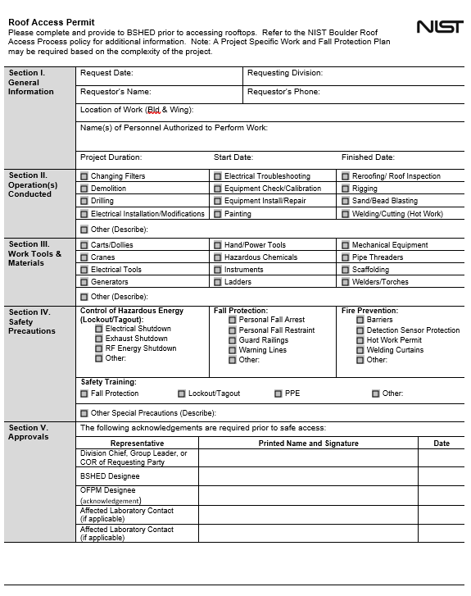
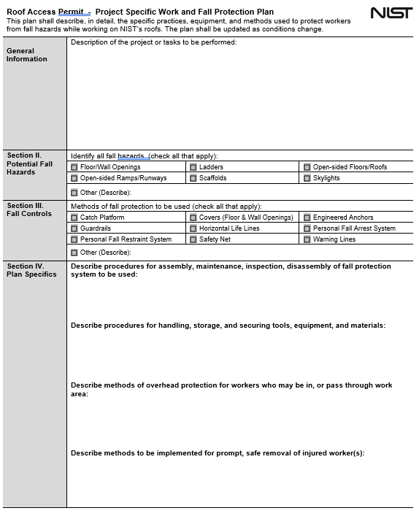
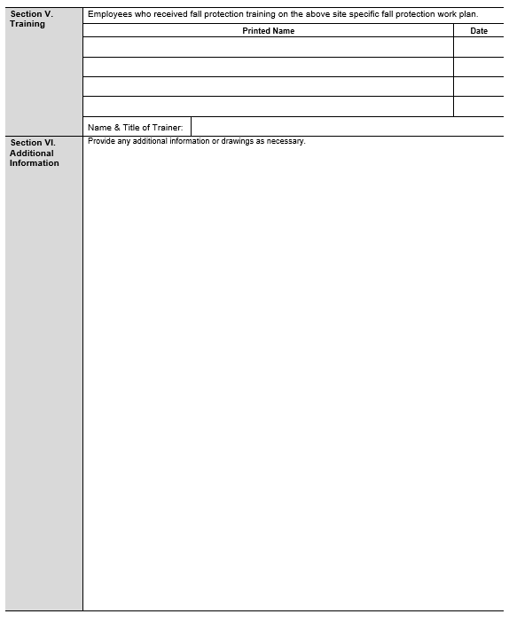

Penetration Permit
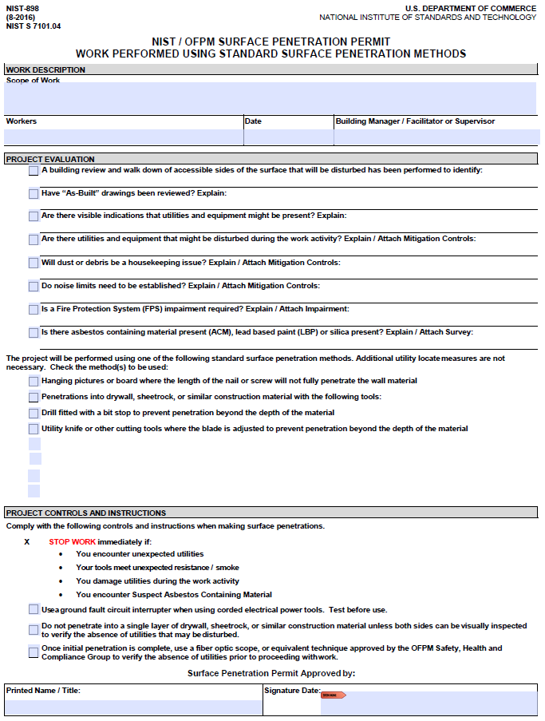

Hot Work Permit
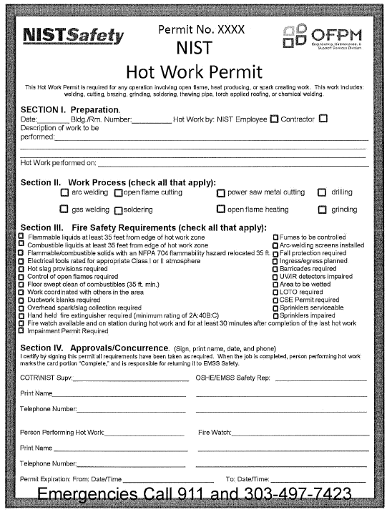

Fire Protection System Impairment
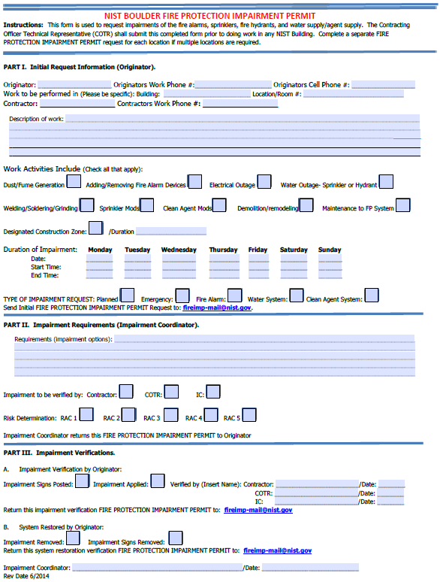

Excavation Permit
