VISUAL GUIDE OF A SAMPLE FLIGHT SUIT
The following are images of a sample Blue Angels’ flight suit, depicted from various angles:
Yellow Suit Sample
Picture Y1  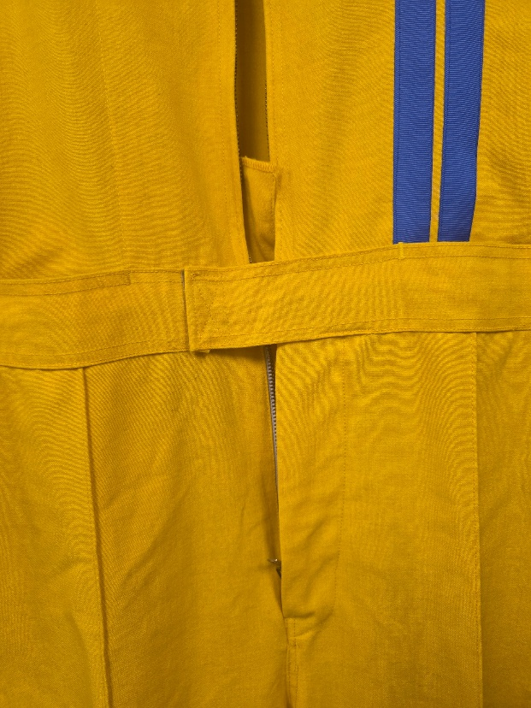 | Picture Y2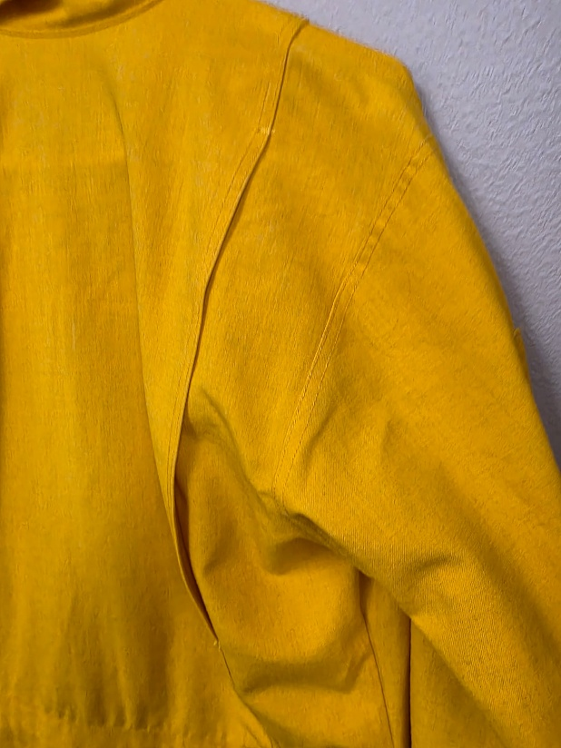
Picture Y3  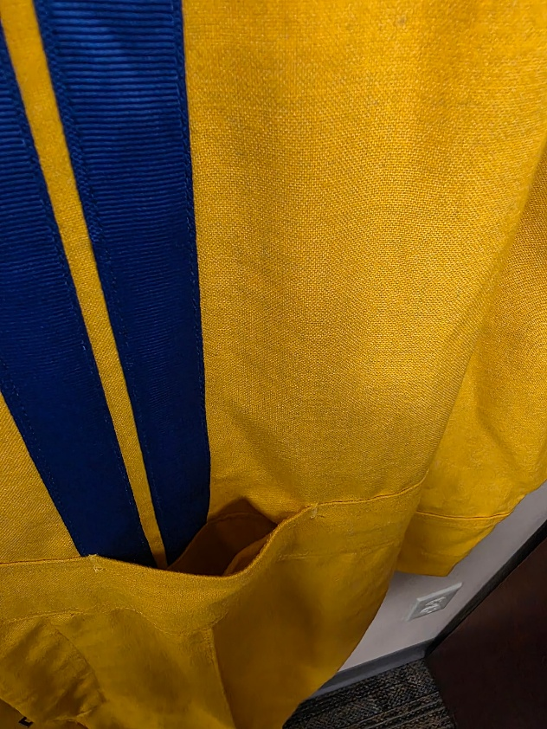 | Picture Y4  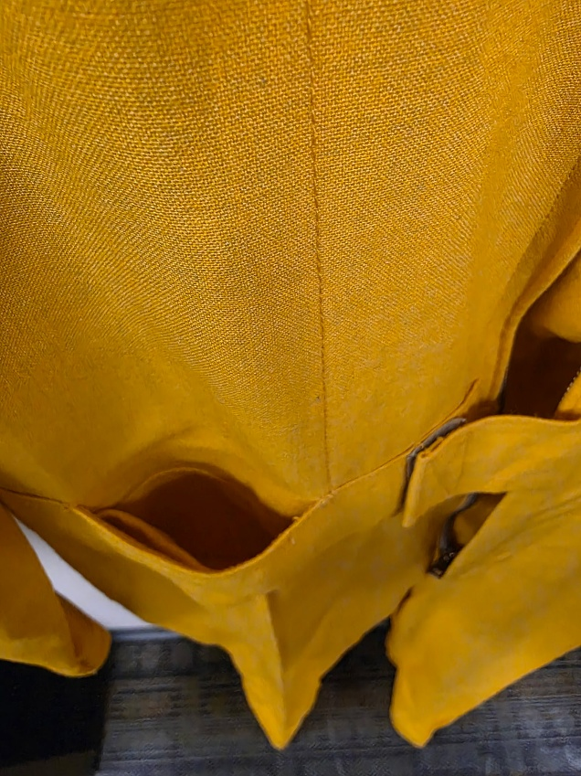
Picture Y5  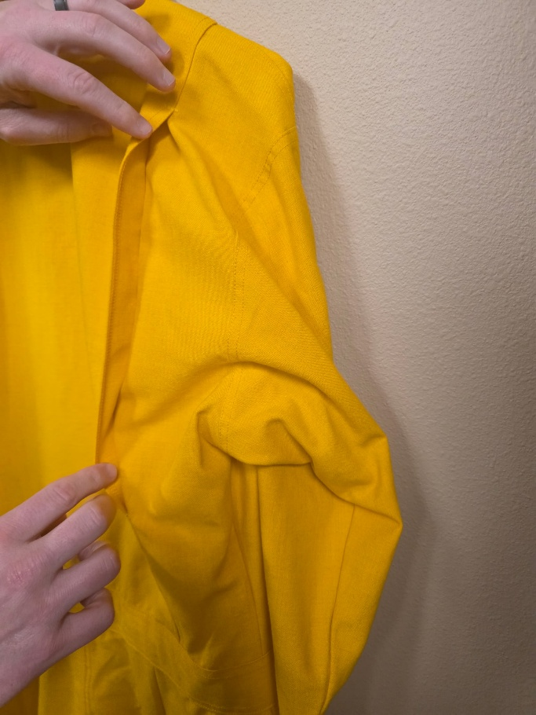 | Picture Y6  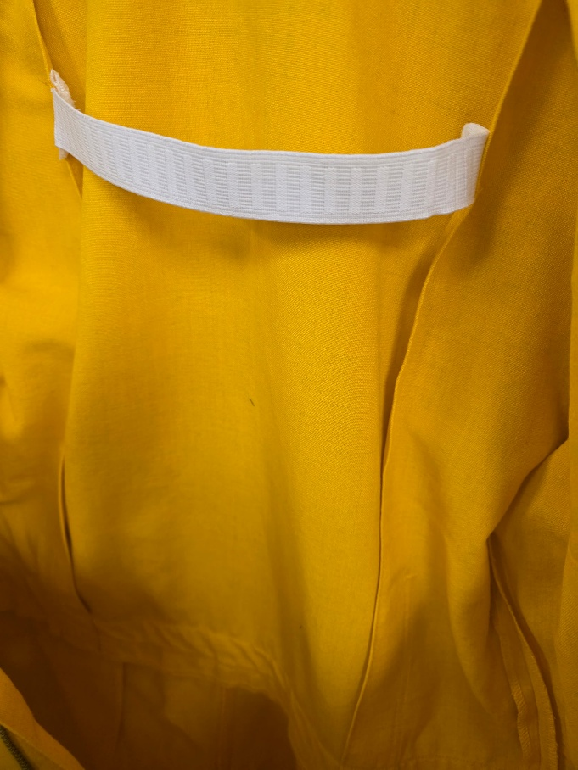
Picture Y7  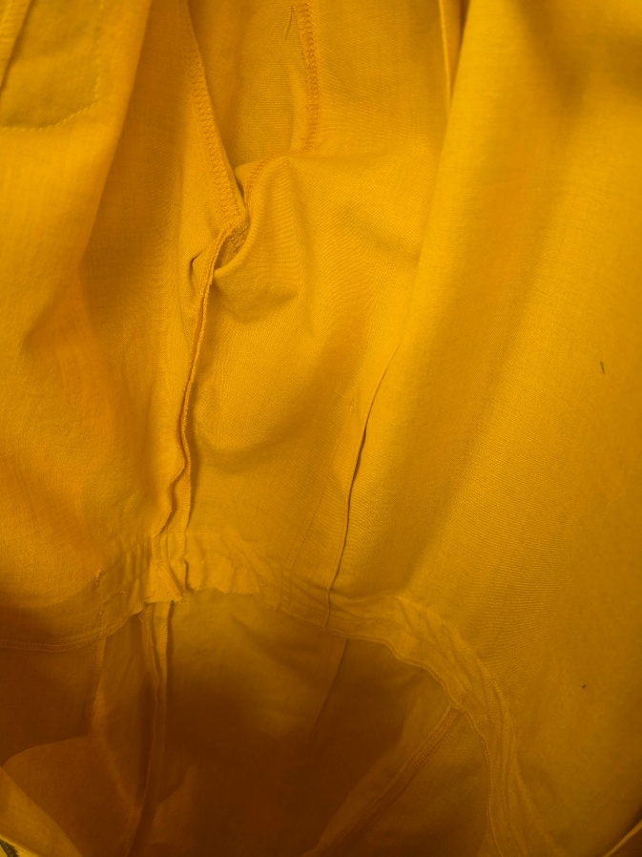 | Picture Y8  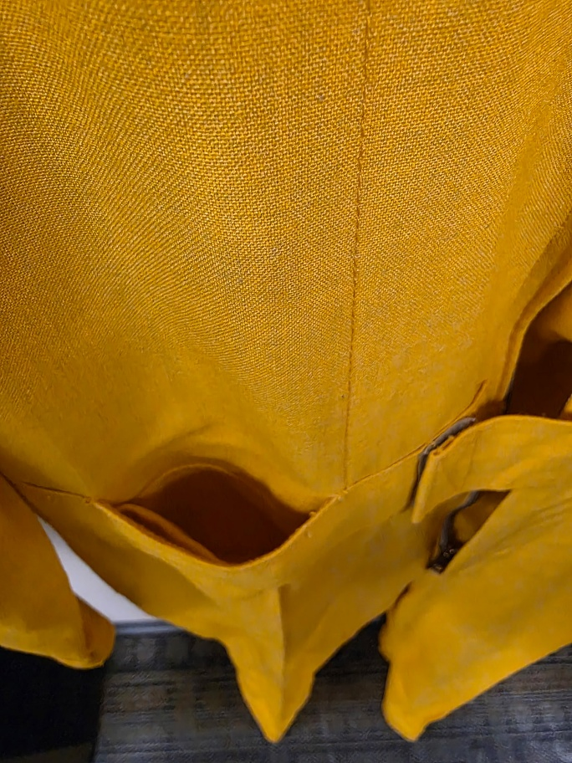

Picture Y9 – Full Front (Yellow)  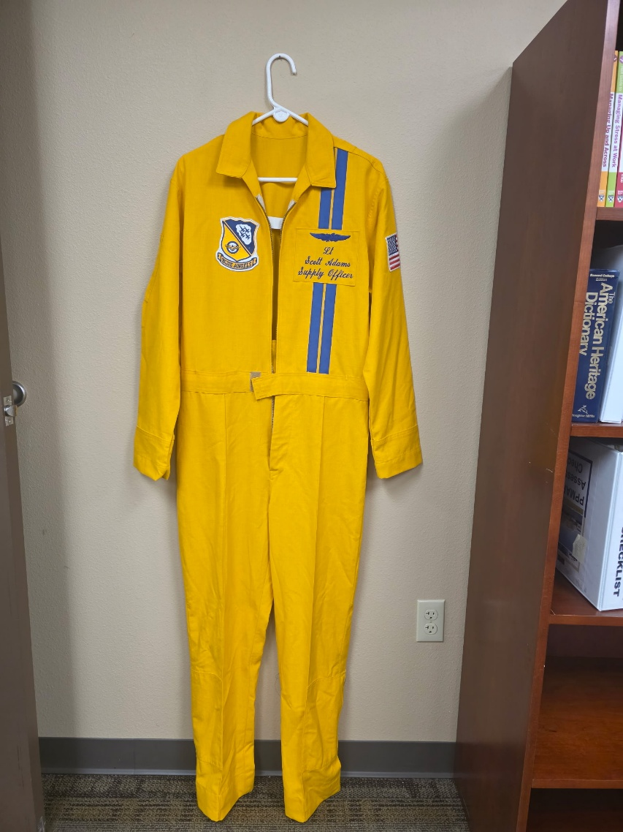 | Picture Y10 – Full Back (Yellow)  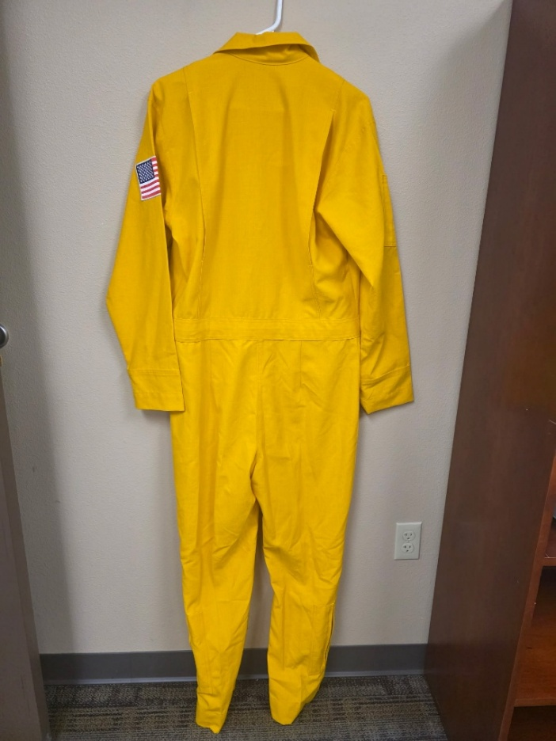

Picture B1  Blue Suit Sample  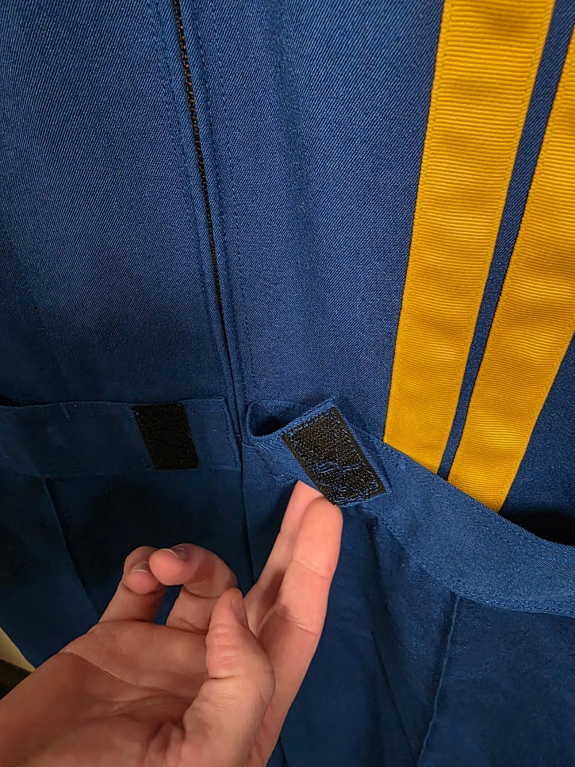 |  | Picture B2  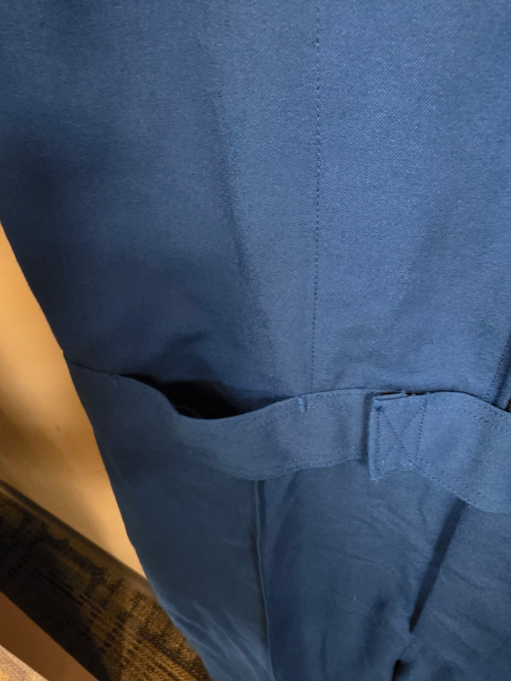
Picture B3
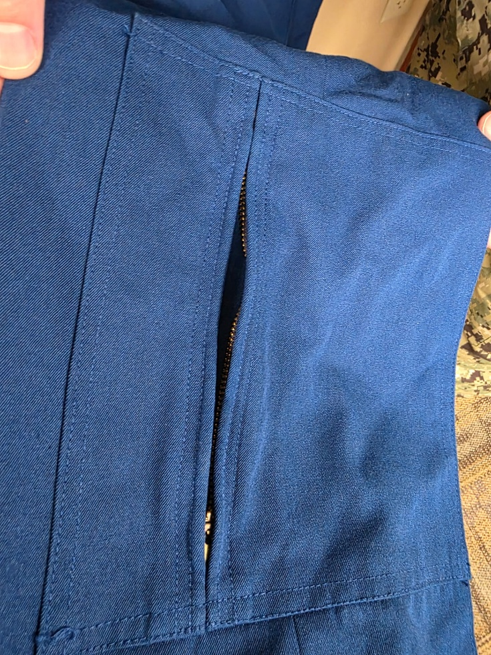

Picture B4 - Full Front (Blue)  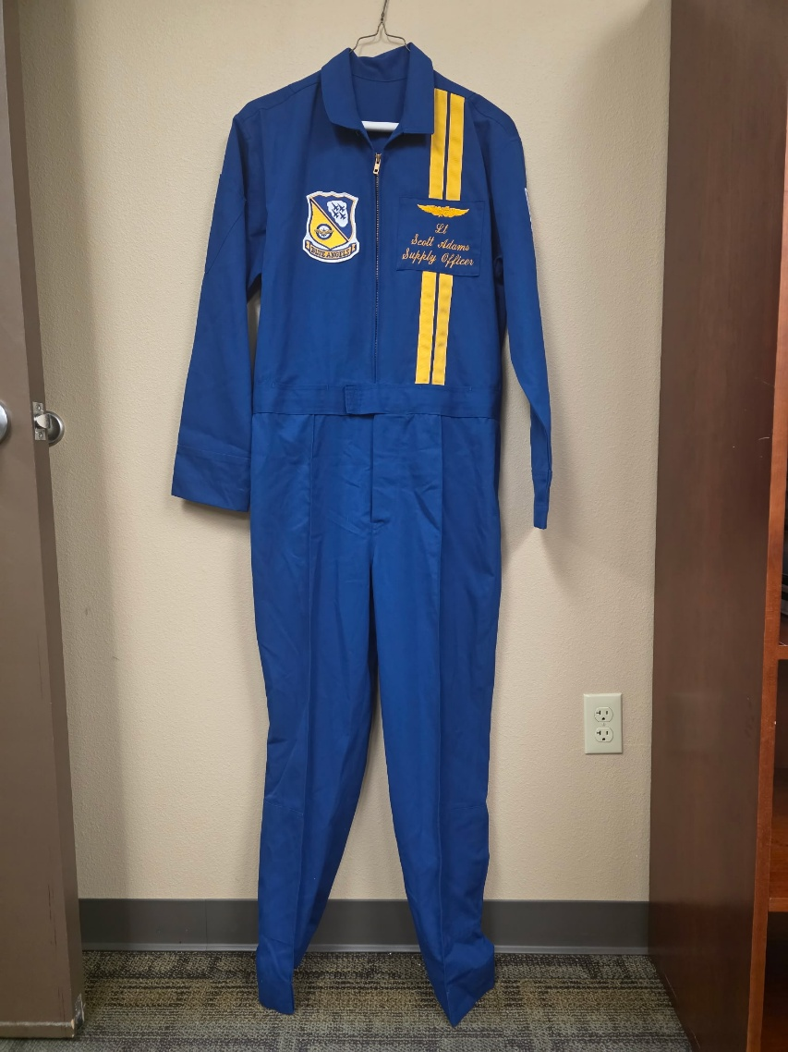 | Picture B5 – Full Back (Blue)  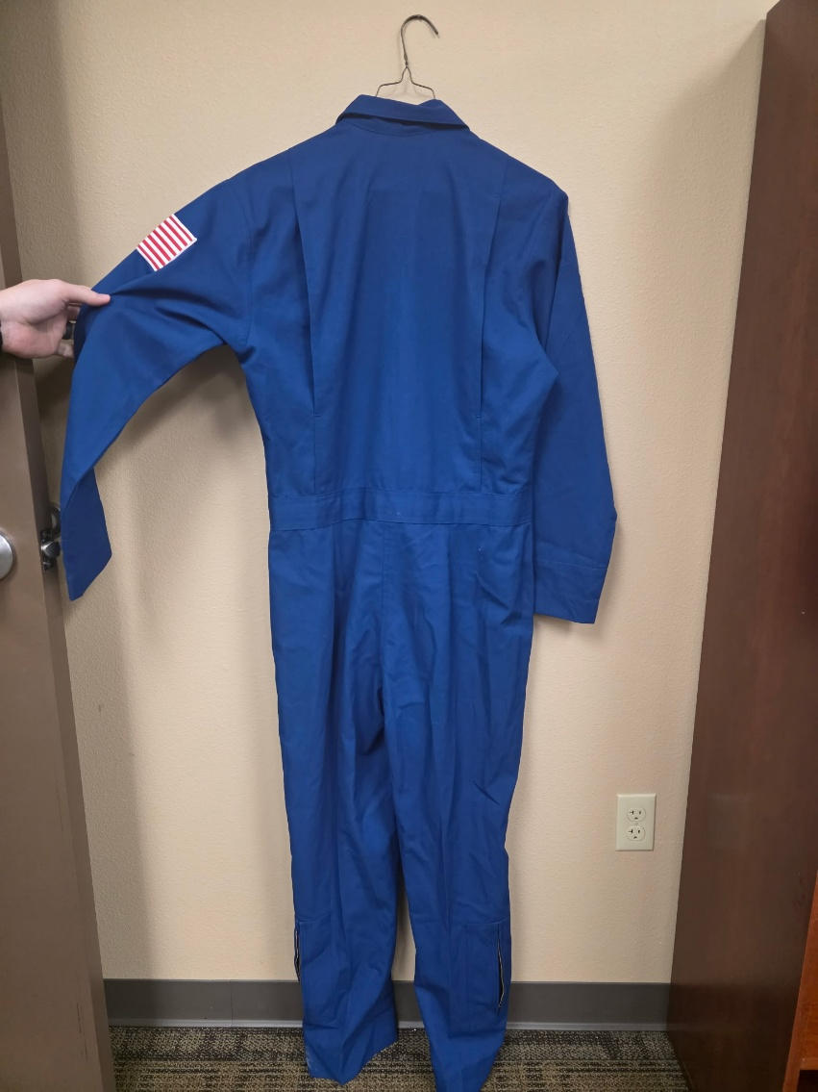
Logos
Picture L1  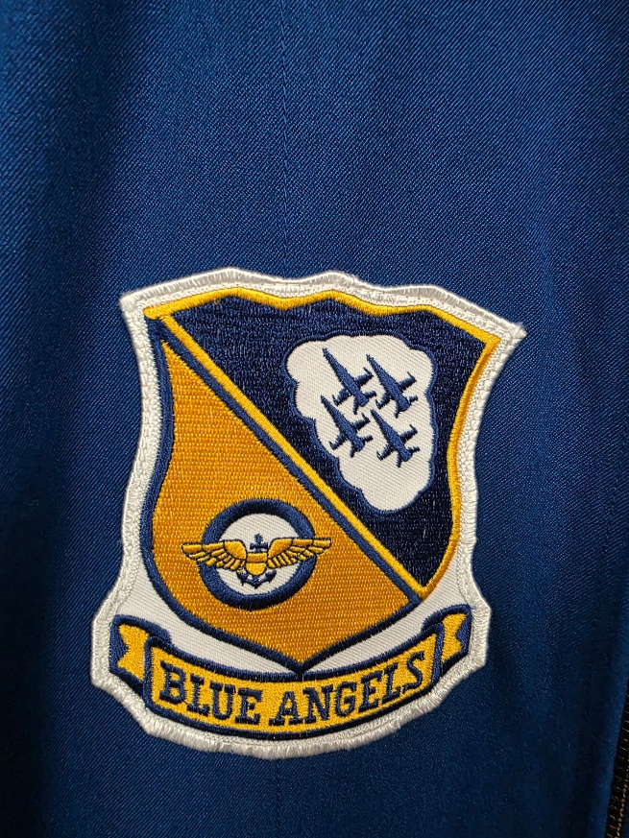 | Picture L2  