SUBJECT* | Omnicell Equipments

GENERAL INFORMATION
CONTRACTING OFFICE’S ZIP CODE* | 90815
SOLICITATION NUMBER* | 36C26226Q0452
RESPONSE DATE/TIME/ZONE | 03-13-2026 10:00 AM PACIFIC TIME, LOS ANGELES, USA
ARCHIVE | 60 DAYS AFTER THE RESPONSE DATE
RECOVERY ACT FUNDS | N
SET-ASIDE
PRODUCT SERVICE CODE* | 6515
NAICS CODE* | 339112
CONTRACTING OFFICE ADDRESS | Department of Veterans Affairs  Network Contracting Office 22  4811 Airport Plaza Drive  Suite 600  Long Beach CA 90815
POINT OF CONTACT* | Contract Specialist  Choo, Sam  sam.choo@va.gov  sam.choo@va.gov

PLACE OF PERFORMANCE
ADDRESS | Department of Veterans Affairs
 | Tucson VA Medical Center
 | 3601 South 6th Avenue
 | Tucson AZ
POSTAL CODE | 85723
COUNTRY | USA

ADDITIONAL INFORMATION
AGENCY’S URL
URL DESCRIPTION
AGENCY CONTACT’S EMAIL ADDRESS
EMAIL DESCRIPTION

DESCRIPTION
THIS REQUEST FOR INFORMATION (RFI) / SOURCES SOUGHT NOTICE ISSUED SOLELY FOR INFORMATION AND PLANNING PURPOSES. THIS IS NOT A SOLICITATION.
SUBMISSION OF INFORMATION ABOUT PRICING, DELIVERY, THE MARKET, AND CAPABILITIES IS HIGHLY ENCOURAGED AND ALLOWED UNDER THIS RFI FOR PLANNING PURPOSES IN ACCORDANCE WITH (IAW) FAR 15.201(e).

DISCLAIMER
This RFI is issued solely for information and planning purposes and does not constitute a solicitation. All information received in response to this RFI that is marked as proprietary will be handled accordingly. IAW FAR 15.201(e), responses to this notice are not offers and cannot be accepted by the Government to form a binding contract. Responders are solely responsible for all expenses associated with responding to this RFI.

SOURCES SOUGHT/RFI DESCRIPTION

This is NOT a solicitation announcement. This is a Sources Sought Notice / RFI only. The purpose of this Sources Sought Notice / RFI is to gain information about potential qualified sources and their size classification relative to NAICS 339112 (size standard of 1,000 Employees). Responses to this Sources Sought Notice / RFI will be used by the Government to make appropriate acquisition decisions. After review of the responses to this Sources Sought Notice / RFI, further RFIs and/or a solicitation or other announcements may be published.

The Department of Veterans Affairs (VA) is seeking sources capable of providing Omnicell Equipments and related services OR EQUAL for Tucson VA Healthcare System.

- Performance Monitoring
  - Pharmacy Service Line staff will ensure proper testing and functionality of the new Omnicell cabinets to ensure proper working order prior to accepting receipt of the items and services.
    - The vendor shall submit a cost proposal with an associated project management plan addressing the tasks associated with the SOW, as described in the evaluation criteria section.
      - Subtasks not specified in the SOW will be identified and include associated costs by project task, milestones and deliverable dates.
      - All written deliverables must be phrased in terms and language that can be easily understood by non-technical personnel, i.e. a person without subject matter expertise.
      - All document deliverables, hard copy and electronic, must be in formats specified-at a minimum, the formats must be in industry accepted standards.
      - A kickoff meeting will be held at a location and time selected by VAMC Tucson where the vendor and its staff will be introduced.
      - The vendor and/or its staff must have knowledge and expertise of the environment for which the work is to be performed.
      - The vendor shall provide total system integration for each of procedure rooms listed above.

- Security Requirements
  - The proposed project uses an existing Virtual Local Area Network (VLAN), standing HL7 interfaces and existing secure vendor remote access.
  - Other Pertinent Information or Special Considerations
    - This system will be located on a secure Virtual Local Area Network (VLAN). The system, while using VA IT resources for networking, does not link, nor have access to, other VA network resources.

- Packaging, Packing and Shipping Instructions
  - All systems/components/software are to be shipped to their final destinations prior to installation; any associated shipping costs must be included in the contract.

- Inspection and Acceptance Criteria.
  - The Program Manager, COR, and/or their representatives will test the equipment prior to acceptance. VA currently utilizes Omnicell in workflow and will run test scenarios that mirror regular workflow to ensure the installed updates/systems are working properly. The staff members are fully trained in the use and functionality of the Omnicell workflow, switching to another manufacturer would increase the costs for retraining.

- Risk Control:
  - The system addition presents no additional infection, physical security, and/or information security risk.
  - Place of Performance
    - Government site: Southern Arizona VA Health Care System – main campus (Tucson, AZ)
    - 3601 S 6’th Avenue (1-119), Tucson AZ 85723

- Equipments:
  - OMNICELL Anesthesia Cart Workstations
    - Deliverables: Successful installation, testing, and, where applicable, staff training
Item # | Description/Part Number* | Qty
1 | FLEXBIN 3131,XT SNGLDOSE  DRW GUIDELIGHT | 16
2 | Drawer, 12 Bin Locking, AWS-XT | 16
3 | XT ANESTHESIA WORKSTATION W-BIO ID | 16
4 | PANEL,EMERGENCY BREAKAWAY,AWS-XT | 16
5 | TILT 4-BIN ORGANIZER, AWS-XT | 16
6 | TILT 5-BIN ORGANIZER, AWS-XT | 16
7 | TILT 6-BIN ORGANZER, AWS-XT | 16
8 | EXTERNAL RETURN BIN, AWS-XT | 16
9 | KIT, UPGRADE, WIRELESS, AWS-XT | 16
10 | SYRINGE LABEL PRINTER-EPSON & SHELF | 16
11 | 2D ITEM SCAN, AWS-XT | 16
12 | PREMIUM WIN10 PACKAGE (120 Months) | 1
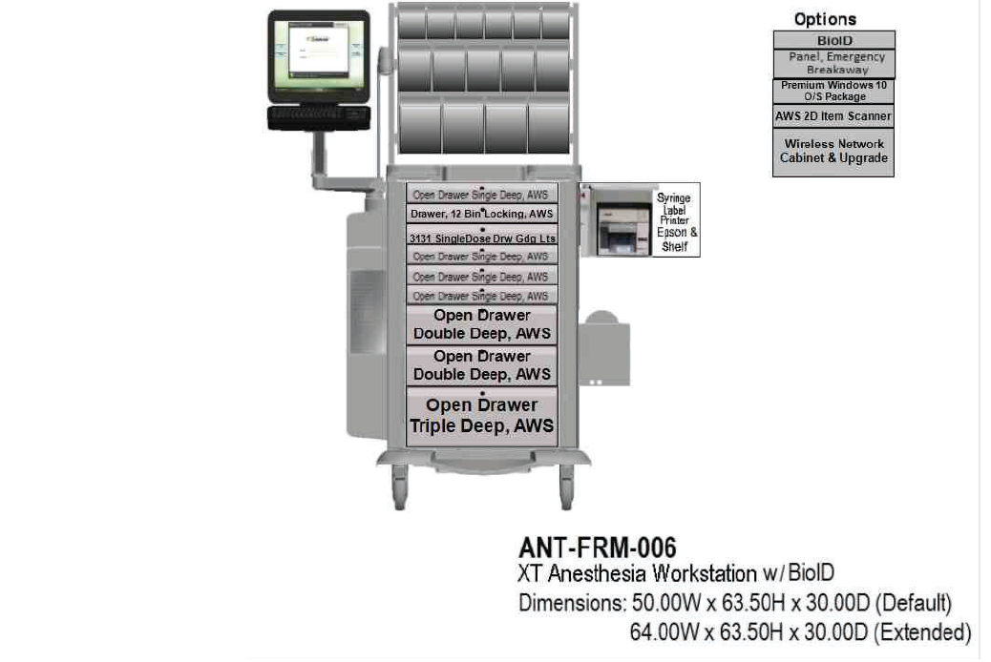
Figure 1

  - OMNICELL Pharmacy Cabinets
    - Deliverables: Successful installation, testing, and, where applicable, staff training

Item # | Description/Part Number* | Qty
MED-DRW-009 | METAL LOCKING DRAWER | 56
MED-FRM-501 | MED 1-CELL CABINET (XTE 2.0) | 5
MED-OPT-002 | MED 2-CELL CABINET (XTE 2.0) | 1
MED-OPT-002 | XT EXTERNAL RETURN BIN,  WIRED CAB MOUNT | 6
MSA-SUB-006 | PREMIUM WIN10 PACKAGE  Prices are calculated based on  120 month subscription term | 6
SRD-OPT-012 | XT FLEXLOCK WITH 50 FT  CABLE,INSTALLED | 6
SUP-OTH-002 | XT PULLOUT SHELF | 16
TSS | TOTAL SUPPORT SERVICES | 1

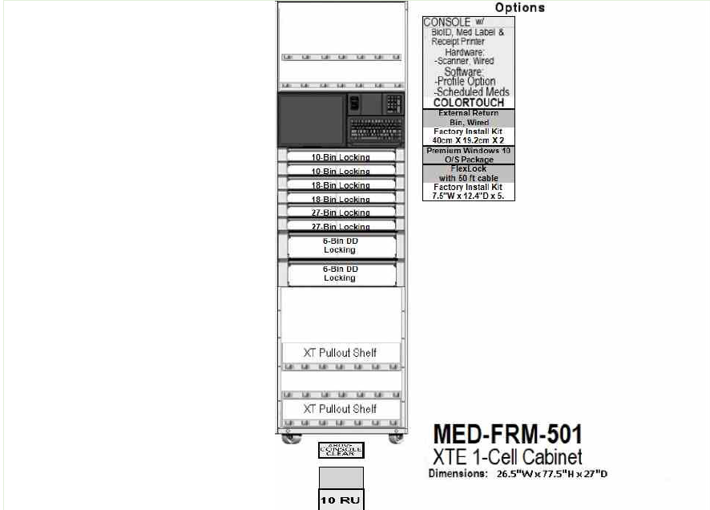
Figure 2
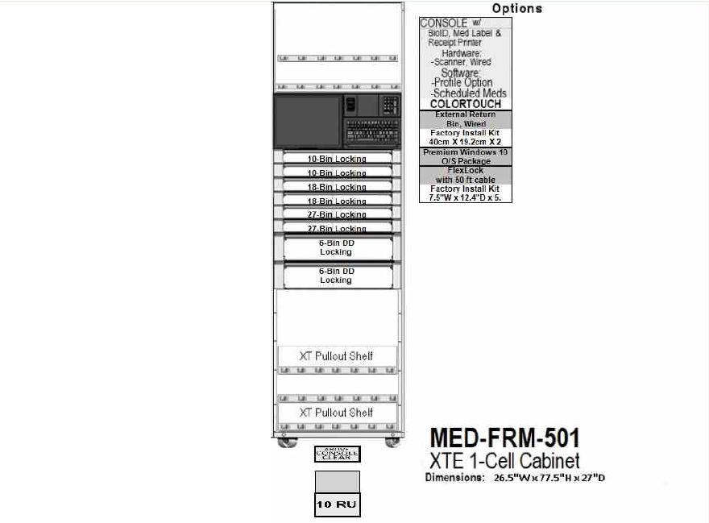
Figure 3
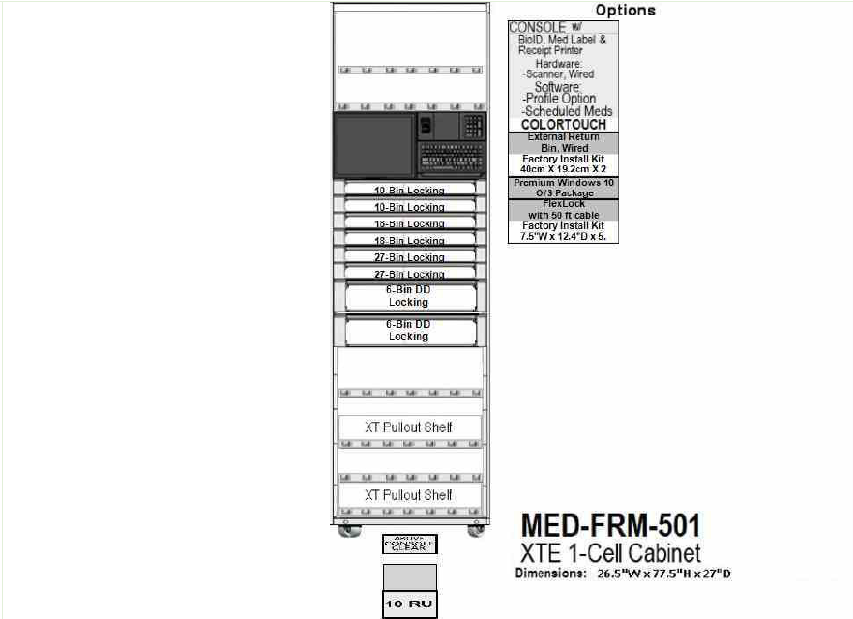
Figure 4
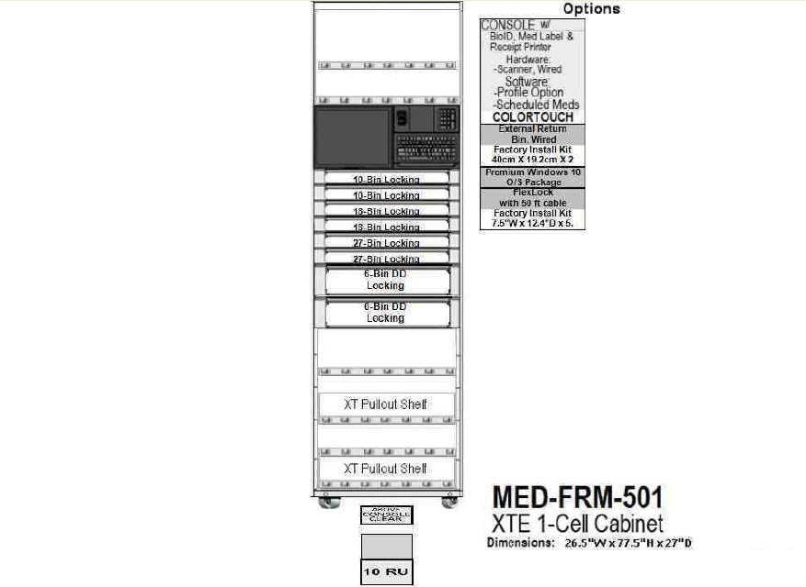
Figure 5
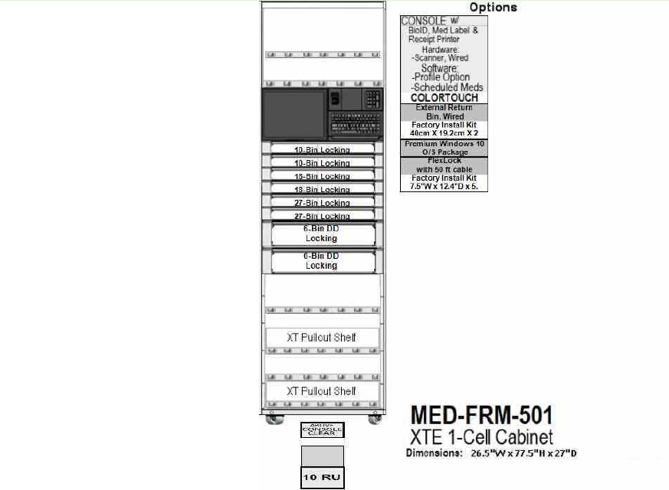
Figure 6
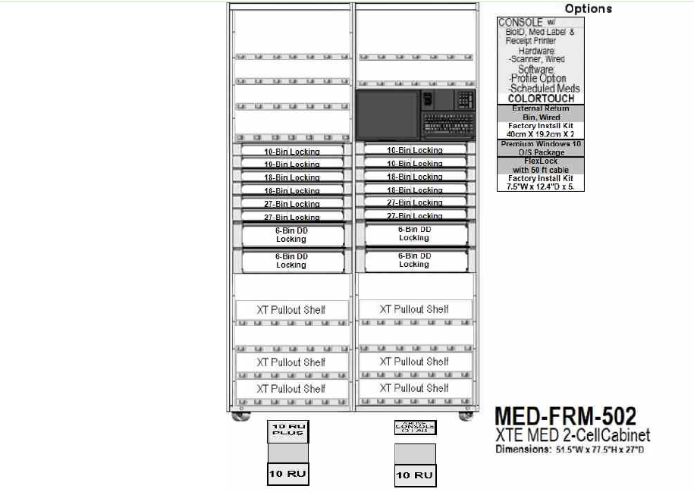
Figure 7
  - Omnicell Return Bins
    - Deliverables: Successful installation, testing, and, where applicable, staff training
Item # | Description/Part Number* | Qty
1 | MED-OPT-002 | 56

  - System Integration:
    - All proposed equipment shall be fully compatible with the facility’s existing Omnicell enterprise server environment, including OmniCenter® or other Omnicell-supported centralized platforms currently in use. The Contractor shall ensure that all components connect reliably to the enterprise server for authentication, data management, and system configuration.

  - Data Management and Integration
    - The systems shall support centralized management of medication inventory, access logs, transaction histories, configuration settings, and user profiles. All data shall be stored and managed through the facility’s Omnicell central server, without local retention beyond temporary operational buffering.
    - The Contractor shall ensure the solution supports integration with the facility’s Electronic Health Record (EHR) system and any associated interface engines required for clinical documentation, medication administration, or workflow interoperability.

  - Cybersecurity and Network Requirements
    - The Contractor shall ensure all communication between the devices and the centralized Omnicell server utilizes secure, encrypted protocols compliant with federal and organizational cybersecurity requirements.
    - The Contractor shall provide documentation outlining required network ports, communication protocols, and server dependencies to support secure deployment and sustainment.

If your company is interested and capable of providing the required supplies/services, you MUST provide the information indicated below OR your intent, interest to participation, and information provided will not be considered as valid for research purposes. Response to this notice should include company name, address, point of contact, size of business pursuant to the following questions:
(1) Submit your capabilities statement illustrating how your organization can/cannot meet the list of DRAFT/SALIENT CHARACTERISTICS/SOW requirements. For instances where your company cannot meet the DRAFT/SALIENT CHARACTERISTICS/SOW requirement(s), please explain. For instances where your company can meet the DRAFT/SALIENT CHARACTERISTICS/SOW requirement(s), please show how your company meets/exceeds each requirement.
(2) Please review the list of DRAFT/SALIENT CHARACTERISTICS/SOW requirements and provide any additional feedback or suggestions. If none, please reply as N/A.
(3) Please indicate the size status and representations of your business, such as but not limited to: Service-Disabled Veteran-Owned Small Business (SDVOSB), Veteran-Owned Small Business (VOSB), HUBZone, Woman Owned Small Business (WOSB), Large Business, etc.
(4) Is your company considered small under the NAICS code identified in this RFI?
(5) Are you the manufacturer, authorized distributor, and/or can your company provide a solution to the required supplies/services described in the list of DRAFT/SALIENT CHARACTERISTICS/SOW?
(6) If you are a large business, do you have any designated/authorized distributors? If so, please provide their company name, telephone, point of contact and size status (if available).
(7) If you’re a small business and you are an authorized distributor/reseller for the items identified above, do you alter; assemble; modify; the items requested in any way? If you do, state how and what is altered; assembled; modified.
(8) Limitations on Subcontracting: How does your business ensure compliance with the limitations on subcontracting as outlined in 13 CFR § 125.6?
(9) Are the items you are identifying/providing considered Commercial of the Shelf (COTS) items as defined in FAR Part 2.101 under commercial items?
(10) Non-Manufacturer Rule: If applicable, can you confirm your business complies with the Non-Manufacturer rule? Specifically, does your company: Provide a product from a small business manufacturer or processor? Not exceed 500 employees? Primarily engage in the retail or wholesale trade and normally sell the type of item being supplied? Take ownership or possession of the item(s) with its personnel, equipment or facilities in a manner consistent with industry practice?
(11) Please indicate whether your product conforms to the requirements of the Buy American Act? Please indicate if manufacturer is/will be US domestic Small Business / US Domestic Large Business / Foreign.
(12) What is your lead time to deliver a single unit with all components? Is there scale in lead time with greater quantities? Please elaborate.
(13) What is estimated life span of your solution? What support/services does that entail?
(14) Does your organization offer a leasing solution? Please elaborate.
(15) Does your company have a Federal Supply Schedule (FSS) GSA/NAC/SAC/BPA/NASA SEWP or any other Federal Government contract? If so, please provide the contract number(s).
(16) If you are an FSS GSA/NAC/SAC/BPA/NASA SEWP or any other Federal Government contract holder, are all the items/solutions you are providing information about available on your schedule/contract? Please state if all or some items are available on the contract.
(17) General pricing of your products/solution is encouraged. Pricing will be used for the purpose of market research only. It will not be used to evaluate for any type of award.
(18) Please provide your SAM.gov Unique Entity ID/Cage Code number.
Responses to this notice shall be submitted via email to sam.choo@va.gov. Telephone responses will not be accepted. Responses must be received no later than Friday, March 13, 2026 by 10:00 AM PST.
All responses to this Sources Sought/RFI will be used for planning purposes only. Responses to this Sources Sought Notice / RFI are not considered a request to be added to a prospective bidders list or to receive a copy of the solicitation. If further RFIs and/or a solicitation or other announcement is issued as a result of the information provided from this RFI, all interested parties must respond to the specific posting separately IAW the specifications of that announcement.

See attached document: 36C26226Q0452 - Omnicell Equipments.

