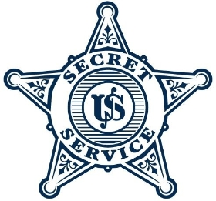

U.S. Secret Service 2026 Virtual Industry Day
Details
The U.S. Secret Service is holding a Virtual Industry Day to introduce the USSS community to a host of vendors in an effort to increase large and small business support and expand means of acquiring goods/services, as well as inform the vendor communities of major acquisitions and possible contract opportunities.
After the presentations, the Government will accept questions. If additional information is needed for certain questions, the Government will record them and attach responses via SAM.gov after the event.
During the Virtual Industry Day Session, each Industry Partner will be asked to fill out a Form with its list of attendees. It is the Government’s intent to release all attendees’ names and contact information to SAM. During registration, you will be given the opportunity to indicate whether you agree or would like to opt out of having this information released.

