
2026 Florida Panhandle Subcontracting Connections
MARKETING TOOLKIT

This toolkit contains:
- Event information
- Social Media Graphics & Suggested posts
- Newsletter Copy
- Email Templates
- Press Release Template

Quick Facts
- Dates: April 8, 2026
- Time: 8 AM - 12 PM
- Location: Santa Rosa Auditorium, 4530 Spikes Way, Milton, FL 32583
- Registration Link: tinyurl.com/apex-subcontracting

Event Description *please use if posting event to other sites*
Unlock Your Next Major Project
Are you a subcontractor looking to scale your business and navigate the complexities of government contracting? Join the Florida APEX Accelerator at UWF for a game-changing opportunity to bridge the gap between your aspirations and your next big contract.
The Florida Panhandle Subcontracting Connections event is specifically designed to bypass traditional barriers and give local subcontractors direct access to the decision-makers who drive the region's economy. Whether you specialize in construction, professional services, or technical support, this event is your gateway to the Florida Panhandle's most lucrative procurement opportunities.
The Florida Panhandle Subcontracting Connections event is a game-changing opportunity for subcontractors looking to expand their business and secure major projects in Northwest Florida. Hosted by the Florida APEX Accelerator at UWF, this event bridges the gap between small business subcontractors and top area prime contractors.
Why You Should Attend:
- Hear from the Experts: Get direct briefings from key decision-makers at Eglin AFB, Hurlburt Field, and local county purchasing offices regarding their upcoming project pipelines and requirements.
- Face-to-Face Networking: Meet one-on-one with leading Prime Contractors who are actively seeking qualified, reliable subcontractors to fulfill mission-critical contracts.
- Insider Strategies: Learn the "rules of engagement" for successful Prime-Sub partnerships and how to position your business as the preferred choice for major government projects.
- Discover Opportunities: Gain a first-look at upcoming regional subcontracting forecasts and learn how to navigate the procurement procedures of local and federal agencies.
Target Audience:
This event is a must-attend for small business owners and subcontractors in the Northwest Florida region who are ready to compete for federal, state, and local government contracts.
Registration:
Seats for this high-demand event are limited to ensure quality networking time. Secure your spot today and take the next step in strengthening America’s industrial base right here in the Florida Panhandle.
Event Agenda:
- 8:00 AM - 9:00 AM: Presentations
  - Florida APEX Accelerator Team
  - Small Business Office, Eglin AFB
  - 1st Special Operations Contracting Squadron, Hurlburt, FL
  - SLED Contracting Officer
- 09:00 AM - 12:00 PM: Business Networking

Event Thumbnail
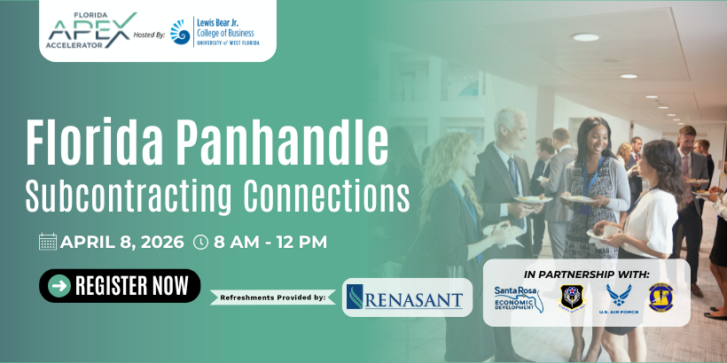
Social Media

Hashtags: #PanhandleContracts #NWFlorida #GovContracting #FloridaAPEX

Event Graphic
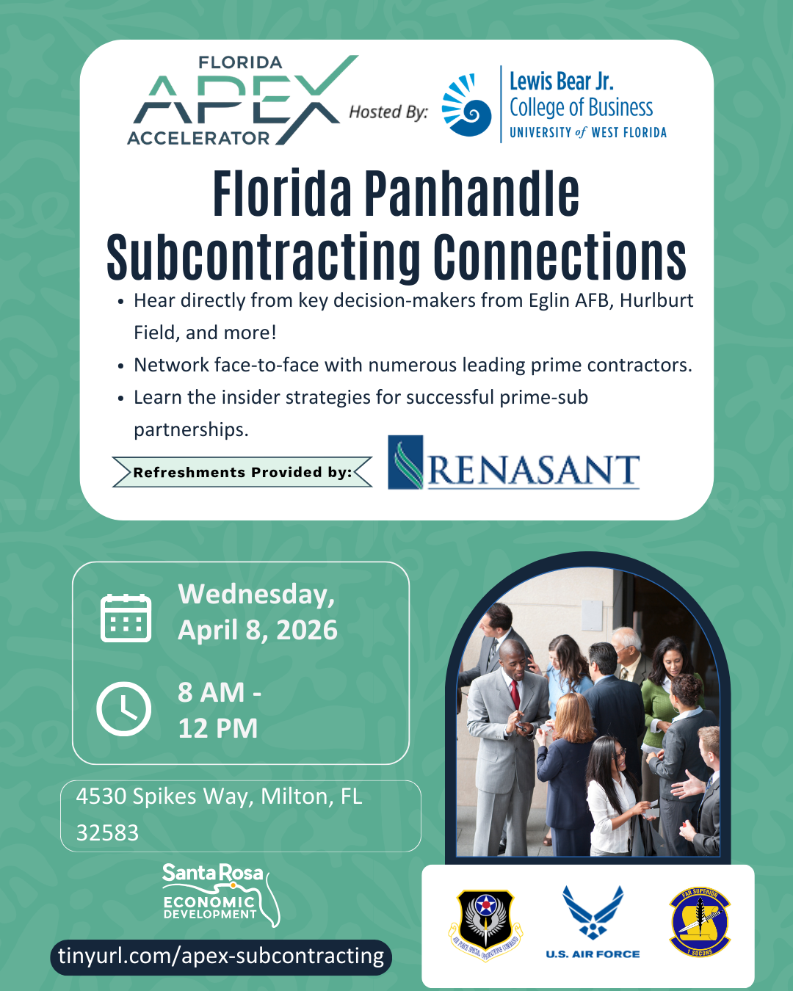

Suggested Posts

Facebook | LinkedIn | Instagram

Post 1: Attention Subcontractors!
Attention Subcontractors! Are you looking to take your business to the next level and secure major government or commercial projects? ✳️ Don’t miss the Florida Panhandle Subcontracting Connections event!
This is your chance to bypass typical barriers and get direct access to the people who can help grow your business. ✅ Connect with top area prime contractors. ✅ Hear from decision-makers at Eglin AFB, Hurlburt Field, and local county purchasing offices. ✅ Learn the strategies you need for successful partnerships.
Seats are limited! Secure your spot now: 👉 tinyurl.com/apex-subcontracting
Post 2: Registration is Open!
Ready to build powerful connections? Registration is officially open for the Florida Panhandle Subcontracting Connections event hosted by Florida APEX Accelerator at UWF!
Join us on April 8th to network face-to-face with leading prime contractors and discover upcoming subcontracting opportunities in our region. This event is free to attend, but registration is required.
Register today: tinyurl.com/apex-subcontracting

Post 3: Meet the Decision-Makers
Want to know what prime contractors are looking for? ✳️ Get direct answers at the Florida Panhandle Subcontracting Connections event!
Join us to network with key representatives from:
✅ Eglin AFB
✅ Hurlburt Field
✅ Local County Purchasing Offices
✅ Top Regional Prime Contractors
This is your opportunity to build the partnerships that lead to major contracts. 👉 Register for FREE: tinyurl.com/apex-subcontracting

Post 4: Grow Your Business in NW Florida Ready to take your subcontracting business to the next level? 📈 The Florida APEX Accelerator at UWF is hosting an exclusive event to help you bypass traditional barriers and connect with the region's biggest projects.
- Network face-to-face with prime contractors.
- Discover upcoming regional opportunities.
- Learn insider strategies for successful partnerships.
Attendance is complimentary, but seats are limited! 👉 Secure your spot: tinyurl.com/apex-subcontracting

Twitter (X)

Post 1: Join Us!
✳️ ATTENTION SUBCONTRACTORS ✳️ Connect with top area prime contractors and key decision-makers from Eglin AFB & Hurlburt Field at the Florida Panhandle Subcontracting Connections event!
Secure your FREE spot today: tinyurl.com/apex-subcontracting #PanhandleContracts #NWFlorida

Post 2: Direct Access
Connect directly with decision-makers from Eglin AFB, Hurlburt Field, and top area prime contractors! 🤝 Don’t miss the Florida Panhandle Subcontracting Connections event!
Register now for FREE: tinyurl.com/apex-subcontracting #PanhandleContracts #FloridaAPEX

Post 3: Don’t Miss Out!
Seats are filling up! ✳️ Join us for a day of networking and strategy to help your subcontracting business thrive in NW Florida.
✅ Free Registration ✅ Prime Contractor Networking ✅ Expert Insights
Sign up today: tinyurl.com/apex-subcontracting #NWFlorida #GovContracting

Newsletter Copy

Join the Florida APEX Accelerator at UWF for Florida Panhandle Subcontracting Connections, a specialized event on April 8th designed to bridge the gap between local subcontractors and major prime contractors. This event will bring small business owners, regional prime contractors, and government partners together to help subcontractors walk away with the strategies and connections needed to further their business.

Why You Should Attend:
This event will feature networking opportunities and direct access to decision-makers that allow small business professionals to walk away with tangible strategies and connections to help their business grow and thrive. Attendees will have the unique chance to:
- Network face-to-face with leading prime contractors actively seeking partners.
- Hear directly from agencies such as Eglin AFB, Hurlburt Field, and Okaloosa County regarding upcoming projects.
- Learn insider strategies for building and maintaining successful subcontracting partnerships.

Don’t miss this one-of-a-kind event! Whether you are looking to secure your first subcontract or expand your current portfolio, this event provides valuable information and connections to help take your small business to the next level. Register today!

Email Templates

Option 1: From Organization/Region
Subject: Open Doors to New Projects: Florida Panhandle Subcontracting Connections
Dear [Name],
As a valued partner of the Florida SBDC / Florida APEX Accelerator at UWF, we want to ensure you have the tools and connections to succeed in the government and commercial contracting space.
We are excited to invite you to the Florida Panhandle Subcontracting Connections event on April 8th at the Santa Rosa Auditorium in Milton.
This event is specifically designed to help subcontractors like you bypass traditional barriers. You will have the unique opportunity to:
- Network face-to-face with leading prime contractors.
- Gain insights from experts at Eglin AFB, Hurlburt Field, and local county purchasing officials.
- Learn insider strategies for winning and maintaining successful partnerships.
Attendance is complimentary, but seats are filling up fast. Please register at the link below to secure your spot: tinyurl.com/apex-subcontracting
We look forward to seeing you there and helping you grow your business!
Best regards, [Your Name/Organization]

Option 2: From Consultant/Individual
Subject: Let’s get your business connected to Prime Contractors!
Hello [Name],
I wanted to reach out personally and invite you to an upcoming event that could be a game-changer for your business: Florida Panhandle Subcontracting Connections.
If you've been looking for a way to get your foot in the door with major prime contractors or government agencies like Eglin AFB, this is the event to attend. It’s a rare chance to meet face-to-face with decision-makers who are actively seeking subcontractors for upcoming regional projects.
Event Details:
- When: April 8, 2026
- Where: Santa Rosa Auditorium, 4530 Spikes Way, Milton, FL 32583
- Cost: Free (Registration Required)
You can find the full agenda and register here: tinyurl.com/apex-subcontracting
I’d love to see your business represented there. Let me know if you have any questions!
Best, [Your Name]

Email Banner


Press Release Template
FOR IMMEDIATE RELEASE [Date]
Media Contact: [Name] [Title] [Email] [Phone Number]
Florida APEX Accelerator at UWF to Host Subcontracting Connections Event for Local Small Businesses
[CITY, FL] — [Organization] is proud to announce the upcoming Florida Panhandle Subcontracting Connections event, taking place on April 8th at the Santa Rosa Auditorium in partnership with the Florida APEX Accelerator at UWF. This premier networking event is designed to connect local subcontractors with major prime contractors and government agencies to spur economic growth in Northwest Florida.
The event features a unique opportunity for small business owners to engage directly with key decision-makers from Eglin Air Force Base, Hurlburt Field, and other local county purchasing offices. Attendees will participate in face-to-face networking sessions, learn strategies for building successful prime-sub partnerships, and gain early insight into upcoming regional projects.
“Our goal is to bypass the typical barriers small businesses face when trying to enter large-scale contracting,” said [Name/Title]. “By bringing prime contractors and subcontractors into the same room, we are facilitating the connections that lead to real contracts and regional prosperity.”
The event is complimentary for all attendees, but pre-registration is required.
Event Highlights:
- Networking with top-tier prime contractors actively seeking partners.
- Briefings from regional military and county leadership.
- Expert-led sessions on successful subcontracting strategies.
For more information and to register, please visit: tinyurl.com/apex-subcontracting
About Florida APEX Accelerator at UWF: The Florida APEX Accelerator helps Florida businesses identify, compete for, and win government contracts.

Our confidential, one-on-one consulting services are available at no cost to any Florida business, large or small, that possesses the interest and potential to perform work – as a prime contractor or a subcontractor – for federal, state, or local government agencies.

The Florida APEX Accelerator is powered statewide by the University of West Florida and funded in part by the State of Florida and local partners. This APEX Accelerator is funded in part through a cooperative agreement with the Department of War.

###

