  - GENERAL INFORMATION

  - This is a non-personal supply contract to provide delivery of Human Cadavers.

1.1.1 Description of services/introduction: The contractor shall provide all personnel, equipment, supplies, facilities, transportation, tools, materials, supervision, and other items and non-personal services necessary to perform delivery of human cadavers/cadaver specimens as defined in this Statement of Work (SOW).

1.1.2 Background: Historically DPE (Directorate for Professional Education) physician / residency programs at Naval Medical Center Portsmouth require human cadavers for the residency program, the absence of this contract would make the GME program non-existent and they would not be able to graduate with the Hands-On Experience needed to graduate.

1.1.3 Scope: Purchase and delivery of soft cure, flushed, and embalmed human cadavers.

1.1.4 Period of Performance (PoP): 01 July 2026 – 30 June 2029
Base Year: 01 July 2026 – 30 June 2027
Option Year 1: 01 July 2027 – 30 June 2028
Option Year 2: 01 July 2028 – 30 June 2029

1.2 Administrative specifications

1.2.1 Place of performance: The work shall be performed at Naval Medical Center Portsmouth, 620 John Paul Jones Circle, Building 3, 1st Floor, Room 1.3 134B, Bioskills Cadaver Lab, Portsmouth, VA 23708.

1.2.2 Recognized Federal holidays: Vendor’s services are not required on federal holidays.
New Year’s Day Labor Day
Martin Luther King Jr.’s Birthday Columbus Day
President’s Day Veteran’s Day
Memorial Day Thanksgiving Day
Juneteenth Day Christmas Day
Independence Day

1.2.3 Hours of operation: The contractor is responsible for conducting business Monday thru Friday 0700 – 1530 except Federal holidays or when the Government facility is closed due to local or national emergencies, administrative closings, or similar Government directed facility closings. The contractor must at all times maintain an adequate workforce for the uninterrupted performance of all tasks defined within this SOW when the Government facility is not closed for the above reasons.

1.2.4 Emergency Services: On occasion, services may be required to support an activation or exercise of contingency plans outside the normal duty hours.

1.3 Contractor Identification
1.3.1 Contractor personnel performing services in a contractor capacity in a Government facility are required to possess and wear an identification badge that displays his or her name and the name of their company. All contractor personnel shall identify themselves as contractor support personnel in all forms of communication with all entities with whom DHA/Deputy Assistant Director for Acquisition (DAD-A)/Head of the Contracting Activity (HCA) has business dealings. The contractor shall: Answer all telephone calls and have a personalized voice message with an introductory statement that includes the fact that the person is contractor support personnel. Ensure all those with whom the person interacts in any face-to-face dealings while supporting the DAD-A understands that the person is contractor support personnel. Include a title block in all emails that states the fact that the person is contractor support personnel. Ensure all those with whom the person interacts in any face-to-face dealings while supporting DHA/DAD-A/HCA understands that the person is contractor support personnel.
1.3.2 Contractor personnel will be required to attend meetings or otherwise communicate with Government and/or other contract representatives to meet the requirements of this order. Contractor personnel shall make their contractor status known during introductions.
1.3.3 Contractor personnel, while performing in a contractor capacity, are prohibited from using their retired or reserve component military rank or title in any written or verbal communications associated with the contracts in which they provide services.

2.0 SPECIFIC TASKS

2.1 Cadaver Order

2.1.1 Cadaver Contract Order Purchase for 26 Human Cadavers for Base Year and 26 Human Cadavers for Option Year One and 26 Human Cadavers for Option Year 2.

2.1.2 Types of Human Cadavers: Within this order there is a variety of human cadavers, the types of cadavers are the following: (63) Soft Cure Thiel Method, (12) Flushed, and (3) Embalmed.

2.2 Delivery Human Cadavers / Specimens: Vendor is to deliver 26 cadavers for the base year and 26 for the option year 1 and 26 for the option year 2. Cadavers shall be delivered within 2 hours of leaving the vendor’s facility, via refrigerated ground transportation.

2.2.1 Schedule of Delivery: The delivery varies upon classes being taught and what type of cadaver is needed for the training. The soft cure cadavers are delivered monthly, usually two at a time, sometimes more. The formaldehyde cadaver is delivered June/July timeframe. The four flushed cadavers are delivered when required training is scheduled.

2.2.2 Turnaround Time: The turnaround time for delivery of cadavers is dependent upon the availability of Vendor and the availability of the Bioskills Lab, however, it is usually scheduled two months prior to delivery date.

2.2.3 Return of Cadaver Ashes (Remains): According to Virginia Code 32.1-301 Burial, cremation, or return of bodies after scientific study, at completion of program usage, it is the responsibility of the user program to return the cremated remains to the designated next of kin or another designated individual. The Vendor will provide any necessary information for the mailing of cremated remains back to the donor's legal representative at the appropriate time.

3.0 QUALIFICATIONS/CONSIDERACTIONS

3.1 Special Qualifications/Considerations: Due to being located on government facility, Contractor must obtain base access through DBIS. This can be done at https://dbids-global.dmdc.mil/home/.

4.0 POINTS OF CONTACT

4.1 Points of Contact:

Clinton Rombaoa, HSBTC Manager, 757-953-4830 clinton.r.rombaoa2.civ@health.mil

HM1 Emily Day, BioSkills Tech, 757-953-4871 emily.a.day5.mil@health.mil

LS1 Aniyah Bibbs, Centralized Contract Administration, 575-953-4871 aniyah.k.bibbs.mil@health.mil

5.0 Attachments

Order Form Base Year Period of Performance: 01JULY2026 – 30JUN2027
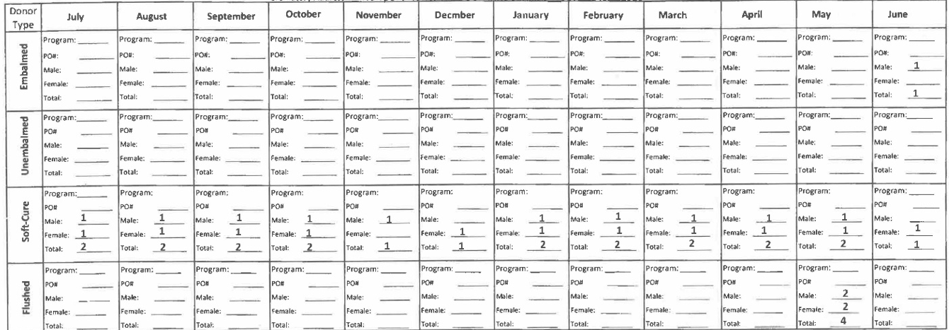

Order Form Option Year 1 Period of Performance: 01 July 2027 – 30 June 2028

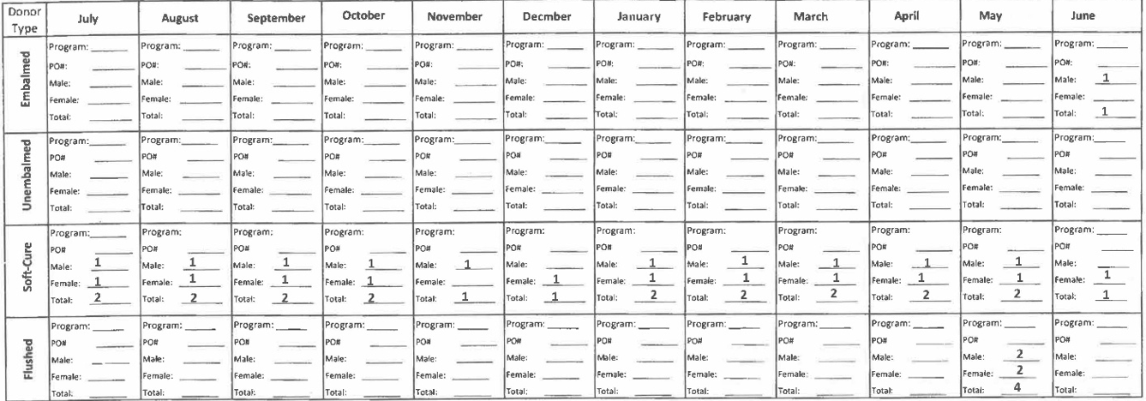

Order Form Option Year 2 Period of Performance: 01 July 2028 – 30 June 2029
