SUBJECT* | 526-17-707 Parking Lot Replacement and Expansion

GENERAL INFORMATION
CONTRACTING OFFICE’S ZIP CODE* | 10468-3904
SOLICITATION NUMBER* | 36C24226B0044
RESPONSE DATE/TIME/ZONE | 03-17-2026 4pm EASTERN TIME, NEW YORK, USA
ARCHIVE | 99 DAYS AFTER THE RESPONSE DATE
SET-ASIDE | SDVOSBC
PRODUCT SERVICE CODE* | Z1LZ
NAICS CODE* | 236220
PLACE OF PERFORMANCE | James J. Peters DVA Medical Center,
 | 130 W. Kingsbridge Road
 | Bronx, NY 10468
POSTAL CODE | 10468
COUNTRY | USA
CONTACT INFORMATION
CONTRACTING OFFICE ADDRESS | Department of Veterans Affairs  Network Contracting Office 2  James J. Peters VA Medical Center  130 West Kingsbridge Road  Bronx NY 10468-3904
POINT OF CONTACT* | Contract Specialist  Patricia Cordero  Patricia.Cordero@va.gov  (718) 584-9000 X4928
ADDITIONAL INFORMATION
AGENCY’S URL
URL DESCRIPTION
AGENCY CONTACT’S EMAIL ADDRESS
EMAIL DESCRIPTION | Patricia.Cordero@va.gov

DESCRIPTION
THIS IS A PRE-SOLICITATION NOTICE ONLY

Project No. 526-17-707; Parking Lot Expansion at the James J. Peters VA Medical Center, Bronx, New York.

CONSTRUCTION SERVICES

GENERAL SCOPE/Statement of Work.
BACKGROUND:
The department of Veterans Affairs is accepting proposals for qualified firms provide Construction services that will include but are not limited to Demolition, Architectural, Electrical, landscape, utility, grading, fencing and pavement markings, as well as other design considerations for the complete renovation of 2300 square feet of parking lot replacement, located at the James J Peters VA Medical Center, 130 West Kingsbridge Road, Bronx, New York 10468.
Prior to submitting a quote, it is mandatory to examine the scope of work and it is highly recommended to visit the facility to take field measurements, evaluations, etc., and become familiar with existing conditions under which the work will be performed.
Schedule work to minimize interference with the facility’s normal operations. Normal operating hours are from 8:00am to 4:30pm Monday thru Friday except federal holidays. Any work during other hours unless otherwise instructed or permitted shall be scheduled and approved with the Contracting Officers Representative.
All disposals shall be done in accordance with federal, state, and local laws and regulations. All bulk waste shall be disposed of in contractor provided dumpsters.
The Contracting Officer’s Representative has the right to reject defective workmanship or materials or work not performed as per the project specifications. Only the Contracting Officer or his/her representative may accept work performed by the contractor.
The C&A requirements do not apply, and that a Security Accreditation Package is not required.
Contractor shall provide all labor, materials, and equipment necessary to complete the following unless noted below:
- Site Preparation and Demolition
- Contractor shall completely prepare site for building operations, including demolition and removal of existing structures, and furnish labor and materials and perform work for VAMC Bronx Parking Lot Replacement and Expansion as required by drawings and specifications.
- Contractor shall Mobilize equipment and establish construction boundaries and safety zones.
- Contractor shall remove all existing pavement (asphalt or concrete), gravel, curbs, sidewalks, wheel stops, signage, and striping
- Visits to the site by Bidders may be made only by appointment with the Medical Center Engineering Officer.

- Offices of Northeast Infrastructure LLC., as Architect-Engineers, will render certain technical services during construction. Such services shall be considered as advisory to the Government and shall not be construed as expressing or implying a contractual act of the Government without affirmations by Contracting Officer or his duly authorized representative.
- Before placement and installation of work subject to tests by testing laboratory retained by Department of Veterans Affairs, the Contractor shall notify the COR in sufficient time to enable testing laboratory personnel to be present at the site in time for proper taking and testing of specimens and field inspection. Such prior notice shall be not less than three work days unless otherwise designated by the COR.

- Grading and Subbase Installation

- Contractor shall excavate and regrade the area to achieve proper drainage (min. 2% slope away from buildings).
- Contractor shall compact subgrade to a minimum of 95% modified Proctor density.
- Contractor shall install new aggregate subbase (e.g., 6–8” of GAB or crushed stone), compacted in lifts.

- Pavement Installation

- Contractor shall Install [6”–8”] of hot mix asphalt or per plan (can be concrete based on region/facility type).
- Contractor shall Place in two lifts (base and surface), rolled and compacted to project specifications.
- Contractor shall include joints, transitions, and connection to adjacent roadways and sidewalks.

- Drainage Improvements
- Contractor shall install or re-grade catch basins, trench drains, swales, or underground piping.
- Contractor shall ensure stormwater runoff is properly managed and directed to approved discharge points.
- Contractor shall ensure that all drainage work must meet EPA stormwater guidelines and municipal codes.

- ADA & Accessibility Compliance
- Contractor shall provide clearly marked and signed ADA-accessible parking spaces.
- Contractor shall ensure proper slope (max 2%) and surfacing for all pedestrian walkways and ramps.
- Contractor shall install compliant signage, curb ramps, and detectable warning strips.

- Curbs, Gutters, and Sidewalks
- Contractor shall replace all concrete curbs, gutters, sidewalks, and transitions affected by demolition.
- Contractor shall Comply with local DOT and federal accessibility specifications.

- Striping, Signage, and Finishing
- Contractor shall layout and stripe all standard and ADA-compliant parking stalls with thermoplastic or approved paint.
- Contractor shall install new signage for traffic direction, ADA access, loading zones, and speed limits.
- Contractor shall replace or install wheel stops and bollards where needed.
- Contractor shall provide, furnish, install, integrate, test, commission, and place into full operation two (2) new LED electronic message signs, including the complete removal, disconnection, and legal disposal of the existing signs and all associated components. The existing system utilizes wired communication infrastructure reporting to the guard shack; the Contractor shall assume full responsibility for evaluating, modifying, replacing, or expanding the existing infrastructure as required to support the new system.
- Contractor shall provide a parking study to determine current needs (FCA Rec # 233213).
- Contractor shall provide and install corrections to (FCA Rec # 15671) on site wayfinding which is currently poor will be updated. Provide a new updated on site signage system for parking lot identification and additional signage on site for the building, and medical department locations.

- Lighting and Electrical (if applicable)
- Contractor shall remove, reinstall, or replace light poles and associated underground conduit/wiring.
- Contractor shall ensure illumination levels comply with security and energy efficiency standards.
- Contractors’ work shall include, but not be limited to, all sign assemblies, mounting hardware, dedicated electrical power, conduit and wiring, low-voltage, data, wired and wireless communication cabling, equipment, controllers, networking equipment, servers, cellular communication equipment, antennas, software, licenses, accessories, wireless radios and/or access points, and all equipment required within the guard shack to provide full monitoring, control, and operation of the signs.
- Contractor shall also provide and include a minimum of two (2) years of cellular communication service for the system, beginning at final acceptance. The Contractor shall deliver a complete, fully integrated, reliable, and code-compliant turnkey system, including all coordination, grounding and bonding, testing, training, documentation, and final commissioning, with no additional cost to the Government.

- Deliverables
- Contractor shall provide the VA Contracting Officer Representative the project:
- Safety plan and phasing schedule
- Stormwater Management Plan
- Shop drawings and product submittals
- Daily logs and weekly progress reports
- Final inspection checklist
- As-built drawings
- Warranty documents (minimum 1-year workmanship, per contract)

- for approval by the VA Contracting Officer Representative

- PERIOD OF PERFORMANCE
- Contractor shall ensure the Project Duration: 180 calendar days from Notice to Proceed (NTP)
- Contractor must submit and follow a detailed project schedule, with critical milestones for demolition, grading, paving, and striping.

- STANDARDS AND REGULATIONS
- Contractor shall adhere to VA specifications and design guides and applicable codes including NFPA, NEC, AISC, ACI, AWS, NSDOT, FAR Subpart 36 Construction & A/E Contracting, U.S. Access Board ADA/ABA Accessibility Guidelines, GSA PBS P-100 (for GSA projects), AASHTO, ASTM, and State DOT standards, EPA SWPPP and stormwater runoff rules, OSHA safety standards (29 CFR 1926)

- SITE CONDITIONS
- Contractor shall coordinate access with federal building management.
- Contractor shall maintain access to loading docks, emergency exits, and contractor occupied areas and roadways as required by VA.
- Contractor shall provide and maintain dust control, site fencing, and signage which are the contractor’s responsibility.

- SAFETY AND SECURITY
- All employees of general contractor and subcontractors shall comply with VA security management program and obtain permission of the VA police, be identified by project and employer, and restricted from unauthorized access.
- Contractor shall provide traffic control plans if work affects public or shared roadways. The plan shall be sent to the VA Contracting Officer Representative for approval before the start of construction.
- Contractor shall submit a Job Hazard Analysis (JHA) and site-specific Safety Plan.

- WARRANTIES AND CLOSEOUT
- Contractor shall provide minimum one (1) year warranty on workmanship and materials.
- Contractor shall provide manufacturer warranties for asphalt/concrete mix, striping paint, and signage.
- Contractor shall submit final as-built drawings in both hard copy and CAD/PDF format.

GENERAL CONSTRUCTION including all Electrical Work: Work includes general construction, demolition, alterations, roads, walks, grading, drainage, excavation, backfill, disposal of excess materials, paving, signage necessary removal of existing structures and construction and certain other items. Electrical Work: Work includes all labor, material, equipment and supervision to perform the required electrical construction work on this project including lighting, electrical demolition and relocations, conduits and wiring, and card reader.
The Contractor shall include rock excavation of 3,500 CY in its bid. No separate payment shall be made for the 3,500 CY of rock excavation quantity bid. The contractor shall measure all actual rock excavation during construction. The contract price and time will be adjusted for overruns or underruns above or below the 3,500 CY quantity in accordance with Articles, DIFFERING SITE CONDITIONS, CHANGES and CHANGES-SUPPLEMENT of the GENERAL CONDITIONS as applicable.

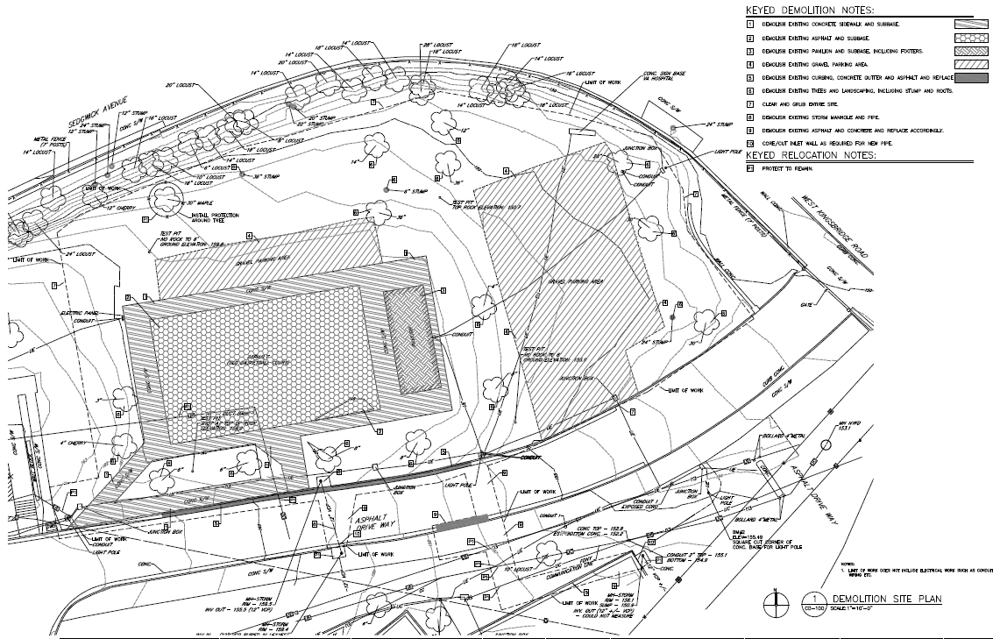

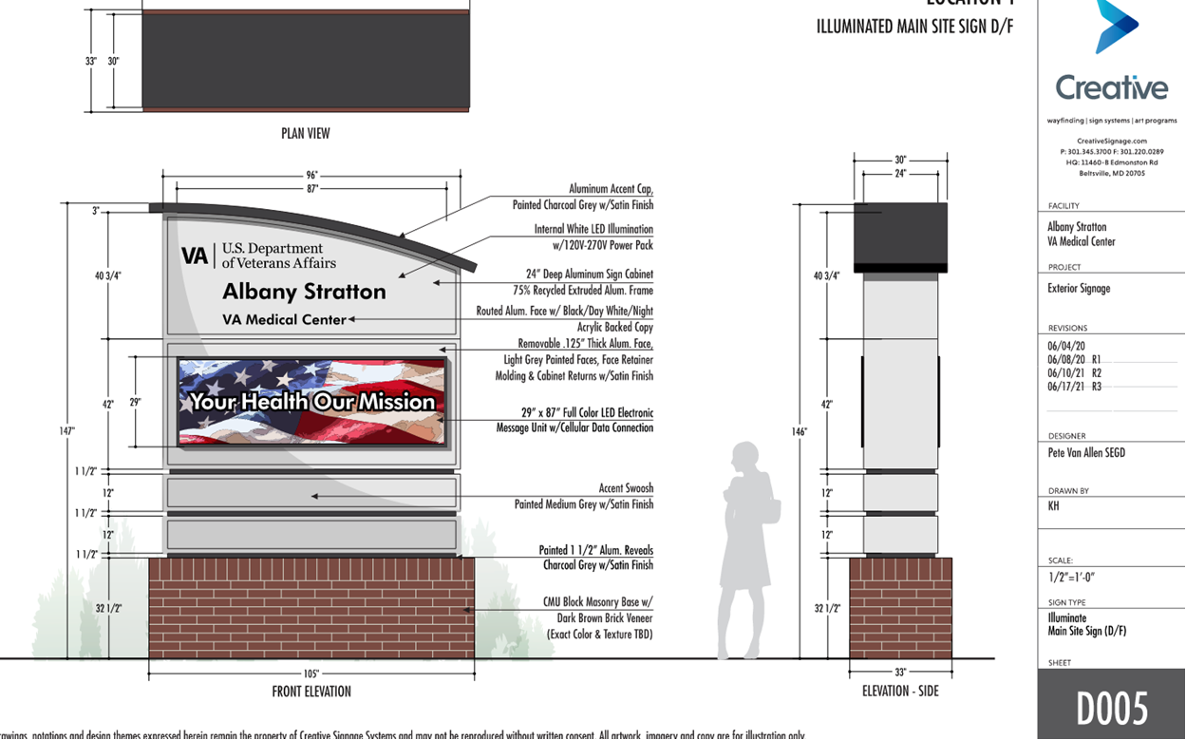

Proposed New Main Entrance Signage

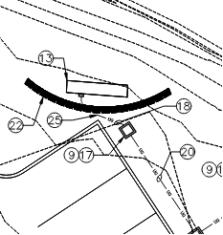

Existing Main Entrance Signage location

Autodesk Build Construction management platform:

Construction contractors and A/E design firms, selected by award to perform work at VISN 2 VA facilities, are required to utilize VISN 2 Autodesk Build Construction management platform, also called Autodesk Construction Cloud (ACC). Access to the platform and training portal will be provided by VISN 2 through project Contracting Officer Representative (COR) at no cost for the duration of the project. Autodesk Build is the management and collaborative environment that VISN 2 uses for all its Non-Recurring Maintenance (NRM), Minor Program projects, Feasibility Studies, Commissioning and Retro-Commissioning contracts. There is no user, license, or subscription fee to the contractor for using this cloud-based platform.
- The contractor shall accomplish and complete the following tasks upon award of contract:
- Request access to ACC platform and ProductivityNOW eLearning Site to project VA COR NLT 14 days from contract award.
- Only staff that shall utilize the platform to be granted access. Examples: Project manager, sub-contractors POC, Site manager, Safety officer, etc.
- The access request shall be in writing and include a list of staff. The list shall include the following information:
- Full Name
- Company Name
- Email Address
- Role/Position on the project (i.e., Project manager, site super)
- Upon granting access, staff shall complete the required ACC training through ProductivityNOW platform within 12 Calendar days.
- Upon successful completion of the training, the contractor shall submit certificates of completion to COR NLT 2 business days.
- Access to ProductivityNOW eLearning will expire after 12 Calendar days after online access is granted. The contractor shall complete ACC training within that period.
- Additional Staff and Subcontractors can be added at any time with a request submission to the project COR as described above.
- The contractor shall only use the ACC platform for contract required submissions, official project correspondence to be acknowledged, reviewed, and actioned by the responsible party. No additional time shall be added to the contract, nor an increase in the contract amount provided for the contractor’s failure to utilize the ACC platform as the project’s official communication and collaboration system. Any correspondence out of platform shall not be the governing authority contradicting direction and will be at the contractor’s expense. Official project correspondence and collaboration includes but not limited to: RFIs, submittals, schedules, shutdown requests, actionable tasks, reports, testing, safety inspections, photos, and site surveys.
- The contractor must inform the COR of any staff changes NLT 2 business days from the change. Staff changes pertain to staff who were granted access to the ACC platform. The contractor shall request termination of access, replacement of personnel and/or any other action that might impact the contractor’s ability to maintain the required utilization of the platform.
- Contractor submission requirements cannot be accepted for work to begin without meeting all ACC Platform requirements outlined herein, including completing required ACC platform training.

Applicable NAICS Code: 236220.
Estimated Completion Time: 180 Calendar Days from receipt of NTP.
Award will depend on availability of funds at time of award.
This procurement is a 100% set-aside for a Service-Disabled Veteran-Owned Small Business (SDVOSB). Prospective contractors must be registered with the SBA Small Business Administration at https://search.certifications.sba.gov/ prior to submitting a bid: Prospective contractors must be registered and current in the System for Award Management (SAM) database prior to contract award: https://www.sam.gov/portal/public/SAM/
Bids will only be accepted from SDVOSBs that are determined to be responsible and responsive contractors. Prospective contractors must be approved under NAICS Code 236220, with a Size Standard of $45.0 Million. The NAICS Code selected has been approved as the most appropriate for the project related tasks and SOW. This NAICS Code will not be subject for discussion or change. The Magnitude of Construction/ construction cost range for this project is between $1-5 Million.
A bid bond will be required, and performance and payment bonds will be required upon award of contract. The solicitation will be released on or around March 20, 2026. The bid submittal address, date and time will be included in the solicitation. Specifications and plans will be available for download from the Sam website at https://www.sam.gov Amendments to this solicitation will be posted on the Sam.gov website as well.
Bidders are responsible for obtaining and acknowledging all amendments to this solicitation prior to the time of bid opening. All bid submissions shall be in hardcopies; faxed or e-mailed bids will not be accepted. E-mail questions concerning the solicitation to Patricia Cordero at patricia.cordero@va.gov.
Interested responses and Capability Statements to this Pre-Solicitation notice must include your firm’s capability statement in writing (email) and must be received no later than March 17, 2026, at 4pm Noon EST. Email: Patricia.Cordero@va.gov. No telephone inquiries will be accepted.

