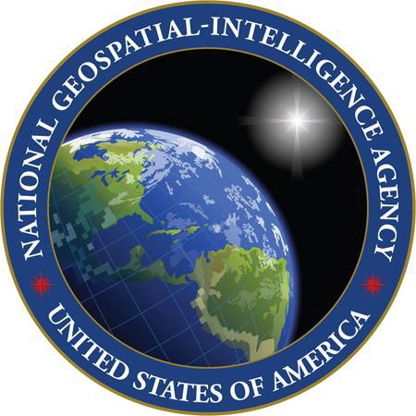

National Geospatial-Intelligence Agency (NGA)

BOE

Placeholder

