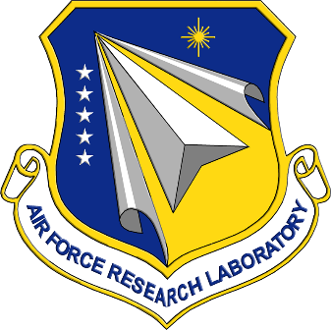

ANNOUNCEMENT: AFRL Strategic Exchange 2026 – 13 May 2026
(Rescheduled from 8 October 2025)
Mark your calendars! You're invited to attend the Air Force Research Laboratory (AFRL) Classified Industry Day on Wednesday, 13 May 2026, from 0800-1600 at Wright-Patterson Air Force Base (WPAFB).
This exclusive event provides a unique opportunity to engage directly with AFRL leadership and gain valuable insights into upcoming research and development opportunities.
Attendees will hear from:
- The AFRL Senior Leaders
- AFRL's Five Integrated Planning Team (IPT) Leads
- AFRL Contracting Office
- AFRL Small Business
- AFWERX
- AFRL Innovation Pipeline
This is a vital opportunity to learn how your organization can contribute to cutting-edge research and development efforts crucial to national security.
Important Security Requirement:
A valid SECRET clearance and US Citizenship is REQUIRED to attend this event. No exceptions will be made.
Registration Information:
Registration closes on April 17^{th.} After the selection process is complete, approved attendees will receive further information, including the agenda and details for security clearance, location and base access. All applicants will be notified of their status no later than April 24, 2026. Please note that space is limited to two attendees per company.
We look forward to seeing you there!
Register Here

