REQUEST FOR INFORMATION (RFI) and Sources Sought Notice
Academic Systems Modernization Program

Section 1: Introduction and Purpose
THIS IS A REQUEST FOR INFORMATION ONLY. This Request for Information (RFI) is issued solely for information and planning purposes to gather input on potential solutions, technologies, and pricing to shape any future solicitation; it does not constitute a Request for Proposal (RFP) or a promise to issue an RFP in the future. This RFI does not commit the Government to contract for any supply or service whatsoever. Responses to this notice are not offers and cannot be accepted by the Government to form a binding contract. The Government is not seeking proposals and will not accept unsolicited proposals. Respondents are advised that the U.S. Government will not pay for any information or administrative costs incurred in response to this RFI; all costs associated with responding to this RFI will be solely at the interested party’s expense.
The Uniformed Services University (USU) is issuing this RFI to conduct market research for its Academic Systems Modernization Initiative. The purpose of this RFI is to gather information from industry regarding currently available solutions, integration capabilities, and best practices for creating a modern, interconnected academic technology ecosystem.
USU is exploring strategies ranging from a single, comprehensive platform to an ecosystem of integrated "best-value" solutions. This initiative encompasses several key areas:
- Core Student Information System (SIS)
- Customer Relationship Management (CRM)
- Specialized Applicant Portals
- Transfer Evaluation Services
- Digital Transcript Processing
- Clinical Rotation Management

Section 2: Background and Current Environment

University Profile: Uniformed Services University (USU)
The Uniformed Services University (USU) is the nation's sole Federal health sciences university. Operating as the Federal health professions academy for the Military Health System (MHS) and the Department of War (DoW), USU is dedicated to supporting the readiness of America’s Warfighters and the well-being of the military community.

Mission and Vision
- Mission: To support Warfighter readiness and beneficiary health by developing uniformed health professionals, scientists, and leaders; conducting military-relevant research; and providing operational support globally.
- Vision: To be internationally recognized as the premier health sciences educational, research, and leadership institution for the DoW.
- Motto: "Learning to Care for Those in Harm’s Way".
- Website: https://www.usuhs.edu

Academic Components and Programs
Component | Key Degrees and Programs
F. Edward Hébert School of Medicine | MD, PhD in basic sciences, MS, MSPH, MPH, MHAP, and MD/PhD physician-scientist tracks.
Daniel K. Inouye Graduate School of Nursing | DNP (Nurse Practitioner, Anesthesia, Clinical Nurse Specialist), PhD, and MSN.
Postgraduate Dental College | MS in Oral Biology and AEGD certificates across 7 mission-critical specialties.
College of Allied Health Sciences | Associate and Bachelor of Science degrees in Health Sciences for enlisted personnel.
Armed Forces Radiobiology Research Institute (AFRRI) | Specialized education and research in radiation injury and medical countermeasures.

Research and Innovation
USU serves as a focal point for cutting-edge, military-relevant research. Its research efforts span from basic discovery at the "bench" to clinical application at the "bedside" and eventually to the "field".
Key research domains include:
- Trauma and Surgery: Combat casualty care, trauma surgery, and regenerative medicine.
- Force Health: Brain health (TBI), behavioral health (PTSD/suicide prevention), and human performance optimization.
- Advanced Technology: Bio-fabrication (4D bioprinting), precision medicine, and genomics.
- Specialized Centers: Includes the Center for Deployment Psychology, Center for the Study of Traumatic Stress, and the Infectious Disease Clinical Research Program.
Personnel and Reach
- Students: The medical student body is composed of officers from all uniformed service branches, including the Public Health Service. The Graduate School of Nursing provides approximately 50% of the nurse anesthetists and advanced practice nurses in the MHS.
- Faculty: A robust network of approximately 5,900 faculty members teach across USU campuses and Military Treatment Facilities (MTFs) worldwide.
- Global Impact: USU is considered the "gold standard" for military medicine academic models internationally and serves as a primary resource for the Joint Staff and Combatant Commands.

Desired Environment
As part of our modernization efforts, USU has committed to adopting modern academic platforms including applicant portals, transfer evaluation services, student information systems, transcript request services, and more.
A primary goal of this RFI is to understand the current state of the academic services industry and how we can leverage this environment to create a seamless experience for applicants, students, and staff. This RFI seeks information on solutions for all of the components of our vision.

Information Sought
We wish to know who can provide any or all of the capabilities sought for our future state ecosystem. Specifically, we are interested in:
- Customer Relations Management (CRM) for either prospective students or alumni,
- Applicant Portals,
- Transfer Evaluation Services,
- Student Information Systems,
- Transcript Request Processing Services,
- Admissions Review Modules,
- And Student Data Warehouse services.
A conceptual diagram of our desired ecosystem is included below.
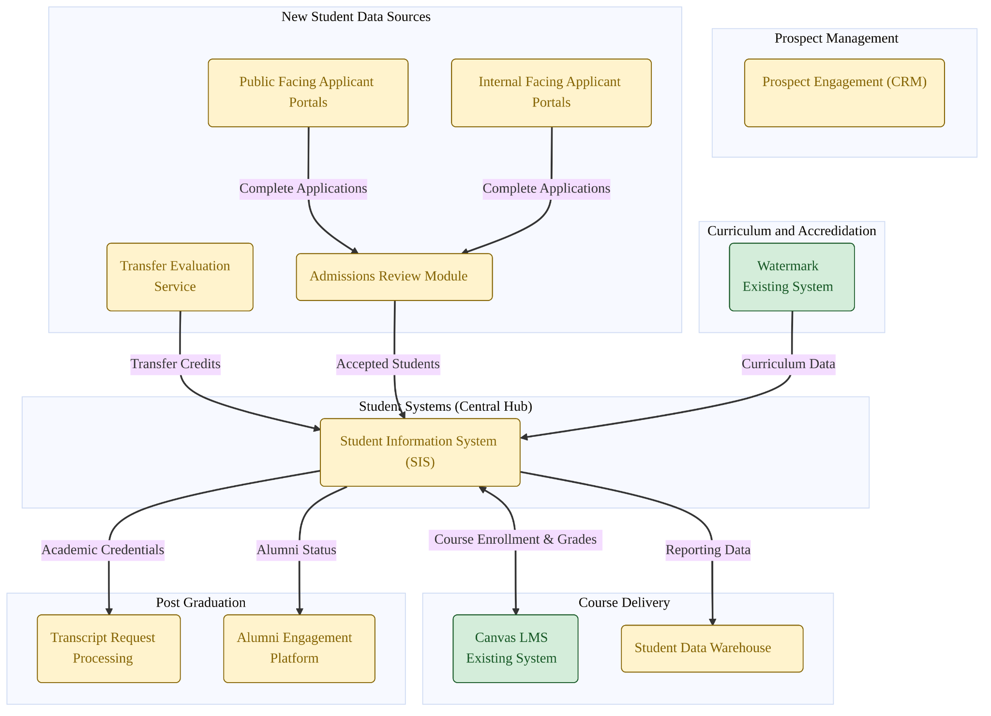
Further, any information not solicited but which may be helpful to understand this industry domain is welcome.

Section 3: General and Technical Information Requested (Mandatory for All Respondents)
All respondents must complete this section to provide a baseline understanding of their company and ability to provide services to a health education and government customer.

3.1 Federal and Health Science Experience
- Federal Footprint: Detail your current active contracts with U.S. Federal agencies or Department of War (DoW) educational entities. Have you successfully navigated the federal contracting process previously?
- Health Science Specialization: What percentage of your total client base consists of academic medical centers or health science universities?

3.2 Integration Architecture
Integration Methods: Please select the primary methods of integration between your solution(s) and other systems. You can select all that apply and provide any elaboration where necessary:
- Real-time Event-Driven API: (e.g., Webhooks, Kafka)
- Synchronous REST/SOAP API: (e.g., On-demand queries)
- Scheduled Batch/Bulk API: (e.g., Nightly sync)
- Legacy Flat File/SFTP: (e.g., CSV drops)
- iPaaS Functionality: Is one or more of your solutions capable of functioning as a "spoke" in a hub-and-spoke integration model managed by an enterprise iPaaS (e.g., MuleSoft, Boomi)?
- Data Standards: Do your solutions adopt higher education and health data standards, where applicable? (e.g., PESC XML/JSON for transcripts, LIS/OneRoster for LMS, HL7/FHIR for clinical data)?
- None: No system-to-system interoperability.

3.3 Security and Compliance
Of the following hosting, compliance, and security criteria, please select all that apply to your solutions:

Hosting Model
- Hosted solution, off-premises.
- Hosted solution, on-premises.
- Single Tenant Software-as-a-Service (SaaS)
- Multi Tenant Software-as-a-Service (SaaS)
- Other - Please Describe:

Compliance and Security
- FedRAMP: One or more of our solutions has received a FedRAMP authorization. (e.g., "FedRAMP Ready," "In Process," "Authorized") and Package ID.
- HECVAT: We can provide a full Higher Education Cloud Vendor Assessment Toolkit (HECVAT) and provide necessary clarifying information as part of a formal risk review process.
- Data Residency: We can contractually guarantee that all data (including primary storage, backups, and failover instances) will reside solely within the continental United States (CONUS).
- Non-US Persons: We can contractually guarantee that no non-US persons will have direct access to USU customer information, or that satisfactory compensating controls are in place to limit and audit access by non-US persons. E.g., access is limited to tier one support and scoped to accessing an individual user/applicant information

Section 4: Functional Capabilities (Modular Sections)
Please respond to the specific modules relevant to your solution. You may respond to one, multiple, or all modules.

Module A: Customer Relations Management
Focus: Recruitment and pipeline management for military and health science prospects.
- Deployment: Is your CRM solution available as a standalone deployment, or is it part of a required bundle with other functionality (e.g., SIS)?
- Application Portal Integration: Describe your native integration capabilities with AMCAS and other common application portal services. Can your CRM automatically ingest applicant data (e.g., verified status, test scores) from these sources to trigger yield communications?
- Identity Matching: Does your system support "suspect matching" logic to link a prospect record in the CRM (e.g., "Inquiry") with an incoming applicant record from CAS to prevent duplicate profiles?
- Military Segmentation: Can the CRM handle complex segmentation rules relevant to military recruitment, such as Branch of Service, Commissioning Source, or Security Clearance Status?

Module B: Configurable Applicant Portals
Focus: Public and internal facing application portals to build student application packages for admissions review or for transfer to an admissions review module..
- Configuration: Is the portal a "low-code/no-code" environment where admissions staff can modify form fields and workflows without IT intervention?
- Health Science Experience: Describe your experience providing application portals for health science, dental, or other specialized graduate programs.
- Specialized Requirements: How does your portal manage the submission and tracking of specialized requirements, such as clinical observation hours, prerequisite coursework, letters of recommendation, and standardized test scores (e.g., DAT, TEAS)?.
- Specialized Testing: Does the system support automated import and validation of standardized test scores relevant to health sciences (e.g., DAT, GRE, TEAS) directly from testing agencies?
- Data Migration: How would your solution transfer and process application data to our TBD admissions review module to provide a unified data stream for our admissions teams?

Module C: Transfer Evaluation Services
Focus: Automated articulation of transfer credits and Joint Services Transcripts (JST).
- Catalog Database: Does your solution connect to a maintained database of national course catalogs (e.g., CollegeSource TES) to automate course description retrieval?
- Workflow & Review: Describe the workflow for faculty review. Can evaluators route specific course descriptions to faculty members for approval via email/web link?
- Military Articulation: Specifically, describe your experience parsing and articulating credits from the Joint Services Transcript (JST) using ACE credit recommendations.
- SIS Integration: Once an evaluation is complete, can the solution automatically write the "awarded credit" transaction directly into the SIS student record tables, or is manual entry required?
- Course Equivalency: How are course equivalency rules created, stored, and maintained over time?

Module D: Student Information System (SIS)
Focus: System of record for student academic history, registration, and grading.
- Architecture: Is the SIS a multi-tenant SaaS solution (single code base), a managed hosted solution, or other hybrid solution? Please explain.
- Non-Standard Terms: Can the system manage programs that do not follow standard semesters (e.g., rolling clinical rotations, modular courses, varying start/end dates for individual students)?
- Competency-Based Education (CBE): Does the system support a data model where progress is measured by mastery of skills/competencies (e.g., EPAs) rather than just credit hours?
- Degree Audit: Does the system include an audit engine? Can the audit engine handle complex "if/then" logic required for dual-degree programs (e.g., MD/PhD) where a single course counts towards multiple requirements?
- Advising: What tools does your system provide to support academic advising and tracking for student success?

Module E: Digital Transcript Request Processing
Focus: Secure exchange of academic records.
- Standards Compliance: Does your solution natively support the receipt and processing of transcripts in PESC XML (v1.9 or later) and PESC JSON formats?
- Network Integration: Describe pre-built integrations with National Student Clearinghouse and Parchment. Do these support both outbound sending and inbound receiving?
- Data Parsing: Can the system render incoming XML or other standard data into a human-readable format while simultaneously mapping the structured data fields into the SIS?
- Identity Verification: How does the system authenticate the identity of alumni requesting records?
- Workflow: Describe the process of both incoming and outgoing electronic transcript requests.
- Integration: Describe your integration with third-party services like the National Student Clearinghouse and application services (AMCAS, Liaison) for direct electronic delivery of transcripts.

Module F: Alumni Engagement
Focus: Lifelong learning and military career progression.
- Data Synchronization: Does the alumni module share a "Golden Record" with the SIS, or is it a separate database requiring synchronization?
- Milestone Tracking: Can the system track post-graduation milestones specific to USU, such as Residency Match results, Board Certification, and Rank Advancement?
- Mentoring: Are there directory features that allow alumni to opt-in to mentoring current students, with matching logic based on military branch and medical specialty?

Module G: Admissions Review Modules
Focus: Streamlining the evaluation and selection process for specialized health science and military programs.
- Application Ingestion: How does your module ingest complete applications from both public-facing and internal-facing applicant portals?
- SIS Handoff: Describe the automated workflow for transmitting data for accepted students directly into the central Student Information System (SIS).
- Committee Workflows: Can the system support customizable, multi-tier review routing suitable for specialized health science faculty?
- Scoring & Rubrics: Does the solution provide configurable rubrics to evaluate applicants against the unique requirements of the university's medical, nursing, dental, and allied health graduate programs?

Module H: Student Data Warehouse Services
Focus: Centralized storage, analytics, and reporting of longitudinal student and institutional data.
- Data Ingestion: How does your platform extract, transform, and harmonize reporting data flowing from the central Student Information System (SIS)?
- Analytics & Reporting: What native business intelligence (BI) or reporting tools are included to support institutional research and federal reporting requirements?
- Security & Compliance: How does the warehouse architecture ensure consistency with approved data dictionaries and compliance with retention policies?
- Historical Migration: How does your data model accommodate and map the migration of historical academic data from legacy systems to provide a complete longitudinal view?

Section 5: Implementation and Support
- Describe your typical implementation methodology and a sample project timeline for an institution of our size.
- Describe your approach to data migration from legacy systems. What are the biggest risks, and how do you mitigate them?
- Describe the training and ongoing support options available to clients.
- Do you support third-party solution implementation teams?

Section 6: Response Instructions
Interested parties shall submit responses electronically to academic-modernization-ggg@usuhs.edu by the closing date of the notice. Responses should be submitted in Adobe PDF or Microsoft Word format and should be succinct and to the point, but should not exceed 15 pages, excluding cover pages, table of contents, pictures, graphs and datasets. Please structure your response to clearly indicate which modules from Part 4 you are addressing.
General marketing information or marketing flyers will not be reviewed. DO NOT include proprietary, classified, confidential, or sensitive information in any part of the RFI response.
Any requests for clarifications or questions will not be responded to by the submission date of this RFI. Any clarifications/questions that are submitted may be addressed in a final Performance Work Statement as part of a potential future solicitation, if any.
To respond to this RFI, please provide the following information:
1. Organization Information.
a. Name and address of organization.
b. Name, title, phone number, and email address of business and technical points of contact.
c. Data Universal Numbering System (DUNS) and/or Unique Entity Identifier (UEI).
d. Commercial and Government Entity (CAGE) code.
e. Indicate whether you are a small business under the NAICS code 513210. Note: To be considered for a small business set-aside, at least 50% of the cost of contract performance incurred for personnel shall be expended for employees of the responder. (FAR 52.219-14 Limitation of Subcontracting)
f. Indicate your size and socio-economic status, including (but not limited to) any of the following designations: Small Disadvantaged Business (SDB), Women Owned Small Business (WOSB), Veteran Owned Small Business (VOSB), Service Disabled Veteran Owned Small Business (SDVOSB), HUBZone, Alaska Native Corporation, Indian Tribe, Native Hawaiian Organization, etc.
g. Indicate whether you are a certified firm in the 8(a) Business Development Program.
2. Review the proposed North American Industry Classification System (NAICS) and Product Service Code (PSC). If you wish to propose an alternative NAICS or PSC, please include the proposed code(s) and rationale/justification for the proposed alternative(s).
3. Include summary on experience providing the same or similar services as outlined herein. Indicate whether all tasks delineated herein can be supported by your organization or if subcontracting would be contemplated. If subcontracting would be contemplated, delineate which tasks would be contemplated for subcontracting.
4. Identify the organization (s) you have provided or currently provide the same or similar services to. Information provided should be within the last 3 years. For each organization identified, provide the following:
a. Contract name
b. Contract number
c. Total award amount
d. Period of performance (including any options)
e. Agency (or business) contract awarded by
f. Agency (or business) point of contact information to include name, title, phone number, and email address
g. Indicate whether your organization was a prime or subcontractor
5. If you hold a GSA Federal Supply Schedule (FSS) or other Governmentwide Acquisition Contract applicable to NAICS 513210 or any alternatively proposed NAICS, please provide the contract number(s).
6. Provide any comments, requests for clarification, or suggestions regarding the scope delineated in this notice.
Any prime contractor, subcontractor, or other personnel must be without exclusions, debarment or other performance issues as listed in the System for Award Management (https://www.sam.gov), the Contractor Performance Reporting System (CPARS) (https://www.cpars.gov). and the Federal Awardee Performance and Integrity Information System (FAPIIS) with CPARS.
Disclaimers
The Government reserves the right to use and/or disclose information provided by respondents for any purpose(s) it deems necessary and legally appropriate. Responses to this RFI will not be returned.
Respondents are advised that the Government is under no obligation to acknowledge receipt of RFI responses or provide feedback on any information submitted. Responses to this RFI are not offered and cannot be accepted by the Government to form a binding contract or award. Responses do not bind the Government to any further actions related to this RFI topic including requesting follow-on proposals from respondents to this RFI. Responders are solely responsible for all expenses associated with responding to this RFI. Response submission is voluntary and is not required to propose a future solicitation (if any) on this topic.

