SUBJECT* | 659-26-700 | AE Replace Steam and Condensate Piping | Salisbury VAMC

GENERAL INFORMATION
CONTRACTING OFFICE’S ZIP CODE* | 28144
SOLICITATION NUMBER* | 36C24626R0032
RESPONSE DATE/TIME/ZONE | 04-17-2026 15:00 EASTERN TIME, NEW YORK, USA
ARCHIVE | 99 DAYS AFTER THE RESPONSE DATE
SET-ASIDE | SDVOSBC
PRODUCT SERVICE CODE* | C1NZ
NAICS CODE* | 541330
PLACE OF PERFORMANCE | W.G. (Bill) Hefner Salisbury VA Medical Center
 | 1601 Brenner Ave
 | Salisbury North Carolina
POSTAL CODE | 28144
COUNTRY | USA
CONTACT INFORMATION
CONTRACTING OFFICE ADDRESS | Department of Veterans Affairs  Network Contracting Office 6  1601 Brenner Ave  Salisbury NC 28144
POINT OF CONTACT* | Contracting Officer  Sean Cosby  sean.cosby@va.gov
ADDITIONAL INFORMATION
AGENCY’S URL
URL DESCRIPTION
AGENCY CONTACT’S EMAIL ADDRESS | sean.cosby@va.gov
EMAIL DESCRIPTION

This request for A-E firm qualifications packages is 100% set-aside for Service-Disabled Veteran Owned Small Business (SDVOSB) concerns under VAAR 852.219-73, VA Notice of Total Set-Aside for Certified Service-Disabled Veteran-Owned Small Businesses (Jan 2023) (Deviation)

THIS IS NOT A REQUEST FOR PROPOSAL. THIS IS A REQUEST FOR SF 330'S ARCHITECT- ENGINEER QUALIFICATION PACKAGES ONLY.

PUBLIC ANNOUNCEMENT FOR PROCUREMENT OF ARCHITECT-ENGINEERING
(A-E) SERVICES: This is a request for Standard Form 330, Architect-Engineer Qualifications only. A-E Services are being procured in accordance with the Selection of Architects and Engineers Statute (Public Law 92-582), formerly known as the Brooks Act, and implemented in the Revolutionary Federal Acquisition Regulation Overhaul (RFO FAR) subpart 36.102. All submissions will be evaluated in accordance with the selection criteria included in this notice.
The Government will not pay, nor reimburse, any costs associated with responding to this request. The Government is under no obligation to award a contract as a result of this announcement. Firms will be selected based on demonstrated competence and qualifications for the required work. Any resulting award for the proposed A-E services will be procured under a negotiated Firm-Fixed Price contract.
At the time the Request for Proposal is issued, all offerors must adhere to VAAR 852.219-75 VA Notice of Limitations on Subcontracting --Certificate of Compliance for Services and Construction. (JAN 2023) (DEVIATION)

GENERAL INFORMATION:
The Department of Veterans Affairs, W.G. Hefner Veterans Administration Medical Center in Salisbury, North Carolina, is seeking sources and intends to award a firm fixed-price contract for Architect-Engineering (A-E) firm to provide Schematics, Design Development, Construction Documents, Technical Specifications, Construction Period Services, Site Visits, Cost Estimates, As-Built Documentation, and all other related information for Project # 659-26-700, “Replace Steam and Condensate Piping” located at 1601 Brenner Ave, Salisbury, North Carolina 28144.
The A-E Services listed herein is being procured in accordance with RFO FAR 36.102, RFO FAR 36.202, and VAAR 836.6. Potential contractors must be registered in SAM (www.sam.gov) and visible/certified in the SBA Certification database at the time of proposal in order to be considered for an award. As a prospective offeror for this Service-Disabled Veteran-Owned Small Business (SDVOSB) set aside, you are verifying your company meets the status requirements of a SDVOSB concern as established by VAAR 852.219-73.
The W.G. (Bill) Hefner Salisbury VA Medical Center is a working facility and phasing plans for minimizing downtime, and provisions for continuation of service during outages is critical to this project.
Point of Contact: Sean Cosby, Contracting Officer Email: Sean.Cosby@va.gov

PROJECT INFORMATION:
Project No. 659-26-700
Project Title: A-E: Replace Steam and Condensate Piping
W.G. Hefner VAMC
1601 Brenner Ave
Salisbury, NC 28144
The NAICS Code for this procurement is 541330, Engineering Services, and the applicable Small Business Size Standard is $25.5 million annual revenue. The projected award date for the anticipated A-E contract is on or before September 23, 2026.
The NAICS code for the anticipated Construction project is projected to be 236220 and magnitude of construction is predicted to be between $5,000,000 and $10,000,000. The anticipated award date of the construction phase of the project is to be determined (TBD).
An Architect & Engineer (A-E) contract will be negotiated for the development of complete construction documents which include working drawings, specifications, reports, and construction period services. The A-E will be given written information; participate in project planning meetings, pre-proposal meeting, and pre-construction meeting as required; communicate with VA personnel via telephone or e-mail; and is expected to coordinate so that the final documents include all requirements in accordance with industry standard practices, VA standards, VA design manuals, and review comments.

STATEMENT OF TASK/SCOPE OF WORK:
PART A – SCOPE OF WORK
Architect-Engineer (A/E) Services shall include:

Provide Professional Architect/Engineer (A/E) and healthcare planning services to include but not limited to:
- Site investigation – architectural, structural, electrical, plumbing, and mechanical including HVAC and control replacement, electrical, and site modifications. Prior request for notice to inspect must be coordinated and scheduled for times and dates.

- Connections to existing utilities must be fully investigated to ensure that the existing utilities can support the load of the new connection during design.

- Contract drawings and specifications for construction.

- Cost Estimates that include attention to phasing and ICRA as well as all other items associated with design.

- Construction period services - review of submissions, provide recommendations and estimates regarding contractor change proposals, visit site per VA's request and add to drawings as-built conditions from contractor's record drawings; A/E will respond within a twenty-four (24) hour period when requested.

- Provide File Transfer system for use throughout duration of project. Site must be in place within 30 days of contract award. Site must remain open until final construction contract is complete. This site is intended for AE, VA, and contractor use. The site must be compatible to transfer large files of types of AutoCAD current, all Microsoft Office current programs (Word, Excel, Project), and pdf files. Site must meet VA OIT rules when transferring the files which will provide encryption during the transfer.
  - Note: Due to requirements of certain construction submittals (i.e. finishes, profiles, shop drawings, etc.), these must be delivered to COR. Any hand delivered submittals must also have a backup copy of the cover sheet on A/E FT Site. A/E FT site must be secure (password protected), user friendly for uploading and downloading of files, and organized for easy file retrieval by the VA COR, Contracting Officer (CO), and contractors. Site must be organized with folders indicating each level of submission as outlined in this scope of work and corresponding required files. Must also submit hard copies to the VA for Design Review Drawings, Specifications, and Construction Documents.
- Comply with VHA Safety & Fire Protection Program to have drawings and specification submittals reviewed by VA at 65% and 95% submissions. Review based on VA standards, codes and regulations. Provide responses back to the VA fire review comments to verify that the comments have been reflected in the project drawings. Bid documents will be re-reviewed to ensure compliance with VA fire review comments. Items that have not been picked up with require changes to the Bid Documents until all review items have been addressed.

- Comply with VA Green Energy Management System (GEMS) program as per specifications.

- Comply with VA Design Manuals/Guides, FGI Guidelines, ISO codes, and applicable codes as outlined in the VA Design Guides (most recent versions of all the codes)

- Infection Control Risk Assessment: The AE shall work with the VA Infection Prevention and Control staff to determine required infection risk assessment levels and shall incorporate VA IPC recommendations into project ICRA drawings.

- Project scheduling and phasing. Phasing drawings shall also have provisions for safety and fire protection measures to be taken during construction. These measures are to be fully developed through coordination with VA Safety Department.

Project Scope:

General:
This project will consist of the investigation and replacement of steam and condensate piping, convectors, and traps in Bldgs 2, 3, 4, 6, and 11.
Specifics:

Bldg 2
Investigate/replace the main steam controls in the basement mechanical room
Bldg 3
Remove the convectors on floors 1 and 2 and cap the steam lines back to the risers
Replace the 2 pipe fan coil units with 4 pipe fan coil units, approximately 120
Install hydronic heating from the risers, down the main hallway, and tie into the new FCU’s
Replace the steam tree in the basement and steam pipe back to the outside manhole. See attached picture of existing on page 33.
Bldg 4
Investigate/replace the main steam controls in the basement mechanical room
Investigate steam cross connections throughout the building. The facility is having a hard time regulating the temperature in this building
Replace the steam tree in the basement and steam pipe back to the outside manhole. See attached picture of existing on page 34.
Bldg 6
Replace the steam line to Bldg 31

Bldg 11
Replace the steam tree in the basement and steam pipe back to the outside manhole. See attached picture of existing on page 35.

All design will be done according to VA specifications, Design guides, Infection Control guidelines and all applicable codes.
The design will be structured so as to require minimum interruption of space function during construction.
All work shall meet NFPA / Life Safety Code and comply with all applicable building codes.
The work will also comply with all Energy Standards as noted at the end of this document and attached summary PDF “VISN6 Energy and Water Requirements for Projects”.
This will include all Architectural, Structural, Electrical and Mechanical engineering associated with this project.

- Provide VA Form 10-6298 AE Fee Proposal for this solicitation.

- Facility design must meet VA TIL requirements first and foremost, followed by requirements laid out in the most recent edition of the FGI guidelines and NFPA.

- Attend design review meetings and make all necessary site visits during design to gather information necessary from the existing sites, building plans, utility plans, etc. to provide a complete assessment of the proposed work. A thorough as-built review shall be conducted of the existing site conditions to complete a full detailed set of documents.

- Assess the intent and scope of this project and work with the Medical Center staff to develop a final design and cost estimate to best suit the needs and constraints of the government, while incorporating VAMC Salisbury Engineering/Facilities Management Service, Safety and Contracting Officer comments into the final design package.

- Field verification of existing space and existing utilities servicing the renovated space.

- Evaluation and design modifications to the existing electrical distribution system servicing the renovated space to provide sufficient power to all new lighting and equipment in the scope of work. Electrical engineers shall perform full survey of all impacted spaces/loads to document existing electrical items and their locations in each space to ensure coordination with architectural scope, future mechanical chases, if required, as well as ceiling renovations and replacements so that no electrical item is missed during construction. Note obsolete items and sensors located within design area and coordinate with the VA to see if the items should be removed. Electrical engineer shall also be responsible for coordination of existing electrical items located above the ceiling with the new design ductwork routes, and for identifying those conduits, cable tray, junction boxes, etc. that require relocation both on drawings for the contractor and to the VA for advance coordination of outages.
- Evaluation and design modifications to the existing Plumbing, Medical Gas, and Fire protection systems servicing the renovated space to provide sufficient water supply and drain lines to all new plumbing fixtures and equipment in the area, as required to accommodate the new scope of work (sanitary drains from roof, modifications to floor drains, make up water or drain coolers as required, etc.). Provide new sprinkler heads in areas within the modifications to existing space layouts to accommodate new layouts where heads are at the end of their service life. Note that sprinkler heads will require modification to maintain accordance with NFPA, especially if new ductwork is over 4 feet wide inside the mechanical room, or if stacked air handling units are provided. Plumbing and fire protection engineer shall also be responsible for coordination of existing plumbing and fire protection items located above the ceiling with the new design ductwork routes, and for identifying those pipes, valves, and other appurtenances that require relocation both on drawings for the contractor and to the VA for advance coordination of outages. Valve and other maintenance access shall not be obstructed by new HVAC installation. If this condition is encountered, the plumbing and fire protection engineer shall provide design documentation for relocation of the associated items.

- Evaluation and design modifications to the existing structure servicing the locations of new / relocated equipment associated with the scope of work for this project to allow for safe installation of new permanent and temporary HVAC equipment as required for completion of the scope of work.

- Architectural evaluation and design modifications for all spaces associated with the work as required to accommodate changes necessary for the scope of work. Expected: new ceilings where ceilings must be removed to complete the scope of work, new lighting where ceilings must be removed to complete the scope of work, modifications to existing and new chases as required to accommodate the new scope of work, and modifications to existing door closers / door operators if evaluation during design requires a more automated door opener approach. Architectural coordination with all trades is required to create a seamless, high-quality project / built environment.

- Also required by architect: provisions for detailed phasing drawings and ICRA planning for each phase. Note that ICRA planning will require topping off existing walls where walls around each phase do not go to deck. Walls, temporary or existing must be floor to deck. The architect shall identify those spaces were topping off of walls is required on the construction drawings, as well as document that the contractor is responsible for 1 hour rated full height walls around each construction phase.
- Design for all new interior finishes that are required to accommodate the scope of work (room modifications – paint, patch, floor base; new ceilings; ceiling access panels; etc.), as well as the small architectural modifications laid out in this scope of work.

- Project completion of construction documents, including final design, contract drawings, specifications, and cost estimate is to be 243 calendar days or 8 months from contract award.

- Project must remain within the approved project scope, time frame, and estimated base construction cost or the project will be canceled and require re-submittal and competition process. Planning must include in the project a total of 20% of deductive bid alternate that will need to be identified and incorporated as part of the bidding documents. Magnitude of Construction $5,000,000 to $10,000,000.

- Recommend bid alternatives as necessary to meet the budget limitations if the project becomes over budget. Note: the AE shall be fully responsible for providing a complete and functional design to the VA within noted budget limitations. Bid alternates will be required to the amount of 20% of the project budget, but bid alternates are not to be used to bring the overall scope within budget. The base bid shall be in budget and bid deduct alternates shall be supplied to the VA to reduce the budget by 20% from the base bid (max budget) price.

- Construction will be addressed in phases to allow operations to continue during construction to the extent possible. Phasing will be incorporated as part of the schematic design options presented during the SD submission, due to the high probable cost of the phasing and its impact upon final system design option selections. Phasing must work within budget and allow the VA to continue operations at minimal interference.

- Attend pre-bid job walk and provide all engineering responses to questions asked by potential bidders and issue an addendum, if necessary.

- Provide expeditious engineering responses to all design/conflict questions encountered during the construction term.

- Provide construction period services to review all shop drawings and submittals prior to sending to the VA for final approval.
- Provide construction period site visits to review progress of construction activities and milestones during construction.

- Provide final Record Drawings (pdf and AutoCAD) which will be developed based on construction period site visits, RFI’s, submittal responses, and As-Built drawings from the contractor within 30 calendar days after completion of construction.

All designs shall be accomplished in accordance with VA guidelines and specifications, which are available on the Internet at http://www.cfm.va.gov/TIL/ A/E shall pay particular attention to all current NFPA, NEC, ICC, and All Design Manuals and Guides as it pertains to this project.

Referenced Drawings

- All designs shall verify and coordinate the referenced drawings in aspects for this construction project. Drawings are noted below:

- Bldg 2
- B2 Grnd Flr South H &V
- B2 Grnd- 1st Flr North H & V
- Bldg 3
- B3 VA44-32-14-P1
- B3 H & V As Built 1949 Drawings
- Bldg 4
- Building 4 Grnd Flr H & V
- B4 Grnd Flr Plumbing
- Bldg 6 to 31
- 1965 -As-built-Steam Distribution_A
- Bldg 11
- 11H1
- 11-H1

Site Investigation

EXPECTATION: A/E will make site visits as necessary to survey existing conditions. Minimum of two visits are required.

Make site visits as required to determine existing as-built conditions affecting this project. Note: Information including drawings and other documentation provided to the A/E is used as reference only. The AE is expected to perform their own site survey to field verify accuracy of existing drawings and to locate any additional utilities / obstructions in a given area to provide quality new project drawings. All additional references and specifications are available in VHA’s Technical Information Library at address http://www.cfm.va.gov/TIL/. Electronic AutoCAD background drawings will be provided by the VA upon request. A/E shall field verify every aspect that relates to the project. The A/E shall field verify all dimensions and utility connections. AE shall take precautions during field surveys to comply with all ICRA requirements. Coordinate site visits with the COR as determined after award. Drawings produced by the AE shall account for obstructions in the path of new utilities, relocation of existing utilities as required to accommodate new work, relocation of existing utilities if the architecture team deems it necessary to relocate an existing chase or shaft, and architectural accommodates as required for new / existing utilities (ie – access panels for new and existing utilities shall be covered under specification noted “as needed”. If utility work is required above a hard / drywall ceiling, architectural drawings shall reflect the need to remove and replace the existing ceiling unless the ceiling in question is a walkable plaster ceiling and include requirements for associated ICRA.). All utility tie in points shall be well researched and clearly shown. Utility tie in points showing a general direction and indicated as “tie into existing ________ system in room _______” will not be allowed.

The A/E shall arrange for and oversee the performance of topographic surveys, test borings, test pits, soil tests, subsurface exploration and other such investigations as he/she determines are required for the proper design of the project.

Design Review Schedule

EXPECTATION: Submit review package so they are received on the noted day.

SUBMISSIONS:
Submit review packages so they are received on the noted day (calendar days after NTP) or earlier:

Initial PDT Meeting 0 days
Design Development Documents (15%) 36 days
(PDT Meeting) 41 days
Design Development Documents (35%) 81 days
(PDT Meeting) 91 days
Design Development Documents 65%) 131 days
(PDT Meeting) 151 days
Design Development Documents 95%) 191 days
(PDT Meeting) 211 days
Design Development Documents 100%) 231 days
(PDT Meeting) 236 days
Final Construction Bid Documents 240 days
(PDT Meeting) 243 days
(3 Sets of Drawings and Specifications)

Note: The issue of the Notice to Proceed (NTP) may be combined with the first Project Design Team (PDT) Meeting. A/E will be required to attend and take minutes of each PDT meeting. Minutes will be submitted electronically via e-mail to the COR and Contracting Officer within three calendar days of each meeting.

All new construction shall be designed to achieve an energy consumption level that is at least 30% below the level achieved under ASHRAE Standard 90.1-2010, if life-cycle cost effective. Use Appendix G of ASHRAE Standard 90.1-2010 to document the energy savings.

Should the 30% reduction in energy consumption prove not to be life-cycle cost effective, then the A/E shall evaluate alternative designs at 5% successive decrements in order to identify the most energy-efficient design that is life-cycle cost effective.

The following parameters shall be used for performing the analysis:

- 20 year life-cycle period for system comparisons
- Use Public domain programs such as TRACE, E-CUBE, Carrier E20-II, etc.
- 7% Discount Factor
- Neither include taxes, nor insurance while computing cost.

Major & Minor Renovations and Major Equipment Replacements:
For Major Renovations: Shall include any renovation where an entire area is “gutted” and rebuilt. Any replacement of central HVAC equipment or changes in air distribution shall be considered a “Major Renovation.”

Reduce the energy cost budget by 20% below pre-renovations 2020 baseline. A/E shall estimate 2020 baseline energy consumption before the renovation and compare it to the proposed design after the renovation and document the 20% savings. The primary unit for energy budget reporting is the British Thermal Unit (BTU) per square foot of the area to be renovated. A/E shall develop the energy budget as required in ASHRAE 90.1-2010, Appendix G, using the same parameters outlined above for new construction.

For Minor Renovations: Shall be defined as a small portion of a building, where only architectural treatments or simple equipment replacement is planned. The renovation will have little to no impact on the central HVAC System, or energy use within the renovated area.

Any part of the renovation which impacts energy consumption shall be designed with the mandate to reduce energy consumption. For example, if exterior walls are part of the project, then their R-Value shall be increased. If lighting fixtures are to be replaced, then they shall be replaced with the most energy efficient fixture that is cost effective (20 year life).

Renewable Energy Resources:
For any work, renewable (geothermal, heat recovery, wind, PV solar, solar hot water, etc.) shall be evaluated for life-cycle cost effectiveness.

Design Requirements / Submissions

EXPECTATIONS: Submit complete review package in accordance with the following requirements and guidelines outlined in
https://www.cfm.va.gov/til/aeDesSubReq.asp PG 18-15 Volume C Document

Please pay specific attention to the schematic, design and construction submission requirements.

Deliver all design packages electronically and hardcopies to the Project Manager on the established dates to allow the VA Project Development Teams to meet as scheduled. A transmittal letter and check lists is required to be emailed to the Contracting Officer and the project manager on the same day as delivery.

Include all information as follows and as outlined in the attachments for each submission. Information required for each submittal is outlined in Program Guide PG-18-15 Volume C. The manual is at the following address: https://www.cfm.va.gov/til/aeDesSubReq.asp

Design Development 15%: See Attachment - A, 15% Submission Requirements
- Requirements for the 15% Schematics Development Documents Submission.
- Address all comments from the Initial PDT Meeting and site visits.
- Provide spreadsheet of VA review comments and their completion status.

Design Development 35%: See Attachment - A, 35% Submission Requirements
- Requirements for the 35% Design Development Documents Submission.
- Address all comments from the Schematic 15% Submission review.
- Provide spreadsheet of VA review comments and their completion status..

Design Development 65%: See Attachment - A, 65% Submission Requirements
- Requirements for the 35% Design Development Documents Submission.
- Address all comments from the Schematic 35% Submission review.
- Provide spreadsheet of VA review comments and their completion status.
- Provide spreadsheet response to VA Fire review comments and their completion status.

Construction Documents 95%: See Attachment - A, 95% Submission Requirements
- Requirements for the 95% Design Development Documents Submission.
- Address all comments from the 65% review.
- Provide spreadsheet of VA review comments and their completion status.
- Provide spreadsheet response to VA Fire review comments and their completion status.
- Provide Design finishes, required submittals.
- Consolidate all necessary submittals by specification section on an Excel spreadsheet. Checklist to be utilized to track/monitor submittal process.

Construction Documents 100%: See Attachment - A, 100% Submission Requirements
- Requirements for the 100% Design Development Documents Submission.
- Address all comments from the 95% review.
- Provide spreadsheet of VA review comments and their completion status.
- Provide spreadsheet response to VA Fire review comments and their completion status.
- Finalize cost estimate.

Final Construction Documents Submission (CD): See Attachment B
- Provide spreadsheet of VA review comments and their completion status.
- Provide spreadsheet response to VA Fire review comments and their completion status.
- Submit a complete document of all contract requirements for approval signatures.
- Continue to update and submit until approved.

As-Built Drawings: See Attachment E
- Submit a complete document of all as-built drawings for VA review and approval. Continue to update and submit until approved.
- Update the record drawings for both campuses, associated floors to include all renovations for this project. Final submitted record drawings should be incorporated into most current floor plan submitted by VA at close of documents.

Construction Period Services

Expectations: Respond to submittals requests in fifteen (15) calendar days.

Provide services:

- Assist the VA to determine whether the contractor or subcontractor meets qualification requirements, support by written recommendations of any problems or litigation encountered in past based on first-hand knowledge.
- The AE shall call into weekly construction meetings with the VA.
- Review all submissions and provide recommendations to the VA within fifteen (15) calendar days or (5) calendar days upon request.
- Review and provide replies to contractors generated RFIs when required by the project manager within (5) Calendar days.
- Review and provide recommendations to contractors generated RFPs and cost estimates within ten (10) calendar days.
- Make ten (10) site visits at a minimum on the requests of the VA and prepare written reports to include agreed upon changes in design as determined necessary during the construction. Visits made based on errors and omissions in design will be at no cost to the VA.
- Participate in partial/final acceptance inspections as scheduled and generate punch list items for completion. The punch list shall reference the contract documents for specific deficiencies (i.e. specification section, drawing detail, etc.)
- Prepare as-built drawings on original set with A/E’s stamp, based on record drawings that the contractor kept during construction and with correspondence performed during construction. Transpose contractor’s as-builts to AutoCAD 2025 file type and provide a set of updated as-builts and specifications on CD and on A/E FTP site within 30 days to the COR. These should be posted on A/E FTP site for VA retrieval.

Attachment A

- SITE DEVELOPMENT: Submit the following:

Site Development: | Schematics* | DD** | CD***
Narrative
Analysis of site
Circulation study
Phasing analysis
Parking analysis
Development concept showing proposed buildings and structures
Landscape drawings with plant groupings
Topographic, utility, and landscape survey
Demolition plan
Layout plan showing location of:
- Building and structures
- Roads
- Fire Access
- Parking
- Accessible spaces
- Van spaces
- Mechanical and electrical equipment on grade
- Future expansion
- Off-site roads
- Off-site utilities
- Service area(s)
- Entrances and exits
- Walks
- Inlets
- Contractor's staging area
- Vertical and horizontal road alignment
- Paving joint patterns
Grading plan showing:
- Existing contours
- Proposed contours
- Spot elevations at structure corners, entrances, equipment pads, etc.
- First floor elevations

- Rim and invert elevations on storm drainage fixtures
- Erosion and sediment control
Rock excavation (quantity)
Planting plan showing:
- List of plant material
- Limits of irrigation
Site details
Landscape details
Signage plan and schedule
Specifications

ARCHITECTURAL: Submit or show the following

 | Architectural: |  | Schematics* |  | DD** |  | CD***
 | Location of:
 | - Rooms1
 | - Doors2
 | - Corridor(s)3
 | - Basic column grid/sizes
 | - Expansion and seismic joints
 | - Electrical closets
 | - Equipment rooms
 | - Signal and telephone closets
 | - Mechanical shafts and space
 | - Stair(s)
 | - Ramp(s)
 | - Elevator(s)
 | - Automatic Conveyances
 | Floor Plans/Drawings:
 | - All floors (new and renovated)
 | - Penthouse
 | - Roof plan
 | - Pipe basement
 | - Pipe tunnel
 | - Reflected ceiling4
 | - Equipment floor plans 1:50 (1/4 inch) scale5
 | - Demolition plans6
 | Room names and numbers7
 | Program net/designed net
 | Exterior dimensions/total building gross area
 | Size and shape of all departmental functions and services9
 | Exterior building elevations10
 | Finish floor elevations11
 | Door locations, sizes, and swings
 | Wall thickness and chase walls
 | Handrail location/dimensions
 | Fixed equipment
 | Equipment elevations and details
 | Plumbing fixtures
 | Wheelchair accessible facilities
Wall sections12
Building sections13
Finish grades at corners, entrances, exits, platforms and ramps
Fire and smoke rated partitions14
Lead-lined and radio-frequency- shielded partitions14
Fire extinguisher cabinets14
Spray-on fire proofing (see fire protection)
Construction details15
Drafting symbols, abbreviations, and general notes
Door, window, and louver schedules
Interior details, elevations, sections
Finish schedule16
Graphics and signage17
Color rendering
Specifications
Lead abatement18
Lead abatement specification19

C. FIRE PROTECTION: Submit the following:

 | Fire Protection: |  | Schematics* |  | DD** |  | CD***
 | Fire protection narrative:1
 | - Fire and smoke separation
 | - Fire sprinkler/standpipe system
 | - Size of fire pumps
 | - Water supply available/max. demand
 | - Water flow testing results
 | - Fire alarm systems2
 | Existing to be modernized
 | Base loop system for interface of new construction
 | - Kitchen extinguishing systems
 | - Size of air handling unit
 | - Exit paths from each zone
 | - Distances to stairs
 | - Occupancy of each area
 | - Exit calculations for each floor
 | - Smoke control features
 | Floor Plans/Drawings:3 & 4
 | - Sprinkler zones
 | - Fire alarm zones
 | - Smoke zones
 | - Building water supply
 | - Interior sprinkler supply lines
 | - Standpipes
 | - Fire extinguisher cabinets
 | - Fireproofing of structural members
 | - Sprinkler/standpipe riser supply piping
 | - Termination of sprinkler main and inspector test drains
 | - Sprinkler alarm valves
 | - Waterflow and tamper switches
 | - Sprinkler system fire department connections
 | - Sprinkler design hazards per NFPA 13
 | - Exit signs and emergency lighting
- Occupied areas not protected by automatic sprinklers
Calculations
Estimated capacities for proposed air handling units in cubic meters (cubic feet) per minute
Location of:
- Fire alarm system
- Annunciator panels
- Pull stations
- Flow switches
- Audio-visual devices
- Smoke detectors
- Duct smoke detectors
- Smoke dampers
- Fire dampers
- Fire alarm risers5
- Exit signs
- Emergency lighting
- Fire sprinklers
- Standpipes
- Fire hydrants
- Fire pumps
- Post indicator valves
- Sectional valves
- Fire extinguisher cabinets
- Electromagnetic door hold open devices
Wall sections indicating fire resistive ratings
Staff sleeping rooms
Excavation plan signage
Door and window schedule with fire rating or fire rated glazing
Zoning of each fire alarm initiating device
Details:
- Fire pump system (capacity and pressure)
- Elevation and isometric view of fire pump
- Stairwell sign
- Annunciator panel
Interconnection of fire alarm system with:
- Smoke dampers
- Air handlers
- Elevator controls
- Kitchen fire extinguishing and fire pump system
- HVAC system with smoke duct detectors
Single line riser diagram for fire alarm system
Height/configuration of storage racks and shelving
Specifications

D. INTERIOR DESIGN: Submit the following:

Interior Design: | Schematics* | DD** | CD***
Written interior design concept1
Illustrate overall design solution2
Material and finish samples
Sketches
Design solution for interior spaces:
- Perspectives
- Plans
- Details
- Elevations
- Sections
- Wayfinding
- Floor patterns
- Wall patterns
- Lighting
- Signage
- Handrails
- Bumper guards
Specification section 09050
Finish schedule
Exterior colors and materials
Sample boards for interior and exterior materials, products, and finishes
Edited carpet and wallcovering specifications
Specifications
Keyed Finnish plans
Interior design details, elevations, and sections

E. STRUCTURAL: Submit the following:

Structural: | Schematics* | DD** | CD***
Three alternative structural systems for typical bays1
Supporting calculations2
Cost estimates for each system3
Recommend preferred system
Column locations
Shear load resisting elements4
Boring location plan5
Structural plans6
Sections
Details
Size/location of:
- Columns
- Beams
Lateral load resisting elements
Load bearing walls
Slabs
Foundations
Elevations
Schedules
General notes
Boring logs
Subsurface investigation report
Estimated quantity of rock
Specifications

- PLUMBING: Submit the following:

Plumbing: | Schematics* | DD** | CD***
Narrative:
- Existing plumbing systems to be used and necessary modifications
- New plumbing systems
- New or modified water treatment
Floor Plans/Drawings:
- Room names
- Identify
Existing plumbing fixtures w/VA numbering system
New plumbing fixtures w/VA numbering system
Existing equipment
New equipment
New medical gas outlets
New laboratory gas outlets
Plumbing piping
- Size of pipe
- Equipment schedule
- Fire & smoke partitions
- Demolition plans
- Riser diagrams
- Legend, notes, and details
Location and size of sprinkler riser, standpipes, and fire pumps (see fire protection)
Location of emergency eyewash and shower equipment
Calculations (equipment & piping)
List of Required Contract Specifications
Contract Specifications

- SANITARY: Submit the following

Sanitary: | Schematics* | DD** | CD***
Narrative:
- Existing sanitary systems: underground water, sanitary sewers, storm sewers, & fuel gas with sources, disposal methods, storage pressures, condition, etc.
- New sanitary systems
- Provide water analysis & expected yield if well required
- Circulation study to assess emergency vehicle access
Install test well, if well is required.
Utility Plans/Drawings showing existing and new sanitary systems:
- Size of pipes
- Invert elevations of sewers
- Locate/size
Pumps
Storage facilities
Treatment equipment
Fire hydrants
Sectional and post indicator valves
Backflow preventer
- Areas of new irrigation system
- New irrigation system
- Profiles of sanitary & storm sewers
- Demolition Plans
- Legend, notes, and details
Point of connection to sprinkler system
Calculations
List of specifications
Contract Specifications

- HVAC: Submit the following

 | HVAC: |  | Schematics* |  | DD** |  | CD***
 | Description of HVAC systems
 | Equipment for each functional space
 | Life cycle cost analysis1
 | Tentative location/sizes:
 | - Mechanical equipment room
 | - Principal vertical shafts
 | Block layout of equipment
 | Louvers:2
 | - Outside air
 | - Exhaust air
 | - Relief air
 | Engineering calculations3
 | Selection of HVAC equipment
 | Catalog cuts of equipment
 | Room by room heating and cooling loads
 | Zone by zone heating & cooling loads
 | Building block heating & cooling loads
 | Tabulation of steam consumption
 | Psychometric chart for air handling unit
 | Coil entering and leaving conditions
 | Fan motor heat gains
 | Consumption of humidification loads
 | Sound/acoustic analysis
 | Room-by-room air balance charts4
 | Chilled water plant:5
 | - Quantity and type of chillers
 | - Capacity in tons of refrigeration
 | - Electrical equipment
 | Heating system:
 | - Total heating load
 | - Domestic hot water load
 | - Humidification load
 | - Equipment steam demand
 | - Zoning of heating system
- Main supply, return and exhaust ductwork
- Volume dampers
- Fire and smoke partitions
- Fire and smoke dampers
- Smoke detectors
- Automatic control dampers
- Air quantities for each room
- Air inlets/outlets
- Rises and drops in ductwork
- Expansion loops
- Anchors
- Vales
- Drip assemblies
- Balancing fittings
Interconnection of HVAC equipment with fire protection equipment (see fire protection)
Plan/section of mechanical equipment rooms
Schematic flow and riser diagrams7
Schematic control diagrams8
HVAC demolition drawings
Phasing plan
Equipment schedule
Seismic bracing
VA symbols and abbreviation
Selection of
- Pumps
- Fans
Sizing and selection of
- Expansion tanks
- Steam to hot water convertor
- Heat exchangers
Sound analysis
Complete selection data
Outside chilled water and condenser water distribution9
Standard detail drawings
Automatic temperature control drawings10
HVAC specifications

- ELECTRICAL: Submit the following:

 | Electrical: |  | Schematics* |  | DD** |  | CD***
 | Narratives:
 | - Design1
 | - Life cycle analysis for electrical systems
 | Location and size of:
 | - Electrical equipment2
 | - Electric closets3
 | - Telephone closets3
 | - Signal closets3
 | - Electrical distribution equipment
 | Drawings showing:
 | - Electrical plot plan of existing and proposed underground power (including manholes)
 | - Telephone systems
 | - Signal inter-building systems
 | - Proposed electrical system4
 | - Electric symbols
 | - Lighting fixture schedule
 | - Emergency Life Safety Equipment (see fire protection)
 | - Symbols, note, abbreviations
 | List of specialty areas
 | Method of short-circuit calculations
 | Method of voltage drop and demand calculations
 | Utility company correspondence
 | Utility company requirements
 | Load calculations for normal & emergency use
 | Drawings:
 | - Lighting layouts
 | - Power layouts
 | - Signal layouts
 | - Specialty area layouts
 | - Demolition plans
 | Riser diagrams
 | Branch circuit wiring (typ.)
Location and size of:
- Primary distribution switchgear/switchboard
- Engine-generator sets
- Substation/padmounted transformer
- Manholes
Location of smoke dampers and duct smoke detectors
Interconnection of electrical control equipment with HVAC equipment (see fire protection)
Smoke partitions and fire alarm zones
Fire alarm and signal riser diagrams (see fire protection)
Calculations for emergency generator(s)
Phasing scheme
Electrical details
Specifications

- EQUIPMENT: Submit the following:

Equipment: | Schematics* | DD** | CD***
Equipment (on architectural drawing)
Activation Equipment List (Excel format)
Specifications

- STEAM GENERATION: Submit the following:

 | Steam Generation: |  | Schematics* |  | DD** |  | CD***
 | Report on new and existing steam loads1
 | Life-cycle cost analysis of steam supply alternatives
 | Analysis of alternate plant locations
 | Life-cycle cost analysis for alternative types of equipment
 | Life-cycle cost analysis for heat recovery alternatives
 | Data on emissions regulations
 | Data on methods of compliance
 | Selection of major equipment
 | Plot plan with new and existing plant locations
 | Fuel related storage and handling facilities
 | Alternate plan view layouts of new and existing plant
 | Plot plan of steam generating facility2
 | Catalog cuts on equipment from two manufacturers
 | Plans/sections/locations of:
 | - Equipment
 | - Major piping
 | - Pipe supports
 | Demolition
 | Schematic flow diagrams of all piping systems
 | Calculations:
 | - Equipment sizing
 | - Major piping systems
 | - Steam load
 | - Control and regulating valve
 | - Flowmeter systems
 | - Steam trap
 | - Heating and ventilating system
 | - Steam piping
 | Schedules
 | Equipment lists
 | Verification of emission regulations
List of standards and details
Specifications

- STEAM DISTRIBUTION (OUTSIDE): Submit the following:

Steam Distribution (Outside): | Schematics* | DD** | CD***
Estimate steam and condensate loads
Life-cycle cost analysis of steam distribution system
Calculations of pipe sizing
Steam distribution plot plan
Existing underground utilities
Soil conditions report
Performance requirements for steam traps
Calculate pipe stress
Select expansion facilities for piping
Location of:
- Manholes
- Pipe expansion devices
Profile drawings including existing utilities
Plan views/sections/dimensions for major piping, pipe layout and pipe supports of:
- Manholes
- Trenches
- Tunnels
Demolition Plans

M. SOLID WASTE DISPOSAL SYSTEM INCLUDING INCINERATION:
Submit the following:

Solid Waste Disposal System Including Incineration: | Schematics* | DD** | CD***
Incineration report including:
- amount and type of waste (new & existing)
- emissions regulations and types of emissions controls required
- life-cycle cost analysis on alternatives for waste disposal
- calculations of equipment sizing and description of types of equipment
- viable alternatives for waste disposal
Evaluation of capability of existing incinerator
Complete description of existing processing system
Tests to determine remaining service life and capacity of system
Plot plan with new plant location and location of existing plant
Plan view layout of new system or existing system showing new equipment location
Load calculations on amount and types of waste
Plot plan with location of new processing system
Plans/sections showing locations of:
- Equipment
- Major piping
Demolition
Catalog cuts (2 min.) of equipment selections
Emissions control devices
Schedules
Equipment lists
List of standards to be furnished later
List of special details to be furnished later
Solid Waste Disposal System Including Incineration: | Schematics* | DD** | CD***
Verification of applicable emissions regulations affecting design or operation
Specifications

- AUTOMATIC TRANSPORT: Submit the following:

 | Automatic Transport: |  | Schematics* |  | DD* |  | CD*
 | Automatic transport systems (ATS):
 | - Narrative w/ recommended improvements for exiting system
 | - Traffic study including existing and proposed ATS w/ alternate methods of distribution
 | Changes to existing systems (arch. dwgs.)
 | Hoistway (arch. dwg.)
 | Machine room vents (arch. dwg.)
 | Type of ventilation (mech. dwg.)
 | Electrical requirements (elect. dwg.)
 | Drawings:1, 2, & 3
 | - Automatic Transport Systems
 | - Elevators
 | - Dumbwaiters
 | - Other ATS systems
 | Sizes/dimensions/details:
 | - Hoistway enclosures
 | - Pits
 | - Pit ladders
 | - Machine area ladder and railings
 | - Entrances
 | - Machine rooms
 | Locations/dimensions:
 | - Elevator cars
 | - Entrances
 | - Counterweights
 | - Trap doors
 | Location of hoistway vents
 | Location of steel hoisting beams
 | Size of machine beams
 | Size of end reactions
 | Location/detail of machine beam pockets
 | Rail loadings
 | Hydraulic elevator piston pit loads
Details
- Hoistway entrances for elevators
- Carlifts
- Dumbwaiters
- Trash chutes
- Linen chutes
- ETVS
Elevator machine room equipment layout
Interface with automatic recall and shutdown (see fire protection)
Specifications

O. ASBESTOS ABATEMENT: Submit the following:

 | Asbestos Abatement: |  | Schematics* |  | DD** |  | CD***
Asbestos abatement report including:
- Summary results of building records
- Summary results of station personnel interview
- determination of materials known to contain asbestos
- visual inspection of building to determine location and condition of asbestos
- sample strategy on the extent of asbestos present
 | Name and location of qualified laboratory for sample analysis
 | Asbestos abatement drawing
Major Decontamination Areas showing:
- Limits of sealing off the location
- Quantities of asbestos material
- Arrangements for auxiliary rooms
- Engineering of negative air systems
- Path of asbestos to loading platform
- Location and connection to required utilities
Minor Decontamination Areas showing:
- location, type, and length of pipe element to be abated by "Glove and Bag" approach
- Other abatement features
 | Summary of:1
 | - Square meter (feet) of floor space for abatement
 | - Total linear and square meter (feet) of asbestos to be abated
 | - Total cost of abatement2
Asbestos abatement drawings including:
- restoration of impacted building sub-systems
- integrated phasing on execution of abatement

P. SPACE PLANNING

 | Schematics | DD | CD
Space-Accounting Summary Table | - 1 | - 2 | - 3

Q. CRITICAL PATH METHOD (CPM): Submit the following:

Critical Path Method (CPM)j: | Schematics | DD | CD
Phasing Narrative
Phasing Plans (on reduced site plans)
Phasing Diagram
Phases (marked on full size drawing)
Written list of systems1
Phasing Diagram (drawn on Phasing Plan)1
CPM Phasing Plans (full size contract drawings)2

R. ESTIMATING: Submit the following:

Estimating: | Schematics | DD | CD
Cost estimate in compliance with Manual for Preparation of Estimates (separate estimates for new construction and alteration work)
Level "A" Summary Sheets for building
Level "A" Summary Sheets for sitework
Building gross area computation (new)
Building gross area computation (alteration work)
Project Data Sheet 1
Project Data Sheet 1 and 2
Asbestos abatement
Detailed estimate take-off sheets
Level "B" Summary Sheets for buildings
Level "B" Summary Sheets for sitework
Supplement A to SF 252
Detail Market Analysis
S. SPECIFICATIONS

 | Schematics | DD | CD
Specifications (All Disciplines) |  | - 1, 2. & 3 | - 4 & 5

Attachment B

Contract Document Submission Requirements

Expectation: Submit complete bid document for final review prior to solicitation. Continue to submit until all changes are incorporated by the A/E for final signature prior to solicitation. Upon approval duplicate copies as required.

Deliver the following (labeled with Contract Documents Submission) and include this attachment as a checklist with your submission:

- 1 set of all drawings updating all previous comments required by project, produced on Auto CAD 2025 software – for final VA review. If approved final sets to be submitted with signed off cover sheet.

- 1 copy of the Cover Sheet (AutoCAD) for final VA signatures. VA will return the signed Cover Sheet (CS) to AE. AE will scan CS post to AE FTP Site

- Upon signature approval, provide and deliver to COR (2) full size sets of final Contract Documents (complete with VA signed Cover Sheet). Provide and deliver to COR (3) ½ size sets of final drawings.

- 2 copies of final project specification (one bound; one loose) prepared in Microsoft Word software. Include a master submittal list in the specifications.

- Posted to AE FTP
- All drawings in AutoCAD 2025 and in PDF file. All CAD drawings are to be bound files with the engineering / architect stamps removed.

- All specifications in Microsoft Word and PDF

- Submittal Spreadsheet via Excel spreadsheet – identifying all the submittals required to be submitted by the Contractor for review. The list shall be organized by division and specification.

- Final copy of itemized cost estimate by spec section or trade (labor, material and equipment) and also by VA criteria, NRM, Minor, BSER and BSEA.

Attachment C

As-Builts Requirements

- 1 set complete set in Auto CAD 2025, uploaded to A/E’s FTP site. Set to include all final mark ups from contractor site set and architect. All CAD drawings are to be bound files with the engineering / architect stamps removed.

- 2 copies of complete set (1 full size, 1 half size) prepared in Auto CAD 2025.

Standards/Codes/Requirements/Regulations

Meet all applicable and current federal and state codes/requirements, i.e.:

OSHA Occupational Safety and Health Administration
EPA Environmental Protection Agency
NFPA 101 Life Safety Code
TJC The Joint Commission
AHERA Asbestos Hazard Emergency Response Act
NESHAPS National Emission Standards for Hazardous Air Pollutants
NFPA Applicable codes published by the National Fire Protection Association
ASTM ASTM International (formerly the American Society for Testing and Materials
UFAS Uniform Federal Accessibility Standards

Design using the following VA publications http://www.cfm.va.gov/TIL

PG-18-1 |  | Master Construction Specifications
PG-18-3 |  | Design and Construction Procedures
PG-18-4 |  | Standard Details and CAD Standards
PG-18-5 |  | Equipment Guide List
H-18-8 |  | Seismic Design Handbook
PG-18-9 |  | Space Planning Criteria
PG-18-10 |  | Design Manuals (by discipline)
PG-18-12 |  | Design Guides (graphical, by function)
PG-18-13 |  | Barrier Free Design Guides
PG-18-14 |  | Room Finishes, Door, and Hardware Schedules
PG-18-15 |  | Minimum Requirements for A/E Submissions
PG-18-17 |  | Environmental Compliance Manual
H-7545 |  | VA Cultural Resource Management
VA Handbook 0730/1 Security and Law Enforcement
References for Mental Health Environmental Care Current Version
VHA DIRECTIVE 7715
All applicable requires per the TIL in reference to VA Guidelines.

Design using the following VA publications are available on the internet address
http://www.cfm.va.gov/TIL

Period of Performance

Design completion: 243 calendar days; includes VA design reviews
Procurement timeframe: 180 days from the time Engineering submits package to contracting. Designer shall answer pre-bid RFIs and provide updated construction documents to capture any changes made through the procurement process.
Construction period services: 730 calendar days from construction award date
Total contract period: 1,153 calendar days

(End of Scope)

Bldg 3 – Steam Pressure Reducing Station

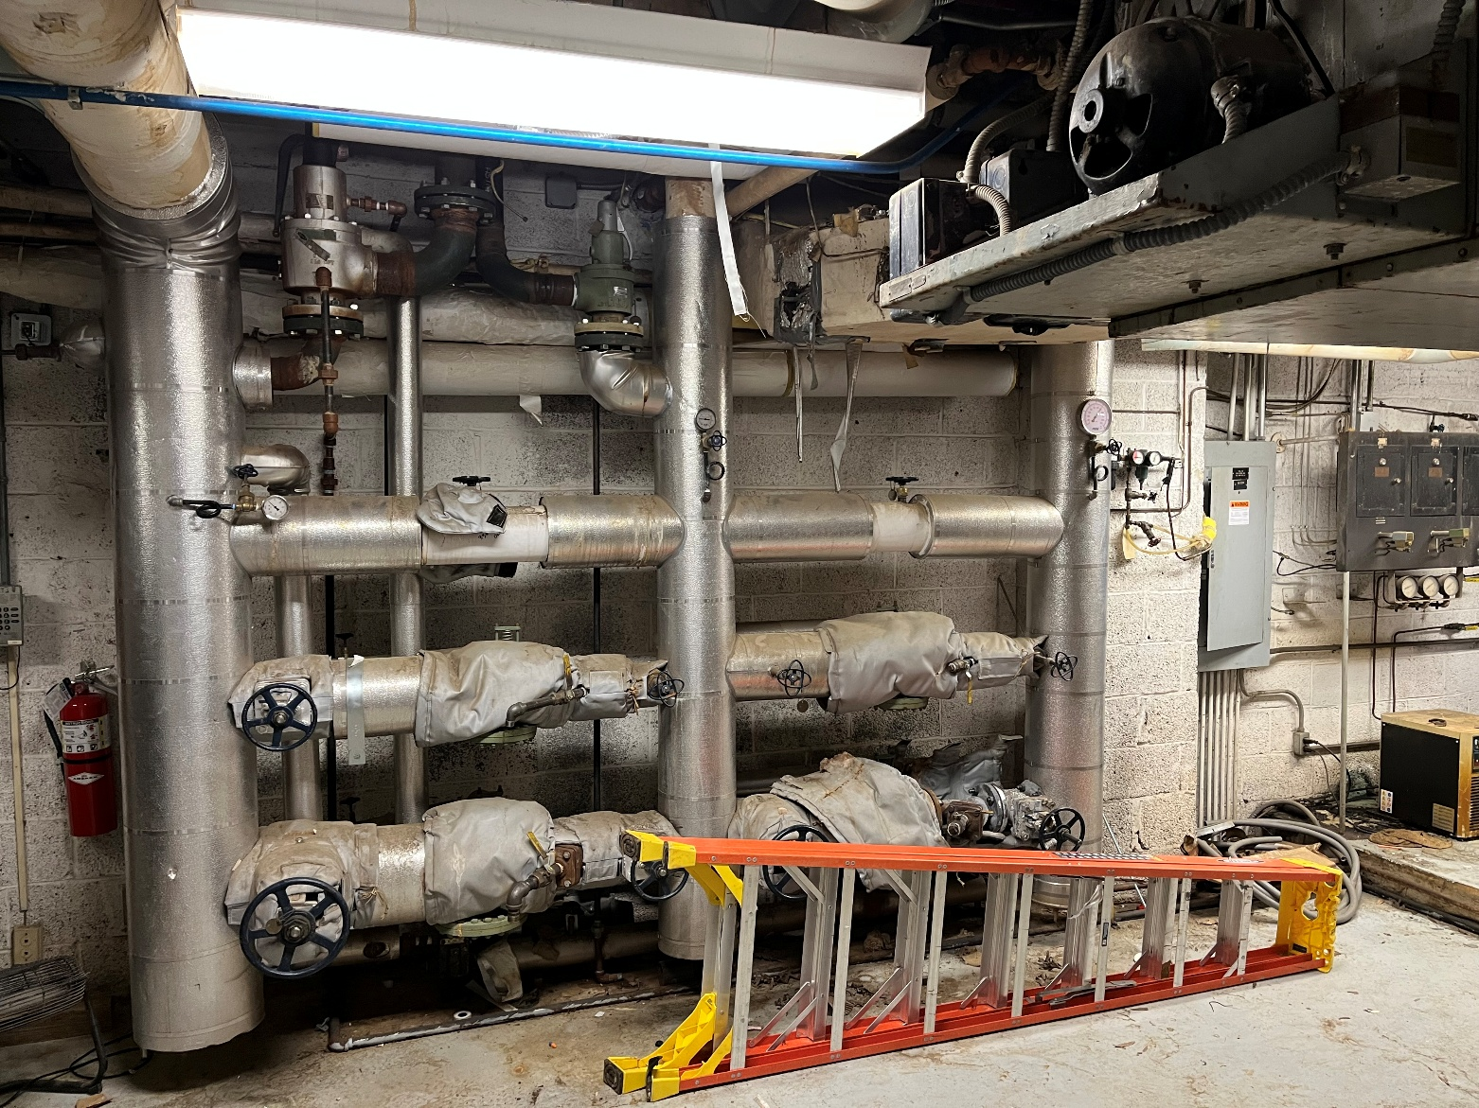

Bldg 4 – Steam Pressure Reducing Station

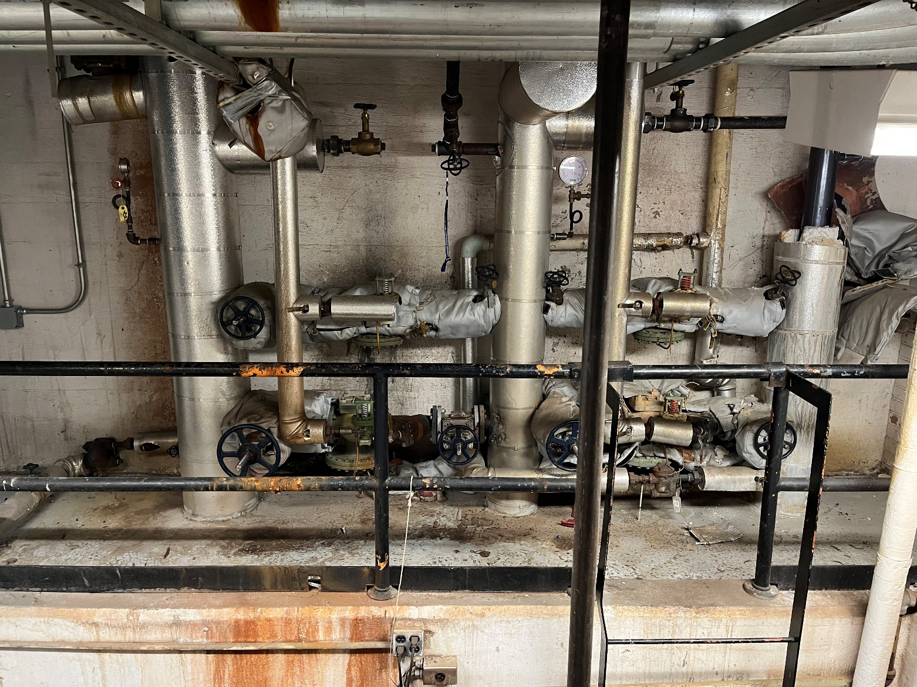

Bldg 11 – Steam Pressure Reducing Station

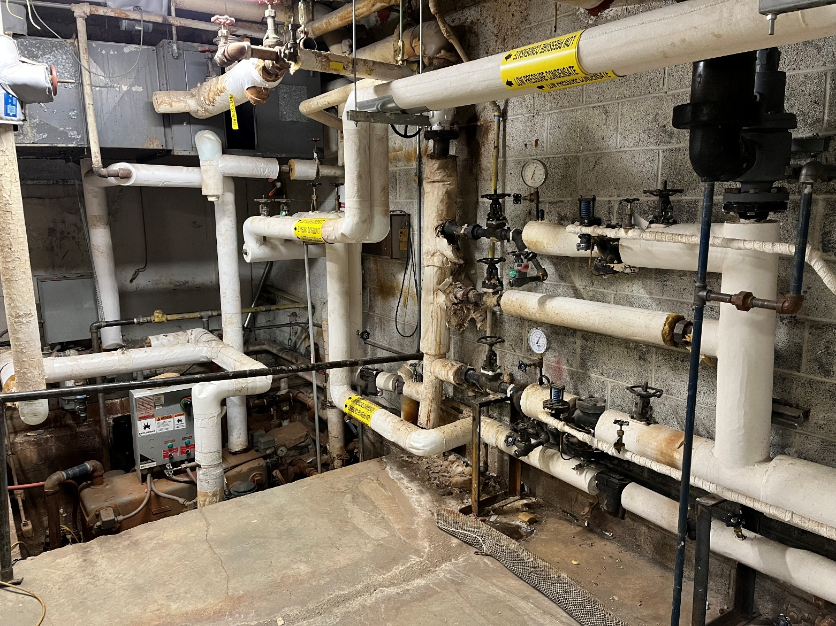

A-E SELECTION PROCESS:
The agency has convened an evaluation board for the evaluation of responses to this notice. Responses will be evaluated in accordance with the Selection of Architects and Engineers Statute (Public Law 92-582), formerly known as the Brooks Act, and implemented in RFO FAR 36.202.
Specifically, SF 330 submissions will be evaluated to identify the most highly qualified firms, using the selection criteria identified below. Discussions will be held with at least three (3) of the most highly qualified firms, in accordance with RFO FAR 36.202-1(b)(2). RFO 36.202-3 will then be followed. Selected firms will be notified by telephone or email of selection and provided further instructions.
Evaluating past performance and experience may include information provided by the firm, customer inquiries, Government databases, and publicly available sources. Failure to provide requested data, accessible points of contact or valid phone numbers could result in a firm being considered less qualified. All projects provided in the SF330 must be completed by the office/branch/individual team member performing the work under this contract.
SELECTION CRITERIA: Evaluation and selection of firms will be based on submissions and direct responses to the following criteria which are numbered in descending order of importance:

- Professional qualifications necessary for satisfactory performance of required services showing recent experience of the project team with comparable hospital projects involving Pharmacy Cleans within the past five years in which the construction has been completed. Each resume shall include a minimum of two (2) specific completed projects through construction.
  - Do the qualifications indicate that the project team has recent direct experience on Hospital projects designing similar improvements to those proposed at a VISN6 VAMC? Is the architect/engineer providing a team where each member has more than 5 years of experience? What will be the role of interns if used during design?
  - Firm shall provide a table of a minimum of 5 comparable projects comparing their IGE with the bid/award amount during construction.
- Specialized experience and technical competence in the type of work required specifically mechanical work and electrical project requirements.
  - Does the architect/engineer provide evidence of understanding of the project; and any unique architectural/engineering aspects associated with the proposed project and how to address them?
- Past performance on contracts with Government agencies and private industry in terms of cost control, quality of work, and compliance with performance schedules in a hospital setting.
  - Does the proposed architect/engineer have past performance with ratings satisfactory and above while working on hospital projects?
  - Does the architect/engineer have a reputation and standing of the firm and its principal officials with respect to professional performance, general management, and cooperativeness.
- Capacity to accomplish the work in the required time for both the prime and subconsultants.
  - This factor evaluates the ability of the firm, given their current projected workload (percentage) and the availability of their key personnel, to accomplish the possible myriad of design projects in the required time. The general workload and staffing capacity of the design office will be evaluated.
I. List current projects of similar complexity being designed in the firms’ office.
II. Indicate the firm’s present workload and the availability of the project team (including sub-consultants) for the specified contract performance period.
III. Describe experience in successfully delivering projects per performance schedule, providing timely construction support, and successfully completing multiple projects with similar delivery dates
IV. Volume of VA contract awards in the last 12 months.

- Construction Period Services experience
  - Experience in construction period services to include professional field inspections during the construction period, review of construction submittals, support in answering requests for information during the construction period, and support of construction contract changes to include drafting statements of work, and cost estimates shall be included as an evaluation criterion when construction period services is included in the statement of work for A-E services.

- Record of significant claims against the firm because of improper or incomplete architectural and engineering services.

The Department of Veterans Affairs shall evaluate each potential contractor in terms of the following as “M” firm meeting the synopsized selection criterion and "NM" means that the firm did not meet the synopsized selection criteria.:
Selection Criteria
- Professional Qualifications
- Specialized Experience and Technical Competence
- Past Performance
- Capacity
- Construction Period Services
- Record of Significant Claim
PLEASE NOTE: The A-E Evaluation Board must be provided with complete and accurate information for ALL six (6) evaluation factors above in order to rank as qualified and eligible firms. Therefore, the A-E firm must expand upon, as it deems necessary, on any evaluation factor not well demonstrated or addressed with Part 1A to Part IG and Part II of the SF330. The A-E firm shall use Part IH and/or use additional sheets to supplement/address all evaluation factors to clearly demonstrate its qualifications.
LIMITATIONS:
852.219-73 VA Notice of Total Set-Aside for Certified Service-Disabled Veteran-Owned Small Businesses.
852.219-75 VA Notice of Limitations on Subcontracting – Certificate of Compliance for Services and Construction.
SUBMISSION CRITERIA/REQUIREMENTS:
Interested firms having the capabilities to perform this work must submit:
ONE (1) ELECTRONIC SF 330, including Parts I and II, and attachments (if any) electronically to Sean.Cosby@va.gov no later than 3:00 P.M. Eastern Daylight Time on April 17, 2026.
Interested firms are responsible for ensuring electronic delivery of submission by the time and the date specified. It is highly recommended that interested firms confirm electronic submissions have been received by the Contracting Officer.
Size limits of e-mails are restricted to 10MB. If more than one email is sent, please number emails in Subjects as “1 of n”. (Example: SF330 Submission, #36C24626R0032_1 – Replace Steam and Condensate Piping, Project #659-26-700 (1 of n, 2 of n, etc.).
All SF330 submissions shall be clearly indicated in subject line, displaying the procurement number and project title (abbreviated or shortened is okay).
Interested firms are responsible for ensuring delivery of submission.
ALL SF 330 SUBMISSIONS MUST INCLUDE THE FOLLOWING INFORMATION, EITHER ON THE SF 330 OR BY ACCOMPANYING DOCUMENT:
1) Cage Code
2) Unique Entity Identifier (UEI) Number
3) Tax ID Number
4) The E-mail address and Phone number of the Primary Point of Contact
The firm and or A-E on staff representing the project must follow State of North Carolina guidelines under State law for all licensing requirements to sign and seal drawings.
Each respondent must be able to demonstrate the ability to comply with the Limitations on Subcontracting, in accordance with RFO FAR Clause 52.219-14 and VAAR Clauses 852.219-73 and 852.219-75.
Electronic submittals received after the date and time specified will not be considered. Late proposal rules per RFO FAR 15.107 will be followed for late submittals. Firms not providing the required information may not be considered. All information must be included in the SF330 submission package.
It is the offeror’s responsibility to check the Contract Opportunities website at: www.SAM.gov for any revisions to this announcement prior to submission of SF330s.
VENDOR QUESTIONS:
All questions shall be submitted to sean.cosby@va.gov no later than 3:00 P.M. Eastern Daylight Time on February 26, 2026.

ATTACHMENTS:
- Standard Form 330 (attached for ease)

See attached document: Standard Form 330.

