SUBJECT* | Sanford Vet Center | New Replacing Lease Sources Sought

GENERAL INFORMATION
CONTRACTING OFFICE’S ZIP CODE* | 04330
SOLICITATION NUMBER* | 36C24126Q0305
RESPONSE DATE/TIME/ZONE | 03-13-2026 4:00 PM EASTERN TIME, NEW YORK, USA
ARCHIVE | 60 DAYS AFTER THE RESPONSE DATE
RECOVERY ACT FUNDS | N
SET-ASIDE
PRODUCT SERVICE CODE* | X1AA
NAICS CODE* | 531120
CONTRACTING OFFICE ADDRESS | Department of Veterans Affairs  Box 90C - NCO1 Contracting  Attn: Sanderson, Melinda  1 VA Center  Augusta ME 04330
POINT OF CONTACT* | Realty Specialist  Melinda Sanderson  Melinda.Sanderson@va.gov  207-623-8411

PLACE OF PERFORMANCE
ADDRESS | Sanford Maine
POSTAL CODE | 04073
COUNTRY

ADDITIONAL INFORMATION
AGENCY’S URL
URL DESCRIPTION
AGENCY CONTACT’S EMAIL ADDRESS | Melinda.Sanderson@va.gov
EMAIL DESCRIPTION

DESCRIPTION

The U.S. Department of Veterans Affairs (VA) Seeks Expressions of Interest for approximately 5,097 American National Standards Institute/Building Owners and Managers Association (ANSI / BOMA) Occupant Area (ABOA) Square Feet of Medical / Clinical Office Space in Sanford Maine.

Notice: This advertisement is a notice of a potential opportunity. This advertisement is not a solicitation for offers, nor is it a request for proposals. The purpose of this advertisement is to identify potential sources and suitable locations and is not intended to pre-qualify or disqualify any potential offers.
Submission of any information in response to this market survey is purely voluntary. The government assumes no financial responsibility for any costs incurred associated to this request for capability information.

VA’s purpose for this notice is to conduct market research and identify capable resources from Service-Disabled Veteran-Owned Small Business (SDVOSB), Veteran-Owned Small Business (VOSB) and/or capable Open Market Sources. The NAICS Codes for use is 531120 Lessors of non-residential buildings (except miniwarahouses), and the small business size standard for 531120 is $47 million.

The Department of Veterans Affairs will give the opportunity to other offerors in the interest of competition. This advertisement is a notice of a potential opportunity. The advertisement is not a solicitation for offers, nor is it a request for proposals. The purpose of this advertisement is to identify potential sources and suitable locations. The Government will not pay for any costs incurred as a result of this advertisement. Respondents are advised that the Government assumes no responsibility to award a lease based upon responses to this advertisement.

Contracting Office Address: United States Department of Veterans Affairs (VA), Togus VAMC, Box 90C – NCO 1 Contracting, Attn: Sanderson, Melinda, 1 VA Ctr, Augusta, ME 04330
Description: The VA seeks to lease approximately 5,097 American National Standards Institute/Building Owners and Managers Association (ANSI/BOMA) Occupant Area (ABOA) square feet (SF) of medical / clinical space, not to exceed 5,720 rentable square feet (RSF) of space, and 20 parking spaces for use by the VA as a Vet Center within the delineated area of the city limits of Sanford Maine. The VA will only consider existing building options.

Parking space requirement is 20 parking spaces, or 5 per 1,000 rentable square feet offered, whichever is greater, and must include a minimum of 2 ADA compliant spaces at the main entrance. Parking must be on-site and be available for dedicated exclusive use by the VA as specified in any resulting RLP as well as fully compliant with local laws, rules and regulations. Handicap Parking spaces shall be designated in accordance with local code. The Offeror must have ownership rights to parking space offered as part of rental consideration.

Proposed Property shall not be located within the 100-year flood plan.

ABOA is generally defined as the space remaining once common areas, Lessor areas, and areas required by code are deducted from the rentable square feet (RSF) of the facility. ABOA does not include areas such as stairs, elevators, mechanical and utility rooms, ducts, shafts, vestibules, public corridors, and public toilets required by local code.

Lease Term: 20 years with 5 years firm term and 15 years soft term.

Delineated Area: To receive consideration, submitted properties must be located within the following city limits of Sanford Maine:

North: Pleasant Street to Shaws Ridge
South: Hanson Ridge Road
East: Route 202
West: Route 11A/Oak to Bridge Street
The following map of the delineated area is provided for further clarification of the boundaries of the delineated area.
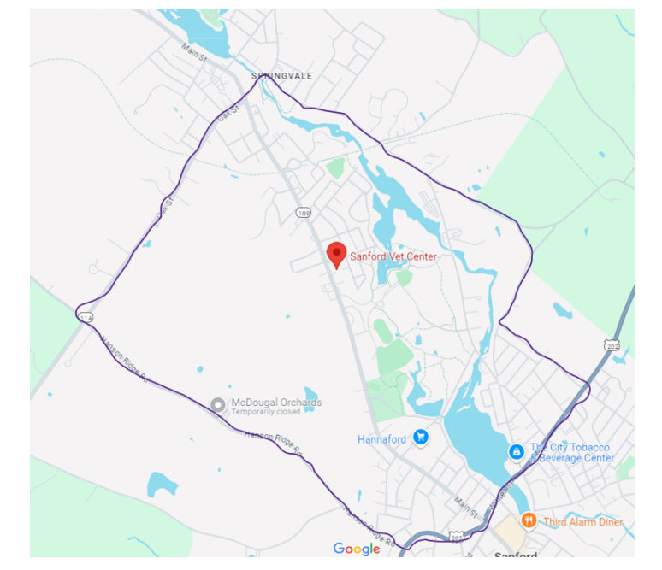

Please Note: Although this notice contains detailed information for interested SDVOSB and VOSB parties, VA encourages all small businesses and other interested open market sources to respond for market research purposes.

Existing Space:
The space must be handicapped accessible, ADA compliant, and can be provided by modification to an existing space. The space offered shall be in a building that has undergone, or will complete by occupancy, modernization or adaptive reuse for the space with modern conveniences.

Space in an existing building on ground level and offices cannot be split between floors or split on the same floor. The building must be able to comply with the Architectural Barriers Act Accessibility Standards (ABAAS)(http://www.access-board.gov/guidelines-and-standards/buildings-and-sites/about-the-aba-standards), the VA Barrier Free Design Standard (http://www.cfm.va.gov/til/etc/dsBarrFree-2025-05.pdf) , and meet security requirements as set forth in the Physical Security Design Manual for VA Mission Critical Facilities: (https://www.cfm.va.gov/til/PhysicalSecurity/dmPhySec.pdf); additionally, space shall be able to comply with recommendations established for Federal facilities by the Department of Justice, Vulnerability Assessment, dated June 28, 1995 (https://www.ncjrs.gov/pdffiles1/Digitization/156412NCJRS.pdf).

Unique Agency Requirements:

The VA shall only consider the most qualified properties meeting the minimum space requirements as listed below. Upon request, the offeror shall make available the offered lease space for survey to determine the below unique requirements are met.

- The space offered must be located on no more than one floor and all space must be contiguous.

- If the space offered is not on the ground floor, then a minimum of two (2) elevators must be provided.

- Space must not be located on a level below ground.

- Entrance doors must be automatic. If they are not currently automatic, they shall be updated prior to occupancy.
- The building must have metro-ethernet data and voice communication circuits available for demarking in the telecommunication room.
- The following space configurations will not be considered: Space with atriums or other areas interrupting contiguous space, extremely long or narrow runs of space (more than twice as long as wide), irregularly shaped space configurations or other unusual building features adversely affecting usage.
- Parking shall be contiguous and adjacent to the building. Handicap spaces shall be within 100 feet of the building entrance.
- Offered site can accommodate square footage and parking requirements. Structured parking under the space is not permissible.

- Offered space cannot be in the FEMA 100-year flood plain.

- Offered space must be zoned for the VA’s intended use.

- Offered space may not be considered if located in close proximity (within a walkable mile of the Vet Center) to property with incompatible uses, including but not limited to the following uses: liquor establishments, methadone clinics, pawn shops, adult entertainment clubs, medical (or otherwise) marijuana distributors, treatment centers, correctional facilities, establishments where firearms are sold/discharged, railroad tracks, within flight paths if flight paths are a noise or vibration disturbance, industrial areas, or agricultural areas that are within proximity to fields where chemical insecticides/herbicides are sprayed.
- Space may not be considered where apartment space or other living quarters are located within the same building.
- The offered space must meet Federal and Local Government requirements for fire safety, physical security, accessibility, seismic, and sustainability standards.
- The building must be handicapped accessible. The space and parking area must meet the requirements of the Architectural Barriers Act Accessibility Standards and the VA Barrier Free Design Standard (available at Barrier Free Design Standard (va.gov).
- A fully serviced lease is required.
- Space configurations do not consist of irregular runs or shapes or unusual features adversely affecting usage.
- Offered site is within the delineated area.
- Space offered must be in an existing building.
- Access to public transportation shall be located within the immediate vicinity of the building, but generally not to exceed a walkable one mile as determined by the Contracting Officer. Alternatively, two or more public or campus bus lines shall be located within the immediate vicinity of the building, but generally not to exceed a walkable mile.

Expressions of Interest:

All submissions should include the following information:

- Offerors Information.
- Company name
- Company address
- Dun & Bradstreet number
- Point of contact
- Phone number
- Email address
- If you are qualified as a small business, Veteran Owned Small Business (VOSB), or Service-Disabled Veteran Owned Small Business (SDVOSB) under NAICS Code 531120 Lessors of Nonresidential Buildings with a small business size standard of $47 million, please read the attachment, entitled, “Small Business, VOSB, or SDVOSB Status”. You are invited, but not required, to submit a Capabilities Statement.

- Address and location of building and space offered. Name of owner must be provided, i.e., property tax records, MLS listing, etc.

- Evidence of ownership, if building is submitted by owner. Non-Owners (e.g., prospective developers/lessors) submitting a building must provide evidence of authority granted by property owner to submit the property to VA for development. A property with an Active MLS listing for sale or lease will be considered acceptable as evidence for consideration for survey.

- Location on map, demonstrating the building lies within the delineated area.

- Description of ingress/egress to the building.

- FEMA map evidencing that the property lies outside the 100-year floodplain.

- A narrative and map describing proximity of the building to the nearest bus and/or train stop, and major transportation routes, if mass transit is available

- Any information related to title issues, easements, or restrictions on the use of the building.
- Specific Building Information:
- Age of building
- Total existing building gross square feet
- Site plan depicting the building and parking
- Floor plan and gross square footage proposed
  - Identify the base Shell annual rent cost and operating cost figure, together these figures equal the total Annual Serviced Rent cost. List in in both American National Standards Institute/Building Owners and Managers Association (ANSI/BOMA) Occupant Area (ABOA) square feet and Rentable Square Feet (RSF) for the full 6-year lease term with any step increases to include operating cost adjustments.
- Identification of on-site parking offered and available for VA’s use.
- A description of any changes to the property necessary to be compatible with VA’s intended use.
- Information on adjacent and proposed building uses, zoning, business functions and site activities.
- A description of any planned land development or construction that will affect the site, including neighboring projects and road/utility line construction.
- A statement indicating the current availability of utilities servicing the proposed space or property.
- Documentation showing compliance with seismic requirements, if any, for the location of the property.
- Date space is available for occupancy

All interested parties must respond to this announcement no later than 4:00 pm EST, Friday March 13, 2026, by email to melinda.sanderson@va.gov and must have “Sources Sought 36C24126Q0305” in the subject line.
Attachment - Small Business, VOSB or SDVOSB Status
The NAICS Code for this procurement is 531120 Lessors of Nonresidential Buildings, and the small business size standard is $47 million. Responses to this notice will assist the VA in determining if the acquisition should be set-aside for competition and restricted to SDVOSB or VOSB concerns in accordance with 38 USC Sec. 8127.

This is not a request for proposals, only a request for information for planning purposes, and does not constitute a solicitation. A solicitation may or may not be issued. This notice is being published in accordance with Federal Acquisition Regulation 19.14 and VA Acquisition Regulation 819.70.

SDVOSB, VOSB, and Small Business firms are invited to provide information to contribute to the market research for this project. SDVOSB and VOSB firms must be registered in VA’s Vendor Information Pages (VIP) site at https://www.vip.vetbiz.va.gov. All business concerns must have the technical skills and financial capabilities necessary to perform the stated requirements. All business concerns are requested to submit a Capabilities Statement if they are interested in participating in this project. A submission checklist is provided below for firms to fill out and submit which will serve as the firm’s Capabilities Statement.

Capabilities Statement Will Include:

1. Company name, address, point of contact, phone number, Dunn & Bradstreet number, and e-mail address;
2. Evidence of SDVOSB or VOSB status through registration at VIP (https://www.vip.vetbiz.va.gov/);

3. Evidence of ability to offer as a small business under NAICS Code 531120 and listing in the System for Award Management (www.SAM.gov), including a copy of the representations and certifications made in that system;

4. A summary describing at least three (3) projects of similar size and scope completed in the past five (5) years that demonstrate your company’s experience designing, constructing, and managing Federal leased facilities or healthcare facilities relevant to the project described above. (3-page limit);

5. Evidence of your company’s bonding capacity to meet a bid bond of $100,000, and evidence from a surety of capability to obtain payment and performance bonds in values based on the project magnitude listed above; and
6. Evidence of capability to obtain financing for a project of this size.
If desired, the company may also submit a narrative describing its capability.
***Although this notice focuses on SDVOSB and VOSB, we encourage all small businesses and other interested parties to respond for market research purposes. ***

