PERFORMANCE WORK STATEMENT
(Integrated Commercial Intrusion Detection System (ICIDS) Maintenance monitoring and Service)

PART 1 GENERAL INFORMATION
1. General. This is a non-personal services contract for the provision of Scheduled and Unscheduled Maintenance Services and Maintenance monitoring necessary to ensure the continuous uninterrupted operability and serviceability of the Integrated Commercial Intrusion Detection System (ICIDS), utilized throughout the Fort Bliss Military Reservation. This contract covers the maintenance of the system throughout the Fort Bliss Military Installation, Dona Ana, Oro Grande, and McGregor Range Facilities as detailed in the Performance Work Statement (PWS). The Government shall not oversee, supervise, or direct the contract service providers performing these services. Such service providers shall be accountable solely to the Contractor, who, in turn, remains responsible to the Government.
1.1. Description of Services / Introduction. This is a non-personal services contract. The Contractor shall independently furnish all personnel, equipment, transportation, tools, materials, supervision, and other resources necessary to perform scheduled and unscheduled maintenance, continuous operational monitoring, repairs, and upgrades for the Integrated Commercial Intrusion Detection System (ICIDS) utilized throughout the Fort Bliss Military Reservation. The FBTX ICIDS system consists of approximately 600 monitored zones and a centralized reporting infrastructure. All services shall be performed in accordance with the standards and specifications outlined in this contract and the Performance Work Statement (PWS), ensuring continuous, uninterrupted operability and serviceability of the ICIDS system. Contractor personnel shall not be subject to direct supervision or control by Government employees.
1.1.1 ICIDS Zone. An ICIDS zone is composed of one actively monitored Remote Area Data Collection (RADC) panel configured with up to eight (8) sensors. These sensors may include encryption devices (Sensitive Compartmented Information Facility only), Motion Sensors (MS), Balanced Magnetic Switches (BMS), Duress Switches (DS), power converter boxes, expansion boards, and associated wiring. All sensors are Government-furnished and issued to the Contractor based on work order requirements. Zones are distributed across Fort Bliss Military Installation, including East Fort Bliss, Dona Ana, Oro Grande, and McGregor Range Facilities. The Contractor shall perform all required scheduled and unscheduled maintenance, continuous operational monitoring, and upgrades to ensure uninterrupted zone functionality and compliance with system performance standards
1.1.2 The ICIDS reporting system—including but not limited to the three (3) Monitoring stations, (3) Device Recording servers, (3) monitoring consoles, and associated internal wiring—is Government-furnished equipment (GFE) and remains the property of the United States Government. These components are provided to the Contractor for the sole purpose of supporting ICIDS zone monitoring operations across Fort Bliss Military Installation, Dona Ana, Oro Grande, and McGregor Range Facilities.
The Contractor shall utilize the ICIDS reporting system to perform continuous operational monitoring of all ICIDS zones. The Contractor is responsible for sustaining the system’s operability, including performing all scheduled and unscheduled maintenance, repairs, upgrades, and reporting any issues or malfunctions to the Government in accordance with the standards outlined in this contract and the Performance Work Statement (PWS).
All services shall be performed in compliance with applicable provisions of the Federal Acquisition Regulation (FAR), and the Contractor shall ensure that all maintenance activities preserve the integrity, functionality, and security of Government-furnished systems.
1.1.2.1 The Contractor shall utilize Department of the Army Qualified Electronics-certified equipment, software, or tools necessary to monitor the operational status of the ICIDS reporting system and its integration with ICIDS zones. While the reporting system is Government-owned, the Contractor shall be responsible for ensuring its continuous functionality and shall promptly notify the Government of any deficiencies, failures, or anomalies. The Contractor’s selected equipment shall meet the performance standards outlined in this contract and the PWS.
1.1.3 Zone Quantity Adjustment. Prior to exercising any option year, the Government reserves the right to adjust the total number of ICIDS zones receiving maintenance and monitoring services by up to ten percent (10%), either as an increase or decrease. This adjustment shall be based on the number of zones actively monitored during the current option year and will be reflected in the scope and pricing for the subsequent period of performance. The Contractor shall ensure that any adjusted zones are incorporated into the maintenance and continuous monitoring schedule without disruption to system operability.
1.1.4 Zone Expansion and Billing Structure. Each RADC panel includes a base configuration of eight (8) sensors, which constitutes one (1) zone. The system supports expansion through additional hardware, and any sensor count exceeding eight (8) requires an expansion board. For contract and billing purposes, every increment of up to eight (8) sensors beyond the initial set will be treated as an additional zone. For example, a panel with nine (9) sensors will be considered two (2) zones; a panel with seventeen (17) sensors will be considered three (3) zones.
1.1.4.1 The Contractor shall be responsible for utilizing any DAQ Electronics-certified equipment necessary to monitor the operational status of each zone, including expanded configurations. The selection and deployment of additional such equipment is at the Contractor’s discretion, provided it meets the performance standards outlined in this contract and PWS.
1.2. Background. The Directorate of Emergency Services (DES) Physical Security Division at Fort Bliss, Texas, provides ICIDS maintenance and monitoring services to support home station and tenant organizations in meeting Army regulatory requirements. These services ensure continuous operational monitoring and compliance with the Army Physical Security Program (AR 190-11) and the Army Information Security Program (AR 380-5). By centrally managing ICIDS maintenance and monitoring, DES enables timely response to security incidents and ensures accountability and safety within controlled areas. All services are delivered under a non-personal services framework, with contractor personnel operating independently from Government supervision.
1.3. Objectives. The primary objective of this contract is to provide scheduled and unscheduled maintenance, continuous operational monitoring, repairs, and upgrades for the Integrated Commercial Intrusion Detection System (ICIDS), which includes approximately 600 monitored zones and the associated reporting infrastructure across Fort Bliss Military Installation, Dona Ana, Oro Grande, and McGregor Range Facilities. These services shall ensure the continuous and uninterrupted operability of all ICIDS zones and reporting components, enabling the Government to maintain persistent surveillance and timely detection of unauthorized intrusions. All services shall be performed under a non-personal services framework, with Contractor personnel operating independently and in compliance with the standards outlined in this contract and the Performance Work Statement (PWS).
1.4. Scope. This contract encompasses all functions, tasks, and responsibilities required to maintain and monitor the ICIDS system. The Contractor shall furnish all necessary personnel, equipment, transportation, tools, materials, supervision, and any other resources required to perform scheduled and unscheduled maintenance, continuous operational monitoring, repairs, and upgrades for up to 600 ICIDS zones (each configured with a maximum of eight sensors) and the associated reporting components.
1.4.1 The Contractor shall be responsible for selecting, furnishing, and utilizing any equipment, software, or additional tools necessary to fulfill these requirements. All equipment used for monitoring and maintenance shall be DAQ Electronics-certified to ensure compatibility with the ICIDS system. The Contractor retains full discretion over how these services are performed, provided they meet the performance standards outlined in this contract and the PWS.
1.4.2 Services shall be performed at designated locations within the Fort Bliss Military Installation, including East Fort Bliss, Dona Ana, Oro Grande, and McGregor Range Facilities. The Contractor shall provide DAQ Electronics-certified on-site technicians, and all personnel must possess the required certifications and qualifications. These shall be verified prior to contract award in accordance with Army Regulation 190-11, paragraph 3-6, which mandates that maintenance be conducted only by qualified personnel. All services shall be executed in strict accordance with this contract and the accompanying PWS, except for those items expressly designated as Government-furnished property and services.
1.5. Period of Performance. The period of performance shall be for one (1) Base Year of 12 months and four (4) 12-month option years. The Period of Performance reads as follows:
Base Year 01 Apr 26 – 31 Mar 27
Option Year I 01 Apr 27 – 31 Mar 28
Option Year II 01 Apr 28 – 31 Mar 29
Option Year III 01 Apr 29 – 31 Mar 30
Option Year IV 01 Apr 30 – 31 Mar 31

1.6. Hours of Operation.
1.6.1. Normal Duty Hours. The contractor shall be responsible for providing preventive maintenance services between the hours of 7:30 AM through 4:30 PM, Mountain Time Zone, Monday through Friday, except on Federal Government Holidays, or when Government facilities are closed due to local or national emergencies, administrative closings, or similar Government directed facility closings. For other than firm fixed price contracts, the Contractor will not be reimbursed when the Government facility is closed for the above reasons. The Contractor shall always maintain an adequate workforce for the uninterrupted performance of all tasks defined within this PWS when the Government facility is not closed for the above reasons. When hiring personnel, the Contractor shall keep in mind the stability and continuity of the workforce is essential.
1.6.2. Customer Service. The contractor shall be responsible for providing after-hours customer service in case of an equipment failure between the hours of 4:30 PM through 7:30 AM, Mountain Time Zone, Monday through Friday and 24-hours Saturday through Sunday, which may include Federal Government Holidays, or when Government facilities are closed due to local or national emergencies, administrative closings, or similar Government directed facility closings. The Contractor shall always maintain an adequate workforce for the uninterrupted performance of all tasks defined within this PWS when the Government facility is closed for the above reasons. When hiring personnel, the Contractor shall keep in mind the stability and continuity of the workforce is essential.
1.6.3. Federal Government Holidays.
a. New Year’s Day 1st Day of January
Martin Luther King, Jr. Birthday 3rd Monday of January
President’s Day 3rd Monday of February
Memorial Day Last Monday in May
Juneteenth 19th day of June
Independence Day 4th Day of July
Labor Day 1st Monday of September
Columbus Day 2nd Monday of October
Veteran’s Day 11th Day of November
Thanksgiving Day 4th Thursday of November
Christmas Day 25th Day of December

b. When one of the above-mentioned holidays falls on a Sunday, the following Monday will be observed as a legal holiday. When a legal holiday falls on a Saturday, the preceding Friday is observed as a legal holiday. This list of holidays relates to Government duty days and is not intended to supplement or otherwise alter the provisions of any Wage Determination regarding applicable paid holidays.
c. It is understood and agreed between the government and the Contractor that observance of such days by Government personnel will not be a reason for an additional period of performance, or entitlement of compensation except as set for within the contract. In the event of contractor’s personnel work during the holiday, the Contractor may reimburse them; however, no form of holiday or other premium compensation will be reimbursed either as a direct or indirect cost, other than their normal compensation for the time worked, unless stipulated otherwise. This provision does not preclude reimbursement for authorized overtime work if applicable.
d. When the Department of War grants excuse absence to its employees, the Contractor agrees to continue to provide sufficient personnel to perform critical tasks already in operation or scheduled and shall be guided by the instructions issued by the Contracting Officer (KO) or the Contracting Officer’s Representative (COR). Changes in employee work schedules shall comply with the terms and conditions of the contract, including payment provisions.
e. If Government personnel are furloughed, the Contractor shall contact the COR or the KO to receive directions.
1.7 Quality Assurance.
1.7.1. The Government shall evaluate the Contractor’s performance under this contract in accordance with (IAW) the Quality Assurance Surveillance Plan (QASP). This plan is a government only document primarily focused on what the Government must do to assure that the Contractor has performed IAW the requirements of the PWS of this contract. It defines how the performance standards will be applied, the frequency of surveillance, and the minimum acceptable deficiency rate.
1.7.2. Post Award Conference/Periodic Progress Meetings. The Contractor shall participate in any post-award conference convened by the contracting activity or contract administration office. Additionally, the Contractor shall attend periodic performance review meetings as scheduled by the Contracting Officer (KO), Contracting Officer’s Representative (COR), and personnel from the Physical Security Division. During these meetings, the Contracting Officer shall provide an assessment of the Contractor’s performance, and the Contractor shall communicate any challenges or concerns encountered in the execution of contract requirements. The parties shall collaboratively identify and implement appropriate corrective actions to resolve outstanding issues. All post-award conferences and periodic progress meetings shall be included in the overall contract price and shall not constitute grounds for additional compensation.
1.8. Quality Control. Quality Control is the responsibility of the Contractor. The Contractor is responsible for the delivery of quality services to the Government.
1.8.1. The Contractor shall develop, implement and maintain an effective Quality Control System which includes a written Quality Control Plan (QCP). The QCP shall implement standardized procedure/ methodology for monitoring and documenting contract performance to ensure all contract requirements are met. The Contractors’ QCP shall contain a systematic approach to monitor operations to ensure acceptable services are provided to the Government. The QCP, as a minimum, shall address continuous process improvement; procedures for scheduling, conducting and documentation of inspection; discrepancy identification and correction; corrective action procedures to include procedures for addressing Government discovered non-conformances; procedures for root cause analysis to identify the root cause and root cause corrective action to prevent re-occurrence of discrepancies; procedures for trend analysis; procedures for collecting and addressing customer feedback/complaints. The Contractor shall provide to the Government their quality control documentation within 30 days after contract award. Changes to the QCP afterwards shall be submitted to the Contracting Officer (KO) and Contracting Officer’s Representative (COR) within five (5) working days prior to the proposed changes thereafter. After acceptance of the quality control plan the Contractor shall receive the Contracting Officer’s acceptance in writing of any proposed change to their QC System regarding this contract.
1.8.2 Periodic Inspections. The Contractor shall be subject to periodic inspections conducted by the Contracting Officer Representative (COR), Installation Alarms Administrator, Physical Security Division Chief for the Directorate of Emergency Services, and/or the end users (units whose assets are being protected). Technicians shall arrive fully prepared with all required tools, test equipment, and supplies necessary to diagnose and resolve system faults immediately following testing. Any failure in the operation of the alarm system during the inspection shall be considered unsatisfactory performance, and the Contractor shall be responsible for taking corrective action to ensure compliance with contractual requirements and operational standards.
1.8.3. Corrective Actions. If at any time, it is determined by the Contracting Officer that the quality control system, personnel, instructions, controls, tests, or records are not providing results which conform to contract requirements, actions shall be taken by the Contractor to correct the deficiency.
1.9 Place of Performance. Fort Bliss Military Installation, Dona Ana, Oro Grande, and McGregor Range Facilities.
1.9.1 Government-Furnished Office Space. To support contract performance, the Government shall provide designated office space within the Fort Bliss Military Installation for use by the Contractor. This space is provided under a revocable license and shall not be construed as a lease or create any landlord-tenant relationship. The Contractor shall use the space solely for activities directly related to the execution of this contract. The Contractor is responsible for maintaining the space in a clean and orderly condition and shall comply with all applicable installation policies regarding access, security, and usage. Utilities and basic furnishings may be provided at the Government’s discretion. Upon contract completion or termination, the Contractor shall vacate the premises and return the space to its original condition, subject to inspection by the Government. See Appendix C.
1.10. Type of Contract. The Government will award a firm-fixed price contract.
1.11. Security.
1.11.1. Security Requirements. Alarm Installation and Maintenance will be accomplished by U.S citizens who have been subjected to a trustworthiness determination. Contractor personnel performing work under this contract must have a minimum-security clearance for unclassified equipment which is a Tier 1 (T1), granted in accordance with AR 380-67, paragraph 3-2 at time of the proposal’s submission, and must maintain the level of security required for the life of the contract. The security requirements are IAW the Department of War Contract Security Classification Specification form DD254, see TAB 1 below. DD254 will be maintained at the security office within the Directorate of Plans, Training, Mobilization, and Security (DPTMS).
1.11.2. Physical Security. The Contractor shall be responsible for safeguarding all Government equipment, information, and property provided for Contractor use IAW AR 190-11, The Army Physical Security Program. At the close of each work period, Government facilities, equipment and materials shall be secured.
1.11.3. Key Control. The Contractor shall establish and implement comprehensive procedures to ensure that all keys and key cards issued by the Government are securely safeguarded, properly managed, and not lost, misplaced, or used by unauthorized individuals. The term "keys" herein includes key cards. The Contractor is strictly prohibited from duplicating any keys or key cards issued by the Government. The Contractor shall develop and maintain a Key Control Program in full compliance with AR 190-51, ensuring accountability, security, and proper management of all issued keys. This program shall be integrated into the Contractor’s Quality Control Plan and must incorporate procedures for the prompt turn-in of keys by personnel who no longer require access to secured areas. The Contractor shall immediately report any instances of lost or duplicated keys or key cards to the Contracting Officer (KO), Contracting Officer Representative (COR), and Security Manager, and shall take appropriate corrective action to mitigate security risks.
1.11.3.1. Duplicated Keys. In the event that keys, excluding master keys, are lost or duplicated, the Contractor shall, upon direction from the Contracting Officer, re-key or replace the affected lock(s). However, the Government reserves the right to perform re-keying or lock replacement at its discretion. If the Government elects to replace locks or conduct re-keying, the Contractor shall reimburse the Government for the total cost incurred. In the event of a lost or duplicated master key, the Government shall replace all locks and keys within that system, with full cost reimbursement from the Contractor. Additionally, should any Government property be stolen or damaged due to the Contractor’s misplacement, loss, or duplication of keys, the Contractor shall fully compensate the Government for the associated damages.
1.11.3.2 Restriction on Use of Government-Issued Keys and Key Cards. The Contractor shall ensure that Government-issued keys and/or key cards are used exclusively by authorized Contractor personnel. Under no circumstances shall Contractor personnel unlock or allow access to secured areas for individuals other than Contractor employees who are engaged in the performance of contract duties within those areas, or other people authorized by the Contracting Officer.
1.11.4 Lock Combinations. The Contractor shall establish and implement procedures to prevent disclosure of lock combinations to unauthorized individuals. Lock combinations shall be changed whenever personnel with access no longer require knowledge of such combinations. These procedures shall be detailed in the Contractor’s Quality Control Plan.
1.11.5 Antiterrorism (AT) Level I Training. All Contractor and subcontractor personnel requiring access to Army installations, facilities, or controlled access areas shall complete Antiterrorism (AT) Level I awareness training within five (5) working days of the contract start date or the effective date of the requirement’s incorporation into the contract, whichever is applicable. The Contractor shall submit certificates of completion for each applicable employee and subcontractor to the Contracting Officer’s Representative (COR) within five (5) working days of training completion. Certificates shall be submitted annually thereafter. AT Level I training is accessible at: http://jko.jten.mil/courses/atl1/launch.html. In cases where computer access is unavailable, the unit’s Level II Antiterrorism Officer (ATO) will administer the training within five (5) working days of contract initiation and retain a training roster for a minimum of one (1) year. Contractor personnel hired after the contract start date shall complete AT Level I training within five (5) working days of hiring. Completion may be through the online course or facilitated by the ATO, with training certificates submitted to the ATO within three (3) calendar days. AT Level I training must be renewed annually, with re-certification completed no later than (NLT) twelve (12) months from the initial training date. If the required activity lacks a designated ATO, the next ATO in the chain of command shall conduct the training.
1.11.6 Access and General Protection/Security: Policies and Procedures In accordance with Homeland Security Presidential Directive (HSPD-12), and under the authority of the Commanding General, Fort Bliss requires the successful vetting of all individuals prior to installation access. Following contract award, the Contractor shall submit a list of employees through the COR using the designated form, which shall be forwarded to the contract COR and the DES Chief of Physical Security. Upon completion of background checks and approval of access, the results will be provided to the COR and the Contractor’s designated point of contact. Subsequently, all personnel shall report to Building 2616, Chaffee Road (Chaffee Commercial Visitor Control Center) to begin the installation badge issuance process. As this process involves Personally Identifiable Information (PII), all communications must be secured and transmitted exclusively to the Contracting Officer Representative. No other individuals are authorized to receive background information. Contractor and subcontractor personnel shall comply with all applicable installation, facility, and area commander security and access requirements, as provided by Government representatives. The Contractor shall furnish all documentation necessary for background investigations, which shall be conducted by the installation’s Provost Marshal Office, Director of Emergency Services, or Security Office. Contractor personnel must also comply with all identity verification directives issued by the Department of War (DOD), Headquarters Department of the Army (HQDA), and local security authorities. Restriction of key use. The Contractor shall prohibit the use of Government issued keys/key cards by any person other than the Contractor’s employees. The Contractor shall prohibit the opening of locked areas by Contractor employees to permit entrance of persons other than Contractor employees engaged in the performance of assigned work in those areas, or personnel authorized entrance by the Contracting Officer.
1.11.6.1. The Contractor shall notify the COR of employees who require access to the installation and have not previously had a background check, within five (5) days of award of the contract. The COR will provide a background check form to the Contractor who, in turn, will input the appropriate details per employee and submit the form directly to the Point of Contact at DES. Any negative results (names only) from the background check will be transmitted from DES to COR and to KO. The KO will enforce the results, and the COR will verify compliance. It will be up to the Contractor to take appropriate action and directly coordinate with DES for information and/or appeals as needed. If during the period of the contract, new personnel are hired, that information shall be submitted to the COR within five (5) days of new hire. It is the Contractor’s responsibility to inform the Government of these changes. The Contractor shall contact DES directly to schedule appointments for the Contractor’s employees that have passed the DES background check to be issued Installation Access Badges. When accessing the installation, contract employees will be required to show at the Access Control Point as state issued driver’s license or identification and the Installation Access Badge. The Contractor shall ensure employees that no longer require access to the installation to support this contract, return the Installation Access Badge to DES prior to final termination. Within 24 hours of the Installation Access Badge turn-in, the Contractor shall provide the COR proof that the badge has been returned to DES.
1.11.6.2 Government-Furnished Office Space Access and Use. The Government shall provide designated office space within the Fort Bliss Military Installation to support the Contractor’s performance under this contract. Access to this space shall be limited to Contractor personnel who have successfully completed the installation’s background check and have been issued an Installation Access Badge. The office space is provided under a revocable license and shall not be construed as a lease or create any landlord-tenant relationship. The Contractor shall use the space solely for contract-related activities and shall comply with all applicable installation policies regarding physical security, access control, and facility use. The Contractor shall maintain the space in a clean and orderly condition and shall ensure that all Government-issued keys or access credentials are safeguarded in accordance with Section 1.11.3. Upon contract completion or termination, the Contractor shall vacate the premises and return the space to its original condition, subject to inspection by the Government. See Appendix C.
1.11.7. iWatch Training. The Contractor and all associates subcontractors shall brief all employees on the local iWatch program (training standards provided by the requiring activity ATO. This locally developed training will be used to inform employees of the types of behavior to watch for and instruct employees to report suspicious activity to the COR. This training shall be completed within five (5) working days of contract award and within five (5) working days of new employees’ commencing performance with the results and certificates provided to the COR no later than five (5) working days from employment start.
1.11.8. Security of Classified Items, Systems and Information. The Contractor, as a rule, shall not have access to classified information; however, should classified documents fall into the possession of the Contractor, the Contractor shall immediately contact the COR for disposition instructions.
1.12. Safety. The Contractor shall establish and maintain a safety plan which shall be submitted to the KO within five (5) days after contract award.
1.12.1. In order to provide safety control for protection to the life and health of employees and other persons; for prevention of damage to property, materials, supplies, and equipment; and for avoidance of work interruptions in the performance of this contract, the Contractor shall comply with the following Safety Accident Prevention Standards: 29 CFR 1910, Occupational Safety and Health Standards; 29 CFR 1926, Safety and Health regulations for Construction; Army Corps of Engineers Manual 385-1-1, Safety and Health Requirements Manual. The Contractor shall comply with the above and all other applicable DoD, Army, Federal, State and Local safety and health requirements.
1.12.2. Reporting Fire and Safety Hazards. The Contractor shall train personnel to recognize fire and safety hazards and encourage personnel in the performance of their duties to report fire and safety hazards and unsafe conditions to their supervisor. The Contactor shall take corrective action to remedy reported deficiencies IAW the terms of this contract. The COR shall be notified of deficiencies beyond the terms of this contract.
1.12.3. Environment and OSHA. The Contractor shall comply with all local, State, and Federal environmental and occupational safety laws, rules, and regulations. Any apparent conflict between compliance with such local, State, and Federal environmental and occupational safety laws, rules, regulations, and compliance with the requirements of the contract shall be immediately brought to the attention of the Contracting Officer or authorized representative for final resolution. The Contractor shall notify the Contracting Officer or authorized representative in writing in addition to any verbal notification of such conflict. The Contractor shall be liable for all fines, penalties, and costs which result from violations of, or failure to comply with, all such local State, or Federal laws, rules, and regulations. All unsafe acts or conditions fostered by the Contractor or Contractor personnel will be remedied by the Contractor at no expense to the government.
1.12.4. Reporting Mishaps. The Contractor shall adhere to reporting of mishaps IAW AR 385-10, The Army Safety Program and DA Pam 385-40, Army Accident Investigations and Reporting. In addition, the Contractor shall report: (1) Injury or occupational illness to on-duty contractors; (2) Damage to GFM, GFP, or GFE provided to a contractor; (3) Contractor accidents involving Army property and personnel.
SERIOUS ACCIDENT AND INCIDENT REPORTING: The Contractor shall report serious accidents and incidents incurred while performing work under this contract immediately by the most expeditious means possible but not more than one hour following the accident or incident to the Fort Bliss Directorate of Emergency Services, the Installation Safety Office, and Contracting Officer. Serious accidents and incidents include, but are not limited to, those defined in AR 385-10 and AR 190-40 respectively or referenced in other applicable directives. Examples are as follows: One or more lives lost, one or more persons critically injured, three or more persons hospitalized due to one incident, property damage estimated to exceed $2,000, fire causing major damage to structures, equipment, or vehicles, and HAZMAT, hazardous substances, and HAZWASTE incidents.
Record of Injury Form: Immediately after a job-connected injury, the Contractor shall prepare a record of the incident/accident and forward it to the COR. The COR will forward the incident/ accident report to the Installation Safety Office and contracting officer. If more information is required, the Command Safety office will coordinate with the COR for the required information.
The Contractor shall maintain reports and records on accidents, safety inspections, and investigations. The contractor shall report to the COR any accident involving any Government Furnished Equipment, Government Furnishing Facilities, or anyone working under this contract within 24 hours of accident. A copy of the accident report shall be provided to the Contracting Officer and COR within three (3) working days of the accident.
1.12.5. Special attention shall be given to historic structures and natural and landscape features of the areas to protect these elements and their surroundings.
1.12.6 TOXIC/HAZARDOUS MATERIAL AND WASTE MANAGEMENT
1.12.6.1. The Contractor shall comply with the Fort Bliss Hazardous Waste Management Plan (HWMP) regarding the use, storage and disposal of generated hazardous wastes. The contractor shall properly manifest and timely dispose of all hazardous waste generated in accordance with Texas Environmental and Conservation laws and regulations.
1.12.7. Personnel Safety. The Contractor shall immediately correct all safety deficiencies upon notification of the deficiencies by the Contracting Officer, designated representative or COR, and shall notify the Contracting Officer of the corrective action to be taken.
1.13. Contracting Officer Representative (COR): The COR will be identified by separate letter. A letter of designation issued to the COR, a copy of which is sent to the Contractor, states the responsibilities and limitations of the COR, especially regarding changes in cost or price, estimates or changes in delivery dates. The COR is not authorized to change any of the terms and conditions of the resulting order.
1.14. Personnel. For purposes of this paragraph, the term “personnel” or “employee(s)” refers to any person performing work related to this contract, including but not limited to, the Contractor’s employees, agents, representatives, or subcontractors. The Contractor shall staff this effort with trained, competent and capable employee(s) for the discipline they are assigned to. Contractor personnel shall present a clean, neat and professional appearance. The Contractor shall ensure that employees meet all applicable federal, state, local, and installation certification, licensing, medical requirements, and qualifications to perform all assigned tasks and functions as defined in this contract prior to commencement of work. The Contractor shall not permit any personnel to work under this contract if such person is identified by the Physical Security Division to the Contractor as a potential threat to the health, safety, security, general well-being, or operational mission of the Army and Fort Bliss, Texas. All Contractors’ personnel shall comply with installation security and access procedures and the Contractor’s safety plan to be submitted no later than (NTL) 5 days after contract award.
1.14.1. Contractor’s personnel, whose tasks involve operation of any vehicles, shall possess a valid U.S. state driver’s license, applicable for the type and class of vehicle being operated.
1.14.2. Contractor’s personnel shall either be a United States Citizen or authorized to work in the United States.
1.14.3 Contractor’s personnel shall only use those laborers trained, qualified and certified to perform all work associated with the installation of the ICIDS-(Star Watch SMS version 4 or newer, DAQ Electronics) (Reference Army Regulation 190-11, paragraph 9-2c (5), maintenance shall only be performed by qualified personnel). Certified technicians to install and operate compatible systems shall be applicable to the pre-existing infrastructure as the system is tied to the ICIDS-that is already in place.
1.14.4 Speaking, Reading, and Understanding English. Where reading, understanding, and discussing environmental, health, and safety warnings are an integral part of an employee’s duties, Contractor’s employee shall be able to understand, read, write, and speak the English language fluently. English shall be the only language used regarding this contract for written correspondence, discussions and other business transactions.
1.14.5. Identification of Contractor Employees. The Contractor (to include subcontractors) shall provide each employee an Identification (ID) Badge, which includes at a minimum, the Company Name, Employee Name, and a color photo of the employee. ID Badges for Key Personnel shall also indicate their job title. ID Badges shall be always worn during which the employee is performing work under this contract. Each Contractor (to include subcontractors) employees shall wear the ID Badge in a conspicuous place on the front of exterior clothing and above the waist except when safety or health reasons prohibit. The Contractor (to include subcontractors) shall be responsible for collection of ID Badges upon completion of the contract or termination of employee. A listing of issued identification cards shall be furnished to the Contracting Officer prior to the contract performance date and updated as needed to reflect Contractor and Subcontractor personnel changes. All contract personnel attending meetings, answering Government telephones, and working in other situations where their contractor status is not obvious to third parties are required to identify themselves as such to avoid creating an impression in the minds of members of the public that they are Government officials. They must also ensure that all documents or reports produced by Contractors are suitably marked as Contractor products or that Contractor participation is appropriately disclosed. Badges will either be issued under the Contractor Verification System (CVS) program (using a Common Access Card (CAC), or under the DES Standardized Contractor ID Badge program. For identification and security purposes, Contractor’s employees shall always wear stated badges, when performing work under this contract. Additional Contractor’s personnel identification is neither required nor recommended.
1.14.6 National Agency Check & Controlled Access Areas. The Contractor shall screen its employees prior to employment under this confidential contract and before being authorized access to the military installation/government facility. The Contractor shall contact the contracting officer if derogatory information concerning the Contractor employee is found. If derogatory information is found the Contractor employee may not be allowed to work under this contract. The Contractor shall assume all costs involved in this screening. The screening checks will include:
1.14.6.1 A Local Law Enforcement Check (required by AR 190-11) conducted in the employee’s county of residence and county of employment. These checks shall cover the past four (4) years.
1.14.6.2 Copies of the above shall be provided to the COR when requested.
1.14.7 Installation’s Rules Apply to Contractor. Restricted Personnel: The Contractor shall not employ persons for work on this contract if such employee is considered by the Installation Commander or designated representative to be a potential threat to the health, safety, security, general well-being, or operational mission of the Installation and its population, to include personnel who are, or become, barred or restricted from the Installation. The Government reserves the right to require removal of any Contractor personnel from the job site who endanger people or property, or whose continued employment is inconsistent with the interests of military security. The Government also reserves the right to require the Contractor to remove from the job site any employee found to be under the influence of alcohol, drugs or any other incapacitating agent or any employee involved in the theft of Government property. The removal from the job site of such personnel shall not relieve the Contractor of the requirement to provide personnel to perform services within the times specified in the contract.
1.14.8. Contractor personnel shall be lawfully employable in the United States. Government rules, regulations, laws, directives and requirements, in place or issued during the performance period, shall apply to all contractor personnel. The contractor shall be solely responsible for any costs resulting from contractor employee violations. Personnel with outstanding felony warrants or felony convictions pose a security risk and shall not perform services under this contract. All personnel must be authorized to work in the United States.
1.14.9. Conduct of Employees. Employee Conduct: The Contractor shall not allow any employee to perform work who has illegal possession of, or who is under the influence of alcohol or controlled substances. Government rules, regulations, laws, directives, and requirements, which are in place or issued during the contract term shall be applicable to all Contractor employees or representatives who enter the Installation or who travel using Government transportation. Violation of such rules, regulations, laws, directives, or requirements shall be grounds for removal (permanently or temporarily as the Government determines) from the work site. Individuals who violate such rules, regulations, laws, directives, or requirements may be denied access to the Installation, either temporarily or permanently.
1.14.10. Employee Uniforms. Employee uniforms will be provided by the contractor. Contractor employees should be appropriately dressed in casual business attires including any necessary individual protective clothing and equipment. They will be kept clean, neat in appearance and free of holes, tears or rips. Contractor clothing will bear the name and logo of the Contractor’s company on the front upper left side of the attire and will always be visible.
1.14.11. Personnel Health and Hygiene. Contractor employees shall maintain a well-groomed appearance and practice good hygiene.
1.14.12. Contractor Vehicles. The Contractor shall provide and maintain sufficient vehicles required to fulfill the terms of this contract. Contractor Vehicles shall bear the name and logo of the Contractor's company on both right and left side of the vehicle. Identification affixed to vehicles shall be in bold text letters not less than one half (1/2) inch in width and not less than three (3) inches high. Color and style of text are at the Contractor's discretion providing the text is in clear and sharp contrast to the surrounding area.
1.14.13. Operation: All Contractor owned equipment shall be operated according to applicable Federal, State, Local, and Installation laws and regulations as they apply to the equipment. This includes the requirement that Contractor personnel shall be adequately trained and possesses all necessary licenses, certification, or other required documents to operate the equipment.
1.14.13.1. The contractor shall be responsible for the physical security of all equipment, tools and facilities made available to him. At the Government’s discretion there will be times when the Contractor has unescorted access to Government property and facilities which include the ICIDS-Server Room and the Directorate of Emergency Services building, and Access Control Points. The contractor is responsible for securing the doors upon completion of work to prevent loss or damage to government property. The contractor shall provide their own tools to satisfy the requirements.
1.14.14. Installation Access and Control: Vehicle Registration: Prior to commencement of the performance period, the Contractor will provide COR with the names of all employees who will be driving onto the installation. This documentation shall include the contract number and the period of performance that is covered by the contract. The contractor shall require the employee to register any privately owned vehicles that will be driven onto a military installation, in the performance of the contract. The Contractor and its employees shall comply with all renewal and registration requirements for these vehicles. To register a vehicle, you must provide and maintain proof of a valid driver's license, state inspection and vehicle registration with valid proof of insurance. The Contractor, upon termination and or completion of the contract or termination of an individual employee, shall remove vehicle registration decals from the vehicle and remnants of the decal shall be turned into the installation PMO. Contractors/Subcontractors and their employees requiring access to the installation will be required to comply with the installation access control policy/procedures. The Government will not be responsible for damages due to delay/stoppage caused by failure to comply. Some areas may be closed due to military training exercises. If an area is closed for training, the contractor shall coordinate with the COR to reschedule/relocate the performance of the requirement.
1.14.15. Contractor Advertising. The Contractor shall not place or display advertising of any kind on government property.
1.14.16. Project Manager (PM): Prior to contract performance, the Contractor shall designate in writing, to the Contracting Officer, a PM, who shall be responsible for the overall management, coordination, and supervision of the work performed. The PM shall have knowledge of the terms and conditions of the contract. This PM shall have full authority to act for the Contractor on all contract matters relating to daily operations of this contract in adherence with this contract. The PM shall be available by phone anytime Contractor personnel are performing services for Fort Bliss and during non-duty hours in the event of an emergency.

PART 2 DEFINITIONS & ACRONYMS
2.1. References. Federal Acquisition Regulation (FAR), Dictionary of US Army Terms, AR 310-25 and Authorized Abbreviations and Brevity Code, AR 310-50.
2.1.1. Acceptable Quality Level (AQL): The AQL is a designated value (percent) of defective outcomes/service that the Government indicates will be accepted using acceptable sampling techniques and procedures.
2.1.2. Contract Administrator. The official Government representative delegated authority by the Contracting Officer to administer a contract. This individual is normally a member of the appropriate Contracting/Procurement career field and advises on all technical contractual matters.
2.1.3. Contractor. A supplier or vendor awarded a contract to provide specific supplies or services to the Government. The term used in this contract refers to the prime.
2.1.4. Contracting Officer. A person with authority to enter, administer, and/or terminate contracts, and make related determinations and findings on behalf of the Government. Note: The only individual who can legally bind the Government.
2.1.5. Contracting Officer’s Representative (COR). An employee of the U.S. Government appointed by the contracting officer to administer the contract. Such an appointment shall be in writing and shall state the scope of authority and limitations. This individual has the authority to provide technical direction to the Contractor if that direction is within the scope of the contract, does not constitute a change, and has no funding implications. This individual does NOT have the authority to change the terms and conditions of the contract.
2.1.6. Controlled Area. A controlled space extending upward and outward from a specified point. This area is typically designated by a commander or director; wherein sensitive information or operations occur and requires limitations of access.
2.1.7. Defective Service. A service output that does not meet the standard of performance associated with PWS.
2.1.8. Deliverable. Anything that can be physically delivered but may include non-manufactured things such as meeting minutes or reports.
2.1.9. Electronic Security Systems (ESS). That part of physical security concerned with the safeguarding of personnel and property by use of electronic systems. These systems include, but are not limited to, ICIDS-systems and components.
2.1.10. Government-Furnished Property (GFP) or Government Property (GP). Property in the possession of, or directly acquired by, the Government and subsequently made available to the Contractor.
2.1.11. Key Personnel. Contractor personnel that are evaluated in a source selection process and that may be required to be used in the performance of a contract by the Key Personnel listed in the PWS. When key personnel are used as an evaluation factor in best value procurement, an offer can be rejected if it does not have a firm commitment from the people that are listed in the proposal.
2.1.12. Physical Security. Actions that prevent the loss or damage of Government property.
2.1.11. Property Administrator (PA) or Plant Clearance Officer (PLCO). An authorized representative of the Contracting Officer appointed in accordance with agency procedures, responsible for the administration of contract requirements and obligations relating to Government property in the possession of the Contractor.
2.1.13. Quality Assurance. The Government procedures to verify that services being performed by the Contractor are acceptable IAW established standards and requirements of this contract.
2.1.14. Quality Assurance Specialist. An official Government representative concerned with matters pertaining to the contract administration process and quality assurance/quality control. Acts as technical advisor to the Contracting Officer in these areas.
2.1.15. Quality Assurance Surveillance Plan (QASP). An organized written document specifying the surveillance methodology to be used for surveillance of Contractor performance.
2.1.16. Quality Control. All necessary measures taken by the Contractor to assure that the quality of a product or service shall meet contract requirements.
2.1.17. Subcontractor. One that enters a contract with a prime Contractor. The Government does not have privet of contract with the subcontractor.
2.1.18. Workday. The number of hours per day the Contractor provides services IAW the contract.
2.1.19. Work Week. Monday through Friday, except for Federal holidays and other days as identified by the Government unless specified otherwise.
2.2. Acronyms.
AQL Acceptable Quality Level
ACOR Alternate Contracting Officer's Representative
AFARS Army Federal Acquisition Regulation Supplement
AQL Acceptable Quality Level
AR Army Regulation
AT Antiterrorism
CCE Contracting Center of Excellence
CDR Contract Deficiency Report
CFR Code of Federal Regulations
CMR Contract Manpower Reporting
COCO Contractor-Owned/Contractor Operated
CONUS Continental United States (excludes Alaska and Hawaii)
COR Contracting Officer Representative
COTS Commercial-Off-the-Shelf
DA Department of the Army
DD250 Department of War Form 250 (Receiving Report)
DD254 Department of War Contract Security Requirement List
DFARS Defense Federal Acquisition Regulation Supplement
DMDC Defense Manpower Data Center
DOD/DoD Department of Defense
FAR Federal Acquisition Regulation
FPCON Force Protection Condition
HIPPA Health Insurance Portability and Accountability Act of 1996
IDIQ Indefinite Deliverable, Indefinite Quantity
JER Joint Ethics Regulation
JTR Joint Travel Regulation
KO Contracting Officer
OCI Organizational Conflict of Interest
OCIE Organizational Clothing and Individual Equipment
OCONUS Outside Continental United States (includes Alaska and Hawaii)
ODC Other Direct Costs
NCR Nonconformance Report
PIPO Phase In/Phase Out
PLCO Plant Clearance Officer
POC Point of Contact
PRS Performance Requirements Summary
PWS Performance Work Statement
QA Quality Assurance
QAP Quality Assurance Program
QASP Quality Assurance Surveillance Plan
QC Quality Control
QCP Quality Control Program
SOW Statement of Work
TE Technical Exhibit

PART 3 GOVERNMENT FURNISHED PROPERTY, EQUIPMENT, AND SERVICES
3.1 Government-Furnished Equipment (GFE)
The following items are designated as Government-furnished equipment (GFE) under this contract and shall be provided to the Contractor solely for use in performing services outlined in the Performance Work Statement (PWS). All GFE remains the property of the United States Government and shall be used exclusively for contract execution. The Contractor shall be responsible for sustaining operability, safeguarding, and reporting any deficiencies in accordance with FAR Part 45 and applicable contract clauses.
3.1.1 ICIDS Reporting System. The ICIDS reporting system includes but is not limited to three (3) Monitoring stations, (3) Device Recording servers, (3) monitoring consoles, and associated internal wiring. These components are Government-furnished and shall be used by the Contractor to monitor ICIDS zones across Fort Bliss Military Installation, Dona Ana, Oro Grande, and McGregor Range Facilities. The Contractor shall perform all scheduled and unscheduled maintenance, repairs, upgrades, and operability checks of these components. Any issues affecting system performance shall be reported to the Government immediately. The Contractor shall ensure compatibility and performance standards are met using DAQ Electronics-certified tools and software. See Appendix D.
3.1.2 Replacement Parts. The Government shall furnish all replacement components necessary to maintain the operational integrity of the ICIDS system. These components include, but are not limited to:
Remote Area Data Collection (RADC) panels
Encryption devices (SCIF-only)
Motion Sensors (MS)
Balanced Magnetic Switches (BMS)
Duress Switches (DS)
Power converter boxes
Expansion cards
Batteries
RADC cases
All parts shall meet DAQ Electronics compatibility specifications. Replacement parts will be issued only upon submission of a validated work order approved by the Contracting Officer’s Representative (COR) or Installation Alarms Administrator (IAA). The Contractor shall be responsible for proper handling, installation, and accountability. Unused, defective, or replaced components must be returned to the COR in accordance with Section 5.5.5.
3.2 Government-Furnished Office Space. The Government shall provide designated office space to support the Contractor’s continuous operational monitoring of ICIDS zones. This space will be located at Building 18519, Charlie Medics Way, Fort Bliss, TX 79918 (subject to change based on availability), and shall include basic furnishings and active NIPR drops to support the zone maintenance monitoring station.
Access shall be limited to Contractor personnel who have completed the installation’s background check and possess valid Installation Access Badges. The space shall be used exclusively for contract-related activities and maintained in a clean, orderly, and secure condition. The Contractor shall be responsible for safeguarding all Government-furnished property located therein.
This office space is provided under a revocable license and shall not be construed as a lease or create any landlord-tenant relationship. Upon contract completion or termination, the Contractor shall vacate and return the space to its original condition, subject to Government inspection. See Appendix C.

PART 4 CONTRACTOR FURNISHED ITEMS AND SERVICES
4.1. GENERAL: The Contractor shall furnish all necessary personnel, equipment, transportation, tools, materials, supervision, and any other resources required to perform scheduled and unscheduled maintenance, continuous operational monitoring, repairs, and upgrades of the Integrated Commercial Intrusion Detection System (ICIDS). These services shall be delivered independently and in accordance with the standards outlined in this contract and the Performance Work Statement (PWS), ensuring continuous and uninterrupted monitoring and operability of all ICIDS zones by the Government. All work shall be performed under a non-personal services framework, with Contractor personnel operating without direct supervision or control by Government employees.
4.2. PERMITS, TAXES, LICENSES, ORDINANCES, and REGULATIONS: The Contractor shall, at its own expense, obtain all necessary permits, give all required notices, pay all license fees and applicable taxes, and comply with all municipal, state, and federal laws, ordinances, rules, and regulations applicable to the performance of services under this contract.
4.3. CONTRACTOR OWNED PROPERTY: All Contractor-furnished equipment used in the execution of this contract shall be inscribed, engraved, stamped, or otherwise permanently marked to identify it as Contractor-owned property. The method of marking and the information displayed shall be at the Contractor’s discretion, provided it clearly identifies the name of the Contractor’s business entity.

PART 5 SPECIFIC TASKS
5.1 Scope of Maintenance and Repair Services. The Contractor shall perform scheduled and unscheduled maintenance, continuous operational monitoring, repairs, and upgrades of the ICIDS system located at Fort Bliss Military Installation, Dona Ana, Oro Grande, and McGregor Range Facilities. All services shall be performed independently and in accordance with the standards outlined in this contract and the Performance Work Statement (PWS). Tasks included, but are not limited to:
5.1.1 Scheduled maintenance: Preventive service performed every six (6) months, including troubleshooting, repairs, upgrades, replacement, adjustments, cleaning, lubrication, testing, and operational status checks of RADC panels, motion sensors, BMS, duress switches, encryption devices, power converters, and batteries. This includes all monitored zones and Government-furnished reporting equipment listed in Section 3.1.1.
5.1.2 Scheduled Customer Service: In addition to preventive maintenance, the Contractor shall perform scheduled services initiated by Government customer service requests and approved by the COR. These services include diagnostics, repairs, upgrades, and replacement of ICIDS components when scheduled in advance. Scheduled services requested through customer service channels shall be performed within five (5) business days of Government request, unless otherwise directed by the COR. The Contractor shall coordinate with the COR to establish mutually agreed service windows to minimize disruption to operations. Scheduled services shall be documented in the ICIDS maintenance log and reported to the COR upon completion in accordance with Section 7.2 Reporting Requirements.
5.1.3 Unscheduled maintenance: Upon Government request and COR approval, corrective actions to restore zone functionality, including diagnostics, repairs, upgrades, and replacement of ICIDS components. All sensors and reporting system components are Government-furnished as defined in Section 3.1.1, 3.2 and Appendix D.
5.1.4 Removal of obsolete components: Upon COR request, the Contractor shall remove and dispose of equipment from inactive zones, defective components, and excess materials. Inactive zones are defined as RADC panels no longer monitored per COR direction.
5.1.5 Installation of components: Upon COR request, the contractor shall install components to include panels and sensors to reactivate a zone that already had ICIDS installed previously. This does not include creating new zones.
5.1.6 Customer Service: The Contractor shall maintain 24/7 availability for emergency support and provide responsive customer service to ensure continuous operational readiness of the ICIDS system. In the event of a system failure or critical malfunction, the Contractor shall be onsite within two (2) hours to perform necessary repairs and restore functionality.
5.1.7 Continuous Monitoring of Zone Operability: The Contractor shall ensure the continuous operational readiness of all ICIDS-monitored zones to enable uninterrupted government surveillance and intrusion detection capabilities. This includes proactive system health checks, real-time status verification, and immediate response to any fault or degradation affecting zone functionality. The Contractor is fully responsible for furnishing and utilizing any equipment, software, or tools necessary to accomplish this task. All equipment used for monitoring and maintenance must be DAQ Electronics-certified to ensure compatibility and compliance with ICIDS system standards. The selection and deployment of such equipment is at the Contractor’s discretion, provided it meets the performance requirements outlined in this contract and the PWS. Any disruption to zone operability shall be treated as a priority maintenance issue and addressed in accordance with the unscheduled maintenance response timelines. These efforts are essential to preserving the integrity of the ICIDS system and supporting mission-critical security operations. Monitoring activities shall include the use of Government-furnished reporting system components, of which the Contractor is responsible for sustaining and reporting any deficiencies to the COR in accordance with Section 3.1.1. See Appendix D.
5.1.8 The Contractor shall utilize the Government-furnished ICIDS reporting system to support continuous monitoring of all zones. The Contractor is responsible for sustaining the operability of these components, performing all required maintenance, and reporting any issues to the COR. All actions shall comply with the standards outlined in Section 3.1.1 and the Performance Work Statement.
5.1.9 Response Time Requirements
Response Type | Definition | Required Contractor Response Time
Scheduled Maintenance | Preventive service performed every six (6) months or as otherwise directed by the COR. | Per approved schedule or within 5 business days of request.
Scheduled Services (Customer Requests) | Services initiated by Government customer service requests and approved by the COR. | Within 5 business days of request, unless otherwise directed.
Unscheduled Maintenance | Corrective actions initiated upon Government request and COR approval to restore zone functionality. | Contractor shall respond onsite within 24 hours of notification.
Emergency Response | Critical system failure, intrusion detection outage, or malfunction impacting operational readiness or security. | Contractors shall be onsite within 2 hours of notification to perform necessary repairs and restore functionality.

5.2 Warranty Coverage and Transition Requirements. Warranty-exempt equipment:
5.2.1 Warranty-Exempt Equipment: Equipment under a 12-month installation warranty remains the responsibility of the original vendor unless authorized by the COR for emergency service.
5.2.2 Transition of Equipment: Upon expiration of the installation warranty, ICIDS components may be incorporated into this contract for continued maintenance, subject to COR approval.

5.3 Work Order Initiation and Completion Timeframes.
5.3.1 Work Order Process: All work orders shall be validated and issued by the COR or Installation Alarms Administrator (IAA).
5.3.2. Internal Work Orders: Triggered by ICIDS system fault notifications. Contractor shall notify the COR immediately and complete repairs within 24 hours of part issuance if required.
5.3.3. External Work Orders: Initiated by customer requests for inspection, maintenance, or emergency repair. Contractor shall complete repairs within 24 hours of part issuance if required.
5.3.4. Scheduled Services: Conducted every six (6) months per the service schedule provided at option year renewal. All actions shall be documented per CDRL 5.6.2.
5.3.5. Completion Confirmation: Contractor shall obtain written confirmation from the COR or customer verifying satisfactory resolution of each work order.
5.3.6. Delay Notification: If service deadlines cannot be met, Contractor must submit written justification to the IAA with cause and projected completion date.

5.4 Equipment Inspection and Compliance Requirements.
5.4.1 Semi-Annual Inspections: Contractor shall inspect all ICIDS zones and monitoring equipment every six (6) months. Zones not serviced within a six-month interval shall be reported to COR immediately.
5.4.2 Regulatory Compliance: Zones designated for continuous monitoring shall be monitored promptly in accordance with AR 190-11 and AR 380-5. Requirements may vary based on force protection levels.
5.4.3 Certification: Contractor shall certify 100% inspection and operational status by the 6- and 12-month marks of the performance period.
5.4.4 Inspection Schedules: Shall be submitted to the COR and Physical Security Division Chief within two weeks of option award. Services shall be coordinated with customers through the COR.
5.4.5 SCIF Access: Inspections in SCIFs require accompaniment by the Security Officer or Security Representative. No mission-related activities shall occur during service.

5.5 Parts, Materials, and Equipment Provision.
5.5.1 Government-Furnished Parts: All ICIDS components listed in Section 3.1.1 and 3.2 required for zone functionality or repair completion will be provided by the Government and must be approved for installation by the COR or the Installation Alarms Administrator (IAA).
5.5.2 Contractor-Furnished Equipment: The Contractor shall be responsible for furnishing and utilizing any additional equipment, software, or tools necessary to perform continuous monitoring and maintenance of ICIDS zones. All equipment used shall be DAQ Electronics-certified to ensure compatibility and compliance with system standards. The selection and deployment of such equipment is at the Contractor’s discretion, provided it meets the performance requirements outlined in this contract and the PWS.
5.5.3 Part Requests: If required Government-furnished parts are unavailable, the Contractor shall notify the COR or IAA immediately and submit a formal request for issuance.
5.5.4 Damage Notification: The Contractor shall notify the COR immediately upon determining that negligence or accidental damage caused by Government personnel has resulted in system or component failure.
5.5.5 Equipment Return: All replaced or removed equipment shall be returned to the COR for proper disposition and accountability. This includes any replaced or defective reporting system components furnished under Section 3.1.1 and Appendix D.
5.6 Deliverable Reports
5.6.1 Monthly Reporting: Contractor shall submit all required documentation and reports on a recurring basis. Due last Friday of each month.
5.6.2 Bi-Annual Inspection Report: Summary of all zones inspected, actions taken, parts replaced, and any inaccessible zones. Due within 30 days of inspection.
5.6.3 Work Order Report: Monthly summary of all work orders, including location, date, POC, findings, parts installed, and closure date. Due last Friday of each month.

5.7 Performance Monitoring and Compliance Actions.
5.7.1 Corrective Action Request: May be issued by the Contracting Officer for unsatisfactory performance.
5.7.2 Corrective Action Response: Contractor shall respond in writing with corrective measures and prevention strategies.

5.8 Customer Service for routine and emergency repairs
5.8.1 General Support: Contractor shall maintain a responsive support structure to ensure continuous operational readiness.
5.8.1.1 Routine Support: Available during normal duty hours for standard service requests and troubleshooting.
5.8.1.2 Emergency Support: Available 24/7 for critical failures affecting security operations.

5.9 Communication and Coordination
5.9.1 Ongoing Communication: Contractor shall maintain active coordination with the COR and IAA regarding service status and equipment readiness.
5.9.2 Delay Reporting: Any service delays shall be reported within 2 hours with justification and revised timelines.
5.9.3 Quarterly Reviews: Contractor shall participate in quarterly performance meetings with Government stakeholders.
5.9.4 Feedback Mechanism: Contractor shall implement a system for Government personnel to provide feedback on service quality.
5.9.5 Service Records: Contractor shall maintain detailed logs of all work performed, including response times and corrective actions. These records will be made available to the COR upon request.
5.9.6 Training Requirements: Contractor shall ensure all technicians and support staff receive ongoing training in ICIDS systems, troubleshooting, and communication protocols. Technicians shall remain proficient in current systems and be trained on future upgrades.

5.10 Contractor Manpower Reporting (CMR):
5.10.1 The Office of the Assistant Secretary of the Army (Manpower & Reserve Affairs) operates and maintains a secure Army data collection site where the Contractor shall report ALL Contractor manpower (including subcontractor manpower) required for performance of this contract.
5.10.2 The Contractor shall completely fill in all the information in the format using the following web address: https://Contractormanpower.army.pentagon.mil.
5.10.3 The required information includes: (1) Contracting Office, Contracting Officer, Contracting Officer’s Technical Representative (COTR) or also known as the Contracting Officer’s Representative (COR); (2) Contract number, including task and delivery order number; (3) Beginning and ending dates covered by reporting period; (4) Contractor's name, address, phone number, e-mail address, identity of Contractor employee entering data; (5) Estimated direct labor hours (including sub-Contractors); (6) Estimated direct labor dollars paid this reporting period (including sub-Contractors); (7) Total payments (including sub-Contractors); (8) Predominant Federal Service Code (FSC) reflecting services provided by Contractor (and separate predominant FSC for each sub-Contractor if different); (9) Estimated data collection cost; (10) Organizational title associated with the Unit Identification Code (UIC) for the Army Requiring Activity (the Army Requiring Activity is responsible for providing the Contractor with its UIC for the purposes of reporting this information); (11) Locations where Contractor and sub-Contractors perform the work (specified by zip code in the United States and nearest city, country, when in an overseas location, using standardized nomenclature provided on website); (12) Presence of deployment or contingency contract language; and (13) Number of Contractor and sub-Contractor employees deployed in theater this reporting period (by country). As part of its submission, the Contractor shall provide the estimated total cost (if any) incurred to comply with this reporting requirement. Reporting period shall be the period of performance not to exceed 12 months ending September 30 of each government fiscal year and must be reported by 31 October of each calendar year. Contractors may use direct XML data transfer to the database server or fill in the fields on the website. The XML direct transfer is a format for transferring files from a contractor’s system to the secure website without the need for separate data entries for each required data element at the website. The specific formats for the XML direct transfer may be downloaded from the website.

PART 6 Publications
6. APPLICABLE PUBLICATIONS (CURRENT EDITIONS)
6.1. The Contractor (to include subcontractors) must abide by all applicable regulations, publications, manuals, and local policies and procedures.
Engineering Manual (EM) 385-1-1, General Safety Requirements 29 CFR 1910, Occupational Health and Safety
DoD 5200.08-R, Physical Security Program
32 CFR 147.24. The National Agency Check
AR 190-11. Physical security of arms, ammunition, and explosives
AR 385-10. The Army Safety Program
AR 380-5. The Army Information Security Program
DA Pam 385-40. Army Accident Investigations and Reporting Fort Bliss Hazardous Waste Management Plan (HWMP)
48 CFR § 752.7008 – Use of Government Facilities or Personnel
DoD 5500.7-R - Department of Defense and the Joint Ethics Regulation
AR 190-13 The Army Physical Security Program

Performance Requirement Summary (PRS)
Performance Objective | Performance Standard | Acceptable Quality Level (AQL) | Incentives/Disincentives
Scheduled Maintenance | Conducted every 6 months per schedule | 100% of zones inspected and serviced | First failure will result in the issuance of a Contractor Action Request (CAR) Continuance of not meeting performance standard (2 or more) a corrective action plan will be developed at the discretion of the KO
Unscheduled Maintenance | Completed within 24 hours of parts issuance | 100% of work orders closed on time | First failure will result in the issuance of a Contractor Action Request (CAR) Continuance of not meeting performance standard (2 or more) a corrective action plan will be developed at the discretion of the KO
Continuous Monitoring | All zones operational and monitored | 100% uptime for monitored zones | First failure will result in the issuance of a Contractor Action Request (CAR) Continuance of not meeting performance standard (2 or more) a corrective action plan will be developed at the discretion of the KO
Reporting Accuracy | Monthly and bi-annual reports submitted on time | 100% timely and complete submissions | First failure will result in the issuance of a Contractor Action Request (CAR) Continuance of not meeting performance standard (2 or more) a corrective action plan will be developed at the discretion of the KO
Customer Service | 24/7 emergency response and routine support | 95% satisfaction rating | First failure will result in the issuance of a Contractor Action Request (CAR) Continuance of not meeting performance standard (2 or more) a corrective action plan will be developed at the discretion of the KO
Compliance Inspections | Adherence to AR 190-11 and AR 380-5 | 100% compliance | First failure will result in the issuance of a Contractor Action Request (CAR) Continuance of not meeting performance standard (2 or more) a corrective action plan will be developed at the discretion of the KO

Appendix A Government Furnished Equipment SensorsSensors
Motion Sensor wall with 180-degree view
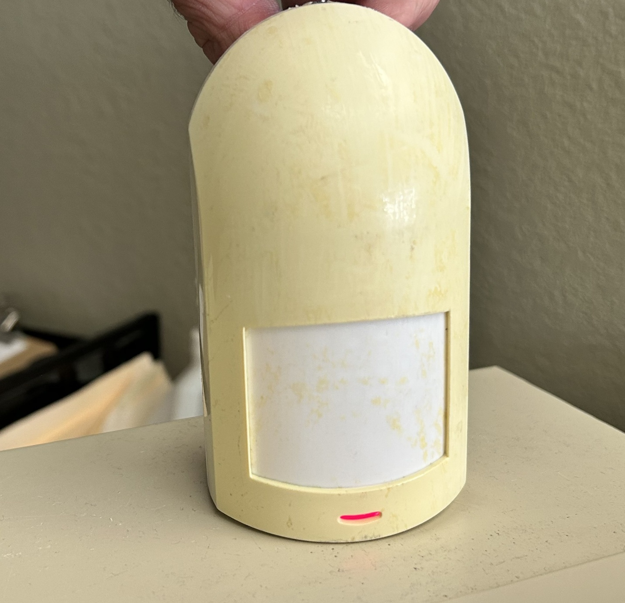

Motion Sensor overhead with 360-degree view
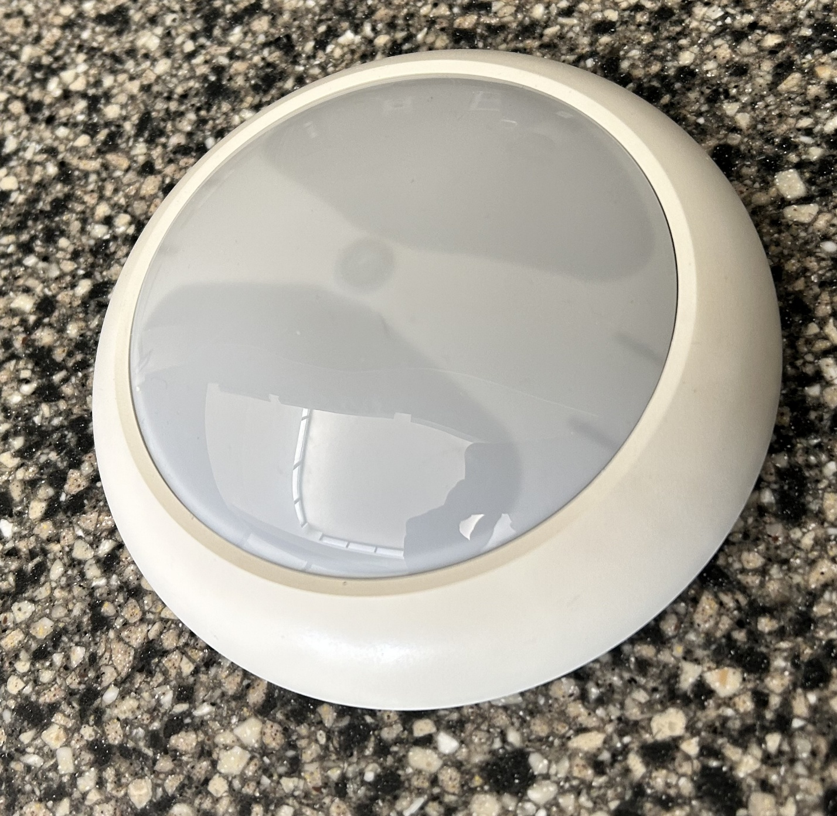

RDAC Panel 8 Zone with modem
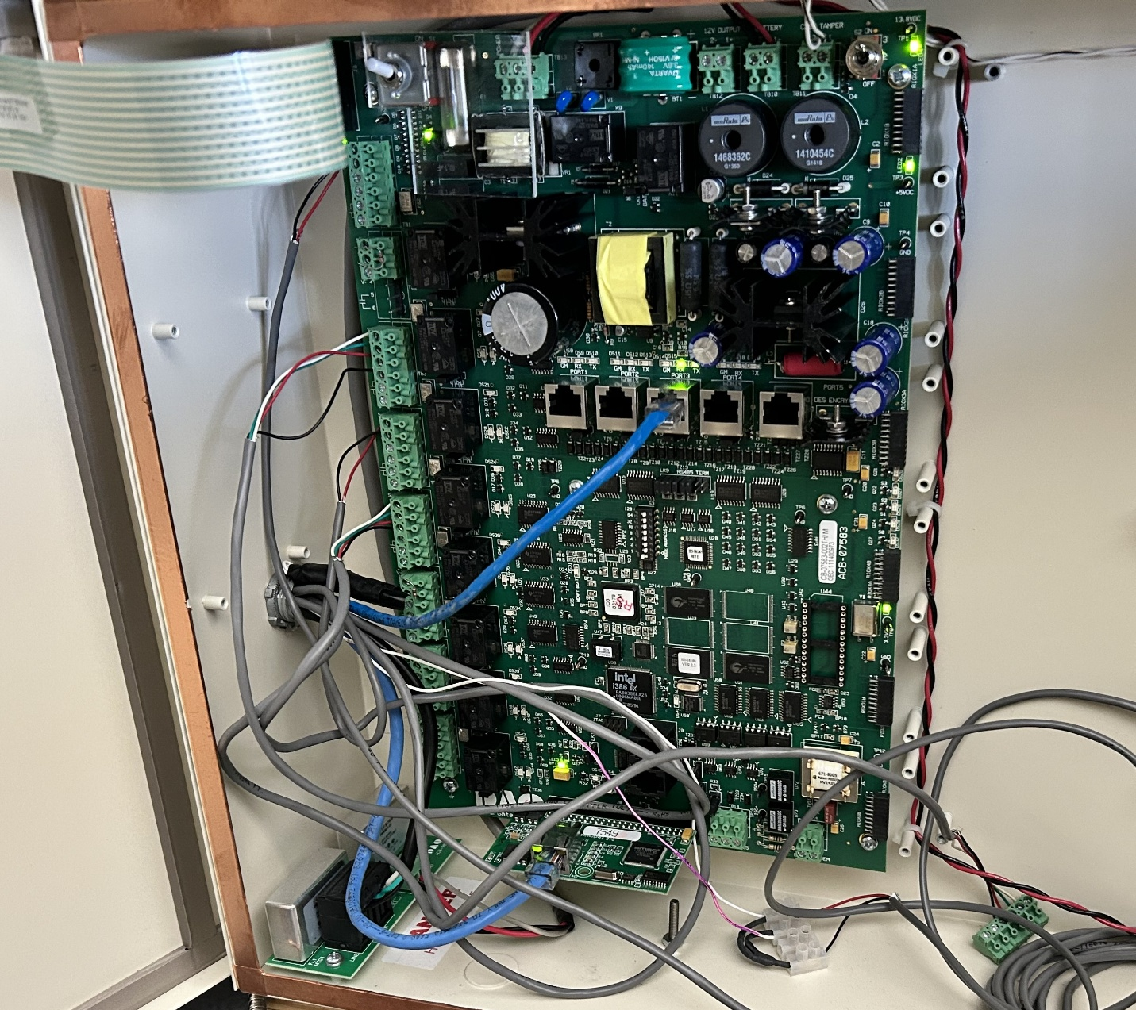

Zone Box with key pad
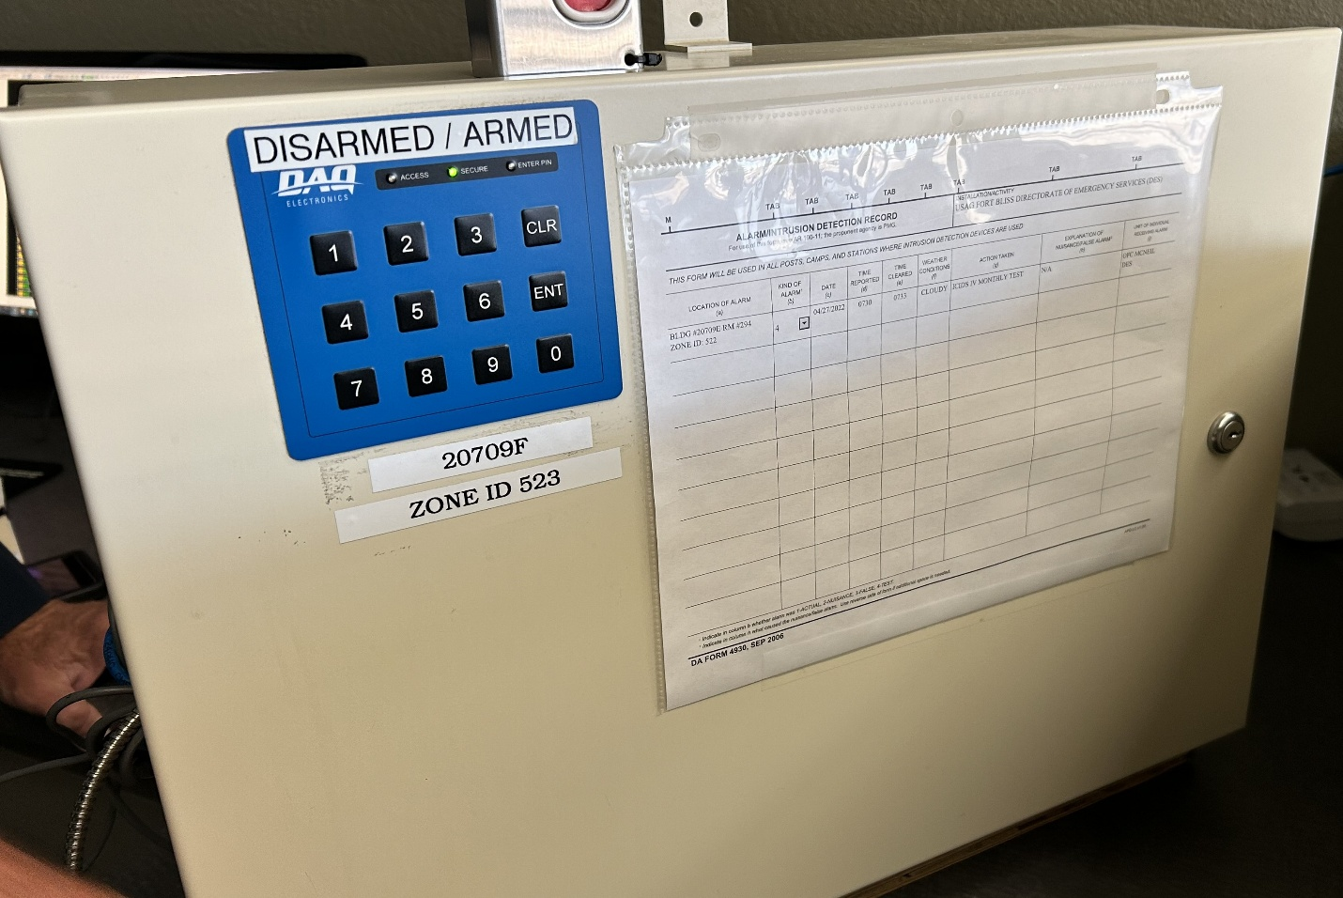

Balance Magnetic Switch for all doors

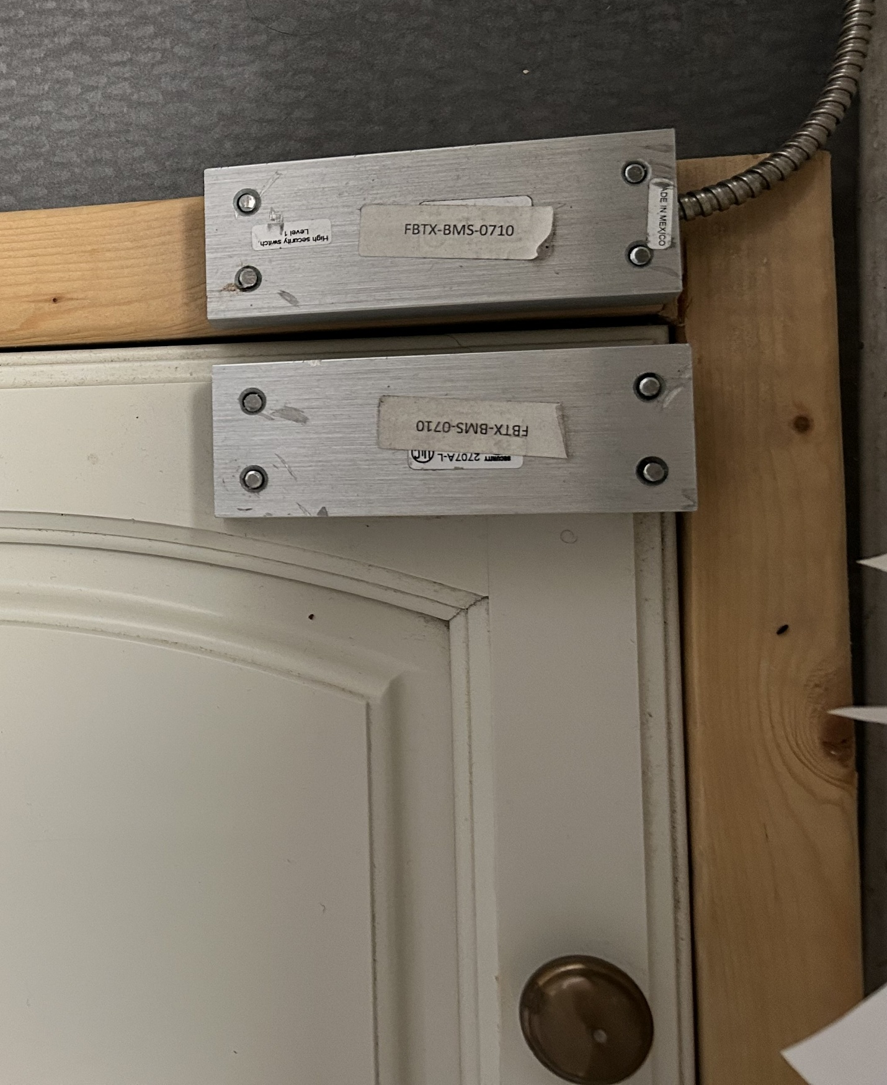

Duress Button

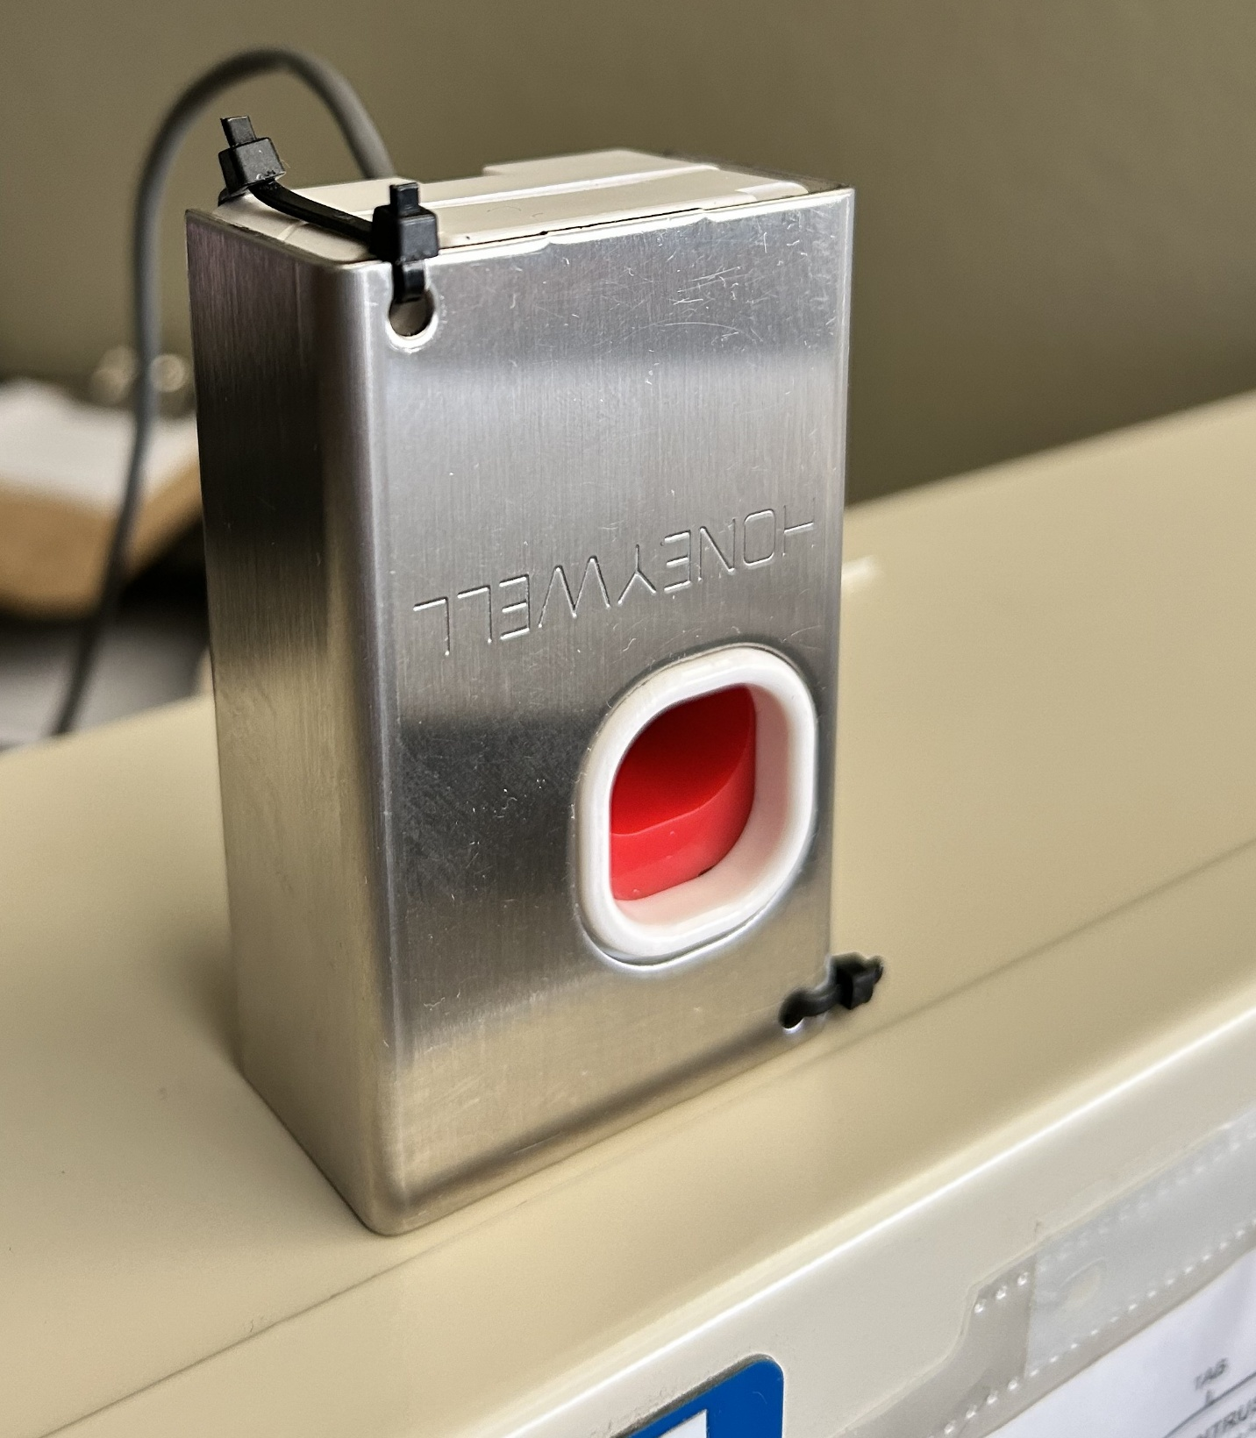

Encryption Device

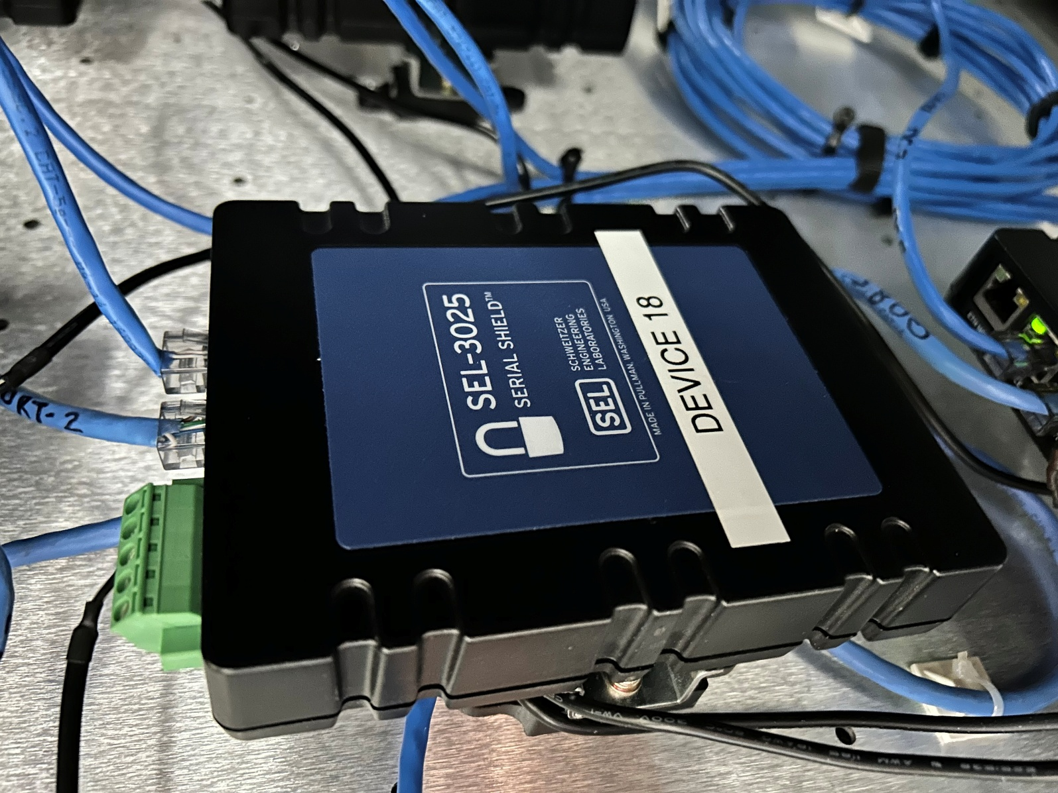

Appendix B Government Responsibilities vs Contractor Responsibilities
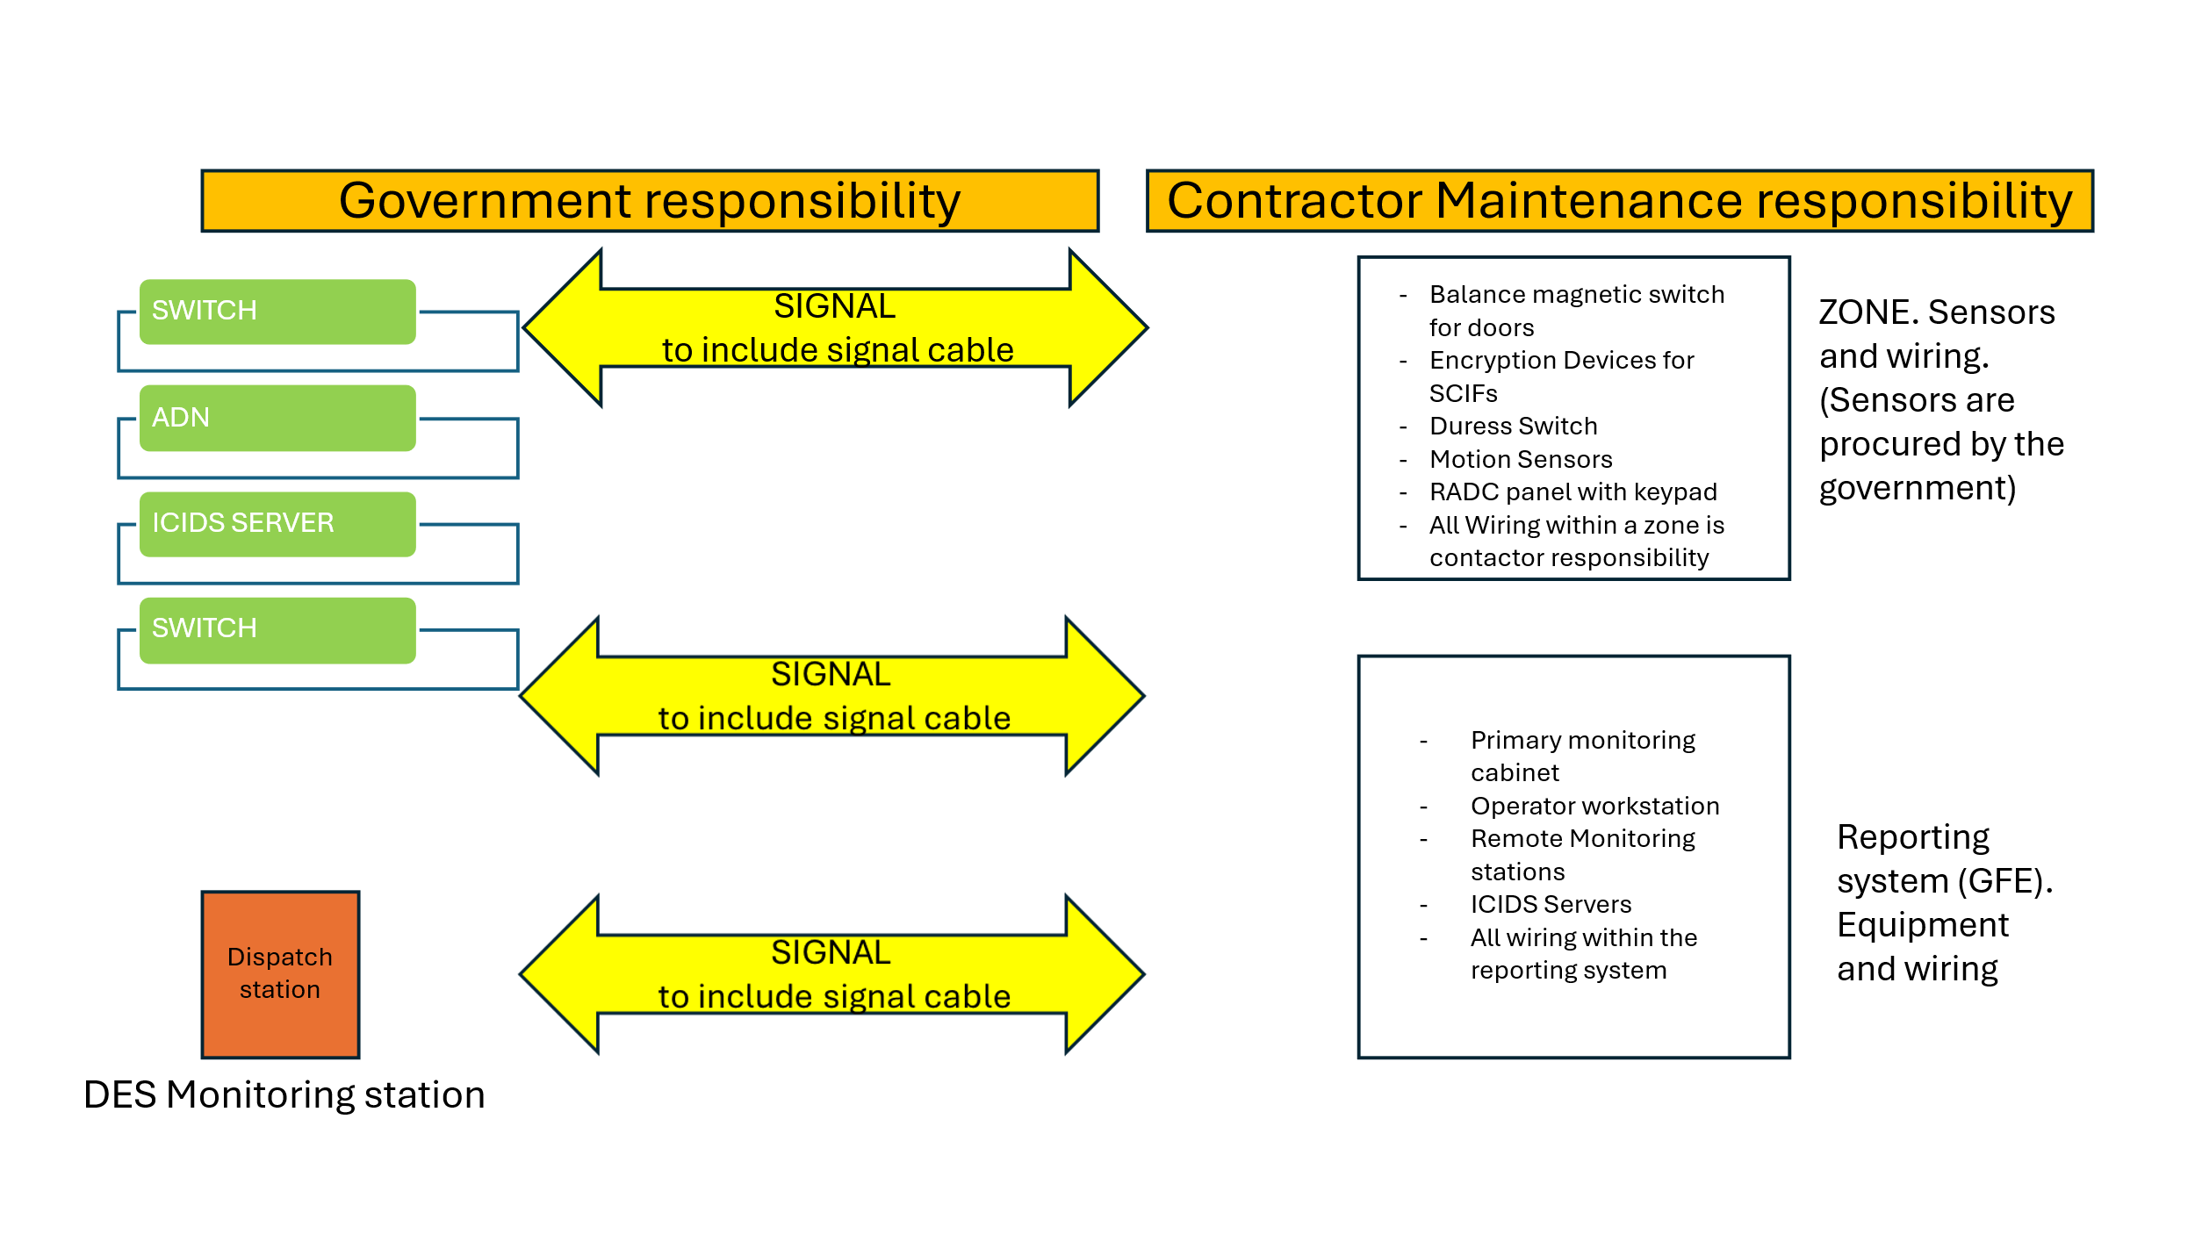

Appendix C Government Furnished Facility

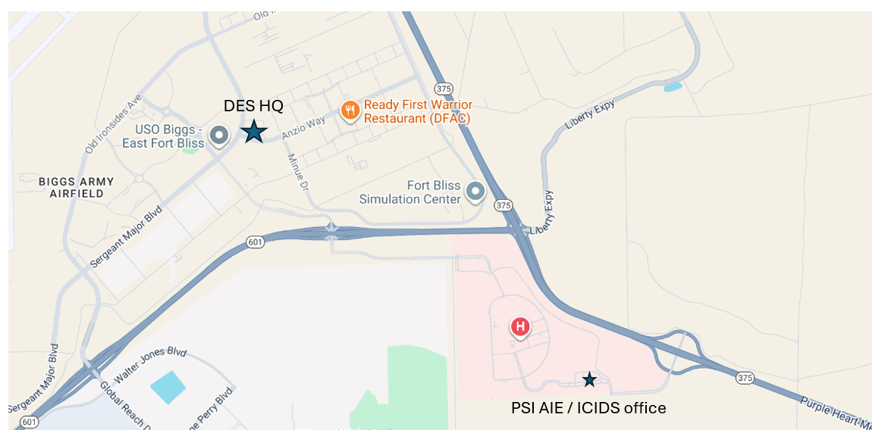
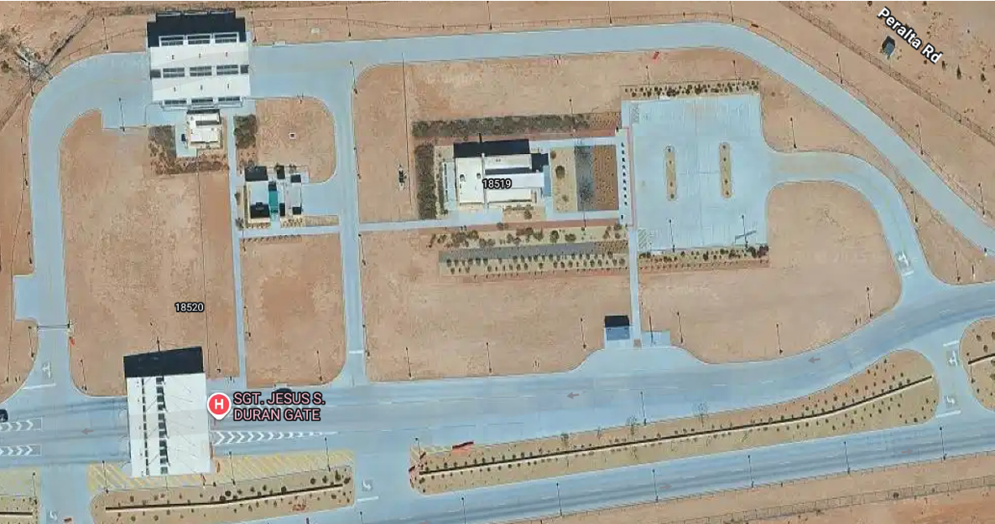

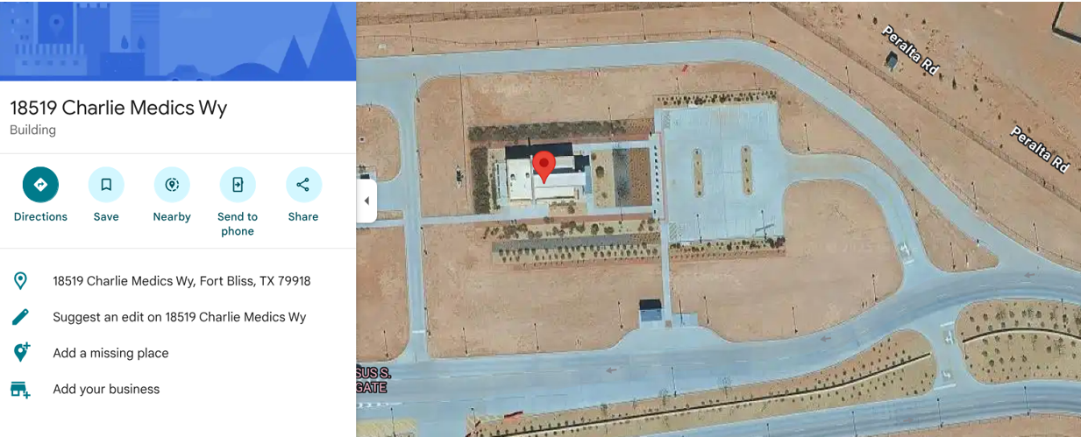

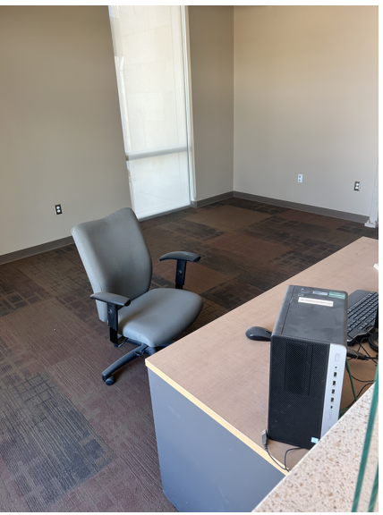

Appendix D ICIDS Government furnished monitoring equipment
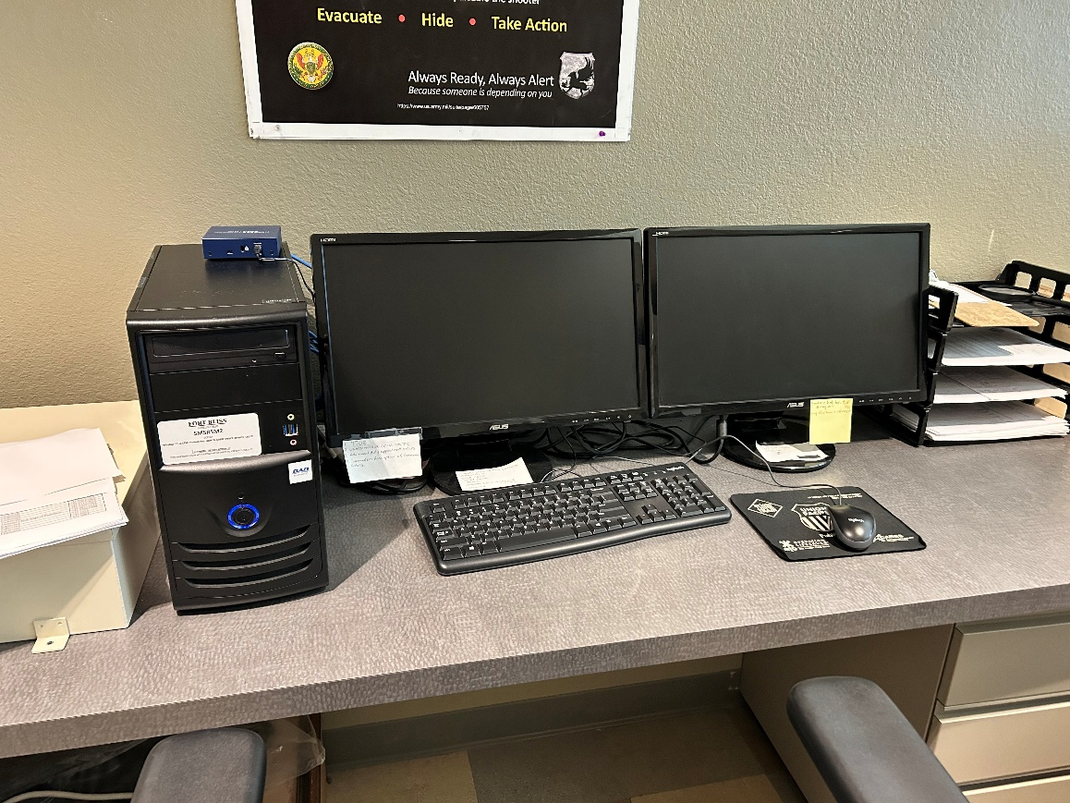
Front Desk monitoring station 1
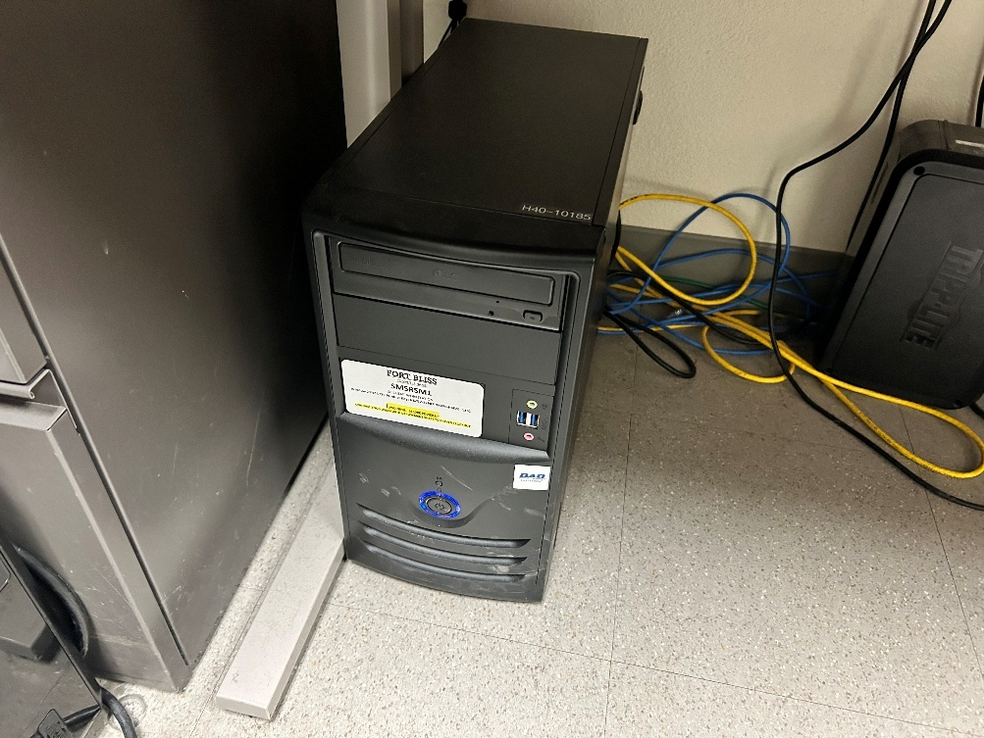
PSI office monitoring station 2

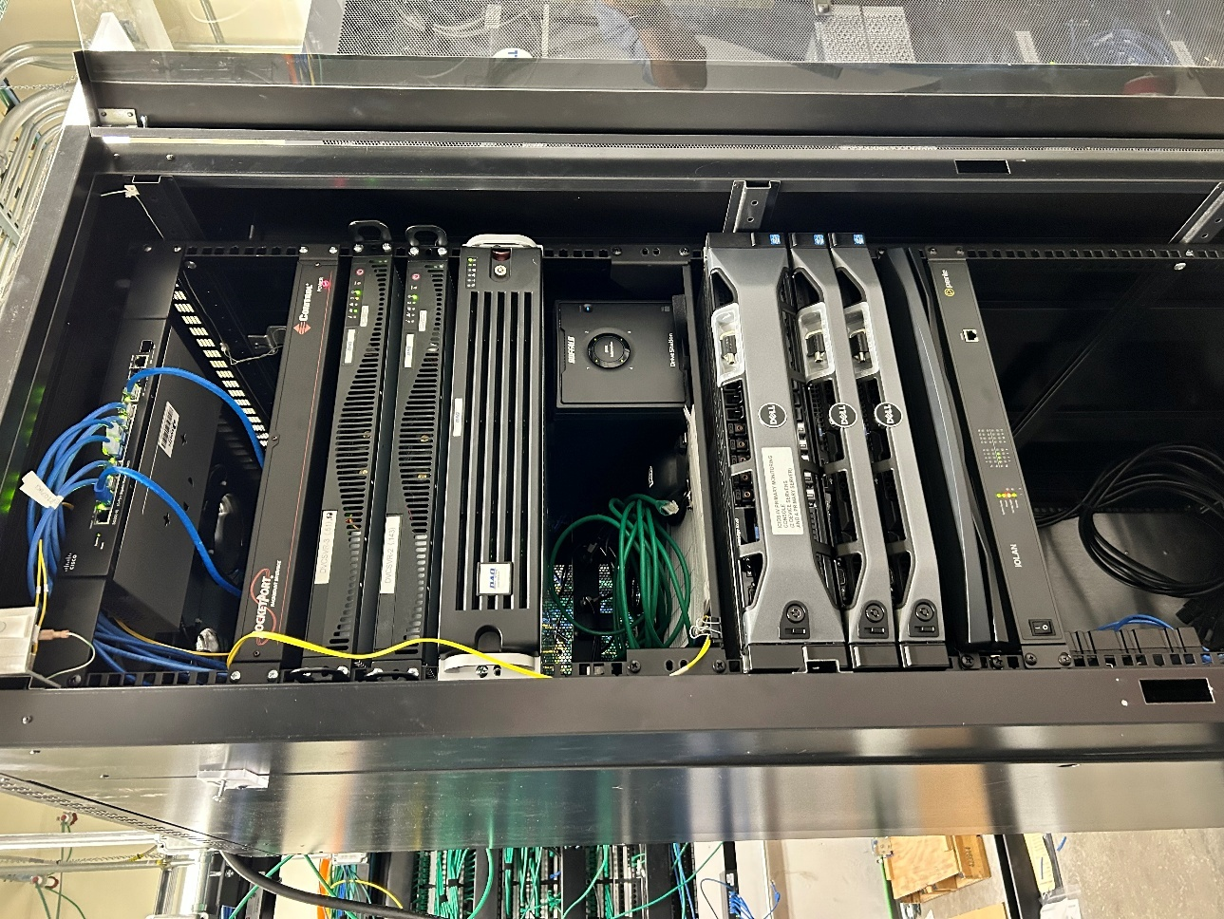
ICIDS Server stack, DVRS, and monitoring station 3
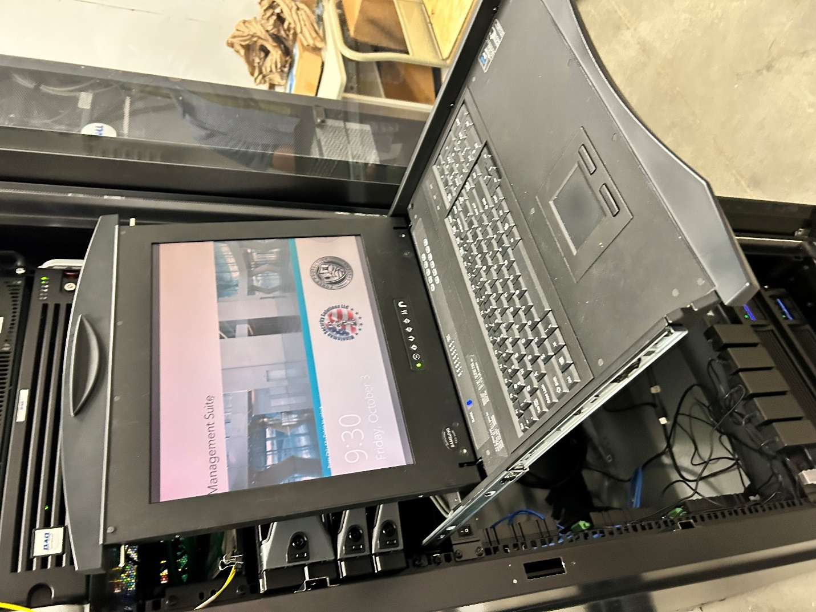
ICIDS monitoring station 3 computer

