SUBJECT* | LICSENSE PLATE RECOGINTION SYSTEM and SUBSCRIPTION

GENERAL INFORMATION
CONTRACTING OFFICE’S ZIP CODE* | 90815
SOLICITATION NUMBER* | 36C26226Q0523
RESPONSE DATE/TIME/ZONE | 03-31-2026 10:00 AM PACIFIC TIME, LOS ANGELES, USA
ARCHIVE | 60 DAYS AFTER THE RESPONSE DATE
RECOVERY ACT FUNDS | N
SET-ASIDE
PRODUCT SERVICE CODE* | 5836
NAICS CODE* | 561621
CONTRACTING OFFICE ADDRESS | Department of Veterans Affairs  Network Contracting Office 22  4811 Airport Plaza Drive  Suite 600  Long Beach CA 90815
POINT OF CONTACT* | Contract Specialist  Choo, Sam  sam.choo@va.gov  sam.choo@va.gov

PLACE OF PERFORMANCE
ADDRESS | Department of Veterans Affairs
 | VA Long Beach Healthcare System
 | 5901 E 7th St
 | Long Beach CA
POSTAL CODE | 90822
COUNTRY | USA

ADDITIONAL INFORMATION
AGENCY’S URL
URL DESCRIPTION
AGENCY CONTACT’S EMAIL ADDRESS
EMAIL DESCRIPTION

DESCRIPTION
THIS REQUEST FOR INFORMATION (RFI) / SOURCES SOUGHT NOTICE ISSUED SOLELY FOR INFORMATION AND PLANNING PURPOSES. THIS IS NOT A SOLICITATION.
SUBMISSION OF INFORMATION ABOUT PRICING, DELIVERY, THE MARKET, AND CAPABILITIES IS HIGHLY ENCOURAGED AND ALLOWED UNDER THIS RFI FOR PLANNING PURPOSES IN ACCORDANCE WITH (IAW) FAR 15.201(e).

DISCLAIMER

This RFI is issued solely for information and planning purposes and does not constitute a solicitation. All information received in response to this RFI that is marked as proprietary will be handled accordingly. IAW FAR 15.201(e), responses to this notice are not offers and cannot be accepted by the Government to form a binding contract. Responders are solely responsible for all expenses associated with responding to this RFI.

SOURCES SOUGHT/RFI DESCRIPTION

This is NOT a solicitation announcement. This is a Sources Sought Notice / RFI only. The purpose of this Sources Sought Notice / RFI is to gain information about potential qualified sources and their size classification relative to NAICS 561621 (Size standard of $25.0 MM) or
541519 (Information Technology Value Added Resellers, Size standard of 150 employees). Responses to this Sources Sought Notice / RFI will be used by the Government to make appropriate acquisition decisions. After review of the responses to this Sources Sought Notice / RFI, further RFIs and/or a solicitation or other announcements may be published.

SCOPE OF WORK
VA is looking to acquire base plus four option year subscriptions of Flock Safety’s Flock OS (License Plate Recognition Platform) with law enforcement grade - infrastructure free license plate recognition cameras including professional installation and integration or Equal.
- Term of Service

  - Contractor must be eligible to provide support service for up to five years (base + four option years) on all installed equipment.
  - For the duration of the contract, the vendor must possess and uphold current certifications and licenses to continue providing hardware and software services.

- Salient Characteristics

  - Platform/System/Software
    - Software/platform must be managed by vendor through its own server and cloud.
    - Must be able to Identify vehicles by make, color, decals, transforming footage into actionable evidence even without plate number information.
    - Must have the ability to Respond faster with automated alerts for NCIC, NCMEC, or custom Hot List vehicles via SMS, email, and app notifications.
    - Must provide unlimited user access to the system.
    - Must have Interagency operability with all of the participating agencies listed below to use real-time data integration and sharing through partner agencies' current systems to detect and locate vehicles that might be connected to criminal activity.
Partnering law enforcement agencies and cities agencies in Los Angeles, Orange County, San Bernadino, Riverside, and San Diego Counties
San Bernardino County Sheriff’s Department
Long Beach Police Department
California State University Long Beach Police
Los Angeles County Sheriff’s Department
Cal State at San Bernardino
Costa Mesa Police Department
Orange County Sheaff’s Department
Chaffey College Police Department
Santa Ana Police Department
Placentia Police Department
Los Angeles Police Department
Whitter/Santa Fe Springs Police
Colton Police Department
Fontana Police Department
Redlands Police Department
Rialto Police Department
Ontario Police Department
Riverside County Sheriff’s Department
Calimesa Police Department
Canyon Lake Police Department
Coachella Police Department
Eastvale Police Department
Indian Wells Police Department
Jurupa Valley Police Department
La Quinta Police Department
Lake Elsinore Police Department
Moreno Valley Police Department
Norco Police Department
Palm Desert Police Department
Perris Police Department
Rancho Mirage Police Department
San Jacinto Police Department
Temecula Police Department
Wildomar Police Department
Mt. San Jacinto College Police Department
Riverside County Regional Medical Center Sheriff station
City of Grand Terrace
City of Chino Hills
City of Calimesa
City of Canyon Lake
City of Eastvale
City of Jurupa Valley
City of La Quinta
City of Lake Elsinore
City of Moreno Valley
City of Norco
City of Palm Desert
City of Perris
City of Rancho Mirage
City of San Jacinto
City of Temecula
City of Wildomar
San Diego Police Department
El Cajon Police Department
Chula Vista Police Department
Coronado Police Department
Loma Linda VA Healthcare System

  - Camera & Monitoring System
    - Must be capable of covering up to two lanes.
    - Must be capable of reading/capture plate information of vehicles moving between 0-60 MPH from 40 to 70 feet away.
    - Must be solar powered and connected via LTE or faster network capability, so they can be installed almost anywhere with minimal infrastructure requirements.
    - Must have the resolution to capture vehicle characteristics (Color, Make, Model, Plate #, etc.) identifiable images and videos of the vehicles entering and exiting parking facilities day, and night.

  - Installation
    - Must be installed by licensed and certified technicians.
    - Must present a complete installation plan, and have it approved by the Chief of Police, prior to initiating the installation.
Installation must be done on the utility and camera poles that are currently in place and indicated in Yellow on the map below.
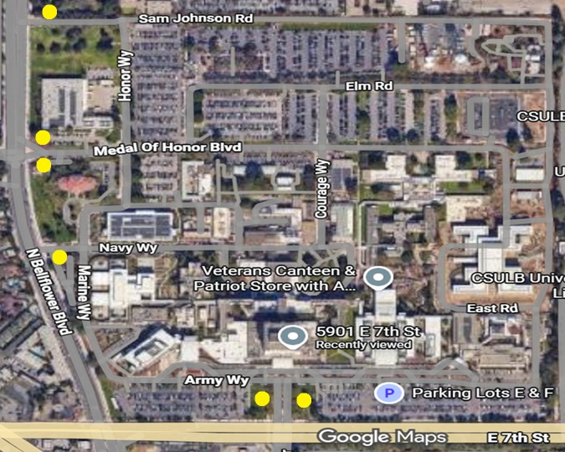
If your company is interested and capable of providing the required supplies/services, you MUST provide the information indicated below OR your intent, interest to participation, and information provided will not be considered as valid for research purposes. Response to this notice should include company name, address, point of contact, size of business pursuant to the following questions:
(1) Submit your capabilities statement illustrating how your organization can/cannot meet the list of DRAFT/SALIENT CHARACTERISTICS/SOW requirements. For instances where your company cannot meet the DRAFT/SALIENT CHARACTERISTICS/SOW requirement(s), please explain. For instances where your company can meet the DRAFT/SALIENT CHARACTERISTICS/SOW requirement(s), please show how your company meets/exceeds each requirement.
(2) Please review the list of DRAFT/SALIENT CHARACTERISTICS/SOW requirements and provide any additional feedback or suggestions. If none, please reply as N/A.
(3) Please indicate the size status and representations of your business, such as but not limited to: Service-Disabled Veteran-Owned Small Business (SDVOSB), Veteran-Owned Small Business (VOSB), HUBZone, Woman Owned Small Business (WOSB), Large Business, etc.
(4) Is your company considered small under the NAICS code identified in this RFI?
(5) Are you the manufacturer, authorized distributor, and/or can your company provide a solution to the required supplies/services described in the list of DRAFT/SALIENT CHARACTERISTICS/SOW?
(6) If you are a large business, do you have any designated/authorized distributors? If so, please provide their company name, telephone, point of contact and size status (if available).
(7) If you’re a small business and you are an authorized distributor/reseller for the items identified above, do you alter; assemble; modify; the items requested in any way? If you do, state how and what is altered; assembled; modified.
(8) Limitations on Subcontracting: How does your business ensure compliance with the limitations on subcontracting as outlined in 13 CFR § 125.6?
(9) Are the items you are identifying/providing considered Commercial of the Shelf (COTS) items as defined in FAR Part 2.101 under commercial items?
(10) Non-Manufacturer Rule: If applicable, can you confirm your business complies with the Non-Manufacturer rule? Specifically, does your company: Provide a product from a small business manufacturer or processor? Not exceed 500 employees? Primarily engage in the retail or wholesale trade and normally sell the type of item being supplied? Take ownership or possession of the item(s) with its personnel, equipment or facilities in a manner consistent with industry practice?
(11) Please indicate whether your product conforms to the requirements of the Buy American Act? Please indicate if manufacturer is/will be US domestic Small Business / US Domestic Large Business / Foreign.
(12) What is your lead time to deliver a single unit with all components? Is there scale in lead time with greater quantities? Please elaborate.
(13) What is estimated life span of your solution? What support/services does that entail?
(14) Does your organization offer a leasing solution? Please elaborate.
(15) Does your company have a Federal Supply Schedule (FSS) GSA/NAC/SAC/BPA/NASA SEWP or any other Federal Government contract? If so, please provide the contract number(s).
(16) If you are an FSS GSA/NAC/SAC/BPA/NASA SEWP or any other Federal Government contract holder, are all the items/solutions you are providing information about available on your schedule/contract? Please state if all or some items are available on the contract.
(17) General pricing of your products/solution is encouraged. Pricing will be used for the purpose of market research only. It will not be used to evaluate for any type of award.
(18) Please provide your SAM.gov Unique Entity ID/Cage Code number.
Responses to this notice shall be submitted via email to sam.choo@va.gov. Telephone responses will not be accepted. Responses must be received no later than Tuesday, March 31, 2026 by 10:00 AM PST.
All responses to this Sources Sought/RFI will be used for planning purposes only. Responses to this Sources Sought Notice / RFI are not considered a request to be added to a prospective bidders list or to receive a copy of the solicitation. If further RFIs and/or a solicitation or other announcement is issued as a result of the information provided from this RFI, all interested parties must respond to the specific posting separately IAW the specifications of that announcement.

See attached document: 36C26226Q0523 - LPR System and Subscription.

