SUBJECT* | Equip PM&R Services - Olympus Fluoview 4000 Confocal Laser Scanning System

GENERAL INFORMATION
CONTRACTING OFFICE’S ZIP CODE* | 15215-1802
SOLICITATION NUMBER* | 36C24E26Q0039
RESPONSE DATE/TIME/ZONE | 05-14-2026 12:00 PM EASTERN TIME, NEW YORK, USA
ARCHIVE | 5 DAYS AFTER THE RESPONSE DATE
RECOVERY ACT FUNDS | N
PRODUCT SERVICE CODE* | J066
NAICS CODE* | 811210
CONTRACTING OFFICE ADDRESS | Veterans Health Administration  Regional Procurement Office East  Building 32 Suite 1A1111  1010 Delafield Road  Pittsburgh PA 15215-1802
POINT OF CONTACT* | Contract Specialist  Mae McGarry  mae.mcgarry@va.gov  412-822-3757

ADDITIONAL INFORMATION
AGENCY’S URL
URL DESCRIPTION
AGENCY CONTACT’S EMAIL ADDRESS
EMAIL DESCRIPTION

DESCRIPTION
NOTICE OF INTENT TO SOLE SOURCE:
IAW FAR 5.101 this notice is to advise the public that The Department of Veterans Affairs RPO-E R&D, intends to award a sole source Firm Fixed Price Contract IAW RFO 12.201-1 to EVIDENT SCIENTIFIC MIS, INC. (SAM UEI U4QDZVJQFC14) for services to provide one preventative maintenance service visit per year. Period of performance is a base of one-year and four one-year options.
THIS NOTICE OF INTENT IS NOT A REQUEST FOR COMPETITIVE PROPOSALS or QUOTATIONS.
Responsible sources may identify their interest by submitting capability information that clearly demonstrates the capability to perform the required work IAW the SOW (attached).
Capability information is required by 12:00 PM (EST) May 14th, 2026 to establish the ability of the source to meet this requirement.
A determination by the Government not to compete this proposed contract based upon responses to this notice is solely within the discretion of the Government.
Information received will be considered solely for the purpose of determining whether to conduct competitive procurement.
The Government will not be responsible for any costs associated with the preparation of responses to this notification.
All inquiries and submittals must be sent via email to Mae McGarry, Contract Specialist mae.mcgarry@va.gov. Telephone inquiries will not be accepted.

Statement of WORK

- GENERAL GUIDANCE:

Title: Olympus Fluoview 4000 Confocal Laser Scanning System Maintenance and Support Service Contract at VA Pittsburgh Healthcare System (VAPHS).

Scope of Work: The contractor shall provide maintenance and repair services for government owned research equipment by the requirements stated herein.

Location:
VA Pittsburgh Healthcare System (VAPHS)
Research Office Building B30
4100 Aliquippa Street
Pittsburgh, PA 15219

Background: This contract is issued to ensure the continuous reliability of the research equipment and auxiliary equipment identified in this Statement of Work (SOW). The system requires repair and maintenance services by trained personnel using manufacturer approved parts and specifications. The reliable and accurate operation of this equipment at all times is considered critical to the research program of the VA

Period of Performance:
Year 1: 06/01/2026 – 05/31/2027
Year 2: 06/01/2027 – 05/31/2028
Year 3: 06/01/2028 – 05/31/2029
Year 4: 06/01/2029 – 05/31/2030

Type of Contract: Firm Fixed Price (FFP).

- GENERAL REQUIREMENTS/ DELIVERABLES:

The contractor shall provide Preventive and Corrective Maintenance services for government owned research equipment by the requirements stated herein.

B.1. Equipment to be Serviced

The following item is to be serviced in accordance with the specifications, terms, and conditions of this contract:
- Olympus Fluoview 4000 Confocal Laser Scanning System (Serial No: 4J90012).

B.2. Scope of Work

This agreement includes the following:

1. Preventative Maintenance
- The contractor shall perform system optimization with one (1) preventive maintenance (PM) service “on-site” visit per Term year. The PM service shall be provided during the fourth quarter of the Term year and must be schedule at least one week in advance to minimize the impact to scheduling. Any exceptions to the PM schedule shall be arranged and approved in advance by the Technical POC and provided in writing to the COR/CO.
- The PM service visit will include the following:
- Laser Scanning System:
- Performance check of scanning unit, laser power and alignment, laser collimating, beam expander, and pupil lens.
- Ancillary Microscope:
    - Optical lenses cleaning:
    - Lubrication of mechanical parts and accessories
    - Optical and mechanical alignment as needed.
- The Contractor shall provide a service report documenting conditions, procedures followed, performance verification of equipment, and tests and/or evaluation results obtained to the POC at the completion of the PM service.
- Travel and labor necessary for PM shall be provided by the contractor at no additional customer cost.
- The Contractor shall provide minor software updates, as available, during scheduled PM services. Minor software updates may include bug fixes, security patches, performance enhancements, and minor interface modifications.

- Corrective Maintenance

- The contractor shall provide on-site repair services, including labor and travel, as well as certain parts as required.
- The Contractor shall provide technical support via telephone and email. This support includes responding to inquiries regarding basic system operation, application use, and software functionality.
- Covered parts under this contract include the following:
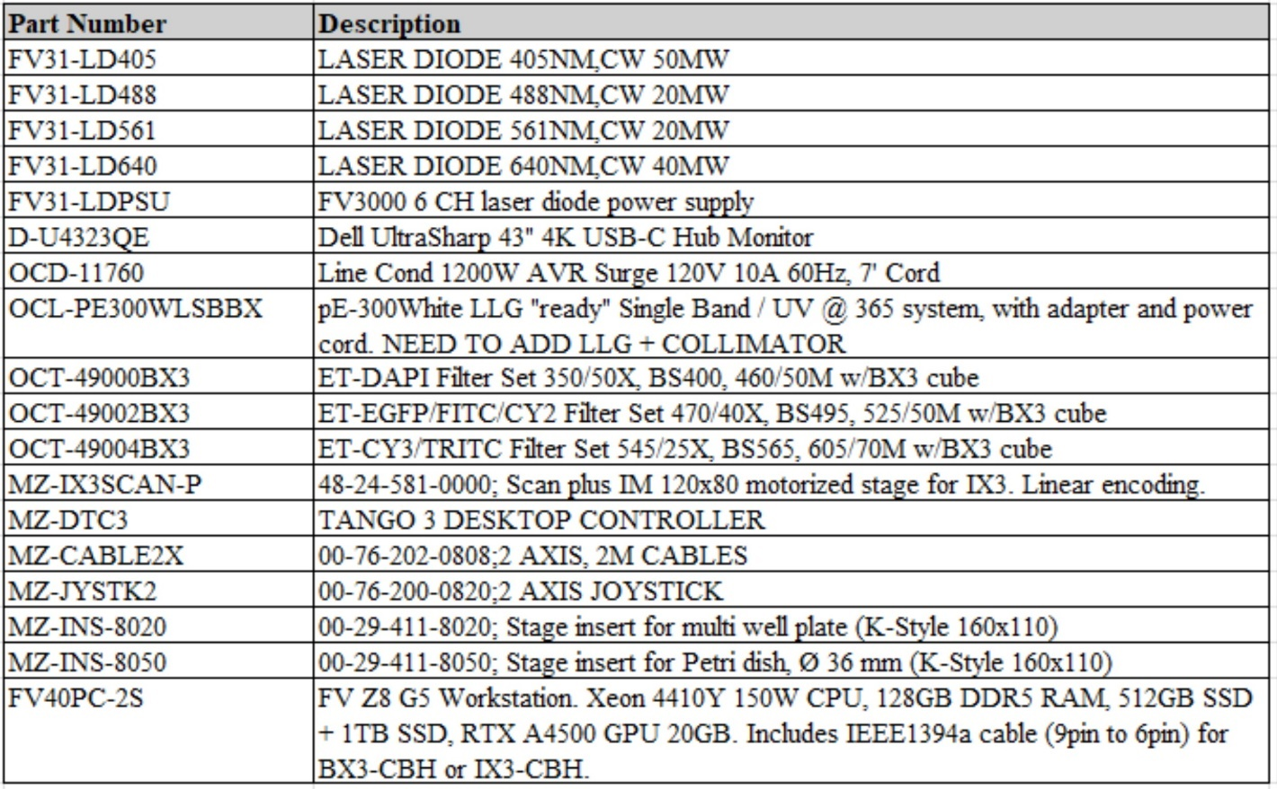

B.3. Service Contract Limitations

This agreement excludes the following:
- Major upgrade of software programs (changes that introduce new features, substantial improvements, or major redesigns to the system. They often alter how the software functions or is used and may require users to adapt or relearn certain aspects.
- Any Product which has been disassembled, repaired, tampered with, altered, changed, or modified by persons other than Evident's own authorized service personnel.
- Defects or damage to the Products resulting from wear, tear, misuse, negligence, sand, liquids, impact, improper storage, non-performance of scheduled operator and maintenance items, custom hardware integration not performed by Evident or an Evident authorized service provider, or use of non-Evident brand accessories, consumables, or supplies.
- Operating supplies or consumables, including immersion oil, lens paper, and lint-free swabs.
- The following product:

B.4. Changes to Statement of Work

Any changes to this SOW shall be authorized and approved only though written correspondence via formal modification issued by the CO and approved in writing by the contractor.

B.6. Information Security
- The contractor will not have access to VA sensitive information or to the VA network under this contract. The service to be performed does not involve storage, generating, transmitting, or exchanging of VA sensitive information.
- The Certification and Accreditation (C&A) requirements do not apply to this contract, and the Security Accreditation Package is not required.

- OTHER REQUIREMENTS:

C.1. Service Hours
- The contractor will provide all required “on-site” services within the normal business hours (8:00 AM to 5:00 PM (EST) M-F), excluding holidays. Work performed outside the normal hours of coverage must be pre-approved by the Technical POC. Contractors must be escorted at all times while on VA premises.

C.2. Identification and Parking

- The contractor's Field Service Engineer (FSE) shall wear visible identification at all times while on the premises of VAPHS. Identification shall include, as a minimum, the employee’s name, position, and the contractor’s trade name.
- It is the responsibility of the contractor to park in the appropriate designated parking areas. Information on parking is available from the VA Police-Security Service. VAPHS will not invalidate or make reimbursement for parking violations of the contractor under any conditions.

C.3. Documentation/Reports

The documentation will include equipment down time and detailed descriptions of the scheduled
and unscheduled maintenance procedures performed, including replaced parts and prices (for
outside normal working hour services) required to maintain the equipment in accordance with
conformance standards. Such documentation shall meet the guidelines as set forth in the
Conformance Standards. In addition, each ESR must at a minimum document the following data
legibly and in complete detail:
- Name of Contractor
- Name of FSE who performed services.
- Date, Time (starting and ending), Hours-On-Site for service call.
- Description of Problem Reported by the Technical POC/User.
- Identification of Equipment to be serviced to include the following: Equipment ID #
or EE# from the bar-code, Manufacturer's Name, Device Name, Model#, Serial #, and
any other Manufacturer's identification numbers.
- Itemized Description of Service(s) Performed (including costs associated with after
normal working hour services), including: Labor and Travel, Parts (with part numbers)
and Materials and Circuit Location of problem/corrective action.
- Signatures from the following:
a. FSE performing services described.
b. VA Employee who witnessed service described.
- Equipment downtime calculated.

