SUBJECT* | REPLACING 2 BARRIER RESISTANT DOORS FOR MENTAL HEALKTH PATIENTS ROOMS

GENERAL INFORMATION
CONTRACTING OFFICE’S ZIP CODE* | 24153
SOLICITATION NUMBER* | 36C24626Q0564
RESPONSE DATE/TIME/ZONE | 05-07-2026 3:00PM EASTERN TIME, NEW YORK, USA
ARCHIVE | 30 DAYS AFTER THE RESPONSE DATE
RECOVERY ACT FUNDS | N
SET-ASIDE
PRODUCT SERVICE CODE* | 5670
NAICS CODE* | 332321
CONTRACTING OFFICE ADDRESS | Department of Veterans Affairs  Network Contracting Office 6  1970 Roanoke Blvd  Salem VA 24153
POINT OF CONTACT* | Jake Puckett  jake.puckett@va.gov  Jake.Puckett@va.gov

PLACE OF PERFORMANCE
ADDRESS | Fayetteville VAMC
 | 2300 Ramsey ST
 | Fayetteville NC
POSTAL CODE | 28301
COUNTRY | USA

ADDITIONAL INFORMATION
AGENCY’S URL | https://va.gov
URL DESCRIPTION | va.gov
AGENCY CONTACT’S EMAIL ADDRESS | jake.puckett@va.gov
EMAIL DESCRIPTION | va.gov

DESCRIPTION
The Department of Veterans Affairs, Network Contracting Office (NCO) 6 on behalf of the Fayetteville VAMC is conducting Market Research through this sources sought notice to help determine the availability of qualified Businesses capable of providing two (2) replacement doors for mental health patients’ rooms:
- The contractor shall furnish labor, parts, supplies and equipment necessary to provide and install new 2 Acrovyn Barrier Resistant Doors.
- The contractor is required to conduct a site visit to gain a complete understanding of the work and requirements that need to be accomplished.
- Services should be performed in accordance with terms and conditions in this statement of work and be in compliance with all manufacturers’ technical specifications.
- The estimate dimensions of the existing door: (Width: 43-1/2” Height: 83-1/4” Thickness: 1-3/4”)
Key Door Requirements for Behavioral Health
- Ligature Resistance: All hardware, including handles, hinges, and closures, must be designed to minimize ligature points.
- Anti-Barricade/Access: Doors often feature double-swing hinges or emergency release stops, allowing them to swing outward into the hallway even if they normally swing inward, enabling staff to overcome barricades.
- Safety Features: Use of concealed hinges, continuous gear hinges.
- Monitoring & Security: Doors usually include door-top sensors that alert staff to self-harm attempts.
- Door Types: Options include "door within a door" (wicket) allowing a smaller portion of the door to open for emergency access.
- Material: Doors are typically constructed from high-strength materials like fully welded, hollow metal steel frames.
Compliance and Standards
- NFPA 101-2012: Provides standards on door-locking arrangements in psychiatric units.
- Joint Commission:
  - Requires compliance with 2021 Behavioral Health standards, including specific requirements for door gaps (not exceeding 1/8 inch) and undercuts (not exceeding 1 inch) to ensure security and smoke resistance.
- UL (Underwriters Laboratories) Standards: UL 10C for fire door assemblies, ensuring fire resistance and integrity.
- NFPA (National Fire Protection Association): NFPA 80 for fire door assemblies and opening protectives.
- ANSI (American National Standards Institute): ANSI/UL 263 for fire resistance testing.
- ASTM (American Society for Testing and Materials): Standards related to material performance, such as ASTM E119 for fire testing.
- ISO Standards: ISO 300-2007 for fire resistance of building elements, depending on project requirements.
- Local Building Codes: Compliance with local and national building codes, which may specify performance and safety standards.

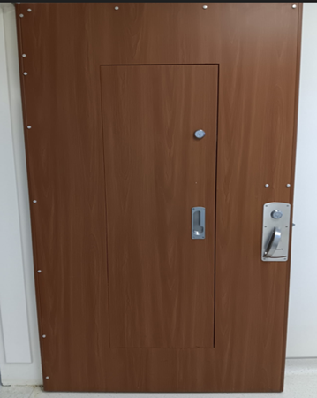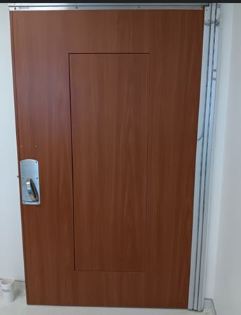

All respondents shall indicate/provide the following:
- Whether or not they are small business manufacturers of the products they wish to offer, or if they are a reseller of a small business manufacturer.
- Is your company interested in providing a Federal Supply Schedule (FSS) quote or Open Market (indicate FSS contract #)?
- Whether or not your company has an active SAM registration and the companies Unique Entity Identifier.
- A copy of its capabilities statement.
Failure to provide the above information may result in the potential offeror being considered incapable of meeting the VA’s needs.
If the contractor can provide the above items, the contractor shall provide a letter from the manufacturer stating they are an authorized distributor/licenser of their products. Failure to submit an authorized distributor letter shall result in the product(s) potentially offered to be considered “grey market” and shall not be considered capable of meeting the VA’s needs.
The capability statements received from this market research are for planning purposes only and will assist the Government in planning its acquisition strategy. This is strictly market research, and the Government will not entertain questions concerning this market research. The Government will not assume any costs incurred by the contractor in the preparation of responses. All responses shall be submitted in writing no later than May 7th, at 3:00PM EST to the attention of: jake.puckett@va.gov
All responses shall be submitted as: Sources Sought 36C24626Q0564: Fayetteville VAMC Replacement Doors for Mental Health Patient Rooms.

