STATEMENT OF WORK FOR RADIOPHARMACEUTICAL ISOTOPES FOR THE IOWA CITY VA HEALTH CARE
SYSTEM

    - GENERAL
      - Services Provided: The Contractor shall provide Radiopharmaceutical Isotopes in accordance with the specifications contained herein and in accordance with all applicable laws, regulations, directives, and policies for the
        - Department of Veterans Affairs
Iowa City VA Health Care System (VAHCS), 601 HWY 6 West
Iowa City, Iowa 52246
      - Place of Performance:
        - Department of Veterans Affairs
Iowa City VA Health Care System (VAHCS), 601 HWY 6 west
Iowa City, Iowa 52246

      - Radiopharmaceutical products will be used at the Iowa City VA Healthcare System, Nuclear Medicine Imaging Service. The Iowa City VA Healthcare System Nuclear Medicine Department is not USP Chapter 797 certified for Radiopharmaceutical products and as such, cannot make kits. All orders shall be delivered in Unit Dose (UD) amounts only. Required products may be in inhalable, ingestible or injectable as indicated in the Price/Cost Schedule.
      - The listed quantity in the Price/Cost Schedule is an estimated maximum. This number was derived from prior contract orders. Actual quantities are contingent upon patient volume and required procedures.
      - The Iowa City VA Healthcare System Nuclear Medicine Department will not require access to any contractor/vendor-owned software, i.e., Hot Lab Management software.
    - QUALIFICATIONS
      - Contractor and any/all sub-contractors shall be licensed by the Nuclear Regulatory Commission and be regularly established in the business of providing radiopharmaceuticals. The contractor shall furnish a copy of its radiopharmaceutical license prior to contract performance and upon any renewal to the Iowa City VA Healthcare System.

      - Personnel assigned by the contractor to prepare and provide the products covered by this contract shall be licensed in a State, Territory or Commonwealth of the United States or the District of Columbia. The qualifications of such personnel shall also be subject to review by the Iowa City VA Healthcare System Chief of Staff and approval by the Iowa City VA Healthcare System Facility Director.
      - Contractor shall be compliant with U.S. Nuclear Regulatory Commission (NRC) Information Notice 92-72, Employee Training and Shipper Registration Requirements for Transporting Radioactive Materials. https://www.nrc.gov/reading-rm/doc-collections/gen- comm/info-notices/1992/in92072.html. Contractor shall provide proof of training annually for all contract employees performing delivery services to the Iowa City VA Healthcare System under contract and remain current with training requirements throughout contract periods.
      - Hazardous Waste/Waste Regulation. The Contractor will comply with all applicable requirements of Federal, State and local hazardous waste regulations.
      - The Government reserves the right to refuse acceptance of any Contractor personnel at any time after performance begins, if personal or professional conduct jeopardizes patient care or interferes with the regular and ordinary operation of the facility. Breaches of conduct include intoxication or debilitation resulting from drug use, theft, patient abuse, dereliction or negligence in performing directed tasks, or other conduct resulting in formal complaints by patient or other staff members to designated Government representatives. Standards for conduct shall mirror those prescribed by current federal personnel regulations. Should the VA COS or designee show documented problems or continual unprofessional behavior/actions with any Contractor employee(s), she/he may request, without cause, immediate replacement of said Contractor employee(s). The CO and COR shall deal with issues raised concerning Contractor employee(s) conduct. The final arbiter on questions of acceptability is the CO.
    - CONTRACTOR REPSPONSIBILITIES
      - The Contractor is responsible for providing the requested radiopharmaceuticals at the requested time.
        - If the ordered radiopharmaceuticals are not available and cannot be delivered to the VA when needed, the contractor will notify the VA Nuclear Medicine Department and obtain the needed doses from another source, including another nuclear pharmacy, to be delivered as close to the requested time in-order-to provide timely care to VA patients.
        - The contractor will provide all radiopharmaceuticals in single dose containers as specified. The cost of each radiopharmaceutical will be calculated on a per vial, per syringe, or a per millicurie amount as indicated in contract pricing.
    - IDENTIFICATION OF CONTRACT PERSONNEL
      - The Government will NOT issue a Government identification badge for contract

personnel. Should this requirement change after contract award, the contractor will be given thirty (30) days to obtain a VA-issued identification badge for each contract employee physically entering the Iowa City VA Healthcare System.
      - Contract employees, such as delivery personnel, shall wear a Contractor-issued identification badge that includes employee name and contractor name.
    - PRODUCT DELIVERY
      - Contractor will meet all requirements of regulatory agencies for shipment of radioactive isotope between facilities and will strictly adhere to these requirements. Shipments not properly handled according to regulations will not be accepted at the Iowa City VA Healthcare System.
      - All shipping containers shall be free of radioactive contamination both, inside and outside
      - Contractor shall provide up to three (3) deliveries per day as required.
      - Orders will be placed at least one day prior to requirement for those pre-scheduled (90% of patients). For patients not pre-scheduled (approximately 10% of patients), orders will be phoned in the same day as testing material is required.
      - Delivery times and dates will be provided when the order is placed.
        - Shipments “called when needed” may be requested during regular work hours and must be delivered within one-hour prior of the dose calibration time. The contractor shall notify the Iowa City VA Healthcare System when a delivery will be delayed.
        - Emergency and/or STAT deliveries may be made on an as needed basis, 365 days a year, and must be delivered within (1) hour. The contractor shall notify the Iowa City VA Healthcare System when a delivery will be delayed.
      - Delivery of products is CRITICAL due to STAT diagnostic imaging requirements. Delays beyond one (1) hour may cause delayed treatment, irreversible bodily damage, and/or death.
      - Delivery Address: 601 Hwy 6 West, Iowa City, Iowa, Nuclear Medicine Department, Building 1, Rm 2w-40.
    - PRODUCT QUALITY
      - The quantity of radioactivity for supplied radiopharmaceuticals will not deviate more than
+10% at the time of calibration from the quantities specified.
      - Contractor will perform all quality control procedures on each radiopharmaceutical according to applicable requirements of licensing authorities and other regulating bodies. A copy of the results of the quality control procedures must be made available to the Iowa City VA Healthcare System upon request.

      - In the event a quality control or material defect is suspected and/or detected the Contractor will be requested to provide consultation necessary to alleviate any said suspicion and/or defect by the following:
        - Provide technical expertise in calibration;
        - Provide professional examination of product; submit results and recommendations to the Contacting Officer;
        - Make expedient replacement of any product suspected of being deficient
      - Contractor shall make quality control records available to the Iowa City VA Healthcare System upon written request from the Contracting Officer.
    - SPECIFIC REQUIREMENTS
      - Quantities expressed in the schedule are estimates based on historical usage over a five year period. Quantities may vary based on patient demand and the type/number of procedures.
      - Contractor shall provide any additional technical support deemed necessary for the technical staff, physicians, and patient education.
      - Any recalled dose for any reason shall be credited to the service for the full amount.
      - All individual doses shall be traceable to the original elution if requested by the service as per pharmacy standards and regulations.
      - Any dose deemed below standard by the facility shall be credited toward the account (e.g. unacceptable thyroid, stomach, kidney, or tissue uptake). This shall be determined by the facility RSO and Authorized User.
      - Substitutions or Generic Brands may only be used with the express written permission of the Iowa City VA Healthcare System facility.
      - Contractor will be responsible for all costs for any radiopharmaceuticals and nonradioactive items contracted for if the Iowa City VA Healthcare System must find an alternate supplier for contracted items.
      - In the event of a manufacturer or pharmacy recall, quality assurance failure, and/or industry shortage, the contractor will notify the Iowa City VA Healthcare System within 24 hours.
      - A radiopharmacist in the employment of the contractor must be available to:
        - Set up the quality assurance program on radiopharmaceutical preparations required by FDA, NRC, CAP, USP, and the Joint Commission.
        - Act as a reference source concerning questions on regulation of radiopharmaceuticals.

        - Provide reference services for research drugs and radionuclides under research protocols.
        - Provide instruction (continuing education) to technologists on new changes in radiopharmaceutical products and availability.
    - QUALITY ASSURANCE SURVEILLANCE PLAN (QASP):
      - Contract performance will be monitored for performance of services according to the following criteria, with the incentive/disincentive being past performance ratings:
        - Accuracy of delivered order: all daily deliveries should match order placed.
        - Timeliness of deliveries: all daily deliveries should arrive according to statements above.
        - Compliance of shipping containers: all containers will be secured and labeled according to NRC and DOT regulations.
        - Radiation safety review: package surveys and wipes for removable contamination will meet NRC and DOT guidelines.
        - Communication of industry issues: industry shortages or product recalls will be communicated within 24 hours.
        - NRC License
        - Courier Training Certification
* Note – any mention of a trade name is for reference only. If you are proposing a clinical or-equal, be sure to provide adequate evidence that your proposed item meets or exceeds the capabilities of the one listed.

PRICE/COST SCHEDULE
*All Quantities are estimates and that the VA is only obligated to the extent of the guaranteed minimum.
*Below period of performance is an estimate dependent upon date of award. IDIQ will consist of a base period plus four ordering periods.
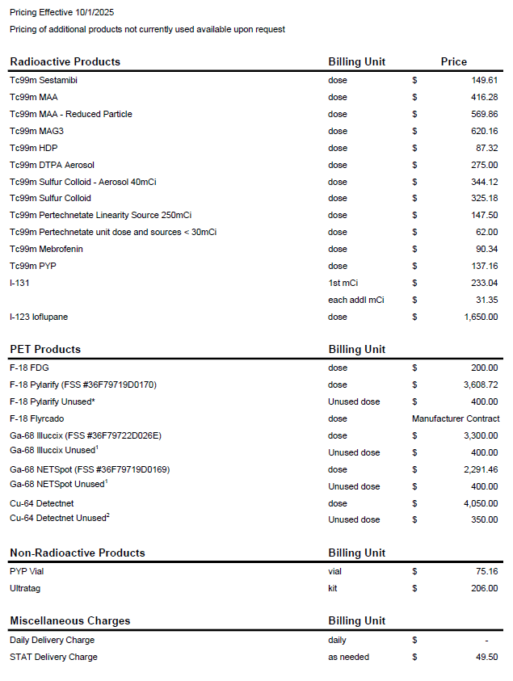

CONTRACT CEILING LIMITS
The Department of Veterans Affairs has set the ceiling limitation for this IDIQ at $XXXX for the lifetime of this contract. The total of all orders placed against this IDIQ will not exceed this ceiling of
$XXXXX.

