A market survey is being conducted to determine if there are a reasonable number of interested small business concerns to set this future project aside for them. If your firm is a Small Business, certified HUBZone, 8A, Woman-Owned Small Business or Service-Disabled Veteran Owned Small Business and you are interested in this project please respond appropriately.

Project Location: Joint Base McGuire Dix Lakehurst (JBMDL), New Jersey

Project Description: This project is a Design-Build for Military Repair Army Reserves restoration of 21,644 SF Area Maintenance Support Activity (AMSA). Project is intended to repair the existing facility to include bay space, storage space, locker room space, breakroom/ classroom space, latrines, and administrative support areas. Project to include, but not limited to, removal and replacement of roof, windows, doors, plumbing, electrical, mechanical, and telecom systems. Project will include some utility relocation and new connections. Utilities include but not limited to electric, data, sewer, water, and telephone. Project to include rehabilitation of Military Equipment Parking (MEP) which may be mill and overlay or full depth replacement.

Contract duration is estimated at 1095 calendar days. The estimated cost range is between $10,000,000 and $25,000,000. NAICS code is 236220. All interested Small Businesses, certified HUBZONE, 8A, Woman-Owned Small Business or Service-Disabled Veteran Owned Small Business contractors should respond to this survey via email by Thursday, 16 April 2026, by 3:00 PM Eastern Time.

If interested in subcontracting opportunities rather than performing as the prime contractor on this future procurement, please identify the feature(s) of work you are interested in and your small business socio-economic category. Complete Item 4 below for the feature(s) of work you are interested.

Responses should include:

- Identification and verification of the company’s small business status.
- Contractor’s Unique Entity Identifier (UEI) and CAGE Code(s).
- Documentation from the firm’s bonding company showing current single and aggregate performance and payment bond limits.
- Provide descriptions of your firm’s past experience with no more than three (3) projects with greater than 90% construction complete or those projects completed within the last five (5) years which are similar to this project in size and scope. Provide documentation demonstrating experience for construction of similar type buildings and managing multiple sub-contractors. Provide documentation demonstrating experience working on similar type projects. Demonstrate experience including at least 15% self-performance of the construction. Each project must include the name, title, project role, e-mail address, and telephone number of at least one reference. References may be used to verify project size, scope, dollar value, percentages and quality of performance.

- Projects similar in Scope to this project include: Renovation of industrial, maintenance or automotive repair facilities with shallow and deep foundations systems. Demonstrating experience with cast in place concrete, masonry structures, structural steel, earthwork, underground utilities, asphalt pavement, concrete pavement, and roof replacement.

- Projects similar in size to this project include: Renovation projects approximately 15,000 square feet or greater.

- Based on definitions above, for each project submitted include:
- Current percentage of construction complete and the date when it was or will be completed.
- Size of the project
- Scope of the project
- The dollar value of the construction contract
- The percentage of work that was self-performed as project and/or construction management services or physical construction type work.
- Whether the project was design build or design/bid/build
- Identify the number of subcontractors by construction trade utilized for each project.

- Small Businesses are reminded under FAR 52.219-14, Limitations on Subcontracting; they must perform at least 15% of the cost of the contract, not including the cost of materials, with the firm’s own employees for general construction-type procurement. Include the percentage of work that will be self-performed on this project, and how it will be accomplished.

Submission Requirement: The only authorized transmission method of responses is via filling out the survey form. No other transmission method will be accepted. Please limit your capability statement to the space provided within the form. The Market Survey Form can be accessed at https://forms.osi.apps.mil/r/0UBkUDAmjR or via the QR Code provided below and as an attachment in SAM.gov.

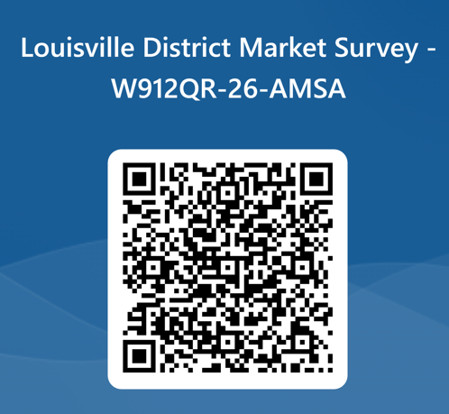

Questions can be emailed to Laura Phillips-Payne at Laura.Phillips-Payne@usace.army.mil NLT 09 April 2026. This is NOT a Request for Proposal and does not constitute any commitment by the Government. Responses to this sources sought notice will be used by the Government to make appropriate acquisition decisions. All interested sources must respond to future solicitation announcements separately for responses to this market survey.

NOTICE: The following information is provided for situational awareness and is not required to respond to this Sources Sought.

All contractors must be registered in the System for Award Management (www.SAM.gov) prior to award of a contract. All proposed contractors are highly encouraged to review FAR Clause 52.232-33 Payments by Electronic Funds Transfer – System for Award Management, which indicates “All payments by the Government under this contract shall be made by electronic funds transfer (EFT).” Those not currently registered can obtain registration by going to the website http://www.SAM.gov. The process can usually be completed from 24 to 48 hours after submission. Contractors will need to obtain a Unique Entity Identifier (formerly DUNS number) for processing their registration. If you do not already have a Unique Entity Identifier, one can be obtained from http://www.SAM.gov. Refer to www.SAM.gov for information formerly found in CCR, EPLS, ORCA and FedReg.

Please begin the registration process immediately in order to avoid delay of the contract award should your firm be selected.

ALERT: You must submit a notarized letter appointing the authorized Entity Administrator before your registration will be activated. This requirement now applies to both new and existing entities. Effective 29 April 2018, the notarized letter process is now mandatory on all CURRENT registrants at SAM who have a requirement to update data on their SAM record. The notarized letter is mandatory and is required before the GSA Federal Service Desk (FSD) will activate the entity's registration.

Effective 29 June 2018, vendors creating or updating their registration can have their registration activated prior to the approval of the required notarized letter. However, the signed copy of the notarized letter must be sent to the GSA Federal Service Desk (FSD) within 30 days of activation or the vendor risks no longer being active in SAM.

Vendors can check whether an account is active by performing a query by their CAGE or Unique Entity Identifier (known as DUNS). The new registration process may now take several weeks, so vendors are highly encouraged to begin registering as soon as possible to avoid any possible delays in future contract awards. Remember, there is no cost to use SAM.
To find out additional information about the changes of the SAM registration process, contractors should visit the Frequently Asked Questions (FAQ) link located at the top of the SAM homepage (www.sam.gov).

