Naval Surface Warfare Center, Panama City Division
INDUSTRY DAY 2026

The Naval Surface Warfare Center, Panama City Division (NSWC PCD) is sponsoring its 2026 Industry Day on Wednesday, 18 February 2026, 0900-1200 CST. The use of Microsoft Teams shall not be construed as a Government endorsement of the product.

The mission of NSWC, Panama City Division is to conduct research, development, test and evaluation, and in-service support of mine warfare systems, mines, naval special warfare systems, diving and life support systems, amphibious and expeditionary maneuver warfare systems, and other missions that occur primarily in coastal (littoral) regions, and execute other responsibilities as assigned by Commander, Naval Surface Warfare Center.

What is Industry Day? Industry Day is an opportunity for the Command to showcase our mission areas while highlighting current and future contracting requirements to our Industry partners that play a critical role in wartime readiness.

Why is hosting this event significant? NSWC PCD’s Department Heads will discuss current and future projects. The intent is for an expanded Industrial awareness that will lead to greater competition and innovative technical solutions at reasonable prices.

Who are the Presenters? Industry Day is supported throughout all levels of the Command to include NSWC PCD Commanding Office; Technical Director; Deputy Technical Director; Chief of Contracting Office, Technical Department Heads; Technology Transfer Director; and Deputy of Small Business.

Industry Day briefings and discussions will be Distribution A. The Industry Day briefings and presentations will be posted to Seaport NxG and SAM.gov once the event concludes. The link for Microsoft Teams Industry Day is provided below.

https://dod.teams.microsoft.us/l/meetup-join/19%3adod%3ameeting_e5917a625100499fb95c0d0b3942b470%40thread.v2/0?context=%7B%22Tid%22%3A%22e3333e00-c877-4b87-b6ad-45e942de1750%22%2C%22Oid%22%3A%2209cc7eb6-7c87-46f2-b761-cc42c8f6fe02%22%2C%22IsBroadcastMeeting%22%3Atrue%2C%22role%22%3A%22a%22%7D&btype=a&role=a

Due to the large number of attendees, NSWC PCD will not be able to address latency, audio or other technical issues (if any) during this event.

The Government will not pay for the information obtained during the Industry Day or for the time and expense of the industry participants involved.

Presentation availability: After the Industry Day event has concluded, all presentations will be posted to SeaPort NxG and SAM.gov via amendments to the announcements.

Join the NSWC PCD Industry Day Live Event

As an attendee of a live event in Teams, you can watch live event and participate in the moderated Q&A.

Open the live event link (above) to join the event.

If you have the Teams desktop or mobile app, clicking the link will launch your app but you will have to join the event as a guest. Do not sign into your MS Teams account.

If you do not have the Teams app, you can join the meeting by selecting “Watch on the web instead” as shown below and join anonymously. If you're attending the live event on the web, use a media-source extension (MSE)-enabled web browser like Chrome, Firefox, or Microsoft Edge.

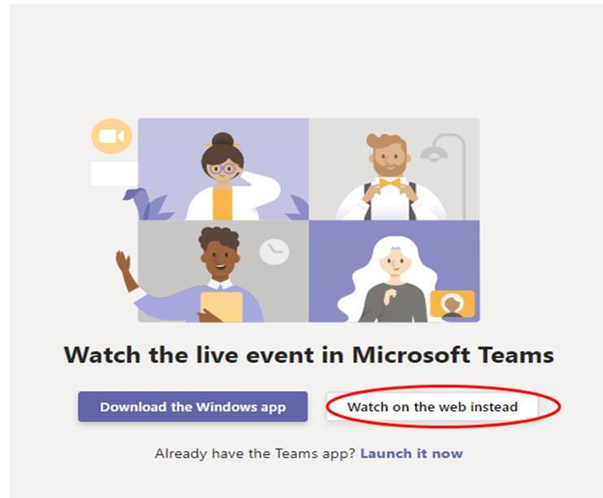

Note: Use your operating system sound settings to choose your speaker for the live event.

If the live event has not started, you will see the message: "The live event has not yet started."

Participating in Q&A

You can interact with producers and presenters through Q&A. To ask a question: 1. Select Q&A on the right side of the screen. 2. Type your question in the compose box, and then select Send.

Use Live Captions and Subtitles

To turn on live captions and subtitles, select Captions/Subtitles on in your video controls.

Any reference to or use of a specific product or service for the Industry Day Live Event, does not constitute or imply an endorsement by the United States Government of the product, service, or its provider.

