083-8.4 All parts ordered under this Contract shall be individually preserved and packaged in accordance with ASTM D 3951, ASTM D3951-10, and MIL-STD-2073-1E. All parts under this contract shall also have appropriate markings in accordance with MIL-STD-129P and MIL-STD-130N. When applicable, specific OEM preservation, packaging, packing, and marking requirements directing a higher standard than referenced shall be adhered to. Bar coding is required in accordance with MIL-STD-129P paragraph 5.1.10.1/page 73 Linear (Code 39) bar code symbology, linear (Code 39) symbols shall be in accordance with ISO/IEC 16388, and ISO/IEC 16388. The barcode is to only contain the stock number provided by the Coast Guard. Marking shall be placed on the container top or one long side (any side if container is square).

The marking for all vessel installation kits shall be formatted as specified below with each data field populated according Attachment 1-Pricing Schedule and/or Contracting Officer Letter:

Stock Number:
Noun:
Part Number:
Contract/Delivery Order Number:

SFLC INVENTORY
PURPOSE CODE “C”
CONDITION CODE "B"
Quantity:
Unit of issue:
Due in number:

********************************************************************
The marking for all spare parts shall be formatted as specified below with each data field populated according to Attachment 1-Pricing Schedule and/or Contracting Officer Letter:

Stock Number:
Noun:
Part Number:
Contract/Delivery Order Number:

SFLC INVENTORY
CONDITION CODE "A"
Quantity:
Unit of issue:
Due in number:

********************************************************************

- Background
  - The USCG, C5I Service Center Portsmouth is preparing to stock provisioned parts at the U.S. Coast Guard Surface Forces Logistics Center Inventory Control Point (ICP) for effective support of boats no longer under warranty.

- Requirements

  - Delivery Location:

    - Deliver all components from the first delivery order in accordance with this contract to:

USCG, C5I Service Center Portsmouth
Attn: (COMPL)
4000 Coast Guard Blvd
Portsmouth, VA 23703

    - Deliver all vessel install kits and inventory spare parts from subsequent delivery orders in accordance with this contract to:

USCG, Surface Forces Logistics Center
2401 Hawkins Point Road
Receiving Bldg 88
Baltimore, MD 21226

  - Included Attachment 1 is the list of required items including the quantity, Part Nomenclature, NSN, Part Number, CAGE, Unit of Issue for all items, and destination.

  - Preservation
    - Exposed shafting and working machined surfaces, gear-trains, the inside of gearboxes, and other surfaces dependent on lubricant for preservation shall be lubricated or coated with an appropriate preservative suitable for protection of equipment stowed in a non-climate controlled warehouse for up to one year. Preservatives shall be compatible with the intended working lubricants. Special treatments should not be necessary to remove preservatives.
    - Piping systems and the inside of individual components shall not be exposed to contaminants during shipment. All piping interface points shall be sealed with commercial grade plastic or metallic caps, plastic or metallic plugs, mating blanked covers, or with blank flanges attached with bolts. Plastic bags and duct tape are not acceptable.
    - Warning tags shall be attached to all gearboxes indicating that they have been drained, preserved with a specific product, and require filling with lubricant before equipment use.
    - Major components shall be shrink-wrapped or otherwise covered and sealed to prevent water damage. To prevent adhesion between protective coverings and painted surfaces, protective coverings shall not be applied until the paint has cured.
    - Documents and other enclosures shall be sealed in a waterproof plastic bag, which shall be permanently affixed to the inside of the shipping container in a conspicuous location when the container is opened.
  - Packaging, handling, shipping, and transportation procedures shall be in accordance with ASTM D3951-98 (Reapproved 2004) Standard Practice for Commercial Packaging. If commercial practices cannot adequately protect and preserve the equipment, the contractor shall package, handle, ship and transport equipment in accordance with MIL-STD-2073-1E Standard Practice for Military Packaging dated May 23, 2008.
    - Each Part shall be packaged separately, or in its designated unit of issue.
    - All parts shall be identified and accounted for by their NSN or ACN on the packing list.
    - Large parts shall be shrink-wrapped or otherwise covered and sealed to prevent water damage. Small parts shall be enclosed in clear plastic packaging.
    - Multiple identical parts may be repackaged in designated quantity units (box lot, case lot, pair, etc) for shipping purposes. The packaging shall be identified by the words MULTI-PACK and the quantity per package.
    - Documents and other enclosures shall be sealed in a waterproof plastic bag, which shall be permanently affixed to the inside of the shipping container in a conspicuous location. The last line of the package label shall contain the words "DOCUMENTS ENCLOSED"
    - Where Pull Test Certificates or other required certifications are attached directly to the Part, (versus loose and enclosed), the last line of the package label shall contain the words "CERTIFICATION ATTACHED."
  - PARTS - CONTAINERS: Parts shall be packed in containers meeting ASTM D 3951 and the requirements herein.
    - Containers with special packing I unpacking instructions shall be stenciled "CAUTION - THIS ITEM MAY BE SERIOUSLY DAMAGED UNLESS UNPACKING INSTRUCTIONS ARE FOLLOWED CAREFULLY.” followed by a notation of the location of instructions.
    - General items:
      - General components weighing less than 70 lbs may be packaged in commercial reinforced cardboard packaging, or its equivalent, or packaged in a skid mounted shipping container. If packaged in a skid mounted shipping container then containers shall be completely enclosed and structurally suitable for stacking at least 2-high. The containers shall be suitable for inside covered stowage. Containers shall be assembled with screws to permit ease of removal of the cover or lid from the base.
      - Reinforced cardboard packaging shall be sealed, but shall be suitable for being opened (without total packaging destruction) for inspection, resealing and subsequent shipment to the fleet.
      - The reinforced cardboard packaging shall be completely enclosed and suitable for stacking. The packaging shall be suitable for long-term inside storage in a warehouse.
    - Small items:
      - Small items which can fit into express carrier standard packaging (maximum 17.5 in x 12.5 in x 3 in box. or 38 x 6 x 6 x 6 triangular tube) for shipment with appropriate cushioning may be sealed in clear plastic packaging, or packaged in a commercial reinforced cardboard packaging. If packaged in a cardboard package then the requirement for general packaging applies.
      - Plastic packaging shall be 6 mil thickness and sufficiently clear for part inspection. Plastic packaging shall have provision for breathing to prevent condensation unless the packaging provides a hermetic seal.
  - DURABILITY The contractor shall ensure that all deliverables, when packed in separate shipping containers, shall be capable of being transported on standard transportation systems, commercial or military carriers. The contractor shall preserve, package, and mark the containers to ensure complete delivery at destination without damage or deterioration due to the hazards of shipping, handling or storage.
    - PARTS - PACKING AND CRIBBING: Restraints, packing and cribbing shall restrain and protect the parts within their packaging from damage during shipment and storage:
      - The internal packaging material shall be sufficient to prevent damage during shipment, handling and storage. Preservation protection shall be sufficient to prevent corrosion, deterioration or decay during warehouse storage for a period of at least one year.
      - Cribbing shall be provided to prevent damage during shipment.
      - Loose fill & Styrofoam packing materials shall not be used
  - MARKING Shipments designated for transport into the SFLC Inventory Control Point (ICP) shall be marked in accordance with the current edition of MIL-STD-129P w/Change 4, Military Marking for Shipment and Storage dated September 19, 2007.
    - The Surface Forces Logistics Center’s (SFLC) Inventory Control Point (ICP), is responsible for material that will be stored and transshipped (PHS&T) to various users in support of the SFLC; therefore material shall be packed and labeled in such a way that it is suitable for shipment via land, air or sea. The following minimum marking requirements apply:
      - Each individual part or part container shall be marked with the NSN, Condition Code and Unit of Issue. Lettering shall be black applied on a highly contrasting background; bar code labeling is acceptable in lieu of stenciled markings when stenciled markings are not provided by the OEM.
      - Markings shall consist of the National Stock Number (NSN), Acquisition Control Number (ACN) if applicable, Item Name, Condition Code, Quantity, Unit of Issue and Due In Number.

For example:
Vessel Install Kit
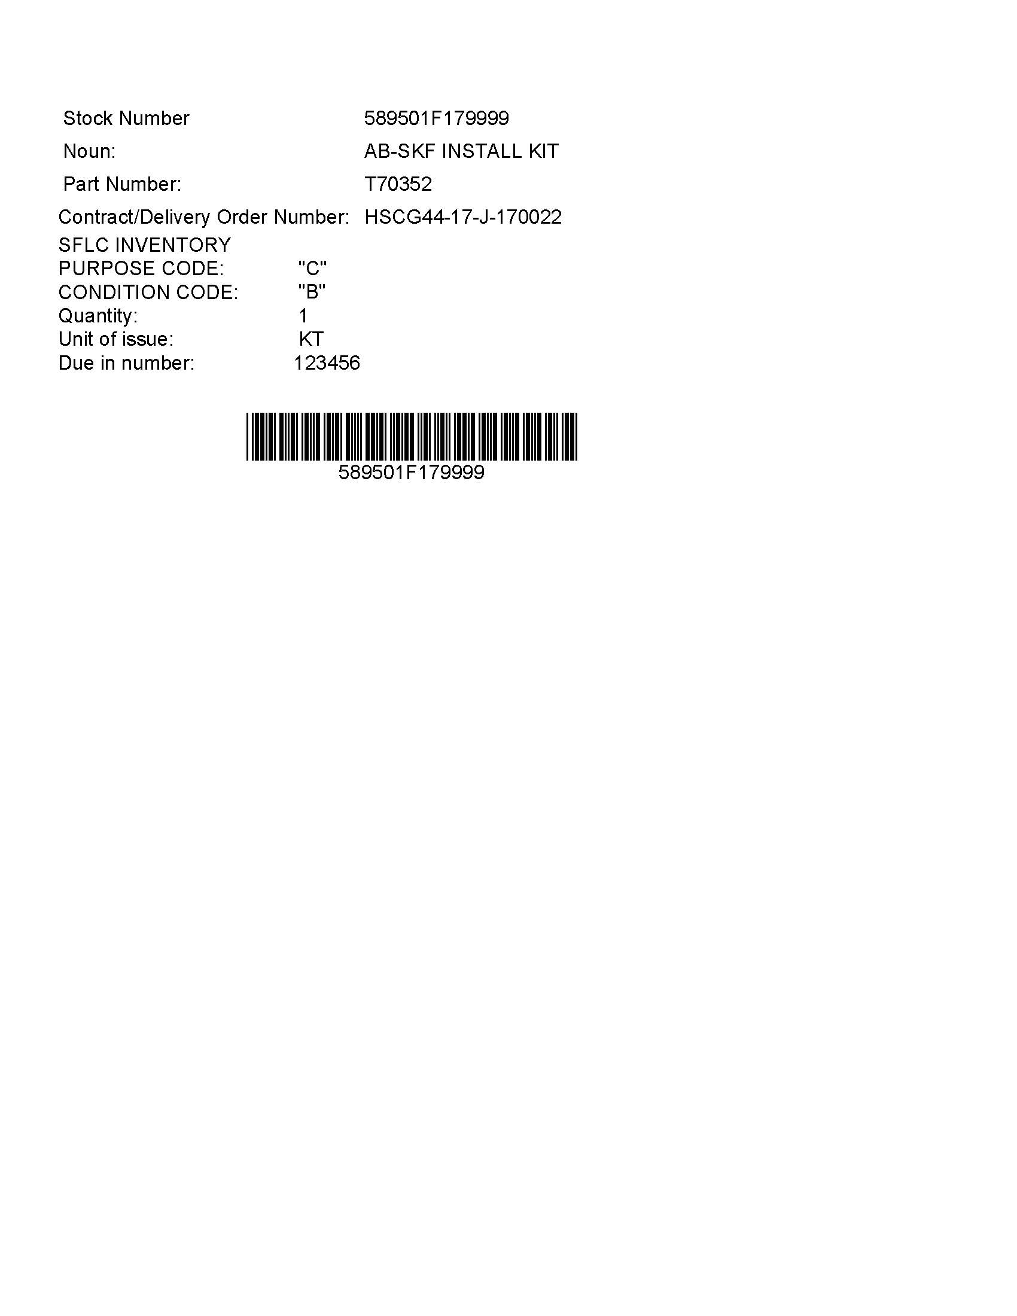

Spare Parts
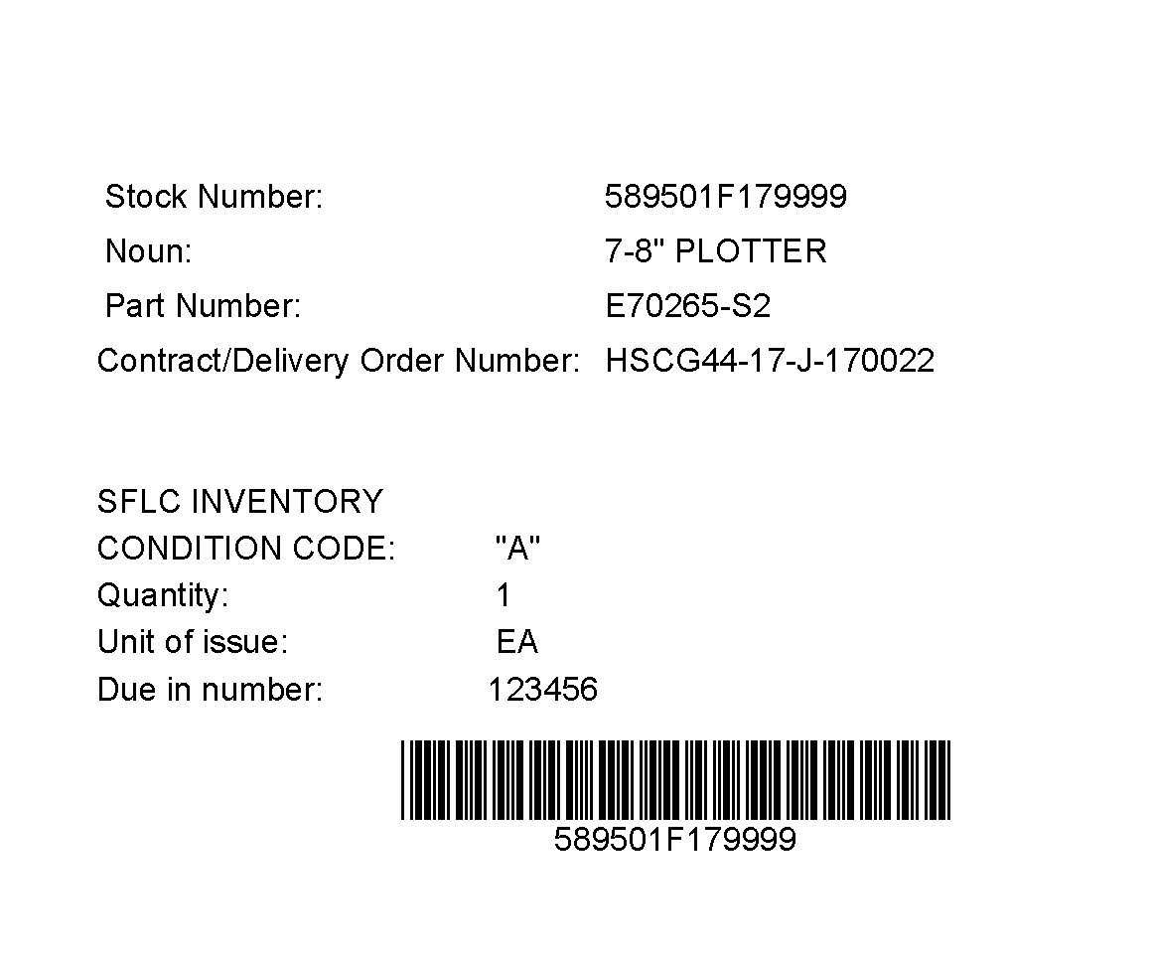

      - Large part shipping container lettering shall be at least ½ inch high or 36 point type. Stenciling is acceptable.
      - General Packaging lettering shall be at least 1/4 inch high or 18 point type.
      - Plastic Bag lettering may be 12 point lettering.
    - Bar Code Labeling: All parts/packages shall have a bar code label applied, or incorporated into the packaging label. The actual labels shall be Type V, Grade B, and Style 2, Composition "B" with or without plastic laminate. Each label shall contain encoded data for the stock number.
  - MARKING WARRANTEED ITEMS Pursuant to the requirements of FAR 46.706 (b) (5), the contractor shall stamp or mark the supplies delivered or otherwise furnish notice with the supplies of the existence of the warranty. Markings may be brief but should include:
    - A brief statement that a warranty exists.
    - The substance of the warranty.
    - Its duration.
    - Who to notify if the supplies are found to be defective.
      - For commercial items, the contractor’s trade practice in warranty marking is acceptable if sufficient information is presented for supply personnel and users to identify warranted supplies.
  - MATERIAL INSPECTION AND RECEIVING REPORT At the time of each delivery for supplies under this order, the contractor shall prepare and furnish to the Coast Guard a properly completed DD Form 250 Material Inspection and Receiving Report or Commercial Bill of Lading.
    - A packing slip shall be prepared for each box or shipping container. The packaging slip shall include the following information: (1) National Stock Number, (2) Part Number, (3) Nomenclature, (4) Serial Number, (5) Contract Number, (6) Delivery Order Number, (7) Line Item Number, and (8) Quantity, (9) Due In Number.
      - One copy of the packaging slip shall be submitted with the shipment and shall be attached to the outside of the shipping carton inside a waterproof, clear envelope;
      - One copy shall be sent to the Contracting Officer upon shipment and shall be clearly marked “Information Only”;
      - And one copy shall be attached to the original invoice when submitted to the payment office.
  - DELIVERY OF REPORTS Evaluations and reports, not otherwise specified, shall be delivered within 15 days of delivery of parts to the Contracting Officer.

