SUBJECT* | Window Shades - New Bldg 05 (WTS Campus), IND

GENERAL INFORMATION
CONTRACTING OFFICE’S ZIP CODE* | 46240
SOLICITATION NUMBER* | 36C25026Q0463
RESPONSE DATE/TIME/ZONE | 04-15-2026 2:00 PM EASTERN TIME, NEW YORK, USA
ARCHIVE | 90 DAYS AFTER THE RESPONSE DATE
RECOVERY ACT FUNDS | N
SET-ASIDE
PRODUCT SERVICE CODE* | 7230
NAICS CODE* | 337920
CONTRACTING OFFICE ADDRESS | Department of Veterans Affairs  Network Contracting Office 10  8888 Keystone Crossing Suite 325  Indianapolis IN 46240
POINT OF CONTACT* | Contract Specialist  Robin Whitfield  robin.whitfield@va.gov  317-988-1502

PLACE OF PERFORMANCE
ADDRESS | Department of Veteran Affairs
 | Richard L. Roudebush VAMC
 | 1481 West 10th Street Building 5
 | Indianapolis IN
POSTAL CODE | 46202
COUNTRY | USA

ADDITIONAL INFORMATION
AGENCY’S URL
URL DESCRIPTION
AGENCY CONTACT’S EMAIL ADDRESS
EMAIL DESCRIPTION

DESCRIPTION
This is a Sources Sought (SS) Notice only, not a solicitation announcement and should not be considered as such. There is no solicitation available at this time. The Government will not pay for any information received in response to this SS, nor will the Government compensate any respondent for any cost incurred in developing the information provided to the Government. This SS does not constitute a commitment by the Government. Any information provided in response to this market survey will be used for informational purposes only and will not be released. Vendor participation is not a promise of future business with the Government. The purpose of this Sources Sought is to conduct Market Research to determine an acquisition strategy for window blinds and installation.
Department of Veterans Affairs Network Contracting Office 10, 8888 Keystone Crossing Suite 325, Indianapolis, IN 46240, intends to solicit offers for Window Blinds and installation for Richard L Roudebush VA Medical Center located at 1481 W 10th St Indianapolis, IN 46202. NAICS Code 337920, Product Service Code 7230 size standard 1000 employees. A firm fixed price contract is anticipated and shall be awarded. Contractors that can meet the requirements below are requested to send:
1. Company Name
2. UEID number
3. Business size under NAICS 337920
4. SBA or VOSB/SDVOSB Certification.

Note If SDVOSB, must be able to comply with VAAR 852.219-76

This is not a solicitation. This is a Request for Information, Sources Sought. Responses must be received NLT 2:00 PM EST Please email all responses to Robin.whitfield@va.gov with subject line “Sources Sought 36C25026Q0463 – Window Blinds”.

The following is a draft Statement of Work:

Line Number | Description | Qty Ea | Country of Origin | Price per unit | Extended Price
001 | 1st & 2nd Floor West Single  Manual Roller Shades | 12
002 | GWS 0002 1st and 2nd Floor South.  Single Manual Roller Shades | 44
003 | Installation | 1

Healthcare contract/commercial grade furnishings associated with this request include:
- contract/commercial grade window shades (operable and stationary) with light filtering preferred (not entirely opaque).

- LOCATION(s) within building (window shades at highlighted area in plan) consists of…

- “Bullpen” area of the 1st/FIRST floor (South wall and West wall; due to ceiling height, may require both stationary and adjustable shades).
- SOUTH wall (of the FIRST FLOOR) roughly measures 357.0” width X 120.0” (2/TWO 60.0” height horizontal bands) height windows; structural beam of building @ 5.0” from face of window frame.
- WEST wall (of the FIRST FLOOR) roughly measures 1078.0” width X 120.0” (2/TWO 60.0” height horizontal bands) height windows; structural beam of building @ 2.5” from face of window frame.

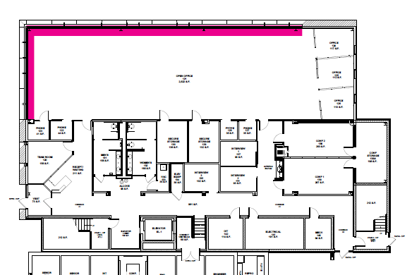

- SOUTH wall (of the 2ND/SECOND FLOOR) roughly measures 357.0” width X 116.0” (2/TWO 58.0” height horizontal bands) height windows; structural beam of building @ 5.0” from face of window frame.
- WEST wall (of the 2ND/SECOND FLOOR) roughly measures 357.0” width X 116.0” (2/TWO 58.0” height horizontal bands) height windows; structural beam of building @ 2.5” from face of window frame.
- “Bullpen” area of the 2nd/SECOND floor (South wall and West wall; ceiling height is lower… may require only adjustable shades).

