NNSY I.D. REQUIREMENTS
1. Two (2) additional forms of ID
OR
2. The Real ID/Enhanced ID.

Example forms of Second ID and Third ID’S:
- Birth certificate.
- Social security card.
- Ret Military or spouse/dependent ID.
- Active duty spouse/dependent ID.
- U.S. Military Reserve ID.
- Veterans Health Identification Card (VHIC).
- Passport or Passport card.
- Permanent Resident card (Form I-551).
- Certificate of Naturalization (Form N-550).
- Certificate of Citizenship (Form 560).
- TWIC

Beginning May 7, 2025
The federal government will require you to present a REAL ID compliant driver's license or ID card, or another federally approved form of ID, in order to board a domestic flight or enter a secure federal facility or Military Bases, such as (NNSY).
To obtain a DBIDS you must have the real ID or passport/card.
OR
Non-Real ID with your BIRTH CERTIFICATE and SOCIAL SECURITY CARD, All 3 together!!
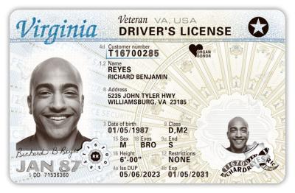

For NAVSEA badges, please ensure to pass along the information the personnel will need to provide proof of US citizenship.

Accepted Proofs of U.S. Citizenship:

-Birth Certificate, showing birth in the United States
-Unexpired U.S. Passport
-Form N-550: Cert. of Naturalization
-Form N-560: Cert. of Citizenship
-Form FS-240: Report of Birth Abroad for US Citizen
-Enhanced Driver’s Licenses from the following states: Washington, Vermont, New York, Minnesota, and Michigan

