SUBJECT* | WATER PURIFICATION SYSTEM HAMPTON VAMC/DIALYSIS LYSI

GENERAL INFORMATION
CONTRACTING OFFICE’S ZIP CODE* | 23667
SOLICITATION NUMBER* | 36C24626Q0335
RESPONSE DATE/TIME/ZONE | 03-20-2026 10am EASTERN TIME, NEW YORK, USA
ARCHIVE | 30 DAYS AFTER THE RESPONSE DATE
RECOVERY ACT FUNDS | N
SET-ASIDE
PRODUCT SERVICE CODE* | 4610
NAICS CODE* | 333310
CONTRACTING OFFICE ADDRESS | Department of Veterans Affairs  Network Contracting Office 6  100 Emancipation Drive  Hampton VA 23667
POINT OF CONTACT* | Contract Specialist  John P Harmsen  john.harmsen@va.gov  757-722-7961

PLACE OF PERFORMANCE
ADDRESS
POSTAL CODE
COUNTRY

ADDITIONAL INFORMATION
AGENCY’S URL
URL DESCRIPTION
AGENCY CONTACT’S EMAIL ADDRESS
EMAIL DESCRIPTION

DESCRIPTION
Service: | Nursing, SCI and Rehab (Dialysis)
Requestor: | LARRY STALCUP
Vendor:
Vendor POC:
Vendor Phone #:
Manufacture: | Mar Cor (McPur)
Nomenclature: | RO, WRO 300 H, 115V, 60Hz
Model: | W3T577585
Quantity: | 12 EA
Dimension: | 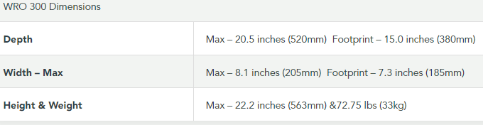
Weight: | 72.75 lbs (33kg)
Volts/Power Requirements: | 100,115 or 220-240V +/- 10%, 50 or 60 Hz
Air/Gas/Water/Drain/: | Regular sink tap water
Specifications: | WRO 300 H Dialysis RO System | Mar Cor (mcpur.com) (below)
Location (Bldg. & Rm.): | Dialysis, Bldg. 110, EIL 870

