SUBJECT* | 766-26-2-400-0507 -Charleston CMOP 5 PHARMACEUTICALS -(VA-26-00044119)

GENERAL INFORMATION
CONTRACTING OFFICE’S ZIP CODE* | 66048-5012
SOLICITATION NUMBER* | 36C77026Q0097
RESPONSE DATE/TIME/ZONE | 03-26-2026 5:00 PM PACIFIC TIME, LOS ANGELES, USA
ARCHIVE | 60 DAYS AFTER THE RESPONSE DATE
SET-ASIDE | SBA
PRODUCT SERVICE CODE* | 6505
NAICS CODE* | 325412
PLACE OF PERFORMANCE | Department of Veterans Affairs
 | CMOP Ladson (Charleston) 766A
 | 4136 Carolina Commerce Parkway
 | Ladson SC
POSTAL CODE | 29456
COUNTRY | USA
CONTACT INFORMATION
CONTRACTING OFFICE ADDRESS | Department of Veterans Affairs  NCO 15 Contracting Ofc - CMOP  3450 S. 4th St. Trafficway  Leavenworth KS 66048-5012
POINT OF CONTACT* | Contract Specialist  Charlene Nye  Charlene.Nye@va.gov  913-684-0162

The Department of Veterans Affairs, Network Contracting Office 15, CMOP Division, intends to release a requirement to procure the five (5) pharmaceuticals listed below for delivery to the Ladson (Charleston) CMOP location.
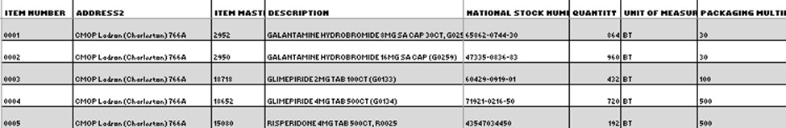

RFQ: 36C77026Q0097
SET ASIDE CATEGORY: Total Small business set-aside
PRODUCT CODES: 6505, Drug and Biologicals.
NAICS CODES: 325412, Pharmaceutical Preparation Manufacturing.
ESTIMATED ISSUE DATE: 03/19/2026.
ESTIMATED RESPONSE DUE DATE: 03/26/2026.
DELIVERY TIME FRAME: TBD

All responsible sources may submit a quotation, which if received timely, shall be considered by this agency.

Responses must be concise and be specifically directed to the requirement referenced above. It is the offeror’s responsibility to monitor SAM.GOV for changes or amendments.

Offeror shall supply their state wholesale distributor licensure, verifying compliance with the Drug Supply Chain Security Act (DSCSA), with their quote. Vendors that fail to submit a copy of their valid/ unexpired state license shall be deemed non-compliant.

All solicitation packages will be submitted via email.
1. SF1449 - Solicitation cover page (Signed).
2. Quote - Price Schedule – Place of Manufacture is required. (Excel format)
3. State Wholesale Distributor License, valid and unexpired.
4. Buy American Act (BAA) Certificate - completed.

Submit the Response to Charlene.Nye@VA.GOV | Phone Number: (913) 684-0162.

