SUBJECT* | 667-26-111 CON Abate Central Chase & Replace Fire Main

GENERAL INFORMATION
CONTRACTING OFFICE’S ZIP CODE* | 71101
SOLICITATION NUMBER* | 36C25626R0047
RESPONSE DATE/TIME/ZONE | 04-10-2026 2:00 pm CENTRAL TIME, CHICAGO, USA
ARCHIVE | 30 DAYS AFTER THE RESPONSE DATE
SET-ASIDE | SDVOSBC
PRODUCT SERVICE CODE* | Z1DA
NAICS CODE* | 236220
PLACE OF PERFORMANCE | Overton Brooks VA Medical Center
 | 510 E Stoner Ave
 | Shreveport, LA
POSTAL CODE | 71101
COUNTRY | US
CONTACT INFORMATION
CONTRACTING OFFICE ADDRESS | Department of Veterans Affairs  Overton Brooks VA Medical Center (90C)  1800 Buckner Street  Shreveport LA 71101  Shreveport LA 71101
POINT OF CONTACT* | Contracting Specialist  Andrea Payton  andrea.payton@va.gov  318-990-4094
ADDITIONAL INFORMATION
AGENCY’S URL | http://www.va.gov
URL DESCRIPTION | Agency Website
AGENCY CONTACT’S EMAIL ADDRESS | andrea.payton@va.gov
EMAIL DESCRIPTION | Contracting Specialist

DESCRIPTION

THIS OPPORTUNITY IS AVAILABLE ONLY TO SERVICE-DISABLED VETERAN-OWNED SMALL BUSINESSES. The Overton Brooks VA Medical Center (OBVAMC) in Shreveport, LA has a requirement titled "Abate Central Chase & Replace Fire Main” for project number 667-26-111, per issue for construction Drawings and Specifications. This acquisition will be solicited pursuant to the Veterans' First Public Law 109-461 as a 100% Service-Disabled Veteran-Owned Small Business Set-Aside (SDVOSB). At least 15 percent of the cost of the contract performance incurred for personnel shall be spent on the concern's employees or the employees of other eligible SDVOSB concerns. Please do not send questions to this notice as it is only a Pre-Solicitation Notice. Questions will be accepted only after the solicitation has been published.
A Firm-Fixed Price construction contract award is anticipated. Contractor shall furnish all supervision, labor, material, tools, and equipment requirements to remove all the asbestos in the central pipe chase and to replace the fire main riser in the main hospital, Building 1. This project will remove friable asbestos-containing material within the main central chase of the hospital. Asbestos-containing material (ACM) is being removed to allow for the facilities primary fire main risers to be replaced. New fire main risers will be installed. Piping in the central chase will be re insulated. Project will require a multi-phase process to prevent asbestos related exposure and to allow for sampling and asbestos abatement. New fire main risers will need to be installed prior to removal of existing ones. Work includes general construction, demolition, architectural, mechanical, electrical, plumbing, medical gas, radiation protection, fire protection, telecommunication, and certain other items as required by provided construction documents. The period of performance will be 200 calendar days from the Notice to Proceed.
Solicitation documents, including specifications and drawings, will be available electronically on or about April 10, 2026, on this website. Hard copies will not be mailed. The solicitation will be issued as a Request for Proposals (RFP). INTERESTED PARTIES ARE STRONGLY ENCOURAGED TO REGISTER TO RECEIVE NOTIFICATION OF ACTIONS INCLUDING POSTING OF THE SOLICITATION AND ANY AMENDMENTS. ADDITIONALLY, OFFERORS ARE ADVISED TO CHECK THE SITE FREQUENTLY AS THEY ARE RESPONSIBLE FOR OBTAINING AMENDMENTS TO THE SOLICITATION NOTICE.
A 30-day proposal acceptance period will be required. A bid bond must be submitted with the proposal. Performance and Payment bonds will be required from the contractor receiving the award. The magnitude of construction is between $1,000,000.00 and $5,000,000.00. North American Industrial Classification Standard (NAICS) code assigned to this construction project is 236220 with a small business size standard of $45 million in average annual receipts for the past three (3) years. Offerors shall be registered with SBA VetCert at Veteran Small Business Certification (sba.gov), in System for Award Management (SAM) database at www.sam.gov and have completed online Representations and Certifications prior to the solicitation due date. Offerors shall be registered with the NAICS code assigned to this acquisition in VetC

ATTACHMENTS
Statement of Work

Abate Central Chase/Replace Fire Main
Project No. 667-18-111

SCOPE OF WORK (SOW):

Overton Brooks VAMC has a requirement to remove all the asbestos in the central pipe chase and to replace the fire main riser in the main hospital, Building 1. The central pipe chase and fire main traverse through all floors of the hospital. This project will remove friable asbestos-containing material within the main central chase of the hospital. Asbestos-containing material (ACM) is being removed to allow for the facilities primary fire main risers to be replaced. New fire main risers will be installed. Piping in the central chase will be re insulated. Project will require a multi-phase process to prevent asbestos related exposure and to allow for sampling and asbestos abatement. New fire main risers will need to be installed prior to removal of existing ones.

The C&A requirements do not apply, and that a Security Accreditation Package is not required.
PERIOD OF PERFORMANCE:
The Contractor shall complete the work 200 Days from the issuance of Notice to Proceed.

CONTRACTOR SITE VISIT AND FIELD VERIFICATION PRIOR TO BIDDING:
Contractor shall be responsible for attending the Pre-Bid Site visit prior to bidding to verify all existing conditions and take any necessary measurements and photos required to adequately bid the project. If the contractor chooses not to attend the Pre-Bid Site visit, the contractor may submit their bid at their own risk.

INFECTION CONTROL DURING CONSTRUCTION:
Contractor shall follow and comply with the established Infection Control Risk Assessment (ICRA) specific for numerous project sites. Contractor is responsible for dust control during demolition, during construction, and during hauling operations. Contractor shall always maintain negative air pressure of -0.02 for the entire chase for the duration of the contract. The chase is a continuous space spanning the length of the hospital vertically (sub-basement through the 12th floor).

DEMOLITION:
Contractor shall protect all adjacent areas of the hospital, especially windows and doors during all operations. Repairing any damage shall be the sole responsibility of the contractor at no additional cost to the government. If any damage is noticed prior to starting work, which may be misconstrued as damage caused by the contractor, the COR shall be notified immediately, and the damage shall be documented as existing conditions.

NEW WORK:
New work includes, but is not limited to:

- All asbestos-containing material in this scope of work shall be abated and pipes re-insulated.
- Existing 6” Fire Sprinkler Standpipe system shall be replaced from the 1st floor to the 12th floor and to the control valves for each floor.
- New system shall include, but not limited to, new control valves at each floor, approved fire cabinet enclosure or with an access panel at each floor (fire rated).
- All chase penetrations or existing breeches are to be sealed per NFPA requirements.
- New Fire rated chase access doors are to be installed at each floor.
- Any items or systems determined to be abandoned or no longer required shall be identified to be removed and capped or terminated. PHASING, NOISE, SMELLS, AND AFTER-HOURS WORK:
PHASING IS LIMITED TO TWO FLOORS AT A TIME, WORKING FROM THE TOP FLOOR DOWN

PHASE 1: TWELFTH AND ELEVENTH FLOORS PHASE 2: TENTH AND NINTH FLOORS PHASE 3: EIGHTH AND SEVENTH FLOORS PHASE 4: SIXTH AND FIFTH FLOORS
PHASE 5: FOURTH AND THIRD FLOORS PHASE 6: SECOND AND FIRST FLOORS
PHASE 7: BASEMENT AND SUB-BASEMENT FLOORS
The areas to be renovated will likely be occupied during construction; therefore, adequate scheduling shall be coordinated with the COR. Work resulting in extensive noise or odor, shall be performed after hours or on weekends. Any required utility outages shall be scheduled at the convenience of the hospital and potentially require after-hours work or on weekends. Any required outages shall also require a written two-week notification to the COR prior to any outages.

DELIVERIES:
Contractor shall coordinate all materials and equipment deliveries, storage, and handling requirements with the COR and use only approved drop-off locations. Contractor shall coordinate all activities with the COR and include clearance air monitoring results following asbestos abatement.

FINAL CLEAN, PRE-FINAL AND FINAL INSPECTIONS:
Once all work has been completed, the Contractor shall adequately clean the project sites prior to a Pre-Final Inspection. Upon completion of the Pre-Final punch list items, the contractor shall request a Final Inspection. Each of these inspections will be scheduled at the convenience of the hospital.

SUBMITTALS:
Submit an electronic copy to the COR and each copy shall have a completed VA transmittal sheet attached.
Contractor shall provide submittal as detailed in the specifications and samples of all finishes showing the full range of available colors and options to be selected by the VA-ID and COR.
ADDITIONAL GUIDANCE:
- Contractor shall remove and dispose of waste daily in accordance with all legal and VA requirements. Dumpsters shall be emptied immediately once full. No debris shall be placed around the dumpster or piled/stacked above the top edge of the dumpster walls.

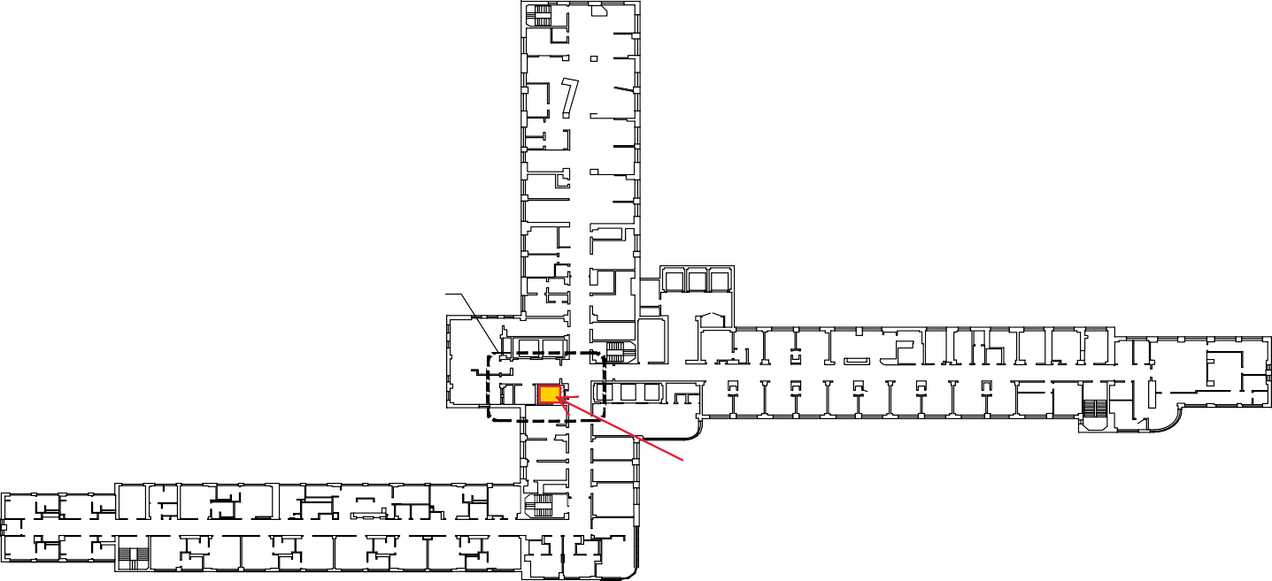
AREA OF WORK
CENTRAL CHASE

