Statement of Work (SOW)
San Joaquin Valley National Cemetery Water Features Cleaning
- This is a non-personal services contract perform a one-time cleaning of water features at San Joaquin Valley National Cemetery (SJVNC). The Contractor will provide all resources, including personal protective equipment (PPE), necessary to safely complete the work as defined in this Statement of Work (SOW) including the standards incorporated by reference.

  - SJVNC will not provide electricity or water for performance of this project. Contractor supplied pumps will require an alternate power supply.

  - SJVNC will refill the water features upon completion of the work.

  - Wildlife, including rattlesnakes, are present at SJVNC requiring caution. The Government is not responsible for theft and/or damage to Contractor and/or Contractor’s employees from environmental events, wildlife, and/or non-Government personnel.

- The performance period will be conducted following contract award and COR confirmation within two contiguous calendar weeks (Monday through Friday and the following Monday through Friday) between April 6, 2026 and May 15, 2026 (tentative dates depending on award).

  - Work hours are Monday through Friday between 7:00 a.m. through 3:00 p.m., Pacific Standard Time. No weather delays are available under the contract.

  - New water accumulation from rain and irrigation run-off must be removed during the period of performance.

- The Contractor shall provide on-site supervision at the location where work is done by Contract employees and subcontractors. All personnel must sign in and out at the Administration Lobby daily.

- The Contractor shall include sjvnc.cor@va.gov in all email correspondence, including daily reports of activity conducted that day with photographs showing progress.

- Contractor personnel performing work under this contract must always be identifiable as uniformed Contractor personnel. Every effort shall be made to avoid creating the impression that Contractor personnel are Government officials. Subcontracted and/or personal service staff hired by the Contractor shall also comply with this requirement.

  - Contractor personnel shall adhere to all standards of dress and conduct while performing work on SJVNC property. Standards and regulations are enforceable under Title 38, U.S.C., Part I, Chapter 9, Section 901. Failure of Contractor-employee or subcontractor-employee to comply may result in contract termination as directed by the Contracting Officer. Immediate removal from the cemetery may be requested by law enforcement, if necessary.

  - Contractor personnel shall not engage in loud or boisterous behavior, angry outbursts or use profane, suggestive, or abusive language at any time while on Government premises. Contractor personnel will be observed by and may have contact with grieving guests during the course of their duties. Consequently, Contractor personnel shall exercise and exhibit absolute decorum, courtesy, and respect within the cemetery and at its perimeter or entrances. Inquiries from Cemetery visitors shall be politely referred to SJVNC staff personnel. Gratuities and solicitation of any kind are strictly prohibited. Personal use of radios, cellular phones, or other devices are permitted only in designated break areas.

  - The Contractor’s personnel shall consume food and beverages only within areas designated by the COR. Consumption of water and mobile watering storage is allowable in field operations to ensure the safety of personnel. Intoxication, violence, and/or criminal acts of any kind will not be tolerated and may result in immediate removal from Government property and/or contract termination. All areas are designated as NO SMOKING except those specifically identified as smoking areas.

  - All Contractor personnel operating vehicles on Government property shall possess a valid state driver's license and must always use safety restraints in all vehicles. All Contractor personnel shall comply with all speed limits (20 mph in most places unless safety requires lower speed; five (5) mph near Administration Building), parking, directional signs, and traffic regulations.

- Safety warnings shall be posted throughout the duration of work to discourage entry into the water feature area.

- The Contractor will provide all materials, parts, equipment, pumps, hoses, cleaning materials, and labor to drain and clean two water features. All organic materials are to be removed and transported/deposited at a COR designated location on SJVNC grounds. The surrounding stage area and all areas dirtied by work shall be cleaned of all debris daily.

  - Parking for employees and staging materials (if needed) will be in a location designated by the COR following contract award. Access to the area will be along Memorial Pathway, which may not be blocked by the Contractor. Parking support vehicles in the area of work will be coordinated with the SJVNC COR TEAM.

  - The water features to be cleaned include the Reflection Pond and the Frog Pond. Overview Photo:
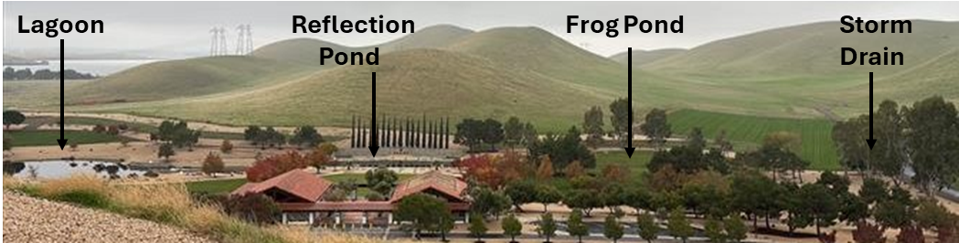

    - The Lagoon and Storm Drain (or nearby drain identified by the COR) are the designated recipient water features for water pumped out of the Reflection Pond and Frog Pond. See overview above and photos in Attachment A.

    - The Reflection Pond is approximately 185 feet long, 65 feet wide and tapered to 6 feet deep in the center. The water shall be pumped from the reflection pool into the adjacent lagoon. See photos in Attachment B.

    - The Frog Pond is approximately 75 feet long, 30 feet wide and tapered to 4 feet deep in the center. The water shall be pumped from the frog pond into the nearby Storm Drain. See photos in Attachment C.

  - Debris and organic sediment removed from the water features must be removed using best practices to ensure the safety of Contractor personnel. Sediment is not toxic but is slick and obnoxious to smell.

    - Contractors should consider the slope of the water features when determining how best to safely remove the sediment. For information, some past efforts included using hand tools (shovels, brooms, buckets, wheel barrows, etc.).

    - No delays for rain are available

Attachment A
Lagoon and Storm Drain Photos

Lagoon photos. Water from the Reflection Pond is to be pumped into the Lagoon.
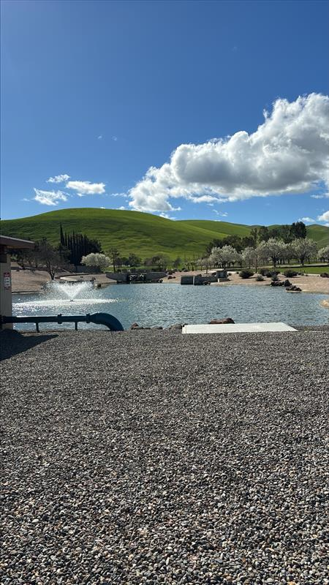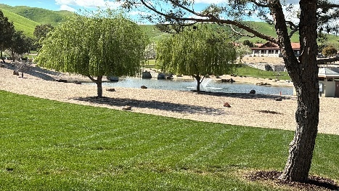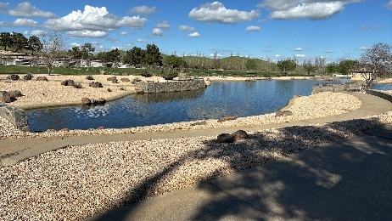

Storm Drain photos. Water from the Frog Pond is to be pumped into the Storm Drain.

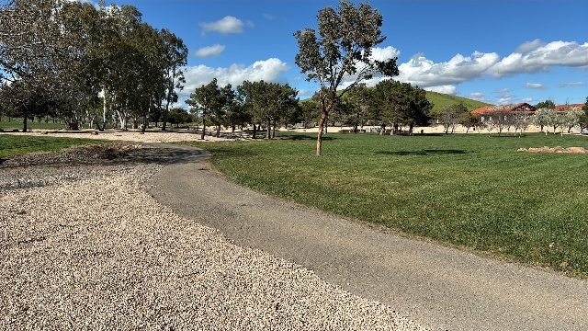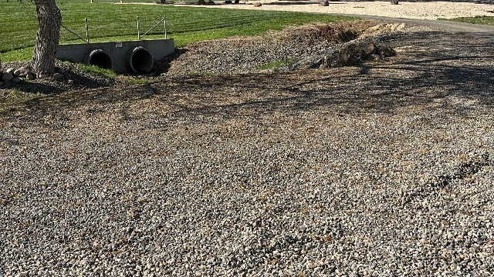

Attachment B
Reflection Pond Photos
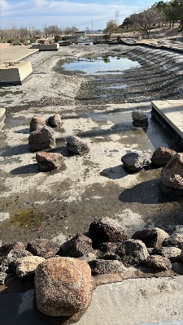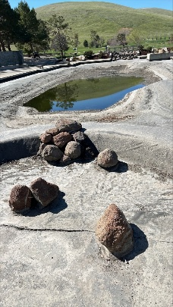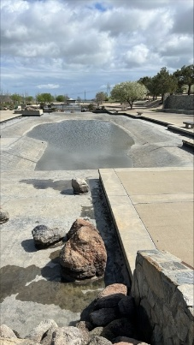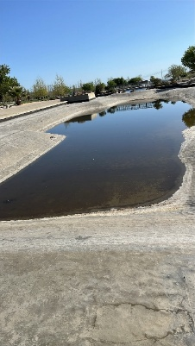
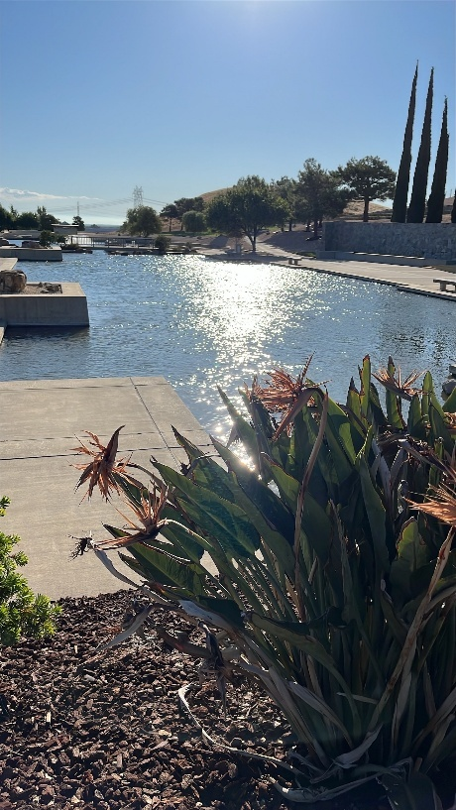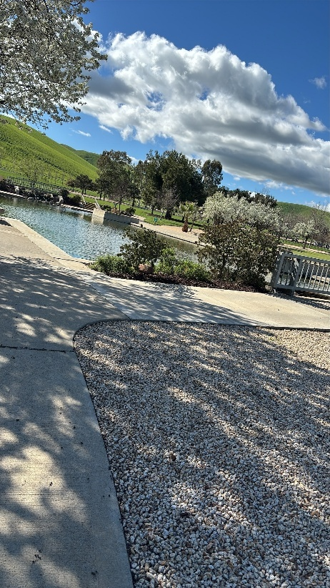

Attachment C

Frog Pond Photos
